**ASSIGNMENT 02**

**Sabaragamuwa University of Sri Lanka**

**Faculty of Computing**

**Department of Software Engineering**

**SE6103 – Parallel & Distributed Systems**

Name : A . Vithurshanan

Reg. No : 19APSE4294

Academic Period : 03rd Year 02nd Semester

Degree Program : Software Engineering

Due Date : 25/11/2024

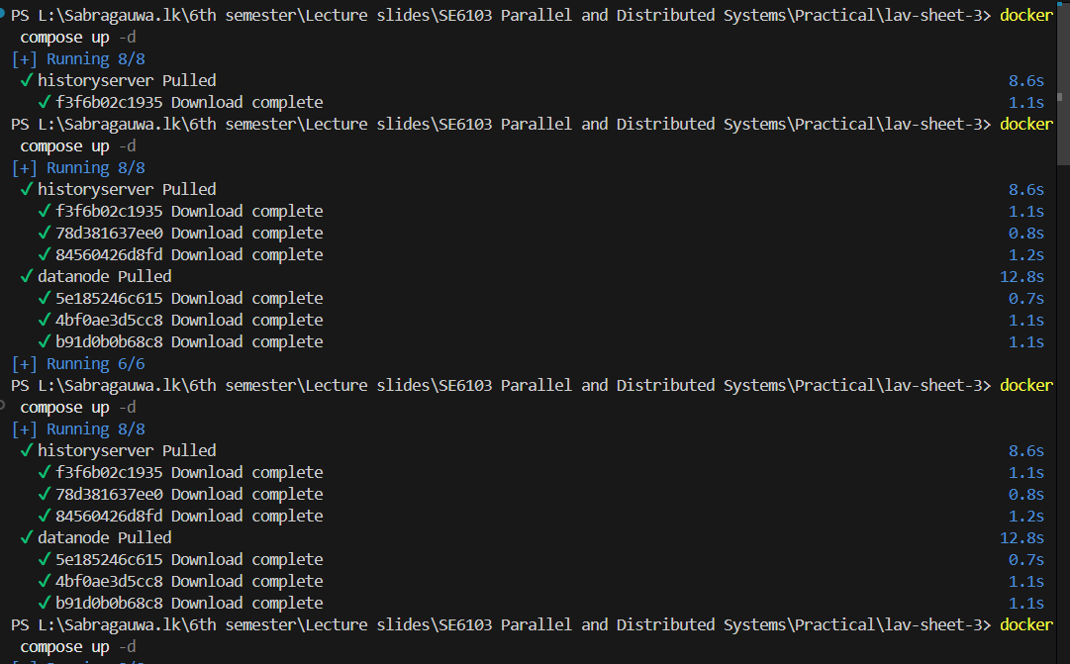Compose yml file

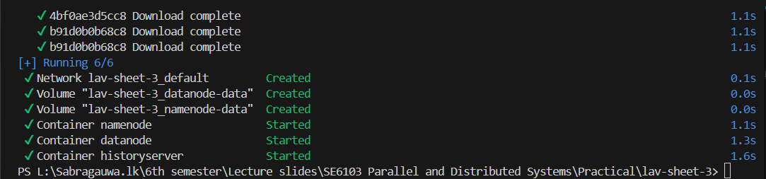Compose up -d

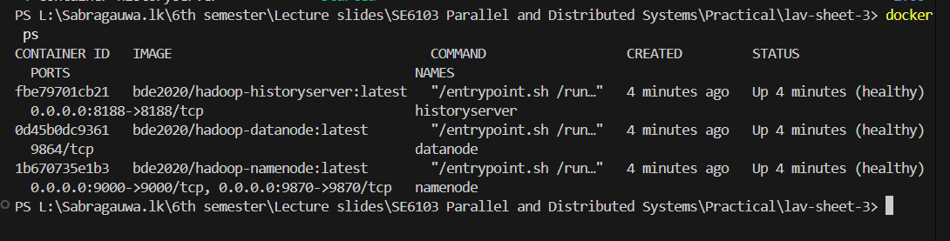Display all running containers

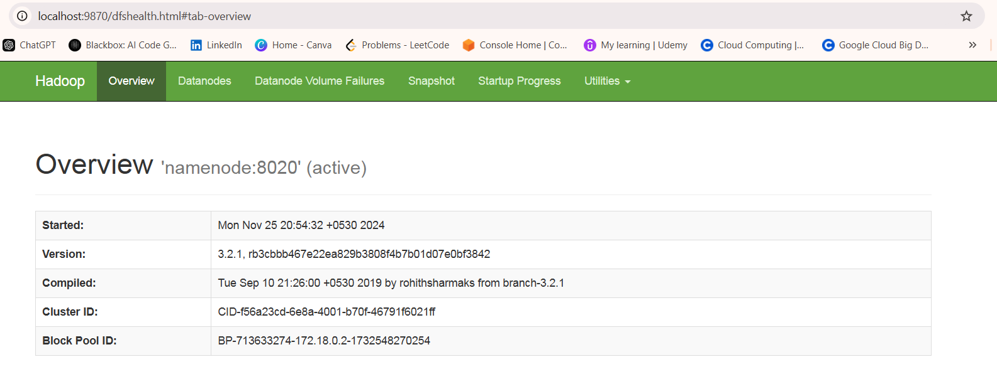

http://Localhost:9870

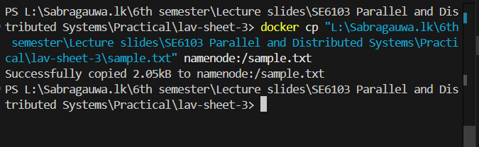Copy sample text file to nodename:sample.txt

docker exec -it namenode ls /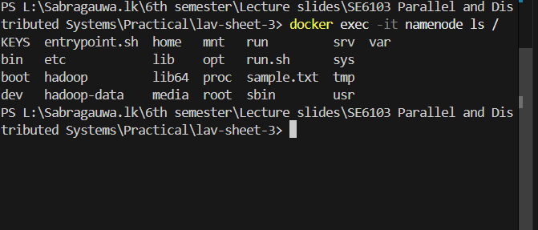

docker exec -it namenode hdfs dfs -mkdir -p /input

docker exec -it namenode hdfs dfs -put /sample.txt /input

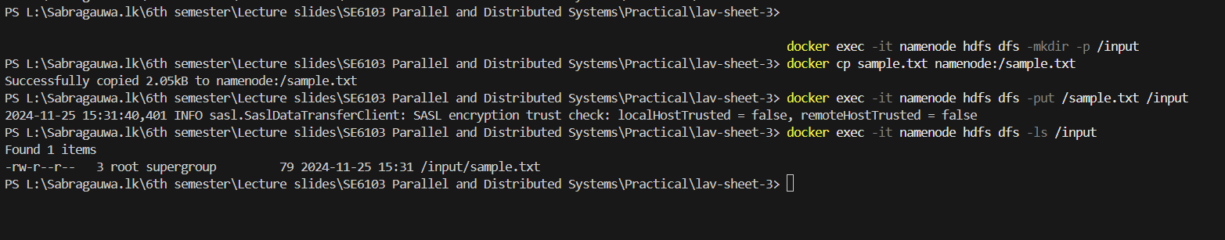docker exec -it namenode hdfs dfs -ls /input

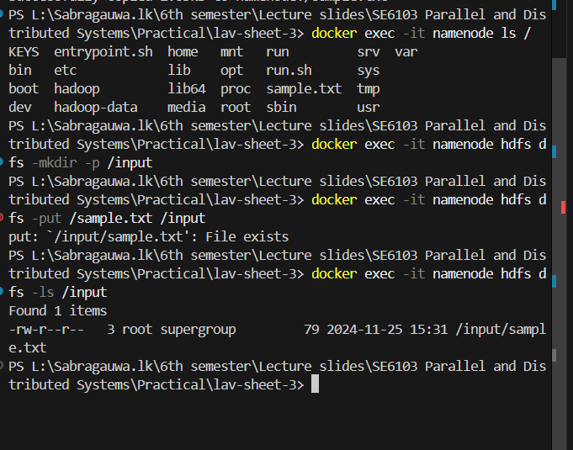

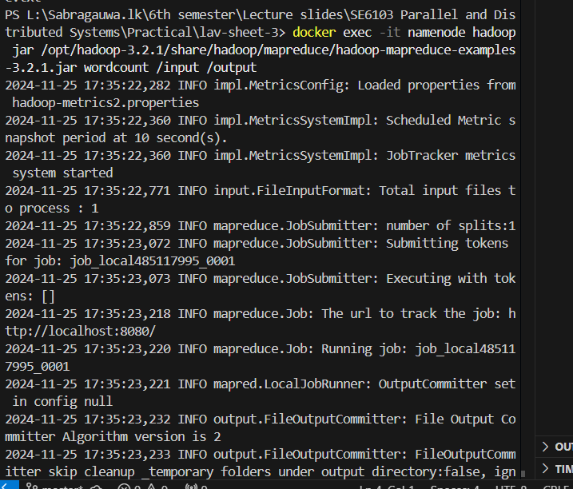docker exec -it namenode hadoop jar /opt/hadoop-3.2.1/share/hadoop/mapreduce/hadoop-mapreduce-examples-3.2.1.jar wordcount /input /output

docker exec -it namenode hdfs dfs -ls /output

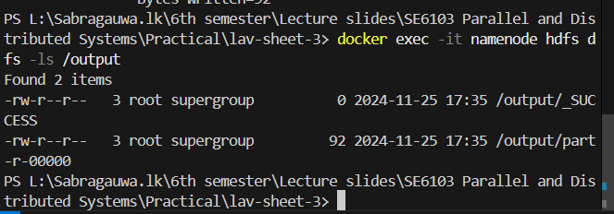

docker exec -it namenode hdfs dfs -cat /output/part-r-00000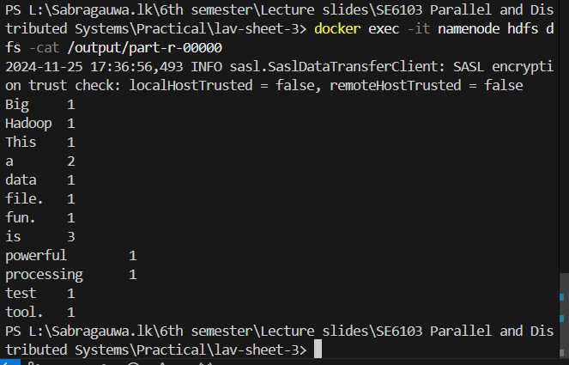

docker-compose down

