**ASSIGNMENT 02**

**Sabaragamuwa University of Sri Lanka**

**Faculty of Computing**

**Department of Software Engineering**

**SE6103 – Parallel & Distributed Systems**

Name : A . Vithurshanan

Reg. No : 19APSE4294

Academic Period : 03rd Year 02nd Semester

Degree Program : Software Engineering

Due Date : 25/11/2024

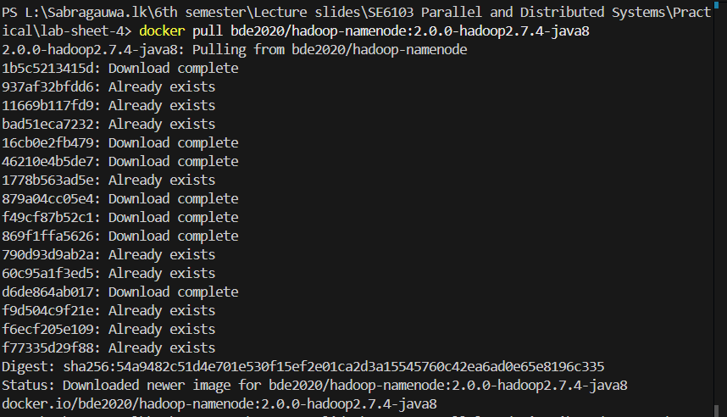Docker Compose yml file

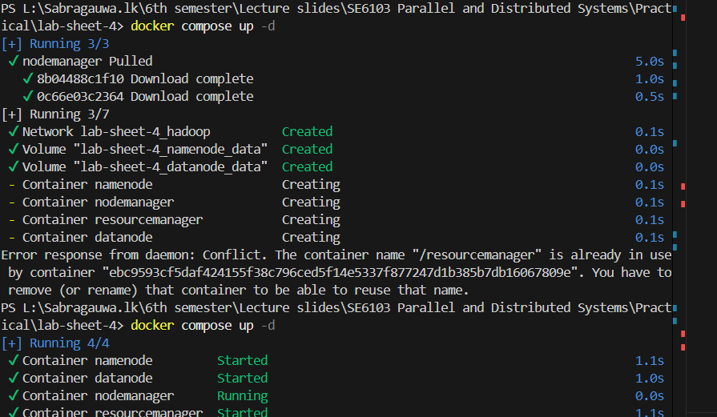Docker Compose up -d

Docker network create hadoop

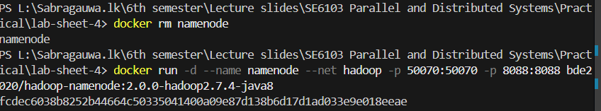Docker run namenode

Docker run datanote

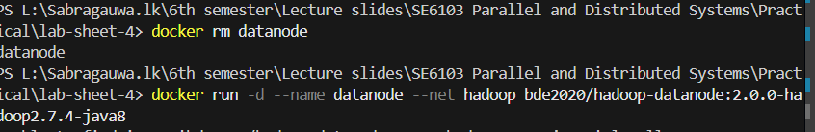

Docker run resourcemanagement

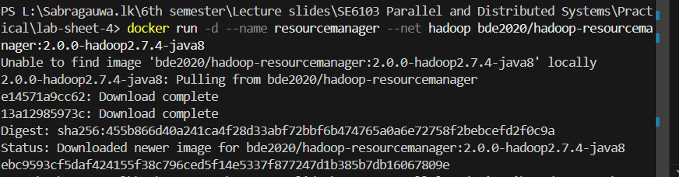

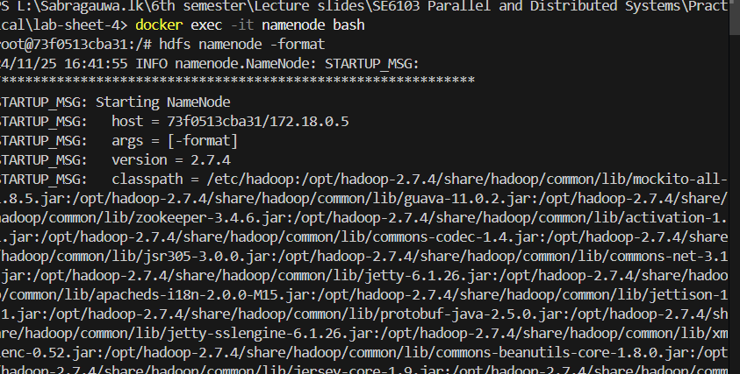

Execute namenode bash

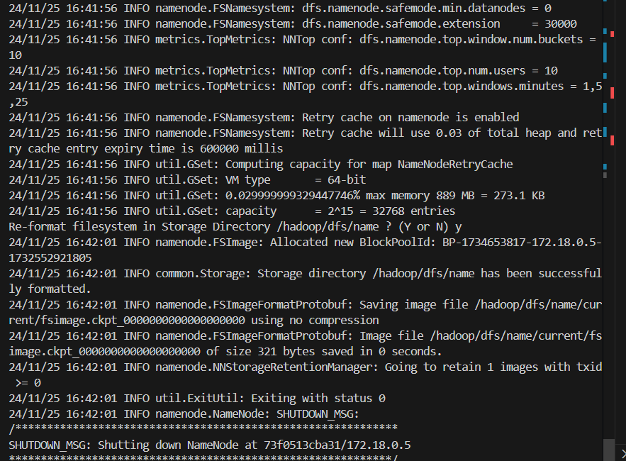

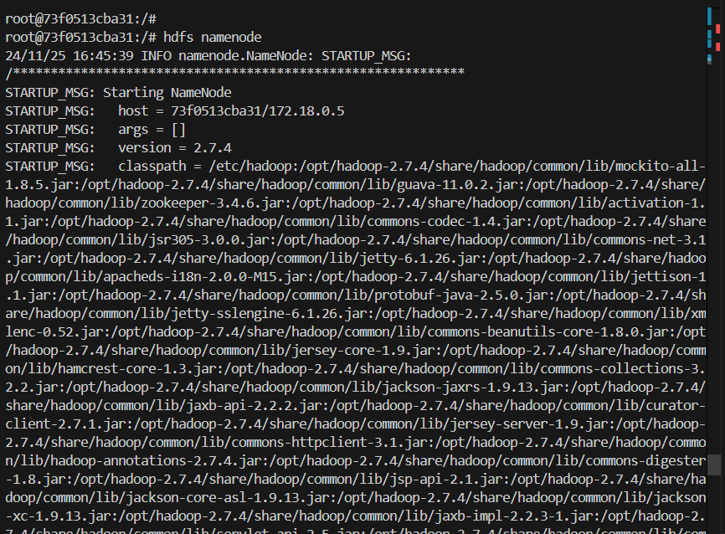hdfs namenode

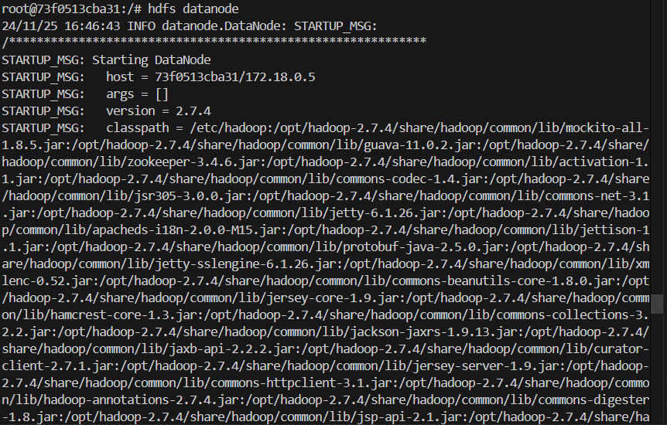

hdfs datanode

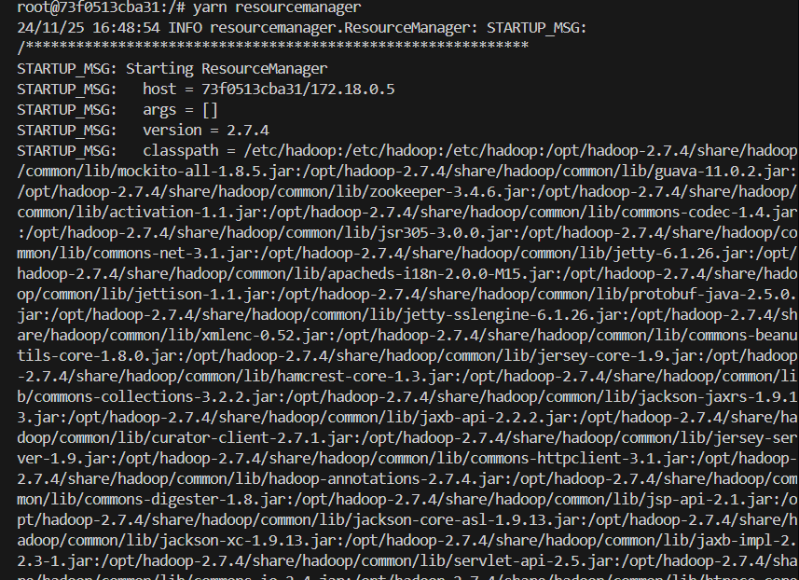yarn resourcemanger

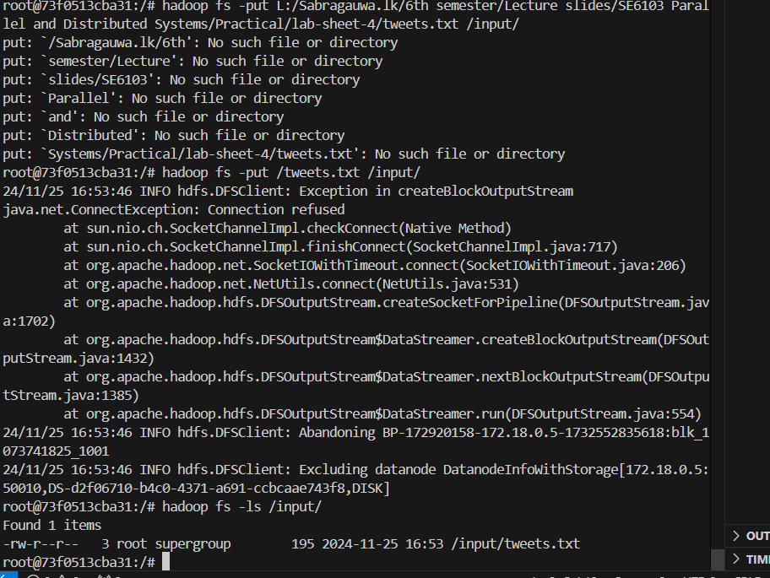put tweets.txt file into /input

make java file as jar file

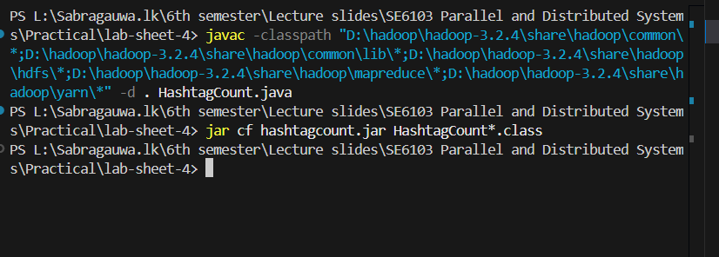

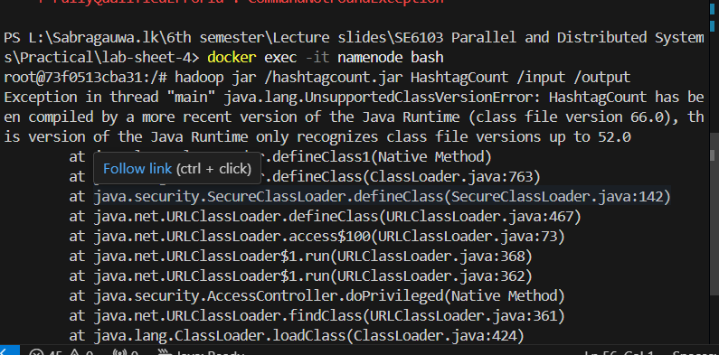Execute namenode bash

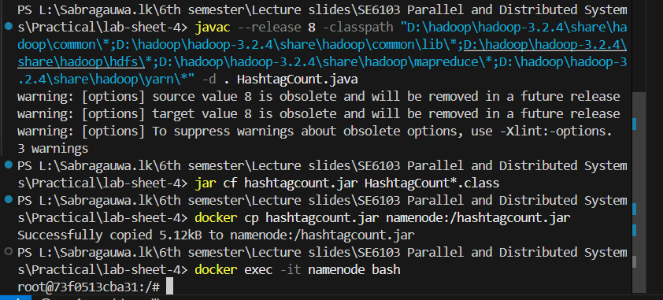

Get output from /input 🡺 hadoop jar /hashtagcount.jar Hashtagcount /input /output

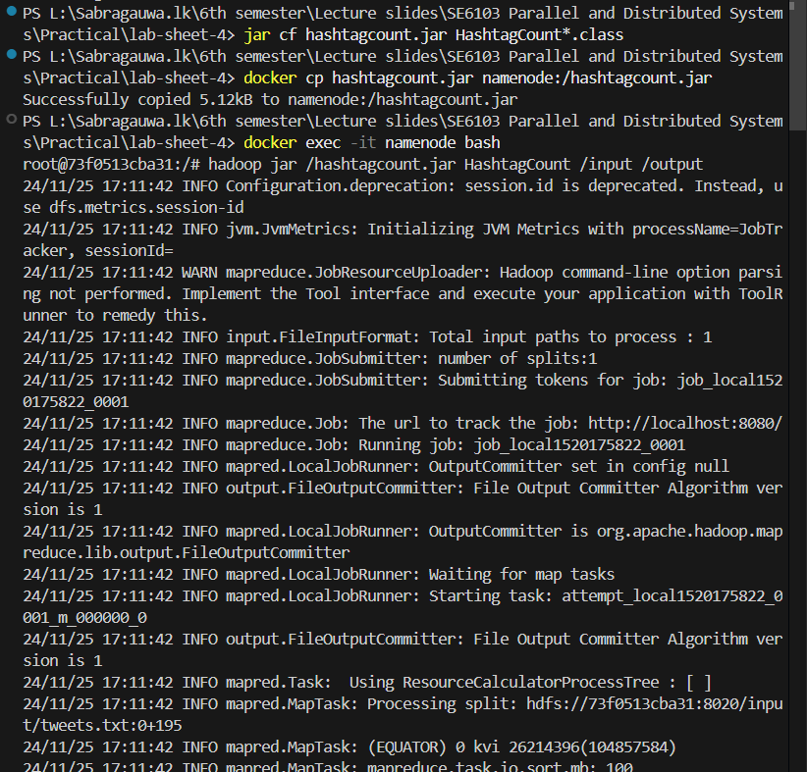

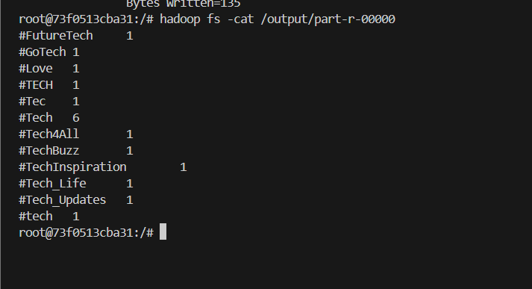Output 🡺 hadoop fs -cat /output/part-r-øøøøø