Optimizing User, Group, and Role Management with Access Control and Workflows

Date | 2 November 2025
Team ID | NM2025TMID08885
Project Name | Optimizing User, Group, and Role Management with Access Control and Workflows

Problem Statement:

In a small project management team consisting of a Project Manager (Alice) and a Team Member (Bob), there is a need to efficiently manage project tasks and ensure accountability throughout the project lifecycle. The current system lacks clear role definitions, access controls, and a structured workflow, leading to confusion regarding task assignments and progress tracking.

Step-1: Create Users
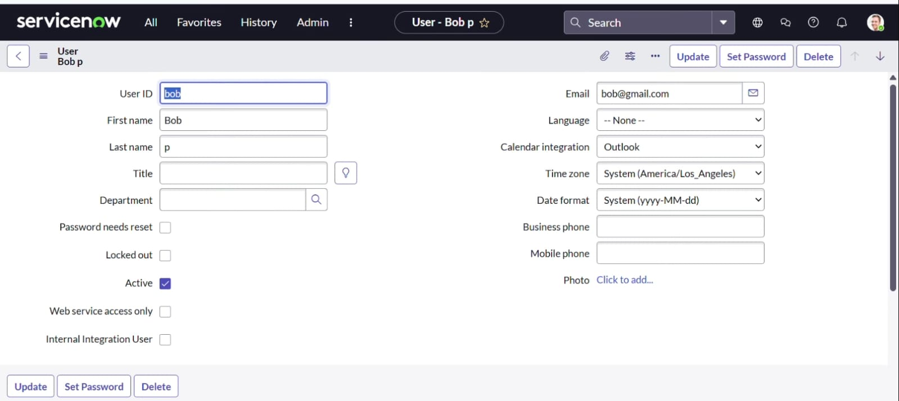

Step-2: Create Groups

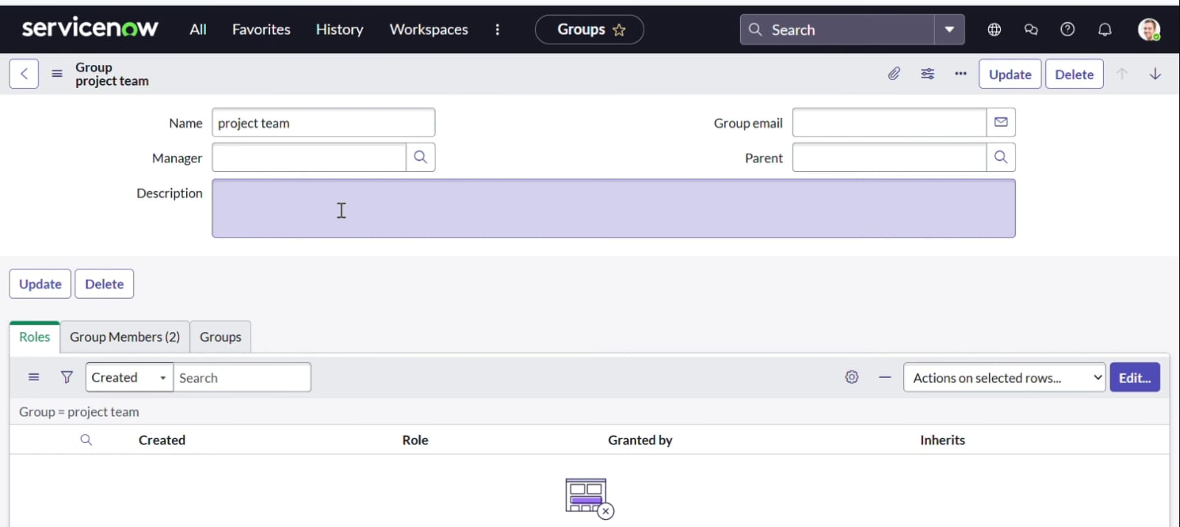

Step-3: Create Roles

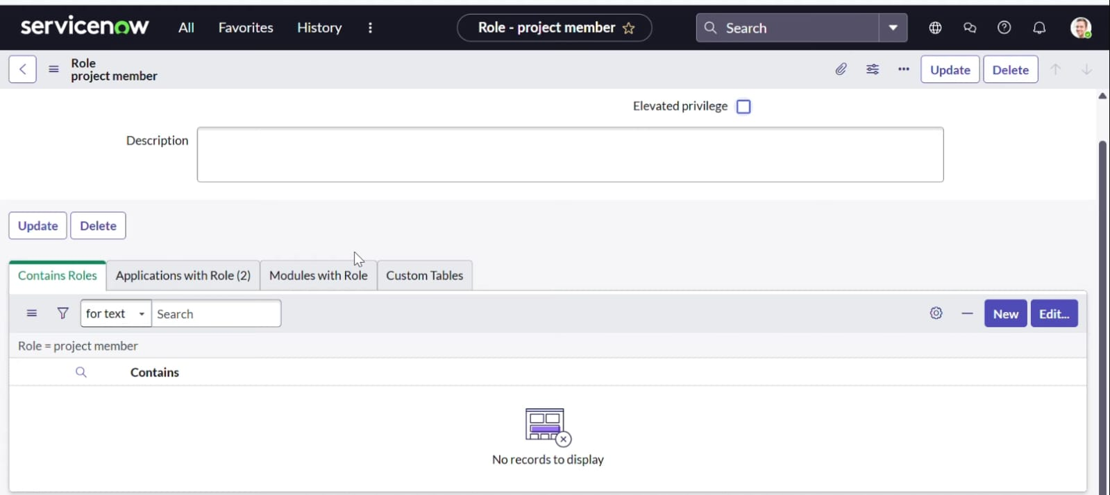

Step-4: Assign roles to project members

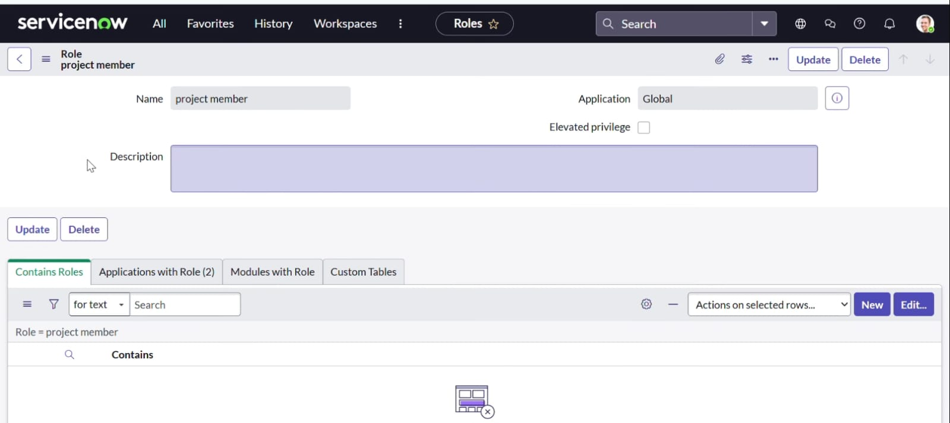

Step-5: Assign table access to application

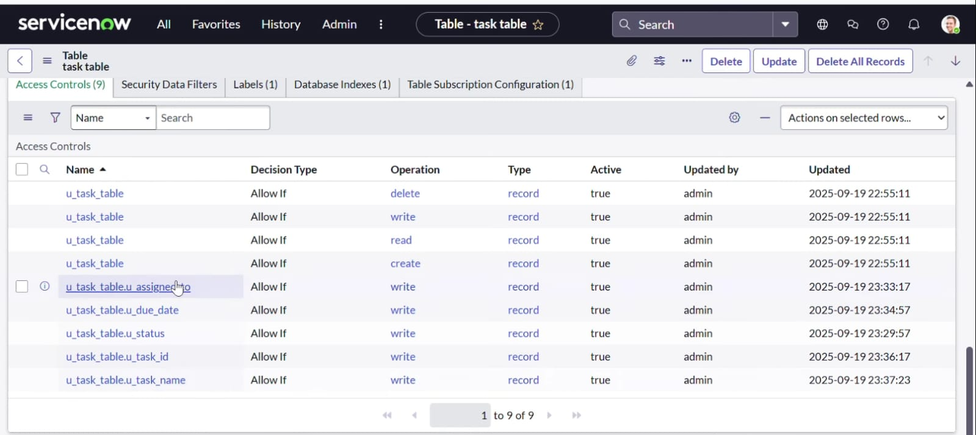

Step-6: Create ACL

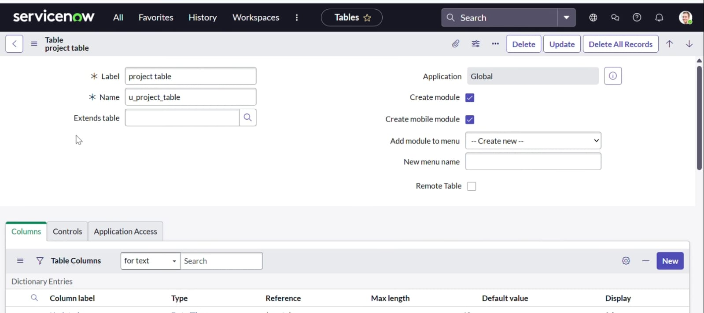

Step-7: Create a Flow to Assign operations ticket to group

