Mini Project Report
Name 1 (Leader): Pranav Srivastava
Purdue username 1: sriva176

Name 2: Austin Lierman
Purdue username 2: alierman

Path chosen (1, 2, or 3): 2

Dataset Description:
We use nyc_bicycle_counts_2016.csv, which contains bicycle traffic count data in New York City from April 1st of 2016 to October 31st of 2016. Each row represents a day. There are 10 columns: Date, Day of Week, High Temp, Low Temp, Precipitation, Brooklyn Bridge, Manhattan Bridge, Williamsburg Bridge, Queensboro Bridge, and Total.
The weather columns describe the daily temperature and how much precipitation there was. The bridge columns describe how much traffic was on each bridge, and total is the combined traffic of all the bridges. Some of the data was stored with comma formatting, so part of our data cleaning involved removing commas to make the values numerical

Methods and Analyses:
Question 1
We used linear regression to determine which of the bridges should receive sensors which used the total bicycle traffic from a subset of three bridge counts. Each model used three of the four bridge count columns as features while the target variable was Total. We evaluated the four possible three bridge sets by dropping one bridge and using a separate model. The model used an 80/20 train/test split with random_state = 42, which we compared using R^2 and the MSE. Linear regression is appropriate because Total is a contiguous variable and is related to the sum of the individual bridge counts. We expected the least useful bridge to be the one whose traffic volume was lowest.

Question 2
In order to test whether the next day weather forecasts would predict total ridership, we used linear regression with inputs High Temp, Low Temp, and Precipitation and Total as the target variable. We used an 80/20 train/test with random_state = 42 again, using R^2, MSE, and RMSE. We expected higher temperatures to be associated with higher ridership and more precipitation to reduce ridership. We used linear regression because the relationship between temperature and outdoor activity is linear over the range in the dataset and the coefficients have a direct interpretation of each weathers effect.

Question 3
We analyzed weekly traffic patterns by using day of the week and calculating the mean total bicycle traffic for each day. We plotted these averages as a bar chart with the days Monday through Sunday. This allowed us to see the patterns in the days of the week. We used 4 classifiers, Logistic Regression, K-Nearest Neighbors, Decision Tree, and Random Forest to predict the day of the week as integers from 0 through 6. We tested all classifiers so their accuracy could be compared directly. Using an 80/20 train/test split with random_state = 42, for reproducibility. Since there are only 214 rows across the 7 classes, we expect the accuracy to be very limited, specifically for distinguishing adjacent weekdays that have similar traffic profiles. We expect weekend days to be easier to classify correctly since they have significantly lower average counts.

Results:
Question 1
The best performing three-bridge subset was the one containing the Brooklyn Bridge, Manhattan Bridge, and Williamsburg Bridge meaning Queensboro Bridge should be the one that we leave without a sensor. The test results were:

Bridges Used | Bridge Left Out | R² | MSE
Manhattan, Williamsburg, Queensboro | Brooklyn | 0.9831 | 697,676.76
Brooklyn, Williamsburg, Queensboro | Manhattan | 0.9856 | 592,865.58
Brooklyn, Manhattan, Queensboro | Williamsburg | 0.9960 | 164,725.04
Brooklyn, Manhattan, Williamsburg | Queensboro | 0.9976 | 97,363.42

From this, we recommend that the sensors should be put on the three bridges aside from the Queensboro bridge. This is because when we tested it, this subset gave us the highest R² value while also having the lowest MSE value out of all the subsets. Our fitted coefficients were 1.193 for the Brooklyn Bridge, 0.943 for the Manhattan Bridge, and 1.592 for the Williamsburg Bridge, and an intercept of 360.06. The Queensboro Bridge giving us the least information makes the most sense, as it is also the bridge with the least traffic out of all four. Removing it would give us the smallest performance drop because its contribution to the total would be more predictable from the other bridges

Question 2
The fitted weather model gave us the following coefficients: 380.09 for High Temp, -177.04 for Low Temp, -8681.59 for Precipitation, and 1896.02 for our intercept. The testing R² was 0.575, the MSE was 17, 498,379, and the RMSE was 4,183.
The positive coefficient of high temp and the negative coefficient of precipitation makes sense with the idea that warmer and drier days would mean more cyclists. The negative coefficient of Low Temp is explained by the fact that High Temp and Low Temp are correlated with each other, and so the model would offset their effects when fitting, so the fact that the Low Temp coefficient is negative should not be taken into account by itself
The R² value of 0.575 means that 57.5% of the changes in bike traffic is explained by the weather. The weather by itself shouldn’t be reliable enough by itself for police decisions because the model doesn’t account for any day-of-week patterns in the data (which Question 3 says have significance), or any seasonal trends between April and October, or any other special external factors that could make a difference.
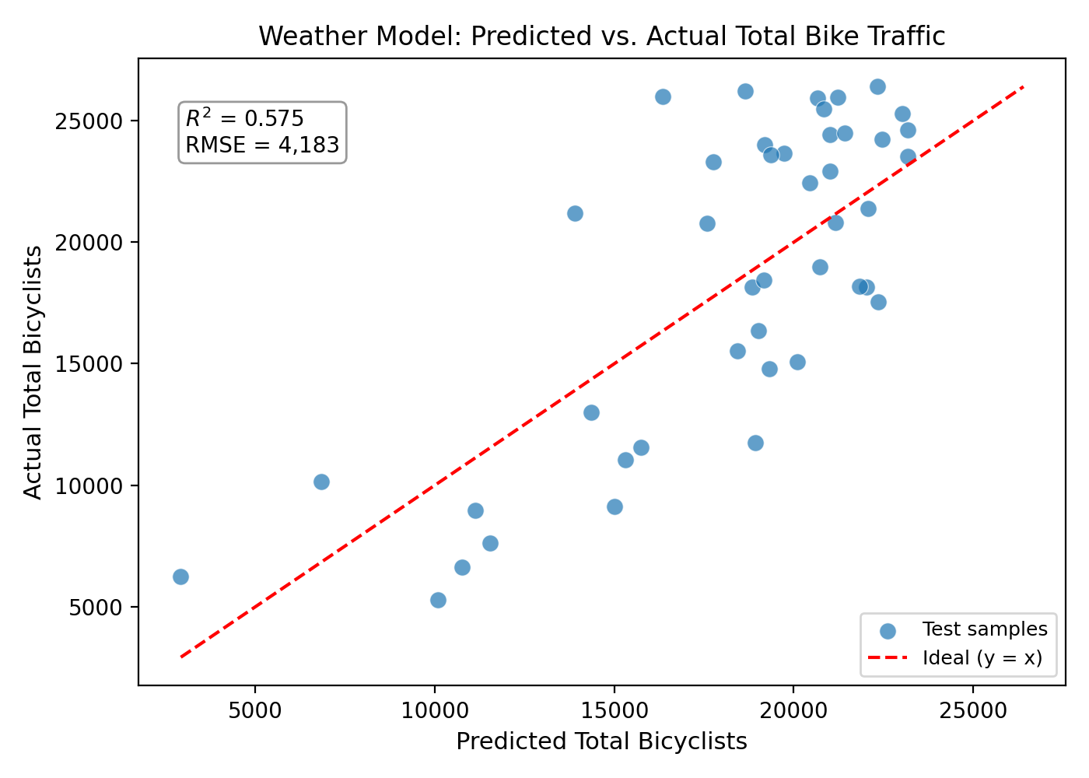
The plot confirms what we thought, the prediction matches with the overall correlation, but scatters a lot along the diagonal

Question 3
Average total bicycle traffic by day of the week:
Day | Average Total Bicyclists
Monday | 19,394
Tuesday | 20,782
Wednesday | 22,422
Thursday | 20,718
Friday | 17,985
Saturday | 15,001
Sunday | 13,716
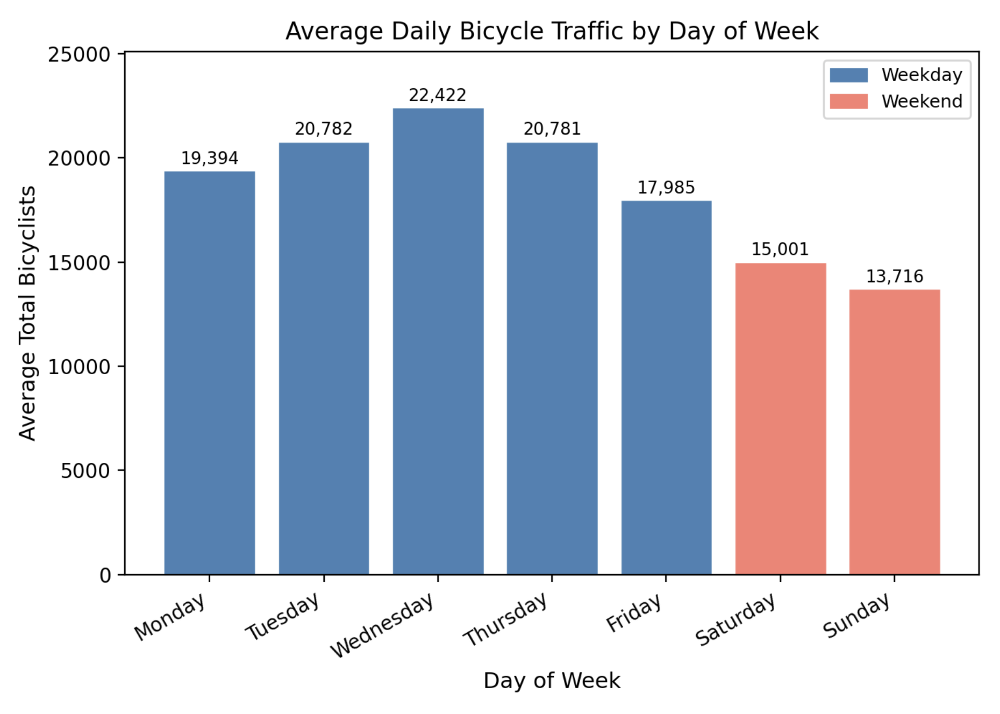
The bar chart above shows that the weekdays have consistently higher average traffic than weekends, with Wednesday peaking at 22,422 and Sunday reaching the lowest average at 13,716. The drop in traffic after the mid-week, and the lowest traffic falling on the weekends indicates that there is commuter dominated ridership. The weekday trips are likely generated by work trips, while weekend cycling is lower due to only recreational cycling, which has fewer riders overall.

The classification results for predicting the day of the week from bridge counts were:
Classifier | Test Accuracy (%)
Logistic Regression | 16.3
K-Nearest Neighbors | 18.6
Decision Tree | 34.9
Random Forest | 23.3

The Decision Tree performed best at 34.9%, followed by Random Forest at 23.3%, K-Nearest Neighbors at 18.6%, and Logistic Regression at 16.3%. All four classifiers performed poorly in absolute terms, which we expected since this is a 7-class problem with only 4 numeric features, 170 training samples, and 43 test samples.

The confusion matrices revealed a consistent pattern across all classifiers: Thursday was the hardest to predict, with zero correct predictions in three of the four classifiers. This is because Thursday’s average traffic is nearly identical to Tuesday’s, making it difficult to distinguish the two from their bridge counts. Wednesday was the most reliable classified weekday across all models, which isn’t surprising since it had the highest average traffic. Sunday was difficult to distinguish from Saturday, since they both share lower overall weekend traffic.

The Logistic Regression’s low accuracy is somewhat explained since it never predicted Monday or Saturday, which defaults its probability mass towards the middle classes. The Decision Tree’s better performance highlights that nonlinear decision boundaries capture the daily structure in bridge counts better than linear models. Overall, the results illustrate that while clear weekly patterns in traffic volume exist, they are not significant enough across all seven days of the week for a classifier trained only on bridge counts to reliably identify each day of the week from another.

