Recommendation Report:

**Recommendation of Method to Establish Network for Smart Lamp-posts**

Vito WU / 117010285 / L2

**The Chinese University of Hong Kong, Shenzhen**



**Executive Summary**

In order to address urban challenges and enhance the effectiveness of city management and improve people’s quality of living as well as sustainability and safe of the city, our client, a company from Hong Kong, has designed a smart lamp-post that has various functions integrated and wants to establish stable network between each lamp-post with both efficiency and reliability. After meticulous analysis and comparisons, we write this report to recommend a method to form a stable network for our client based on the criteria including transmission cost, bandwidth, deployment cost and latency. We select ZigBee, Wi-Fi, 4G and fiber as the eligible choices. After the overall consideration, we intensively recommend Wi-Fi because it can provide sufficient network performance to support the requirements of our client with reasonable transmission cost and deployment cost.

**Introduction**

Smart lamp-post is an intelligent system generally embedded in streetside lamp-posts, with a variety of functions integrated such as adaptive street lighting, PM2.5 detections, streetside Wi-Fi (Access Point), video capturing and so on. In order to control each lamp-post in the data center and collect data from sensors, a company from Hong Kong of which main business is manufacturing smart lamp-post need us to provide a method to form a network between each lamp-post with both efficiency and reliability. Additionally, the company has required for a reasonable deployment and transmission fee while applying our recommendation. Available options are Wi-Fi (wireless network based on IEEE 802.11), ZigBee (wireless network based on IEEE 802.15.4), 4G network and fiber. The difficulty of selecting among is that each option has its merits and precedents, which implies the recommendation will highly depend on the actual scenario. The purpose of this report is to evaluate each method and determine a recommended method to form a hop-by-hop network which is most suitable for the actual scenario.

**Selection Criteria**

Based on the demands of the company and the actual scenario, we filter the specification of each type of network into four selection criteria, which are transmission cost per bit, bandwidth, deployment cost and latency.

Transmission cost

The first criterion is the transmission cost. Transmission cost is the most important criteria in actual scenario since the company has the demands for video capturing and 4K cameras can instantly produce 100 MB traffic to the network within a second. Consequently, the daily network traffic is expected to reach and exceed 1400 GB. Also, in order to reduce additional expenses, as the largest part of daily operation fee, the transmission cost of the network ought to be evaluated and controlled.

Bandwidth

The second important criterion is the bandwidth, which will affect the quality of streaming video and streetside Wi-Fi. (need to add further illustration)

Deployment cost

The deployment cost is the third criterion we consider, aiming to evaluate whether the lamp-post is convenient for related departments to deploy, such as the lamp-post company, highway department and so on. For instance, we will consider the cost of wireless devices, the cost of construction and cost of deployment.

Latency

The last criterion, latency, is a significant factor in a scenario while users are making video or voice calls with others by using the streetside Wi-Fi. Since in other cases like adaptive street lighting and PM2.5 a low latency is not essential, we take latency into our consideration with the lowest priority.

**Finding and Analysis**

We create the following table to show different specifications of each four options among the criteria.

|  |  |  |  |  |
| --- | --- | --- | --- | --- |
|  | ZigBee  (2.4 GHz module based on 802.15.4) | Wi-Fi  (2.4 GHz module based on 802.11ac) | 4G | Fiber |
| Transmission Cost | * Traffic cost-free * Maximum output power 250 mW | * Traffic cost-free * Maximum output power 100 mW | * $48 unlimited data access monthly * Maximum output power 250 mW | * Traffic cost-free * Energy cost is negligible |
| Bandwidth | * Max signal rate 250 Kbps   (Gaotao Shi, Keqiu Li, 2016)   * 1.65% packet loss in 85m 1-hop network   (Silicon Labs, 2017) | * Max signal rate 3.12 Gbps * Packet loss depends on various factors | * Max access speed 7.2Mbps * Packet loss less than 3% while no more than 300 devices sharing one base station. | * Max speed 100 Gbps * Packet loss is not significant |
| Deployment Cost | * Price of CC2520 (ZigBee Module) is approximately $2 each * No explicit deployment and construction fee | * Price of Quantum 867M (802.11ac Module) is approximately $10 each * No explicit deployment and construction fee | * Price of EC20-E (4G Module) is approximately $20 each * No explicit deployment and construction fee | * Price of Optical Fiber Cable is approximately $2 per meter * $54.79 Highway construction cost per meter   (UNESCAP, 2018) |
| Latency | * 18.6 milliseconds ***(85m 1-hop roundtrip)***      * 250 milliseconds ***(85m 6-hop roundtrip)***   (Silicon Labs, 2017)   * latency increase when the number of lamp-posts in the network increases(Strix Systems, 2005; Ivan Wang-Hei Ho, et al., 2011; Torsten, et al. 1998) | * 10-100 milliseconds   (Cisco, 2018)   * depends on various factors   (Dan Pan, 2017)   * latency increase when the number of lamp-posts in the network increases | * 200-300 milliseconds   **(radio network latency)**   * latency does not appear to increase when the size of the network is large   (Ashish Kurian, 2018) | * the latency of fiber network can be omitted. |

First choice: Wi-Fi

After reviewing and comparing these four options, we find that Wi-Fi can be utilized to form the network that commendably meets the requirements. The advantages of using Wi-Fi is that both the transmission cost and deployment cost of Wi-Fi is the cheapest among the four options. Also, the bandwidth and bitrate of Wi-Fi are sufficient enough to support high-resolution video transmission. Although there is an increment of latency when the number of lamp-post increases (Appendix I), Wi-Fi can already meet most of the ordinary cases, thus we make it the first choice.

Second choice: Fiber

The option which ranks after Wi-Fi is fiber optic as for its outstanding feature to establish a stable and reliable network. Since that the bandwidth and latency of fiber are optimal among four options, the requirements of the company can also be meet if fiber optic is adopted to form the network. However, we make it the second choice because of its expensive cost in deployment fee (Appendix II).

Third choice: 4G

The third choice is the 4G network. Due to its specifications which were designed for mobile and portable usages, the network performance of 4G is inferior to Wi-Fi and fiber optic. Since 4G does not fit the actual scenario and has monthly additional expanses, we rank 4G after Wi-Fi and fiber optical.

Forth choice: ZigBee

The last one is ZigBee, which only shows its advantage in saving transmission and deployment cost. The bottleneck of a ZigBee-based network is that the max signal rate of a ZigBee module is merely 250 Kbps, thus ZigBee is not capable to support video transmission. In most cases, ZigBee can be substituted by using Wi-Fi which has better network performance, and therefore we make it the last choice.

**Recommendation**

According to the comparisons above, we highly recommend you to use Wi-Fi for establishing a network between smart lamp-posts. The network performance of Wi-Fi can bear the job to provide stable network service to all functions of smart lamp-post with low deployment cost and insignificant transmission cost. If you have strict requirements for ultimate network performance, we have a second choice, fiber optic, which will provide a better network than Wi-Fi. In order to reduce the expensive deployment fee of fiber optic, we recommend using fiber optic in only two cases, that either the construction of smart lamp-post and a scheduled highway refinement are going to proceed in parallel, or perfect network performance is a must.

***Reference***

**[1]** Paramananda Joshi, Davide Colombi, Bjorn Thors, Lars-Eric Larsson, and Christer

Tornevik (2017). “Output Power Levels of 4G User Equipment and Implications on Realistic RF EMF Exposure Assessments”, *IEEE Access*, pp.4545-4550.

**[2]** Libelium (2018). “Waspmote 4G networking Guide”.

**[3]** Torsten Braun, Andreas Kassler, Maria Kihl, Veselin Rakocevic, Vasilios Siris, Geert Heijenk (1998). “Chapter 5: Multi-hop Wireless Networks”, *Traffic and QoS Management in Wireless Multimedia Networks,* COST 290 Final Report.

**[4]** Strix Systems (2005), “Solving the Wireless Mesh Multi-hop Dilemma” White Paper.

**[5]** Cisco (2018), “IEEE 802.11ax: The Sixth Generation of Wi-Fi”, *Cisco public technical white paper*.

**[6]** Dan Pan (2017), “Analysis of Wi-Fi performance data for a Wi-Fi throughput prediction approach”, *KTH School of Information and Communications Technology Communication System*, Sweden

**[7]** Silicon Labs (2017), “AN1138: ZigBee Mesh Network Performance”.

**[8]** Ivan Wang-Hei Ho, Patrick P. Lam, Peter Han Joo Chong and Soung Change Liew (2011), “Real-life Multi-hop Multi-radio Multi-channel Wireless Mesh Network Experiments: 802.11n is not any better than 802.11a!”, *2011 8th International Conference on Information, Communications & Signal Processing.*

**[9]** Gaotao Shi, Keqiu Li (2016), “Chapter 2: Fundamentals of ZigBee and Wi-Fi”, *Signal Interference in Wi-Fi and ZigBee Networks*, pp.9-27. Germany: Springer.

**[10]** Ashish Kurian (2018), “Latency Analysis and Reduction in a 4G Network”, *Delft University of Technology.*

**[11]** United Nations Economic and Social Commission for Asia and the Pacific (2018), “A Study on Cost-Benefit Analysis of Fibre-Optic Co-Deployment with the Asian Highway Connectivity”.

**Appendix I. Wi-Fi Mesh Network Performance** (Strix Systems, 2005)

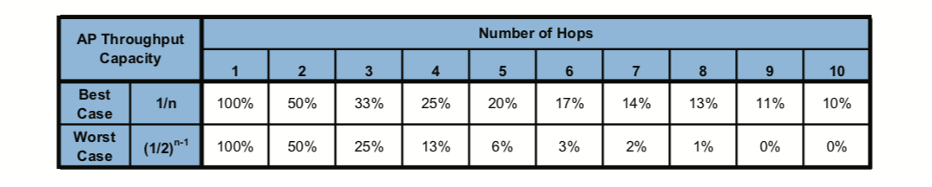

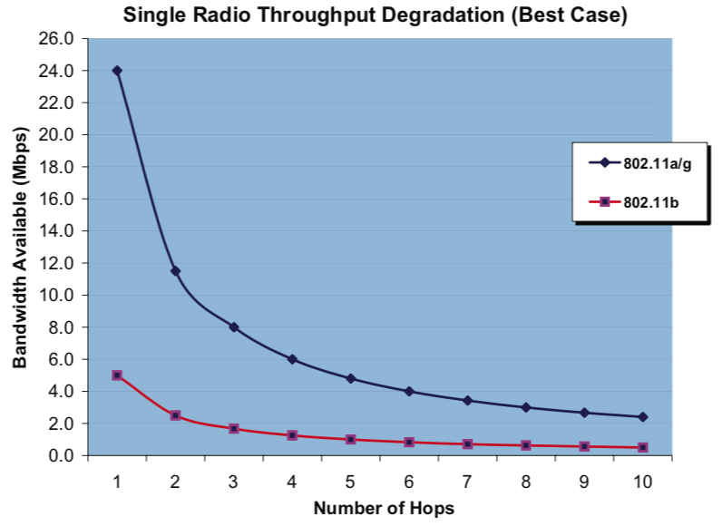

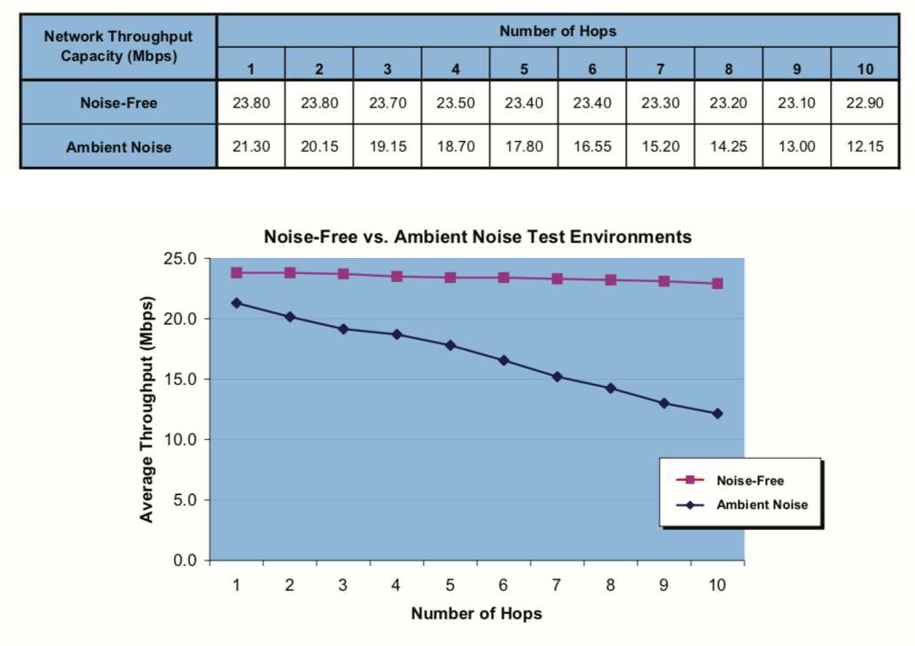

**Appendix II. Highway unit cost** (UNESCAP, 2018)

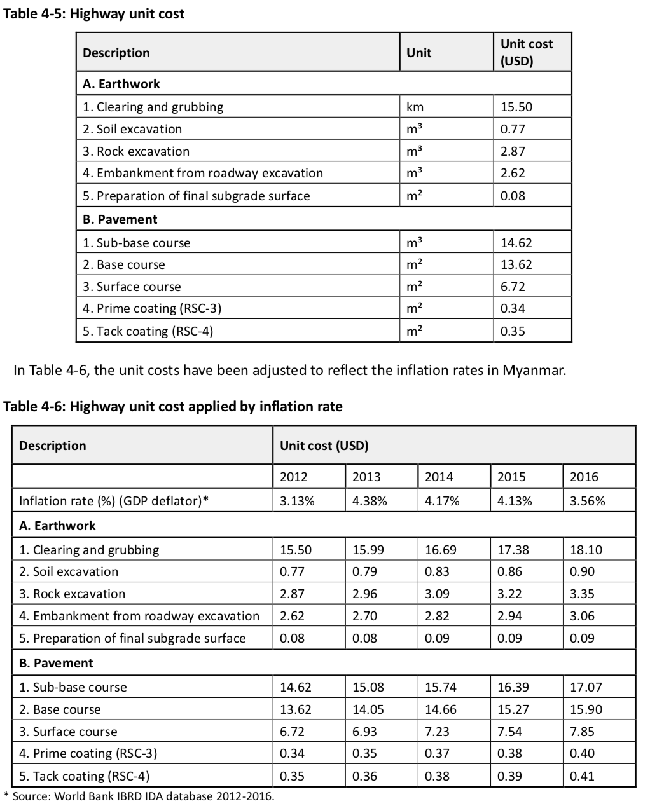

**Appendix III. ZigBee Mesh Network Performance**  (Silicon Labs, 2017)

