Campbell Essential Biology, 6e, Global Edition (Simon/Dickey/Hogan/Reece)

Chapter 2 Essential Chemistry for Biology

Chapter 2 Learning Outcomes

2 Biology and Society: Radioactivity and Health
2.1. Define radiation and explain how it can be dangerous. Explain how radiation can be used in medicine.
2.1 Some Basic Chemistry
2.2. Distinguish between matter, mass, elements, and compounds. Give examples of each.
2.3. Explain why trace elements are important for human health.
2.4. Describe the relative size, location, and electrical charge of protons, neutrons, and electrons within an atom. Explain how the atomic number, mass number, and atomic mass are determined.
2.5. Define an isotope and explain how radioactive isotopes are used in biological research and medicine.
2.6. Distinguish between ionic, covalent, and hydrogen chemical bonds.
2.7. Describe the structure of water and explain how its shape makes water a polar molecule.
2.8. Distinguish between the reactants and products of chemical reactions.
2.2 Water and Life
2.9. Describe the four life-supporting properties of water. Describe an example of how each property affects some form of life.
2.10. Distinguish between the chemical properties of acids, bases, and neutral solutions. Explain how buffers stabilize the pH of acidic and basic solutions.
2.11. Describe the potential impact of rising levels of carbon dioxide on the pH of the ocean.
2 Evolution Connection: Radioactivity as an Evolutionary Clock
2.12. Explain how radioactive isotopes are used in radiometric dating.

Global Learning Outcomes
- Demonstrate an understanding of the principles of scientific inquiry.
- Demonstrate the ability to think critically and employ critical-thinking skills.
- Read and interpret models, graphs, and data.
- Demonstrate the quantitative skills needed to succeed in biology.
- Demonstrate an understanding of the impact of science on society.
- Evaluate the credibility of scientific information from various sources.
- Demonstrate the ability to make connections between concepts across biology.
- Communicate effectively in writing.
- Apply the scientific method to interpret information and draw conclusions.

2.1 Multiple Choice Questions

1) How can radiation be controlled and safely used in medicine?
A) Apply radiation throughout the body at uncontrolled doses.
B) Apply radiation throughout the body at controlled doses.
C) Apply radiation to specific parts of the body at uncontrolled doses.
D) Apply radiation to specific parts of the body at controlled doses.
Answer: D
Topic: 2.1 Some Basic Chemistry
Skill: Knowledge/Comprehension
Learning Outcome: 2.1

2) ________ is an example of an element.
A) Water
B) Carbon
C) Glucose
D) Salt
Answer: B
Topic: 2.1 Some Basic Chemistry
Skill: Knowledge/Comprehension
Learning Outcome: 2.2

3) The four most common elements found in living organisms are ________.
A) nitrogen, oxygen, phosphorus, and carbon
B) carbon, oxygen, nitrogen, and hydrogen
C) carbon, oxygen, potassium, and calcium
D) oxygen, calcium, hydrogen, and carbon
Answer: B
Topic: 2.1 Some Basic Chemistry
Skill: Knowledge/Comprehension
Learning Outcome: 2.2

4) Which of the following elements, essential to life, is a trace element?
A) phosphorus
B) carbon
C) iodine
D) calcium
Answer: C
Topic: 2.1 Some Basic Chemistry
Skill: Knowledge/Comprehension
Learning Outcome: 2.3
5) In order to have a positive charge, an atom must have ________.
A) more protons than electrons
B) more electrons than protons
C) more neutrons than protons
D) more protons than neutrons
Answer: A
Topic: 2.1 Some Basic Chemistry
Skill: Knowledge/Comprehension
Learning Outcome: 2.4

6) All atoms of an element have the same number of ________.
A) protons plus neutrons
B) protons
C) electrons
D) neutrons
Answer: B
Topic: 2.1 Some Basic Chemistry
Skill: Knowledge/Comprehension
Learning Outcome: 2.4

7) An atom's ________ are found in its nucleus.
A) neutrons and protons
B) protons only
C) neutrons and electrons
D) electrons, protons, and neutrons
Answer: A
Topic: 2.1 Some Basic Chemistry
Skill: Knowledge/Comprehension
Learning Outcome: 2.4

8) Beryllium's atomic mass is 9, and its atomic number is 4. How many neutrons are found in a beryllium atom?
A) 9
B) 13
C) 4
D) 5
Answer: D
Topic: 2.1 Some Basic Chemistry
Skill: Application/Analysis
Learning Outcome: 2.4
Global LO: 2, 4

9) An uncharged atom of gold has an atomic number of 79 and an atomic mass of 197. This atom has ________ protons, ________ neutrons, and ________ electrons.
A) 79... 118... 79
B) 118... 79... 118
C) 118... 276... 118
D) 79... 34... 79
Answer: A
Topic: 2.1 Some Basic Chemistry
Skill: Application/Analysis
Learning Outcome: 2.4
Global LO: 2, 4
10) The way Earth moves about the sun is most like ________.
A) a neutron and electron moving around a proton
B) an electron moving around the nucleus of an atom
C) a proton moving about an electron
D) a neutron moving about a proton
Answer: B
Topic: 2.1 Some Basic Chemistry
Skill: Application/Analysis
Learning Outcome: 2.4
Global LO: 2

11) Isotopes of an element have the same number of ________ and different numbers of ________.
A) protons... neutrons
B) protons... electrons
C) neutrons... protons
D) electrons... protons
Answer: A
Topic: 2.1 Some Basic Chemistry
Skill: Knowledge/Comprehension
Learning Outcome: 2.5

12) How do radioactive isotopes differ from isotopes?
A) Radioactive isotopes have more neutrons than do isotopes.
B) Radioactive isotopes are stable; isotopes are unstable.
C) Radioactive isotopes have fewer neutrons than do isotopes.
D) Radioactive isotopes are unstable; isotopes are stable.
Answer: D
Topic: 2.1 Some Basic Chemistry
Skill: Knowledge/Comprehension
Learning Outcome: 2.5

13) An atom with an electrical charge is a(n) ________.
A) isotope
B) molecule
C) ion
D) compound
Answer: C
Topic: 2.1 Some Basic Chemistry
Skill: Knowledge/Comprehension
Learning Outcome: 2.6

14) The bond between oppositely charged ions is a(n) ________ bond.
A) ionic
B) polar
C) hydrogen
D) covalent
Answer: A
Topic: 2.1 Some Basic Chemistry
Skill: Knowledge/Comprehension
Learning Outcome: 2.6
15) In the following reaction, what type of bond is holding the two atoms together?
K+Cl → K+ + Cl− → KCl
A) hydrophilic
B) ionic
C) hydrophobic
D) covalent
Answer: B
Topic: 2.1 Some Basic Chemistry
Skill: Application/Analysis
Learning Outcome: 2.6
Global LO: 2

16) What name is given to bonds that involve the sharing of electrons?
A) covalent
B) hydrogen
C) ionic
D) polar
Answer: A
Topic: 2.1 Some Basic Chemistry
Skill: Knowledge/Comprehension
Learning Outcome: 2.6

17) Sulfur has an atomic number of 16. How many covalent bonds can sulfur form?
A) 1
B) 2
C) 4
D) 0
Answer: B
Topic: 2.1 Some Basic Chemistry
Skill: Application/Analysis
Learning Outcome: 2.6
Global LO: 2, 4

18) The hydrogen and oxygen atoms of a water molecule are held together by ________ bonds.
A) ionic
B) hydrogen
C) covalent
D) polar
Answer: C
Topic: 2.1 Some Basic Chemistry
Skill: Knowledge/Comprehension
Learning Outcome: 2.6, 2.7
19) Why is water considered a polar molecule?
A) The oxygen atom is found between the two hydrogen atoms.
B) The oxygen atom attracts the hydrogen atoms.
C) The oxygen end of the molecule has a slight negative charge, and the hydrogen end has a slight positive charge.
D) Both hydrogen atoms are at one end of the molecule, and the oxygen atom is at the other end.
Answer: C
Topic: 2.1 Some Basic Chemistry
Skill: Knowledge/Comprehension
Learning Outcome: 2.7

20) Adjacent water molecules are joined by ________ bonds.
A) covalent only
B) ionic
C) polar and covalent
D) hydrogen
Answer: D
Topic: 2.1 Some Basic Chemistry
Skill: Knowledge/Comprehension
Learning Outcome: 2.6, 2.7

21) Adjacent water molecules are connected by the ________.
A) sharing of electrons between the hydrogen of one water molecule and the oxygen of another water molecule
B) electrical attraction between the hydrogen of one water molecule and the oxygen of another water molecule
C) sharing of electrons between adjacent oxygen molecules
D) electrical attraction between the hydrogen atoms of adjacent water molecules
Answer: B
Topic: 2.1 Some Basic Chemistry
Skill: Knowledge/Comprehension
Learning Outcome: 2.6, 2.7

22) How many oxygen atoms are in the products of the following reaction?
C6H12O6 + 6 H2O + 6 O2 → 6 CO2 + 12 H2O
A) 18
B) 6
C) 12
D) 24
Answer: D
Topic: 2.1 Some Basic Chemistry
Skill: Application/Analysis
Learning Outcome: 2.8
Global LO: 2, 4
23) What are the reactant(s) in the following chemical reaction?
C6H12O6 + 6 H2O + 6 O2 → 6 CO2 + 12 H2O
A) CO2 and H2O
B) C6H12O6, H2O, and O2
C) O2 only
D) C6H12O6, H2O, O2, CO2, and H2O
Answer: B
Topic: 2.1 Some Basic Chemistry
Skill: Application/Analysis
Learning Outcome: 2.8
Global LO: 2

24) Human body cells are approximately ________ water.
A) 95–99%
B) 25–35%
C) 50–55%
D) 70–95%
Answer: D
Topic: 2.2 Water and Life
Skill: Knowledge/Comprehension
Learning Outcome: 2.9

25) The tendency of molecules of the same kind to stick together is called ________.
A) bonding
B) cohesion
C) polarity
D) adhesion
Answer: B
Topic: 2.2 Water and Life
Skill: Knowledge/Comprehension
Learning Outcome: 2.9

26) Why (if you are careful) are you able to float a needle on the surface of water?
A) Water has adhesive properties.
B) The surface tension that is a result of water's cohesive properties makes this possible.
C) The covalent bonds that hold a water molecule together make this possible.
D) A single needle is less dense than water.
Answer: B
Topic: 2.2 Water and Life
Skill: Knowledge/Comprehension
Learning Outcome: 2.9

27) Sweating cools your body by ________.
A) cohesion
B) radiation
C) evaporative cooling
D) hydrogen bonding
Answer: C
Topic: 2.2 Water and Life
Skill: Knowledge/Comprehension
Learning Outcome: 2.9
28) As water freezes, ________.
A) its molecules move farther apart
B) it cools the surrounding environment
C) its hydrogen bonds break apart
D) it loses its polarity
Answer: A
Topic: 2.2 Water and Life
Skill: Knowledge/Comprehension
Learning Outcome: 2.9

29) Sugar dissolves when stirred into water. The sugar is the ________, the water is the ________, and the sweetened water is the ________.
A) solution... solvent... solute
B) solute... solvent... solution
C) solvent... solute... solution
D) solution... solute... solvent
Answer: B
Topic: 2.2 Water and Life
Skill: Application/Analysis
Learning Outcome: 2.9
Global LO: 2

30) Which of the following is an acid?
A) NaOH
B) NaCl
C) HCl
D) CH4
Answer: C
Topic: 2.2 Water and Life
Skill: Knowledge/Comprehension
Learning Outcome: 2.10

31) A base ________.
A) removes H2O molecules from a solution
B) decreases the pH of a solution
C) removes OH— ions from a solution
D) removes H+ ions from a solution
Answer: D
Topic: 2.2 Water and Life
Skill: Knowledge/Comprehension
Learning Outcome: 2.10

32) The lower the pH of a solution, the ________.
A) greater the number of oxygen atoms
B) more acidic the solution
C) less toxic the solution
D) higher the OH— concentration
Answer: B
Topic: 2.2 Water and Life
Skill: Knowledge/Comprehension
Learning Outcome: 2.10
33) Relative to a pH of 6, a pH of 4 has a ________.
A) 200 times higher H+ concentration
B) 100 times higher H+ concentration
C) 20 times higher H+ concentration
D) 100 times lower H+ concentration
Answer: B
Topic: 2.2 Water and Life
Skill: Application/Analysis
Learning Outcome: 2.10
Global LO: 2, 4

34) What name is given to substances that resist changes in pH?
A) buffers
B) solutions
C) acids
D) bases
Answer: A
Topic: 2.2 Water and Life
Skill: Knowledge/Comprehension
Learning Outcome: 2.10

35) When a base is added to a buffered solution, the buffer will ________.
A) donate OH− ions
B) accept water molecules
C) donate H+ ions
D) form covalent bonds with the base
Answer: C
Topic: 2.2 Water and Life
Skill: Knowledge/Comprehension
Learning Outcome: 2.10

36) Which of the following is NOT a potential impact of ocean acidification?
A) Decreasing H+ concentrations
B) Coral bleaching
C) Changes in metabolism of marine animals
D) Increasing carbonic acid concentrations
Answer: A
Topic: 2.2 Water and Life
Skill: Knowledge/Comprehension
Learning Outcome: 2.11

37) A fossil was found and determined by radiometric dating to be 11,400 years old. What is the ratio of carbon-14 to carbon-12 in this fossil compared to its environment?
A) 12.5%
B) 25%
C) 37.5%
D) 50%
Answer: B
Topic: 2.1 Some Basic Chemistry
Skill: Application/Analysis
Learning Outcome: 2.12
Global LO: 2, 4
2.2 Art Questions

1) Examine the drawing of an atom below. The art is technically INCORRECT in that ________.

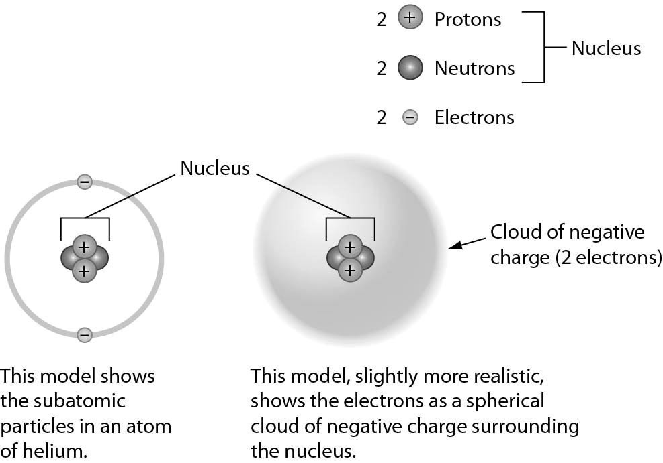

A) neutrons are not located in the nucleus
B) the electrons should be much farther away from the nucleus
C) electrons do not orbit the nucleus
D) electrons do not have a negative charge
Answer: B
Topic: 2.1 Some Basic Chemistry
Skill: Synthesis/Evaluation
Learning Outcome: 2.4
Global LO: 2
2) All of the representations in the following figure EXCEPT one clearly show double bonds. Choose the exception.

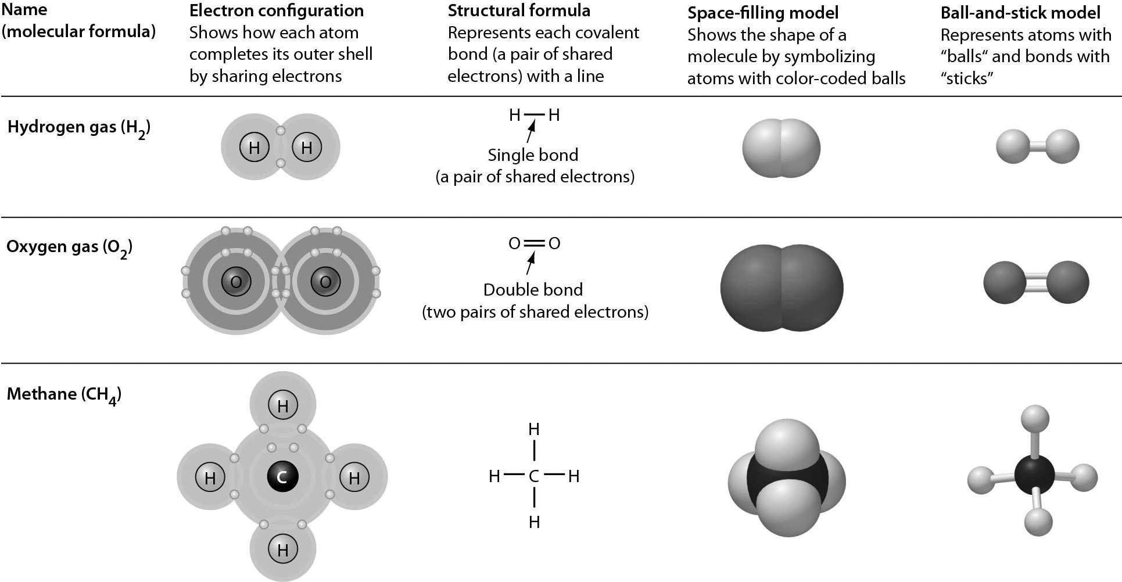

A) electron configuration
B) structural formula
C) space-filling model
D) ball-and-stick model
Answer: C
Topic: 2.1 Some Basic Chemistry
Skill: Application/Analysis
Learning Outcome: 2.6
Global LO: 2
3) Examine the pH scale below. How does household bleach compare to household ammonia?

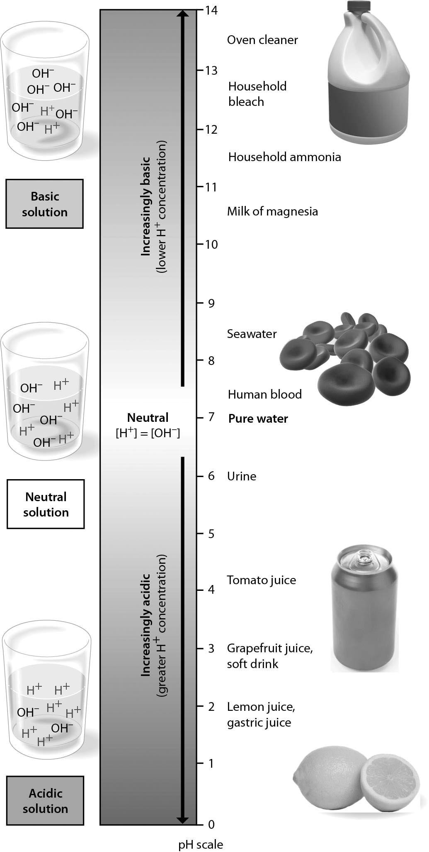

A) Household ammonia has 100 times higher H+ concentration than household bleach.
B) Household bleach has 10 times higher H+ concentration than household ammonia.
C) Household bleach has 100 times higher H+ concentration than household ammonia.
D) Household ammonia has 10 times higher H+ concentration than household bleach.
Answer: D
Topic: 2.2 Water and Life
Skill: Application/Analysis
Learning Outcome: 2.10
Global LO: 2, 4
4) The graph below shows data regarding radioactive decay of carbon-14. If decay continues to occur normally, how much C-14 will remain after 22,800 years?

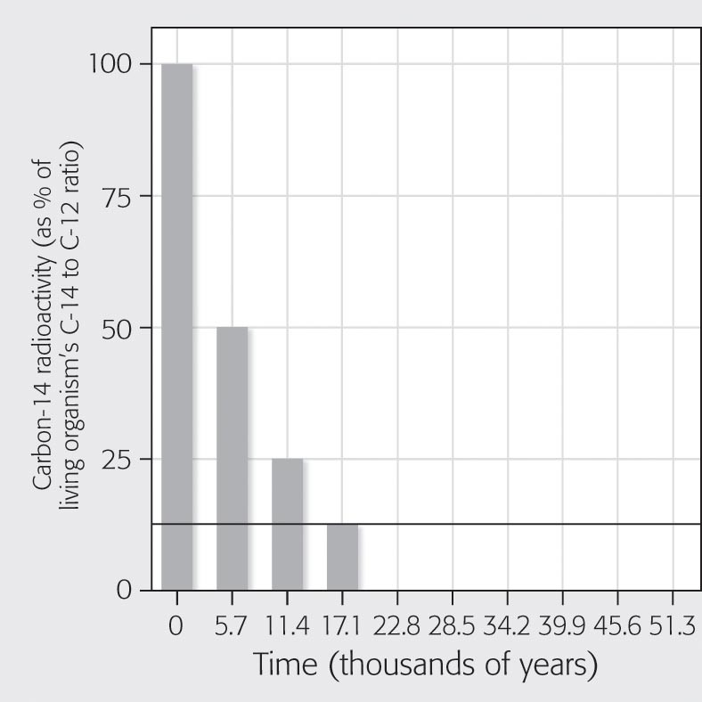
A) 25%
B) 12.5%
C) 6.25%
D) 3.125%
Answer: C
Topic: 2.1 Some Basic Chemistry
Skill: Synthesis/Evaluation
Learning Outcome: 2.12
Global LO: 2, 3, 4

2.3 Scenario Questions

Please read the following scenario to answer the following questions.

The last few miles of the marathon are the most difficult for Heather. Her hair is plastered to her head, sweat clings to her arms, and her legs feel as if they had nothing left. Heather grabs a cup of ice water. The ice cubes smash against her nose as she gulps some cool refreshment and keeps on running. Then a breeze kicks up and she finally feels some coolness against her skin. Drops of sweat, once clinging to her forehead, now spill down, and Heather feels a stinging as the sweat flows into her eyes.

1) Why did the sweat on Heather's forehead and arms form drops?
A) because of the high salt content of sweat
B) because of the cohesive nature of water
C) because of the ability of water to moderate heat
D) because of the high evaporative cooling effect of water
Answer: B
Topic: 2.2 Water and Life
Skill: Application/Analysis
Learning Outcome: 2.9
2) When Heather grabbed the glass of ice water, the ice cubes were floating at the top. Why were the ice cubes floating in the water?
A) Water can store large amounts of heat.
B) Water can moderate temperatures through evaporative cooling.
C) The density of water decreases when it freezes.
D) Water has a cohesive nature.
Answer: C
Topic: 2.2 Water and Life
Skill: Knowledge/Comprehension
Learning Outcome: 2.9

Please read the following scenario to answer the following questions.

While radioactive isotopes are used in medicine to identify tumors and other diseases, they can also be used to treat diseases such as cancer. One method to treat cancerous tumors is to expose them to radiation, which can kill the cancerous cells and the tumor. In 2013, the U.S. Food and Drug Administration approved a new cancer treatment based on the radioactive isotope radium-223; this isotope has a half-life of 11.4 days. The radioactive drug, known as Xofigo®, is injected into the patient's bloodstream and travels to certain regions of the body. Because it emits high-energy radiation over short distances, it can kill cancerous cells in the sites where it localizes.

After the drug was injected into a person, the following data were collected regarding the amount of radiation measured in different organs in the person's body.

Organ | Measured radiation
Brain | 0.37
Liver | 11.01
Bones | 4262.60
Lungs | 0.27
Urinary bladder | 14.90

3) Which of the following would be the best experiment to determine whether this drug is an effective treatment option for cancer patients?
A) Give the drug to a single cancer patient and ask him how he feels several months later.
B) Give the drug to a group of mice that have artificially induced tumors and measure whether their tumors are destroyed.
C) Give the drug to a group of cancer patients and measure whether their tumors are destroyed.
D) Give the drug to a single cancer patient and measure whether her tumor is destroyed.
Answer: C
Topic: 2.1 Some Basic Chemistry
Skill: Synthesis/Evaluation
Learning Outcome: 2.1, 2.5
Global LO: 1, 2, 3, 5, 9
4) A cancer patient receives an injection of the drug on March 1. Suppose that the patient must receive a second injection once the amount of the drug decreases to less than 6% in his or her body. On approximately what day should the cancer patient schedule an appointment to receive another injection?
A) March 13
B) March 23
C) April 3
D) April 25
Answer: D
Topic: 2.1 Some Basic Chemistry
Skill: Synthesis/Evaluation
Learning Outcome: 2.1, 2.5
Global LO: 1, 2, 4, 5, 9

5) Using the table above, what kind of cancer do you think Xofigo® is used to treat?
A) liver cancer
B) bone cancer
C) brain cancer
D) lung cancer
Answer: B
Topic: 2.1 Some Basic Chemistry
Skill: Synthesis/Evaluation
Learning Outcome: 2.1, 2.5
Global LO: 1, 2, 3, 5, 9

