Campbell Essential Biology, 6e, Global Edition (Simon/Dickey/Hogan/Reece)

Chapter 7 Photosynthesis: Using Light to Make Food

Chapter 7 Learning Outcomes

7 Biology and Society: A Greasy Crime Wave
7.1. Explain how biofuels are produced and used.
7.1 The Basics of Photosynthesis
7.2. Relate the structure of leaves and chloroplasts within them to the functions of bringing in light, water, oxygen, and carbon dioxide and releasing carbon dioxide and oxygen.
7.3. Explain how the process of photosynthesis is complementary to cellular respiration.
7.4. Compare the reactants and products of the light reactions and the Calvin cycle.
7.2 The Light Reactions: Converting Solar Energy to Chemical Energy
7.5. Identify the wavelengths that are absorbed by and reflected from an object that appears green and describe green in terms of its wavelength and its place on the electromagnetic spectrum.
7.6. Describe the properties of chlorophyll a, chlorophyll b, and carotenoids including how they assist in transferring the energy of photons within a photosystem driving reactions that generate ATP and NADPH.
7.7. Describe the light reactions and compare the process of ATP production in the thylakoid membrane of chloroplasts to that in the inner mitochondrial membrane.
7 The Process of Science: What Colors of Light Drive Photosynthesis?
7.8. Explain how Theodor Engelmann was able to determine that only certain wavelengths of light are used in photosynthesis.
7.3 The Calvin Cycle: Making Sugar from Carbon Dioxide
7.9. Describe the reactants and products of the Calvin cycle, explaining where each reactant comes from and where each product goes.
7 Evolution Connection: Creating a Better Biofuel Factory
7.10. Explain how directed evolution can help to produce algae that efficiently produce biofuels.

Global Learning Outcomes
1. Demonstrate an understanding of the principles of scientific inquiry.
2. Demonstrate the ability to think critically and employ critical-thinking skills.
3. Read and interpret models, graphs, and data.
4. Demonstrate the quantitative skills needed to succeed in biology.
5. Demonstrate an understanding of the impact of science on society.
6. Evaluate the credibility of scientific information from various sources.
7. Demonstrate the ability to make connections between concepts across biology.
8. Communicate effectively in writing.
9. Apply the scientific method to interpret information and draw conclusions.

7.1 Multiple Choice Questions

1) Which of these is NOT considered an advantage of biofuels from food crops?
A) reduced carbon emissions
B) a renewable resource
C) increased fuel efficiency
D) increased crop prices
Answer: D
Topic: 7 Biology and Society
Skill: Knowledge/Comprehension
Learning Outcome: 7.1
Global LO: 5

2) Which of the following is an autotroph?
A) human
B) mushroom
C) pine tree
D) fish
Answer: C
Topic: 7.1 The Basics of Photosynthesis
Skill: Application/Analysis
Learning Outcome: 7.2
Global LO: 2

3) Photosynthesis contributes to plant growth by ________.
A) taking in oxygen and making wood
B) taking in carbon dioxide and making sugars (carbohydrates)
C) synthesizing carbon dioxide and making cellulose
D) converting sugar to oxygen and water
Answer: B
Topic: 7.1 The Basics of Photosynthesis
Skill: Knowledge/Comprehension
Learning Outcome: 7.2

4) Within the inner membrane of a chloroplast, interconnected sacs of membrane called ________ are suspended in a thick fluid called the ________.
A) chlorophyll... thylakoid
B) thylakoids... grana
C) thylakoids... stroma
D) grana... thylakoid
Answer: C
Topic: 7.1 The Basics of Photosynthesis
Skill: Knowledge/Comprehension
Learning Outcome: 7.2
5) What is the function of stomata?
A) water absorption
B) Calvin cycle
C) location of photosystems
D) gas exchange
Answer: D
Topic: 7.1 The Basics of Photosynthesis
Skill: Knowledge/Comprehension
Learning Outcome: 7.2

6) Through what structure(s) do plants obtain most of their water?
A) roots
B) interior cells
C) stomata
D) leaves
Answer: A
Topic: 7.1 The Basics of Photosynthesis
Skill: Knowledge/Comprehension
Learning Outcome: 7.2

7) What name is given to the membranous sacs found within a chloroplast?
A) stroma
B) mitochondria
C) thylakoids
D) vesicles
Answer: C
Topic: 7.1 The Basics of Photosynthesis
Skill: Knowledge/Comprehension
Learning Outcome: 7.2

8) What are grana?
A) thick fluids inside chloroplasts
B) convolutions of the inner chloroplast membrane
C) stacks of membranous sacs
D) pigments found in chloroplasts
Answer: C
Topic: 7.1 The Basics of Photosynthesis
Skill: Knowledge/Comprehension
Learning Outcome: 7.2

9) If you provided your shade-tolerant plants with their preferred wavelength of light, but only minimal amounts of water, which of the following would you expect to occur?
A) increased plant growth
B) increased amounts of oxygen released by the plants
C) decreased amounts of ATP being produced by the plants
D) increased growth of the plants' leaves
Answer: C
Topic: 7.1 The Basics of Photosynthesis
Skill: Application/Analysis
Learning Outcome: 7.4
Global LO: 2
10) Which of the following equations best summarizes photosynthesis?
A) 6 CO2 + 6 H2O + 6 O2 → C6H12O6
B) 6 CO2 + 6 H2O → C6H12O6 + 6 O2
C) 6 CO2 + 6 O2 → C6H12O6 + 6 H2O
D) C6H12O6 + 6 O2 → 6 CO2 + 6 H2O
Answer: B
Topic: 7.1 The Basics of Photosynthesis
Skill: Knowledge/Comprehension
Learning Outcome: 7.4

11) In photosynthesis, redox reactions ultimately transfer electrons from ________ to ________.
A) O2... CO2
B) C6H12O6... O2
C) H2O... C6H12O6
D) H2O... CO2
Answer: D
Topic: 7.1 The Basics of Photosynthesis
Skill: Application/Analysis
Learning Outcome: 7.4
Global LO: 2

12) Which of the following is produced during the light reactions of photosynthesis?
A) O2
B) CO2
C) C6H12O6
D) ADP
Answer: A
Topic: 7.1 The Basics of Photosynthesis
Skill: Knowledge/Comprehension
Learning Outcome: 7.7

13) The Calvin cycle requires ________ and ________ from the light reactions in order to operate.
A) glucose... carbon dioxide
B) electrons... NADH
C) ATP... NADPH
D) RuBP... NADP+
Answer: C
Topic: 7.1 The Basics of Photosynthesis
Skill: Knowledge/Comprehension
Learning Outcome: 7.9

14) The products of the light reactions of photosynthesis are ________.
A) ATP and NADH
B) ATP and NADPH
C) RuBP and O2
D) ATP and NADP+
Answer: B
Topic: 7.1 The Basics of Photosynthesis
Skill: Knowledge/Comprehension
Learning Outcome: 7.6
15) The color that we see when looking at a pigmented object is ________.
A) the wavelengths that are absorbed by the pigmented object
B) the wavelengths that are reflected or transmitted by the pigmented object
C) the wavelengths that have been raised to an excited state by the pigmented object
D) the wavelengths that the pigmented object created after interacting with sunlight
Answer: B
Topic: 7.2 The Light Reactions: Converting Solar Energy to Chemical Energy
Skill: Knowledge/Comprehension
Learning Outcome: 7.5

16) If a plant appears blue to us, what wavelength of light is being reflected?
A) blue
B) green
C) red
D) yellow
Answer: A
Topic: 7.2 The Light Reactions: Converting Solar Energy to Chemical Energy
Skill: Application/Analysis
Learning Outcome: 7.5
Global LO: 2

17) The energy of wavelengths that appear ________ is LEAST useful to photosynthesis.
A) red
B) green
C) blue
D) orange
Answer: B
Topic: 7 The Process of Science: What Colors of Light Drive Photosynthesis?
Skill: Knowledge/Comprehension
Learning Outcome: 7.8

18) What is responsible for the yellow-orange coloration of leaves in the fall?
A) RuBP
B) chlorophyll a
C) carotenoids
D) chlorophyll b
Answer: C
Topic: 7.2 The Light Reactions: Converting Solar Energy to Chemical Energy
Skill: Knowledge/Comprehension
Learning Outcome: 7.6

19) What is one reason why plants have accessory pigment molecules, like chlorophyll b and carotenoids?
A) to reflect more energy
B) to absorb energy in parts of the electromagnetic spectrum that chlorophyll a cannot
C) to give them different colors
D) because plants cannot make enough chlorophyll a for all of their energy needs
Answer: B
Topic: 7.2 The Light Reactions: Converting Solar Energy to Chemical Energy
Skill: Knowledge/Comprehension
Learning Outcome: 7.6
20) What name is given to a discrete packet of light?
A) phaser
B) wavelength
C) photon
D) quantum
Answer: C
Topic: 7.2 The Light Reactions: Converting Solar Energy to Chemical Energy
Skill: Knowledge/Comprehension
Learning Outcome: 7.6

21) The shorter the wavelength of visible light, the ________.
A) less energy absorbed by photosynthetic pigments
B) redder the color
C) more photons it contains
D) greater the energy
Answer: D
Topic: 7.2 The Light Reactions: Converting Solar Energy to Chemical Energy
Skill: Knowledge/Comprehension
Learning Outcome: 7.5

22) When a molecule absorbs a photon, one of its electrons is raised to the ________ state.
A) energetic
B) quantum
C) positive
D) excited
Answer: D
Topic: 7.2 The Light Reactions: Converting Solar Energy to Chemical Energy
Skill: Knowledge/Comprehension
Learning Outcome: 7.6

23) Which of the following is a way that a molecule releases energy gained by absorption of a photon?
A) heat
B) fluorescence
C) light
D) all of the above
Answer: D
Topic: 7.2 The Light Reactions: Converting Solar Energy to Chemical Energy
Skill: Knowledge/Comprehension
Learning Outcome: 7.6

24) Where are photosystems located?
A) chlorophyll
B) thylakoid membrane
C) mitochondria
D) stroma
Answer: B
Topic: 7.2 The Light Reactions: Converting Solar Energy to Chemical Energy
Skill: Knowledge/Comprehension
Learning Outcome: 7.6
25) What compound is found at the reaction center of a photosystem?
A) chlorophyll b
B) carotenoids
C) phycobilins
D) chlorophyll a
Answer: D
Topic: 7.2 The Light Reactions: Converting Solar Energy to Chemical Energy
Skill: Knowledge/Comprehension
Learning Outcome: 7.6

26) The light reactions of photosynthesis take place ________.
A) in the stroma
B) in the mitochondria
C) in the thylakoid membrane
D) in the cytosol
Answer: C
Topic: 7.2 The Light Reactions: Converting Solar Energy to Chemical Energy
Skill: Knowledge/Comprehension
Learning Outcome: 7.7

27) ________ is the source of the oxygen gas released by a photosystem.
A) H2O
B) Chlorophyll a
C) CO2
D) C6H12O6
Answer: A
Topic: 7.2 The Light Reactions: Converting Solar Energy to Chemical Energy
Skill: Knowledge/Comprehension
Learning Outcome: 7.7

28) Which of the following is the source of electrons for the light reactions?
A) C6H12O6
B) CO2
C) NADPH
D) H2O
Answer: D
Topic: 7.2 The Light Reactions: Converting Solar Energy to Chemical Energy
Skill: Knowledge/Comprehension
Learning Outcome: 7.7

29) Which of the following is found in both cellular respiration and in the light reactions of photosynthesis?
A) citric acid cycle
B) glycolysis
C) Calvin cycle
D) electron transport chain
Answer: D
Topic: 7.2 The Light Reactions: Converting Solar Energy to Chemical Energy
Skill: Knowledge/Comprehension
Learning Outcome: 7.7
30) In photosynthesis, an H+ ion gradient forms across the ________.
A) thylakoid membrane
B) outer chloroplast membrane
C) endomembrane
D) inner chloroplast membrane
Answer: A
Topic: 7.2 The Light Reactions: Converting Solar Energy to Chemical Energy
Skill: Knowledge/Comprehension
Learning Outcome: 7.6

31) The Calvin cycle makes direct use of ________ to make ________.
A) light energy and CO2... sugar
B) CO2, ATP, and NADPH... sugar and O2
C) light energy, CO2, and water... sugar and O2
D) CO2, ATP, and NADPH... sugar
Answer: D
Topic: 7.3 The Calvin Cycle: Making Sugar from Carbon Dioxide
Skill: Knowledge/Comprehension
Learning Outcome: 7.9

32) C4 plants conserve water by ________.
A) shuttling CO2 from the Calvin cycle to the water-splitting photosystem
B) keeping their stomata closed when the weather is hot and dry
C) growing very deep roots
D) running the Calvin cycle at night
Answer: B
Topic: 7.3 The Calvin Cycle: Making Sugar from Carbon Dioxide
Skill: Knowledge/Comprehension
Learning Outcome: 7.9

33) CAM plants conserve water by ________.
A) opening their stomata only at night
B) incorporating CO2 into RuBP
C) keeping their stomata closed at night
D) running the Calvin cycle at night
Answer: A
Topic: 7.3 The Calvin Cycle: Making Sugar from Carbon Dioxide
Skill: Knowledge/Comprehension
Learning Outcome: 7.9

34) Scientists are working to create a better biofuel factory through which of the following processes?
A) increasing the rate at which certain algae reproduce
B) developing strains of algae that can clean up oil spills
C) increasing the genetic diversity of groups of algae
D) restricting hydrocarbon production
Answer: C
Topic: 7 Evolution Connection
Skill: Application/Analysis
Learning Outcome: 7.10
Global LO: 1, 2, 5
7.2 Art Questions

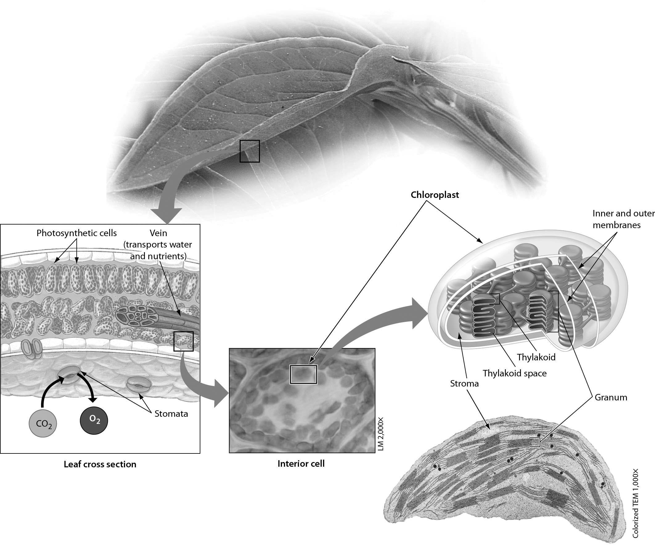

1) Refer to the accompanying figure. Plant cells that contain the organelle responsible for photosynthesis are concentrated in cells of the ________.
A) roots
B) leaves
C) stomata
D) grana
Answer: B
Topic: 7.1 The Basics of Photosynthesis
Skill: Knowledge/Comprehension
Learning Outcome: 7.2
Global LO: 3
2) In the accompanying figure, the molecule that makes up the bulk of the mass of the plant comes in mostly ________.
A) through the veins, which bring materials from the roots
B) through the transparent covering of the leaf into the photosynthetic cells
C) through the stomata
D) from the roots where they are stored during the night
Answer: B
Topic: 7.1 The Basics of Photosynthesis
Skill: Application/Analysis
Learning Outcome: 7.2
Global LO: 2, 3

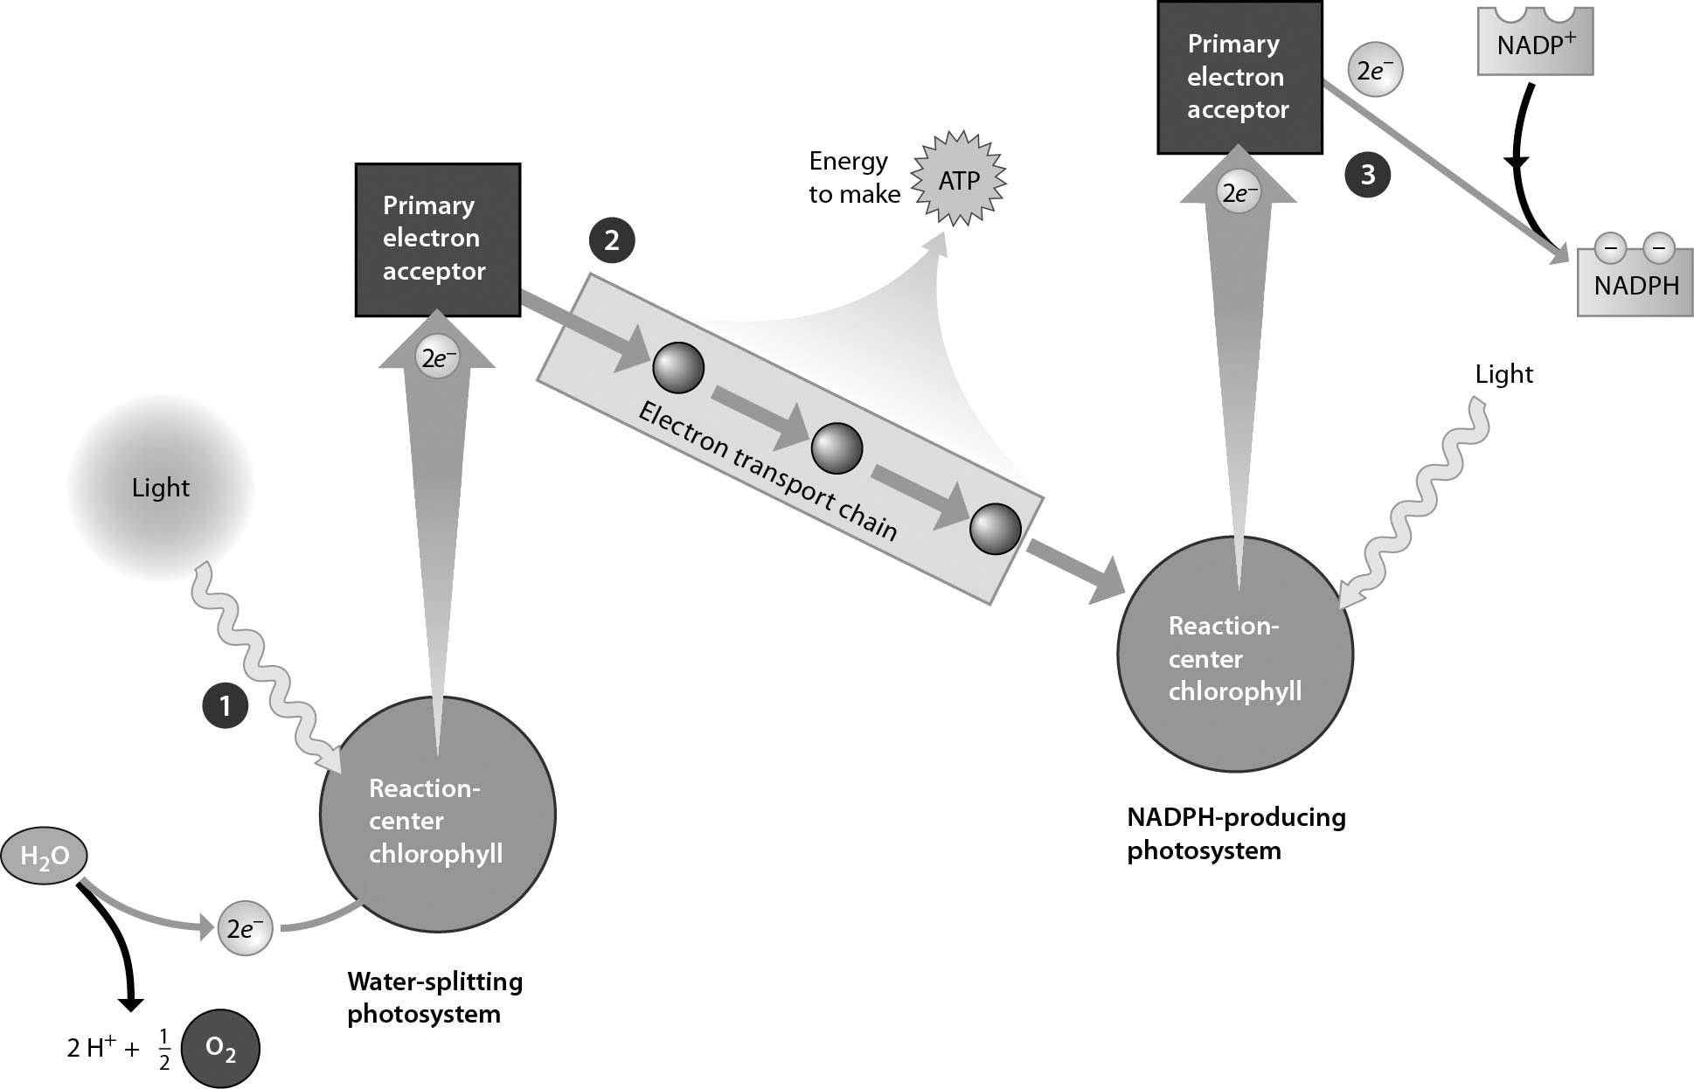

3) Refer to the accompanying figure. Which of the following is TRUE regarding the behavior of a chlorophyll molecule as it absorbs a photon?
A) An electron goes from the excited state to the ground state.
B) Light is released.
C) The energy of a photon raises an electron to the excited state.
D) ATP is broken down.
Answer: C
Topic: 7.2 The Light Reactions: Converting Solar Energy to Chemical Energy
Skill: Knowledge/Comprehension
Learning Outcome: 7.7
Global LO: 3
4) The light reactions are generally presented in zig-zag patterns, as shown in the accompanying figure. What is the significance of the primary electron receptor shown at position 2 being slightly higher than the primary electron receptor shown at position 3?
A) The electron that has been accepted gains energy as it leaves the primary electron receptor at 2 and heads to the primary electron receptor at position 3.
B) The primary electron receptor at 2 has slightly less energy than the primary electron receptor at position 3.
C) The primary electron receptor at position 2 comes before the primary electron receptor at position 3.
D) Since electrons have given off energy in the electron transport chain, they can be boosted higher by the second photosystem.
Answer B
Answer: B
Topic: 7.2 The Light Reactions: Converting Solar Energy to Chemical Energy
Skill: Synthesis/Evaluation
Learning Outcome: 7.7
Global LO: 2, 3

Please refer to the following art to answer the following questions.

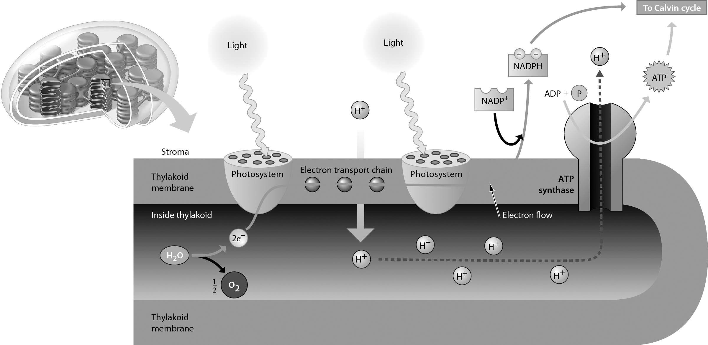

5) Which of the following BEST describes the direct mechanism of ATP production during photosynthesis?
A) use of the energy generated as hydrogen ions (H+) move up a proton gradient; this energy is used to make ATP
B) use of the energy released as excited electrons are passed from one molecule to another in the electron transport system; the energy is converted to the chemical bond energy of ATP
C) use of the energy stored in excited electrons; as the electrons move from the excited state to the ground state, the energy released is converted to the energy stored in the third phosphate bond in ATP
D) use of the energy stored in hydrogen ion (H+) gradients; the potential energy of the proton gradient is released as the protons move down their gradient through special membrane protein channels; this energy is converted to chemical bond energy in the ATP molecule
Answer: D
Topic: 7.2 The Light Reactions: Converting Solar Energy to Chemical Energy
Skill: Knowledge/Comprehension
Learning Outcome: 7.7
Global LO: 3

6) The energy in the proton gradient above is ________.
A) potential energy
B) sunlight light energy
C) sugar energy
D) heat energy
Answer: A
Topic: 7.2 The Light Reactions: Converting Solar Energy to Chemical Energy
Skill: Synthesis/Evaluation
Learning Outcome: 7.7
Global LO: 2, 3, 7

7) If the interior of the thylakoid were not a sealed compartment ________.
A) There would be no location for the electron transport chain
B) Light would not be able to reach the photosystems
C) Water could not be split
D) The proton gradient could not be maintained
Answer: D
Topic: 7.2 The Light Reactions: Converting Solar Energy to Chemical Energy
Skill: Synthesis/Evaluation
Learning Outcome: 7.7
Global LO: 2, 3, 7
Please refer to the following art to answer the following questions.

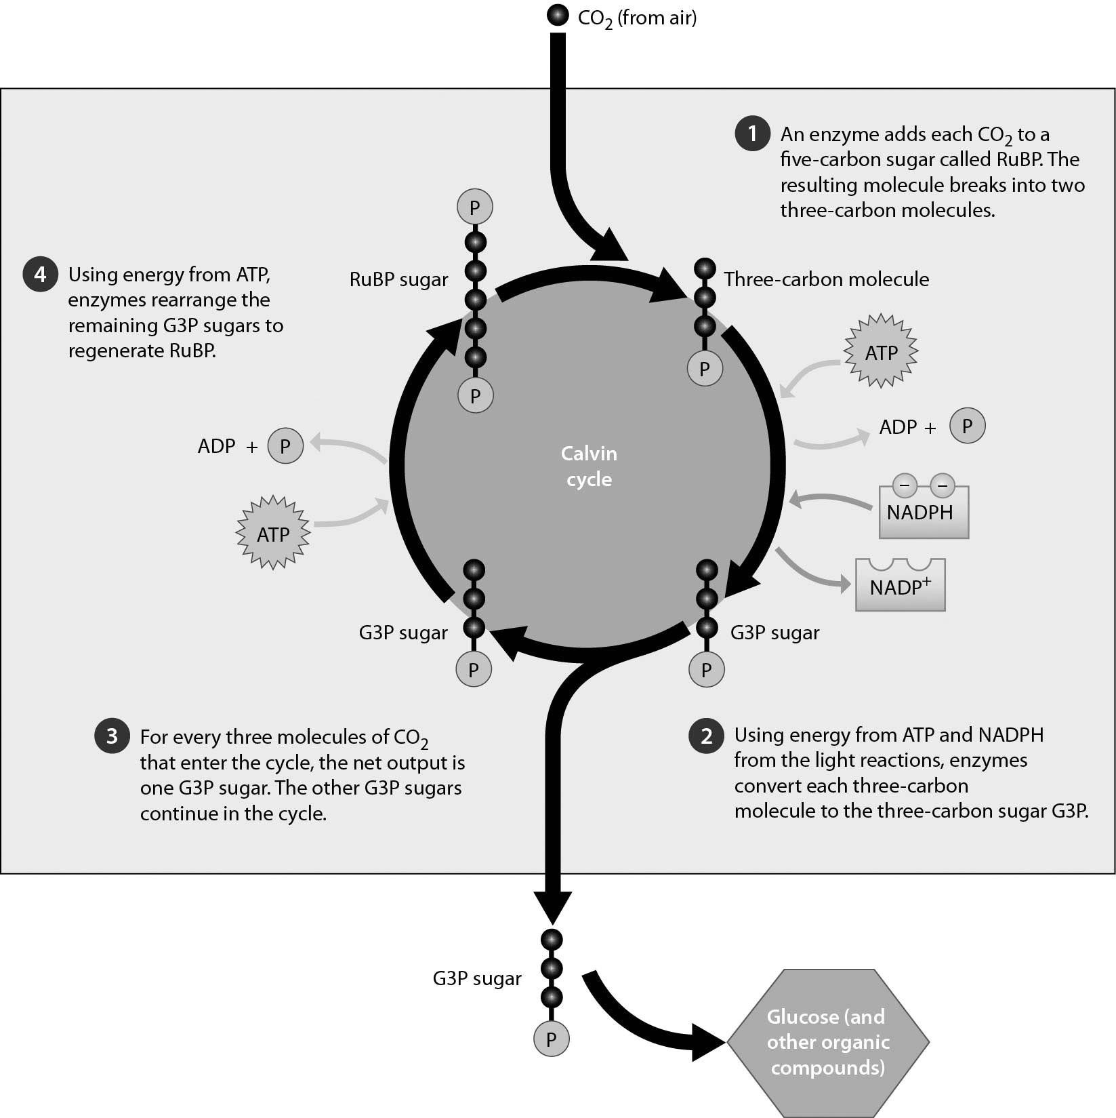

8) How many times must the Calvin cycle turn for the plant cell to be able to produce one molecule of glucose?
A) one
B) two
C) three
D) six
Answer: D
Topic: 7.3 The Calvin Cycle: Making Sugar from Carbon Dioxide
Skill: Application/Analysis
Learning Outcome: 7.9
Global LO: 2, 3, 4
9) One of the compounds that is a direct output of the Calvin cycle is ________.
A) C6H12O6
B) NADPH
C) G3P
D) ATP
Answer: C
Topic: 7.3 The Calvin Cycle: Making Sugar from Carbon Dioxide
Skill: Knowledge/Comprehension
Learning Outcome: 7.9
Global LO: 3

10) The first step of the Calvin cycle is the incorporation of ________ into ________.
A) O2... G3P
B) RuBP... O2
C) CO2... RuBP
D) G3P... RuBP
Answer: C
Topic: 7.3 The Calvin Cycle: Making Sugar from Carbon Dioxide
Skill: Knowledge/Comprehension
Learning Outcome: 7.9
Global LO: 3

11) The last stage of one complete turn of the Calvin cycle involves ________.
A) G3P production
B) oxidation of CO2
C) regeneration of RuBP
D) sugar production
Answer: C
Topic: 7.3 The Calvin Cycle: Making Sugar from Carbon Dioxide
Skill: Knowledge/Comprehension
Learning Outcome: 7.9
Global LO: 3

12) If an herbicide blocked the Calvin cycle before the generation of glyceraldehyde 3-phosphate (G3P), which of the following statements would be TRUE?
A) The plant would still be able to make sugar, just a lot less.
B) No oxygen would be released by the plant.
C) No sugar would be made by the plant.
D) Only RuBP would be recycled.
Answer: C
Topic: 7.3 The Calvin Cycle: Making Sugar from Carbon Dioxide
Skill: Application/Analysis
Learning Outcome: 7.9
Global LO: 2, 3
13) The Calvin cycle is sometimes called the "dark reactions." Could it take place if a plant were grown in the dark continuously?
A) No, because plants cannot take in CO2 without sunlight.
B) No, because sunlight is needed to split water to provide NADH.
C) Yes, because taking in carbon dioxide, the only outside input to the Calvin cycle, does not need sunlight.
D) Yes, because plants have stored materials in their roots which can provide what the Calvin cycle needs.
Answer: B
Topic: 7.3 The Calvin Cycle: Making Sugar from Carbon Dioxide
Skill: Application/Analysis
Learning Outcome: 7.9
Global LO: 2, 3
7.3 Scenario Questions

Please use the following information to answer the following questions.

You work for a company selling tropical rain forest plants commonly found in the understory of the forest. These plants are shade tolerant and can be grown indoors because they require low light. Your employer wants you to find out what is the best type of light to maximize growth of these understory plants. Using a full spectrum of natural light would cause these plants to die because they are a shade-tolerant plant species.

From your biology class, you recall that the light-dependent reactions of photosynthesis involve pigment molecules that absorb light of specific wavelengths. You also remember the experiments done by the German biologist Theodor Engelmann, in which he separated light using a prism into different wavelengths and then determined which wavelengths were best for promoting photosynthesis in the algae species he was examining. Your goal is to determine which wavelengths (colors) of light are best for promoting photosynthesis to enhance growth in your species of plant. To achieve this, you grew your plants under different wavelengths of light and measured their growth rates. The wavelengths were measured in nanometers (nm), and the growth rate was measured in millimeters per day (mm/day). The data you collected are as follows:

Wavelengths | Growth
400 nm | 0.33 mm/day
450 nm | 0.46 mm/day
500 nm | 0.88 mm/day
550 nm | 0.12 mm/day
600 nm | 0.54 mm/day
650 nm | 0.28 mm/day
700 nm | 0.08 mm/day
750 nm | 0.00 mm/day

Make a bar graph plotting growth rates on the y-axis and wavelengths of light on the x-axis. Referring to your graph, answer the following questions:

1) Which wavelength is best for your plants' growth?
A) 650 nm
B) 550 nm
C) 500 nm
D) 400 nm
Answer: C
Topic: 7.2 The Light Reactions: Converting Solar Energy to Chemical Energy
Skill: Application/Analysis
Learning Outcome: 7.5
Global LO: 2, 3, 4
2) Of the following, which wavelength is LEAST useful to your plants?
A) 650 nm
B) 450 nm
C) 550 nm
D) 400 nm
Answer: C
Topic: 7.2 The Light Reactions: Converting Solar Energy to Chemical Energy
Skill: Application/Analysis
Learning Outcome: 7.5
Global LO: 2, 3, 4

3) Which wavelength of light is the LEAST useful to your plant's growth?
A) 750 nm
B) 650 nm
C) 550 nm
D) 500 nm
Answer: A
Topic: 7.2 The Light Reactions: Converting Solar Energy to Chemical Energy
Skill: Application/Analysis
Learning Outcome: 7.5
Global LO: 2, 3, 4

4) Some plant species require shaded conditions while other plant species require bright sunlight. Shade tolerance is best related to which of these characteristics?
A) Different species of plants have different ratios of pigment molecules that utilize different wavelengths of light.
B) Plant leaves without a protective coating are subject to sunburn.
C) Some species of plants are able to produce sugar without ever having been exposed to sunlight.
D) Some species of plants are consumers and do not need sunlight.
Answer: A
Topic: 7.2 The Light Reactions: Converting Solar Energy to Chemical Energy
Skill: Synthesis/Evaluation
Learning Outcome: 7.5
Global LO: 2

5) Shade-tolerant plants have many adaptations for living in areas of low light. Predict whether each of the following processes would be high or low in comparison with other plants and choose the answer that is most CORRECT.
Net photosynthetic rate
Chlorophyll per area of the leaf
Electron transport chain rate
A) high, high, high
B) high, high low
C) low, high, high
D) low, high, low
Answer: D
Topic: 7.2 The Light Reactions: Converting Solar Energy to Chemical Energy
Skill: Synthesis/Evaluation
Learning Outcome: 7.2
Global LO: 2, 7
6) Shade-tolerant plants have many adaptations for living in areas of low light. Predict whether each of the following processes would be high or low in comparison with other plants and choose the answer that is most CORRECT.
Density of stomata on leaves
Leaf size
Carbohydrate storage
A) High, high, high
B) High, high, low
C) Low, high, high
D) Low, high, low
Answer: C
Topic: 7.2 The Light Reactions: Converting Solar Energy to Chemical Energy
Skill: Synthesis/Evaluation
Learning Outcome: 7.2
Global LO: 2, 7

