Campbell Essential Biology, 6e, Global Edition (Simon/Dickey/Hogan/Reece)

Chapter 17 The Evolution of Animals

Chapter 17 Learning Outcomes

17 Biology and Society: The Discovery of the Hobbit People
17.1. Describe the fossil discoveries on the Indonesian island of Flores and relate the findings to modern humans.
17.1 The Origins of Animal Diversity
17.2. Define what it means to be an animal, including structure and function of a body cavity, and describe common aspects of animal development.
17.3. Summarize the likely causes and significance of the Cambrian explosion.
17.4. Within the context of animal phylogeny, compare the presence of true tissues and the type of body symmetry found in each of the nine major animal phyla.
17.2 Major Invertebrate Phyla
17.5. Compare the body structure, lifestyles, and feeding strategies of the nine major animal phyla, distinguishing between distinct subgroups of these phyla.
17.3 Vertebrate Evolution and Diversity
17.6. Describe four defining characteristics of the phylum Chordata and compare body structure, lifestyles, and feeding strategies of four subgroups of Chordata.
17.7. Compare aquatic and terrestrial adaptations of amphibians, adaptations of reptiles to life on land, and adaptations for flight found in birds.
17.8. Describe the characteristics common to all mammals, distinguishing between monotremes, marsupials, and eutherian mammals.
17.4 The Human Ancestry
17.9. Compare the three main groups of primates, including adaptations for arboreal living.
17.10. Explain the misconceptions that (a) chimpanzees are our ancestors, (b) human evolution is a ladder, and (c) human traits evolved together.
17.11. Compare the traits of the major hominin species and the relationships between them.
17.12. Describe the evolution and impact of our species as we spread across the world.

Global Learning Outcomes
1. Demonstrate an understanding of the principles of scientific inquiry.
2. Demonstrate the ability to think critically and employ critical-thinking skills.
3. Read and interpret models, graphs, and data.
4. Demonstrate the quantitative skills needed to succeed in biology.
5. Demonstrate an understanding of the impact of science on society.
6. Evaluate the credibility of scientific information from various sources.
7. Demonstrate the ability to make connections between concepts across biology.
8. Communicate effectively in writing.
9. Apply the scientific method to interpret information and draw conclusions.

17.1 Multiple Choice Questions

1) J. R. R. Tolkien is a famous author who wrote, among others, several books about the adventures of a community of a humanoid (meaning resembling a human) race. The individuals of this race are described by Tolkien as being "…between 2 and 4 feet (0.61-1.22 m) tall, the average height being 3 feet 6 inches (1.07 m) … a fairly human figure." This general description characterizes the humanoids mostly closely resembling ________.
A) Homo sapiens
B) Homo floresiensis
C) mandrills
D) lemurs
Answer: B
Topic: 17 Biology and Society
Skill: Application/Analysis
Learning Outcome: 17.1
Global LO: 2

2) Which of these is a defining characteristic of animals that distinguishes them from other eukaryotes?
A) Animals are multicellular.
B) Animals ingest food.
C) Animals are heterotrophs.
D) Animals use photosynthesis.
Answer: B
Topic: 17.1 The Origins of Animal Diversity
Skill: Knowledge/Comprehension
Learning Outcome: 17.2

3) The common ancestor of all animals is likely to have been a ________.
A) colonial, flagellated protist
B) colonial, ciliated protist
C) colonial, flagellated bacterium
D) sponge
Answer: A
Topic: 17.1 The Origins of Animal Diversity
Skill: Knowledge/Comprehension
Learning Outcome: 17.3

4) Which of these exhibits radial symmetry?
A) butterfly
B) spoon
C) snowflake
D) shoe box
Answer: C
Topic: 17.1 The Origins of Animal Diversity
Skill: Application/Analysis
Learning Outcome: 17.4
Global LO: 2
5) Humans are chordates. Which animal group is most closely related to chordates?
A) molluscs
B) echinoderms
C) annelids
D) arthropods
Answer: B
Topic: 17.1 The Origins of Animal Diversity
Skill: Knowledge/Comprehension
Learning Outcome: 17.4

6) How do sponges differ from all other animals?
A) Sponges exhibit radial symmetry.
B) Sponges are autotrophs.
C) Sponges lack a true body cavity.
D) Sponges lack true tissues.
Answer: D
Topic: 17.2 Major Invertebrate Phyla
Skill: Knowledge/Comprehension
Learning Outcome: 17.5

7) What name is given to the food-trapping cells of sponges?
A) cnidocytes
B) amoebocytes
C) skeletal fibers
D) choanocytes
Answer: D
Topic: 17.2 Major Invertebrate Phyla
Skill: Knowledge/Comprehension
Learning Outcome: 17.5

8) The mobile stage of the cnidarian life cycle is the ________ stage.
A) bilateral
B) polyp
C) tadpole
D) medusa
Answer: D
Topic: 17.2 Major Invertebrate Phyla
Skill: Knowledge/Comprehension
Learning Outcome: 17.5

9) ________ are characterized by stinging cells used for defense and for capturing prey.
A) Annelids
B) Sponges
C) Cnidarians
D) Roundworms
Answer: C
Topic: 17.2 Major Invertebrate Phyla
Skill: Knowledge/Comprehension
Learning Outcome: 17.5
10) A(n) ________ is an example of a mollusc that does not have a shell.
A) octopus
B) snail
C) spider
D) oyster
Answer: A
Topic: 17.2 Major Invertebrate Phyla
Skill: Knowledge/Comprehension
Learning Outcome: 17.5

11) Which animals have a cylindrical body that is tapered at both ends?
A) platyhelminthes
B) cnidarians
C) annelids
D) roundworms
Answer: D
Topic: 17.2 Major Invertebrate Phyla
Skill: Knowledge/Comprehension
Learning Outcome: 17.5

12) There are more species of ________ than of any other type of animal.
A) nematodes
B) molluscs
C) arthropods
D) chordates
Answer: C
Topic: 17.2 Major Invertebrate Phyla
Skill: Knowledge/Comprehension
Learning Outcome: 17.5

13) A characteristic of arthropods that has allowed for their great success is the presence of ________.
A) bilateral symmetry
B) an endoskeleton
C) a brain
D) specialized segments
Answer: D
Topic: 17.2 Major Invertebrate Phyla
Skill: Knowledge/Comprehension
Learning Outcome: 17.5

14) The arthropod skeleton is composed of ________.
A) cellulose
B) peptidoglycan
C) chitin
D) glycogen
Answer: C
Topic: 17.2 Major Invertebrate Phyla
Skill: Knowledge/Comprehension
Learning Outcome: 17.5
15) Nearly all ________ are aquatic.
A) crustaceans
B) arachnids
C) flatworms
D) roundworms
Answer: A
Topic: 17.2 Major Invertebrate Phyla
Skill: Knowledge/Comprehension
Learning Outcome: 17.5

16) ________ are the most diverse group of arthropods.
A) Insects
B) Millipedes
C) Arachnids
D) Crustaceans
Answer: A
Topic: 17.2 Major Invertebrate Phyla
Skill: Knowledge/Comprehension
Learning Outcome: 17.5

17) What characteristic is unique to echinoderms?
A) a lack of segmentation
B) a water vascular system
C) radial symmetry
D) larvae with bilateral symmetry
Answer: B
Topic: 17.2 Major Invertebrate Phyla
Skill: Knowledge/Comprehension
Learning Outcome: 17.5

18) You are given the task of confirming the categorization of a newly discovered animal that has been tagged as a species of annelid. What evidence would convince you that it is indeed an annelid and not a roundworm or flatworm?
A) an incomplete digestive tract
B) a highly branched gastrovascular cavity
C) parasitic feeding habits
D) body segmentation
Answer: D
Topic: 17.2 Major Invertebrate Phyla
Skill: Application/Analysis
Learning Outcome: 17.5
Global LO: 2
19) You encounter an insect with small eyes, long sensory antennae, and a long mouthpart shaped like a sword. What can you conclude about the environment in which it lives?
A) The environment is dark and has many plants.
B) The environment is wet and has many other insects.
C) The environment is hot and has many primates.
D) The environment is cool and has many reptiles.
Answer: A
Topic: 17.2 Major Invertebrate Phyla
Skill: Synthesis/Evaluation
Learning Outcome: 17.5
Global LO: 2

20) You discover an organism that has scaly skin and is aquatic but returns to the land to reproduce. What else would you expect to find in this organism?
A) asexual reproduction
B) amniotic egg
C) a water vascular system
D) radial symmetry
Answer: B
Topic: 17.2 Major Invertebrate Phyla
Skill: Synthesis/Evaluation
Learning Outcome: 17.5, 17.6
Global LO: 2

21) Unique features of vertebrates include the presence of a(n) ________.
A) endoskeleton
B) notochord
C) skull and a backbone
D) pharyngeal slit
Answer: C
Topic: 17.3 Vertebrate Evolution and Diversity
Skill: Knowledge/Comprehension
Learning Outcome: 17.6

22) Which of the following is a characteristic of all chordates?
A) They all have vertebral columns.
B) They all exhibit radial symmetry.
C) They all have a notochord sometime during their life cycle.
D) They all have an exoskeleton sometime during their life cycle.
Answer: C
Topic: 17.3 Vertebrate Evolution and Diversity
Skill: Knowledge/Comprehension
Learning Outcome: 17.6

23) A(n) ________ is an example of a chordate that is not a vertebrate.
A) lancelet
B) echinoderm
C) bird
D) fish
Answer: A
Topic: 17.3 Vertebrate Evolution and Diversity
Skill: Knowledge/Comprehension
Learning Outcome: 17.6
24) Among vertebrates, the unique feature of lampreys and hagfish is the ________.
A) presence of a cartilaginous skeleton
B) absence of a backbone
C) absence of jaws
D) absence of a postanal tail
Answer: C
Topic: 17.3 Vertebrate Evolution and Diversity
Skill: Knowledge/Comprehension
Learning Outcome: 17.6

25) Rays are a type of ________.
A) tunicate
B) cartilaginous fish
C) jawless fish
D) bony fish
Answer: B
Topic: 17.3 Vertebrate Evolution and Diversity
Skill: Knowledge/Comprehension
Learning Outcome: 17.6

26) Swim bladders ________.
A) contain the gills
B) are required for fish to exchange gases with the surrounding water
C) are present in both bony and cartilaginous fishes
D) help bony fish maintain buoyancy
Answer: D
Topic: 17.3 Vertebrate Evolution and Diversity
Skill: Knowledge/Comprehension
Learning Outcome: 17.6

27) Which group of fishes includes a lineage that migrated out of fresh water and adapted to life on land?
A) ray-finned fishes
B) jawless fishes
C) lobe-finned fishes
D) cartilaginous fishes
Answer: C
Topic: 17.3 Vertebrate Evolution and Diversity
Skill: Knowledge/Comprehension
Learning Outcome: 17.6, 17.7

28) What does the term "tetrapod" mean?
A) egg-laying
B) living on land
C) living a double life
D) having four feet
Answer: D
Topic: 17.3 Vertebrate Evolution and Diversity
Skill: Knowledge/Comprehension
Learning Outcome: 17.7
29) A feature that freed reptiles from dependence on water for reproduction is ________.
A) parental care of eggs
B) ectothermy
C) metamorphosis
D) the amniotic egg
Answer: D
Topic: 17.3 Vertebrate Evolution and Diversity
Skill: Knowledge/Comprehension
Learning Outcome: 17.7

30) A characteristic that is shared by snakes and birds is ________.
A) being ectothermic
B) the presence of only a single ovary in females
C) the amniotic egg
D) being endothermic
Answer: C
Topic: 17.3 Vertebrate Evolution and Diversity
Skill: Knowledge/Comprehension
Learning Outcome: 17.7

31) Almost every element of bird anatomy is modified for what?
A) laying eggs
B) eating seeds
C) enhancement of flight
D) singing unique songs
Answer: C
Topic: 17.3 Vertebrate Evolution and Diversity
Skill: Knowledge/Comprehension
Learning Outcome: 17.7

32) A feature unique to mammals includes ________.
A) the presence of hair
B) extended parental care of the young
C) being endotherms
D) having no egg-laying members
Answer: A
Topic: 17.3 Vertebrate Evolution and Diversity
Skill: Knowledge/Comprehension
Learning Outcome: 17.8

33) ________ are the mammalian group that lays eggs.
A) Eutherians
B) Tunicates
C) Monotremes
D) Marsupials
Answer: C
Topic: 17.3 Vertebrate Evolution and Diversity
Skill: Knowledge/Comprehension
Learning Outcome: 17.8
34) All chordates have ________.
A) a dorsal, hollow nerve cord and a notochord
B) a postanal tail and a single opening for the mouth and anus
C) a cranium and vertebrae
D) pharyngeal slits and a cranium
Answer: A
Topic: 17.3 Vertebrate Evolution and Diversity
Skill: Knowledge/Comprehension
Learning Outcome: 17.6

35) The lancelet is a(n) ________.
A) annelid
B) flatworm
C) chordate
D) tunicate
Answer: C
Topic: 17.3 Vertebrate Evolution and Diversity
Skill: Knowledge/Comprehension
Learning Outcome: 17.6

36) The platypus is a ________.
A) bird
B) marsupial
C) eutherian
D) monotreme
Answer: D
Topic: 17.3 Vertebrate Evolution and Diversity
Skill: Knowledge/Comprehension
Learning Outcome: 17.8

37) While on an archaeology expedition, you unearth a skeleton with the following characteristics: four long, slender finger bones and a smaller opposable thumb bone, long arm bones, fingernails, and eye sockets close together on a skull. What type of organism do you suspect you may have found?
A) an anthropoid
B) a tarsier
C) a crustacean
D) a marsupial
Answer: A
Topic: 17.4 The Human Ancestry
Skill: Application/Analysis
Learning Outcome: 17.9
Global LO: 2
38) At a natural history museum, you see a skeleton with the following characteristics: four long, slender finger bones and a smaller opposable thumb bone, and larger feet with long toes. In what type of environment would you expect this organism to have lived?
A) one that lacks vegetation
B) one that is very cold
C) one that is very dry
D) one that is heavily forested
Answer: D
Topic: 17.4 The Human Ancestry
Skill: Synthesis/Evaluation
Learning Outcome: 17.9
Global LO: 2

39) How do New World monkeys differ from Old World monkeys?
A) New World monkeys have a prehensile tail.
B) New World monkeys have enhanced depth perception.
C) Old World monkeys are arboreal.
D) Old World monkeys have claws.
Answer: A
Topic: 17.4 The Human Ancestry
Skill: Knowledge/Comprehension
Learning Outcome: 17.9

40) Which anthropoids are most closely related to humans?
A) orangutans
B) chimpanzees
C) gorillas
D) gibbons
Answer: B
Topic: 17.4 The Human Ancestry
Skill: Knowledge/Comprehension
Learning Outcome: 17.10

41) Which of these human characteristics is hypothesized to have evolved first?
A) enlarged brain
B) erect posture
C) language
D) loss of body hair
Answer: B
Topic: 17.4 The Human Ancestry
Skill: Knowledge/Comprehension
Learning Outcome: 17.11

42) The first hominid to spread beyond Africa was ________.
A) "Lucy"
B) Australopithecus afarensis
C) Homo erectus
D) Homo neanderthalensis
Answer: C
Topic: 17.4 The Human Ancestry
Skill: Knowledge/Comprehension
Learning Outcome: 17.12
43) Where did humans first appear?
A) South America
B) Africa
C) Asia
D) Europe
Answer: B
Topic: 17.4 The Human Ancestry
Skill: Knowledge/Comprehension
Learning Outcome: 17.12

44) Which of the following is one way in which scientists can test hypotheses about events that occurred in the distant past?
A) by dissecting current animal specimens
B) by analyzing fossils recovered from the Earth
C) by visiting local libraries to research the events
D) by interviewing current scientists and researchers
Answer: B
Topic: 17 Process of Science, 17.4 The Human Ancestry
Skill: Knowledge/Comprehension
Learning Outcome: 17.11

45) The process of biological evolution often allows humans to survive consistent environmental stresses that occur across multiple generations. As humans colonized Earth's diverse environments, they encountered hot, dry areas and decided to settle. What trait likely offered an advantage in this environment?
A) the ability to produce sweat to cool their bodies
B) the ability to shiver to create body heat
C) the ability to squint eyes to block out bright light
D) the ability to dig deep holes to find groundwater
Answer: A
Topic: 17 Evolution Connection
Skill: Application/Analysis
Learning Outcome: 17.12
Global LO: 2
17.2 Art Questions

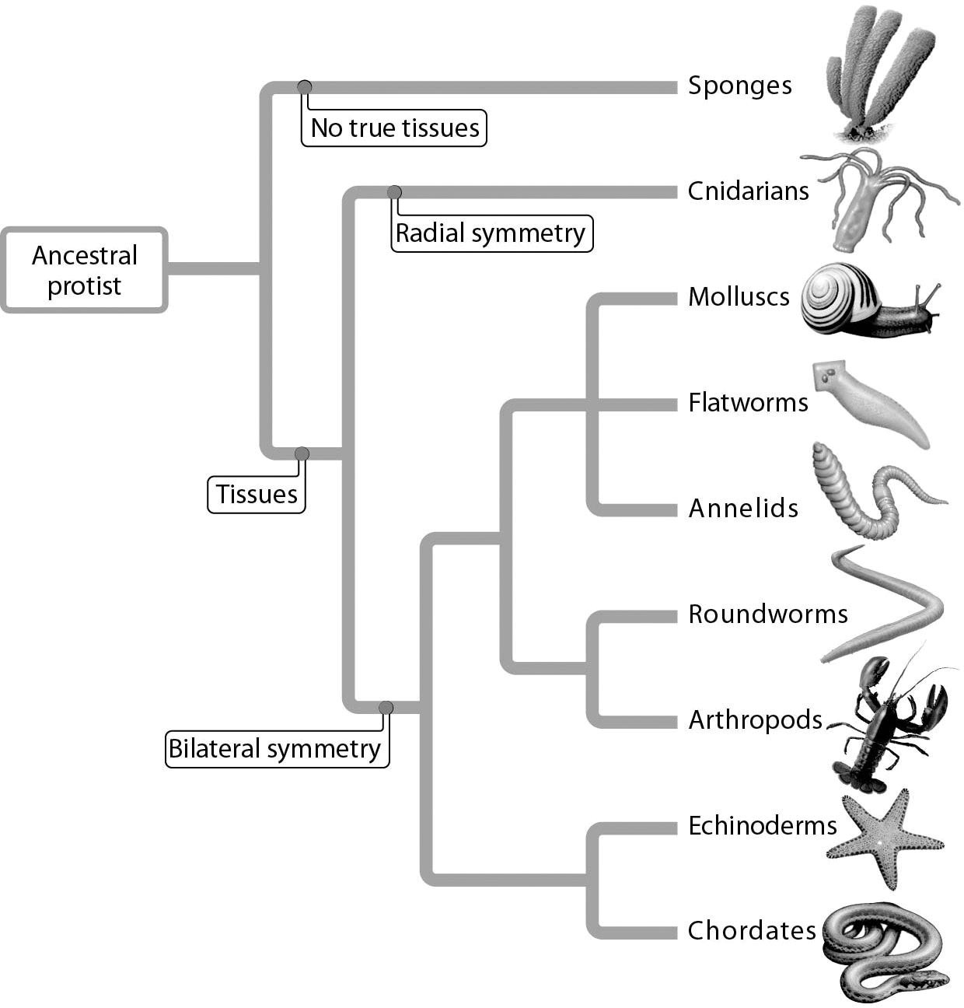

1) Annelids are most closely related to ________.
A) chordates
B) arthropods
C) molluscs
D) echinoderms
Answer: C
Topic: 17.1 The Origins of Animal Diversity
Skill: Application/Analysis
Learning Outcome: 17.4
Global LO: 2, 3

2) According to the figure, which organism group demonstrates the most advanced body plan in reference to presence of tissue and symmetry?
A) sponges
B) cnidarians
C) ancestral protists
D) arthropods
Answer: D
Topic: 17.1 The Origins of Animal Diversity
Skill: Application/Analysis
Learning Outcome: 17.4
3) All organisms with bilateral symmetry also have ________.
A) hard skeletons
B) bilateral adults
C) sense organs
D) an anterior head
Answer: C
Topic: 17.1 The Origins of Animal Diversity
Skill: Application/Analysis
Learning Outcome: 17.4

4) Flatworms are similar to cnidarians in that both ________.
A) are chordates
B) have true tissues
C) lack a gastrovascular cavity
D) exhibit bilateral symmetry
Answer: B
Topic: 17.1 The Origins of Animal Diversity
Skill: Application/Analysis
Learning Outcome: 17.4
Global LO: 2, 3

5) What type of symmetry does this organism exhibit?

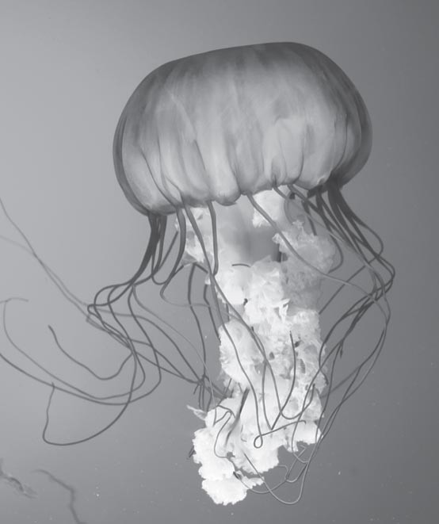

A) asymmetrical
B) binomial
C) radial
D) bilateral
Answer: C
Topic: 17.1 The Origins of Animal Diversity
Skill: Application/Analysis
Learning Outcome: 17.4
Global LO: 2, 3
6) The figure below shows a simple worm. Bilateral symmetry and a highly branched gastrovascular cavity all suggest that the worm is a(n) ________.

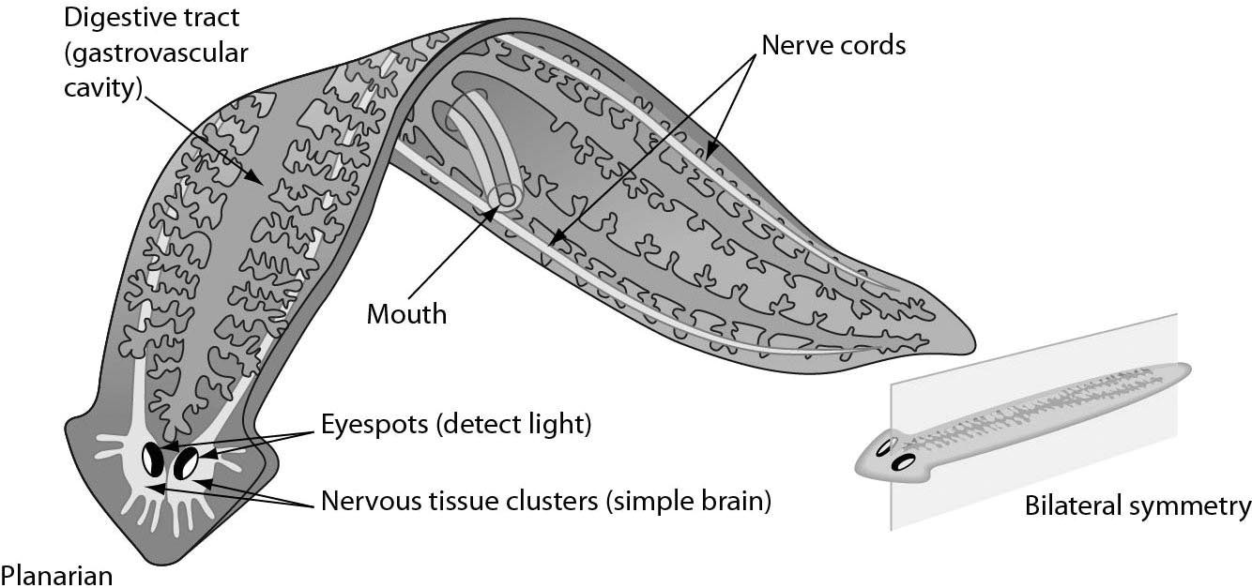

A) annelid
B) mollusk
C) chordate
D) flatworm
Answer: D
Topic: 17.2 Major Invertebrate Phyla
Skill: Application/Analysis
Learning Outcome: 17.4, 17.5
Global LO: 2, 3
7) The segmented body of the worm below suggests that it is a(n) ________.
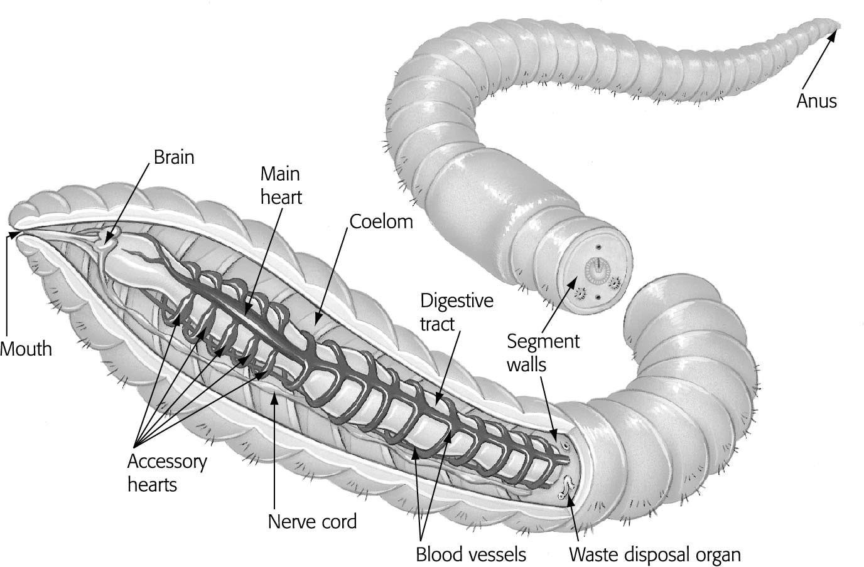

A) annelid
B) arthropod
C) snake
D) roundworm
Answer: A
Topic: 17.2 Major Invertebrate Phyla
Skill: Application/Analysis
Learning Outcome: 17.5
Global LO: 2, 3
8) Insects, such as the grasshopper shown below, have ________.

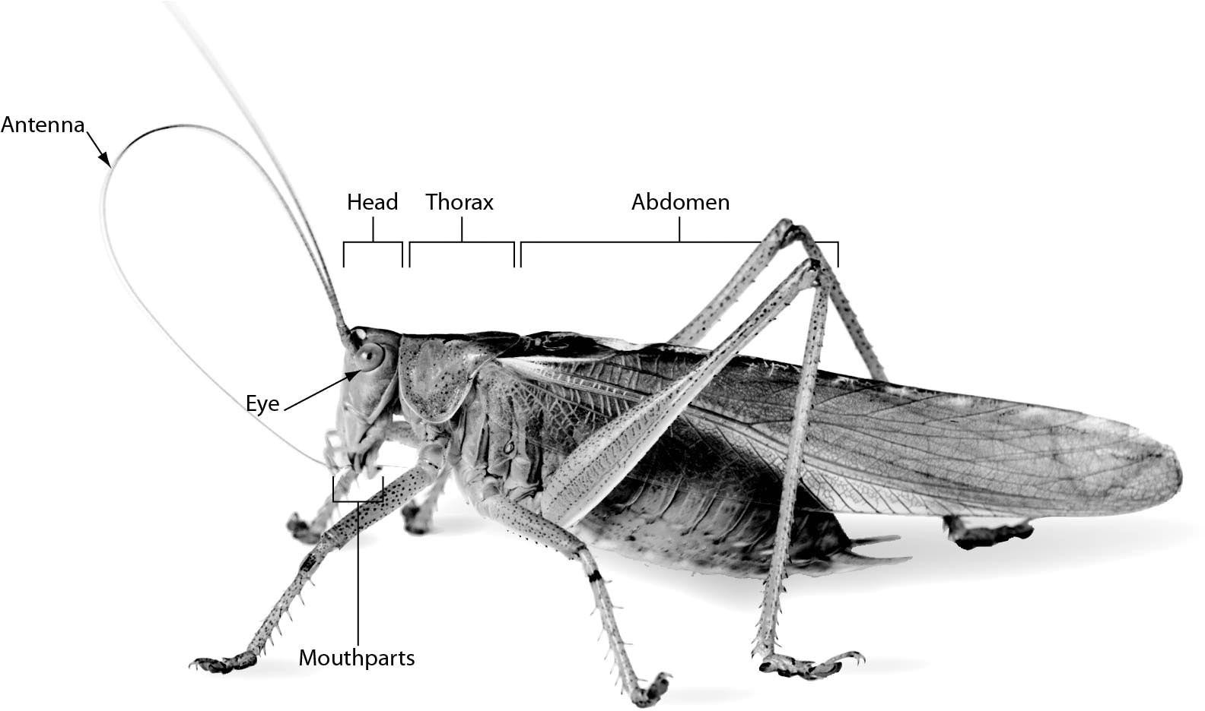
A) eight legs
B) a two-part body: head and abdomen
C) a three-part body: head, thorax, and abdomen
D) no wings
Answer: C
Topic: 17.2 Major Invertebrate Phyla
Skill: Knowledge/Comprehension
Learning Outcome: 17.5
Global LO: 3
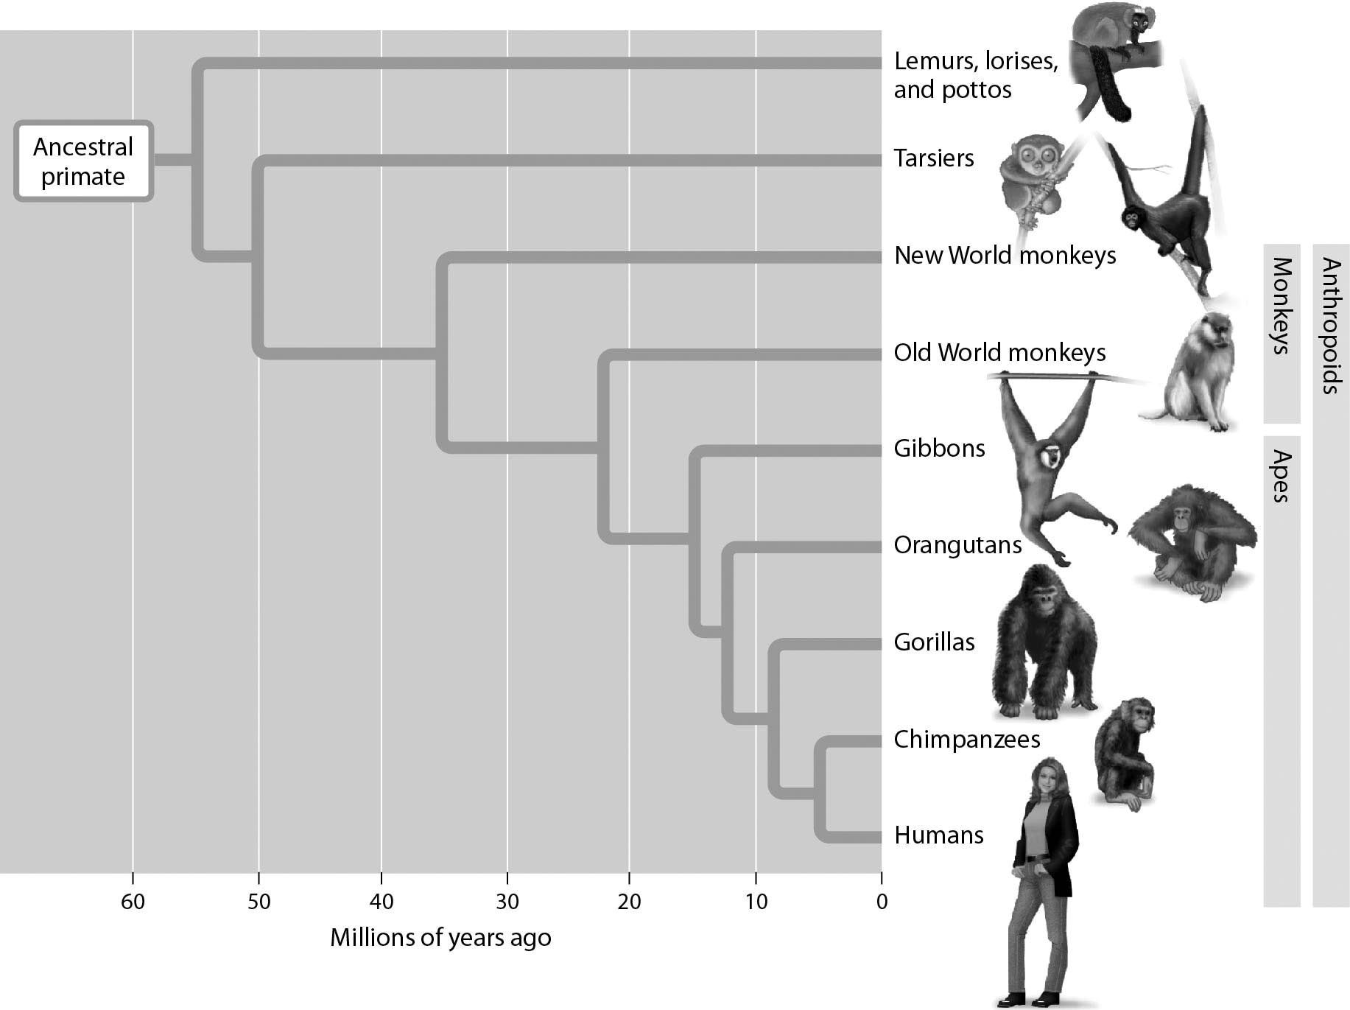

9) According to this evolutionary tree, approximately how many years ago did humans and orangutans share a common ancestor?
A) 1 million years ago
B) 7 million years ago
C) 12 million years ago
D) 20 million years ago
Answer: C
Topic: 17.4 The Human Ancestry
Skill: Application/Analysis
Learning Outcome: 17.9
Global LO: 2, 3

10) According to this evolutionary tree, how would you characterize a new anthropoid specimen discovered and estimated to be approximately 42 million years old?
A) one that could be a New World monkey or an Old World monkey
B) one that is likely a species of lemur
C) one that is likely a species of tarsier
D) one that evolved from a new ancestral primate
Answer: A
Topic: 17.4 The Human Ancestry
Skill: Application/Analysis
Learning Outcome: 17.9
Global LO: 2, 3
17.3 Scenario Questions

Read the following scenario to answer the following questions.

Birds are a widespread group of animals with approximately 10,000 different species found throughout the world today. Because they are relatively easy to find and so visually appealing, they have been studied more thoroughly than many other groups of animals. They are also valuable biological indicators because many species live in different habitats during different times of the year and cover long migration routes. According to the World Conservation Union, extinction threatens over 1,200 bird species today, and at least 179 are critically endangered. Some of the most endangered species include the Tahiti monarch, with only 10 pairs remaining, and the Bali starling, with only 12 wild individuals left. In Hawaii, the last captive po'ouli died in 2005, and the last two known to be alive in the wild have not been seen since 2003—2004. Common birds are also disappearing. In North America, red-winged blackbird populations declined by at least 1 percent each year between 1980 and 1999. These examples can serve as a warning. Habitat loss through destruction, degradation, and fragmentation are serious problems that affect 86 percent of threatened birds and are exacerbated by unsustainable forestry practices and intensifying agriculture. All of this shows that conservation of habitats is critical if many of the world's bird species are going to be saved from extinction in the near future.

1) What is a feature of birds that makes them valuable as biological indicators?
A) Many migrate long distances.
B) Many are brightly colored.
C) There are over 10,000 different species of birds.
D) Birdwatching is a popular hobby.
Answer: A
Topic: 17.3 Vertebrate Evolution and Diversity
Skill: Knowledge/Comprehension
Learning Outcome: 17.7, 17.12

2) What is the greatest threat to birds today?
A) pollution
B) poaching
C) habitat loss
D) the illegal pet trade
Answer: C
Topic: 17.3 Vertebrate Evolution and Diversity
Skill: Knowledge/Comprehension
Learning Outcome: 17.7, 17.12

3) Approximately what percent of bird species are threatened with extinction today?
A) 5%
B) 12%
C) 25%
D) 45%
Answer: B
Topic: 17.3 Vertebrate Evolution and Diversity
Skill: Application/Analysis
Learning Outcome: 17.7, 17.12

