Campbell Essential Biology, 6e, Global Edition (Simon/Dickey/Hogan/Reece)

Chapter 20 Communities and Ecosystems

Chapter 20 Learning Outcomes

20 Biology and Society: Why Biodiversity Matters
20.1. Define biodiversity and explain why it matters. Describe the important economic roles of natural or near-natural ecosystems.
20.1 The Loss of Biodiversity
20.2. Describe the three levels of biological diversity, and describe the four main factors responsible for the loss of biodiversity.
20.2 Community Ecology
20.3. Define and give an example of a community, an ecological niche, and the competitive exclusion principle.
20.4. Define the types of helpful (+/+) and harmful (+/-) (-/-) interspecific interactions; describe examples of each; and describe the adaptations derived from these relationships.
20.5. Define and list examples roles of organisms in a food chain or a food web, explaining how their position influences biological magnification.
20.6. Describe the components of species diversity, and how the interactions between species can maintain species diversity.
20.7. Describe the types and effects of disturbances in communities, and define and distinguish between the processes of primary and secondary succession that follow a disturbance.
20.3 Ecosystem Ecology
20.8. Compare the processes of energy flow and chemical cycling as they relate to ecosystem dynamics, and explain how the input of energy is related to the structure and function of the pyramid of production.
20.9. Describe the biogeochemical cycles; distinguish between the biotic and abiotic components of them; and describe how humans have altered them.
20.4 Conservation and Restoration Biology
20.10. Define conservation biology and restoration ecology, and describe the approaches that they use to accomplish their goals.
20.11. Define landscape ecology, and explain how landscapes influence biodiversity.
20 Evolution Connection: Can Biophilia Save Biodiversity?
20.12 Describe the concept and significance of biophilia.

Global Learning Outcomes
1. Demonstrate an understanding of the principles of scientific inquiry.
2. Demonstrate the ability to think critically and employ critical-thinking skills.
3. Read and interpret models, graphs, and data.
4. Demonstrate the quantitative skills needed to succeed in biology.
5. Demonstrate an understanding of the impact of science on society.
6. Evaluate the credibility of scientific information from various sources.
7. Demonstrate the ability to make connections between concepts across biology.
8. Communicate effectively in writing.
9. Apply the scientific method to interpret information and draw conclusions.

20.1 Multiple Choice Questions

1) The present rate of species loss ________.
A) suggests that about 25% of all plant and animal species may be extinct by the end of the century
B) is about the same as it has been during the last 100,000 years
C) is as much as 100 times higher than at any time in the last 100,000 years
D) is slower than in recent years because of conservation efforts
Answer: C
Topic: 20.1 The Loss of Biodiversity
Skill: Knowledge/Comprehension
Learning Outcome: 20.2
Global LO: 5

2) The single greatest threat to biodiversity comes from ________.
A) habitat destruction and fragmentation
B) invasive species
C) overexploitation
D) pollution
Answer: A
Topic: 20.1 The Loss of Biodiversity
Skill: Knowledge/Comprehension
Learning Outcome: 20.2
Global LO: 5

3) Several years ago, I was crossing the border from Canada to the United States and I had a bag of Washington State apples with me. The customs officer at the border would not let me take the apples with me into the United States (and I really hated the idea of getting rid of a bag of perfectly good apples). Why did the customs officer refuse to allow me to cross the border with my apples?
A) Washington State apples are considered an endangered fruit.
B) Apples grown in the United States for export may be contaminated with DDT.
C) There may have been a species that was not native to the United States hitching a ride on my apples.
D) Economics: If I couldn't bring the apples in with me, I would have to buy my apples from a store in the United States.
Answer: C
Topic: 20.1 The Loss of Biodiversity
Skill: Application/Analysis
Learning Outcome: 20.2
Global LO: 2, 5
4) An example of a mutualism, or +/+ relationship, is ________.
A) the relationship between corals and unicellular algae
B) cryptic coloration in frogs
C) herbivory
D) the relationship between Virginia's warblers and orange-crowned warblers, which use some of the same resources
Answer: A
Topic: 20.2 Community Ecology
Skill: Application/Analysis
Learning Outcome: 20.4
Global LO: 2

5) Populations of two coexisting species are both tertiary consumers in a community. What relationship may exist between these two organisms?
A) predation
B) mutualism
C) competition
D) succession
Answer: C
Topic: 20.2 Community Ecology
Skill: Synthesis/Evaluation
Learning Outcome: 20.3, 20.4, 20.5
Global LO: 2

6) As a result of a severe disturbance, a community will ________.
A) not be repopulated
B) be replaced by organisms in random order
C) not change
D) undergo succession
Answer: D
Topic: 20.2 Community Ecology
Skill: Knowledge/Comprehension
Learning Outcome: 20.7

7) Organisms that consume producers are ________.
A) detritivores
B) decomposers
C) primary consumers
D) producers
Answer: C
Topic: 20.2 Community Ecology
Skill: Knowledge/Comprehension
Learning Outcome: 20.5
8) In the food chain grass → antelope → human → lion, the antelope is ________.
A) both an herbivore and a secondary consumer
B) both a producer and a primary consumer
C) both an herbivore and a primary consumer
D) a secondary consumer only
Answer: C
Topic: 20.2 Community Ecology
Skill: Application/Analysis
Learning Outcome: 20.5
Global LO: 2

9) In the food chain grass → antelope → human → lion, the human is a ________.
A) tertiary consumer
B) secondary consumer
C) primary consumer
D) producer
Answer: B
Topic: 20.2 Community Ecology
Skill: Application/Analysis
Learning Outcome: 20.5
Global LO: 2

10) Small fishes that eat zooplankton are ________.
A) primary consumers
B) producers
C) tertiary consumers
D) secondary consumers
Answer: D
Topic: 20.2 Community Ecology
Skill: Knowledge/Comprehension
Learning Outcome: 20.5

11) Which of these convert organic matter to inorganic matter by breaking down dead organisms?
A) producers
B) detritivores
C) decomposers
D) primary consumers
Answer: C
Topic: 20.2 Community Ecology
Skill: Knowledge/Comprehension
Learning Outcome: 20.5

12) Most decomposers are ________.
A) plants and fungi
B) bacteria and plants
C) fungi and prokaryotes
D) animals
Answer: C
Topic: 20.2 Community Ecology
Skill: Knowledge/Comprehension
Learning Outcome: 20.5
13) Bears eat berries, humans, and large fish; large fish eat smaller fish and insects; humans eat bears, large fish, and berries; Venus flytraps eat insects. The scenario described here is an example of ________.
A) an ecosystem
B) parasitism
C) a food web
D) a food chain
Answer: C
Topic: 20.2 Community Ecology
Skill: Application/Analysis
Learning Outcome: 20.5
Global LO: 2

14) Herbivory is an example of a ________ interaction.
A) +/+
B) -/-
C) 0/+
D) +/-
Answer: D
Topic: 20.2 Community Ecology
Skill: Knowledge/Comprehension
Learning Outcome: 20.4

15) In order to assess the species diversity of a community, you would need to know the number of different species present as well as ________.
A) the number of trophic levels in the community
B) the intensity of interspecific competition in the community
C) the fraction of these species that are plants
D) the relative abundance of the different species
Answer: D
Topic: 20.2 Community Ecology
Skill: Knowledge/Comprehension
Learning Outcome: 20.6

16) In Yellowstone National Park, wolves were hunted to extinction in the 1920s. A current restoration project has reintroduced wolves to Yellowstone National Park. Predict the response of the Yellowstone ecological community if wolves are a keystone species.
A) Species richness should decrease.
B) The relative abundances of each species should become more unequal.
C) Species diversity should decrease.
D) Species richness should increase, and the relative abundances of each species should be about equal.
Answer: D
Topic: 20.2 Community Ecology
Skill: Synthesis/Evaluation
Learning Outcome: 20.6, 20.10
Global LO: 2
17) Two lakes have the same number of species. Most of the fish in Lake 1 are of a single species, with a few individuals each for the remaining species. Lake 2, on the other hand, has about equal numbers of each species. Which lake has higher species diversity?
A) Lake 1
B) Lake 2
C) They are equally diverse.
D) The number and relative abundance of species are not related to diversity.
Answer: B
Topic: 20.2 Community Ecology
Skill: Application/Analysis
Learning Outcome: 20.6
Global LO: 2

18) What is one way in which energy flow differs from chemical cycling?
A) Energy flow is unidirectional; chemical elements can be recycled.
B) Energy can enter but cannot leave an ecosystem; chemical elements can leave but cannot enter an ecosystem.
C) Energy flows from lower to higher trophic levels; chemicals cycle from higher to lower trophic levels.
D) Energy can both enter and leave an ecosystem; chemical elements always remain within a single ecosystem.
Answer: A
Topic: 20.3 Ecosystem Ecology
Skill: Knowledge/Comprehension
Learning Outcome: 20.8

19) Approximately what percentage of the visible light that reaches Earth's producers is converted to chemical energy?
A) 10%
B) 0.1%
C) 1%
D) 0.01%
Answer: C
Topic: 20.3 Ecosystem Ecology
Skill: Knowledge/Comprehension
Learning Outcome: 20.8

20) Biomass is the total amount of ________ an ecosystem.
A) organic matter tied up in the consumers of
B) organic matter tied up in the producers of
C) chemical elements recycled by the detritivores of
D) living organic material in
Answer: D
Topic: 20.3 Ecosystem Ecology
Skill: Knowledge/Comprehension
Learning Outcome: 20.8
21) The rate at which an ecosystem's producers convert solar energy to chemical energy stored in biomass is called ________.
A) energy flow
B) chemical cycle
C) primary productivity
D) trophic structure
Answer: C
Topic: 20.3 Ecosystem Ecology
Skill: Knowledge/Comprehension
Learning Outcome: 20.8

22) On average, what percentage of the energy in one trophic level becomes incorporated into the next higher trophic level?
A) 10%
B) 30%
C) 50%
D) 90%
Answer: A
Topic: 20.3 Ecosystem Ecology
Skill: Knowledge/Comprehension
Learning Outcome: 20.8

23) Which type of ecosystem has low primary production but nonetheless contributes a large proportion of Earth's total net primary production?
A) tropical rain forest
B) coral reef
C) open ocean
D) desert
Answer: C
Topic: 20.3 Ecosystem Ecology
Skill: Knowledge/Comprehension
Learning Outcome: 20.8

24) Why are most food chains limited to three to five trophic levels?
A) The higher the trophic level, the larger the organism; the larger the organism, the less likely it will be prey.
B) The nutritional quality of existing biomass decreases with increasing trophic level.
C) Most ecosystems have insufficient space to support the increased number of organisms that more trophic levels would require.
D) There is insufficient energy to support more trophic levels.
Answer: D
Topic: 20.3 Ecosystem Ecology
Skill: Knowledge/Comprehension
Learning Outcome: 20.8
25) Besides the atmosphere, abiotic reservoirs of carbon dioxide include ________.
A) fossil fuels and dissolved carbon compounds in the oceans
B) rocks and dissolved carbon compounds in the oceans
C) fossil fuels only
D) rocks only
Answer: A
Topic: 20.3 Ecosystem Ecology
Skill: Knowledge/Comprehension
Learning Outcome: 20.9

26) The atmosphere is approximately 80% ________ gas.
A) CO2
B) H2O
C) CH4
D) N2
Answer: D
Topic: 20.3 Ecosystem Ecology
Skill: Knowledge/Comprehension
Learning Outcome: 20.9

27) Plants can most readily utilize the ________ form of nitrogen.
A) nitrous oxide
B) N2
C) amino
D) nitrate
Answer: D
Topic: 20.3 Ecosystem Ecology
Skill: Knowledge/Comprehension
Learning Outcome: 20.9

28) Which of these organisms convert atmospheric nitrogen gas to a form that can be utilized by plants?
A) bacteria
B) protists
C) animals
D) fungi
Answer: A
Topic: 20.3 Ecosystem Ecology
Skill: Knowledge/Comprehension
Learning Outcome: 20.9

29) ________ convert nitrogen from nitrates to N2.
A) Nitrifying bacteria
B) Nitrogen-fixing bacteria living in the soil
C) Denitrifying bacteria
D) Nitrogen-fixing bacteria living in the root nodules of legumes
Answer: C
Topic: 20.3 Ecosystem Ecology
Skill: Knowledge/Comprehension
Learning Outcome: 20.9
30) The major abiotic reservoir for phosphorus is ________.
A) the oceans
B) the atmosphere
C) rock
D) dead organic matter
Answer: C
Topic: 20.3 Ecosystem Ecology
Skill: Knowledge/Comprehension
Learning Outcome: 20.9

31) With regard to nutrient pollution in aquatic ecosystems, when is the worst time to apply fertilizer to your lawn?
A) when it is raining, or is about to rain
B) when it is cold, or is about to get cold
C) at the same time you apply pesticides
D) at night
Answer: A
Topic: 20.3 Ecosystem Ecology
Skill: Knowledge/Comprehension
Learning Outcome: 20.9
Global LO: 5

32) The primary goal of conservation biology is to ________.
A) catalog species
B) maximize the land set aside for wildlife
C) integrate human culture back into nature
D) counter the loss of biodiversity
Answer: D
Topic: 20.4 Conservation and Restoration Biology
Skill: Knowledge/Comprehension
Learning Outcome: 20.10
Global LO: 5

33) Modern conservation science increasingly aims at ________.
A) protecting federally listed endangered species
B) countering pollution
C) sustaining entire ecosystems
D) maintaining genetic diversity within species
Answer: C
Topic: 20.4 Conservation and Restoration Biology
Skill: Knowledge/Comprehension
Learning Outcome: 20.10
Global LO: 5

34) Species found in only one place on Earth are called ________ species.
A) hot spot
B) exotic
C) keystone
D) endemic
Answer: D
Topic: 20.4 Conservation and Restoration Biology
Skill: Knowledge/Comprehension
Learning Outcome: 20.10
35) Small areas that have a large number of endangered and threatened species are referred to as ________.
A) biologically magnified
B) endemic environments
C) biodiverse environments
D) biodiversity hot spots
Answer: D
Topic: 20.4 Conservation and Restoration Biology
Skill: Knowledge/Comprehension
Learning Outcome: 20.10
Global LO: 5

36) A regional assemblage of interacting ecosystems is a ________.
A) community
B) landscape
C) movement corridor
D) hot spot
Answer: B
Topic: 20.4 Conservation and Restoration Biology
Skill: Knowledge/Comprehension
Learning Outcome: 20.11
Global LO: 5

37) Landscape ecology ________.
A) is the application of ecological principles to the study of land-use patterns
B) focuses primarily on how to restore human-altered ecological systems
C) deals primarily with ecosystems in urban settings
D) deals with the study of the ranges of different species
Answer: A
Topic: 20.4 Conservation and Restoration Biology
Skill: Knowledge/Comprehension
Learning Outcome: 20.11
Global LO: 5

38) A movement corridor ________.
A) is a path used by migratory animals when they move to their winter habitats
B) is the path most commonly used by an animal within its home range
C) connects otherwise isolated patches of quality habitat for a species
D) is a natural component of the environment
Answer: C
Topic: 20.4 Conservation and Restoration Biology
Skill: Knowledge/Comprehension
Learning Outcome: 20.11
39) Movement corridors are ________.
A) always created by humans
B) found only along stream sides
C) not harmful, but are beneficial because they allow for dispersal
D) harmful because they allow for the spread of disease and beneficial because they allow for dispersal
Answer: D
Topic: 20.4 Conservation and Restoration Biology
Skill: Knowledge/Comprehension
Learning Outcome: 20.11

40) Sustainable development ________.
I) will require making difficult decisions regarding the environment and lifestyle
II) must be achieved if the human species is to survive
III) will require global, multinational cooperation
A) I only
B) II only
C) III only
D) I, II, and III
Answer: D
Topic: 20.4 Conservation and Restoration Biology
Skill: Knowledge/Comprehension
Learning Outcome: 20.10
Global LO: 5

41) E. O. Wilson coined the term ________ for our innate appreciation of wild environments and living organisms.
A) bioremediation
B) bioethics
C) biophilia
D) biophobia
Answer: C
Topic: 20.4 Conservation and Restoration Biology
Skill: Knowledge/Comprehension
Learning Outcome: 20.12
Global LO: 5

42) One problem with eradicating invasive species is that sometimes the disturbed area is unable to be colonized by native species. For example, in forests where the invasive plant garlic mustard has been removed, native plants and animals do not recolonize because they are extinct in that patch of forest. How should restoration ecologists increase species diversity and recover ecosystem function?
A) Introduce tertiary consumers.
B) Develop movement corridors for primary producers.
C) Develop movement corridors for species with similar niches.
D) Eliminate keystone species.
Answer: B
Topic: 20.2 Community Ecology, 20.4 Conservation and Restoration Biology
Skill: Synthesis/Evaluation
Learning Outcome: 20.3, 20.5, 20.6, 20.11
Global LO: 2, 5
43) What is the estimated annual value of ecosystem services?
A) $1 billion
B) $33 trillion
C) $33 billion
D) $1 trillion
Answer: B
Topic: 20 Biology and Society
Skill: Knowledge/Comprehension
Learning Outcome: 20.1
Global LO: 5
20.2 Art Questions

Please refer to the following art to answer the following questions.

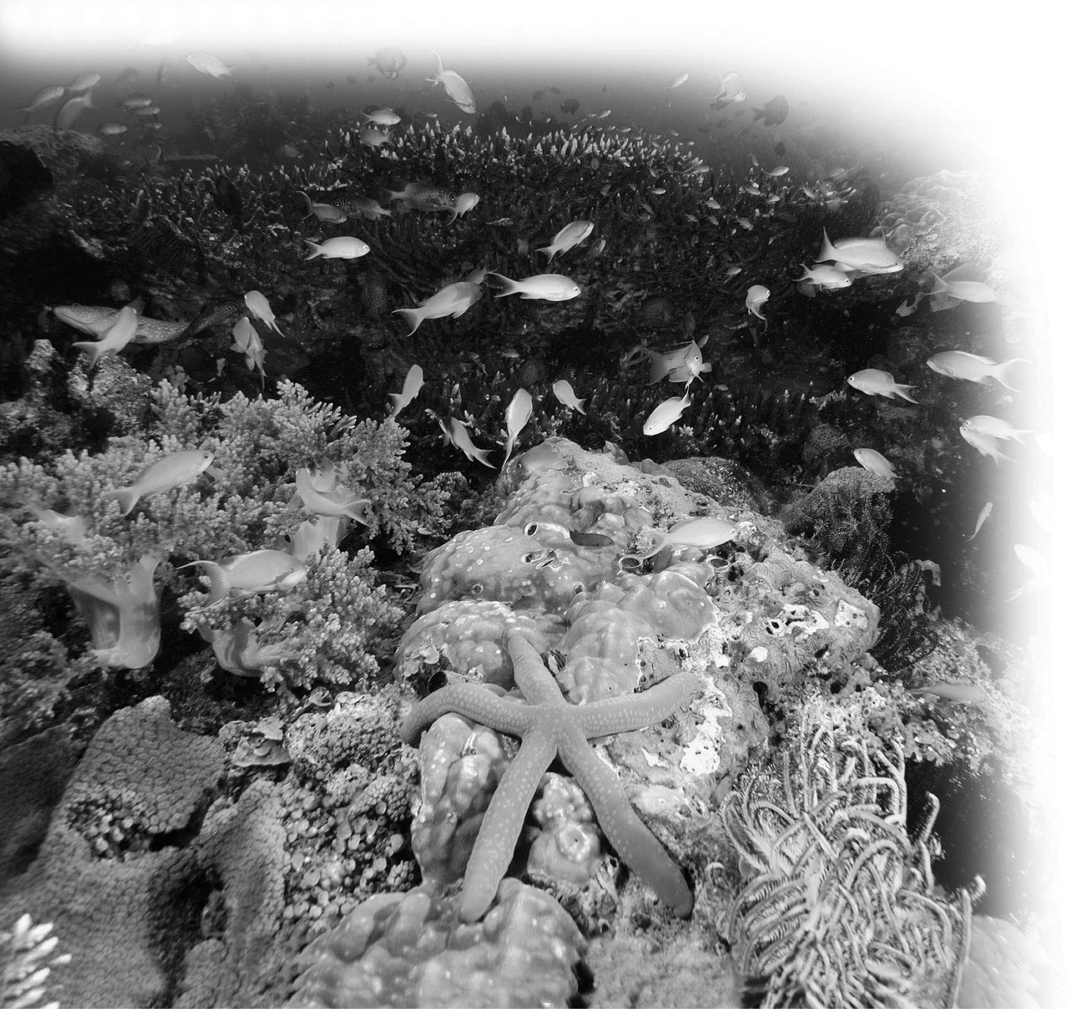

1) Refer to the accompanying figure. All of the living components of the coral reef represent a(n) ________.
A) population
B) species
C) community
D) ecosystem
Answer: C
Topic: 20.2 Community Ecology
Skill: Knowledge/Comprehension
Learning Outcome: 20.3
2) In the ecosystem shown above, a toxin that accumulates in body tissues would have the largest effect on ________.
A) corals that obtain their food from photosynthesizing dinoflagellates
B) herbivorous shrimp
C) fish that eat shrimp and other invertebrates
D) The toxin would affect all of these equally.
Answer: C
Topic: 20.2 Community Ecology
Skill: Synthesis/Evaluation
Learning Outcome: 20.5
Global LO: 2, 4

3) The figure below shows the growth curves of two populations of Paramecium, P. aurelia and P. caudatum. From the data, we can conclude that ________.

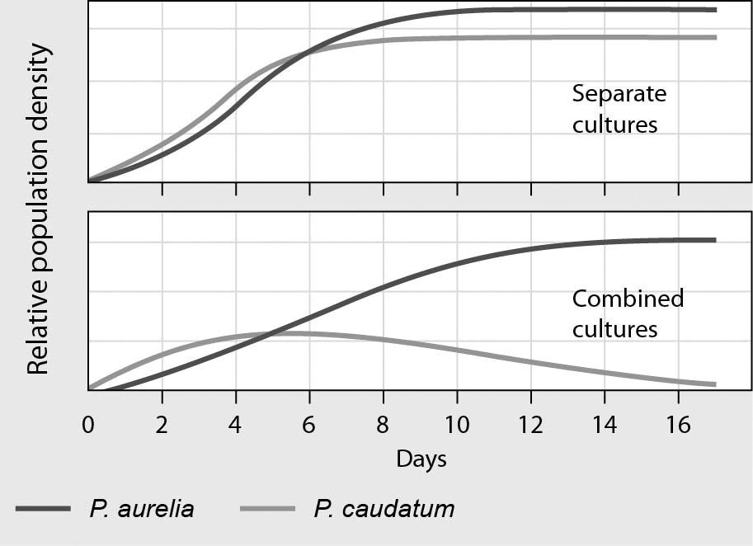

A) the ecological niches of the two species are very different
B) P. aurelia is a predator of P. caudatum
C) P. aurelia and P. caudatum have a mutualistic relationship
D) P. aurelia is the superior competitor in this habitat
Answer: D
Topic: 20.2 Community Ecology
Skill: Application/Analysis
Learning Outcome: 20.3
Global LO: 2, 3
4) Refer to the following figure. If there were an additional trophic level that consisted of organisms that prey on snakes, about how much energy would be available to organisms at that trophic level?

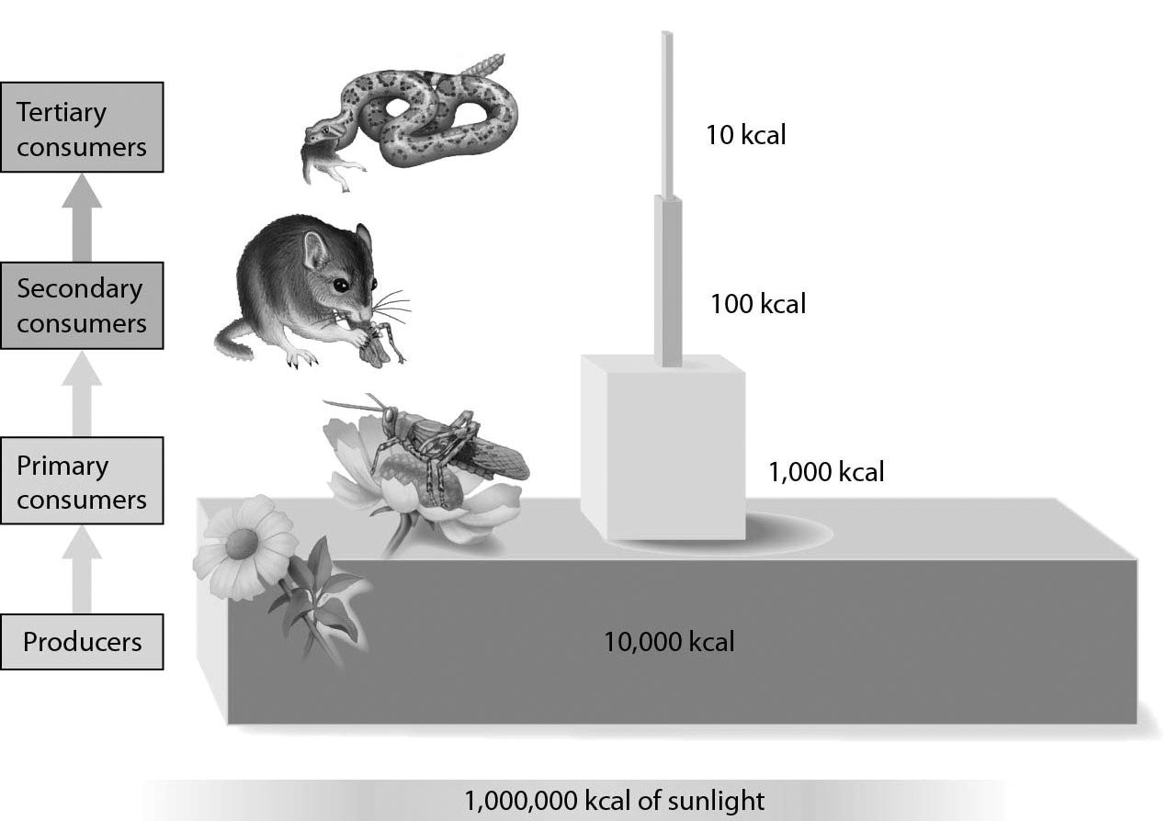

A) 100 kcal
B) 90%
C) 1 kcal
D) 10 kcal
Answer: C
Topic: 20.3 Ecosystem Ecology
Skill: Application/Analysis
Learning Outcome: 20.8
Global LO: 2, 3, 4
20.3 Scenario Questions

Use the following information to answer the following questions.

Malaria is an infectious disease caused by a unicellular eukaryotic organism belonging to the genus Plasmodium. These eukaryotic organisms are transmitted from one person to another by the female Anopheles mosquito when it feeds on human blood. Within humans, the Plasmodium species destroy red blood cells and, without effective treatment, serious infections can lead to death. Currently, more than 400 million people are afflicted with malaria and between 1 and 3 million people die from it each year. Historically, a chemical compound called quinine has been used in developing effective drugs against malaria. In its natural environment, quinine is produced by certain trees native to South America. This chemical is synthesized in the outer layer of tree trunks and acts as an herbivore deterrent.

1) Based on the relationship between Plasmodium spp. and humans, Plasmodium would be considered ________.
A) parasites
B) hosts
C) producers
D) carnivores
Answer: A
Topic: 20.2 Community Ecology
Skill: Application/Analysis
Learning Outcome: 20.4
Global LO: 2

2) Humans, mosquitoes, and Plasmodium together would be considered a(n) ________.
A) population
B) community
C) ecosystem
D) population and community
Answer: B
Topic: 20.2 Community Ecology
Skill: Application/Analysis
Learning Outcome: 20.3
Global LO: 2

3) Despite being used for many years, quinine-based drugs have not led to the eradication of malaria and currently there are parasites that are resistant to the compound. Which of the following were likely important in the development of this resistance to quinine?
A) natural selection
B) mutualism
C) interspecific competition
D) biological magnification
Answer: A
Topic: 20.2 Community Ecology
Skill: Application/Analysis
Learning Outcome: 20.4
Use the following information to answer the following questions.

In East Java, Indonesia, a mud volcano has been erupting since 2006. One controversial hypothesis is that the mud volcano in East Java is erupting because a gas mining company was drilling a deep hole nearby. When a mud volcano erupts, hot water deep below the earth's surface mixes with various minerals, and this mud spews out over the surface of the earth. The hot mud flow destroys organismal habitats, including the homes and livelihoods of people.

4) When the mud volcano stops erupting, the disturbed area will be colonized by a variety of species. This process of colonization is called ________.
A) biological magnification
B) species diversity
C) ecological succession
D) disturbance
Answer: C
Topic: 20.2 Community Ecology
Skill: Application/Analysis
Learning Outcome: 20.7
Global LO: 2

5) When the mud volcano stops erupting, colonization of the disturbed area would be ________.
A) primary succession if there is no biomass inside the area
B) primary succession if primary production relies on plants that survived the disturbance
C) secondary succession if there are no biotic components of the carbon cycle
D) secondary succession if there is no organic matter in the area
Answer: A
Topic: 20.2 Community Ecology, 20.3 Ecosystem Ecology
Skill: Synthesis/Evaluation
Learning Outcome: 20.7, 20.9
Global LO: 2

