Campbell Essential Biology, 6e, Global Edition (Simon/Dickey/Hogan/Reece)
Chapter 22 Nutrition and Digestion

Chapter 22 Learning Outcomes
22 Biology and Society: The “Secret” to Shedding Pounds
22.1. Explain why there are really no tricks to losing weight.
22.1 An Overview of Animal Nutrition
22.2. Define and distinguish between different types of animal diets.
22.3. List and describe the general steps involved in digestion, and explain how and why mechanical and chemical digestion dismantles large food molecules.
22.4. Describe the structure and functions of different types of digestive compartments.
22.2 A Tour of the Human Digestive System
22.5. Describe the structure and function of the main components of the human digestive tract and the associated digestive glands.
22.6. Describe the causes and treatments of disorders of the human digestive system.
22.3 Human Nutritional Requirements
22.7. Explain how energy in food is measured, and how metabolic activity results in weight loss or gain.
22.8. List and define essential components of the human diet, and describe how deficiencies in these components can lead to health problems.
22.9. Describe the types of information found on food labels.
22.4 Nutritional Disorders
22.10. Describe the causes and treatments of different nutritional disorders.
22 Evolution Connection: Fat and Sugar Cravings
22.11. Explain how cravings for fat might have evolved in humans.

Global Learning Outcomes

1. Demonstrate an understanding of the principles of scientific inquiry.
2. Demonstrate the ability to think critically and employ critical-thinking skills.
3. Read and interpret models, graphs, and data.
4. Demonstrate the quantitative skills needed to succeed in biology.
5. Demonstrate an understanding of the impact of science on society.
6. Evaluate the credibility of scientific information from various sources.
7. Demonstrate the ability to make connections between concepts across biology.
8. Communicate effectively in writing.
9. Apply the scientific method to interpret information and draw conclusions.

22.1 Multiple Choice Questions

1) Spiders are ________.
A) herbivores
B) filter feeders
C) carnivores
D) omnivores
Answer: C
Topic: 22.1 An Overview of Animal Nutrition
Skill: Knowledge/Comprehension
Learning Outcome: 22.2

2) Digestion is ________.
A) the absorption of nutrients
B) the breakdown of food into small nutrient molecules that the body can absorb
C) the churning of food in the stomach and intestine
D) eating
Answer: B
Topic: 22.1 An Overview of Animal Nutrition
Skill: Knowledge/Comprehension
Learning Outcome: 22.3

3) The four stages of food processing are, in order ________.
A) ingestion, absorption, elimination, digestion
B) ingestion, elimination, digestion, absorption
C) ingestion, digestion, absorption, elimination
D) digestion, absorption, ingestion, elimination
Answer: C
Topic: 22.1 An Overview of Animal Nutrition
Skill: Knowledge/Comprehension
Learning Outcome: 22.3

4) Which of the following is an example of mechanical digestion?
A) the breakdown of proteins into amino acids
B) peristalsis
C) the digestion of fats by lipases
D) chewing
Answer: D
Topic: 22.1 An Overview of Animal Nutrition
Skill: Knowledge/Comprehension
Learning Outcome: 22.3
5) The digestive sac of a jellyfish has ________ opening(s).
A) one
B) two
C) three
D) four
Answer: A
Topic: 22.1 An Overview of Animal Nutrition
Skill: Knowledge/Comprehension
Learning Outcome: 22.4

6) A digestive tube is best defined as ________.
A) the compartment in which an animal digests its food
B) a tube-shaped digestive compartment with either one or two openings
C) a tube-shaped digestive compartment that has two openings and through which food moves in one direction
D) a digestive compartment that conducts both chemical and mechanical digestion
Answer: C
Topic: 22.1 An Overview of Animal Nutrition
Skill: Knowledge/Comprehension
Learning Outcome: 22.4

7) The main function of salivary amylase is to ________.
A) moisten food
B) break down proteins
C) absorb nutrients
D) break down starch
Answer: D
Topic: 22.2 A Tour of the Human Digestive System
Skill: Knowledge/Comprehension
Learning Outcome: 22.5

8) Which of the following choices lists the organs of the human alimentary canal in the CORRECT order?
A) pharynx, oral cavity, esophagus, stomach, large intestine
B) oral cavity, pharynx, esophagus, stomach, small intestine, large intestine
C) esophagus, pharynx, stomach, large intestine, small intestine
D) oral cavity, esophagus, stomach, large intestine, small intestine
Answer: B
Topic: 22.2 A Tour of the Human Digestive System
Skill: Knowledge/Comprehension
Learning Outcome: 22.5

9) Digestion begins in the ________.
A) oral cavity
B) esophagus
C) pharynx
D) stomach
Answer: A
Topic: 22.2 A Tour of the Human Digestive System
Skill: Knowledge/Comprehension
Learning Outcome: 22.5
10) The tongue does all of the following EXCEPT ________.
A) taste food
B) shape food into a ball
C) secrete saliva
D) push food into the pharynx
Answer: C
Topic: 22.2 A Tour of the Human Digestive System
Skill: Knowledge/Comprehension
Learning Outcome: 22.5

11) Muscular contraction moves food through the alimentary canal by a process called ________.
A) propulsion
B) active transport
C) peristalsis
D) swallowing
Answer: C
Topic: 22.2 A Tour of the Human Digestive System
Skill: Knowledge/Comprehension
Learning Outcome: 22.5

12) What is the epiglottis?
A) a muscle that moves the esophagus into line with the pharynx during swallowing
B) a muscle that moves the trachea out of line with the pharynx during swallowing
C) a flap that flips down to cover the entry to the trachea during swallowing
D) a muscular sphincter that closes off the entry to the trachea during swallowing
Answer: C
Topic: 22.2 A Tour of the Human Digestive System
Skill: Knowledge/Comprehension
Learning Outcome: 22.5

13) The esophagus and trachea are both open to the ________.
A) pharynx
B) posterior oral cavity
C) posterior nasal cavity
D) larynx
Answer: A
Topic: 22.2 A Tour of the Human Digestive System
Skill: Knowledge/Comprehension
Learning Outcome: 22.5

14) A food ball moves through the esophagus by ________.
A) peristalsis
B) gastric juice
C) mastication
D) regurgitation
Answer: A
Topic: 22.2 A Tour of the Human Digestive System
Skill: Knowledge/Comprehension
Learning Outcome: 22.5
15) The stomach's gastric juice consists of ________.
A) digestive enzymes only
B) hydrochloric acid only
C) digestive enzymes and hydrochloric acid only
D) mucus, digestive enzymes, and hydrochloric acid
Answer: D
Topic: 22.2 A Tour of the Human Digestive System
Skill: Knowledge/Comprehension
Learning Outcome: 22.5

16) When contracted, ________ prevents movement of chyme from the stomach to the small intestine.
A) peristalsis
B) reverse peristalsis
C) the epiglottis
D) a sphincter
Answer: D
Topic: 22.2 A Tour of the Human Digestive System
Skill: Knowledge/Comprehension
Learning Outcome: 22.5

17) Which of the following is the usual cause of heartburn?
A) backflow of chyme from the stomach into the esophagus
B) retention of food at the bottom of the esophagus by a sphincter that is reluctant to open
C) irritation of the lower esophagus by substances in spicy food
D) compression of the lower esophagus by an overfilled stomach
Answer: A
Topic: 22.2 A Tour of the Human Digestive System
Skill: Knowledge/Comprehension
Learning Outcome: 22.5

18) Which of the following mechanisms helps prevent gastric juice from digesting the stomach lining?
A) mucus coating the inside surface of the stomach
B) contractions of the stomach constantly moving chyme into the small intestine
C) the continuous secretion of gastric juice
D) the inactivation of pepsin by hydrochloric acid
Answer: A
Topic: 22.2 A Tour of the Human Digestive System
Skill: Knowledge/Comprehension
Learning Outcome: 22.5

19) The stomach mixes food with the secretions of the stomach wall to form ________.
A) gastric juice
B) a food ball
C) chyme
D) acid gastrin
Answer: C
Topic: 22.2 A Tour of the Human Digestive System
Skill: Knowledge/Comprehension
Learning Outcome: 22.5
20) When the wall of the stomach fails to protect itself from erosion by gastric juice, the result is ________.
A) heartburn
B) obesity
C) GERD
D) a gastric ulcer
Answer: D
Topic: 22.2 A Tour of the Human Digestive System
Skill: Knowledge/Comprehension
Learning Outcome: 22.6
Global LO: 5

21) How does Helicobacter pylori cause gastric ulcers in humans?
A) It neutralizes the acids of the stomach.
B) It causes the production of excess acid in the stomach.
C) It damages the stomach's mucus coat.
D) It causes the stomach to produce stronger acids.
Answer: C
Topic: 22.2 A Tour of the Human Digestive System
Skill: Knowledge/Comprehension
Learning Outcome: 22.6
Global LO: 5

22) Most nutrient absorption occurs in which part of the digestive system?
A) stomach
B) duodenum
C) the several meters of the small intestine that come after the duodenum
D) large intestine
Answer: C
Topic: 22.2 A Tour of the Human Digestive System
Skill: Knowledge/Comprehension
Learning Outcome: 22.5

23) Bile from the liver is stored in the ________ before entering the intestine.
A) pancreas
B) gallbladder
C) large intestine
D) bile duct
Answer: B
Topic: 22.2 A Tour of the Human Digestive System
Skill: Knowledge/Comprehension
Learning Outcome: 22.5

24) What is the main digestive function of the pancreas?
A) It produces digestive enzymes and bile.
B) It produces bile.
C) It produces digestive enzymes and neutralizes stomach acids.
D) It secretes mucus into the small intestine.
Answer: C
Topic: 22.2 A Tour of the Human Digestive System
Skill: Knowledge/Comprehension
Learning Outcome: 22.5
25) Someone with liver failure will, in particular, have problems with the digestion and absorption of ________.
A) minerals
B) fats
C) carbohydrates
D) proteins
Answer: B
Topic: 22.2 A Tour of the Human Digestive System
Skill: Application/Analysis
Learning Outcome: 22.5, 22.6
Global LO: 2, 5

26) Which of the following nutrients begins undergoing chemical digestion in the mouth?
A) amino acids
B) protein
C) starch
D) glucose
Answer: C
Topic: 22.2 A Tour of the Human Digestive System
Skill: Knowledge/Comprehension
Learning Outcome: 22.5

27) The epithelial cells lining the intestine have surface projections that increase the area for absorption. These projections are called ________.
A) villi
B) mucus
C) microvilli
D) bile
Answer: C
Topic: 22.2 A Tour of the Human Digestive System
Skill: Knowledge/Comprehension
Learning Outcome: 22.5

28) Together with the small intestine, the ________ absorbs water.
A) stomach
B) colon
C) rectum
D) appendix
Answer: B
Topic: 22.2 A Tour of the Human Digestive System
Skill: Knowledge/Comprehension
Learning Outcome: 22.5

29) Altogether, the body secretes about 7 liters of water into the alimentary canal each day. About what percentage of this water gets reabsorbed?
A) 30%
B) 50%
C) 60%
D) 90%
Answer: D
Topic: 22.2 A Tour of the Human Digestive System
Skill: Knowledge/Comprehension
Learning Outcome: 22.5
30) Which structure stores feces until they can be eliminated?
A) rectum
B) appendix
C) anus
D) colon
Answer: A
Topic: 22.2 A Tour of the Human Digestive System
Skill: Knowledge/Comprehension
Learning Outcome: 22.5

31) ________ the direct source of energy for cells.
A) Fats are
B) Glucose is
C) ATP is
D) Amino acids are
Answer: C
Topic: 22.3 Human Nutritional Requirements
Skill: Knowledge/Comprehension
Learning Outcome: 22.7
Global LO: 5

32) Most humans need about ________ kcal per day.
A) 500-700
B) 1,300-1,800
C) 2,500-3,000
D) 20,000-30,000
Answer: B
Topic: 22.3 Human Nutritional Requirements
Skill: Knowledge/Comprehension
Learning Outcome: 22.7
Global LO: 5

33) Your metabolic rate depends on ________.
I) your age
II) your activity levels
III) genetics
A) I only
B) I and II, but not III
C) II only
D) I, II, and III
Answer: D
Topic: 22.3 Human Nutritional Requirements
Skill: Knowledge/Comprehension
Learning Outcome: 22.7
Global LO: 5
34) Humans need food in order to obtain ________.
I) essential nutrients
II) fuel to power all body activities
III) organic raw materials to make their own molecules
A) I only
B) I and II, but not III
C) II only
D) I, II, and III
Answer: D
Topic: 22.3 Human Nutritional Requirements
Skill: Knowledge/Comprehension
Learning Outcome: 22.8
Global LO: 5

35) Vitamins are ________.
A) organic molecules that are required in the diet in very small amounts
B) nutrients that we can synthesize from simpler molecules
C) important supplements for children, but not adults
D) required to synthesize most amino acids
Answer: A
Topic: 22.3 Human Nutritional Requirements
Skill: Knowledge/Comprehension
Learning Outcome: 22.8
Global LO: 5

36) Certain amino acids are called essential because they ________.
A) are required for making protein
B) cannot be made by the body from other compounds
C) store energy
D) are required for making nucleic acids
Answer: B
Topic: 22.3 Human Nutritional Requirements
Skill: Knowledge/Comprehension
Learning Outcome: 22.8
Global LO: 5

37) Which mineral is needed for the proper functioning of nerves, muscles, and bones?
A) calcium
B) linoleic acid
C) sodium
D) salt
Answer: A
Topic: 22.3 Human Nutritional Requirements
Skill: Knowledge/Comprehension
Learning Outcome: 22.8
Global LO: 5
38) What do the vitamins biotin and Vitamin K have in common?
A) They are both water-soluble vitamins.
B) They are both obtained from meat.
C) They are both produced by intestinal bacteria.
D) They are both common deficiencies in the human diet.
Answer: C
Topic: 22.3 Human Nutritional Requirements
Skill: Synthesis/Evaluation
Learning Outcome: 22.8
Global LO: 2

39) On a global scale, the most significant type of malnutrition is ________.
A) vitamin A deficiency
B) calcium deficiency
C) iron deficiency
D) protein deficiency
Answer: D
Topic: 22.4 Nutritional Disorders
Skill: Knowledge/Comprehension
Learning Outcome: 22.10
Global LO: 5

40) Anorexia and bulimia ________.
A) occur when the body does not receive enough vitamin C
B) occur when there is a protein-deficient diet
C) occur mainly in affluent countries where thinness is idealized
D) occur when a person does not obtain all the essential amino acids
Answer: C
Topic: 22.4 Nutritional Disorders
Skill: Knowledge/Comprehension
Learning Outcome: 22.10
Global LO: 5

41) Modern humans possess the same craving for ________ and ________ as our ancestors, despite the obesity these cravings can cause today.
A) fat … sugar
B) sugar … salt
C) protein … vitamin C
D) iron; iodine
Answer: A
Topic: 22 Evolution Connection
Skill: Knowledge/Comprehension
Learning Outcome: 22.11
22.2 Art Questions

1) The figure below shows ________.

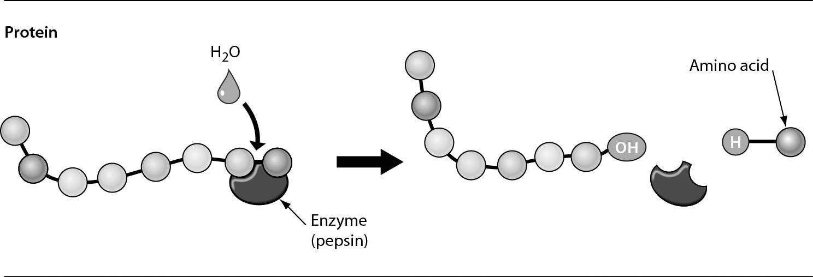

A) the chemical digestion of a protein
B) the building of a protein by the enzyme pepsin
C) the mechanical digestion of a protein
D) the addition of a water molecule to add an amino acid to a protein
Answer: A
Topic: 22.1 Overview of Animal Nutrition
Skill: Application/Analysis
Learning Outcome: 22.3
Global LO: 2, 3

2) The figure below shows that ________.

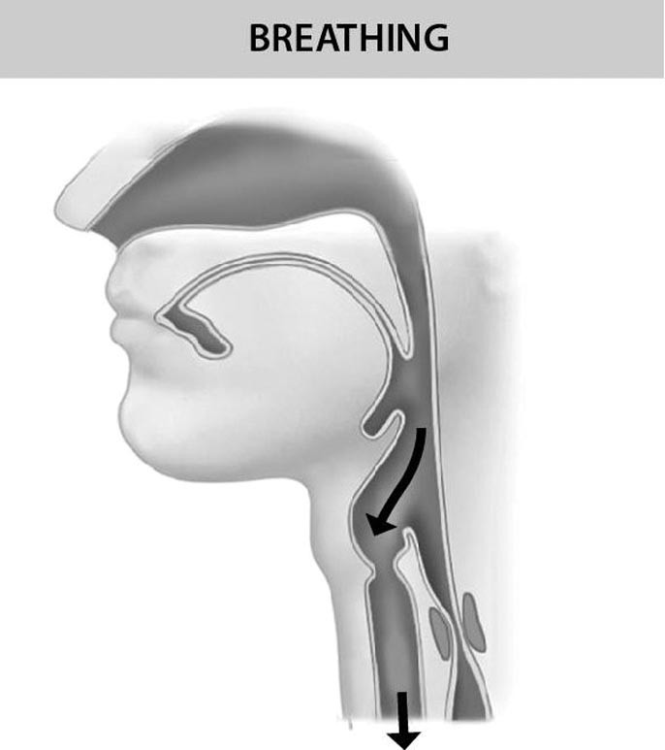

A) peristalsis moves food down the esophagus
B) air cannot get into the trachea when the epiglottis closes the trachea
C) the trachea is open when you are not swallowing
D) the trachea is closed when you are not swallowing
Answer: C
Topic: 22.2 A Tour of the Human Digestive System
Skill: Knowledge/Comprehension
Learning Outcome: 22.5
Global LO: 3
3) The function of the structure shown below is ________.

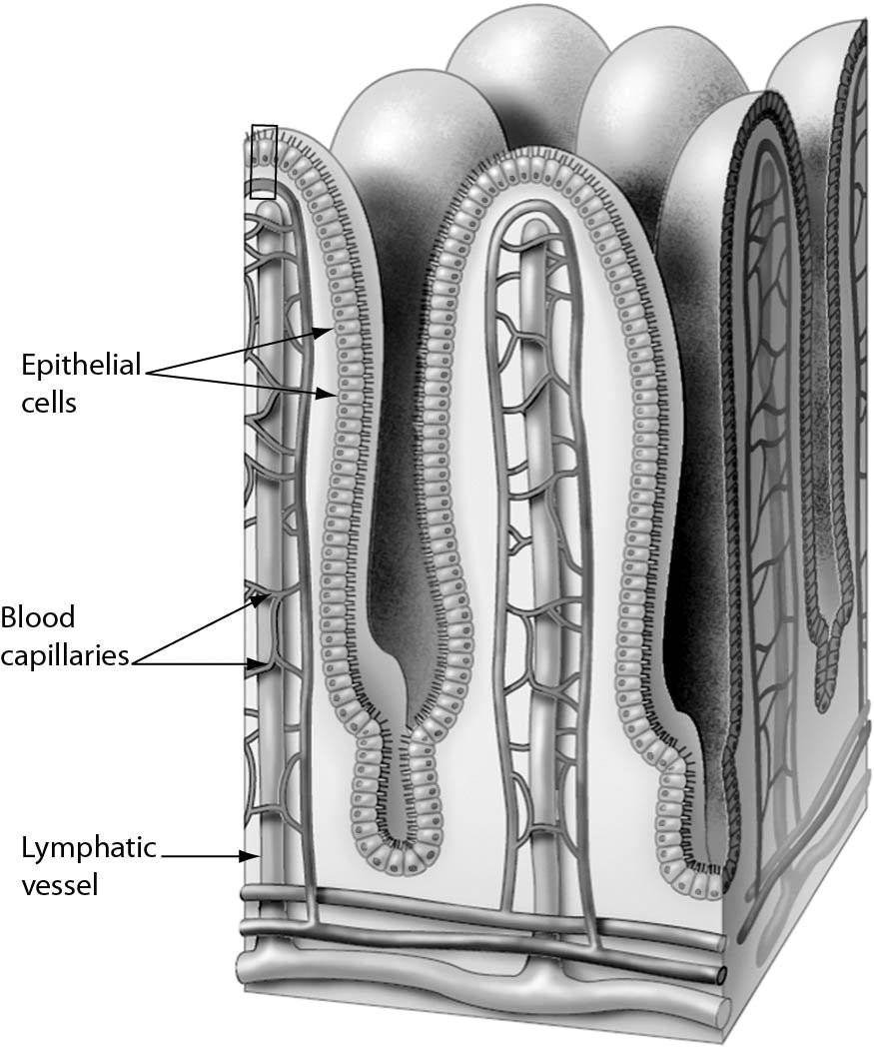

A) to digest proteins
B) to absorb nutrients into the body
C) to aid in mechanical digestion of food
D) to break fats into smaller droplets
Answer: B
Topic: 22.2 A Tour of the Human Digestive System
Skill: Knowledge/Comprehension
Learning Outcome: 22.5
Global LO: 3
Please refer to the following art to answer the following questions.

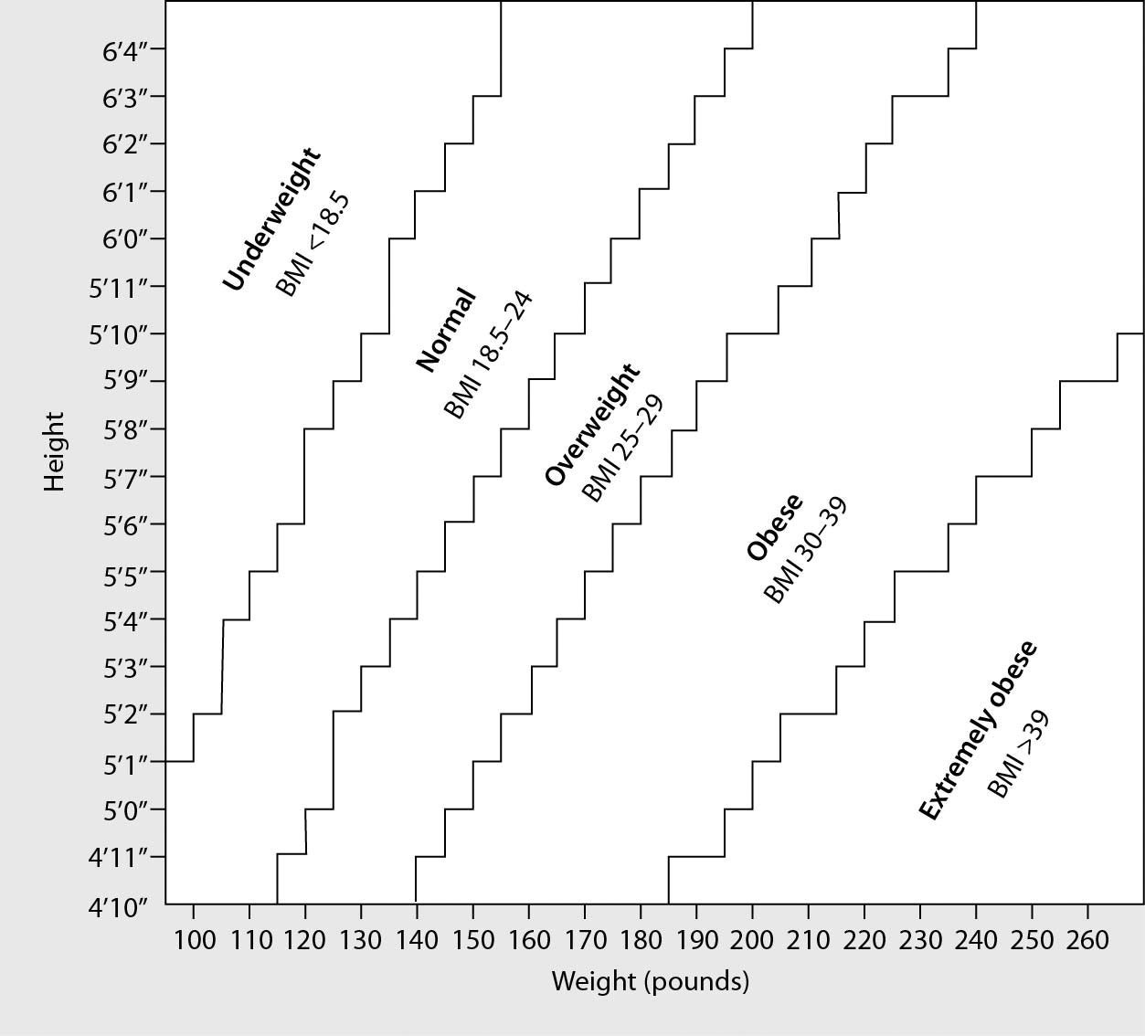

4) A person with a BMI of 27 would be described as ________.
A) overweight
B) normal weight
C) underweight
D) It depends on the person's height.
Answer: A
Topic: 22.4 Nutritional Disorders
Skill: Application/Analysis
Learning Outcome: 22.10
Global LO: 2, 3, 5

5) Which of the following people is shifting from an unhealthy category to a healthy category?
A) A 120 lb, 5'5" male loses 15 lbs.
B) A 160 lb, 5'10" female loses 5 lbs.
C) A 180 lb, 5'10" male loses 20 lbs.
D) A 130 lb, 5'0" female gains 10 lbs.
Answer: C
Topic: 22.4 Nutritional Disorders
Skill: Application/Analysis
Learning Outcome: 22.7, 22.10
Global LO: 2, 3, 5
6) Regarding the amount of energy consumed versus used, what would you recommend to a person who has a BMI of 27 to change to a normal BMI?
A) Take in more calories by eating than are burned by physical activity.
B) Burn more calories by physical activity than are taken in by eating.
C) Take in the same amount of calories by eating compared to that which is burned by physical activity.
D) Weight gain is not related to the amount of calories taken in compared to that burned by physical activity.
Answer: B
Topic: 22 Biology and Society: The "Secret" to Shedding Pounds, 22.4 Nutritional Disorders
Skill: Application/Analysis
Learning Outcome: 22.1, 22.7, 22.10
Global LO: 2, 3, 4, 5

Examine the FDA label for the loaf of Baker Organic Bread and answer the following questions.

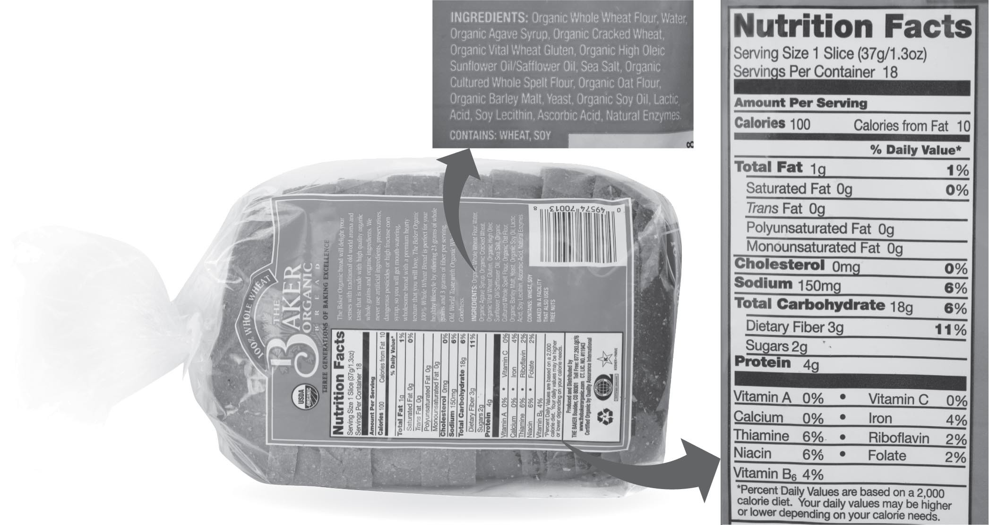

7) A person who is trying to lose weight eats four servings of bread. Which of the following activities would burn more total Calories than is consumed in those four servings?
A) an hour of leisurely biking (<10 mph), 292 Calories
B) an hour of canoeing, 256 Calories
C) an hour of resistance (weight) training, 365 Calories
D) an hour of hiking, 438 Calories
Answer: D
Topic: 22 Biology and Society: The "Secret" to Shedding Pounds, 22.3 Human Nutritional Requirements
Skill: Application/Analysis
Learning Outcome: 22.1, 22.7, 22.9
Global LO: 2, 3, 4, 5
8) How many servings of bread would an average person have to eat in order to get the FDA Daily Value of the water-soluble vitamin needed for reducing the risk of birth defects?
A) 50
B) 25
C) 17
D) Bread does not contain this vitamin.
Answer: A
Topic: 22.3 Human Nutritional Requirements
Skill: Synthesis/Evaluation
Learning Outcome: 22.8, 22.9
Global LO: 2, 3, 4, 5

9) How many loaves of bread would an average person need to eat in order to get the FDA Daily Value of the vitamin needed to prevent photophobia?
A) 0.9
B) 1.4
C) 2.8
D) Bread does not contain this vitamin
Answer: C
Topic: 22.3 Human Nutritional Requirements
Skill: Synthesis/Evaluation
Learning Outcome: 22.8, 22.9
Global LO: 2, 3, 4, 5

10) Which of the following ingredients of the bread pictured would prevent beriberi?
A) ascorbic acid
B) sea salt
C) sunflower oil
D) whole wheat (whole grain) flour
Answer: D
Topic: 22.3 Human Nutritional Requirements
Skill: Synthesis/Evaluation
Learning Outcome: 22.9, 22.10
Global LO: 2, 3, 5
22.3 Scenario Questions

Use the following information to answer the following questions.

Several years ago, scientists discovered a mutation in zebrafish larvae that prevented the absorption of lipids from dietary fat. Larvae carrying this mutation died shortly after they hatched because all cells need fat to carry out their normal functions. More recent studies have determined that the mutation leading to this disorder occurs in a single gene on chromosome 10. When a normal gene is inserted into embryos carrying the mutation, these fish are able to process fats normally when they hatch. To discover more about the gene's function, researchers examined and compared cells from normal and mutant fish larvae under a microscope. A major difference was noticed in the intestinal cells. The Golgi apparatus in the intestinal cells of mutant larvae is much larger than those of normal larvae. As the Golgi apparatus processes fats and proteins, the lipids become trapped, resulting in the abnormally large size of the organelle.

1) Assuming that the digestive system of zebrafish works like that of a human, what substance do zebrafish need to make fats more easily digested by enzymes?
A) chyme
B) bile
C) lipase
D) pepsin
Answer: B
Topic: 22.2 A Tour of the Human Digestive System
Skill: Application/Analysis
Learning Outcome: 22.5
Global LO: 2

2) Assuming that the digestive system of zebrafish works like that of a human, which portion of the digestive tract is specialized for absorption of the nutrients?
A) stomach
B) small intestine
C) large intestine
D) pharynx
Answer: B
Topic: 22.2 A Tour of the Human Digestive System
Skill: Application/Analysis
Learning Outcome: 22.5
Global LO: 2
Use the following information to answer the following questions.

There are many diseases of the digestive system. Sjögren's syndrome is an autoimmune disease that destroys tear ducts and salivary glands. In megaesophagus, peristalsis fails to occur properly and the esophagus is enlarged. In achlorhydria (also called "hypochlorhydria") production of gastric acid is absent or low. When a person has diverticulitis, feces are trapped in small pouches of the large intestine, and cause infection. Infected portions of the large intestine can swell and block the large intestine. In exocrine pancreatic insufficiency, there is a progressive loss of pancreatic cells that make digestive enzymes. In gallstone cholestasis, bile cannot flow from the liver to the duodenum.

3) Difficulty swallowing could indicate ________.
A) Sjögren's syndrome
B) megaesophagus
C) diverticulitis
D) gallstone cholestasis
Answer: A
Topic: 22.2 A Tour of the Human Digestive System
Skill: Application/Analysis
Learning Outcome: 22.6
Global LO: 2, 5

4) A protein deficiency in the blood could indicate ________.
A) megaesophagus
B) achlorhydria
C) Sjögren's syndrome
D) diverticulitis
Answer: B
Topic: 22.2 A Tour of the Human Digestive System
Skill: Application/Analysis
Learning Outcome: 22.6
Global LO: 2, 5

5) Regurgitation of food could indicate ________.
A) Sjögren's syndrome
B) achlorhydria
C) megaesophagus
D) celiac disease
Answer: C
Topic: 22.2 A Tour of the Human Digestive System
Skill: Application/Analysis
Learning Outcome: 22.6
Global LO: 2, 5

6) Exocrine pancreatic insufficiency would show symptoms most similar to______.
A) Sjögren's syndrome
B) megaesophagus
C) diverticulitis
D) celiac disease
Answer: D
Topic: 22.2 A Tour of the Human Digestive System
Skill: Application/Analysis
Learning Outcome: 22.6
Global LO: 2, 5

