Campbell Essential Biology, 6e, Global Edition (Simon/Dickey/Hogan/Reece)

Chapter 23 Circulation and Respiration

Chapter 23 Learning Outcomes
23 Biology and Society: Avoiding “The Wall”
23.1. Explain what limits the speed and stamina of most endurance athletes.
23.1 Unifying Concepts of Animal Circulation
23.2. Describe the function and main components of animal circulatory systems, and compare the structures of different types of circulatory systems.
23.2 The Human Cardiovascular System
23.3. Describe the path of blood as it makes one full circuit through the human body, including the heart, and compare the function of each structure in enabling this circuit to be completed.
23.4. Relate heart rate to blood pressure, explaining how they are controlled and how they are measured.
23.5. Describe the components of blood, their functions, and how donation of these components works.
23.6. Explain why it is better to “live high and train low” for some athletes.
23.7. Describe the causes, frequency, treatment, and prevention of cardiovascular disease and blood disorders.
23.3 Unifying Concepts of Animal Respiration
23.8. Explain why all working cells require a steady supply of oxygen and a way to dispose of carbon dioxide, and how the four types of respiratory surfaces facilitate gas exchange.
23.4 The Human Respiratory System
23.9. Describe the three phases of gas exchange in humans, including the path of a breath of air and how breathing is controlled.
23.10. Describe the functions of hemoglobin, and how different factors can interfere with oxygen transport.
23.11. Explain how cigarette smoking affects public health.
23 Evolution Connection: Evolving Endurance
23.12. Explain how Tibetans are adapted to living at very high altitudes.

Global Learning Outcomes
1. Demonstrate an understanding of the principles of scientific inquiry.
2. Demonstrate the ability to think critically and employ critical-thinking skills.
3. Read and interpret models, graphs, and data.
4. Demonstrate the quantitative skills needed to succeed in biology.
5. Demonstrate an understanding of the impact of science on society.
6. Evaluate the credibility of scientific information from various sources.
7. Demonstrate the ability to make connections between concepts across biology.
8. Communicate effectively in writing.
9. Apply the scientific method to interpret information and draw conclusions.

23.1 Multiple Choice Questions

1) Animals such as hydras and jellies can exchange gases directly with the environment by ________.
A) diffusion
B) active transport
C) osmosis
D) bulk transport
Answer: A
Topic: 23.1 Unifying Concepts of Animal Circulation
Skill: Knowledge/Comprehension
Learning Outcome: 23.2

2) In humans, oxygen is delivered to the cells of the body by ________.
A) a closed circulatory system
B) an open circulatory system
C) diffusion
D) diffusion and facilitated diffusion
Answer: A
Topic: 23.1 Unifying Concepts of Animal Circulation
Skill: Knowledge/Comprehension
Learning Outcome: 23.2

3) Which one of the following is a characteristic of open circulatory systems but NOT closed circulatory systems?
A) a heart
B) a vascular system
C) blood
D) open-ended blood vessels
Answer: D
Topic: 23.1 Unifying Concepts of Animal Circulation
Skill: Knowledge/Comprehension
Learning Outcome: 23.2

4) In animals with a closed circulatory system, gas exchange occurs across the thin walls of ________.
A) arteries
B) arterioles
C) capillaries
D) venules
Answer: C
Topic: 23.1 Unifying Concepts of Animal Circulation
Skill: Knowledge/Comprehension
Learning Outcome: 23.2

5) Veins carry ________.
A) blood away from the heart
B) oxygen-rich blood
C) oxygen-poor blood
D) blood toward the heart
Answer: D
Topic: 23.1 Unifying Concepts of Animal Circulation
Skill: Knowledge/Comprehension
Learning Outcome: 23.2

6) How does a shark's cardiovascular system differ from that of a mammal?
A) The shark's heart does not directly pump oxygenated blood to the systemic tissues.
B) The shark's heart receives both oxygenated and deoxygenated blood.
C) The shark's circulatory system has a pulmonary and a systemic circuit.
D) The shark's blood is pumped through open-ended tubes.
Answer: A
Topic: 23.1 Unifying Concepts of Animal Circulation
Skill: Application/Analysis
Learning Outcome: 23.2
Global LO: 2

7) What is one way in which the cardiovascular system of a mammal is different than that of an arthropod such as an insect?
A) The heart of the mammal pumps blood into arteries, while the insect heart does not.
B) Veins send blood to a mammal's lungs, while insect veins send blood to the heart.
C) A mammal's blood is always contained inside vessels, while an insect's blood sometimes leaves the vessels.
D) A mammal has a heart to pump blood, while an insect does not have a heart.
Answer: C
Topic: 23.1 Unifying Concepts of Animal Circulation
Skill: Application/Analysis
Learning Outcome: 23.2
Global LO: 2
8) Trace the path of a red blood cell in a circuit that takes it from the capillary bed of the right kidney to the capillary bed of the left kidney. Assume that you are doing this for an animal with a double circulation system.
A) capillary bed of right kidney → venules → veins → right atrium → right ventricle → pulmonary arteries → capillaries of lungs → pulmonary veins → left atrium → left ventricle → aorta → arteries → arterioles → capillary bed of left kidney
B) capillary bed of right kidney → venules → veins → right atrium → right ventricle → pulmonary veins → capillaries of lungs → pulmonary arteries → left atrium → left ventricle → aorta → arteries → arterioles → capillary bed of left kidney
C) capillary bed of right kidney → venules → veins → left atrium → left ventricle → pulmonary arteries → capillaries of lungs → pulmonary veins → right atrium → right ventricle → aorta → arteries → arterioles → capillary bed of left kidney
D) capillary bed of right kidney → arterioles → arteries → aorta → right atrium → right ventricle → pulmonary arteries → capillaries of lungs → pulmonary veins → left atrium → left ventricle → veins → venules → capillary bed of left kidney
Answer: A
Topic: 23.2 The Human Cardiovascular System
Skill: Application/Analysis
Learning Outcome: 23.3
Global LO: 2

9) Which of these animals has a double circulatory system?
A) fish
B) grasshopper
C) dog
D) hydra
Answer: C
Topic: 23.1 Unifying Concepts of Animal Circulation
Skill: Knowledge/Comprehension
Learning Outcome: 23.2

10) Which of these carry(ies) oxygen-poor blood?
A) pulmonary arteries
B) pulmonary veins
C) aorta
D) left ventricle
Answer: A
Topic: 23.2 The Human Cardiovascular System
Skill: Knowledge/Comprehension
Learning Outcome: 23.3

11) A heart murmur occurs when there is a defect in ________.
A) a heart valve
B) the sinoatrial node
C) arterioles
D) the timing of the cardiac cycle
Answer: A
Topic: 23.2 The Human Cardiovascular System
Skill: Knowledge/Comprehension
Learning Outcome: 23.4
12) Why is blood pressure higher during systole than during diastole?
A) The contraction of the heart during systole increases the blood pressure against arterial walls.
B) The relaxation of the heart during systole increases the blood pressure against arterial walls.
C) The contraction of the heart during diastole decreases the blood pressure against arterial walls.
D) More blood flows into the heart during systole than during diastole.
Answer: A
Topic: 23.2 The Human Cardiovascular System
Skill: Knowledge/Comprehension
Learning Outcome: 23.4
Global LO: 5

13) The basic rhythm of the heartbeat is set by the ________.
A) systolic pressure
B) EKG
C) sinoatrial node
D) "fight-or-flight" hormone
Answer: C
Topic: 23.2 The Human Cardiovascular System
Skill: Knowledge/Comprehension
Learning Outcome: 23.4

14) If your blood pressure were 120/70, it would mean that ________.
A) your blood pressure during systole is 120 and your blood pressure during diastole is 70
B) you have high blood pressure
C) you have low blood pressure
D) your blood pressure during systole is 120 and your heart rate is 70
Answer: A
Topic: 23.2 The Human Cardiovascular System
Skill: Knowledge/Comprehension
Learning Outcome: 23.4
Global LO: 5

15) Blood pressure that is consistently ________ or higher would indicate that you have hypertension.
A) 120/80
B) 140/90
C) 110/85
D) 100/75
Answer: B
Topic: 23.2 The Human Cardiovascular System
Skill: Knowledge/Comprehension
Learning Outcome: 23.4
Global LO: 5
16) Which blood vessels have thin, leaky walls?
A) capillaries
B) venules
C) arteries
D) none of the above
Answer: A
Topic: 23.2 The Human Cardiovascular System
Skill: Knowledge/Comprehension
Learning Outcome: 23.3

17) Blood pressure is lowest in ________.
A) veins
B) capillaries
C) arterioles
D) venules
Answer: A
Topic: 23.2 The Human Cardiovascular System
Skill: Knowledge/Comprehension
Learning Outcome: 23.4

18) Heart Block is one type of electrical defect in the heart in which the electrical signal from the sinoatrial node to the relay point is delayed. Predict the effect of Heart Block on the cardiac cycle.
A) The atria relax for a shorter period of time.
B) The atria relax for a longer period of time.
C) The ventricles relax for a shorter period of time.
D) The ventricles relax for a longer period of time.
Answer: D
Topic: 23.2 The Human Cardiovascular System
Skill: Synthesis/Evaluation
Learning Outcome: 23.3, 23.4
Global LO: 2

19) If you separated the components of blood and looked closely at only the plasma, you might find ________.
A) white blood cells
B) red blood cells
C) hormones
D) platelets
Answer: C
Topic: 23.2 The Human Cardiovascular System
Skill: Knowledge/Comprehension
Learning Outcome: 23.5

20) As a consequence of red blood cells' lack of nuclei and other organelles, they ________.
A) have more room to carry hemoglobin
B) have a small surface area
C) contain less hemoglobin than they might otherwise be able to carry
D) can carry more calcium
Answer: A
Topic: 23.2 The Human Cardiovascular System
Skill: Knowledge/Comprehension
Learning Outcome: 23.5
21) Which of the following can cause anemia?
I) bone marrow disease
II) iron deficiency
III) low number of white blood cells
A) I
B) II
C) III
D) I and II
Answer: D
Topic: 23.2 The Human Cardiovascular System
Skill: Synthesis/Evaluation
Learning Outcome: 23.7
Global LO: 2, 5

22) When tissue lining a blood vessel is damaged, the first thing that happens is ________.
A) erythrocytes release fibrin
B) leukocytes multiply
C) platelets convert fibrinogen to fibrin
D) platelets adhere to the damaged tissue
Answer: D
Topic: 23.2 The Human Cardiovascular System
Skill: Knowledge/Comprehension
Learning Outcome: 23.5

23) White blood cells play a particularly important role in ________.
A) fighting infections
B) supporting the activity of red blood cells
C) carrying carbon dioxide
D) blood clotting
Answer: A
Topic: 23.2 The Human Cardiovascular System
Skill: Knowledge/Comprehension
Learning Outcome: 23.5

24) Leukemia ________.
A) decreases the production of white blood cells
B) increases the production of red blood cells
C) is a cancer of the white blood cells
D) is a cancer that arises in the lungs
Answer: C
Topic: 23.2 The Human Cardiovascular System
Skill: Knowledge/Comprehension
Learning Outcome: 23.7
Global LO: 5
25) You increase your risk of cardiovascular disease by reducing your consumption of ________.
A) fruits and vegetables
B) red meats
C) products containing trans fats
D) tobacco products
Answer: A
Topic: 23.2 The Human Cardiovascular System
Skill: Application/Analysis
Learning Outcome: 23.7
Global LO: 2

26) The buildup of plaque in the walls of arteries results in ________.
A) leukemia
B) atherosclerosis
C) anemia
D) low blood pressure
Answer: B
Topic: 23.2 The Human Cardiovascular System
Skill: Knowledge/Comprehension
Learning Outcome: 23.7

27) Gas exchange requires a surface that is both ________.
A) durable and stiff
B) protected within the body and connected to the circulatory system
C) thin and moist
D) permeable to oxygen and impermeable to carbon dioxide
Answer: C
Topic: 23.3 Unifying Concepts of Animal Respiration
Skill: Knowledge/Comprehension
Learning Outcome: 23.8

28) Earthworms use ________ as their respiratory surface.
A) lungs
B) gills
C) their skin
D) tracheae
Answer: C
Topic: 23.3 Unifying Concepts of Animal Respiration
Skill: Knowledge/Comprehension
Learning Outcome: 23.8

29) What structure do lobsters use for gas exchange?
A) gills
B) lungs
C) skin
D) tracheae
Answer: A
Topic: 23.3 Unifying Concepts of Animal Respiration
Skill: Knowledge/Comprehension
Learning Outcome: 23.8
30) Insects breathe using ________.
A) lungs
B) tracheae
C) their entire outer skin
D) book lungs
Answer: B
Topic: 23.3 Unifying Concepts of Animal Respiration
Skill: Knowledge/Comprehension
Learning Outcome: 23.8

31) Animals need O2 because it ________.
A) plays a role in obtaining energy from food
B) helps animals synthesize proteins
C) is necessary to make CO2
D) is needed to deliver hemoglobin to the cells of an animal's body
Answer: A
Topic: 23.3 Unifying Concepts of Animal Respiration
Skill: Knowledge/Comprehension
Learning Outcome: 23.8

32) In a human, the ________ provide(s) a common passageway for both food and air.
A) bronchioles
B) trachea
C) pharynx
D) alveoli
Answer: C
Topic: 23.4 The Human Respiratory System
Skill: Knowledge/Comprehension
Learning Outcome: 23.9

33) What path does a molecule of O2 take from the nose to the respiratory surface?
A) pharynx → larynx → trachea → bronchus → bronchiole → alveolus
B) larynx → pharynx → trachea → bronchus → bronchiole → alveolus
C) pharynx → larynx → bronchus → bronchiole → alveolus → trachea
D) pharynx → larynx → trachea → bronchiole → bronchus → alveolus
Answer: A
Topic: 23.4 The Human Respiratory System
Skill: Knowledge/Comprehension
Learning Outcome: 23.9

34) In the human respiratory system, gas exchange occurs across the cells of the ________.
A) diaphragm
B) trachea
C) bronchi
D) alveoli
Answer: D
Topic: 23.4 The Human Respiratory System
Skill: Knowledge/Comprehension
Learning Outcome: 23.9
35) Together, inhalation and exhalation are referred to as ________.
A) diffusion
B) breathing
C) active transport
D) negative pressure
Answer: B
Topic: 23.4 The Human Respiratory System
Skill: Knowledge/Comprehension
Learning Outcome: 23.9

36) Breathing is regulated by ________.
A) the diaphragm and chest muscles
B) the spinal cord
C) the circulatory system
D) control centers in the brain stem
Answer: D
Topic: 23.4 The Human Respiratory System
Skill: Knowledge/Comprehension
Learning Outcome: 23.9

37) When you hold your breath, which of the following blood gas changes leads initially to the urge to breathe again?
A) rising carbon monoxide level
B) rising carbon dioxide level
C) falling carbon monoxide level
D) rising carbon dioxide level and falling carbon monoxide level
Answer: B
Topic: 23.4 The Human Respiratory System
Skill: Application/Analysis
Learning Outcome: 23.9
Global LO: 2

38) Oxygen is transported through the body mostly ________.
A) dissolved in the blood
B) dissolved in red blood cells
C) bound to hemoglobin
D) bound to dissolved iron
Answer: C
Topic: 23.4 The Human Respiratory System
Skill: Knowledge/Comprehension
Learning Outcome: 23.10

39) Cigarette smoking ________.
A) is responsible for about one in five deaths of Americans every year
B) accounts for 80—90% of all cases of lung cancer
C) can affect the health of nonsmokers through secondhand smoke
D) all of the above
Answer: D
Topic: 23.4 The Human Respiratory System
Skill: Knowledge/Comprehension
Learning Outcome: 23.11
Global LO: 5
40) Why do cigarette smokers cough more than most people do?
A) The tar in cigarette smoke tends to make alveoli stick closed. Coughing opens them.
B) Coughing is the respiratory system's attempt to clear itself of the thick mucus that is produced in response to smoke exposure.
C) Cigarette smoking partially paralyzes the lungs; coughing exchanges the resultant "dead air."
D) Coughing stimulates blood flow to the lungs.
Answer: B
Topic: 23.4 The Human Respiratory System
Skill: Knowledge/Comprehension
Learning Outcome: 23.11
Global LO: 5

41) Which of the following best describes the pathway an oxygen molecule would take through the human circulatory system?
A) systemic tissues → alveoli → pulmonary vein → pulmonary capillaries → systemic capillaries → left ventricle → left atrium → aorta → systemic arteries
B) alveoli → pulmonary capillaries → pulmonary vein → left atrium → left ventricle → aorta → systemic arteries → systemic capillaries → systemic tissues
C) alveoli → pulmonary capillaries → pulmonary artery → right atrium → right ventricle → pulmonary vein → systemic arteries → systemic capillaries → systemic tissues
D) alveoli → pulmonary vein → pulmonary capillaries → systemic capillaries → left atrium → left ventricle → aorta → systemic arteries → systemic tissues
Answer: B
Topic: 23.2 The Human Cardiovascular System, 23.4 The Human Respiratory System
Skill: Application/Analysis
Learning Outcome: 23.3, 23.10
Global LO: 2

42) The cardiovascular system of a mouse works like that of a human. A mouse is moved from sea level (low altitude) to the top of a mountain (high altitude). How could this mouse's cardiovascular system maintain a similar rate of oxygen delivery to its tissues now that the mouse is at the top of the mountain?
A) Decrease breathing rate.
B) Decrease heart rate.
C) Increase the depth of ventilation.
D) Increase lung pressure.
Answer: C
Topic: 23.2 The Human Cardiovascular System, 23.4 The Human Respiratory System, 23 The Process of Science
Skill: Application/Analysis
Learning Outcome: 23.1, 23.3, 23.6, 23.9
Global LO: 2
43) The Antarctic icefishes are the only known vertebrates to lack hemoglobin. Which of the following would be LEAST likely to alter gas transport from the environment to an icefish's cells?
A) higher oceanic temperatures from global warming
B) higher concentrations of carbon monoxide in the water from pollution
C) higher concentrations of carbon dioxide in the water from pollution
D) an injury that reduces the surface area of gills
Answer: B
Topic: 23.3 Unifying Concepts of Animal Respiration, 23.4 The Human Respiratory System
Skill: Synthesis/Evaluation
Learning Outcome: 23.10
Global LO: 2, 5, 7

23.2 Art Questions

1) The following figure illustrates ________.

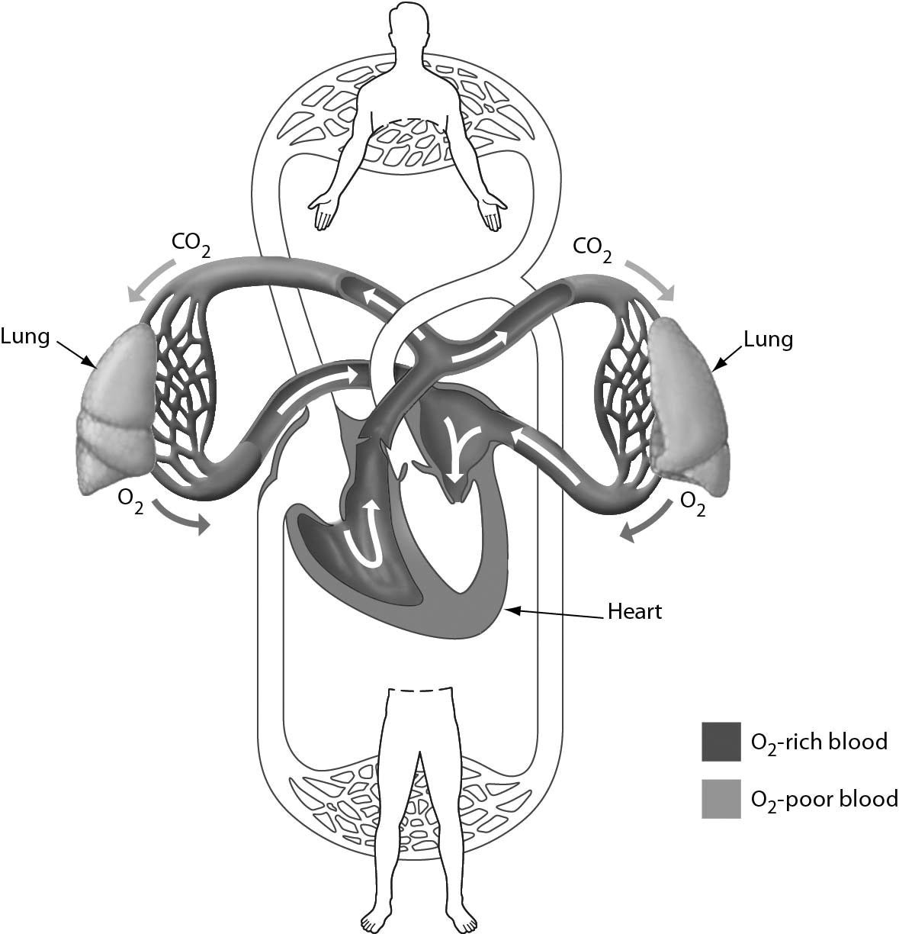

A) diastolic blood pressure
B) systolic blood pressure
C) the pulmonary circuit
D) the systemic circuit
Answer: C
Topic: 23.2 The Human Cardiovascular System
Skill: Knowledge/Comprehension
Learning Outcome: 23.3
Global LO: 3
Please refer to the following art to answer the following questions.

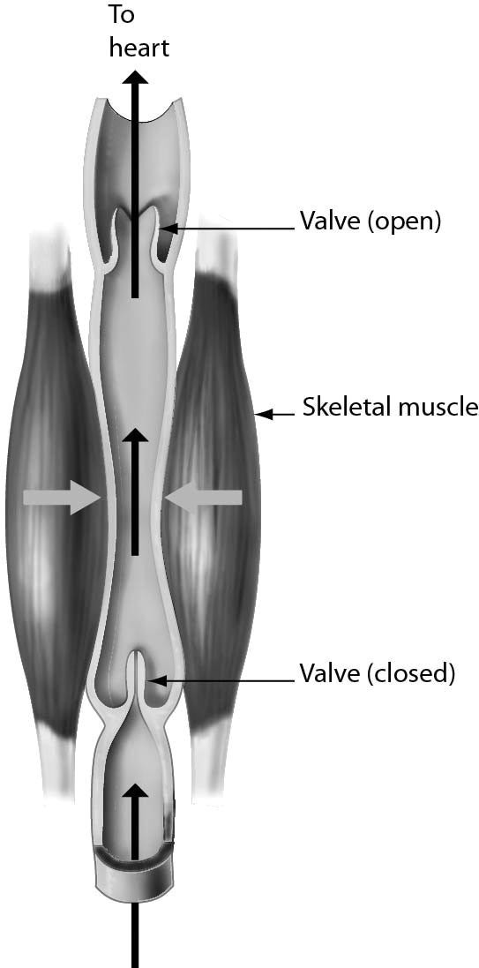

2) The one-way flow of blood in veins is maintained by ________.
A) blood pressure
B) muscles pressing against the veins
C) their thick walls
D) valves
Answer: D
Topic: 23.2 The Human Cardiovascular System
Skill: Knowledge/Comprehension
Learning Outcome: 23.3
Global LO: 3

3) In varicose veins, the one-way flow of blood in veins is disrupted, which can cause swelling and blood clots. What might help return the blood flow in these veins to normal?
A) Reduce physical activity.
B) Raise legs above the level of the heart when resting.
C) Remove valves from varicose veins.
D) Stand or sit still for long periods of time.
Answer: B
Topic: 23.2 The Human Cardiovascular System
Skill: Application/Analysis
Learning Outcome: 23.3
Global LO: 2, 3
4) Examine the structure of blood vessels in the following figure. Which one of the following has the structure best suited to chemical exchange between the blood and tissues?

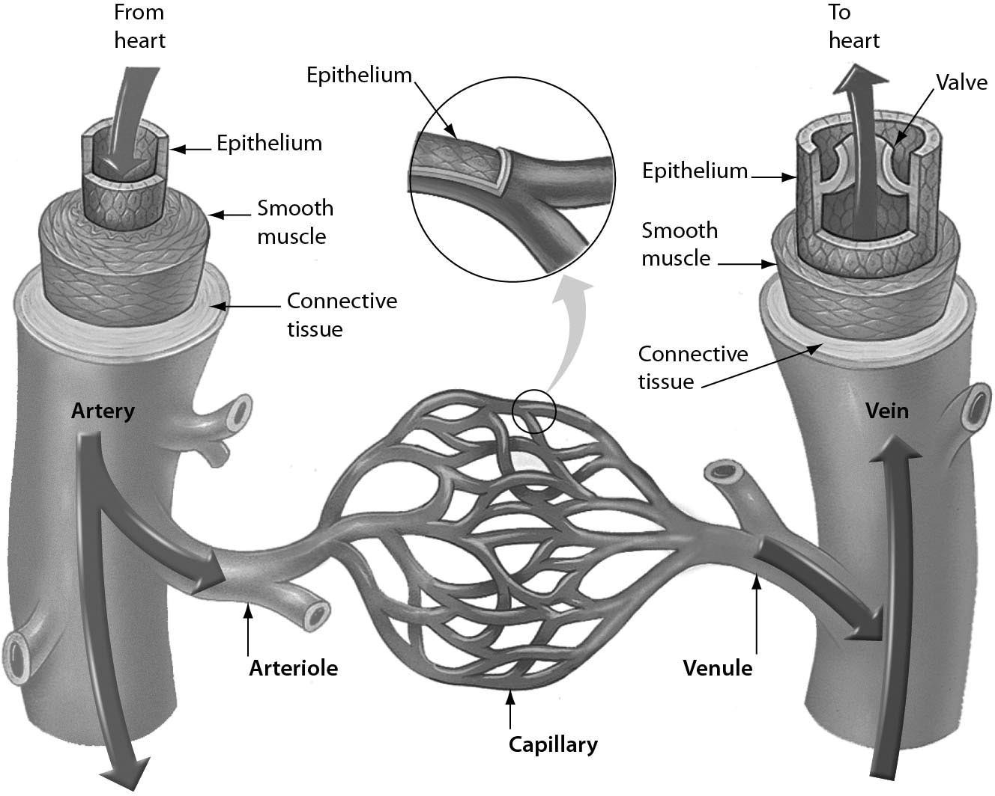

A) venule
B) capillary
C) arteriole
D) artery
Answer: B
Topic: 23.2 The Human Cardiovascular System
Skill: Knowledge/Comprehension
Learning Outcome: 23.3
Global LO: 3
5) Examine the figure shown. During negative pressure breathing, ________.

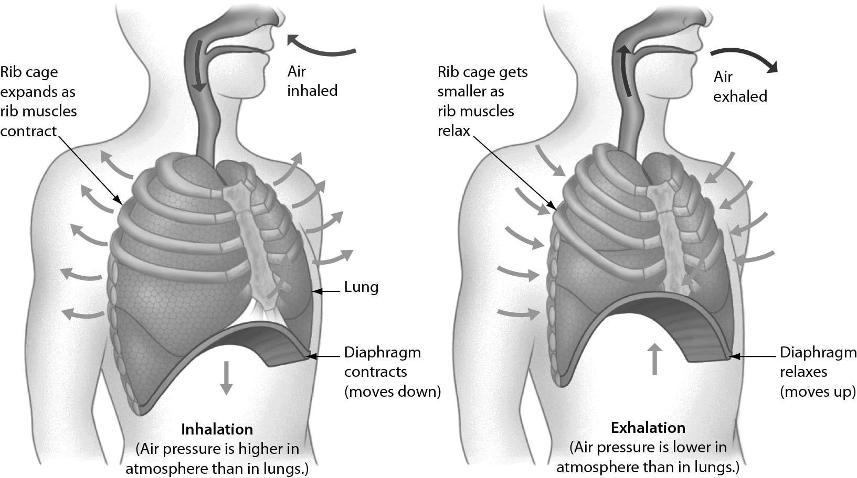

A) the diaphragm moves downward and the rib muscles contract, increasing the size of the chest cavity and decreasing the air pressure within the chest cavity
B) the nasal cavities expand and the diaphragm relaxes
C) the diaphragm and rib muscles contract, decreasing the size of the chest cavity and increasing the pressure within the chest cavity
D) the diaphragm moves downward and the rib muscles relax, increasing the size of the chest cavity and decreasing the air pressure within the chest cavity
Answer: A
Topic: 23.4 The Human Respiratory System
Skill: Knowledge/Comprehension
Learning Outcome: 23.9
Global LO: 3
6) The figure below shows that ________.

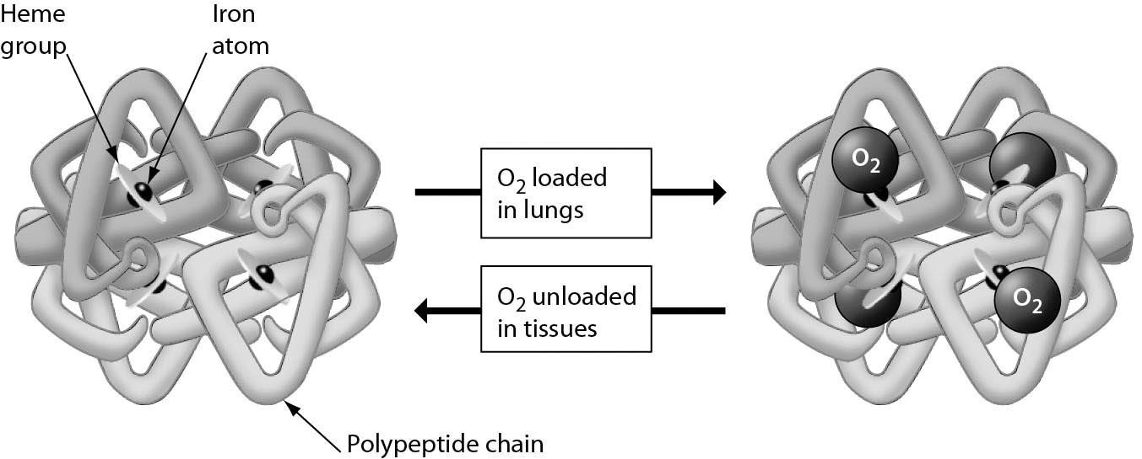

A) hemoglobin can bind to either oxygen or carbon dioxide
B) a hemoglobin molecule can bind up to four molecules of oxygen
C) a red blood cell contains four hemoglobin molecules
D) each iron atom can bind four oxygen molecules
Answer: B
Topic: 23.4 The Human Respiratory System
Skill: Knowledge/Comprehension
Learning Outcome: 23.10
Global LO: 3

23.3 Scenario Questions

Read the following scenario to answer the following questions.

Blood flowing away from the heart is under tremendous pressure, able to travel to just about any portion of the body. However, blood pressure drops considerably as it moves away from the heart. When blood finally reaches capillaries, the blood pressure drops to nearly zero. Therefore, when a person is standing, blood returning from the feet is not moved back towards the heart by contractions of the heart.

1) Blood is propelled back to the heart by ________.
A) rhythmic contractions of muscles in the walls of veins and the action of one-way valves
B) skeletal muscle contractions around veins and the action of one-way valves
C) the negative pressure of the heart pulling blood into the empty chambers
D) the natural flow of blood into ever-larger blood vessels leading to the heart
Answer: B
Topic: 23.2 The Human Cardiovascular System
Skill: Knowledge/Comprehension
Learning Outcome: 23.3
2) A scientist claimed that students might get better scores on written exams if they wiggle their legs frequently while taking an exam. This could work (but it is not better than studying) because wiggling legs might ________.
A) propel more blood from the legs back to the heart, increasing oxygen flow to the brain
B) add more oxygen to the blood that is returning to the heart
C) shake out more of the carbon dioxide that lingers in the blood returning to the heart
D) break up blood clots in the legs, which slow the movement of blood back to the heart
Answer: A
Topic: 23.2 The Human Cardiovascular System
Skill: Application/Analysis
Learning Outcome: 23.3
Global LO: 2

3) Because of the changes in blood pressure through the circulatory system, the best way to feel a pulse is by pressing a finger against ________.
A) a vein
B) a capillary
C) an artery
D) either an artery or a vein
Answer: C
Topic: 23.2 The Human Cardiovascular System
Skill: Knowledge/Comprehension
Learning Outcome: 23.4

Read the following scenario to answer the following questions.

In sickle cell disease (SCD), a mutation in hemoglobin causes deoxygenated hemoglobin to stick together in long chains, which in turn distorts red blood cells into an elongated, sickle (crescent) shape.

4) In a person with SCD, where would red blood cells with a sickle shape be LEAST likely to be found?
A) pulmonary arteries
B) pulmonary veins
C) right atrium
D) right ventricle
Answer: B
Topic: 23.2 The Human Cardiovascular System
Skill: Application/Analysis
Learning Outcome: 23.3, 23.7
Global LO: 2, 5

5) Red blood cells with a sickle shape can block circulation in small blood vessels. Which blood vessels are most likely to become blocked by sickle cells?
A) veins
B) arteries
C) arterioles
D) capillaries
Answer: D
Topic: 23.2 The Human Cardiovascular System
Skill: Application/Analysis
Learning Outcome: 23.3
Global LO: 2, 5
Read the following scenario to answer the following questions.

Yawning is a reflexive action that is often associated with sleepiness. When a person yawns, the mouth opens, and a longer than normal breath of air is inhaled, followed by a longer than normal exhalation. Hypothesizing that yawning has a regulatory mechanism similar to breathing, scientists conducted an experiment on college students to test the effect of ambient carbon dioxide levels on yawning.

6) The structure where the respiratory and digestive systems meet expands during a yawn. What is the name of this structure?
A) bronchus
B) larynx
C) pharynx
D) trachea
Answer: C
Topic: 23.4 The Human Respiratory System
Skill: Application/Analysis
Learning Outcome: 23.9
Global LO: 2

7) When a person exhales to complete a yawn, what happens?
A) The rib muscles contract.
B) The diaphragm contracts.
C) The rib muscles act in the same way that they do in an inhalation.
D) The diaphragm relaxes.
Answer: D
Topic: 23.4 The Human Respiratory System
Skill: Application/Analysis
Learning Outcome: 23.9
Global LO: 2

8) If yawning has a regulatory mechanism similar to breathing, then which of the following is TRUE?
A) Athletes should yawn more when exercising compared to when they are not exercising.
B) Tibetan mountaineers yawn more when they are walking compared to when they are standing still.
C) People adapted to lower altitudes should yawn the same amount when they are at high altitudes.
D) Athletes who have trained at high altitudes should inhale a greater volume of air when yawning compared to those who have trained only at low altitudes.
Answer: A
Topic: 23.4 The Human Respiratory System, 23 Evolution Connection
Skill: Application/Analysis
Learning Outcome: 23.1, 23.6, 23.9, 23.12
Global LO: 2
9) The scientists investigated carbon dioxide levels in their experiment because high carbon dioxide levels in the ________ signal control centers in the brain to increase rate and depth of inhalations and exhalations.
A) alveoli
B) blood
C) heart muscle
D) pharynx
Answer: B
Topic: 23.4 The Human Respiratory System
Skill: Synthesis/Evaluation
Learning Outcome: 23.9
Global LO: 1, 2, 7, 9

10) To graph their results, the scientists would plot the ________.
A) number of yawns on the x-axis
B) dependent variable on the x-axis
C) level of carbon dioxide on the x-axis
D) age of college students on the x-axis
Answer: C
Topic: 23.4 The Human Respiratory System
Skill: Synthesis/Evaluation
Learning Outcome: 23.9
Global LO: 1, 2, 3, 4

11) Which of the following would be considered support for the hypothesis tested by the scientists?
A) College students produce more carbon dioxide when they yawn more frequently.
B) College students yawn with the same frequency regardless of carbon dioxide levels.
C) College students yawn more when they are in lecture, compared to when they are in lab.
D) College students yawn more when they are exposed to higher levels of carbon dioxide.
Answer: D
Topic: 23.4 The Human Respiratory System
Skill: Synthesis/Evaluation
Learning Outcome: 23.9
Global LO: 1, 2, 9

12) The scientists found that the level of carbon dioxide in the air did not cause college students to yawn more frequently. What other experiment could they conduct to confirm that they should reject the hypothesis that yawning is regulated in the same way as breathing?
A) Test the effect of hemoglobin amounts on the frequency of yawning.
B) Test the effect of exercise levels on the frequency of yawning.
C) Test the effect of carbon monoxide (CO) levels on the frequency of yawning.
D) Test the effect of diet on the frequency of yawning.
Answer: B
Topic: 23.4 The Human Respiratory System
Skill: Synthesis/Evaluation
Learning Outcome: 23.9
Global LO: 1, 2, 7, 9

