Campbell Essential Biology, 6e, Global Edition (Simon/Dickey/Hogan/Reece)

Chapter 24 The Body's Defenses

Chapter 24 Learning Outcomes
24 Biology and Society: Herd Immunity
24.1. Define herd immunity, and explain how decreasing vaccination rates can threaten herd immunity.
24.1 An Overview of the Immune System
24.2. Define the immune system, and distinguish between innate and adaptive immunity.
24.2 Innate Immunity
24.3. Compare and contrast external and internal innate defenses.
24.4. Describe the inflammatory response, the role of histamine, and the effects of drugs such as ibuprofen.
24.3 The Lymphatic System
24.5. Compare the circulatory and immune functions of the lymphatic system, and explain how lymph is formed.
24.4 Adaptive Immunity
24.6. Explain how the immune system recognizes foreign substances with antigens.
24.7. Describe the process of clonal selection, and explain how effector cells and antibodies are produced and what their functions are.
24.8. Compare and contrast the roles of cytotoxic T cells, helper T cells, and B cells in the immune response.
24.9. Explain how the immune system has “memory.”
24.10. Explain how vaccinations can prevent disease.
24.5 Immune Disorders
24.11. Define an allergen, an allergy, and anaphylactic shock. Describe the two steps of an allergic reaction.
24.12. Compare and contrast autoimmune diseases and immunodeficiency diseases.
24 Evolution Connection: Viral Evolution versus the Flu Vaccine
24.13. Explain why the preparation of flu and HIV vaccines is especially challenging.

Global Learning Outcomes

- Demonstrate an understanding of the principles of scientific inquiry.
- Demonstrate the ability to think critically and employ critical-thinking skills.
- Read and interpret models, graphs, and data.
- Demonstrate the quantitative skills needed to succeed in biology.
- Demonstrate an understanding of the impact of science on society.
- Evaluate the credibility of scientific information from various sources.
- Demonstrate the ability to make connections between concepts across biology.
- Communicate effectively in writing.
- Apply the scientific method to interpret information and draw conclusions.

24.1 Multiple Choice Questions

1) Herd immunity fails when what percentage of the population is NOT vaccinated?
A) 1%
B) 5%
C) 10%
D) 50%
Answer: B
Topic: 24 Biology and Society
Skill: Knowledge/Comprehension
Learning Outcome: 24.1
Global LO: 5

2) Which of the following is one of the body's first lines of defense against infection?
A) antibodies
B) obstacles such as skin and mucous membranes
C) increased production of certain hormones
D) decreased heart rate
Answer: B
Topic: 24.1 An Overview of the Immune System
Skill: Knowledge/Comprehension
Learning Outcome: 24.2

3) Slugs produce mucus all over their bodies that helps keep them moist and helps them move. The mucus also can protect the slugs from pathogens. A slug's mucus is a component of which part of the immune system?
A) internal innate immunity
B) external innate immunity
C) adaptive immunity
D) lymphatic system
Answer: B
Topic: 24.1 An Overview of the Immune System
Skill: Application/Analysis
Learning Outcome: 24.2
Global LO: 2

4) What kinds of cells engulf whatever foreign cells and molecules they encounter and recognize?
A) natural killer cells
B) red blood cells
C) phagocytic cells
D) B cells
Answer: C
Topic: 24.2 Innate Immunity
Skill: Knowledge/Comprehension
Learning Outcome: 24.3
5) Which of the following kinds of proteins circulates in the blood and coats the surfaces of microbes to make them more susceptible to engulfment by phagocytic cells?
A) defensive
B) histamine
C) B cell receptor
D) antigen
Answer: A
Topic: 24.2 Innate Immunity
Skill: Knowledge/Comprehension
Learning Outcome: 24.3

6) A major function of natural killer cells is to ________.
A) attack and kill pathogenic microorganisms
B) attack virus-infected cells
C) tag pathogenic microorganisms with antibodies
D) phagocytize microorganisms that have been tagged with antibodies
Answer: B
Topic: 24.2 Innate Immunity
Skill: Knowledge/Comprehension
Learning Outcome: 24.3

7) Defensive proteins can assist the immune response by ________.
A) helping viruses reproduce
B) directly destroying pathogens
C) reducing inflammation
D) increasing lymph production
Answer: B
Topic: 24.2 Innate Immunity
Skill: Knowledge/Comprehension
Learning Outcome: 24.3

8) A researcher detects an increase in the amount of natural killer cells in a laboratory rat and concludes that ________.
A) the rat has, or recently had, a viral infection
B) the rat does not have any cancerous tumors
C) the rat's lymphatic system is not functioning properly
D) the rat's internal innate defenses are weakened
Answer: A
Topic: 24.2 Innate Immunity
Skill: Application/Analysis
Learning Outcome: 24.3
Global LO: 2

9) Which of the following is a response of our innate defense system?
A) adaptive immunity
B) inflammation
C) cytotoxic T cell response
D) helper T cell response
Answer: B
Topic: 24.2 Innate Immunity
Skill: Knowledge/Comprehension
Learning Outcome: 24.3
10) When you cut yourself, the damaged cells immediately release which of the following chemical alarm signals?
A) defensive proteins
B) antibodies
C) histamine
D) antihistamines
Answer: C
Topic: 24.2 Innate Immunity
Skill: Knowledge/Comprehension
Learning Outcome: 24.4

11) Histamine ________.
A) causes local blood vessels to dilate
B) attracts natural killer cells
C) stimulates the release of defensive proteins
D) repels phagocytic cells
Answer: A
Topic: 24.2 Innate Immunity
Skill: Knowledge/Comprehension
Learning Outcome: 24.4

12) The major result of the inflammatory response is to ________.
A) initiate the production of antibodies
B) disinfect and clean damaged tissues
C) initiate the release of defensive proteins
D) initiate the production of natural killer cells
Answer: B
Topic: 24.2 Innate Immunity
Skill: Knowledge/Comprehension
Learning Outcome: 24.4

13) Why do diseases involving widespread infection often result in a fever?
A) The inflammatory and immune responses result in extra heat production.
B) The microorganisms trick the brain's temperature control center into creating a hot environment that favors their growth.
C) The brain's temperature control center responds to inflammation by creating a hot environment unfavorable to the growth of microorganisms.
D) The inflammatory response result is less heat production.
Answer: C
Topic: 24.2 Innate Immunity
Skill: Knowledge/Comprehension
Learning Outcome: 24.4

14) A role of the lymphatic system is to ________.
A) transport histamine
B) produce hormones related to fighting infections
C) produce white blood cells
D) return tissue fluid to the circulatory system
Answer: D
Topic: 24.3 The Lymphatic System
Skill: Knowledge/Comprehension
Learning Outcome: 24.5
15) A person's spleen may be removed (splenectomy) if it becomes enlarged due to certain types of cancer, traumatic injury, or damage. What part of the immune system will be most affected by a splenectomy?
A) internal innate immunity
B) external innate immunity
C) adaptive immunity
D) lymphatic system
Answer: D
Topic: 24.3 The Lymphatic System
Skill: Application/Analysis
Learning Outcome: 24.5
Global LO: 2, 5

16) Antibodies are ________.
A) composed of four fatty acid chains
B) a type of lymphocyte
C) proteins with short carbohydrates attached
D) proteins consisting of four polypeptide chains
Answer: D
Topic: 24.4 Adaptive Immunity
Skill: Knowledge/Comprehension
Learning Outcome: 24.7

17) A substance that can elicit an immune response from a lymphocyte is called a(n) ________.
A) defensive protein
B) pathogen
C) antibody
D) antigen
Answer: D
Topic: 24.4 Adaptive Immunity
Skill: Knowledge/Comprehension
Learning Outcome: 24.6

18) If a person had the thymus gland removed, which of the following would NOT occur in his or her body?
A) production of B cells
B) production of T cells
C) maturation of B cells
D) maturation of T cells
Answer: D
Topic: 24.4 Adaptive Immunity
Skill: Application/Analysis
Learning Outcome: 24.6
Global LO: 2
19) Which statement about antigen recognition in B and T cells is TRUE?
A) B cell antigen receptors can bind to intact freely circulating antigens that are bound to self proteins.
B) T cell antigen receptors can bind to intact antigens that are bound to self proteins.
C) B cell antigen receptors can bind to intact antigens that are on pathogen surfaces.
D) T cell antigen receptors can bind to intact freely circulating antigens.
Answer: C
Topic: 24.4 Adaptive Immunity
Skill: Knowledge/Comprehension
Learning Outcome: 24.6

20) One kind of vaccine consists of a solution containing ________.
A) antibodies
B) horse serum
C) B cells
D) a harmless variant of a disease-causing microbe
Answer: D
Topic: 24.4 Adaptive Immunity
Skill: Knowledge/Comprehension
Learning Outcome: 24.10

21) Which of the following cell types are specifically responsible for the B cell response?
A) T cells
B) B cells
C) phagocytic cells
D) natural killer cells
Answer: B
Topic: 24.4 Adaptive Immunity
Skill: Knowledge/Comprehension
Learning Outcome: 24.6

22) Which of the following cell types are specifically responsible for the cytotoxic T cell response?
A) T cells
B) B cells
C) natural killer cells
D) phagocytic cells
Answer: A
Topic: 24.4 Adaptive Immunity
Skill: Knowledge/Comprehension
Learning Outcome: 24.6

23) The immune system is capable of mounting specific responses to particular microorganisms because ________.
A) lymphocytes are able to change their antigen specificity as required to fight infection
B) the body is able to determine which type of B and T cells to make
C) the body contains an enormous diversity of B and T cells, each with a specific kind of antigen receptor
D) the body is able to make different antigen receptors depending on the invading microorganism
Answer: C
Topic: 24.4 Adaptive Immunity
Skill: Knowledge/Comprehension
Learning Outcome: 24.6
24) Antibodies ________.
A) are shaped like the letter B
B) are generalists in that any antibody can bind to any antigen
C) assist in destroying particular antigens
D) are produced by T cells
Answer: C
Topic: 24.4 Adaptive Immunity
Skill: Knowledge/Comprehension
Learning Outcome: 24.7

25) One function of antibodies is to ________.
A) deactivate defensive proteins
B) stimulate the production of antigens
C) phagocytose invading bacteria
D) clump invader cells
Answer: D
Topic: 24.4 Adaptive Immunity
Skill: Knowledge/Comprehension
Learning Outcome: 24.7

26) When in its life cycle does a B cell first exhibit its particular surface antigen receptor?
A) after the memory cell giving rise to it divides
B) before it ever encounters an antigen
C) after it encounters several antigens
D) after it encounters a single antigen
Answer: B
Topic: 24.4 Adaptive Immunity
Skill: Knowledge/Comprehension
Learning Outcome: 24.7

27) When a B or T cell is primed by an interaction with its particular antigen, the cell ________.
A) dies, killing the antigen
B) engulfs the antigen and destroys it
C) grows, divides, and develops further
D) sticks to other cells with attached antigens to form a large clot
Answer: C
Topic: 24.4 Adaptive Immunity
Skill: Knowledge/Comprehension
Learning Outcome: 24.7

28) A primary immune response is the ________.
A) production of primary-type antibodies in the first day of exposure to a microorganism
B) immune response elicited by the second exposure of lymphocytes to a particular antigen
C) immune response elicited by the first exposure of lymphocytes to a particular antigen
D) immune response elicited by the first exposure of memory cells to a particular antigen
Answer: C
Topic: 24.4 Adaptive Immunity
Skill: Knowledge/Comprehension
Learning Outcome: 24.7
29) The primary immune response ________.
A) results in the production of short-lived effector cells via clonal selection
B) results in the production of short-lived memory cells via clonal selection
C) peaks about 2 days after first exposure
D) triggers the secondary immune response
Answer: A
Topic: 24.4 Adaptive Immunity
Skill: Knowledge/Comprehension
Learning Outcome: 24.7

30) Which of the following cell types initiates a secondary immune response?
A) natural killer cells
B) memory cells
C) effector cells
D) plasma cells
Answer: B
Topic: 24.4 Adaptive Immunity
Skill: Knowledge/Comprehension
Learning Outcome: 24.7

31) The secondary response in the B cell response occurs when memory cells bind to ________.
A) antibodies
B) antigens
C) histamine
D) defensive proteins
Answer: B
Topic: 24.4 Adaptive Immunity
Skill: Knowledge/Comprehension
Learning Outcome: 24.7

32) A secondary immune response differs from a primary immune response in that the secondary response ________.
A) produces helper T cells
B) produces cytotoxic T cells
C) produces effector cells
D) produces memory cells
Answer: D
Topic: 24.4 Adaptive Immunity
Skill: Knowledge/Comprehension
Learning Outcome: 24.7

33) The basic function of cytotoxic T cells is to identify and destroy invaders in our ________.
A) blood or lymph
B) interstitial fluid
C) cells
D) immune system
Answer: C
Topic: 24.4 Adaptive Immunity
Skill: Knowledge/Comprehension
Learning Outcome: 24.8
34) Strep throat can develop from an infection by the bacterium Streptococcus pyogenes. After infection by this bacterium, cells in the body will respond by producing antibodies against the bacterium and the toxins it produces. What type of immune response is being described in this situation?
A) cytotoxic T cell response
B) helper T cell response
C) B cell response
D) inflammation
Answer: C
Topic: 24.4 Adaptive Immunity
Skill: Application/Analysis
Learning Outcome: 24.8
Global LO: 2, 5

35) ________ may destroy infected body cells.
A) Phagocytic cells
B) Helper T cells
C) Natural killer cells
D) Cytotoxic T cells
Answer: D
Topic: 24.4 Adaptive Immunity
Skill: Knowledge/Comprehension
Learning Outcome: 24.8

36) Which of the following compounds do mast cells produce?
A) defensive proteins
B) antihistamines
C) histamine
D) antibodies
Answer: C
Topic: 24.5 Immune Disorders
Skill: Knowledge/Comprehension
Learning Outcome: 24.11

37) Anaphylactic shock ________.
A) occurs when blood vessels constrict abruptly
B) is a symptom of an immunodeficiency disease
C) causes blood pressure to drop dangerously
D) has no treatment
Answer: C
Topic: 24.5 Immune Disorders
Skill: Knowledge/Comprehension
Learning Outcome: 24.11

38) It is best to receive an organ transplant from a donor who ________.
A) looks like you
B) rarely consumes alcohol
C) does not have any allergies
D) best matches your self proteins
Answer: D
Topic: 24.4 Adaptive Immunity
Skill: Knowledge/Comprehension
Learning Outcome: 24.8
39) When the immune system improperly turns against the body's own molecules, the result is ________.
A) an allergy
B) AIDS
C) an autoimmune disease
D) an immunodeficiency disease
Answer: C
Topic: 24.5 Immune Disorders
Skill: Knowledge/Comprehension
Learning Outcome: 24.12

40) Which of the following statements best explains why people with Hodgkin's disease often show signs of immunodeficiency?
A) The Hodgkin's disease virus infects and destroys B cells.
B) Hodgkin's disease involves the deposition of immune complexes in the kidneys.
C) Hodgkin's disease is a type of cancer that affects lymphocytes.
D) Hodgkin's disease occurs when an immune response elicited by streptococcal bacteria kills normal heart cells as well.
Answer: C
Topic: 24.5 Immune Disorders
Skill: Knowledge/Comprehension
Learning Outcome: 24.12
Global LO: 2

41) Which of the following types of cells does HIV preferentially infect?
A) cytotoxic T cells
B) natural killer cells
C) helper T cells
D) phagocytic cells
Answer: C
Topic: 24.5 Immune Disorders
Skill: Knowledge/Comprehension
Learning Outcome: 24.12

42) Suppose that you encounter an antigen for the first time. What types of cells stored in your lymph nodes can be activated in case you encounter the antigen again?
A) memory cells
B) effector cells
C) phagocytic cells
D) helper T cells
Answer: A
Topic: 24.4 Adaptive Immunity
Skill: Knowledge/Comprehension
Learning Outcome: 24.9
43) What did Jonas Salk's polio vaccine experiment find?
A) Vaccines could be developed from bacteria.
B) Vaccines were safe only for the elderly.
C) Inactivated viruses can be used as vaccines.
D) Polio could not be prevented with a vaccine.
Answer: C
Topic: 24 The Process of Science
Skill: Knowledge/Comprehension
Learning Outcome: 24.10
Global LO: 5

44) Jonas Salk's polio vaccine trials of 1954 involved giving placebos to 201,229 children and the polio vaccine to 200,745 children. Out of the placebo group, 142 children developed polio, whereas 57 children from the vaccine group developed polio. Approximately how many more times likely was a child to develop polio if he or she were NOT vaccinated?
A) thirty
B) ten
C) five
D) three
Answer: D
Topic: 24 The Process of Science
Skill: Application/Analysis
Learning Outcome: 24.10
Global LO: 2, 4, 5

45) Why do some viruses mutate faster than others?
A) They are usually smaller.
B) They are usually larger.
C) They usually have RNA genomes.
D) They usually have DNA genomes.
Answer: C
Topic: 24 Evolution Connection
Skill: Knowledge/Comprehension
Learning Outcome: 24.13
Global LO: 7
24.2 Art Questions

1) Examine the numerous long structures extending from the surface of some of the cells in the following figure. Cells with these long structures could be found lining ________.

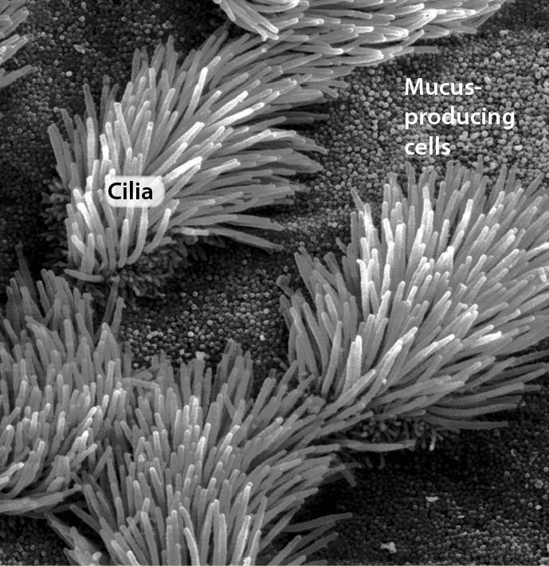

A) the digestive tract
B) arteries
C) veins
D) the trachea
Answer: D
Topic: 24.1 An Overview of the Immune System
Skill: Application/Analysis
Learning Outcome: 24.2
Global LO: 2, 3
2) The figure below shows a Y-shaped antibody molecule. How many antigens can a single antibody molecule bind?

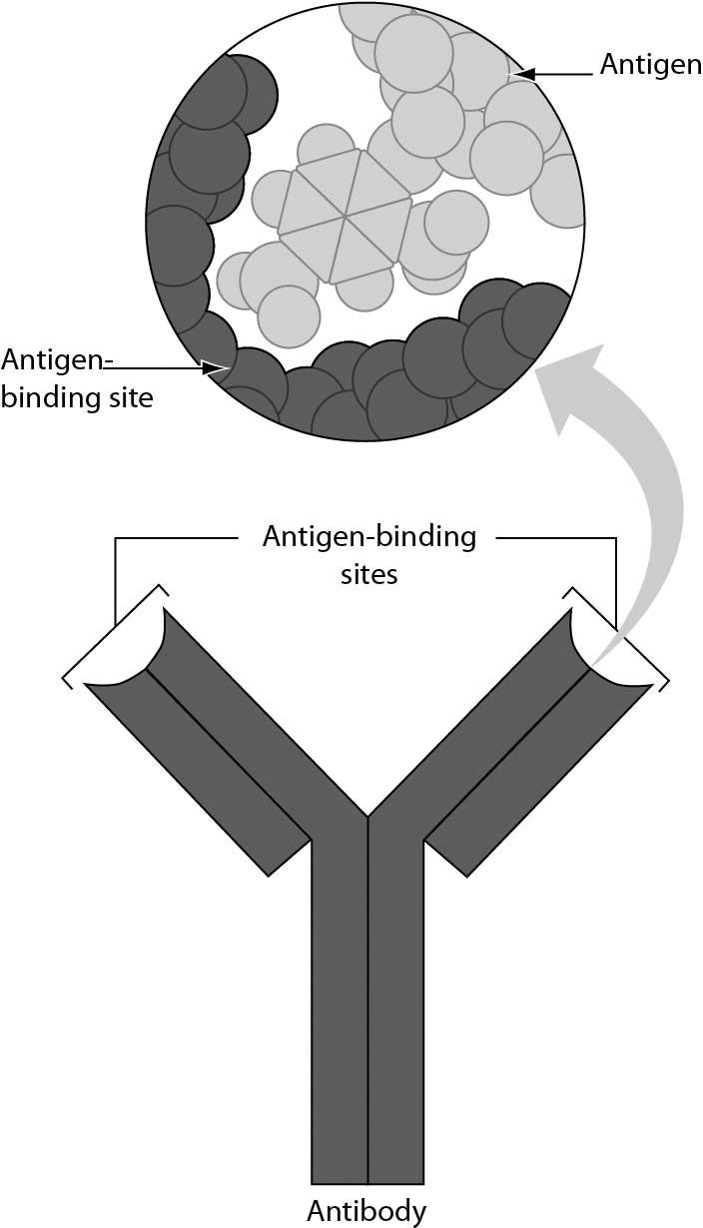
A) one
B) two
C) three
D) four
Answer: B
Topic: 24.4 Adaptive Immunity
Skill: Knowledge/Comprehension
Learning Outcome: 24.7
Global LO: 3
3) Three B cells are shown in the figure. Which of these B cells will begin to grow, divide, and differentiate further?
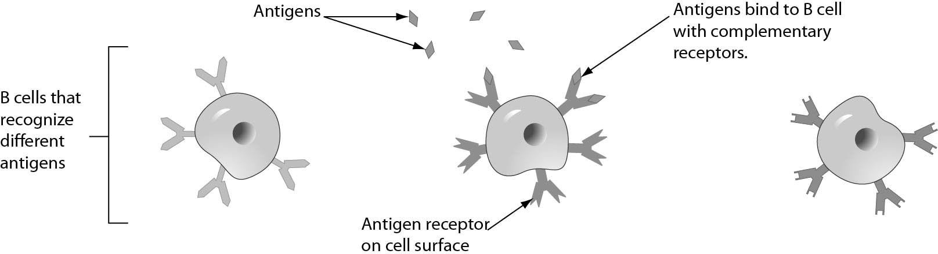

A) only the B cell on the left
B) only the B cell in the middle
C) only the B cell on the right
D) all three B cells
Answer: B
Topic: 24.4 Adaptive Immunity
Skill: Application/Analysis
Learning Outcome: 24.8
Global LO: 2, 3

4) Examine the photograph of the hand in the following figure. The person's joints are severely damaged because ________.

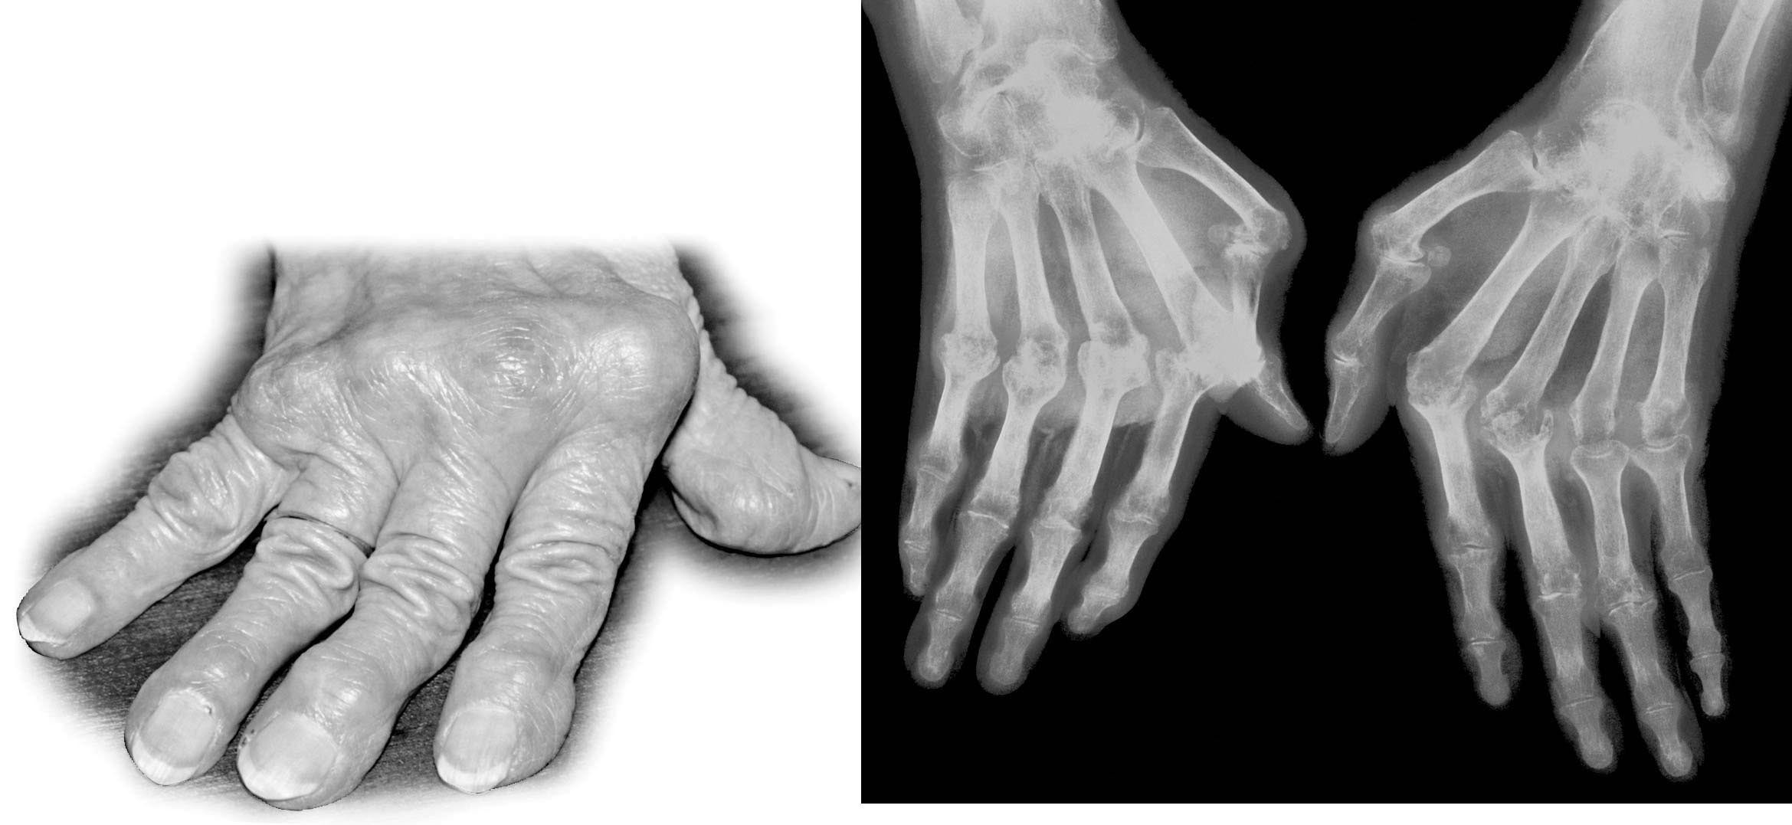

A) the immune system has damaged the cartilage and bone of the joints
B) a viral infection has attacked the cartilage of the fingers
C) cytotoxic T cells have destroyed the bone in the fingers
D) T cells have reacted against the myelin in the hand
Answer: A
Topic: 24.5 Immune Disorders
Skill: Knowledge/Comprehension
Learning Outcome: 24.12
Global LO: 3
5) Suppose that the figure below shows the concentration of antibodies for an antigen produced by Clostridium tetani, a bacterium that causes tetanus. What could trigger the increase in antibody production marked by the arrow?

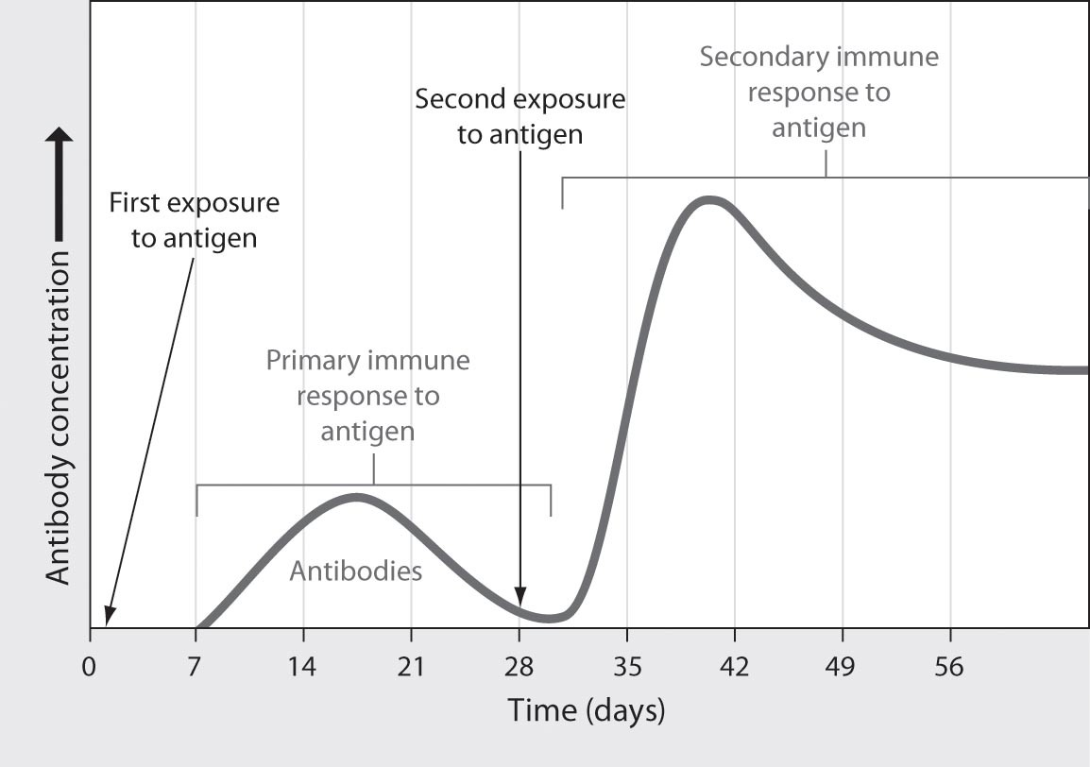

A) a decrease in antigen concentration
B) an increase in histamine production
C) an initial exposure to Pseudomonas aeruginosa, a bacterium that causes pneumonia
D) a second exposure to Clostridium tetani
Answer: D
Topic: 24.4 Adaptive Immunity
Skill: Application/Analysis
Learning Outcome: 24.8
Global LO: 2, 3

24.3 Scenario Questions

Read the following scenario to answer the following questions.

Avian influenza is a viral infection that naturally occurs in wild birds with few damaging effects. However, avian influenza is highly contagious and can quickly kill domesticated birds. Some human influenza viruses are similar to the avian influenza. People infected with avian influenza develop typical flu symptoms (fever, cough, muscle aches). However, symptoms may become more severe and life-threatening. If avian influenza evolves into a form that is easily transmissible from person to person, a global pandemic of widespread human death might occur.

1) One way to prevent a global pandemic of avian influenza would be to ________.
A) keep large doses of histamine available to treat anyone who shows signs of infection
B) treat any infected birds with large doses of antibiotics
C) develop a vaccine against the avian influenza virus
D) develop drugs that could effectively block anaphylactic shock
Answer: C
Topic: 24.4 Adaptive Immunity
Skill: Knowledge/Comprehension
Learning Outcome: 24.8
Global LO: 5
2) Which of the following cells would be active during an immune response to a viral infection?
A) natural killer cells, only
B) phagocytic cells, only
C) T cells, only
D) all of these cell types
Answer: D
Topic: 24.4 Adaptive Immunity
Skill: Knowledge/Comprehension
Learning Outcome: 24.8

3) Humans who are infected with avian influenza are likely to have elevated levels of ________.
A) defensive proteins
B) histamine
C) antihistamines
D) bacterial cells
Answer: A
Topic: 24.2 Innate Immunity
Skill: Knowledge/Comprehension
Learning Outcome: 24.2

4) Which of the following methods do you think would be the best way to test the effectiveness of a vaccine against avian influenza that is intended for human use?
A) Give the vaccine to a single mouse that has the virus, and assess whether influenza symptoms develop.
B) Give the vaccine to a group of mice that have the virus, and give a placebo to another group of mice that have the virus. Assess whether influenza symptoms develop in either group.
C) Give the vaccine to a single human who has the virus, and assess whether influenza symptoms develop.
D) Give the vaccine to a group of humans who have the virus, and give a placebo to another group of humans who have the virus. Assess whether influenza symptoms develop in either group.
Answer: D
Topic: 24 The Process of Science, 24 Evolution Connection
Skill: Synthesis/Evaluation
Learning Outcome: 24.10, 24.13
Global LO: 1, 2, 9
Read the following scenario to answer the following questions.

In order for cytotoxic T cells to kill infected cells, they must bind to the self protein on the surface of the infected cell. Other proteins on the surface of the cytotoxic T cells assist with this binding process. One of these accessory proteins, CD8, has been implicated in many immunodeficiency disorders, including AIDS. CD8 is required for cytotoxic T cells to function normally.

Chronic alcohol use is associated with increased rates of pulmonary bacterial and viral infections. A recent study examined this association by investigating the effects of alcohol on the immune system in mice. Mice were given either water or alcohol (ethanol) to drink and then were infected with the influenza virus. The number of cytotoxic T cells that have the CD8 accessory protein was measured in both groups of mice. The data collected are shown in the figure below.

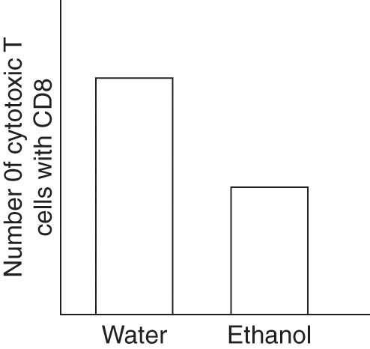

5) Which group of mice has more functional cytotoxic T cells?
A) The mice that drank water.
B) The mice that drank alcohol.
C) Both groups of mice have similar amounts of functional cytotoxic T cells.
D) There is not enough information to make a conclusion.
Answer: A
Topic: 24.4 Adaptive Immunity
Skill: Application/Analysis
Learning Outcome: 24.8
Global LO: 1, 2, 3, 9

6) Which group of mice would have a stronger cytotoxic C cell response?
A) The mice that drank water.
B) The mice that drank alcohol.
C) Both groups of mice would have the same responses.
D) There is not enough information to make a conclusion.
Answer: A
Topic: 24.4 Adaptive Immunity
Skill: Synthesis/Evaluation
Learning Outcome: 24.8
Global LO: 1, 2, 3, 9
7) What other observation would suggest that alcohol consumption contributes to increased bacterial and viral infections?
A) decreased histamine concentration in the mice that drank alcohol
B) increased histamine concentration in the mice that drank alcohol
C) increased numbers of B cells in the mice that drank alcohol
D) decreased numbers of B cells in the mice that drank alcohol
Answer: D
Topic: 24.4 Adaptive Immunity
Skill: Synthesis/Evaluation
Learning Outcome: 24.8
Global LO: 1, 2, 9

