Campbell Essential Biology, 6e, Global Edition (Simon/Dickey/Hogan/Reece)

Chapter 25 Hormones

Chapter 25 Learning Outcomes
25 Biology and Society: Should Steroids Be Allowed?
25.1. Compare the advantages and disadvantages of synthetic hormone use.
25.1 Hormones: An Overview
25.2. Compare ways that water-soluble and lipid-soluble hormones trigger changes in target cells.
25.2 The Human Endocrine System
25.3. Describe different types and functions of vertebrate endocrine glands and the hormones they produce.
25.4. Draw and describe the interrelationships between the hypothalamus and the anterior and posterior pituitary glands including hormones that control each part of the system.
25.5. Explain how taking potassium iodide before or immediately after exposure to nuclear fallout can prevent thyroid cancer.
25.6. Relate type 1 and type 2 diabetes to disruption of proper hormonal regulation of glucose levels.
25.7. Explain how body posture can affect the balance of your stress hormones.
25.8. Relate endocrine disruptors to functioning of thyroid and sex hormones.
25 The Process of Science: Do ‘Roids Cause Rage?
25.9. compare the advantages and disadvantages of synthetic hormone use.
25 Evolution Connection: Steroids and Male Aggression
25.10. Compare the effects of androgens among several vertebrates.

Global Learning Outcomes
1. Demonstrate an understanding of the principles of scientific inquiry.
2. Demonstrate the ability to think critically and employ critical-thinking skills.
3. Read and interpret models, graphs, and data.
4. Demonstrate the quantitative skills needed to succeed in biology.
5. Demonstrate an understanding of the impact of science on society.
6. Evaluate the credibility of scientific information from various sources.
7. Demonstrate the ability to make connections between concepts across biology.
8. Communicate effectively in writing.
9. Apply the scientific method to interpret information and draw conclusions.

25.1 Multiple Choice Questions

1) Hormones are usually transported through ________ and affect only cells with ________.
A) ducts... specific receptors
B) intercellular junctions... cell junctions
C) blood vessels... specific receptors
D) blood vessels... cell junctions
Answer: C
Topic: 25.1 Hormones: An Overview
Skill: Knowledge/Comprehension
Learning Outcome: 25.3

2) If a cell is like a house, which one of the following is most similar to the way that a steroid hormone works?
A) A postal worker leaves mail for you at your front door.
B) A visitor to your home knocks on your front door.
C) Radio signals are received by a stereo in your bedroom.
D) You walk outside of your home to get a better signal on your cell phone.
Answer: C
Topic: 25.1 Hormones: An Overview
Skill: Application/Analysis
Learning Outcome: 25.2
Global LO: 2

3) Hormones regulate ________.
A) growth, only
B) reproduction, only
C) metabolism, only
D) Growth, reproduction, and metabolism are regulated by hormones.
Answer: D
Topic: 25.1 Hormones: An Overview
Skill: Application/Analysis
Learning Outcome: 25.3
Global LO: 2

4) In general, hormones that bind to plasma membrane receptors ________.
A) are steroid hormones
B) bind to DNA and cause changes in transcription
C) cannot pass through cell membranes
D) are produced in the interstitial fluid
Answer: C
Topic: 25.1 Hormones: An Overview
Skill: Knowledge/Comprehension
Learning Outcome: 25.2

5) Generally, a cell that is affected by a particular steroid hormone would be expected to have ________.
A) DNA sites that interact with the hormone
B) a receptor inside the cell that binds the hormone
C) a cell-surface receptor that binds the hormone
D) enzymes that are activated or inactivated by the hormone's second messenger
Answer: B
Topic: 25.1 Hormones: An Overview
Skill: Application/Analysis
Learning Outcome: 25.2
Global LO: 2

6) Steroid hormones ________.
A) begin their action outside the membrane
B) usually diffuse through the plasma membrane into target cells
C) bind to receptors in the plasma membrane
D) are water soluble
Answer: B
Topic: 25.1 Hormones: An Overview
Skill: Knowledge/Comprehension
Learning Outcome: 25.2

7) Steroid hormones ________.
A) usually trigger a signal transduction pathway when they bind to a membrane receptor
B) usually bind to mRNA in the cytoplasm to initiate transcription
C) usually bind to receptors in the cytoplasm or nucleus
D) usually bind to rRNA to prevent translation
Answer: C
Topic: 25.1 Hormones: An Overview
Skill: Knowledge/Comprehension
Learning Outcome: 25.2

8) Water-soluble hormones can cause different effects in different cells depending on the type of cell and ________.
A) its signal transduction pathway
B) the particular organelle that is targeted
C) the binding of the hormone to either DNA or RNA
D) the type of ribosomes in the cell
Answer: A
Topic: 25.1 Hormones: An Overview
Skill: Knowledge/Comprehension
Learning Outcome: 25.2

9) Which of the following has both endocrine and nonendocrine functions?
A) pancreas
B) salivary gland
C) anterior pituitary gland
D) skeletal muscle
Answer: A
Topic: 25.2 The Human Endocrine System
Skill: Knowledge/Comprehension
Learning Outcome: 25.3
10) Which of the following is a nonsteroid hormone?
A) glucagon
B) a progestin
C) a glucocorticoid
D) androgen
Answer: A
Topic: 25.2 The Human Endocrine System
Skill: Application/Analysis
Learning Outcome: 25.2
Global LO: 2

11) Which of the following is part of the brain?
A) thymus
B) hypothalamus
C) adrenal cortex
D) thyroid
Answer: B
Topic: 25.2 The Human Endocrine System
Skill: Knowledge/Comprehension
Learning Outcome: 25.3

12) Which one of the following statements is TRUE?
A) The anterior pituitary is composed of nervous tissue.
B) The anterior pituitary and posterior pituitary work together to secrete the same hormones.
C) Inhibiting hormones make the anterior pituitary secrete hormones.
D) The pituitary secretes hormones that influence numerous body functions.
Answer: D
Topic: 25.2 The Human Endocrine System
Skill: Knowledge/Comprehension
Learning Outcome: 25.4

13) Follicle-stimulating hormone (FSH) is a hormone that ________.
A) helps to regulate the female menstrual cycle
B) stimulates general body growth
C) raises blood glucose levels
D) regulates hair growth and skin growth
Answer: A
Topic: 25.2 The Human Endocrine System
Skill: Knowledge/Comprehension
Learning Outcome: 25.3

14) Which of the following hormones is made by the hypothalamus and released by the posterior pituitary?
A) estrogen
B) growth hormone
C) ADH
D) insulin
Answer: C
Topic: 25.2 The Human Endocrine System
Skill: Knowledge/Comprehension
Learning Outcome: 25.4
15) Which of these hormones acts in opposition to diuretics such as alcohol?
A) ADH
B) glucagon
C) HGH
D) FSH
Answer: A
Topic: 25.2 The Human Endocrine System
Skill: Application/Analysis
Learning Outcome: 25.3
Global LO: 2, 5

16) Which of the following choices INCORRECTLY pairs an endocrine gland or hormone with an aspect of metabolism that it regulates?
A) TSH–thyroid hormone
B) pancreas–blood glucose levels
C) prolactin–blood potassium levels
D) ovary–female sexual characteristics
Answer: C
Topic: 25.2 The Human Endocrine System
Skill: Knowledge/Comprehension
Learning Outcome: 25.3

17) Which of the following hormones affects the greatest variety of cell types?
A) prolactin
B) insulin
C) growth hormone
D) calcitonin
Answer: C
Topic: 25.2 The Human Endocrine System
Skill: Knowledge/Comprehension
Learning Outcome: 25.3

18) Eating very spicy food stimulates the release of ________.
A) endorphins
B) insulin
C) glucagon
D) calcitonin
Answer: A
Topic: 25.2 The Human Endocrine System
Skill: Knowledge/Comprehension
Learning Outcome: 25.3
Global LO: 5
19) One of your best friends loves to run long distances. You ask her what she enjoys about running. In addition to good physical fitness, she tells you that after a run she feels extra happy. You suspect that her joy might be related to increased production of ________ by the anterior pituitary gland.
A) endorphins
B) releasing hormones
C) prolactin
D) adrenalin
Answer: A
Topic: 25.2 The Human Endocrine System
Skill: Application/Analysis
Learning Outcome: 25.3
Global LO: 2, 5

20) Which gland requires the element iodine to produce its hormones?
A) thyroid
B) pineal
C) anterior pituitary
D) ovary
Answer: A
Topic: 25.2 The Human Endocrine System
Skill: Knowledge/Comprehension
Learning Outcome: 25.3

21) ________ can be a symptom of hypothyroidism.
A) Goiter
B) A low sperm count
C) Graves' disease
D) Hyperactivity
Answer: A
Topic: 25.2 The Human Endocrine System
Skill: Knowledge/Comprehension
Learning Outcome: 25.3
Global LO: 5

22) Which of the following best describes the relationship of insulin to glucagon?
A) They work together to prepare the body to deal with stress.
B) Insulin stimulates the pancreas to secrete glucagon.
C) High levels of insulin inhibit pancreatic secretion of glucagon.
D) They are antagonistic hormones.
Answer: D
Topic: 25.2 The Human Endocrine System
Skill: Knowledge/Comprehension
Learning Outcome: 25.6
23) Which structure exerts primary control over the concentration of sugar in the blood?
A) liver
B) pituitary
C) pineal
D) pancreas
Answer: D
Topic: 25.2 The Human Endocrine System
Skill: Knowledge/Comprehension
Learning Outcome: 25.6

24) When the concentration of glucose in the blood rises following the digestion of a meal, what is the hormonal response?
A) Increased amounts of both glucagon and insulin are released.
B) An increased amount of glucagon is released.
C) An increased amount of insulin is released.
D) Glucagon and insulin levels in the blood stay the same.
Answer: C
Topic: 25.2 The Human Endocrine System
Skill: Knowledge/Comprehension
Learning Outcome: 25.6

25) Which of the following hormones causes a rise in the concentration of glucose in the blood?
A) insulin
B) glucagon
C) melatonin
D) calcitonin
Answer: B
Topic: 25.2 The Human Endocrine System
Skill: Knowledge/Comprehension
Learning Outcome: 25.6

26) What is the metabolic abnormality that underlies the characteristic symptoms of diabetes mellitus, such as frequent urination?
A) a failure of the kidney tubules to reabsorb enough glucose from the urine
B) a failure of the gastrointestinal epithelium to absorb enough glucose from food
C) an inability of the body's cells to retain glucose they have absorbed from the blood
D) an inability of the body's cells to absorb enough glucose from the blood
Answer: D
Topic: 25.2 The Human Endocrine System
Skill: Application/Analysis
Learning Outcome: 25.6
Global LO: 2, 5

27) Which of the following is almost always associated with being overweight and underactive?
A) type 1 diabetes
B) type 2 diabetes
C) type 3 diabetes
D) hypoglycemia
Answer: B
Topic: 25.2 The Human Endocrine System
Skill: Knowledge/Comprehension
Learning Outcome: 25.6
Global LO: 5
28) Which of the following glands is located nearest the kidneys?
A) ovaries
B) pineal gland
C) thyroid gland
D) adrenal glands
Answer: D
Topic: 25.2 The Human Endocrine System
Skill: Knowledge/Comprehension
Learning Outcome: 25.3

29) Which of the following glands secretes hormones that enable the body to respond to stress?
A) pancreas
B) adrenal
C) pineal
D) parathyroid
Answer: B
Topic: 25.2 The Human Endocrine System
Skill: Knowledge/Comprehension
Learning Outcome: 25.3

30) Epinephrine ________.
A) decreases metabolic rate
B) decreases heart rate
C) increases absorption of glucose by the digestive tract
D) increases breathing rate
Answer: D
Topic: 25.2 The Human Endocrine System
Skill: Knowledge/Comprehension
Learning Outcome: 25.3

31) Which of the following is(are) mostly involved in a long-lasting response to stress?
A) mineralocorticoids
B) glucocorticoids
C) androgens
D) oxytocin
Answer: B
Topic: 25.2 The Human Endocrine System
Skill: Knowledge/Comprehension
Learning Outcome: 25.3

32) Which of the following hormones can make a person susceptible to infection when administered for too long as a drug?
A) glucagon
B) growth hormone
C) glucocorticoids
D) antidiuretic hormone
Answer: C
Topic: 25.2 The Human Endocrine System
Skill: Knowledge/Comprehension
Learning Outcome: 25.3
33) Hyposecretion of ________ may inhibit your response to stress.
A) ACTH
B) insulin
C) HGH
D) prolactin
Answer: A
Topic: 25.2 The Human Endocrine System
Skill: Application/Analysis
Learning Outcome: 25.3
Global LO: 2

34) Estrogens stimulate the development of ________.
A) breasts
B) a low-pitched voice
C) sperm production
D) facial hair
Answer: A
Topic: 25.2 The Human Endocrine System
Skill: Knowledge/Comprehension
Learning Outcome: 25.3

35) Which of the following are sex hormones?
A) androgens, only
B) estrogens, only
C) progestins, only
D) All of these are sex hormones.
Answer: D
Topic: 25.2 The Human Endocrine System
Skill: Knowledge/Comprehension
Learning Outcome: 25.3

36) Which of the following is secreted by a sexually mature woman?
A) testosterone, only
B) estrogen, only
C) progestins, only
D) All of these are secreted by a sexually mature woman.
Answer: D
Topic: 25.2 The Human Endocrine System
Skill: Application/Analysis
Learning Outcome: 25.3
Global LO: 2

37) If body cells have too few receptors for insulin, ________.
A) the insulin level is likely to decrease
B) the blood glucose level may rise to abnormal levels
C) the liver will need to break down more glycogen
D) more glucagon will be needed
Answer: B
Topic: 25.2 The Human Endocrine System
Skill: Synthesis/Evaluation
Learning Outcome: 25.6
Global LO: 2, 5, 7
38) Nate is gaining weight, is often tired, and feels cold. His thyroid hormone level is high as is the level of TSH. Nate also has a goiter. Which of these diagnoses is the most likely for Nate's condition?
A) defective thyroid hormone receptors in his body cells
B) insufficient iodine in his diet
C) defective receptors for thyroid hormone control by the anterior pituitary
D) too much iodine in the diet
Answer: A
Topic: 25.2 The Human Endocrine System
Skill: Synthesis/Evaluation
Learning Outcome: 25.3
Global LO: 2, 5, 7

39) Natalie is lethargic, has poor tolerance to cold, and the amount of thyroid hormone in her body is low even though the level of TSH is high. Natalie has a goiter. Which of these diagnoses is the most likely for Natalie's condition?
A) defective thyroid hormone receptors in the body cells
B) insufficient iodine in the diet
C) defective receptors for thyroid hormone control by the anterior pituitary
D) too much iodine in the diet
Answer: B
Topic: 25.2 The Human Endocrine System
Skill: Synthesis/Evaluation
Learning Outcome: 25.3
Global LO: 2, 5, 7

40) Jenny is losing weight, has poor tolerance to heat, and has mood swings, high blood pressure, and a rapid heart rate. She has very high levels of thyroid hormone, high levels of TSH, and a goiter. Which of these diagnoses is the most likely for Jenny's condition?
A) defective thyroid hormone receptors in the body cells
B) insufficient iodine in the diet
C) defective receptors for thyroid hormone control by the anterior pituitary
D) too much iodine in the diet
Answer: C
Topic: 25.2 The Human Endocrine System
Skill: Synthesis/Evaluation
Learning Outcome: 25.3
Global LO: 2, 5, 7

41) Which of these is generally considered a benefit of synthetic hormones?
A) effects on kidney and liver
B) cardiovascular effects
C) increased hostility
D) mimicking estrogen
Answer: D
Topic: 25 Biology and Society, 25.2 The Human Endocrine System, and 25 The Process of Science
Skill: Knowledge/Comprehension
Learning Outcome: 25.1
Global LO: 5
42) Which of these is an example of the action of an endocrine disruptor?
A) BPA in bottles affects particular glands.
B) Feedback from estrogen inhibits FSH.
C) Lack of iodine prevents synthesis of adequate thyroid hormone.
D) Lowered levels of calcitonin causes increased bone density.
Answer: A
Topic: 25.2 The Human Endocrine System
Skill: Knowledge/Comprehension
Learning Outcome: 25.8
Global LO: 5

43) Many cases of pediatric thyroid cancer occurred after the 1986 Chernobyl nuclear accident in Ukraine and the cause was traced to milk containing iodine-131. Which of these might be the most effective method to prevent thyroid cancer increase following exposure to excessive radiation?
A) Do not allow anyone to drink any milk.
B) Give dairy cows large doses of iodine.
C) Give humans large doses of iodine before exposure.
D) Give people large doses of iodine a few days following exposure.
Answer: A
Topic: 25.2 The Human Endocrine System
Skill: Application/Analysis
Learning Outcome: 25.5
Global LO: 2, 5

44) Which of these behaviors is NOT associated with androgens?
A) body-slamming elephant seals
B) mating songs in frogs
C) territorial battles in fish
D) maturation of ovaries in bears
Answer: D
Topic: 25 Evolution Connection
Skill: Knowledge/Comprehension
Learning Outcome: 25.10
25.2 Art Questions

Please refer to the following art to answer the following questions.

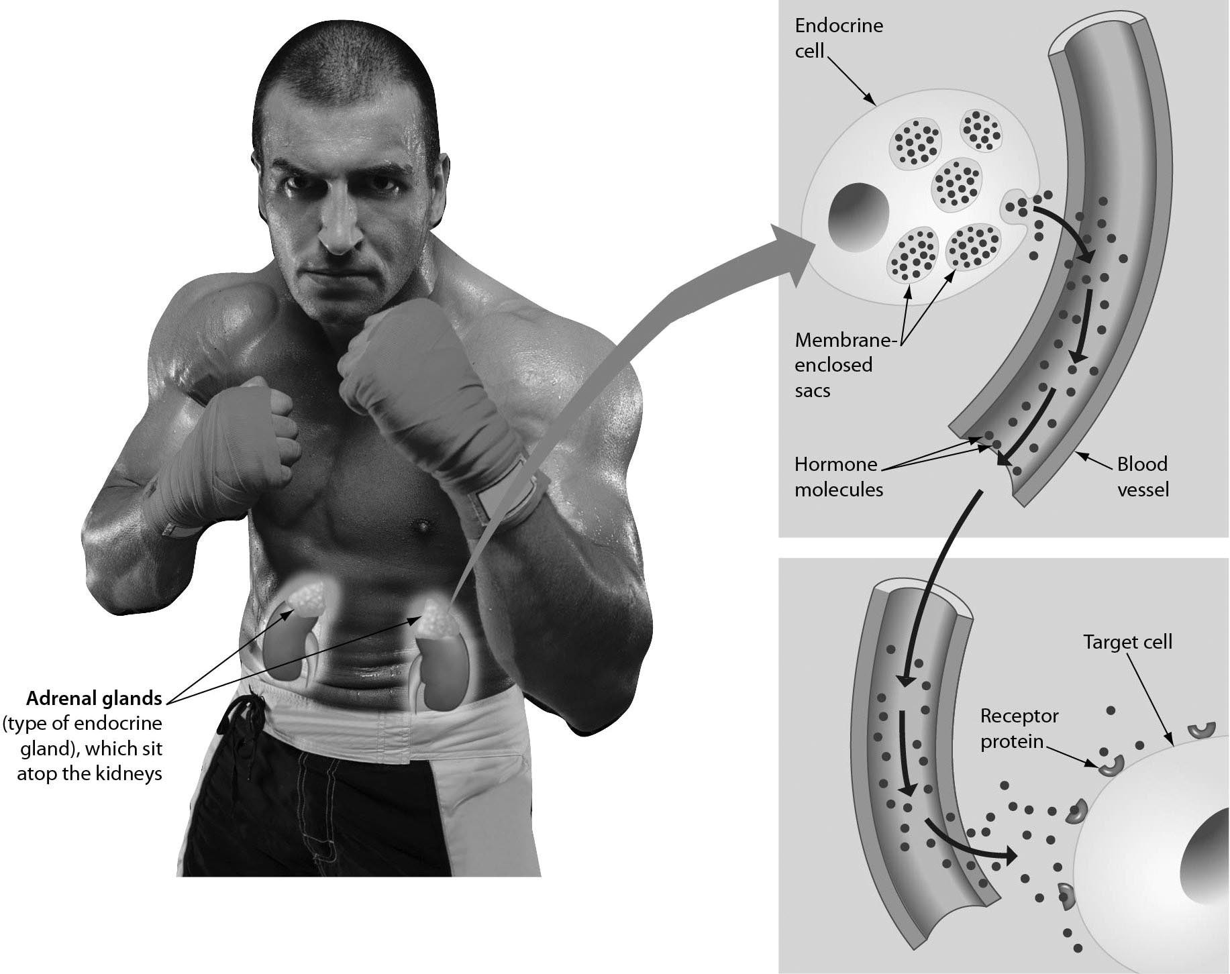

1) What is special about the target cells that allows them to respond to the hormone? Only the target cells ________.
A) are close enough to the blood vessels to respond
B) touch the blood vessels
C) have specific receptors to the hormone
D) located in organs next to the kidneys can respond
Answer: C
Topic: 25.1 Hormones: An Overview
Skill: Application/Analysis
Learning Outcome: 25.3
Global LO: 2
2) As this boxer is finishing his fight, which of these hormone is NOT likely to be elevated?
A) adrenalin
B) ADH
C) insulin
D) androgens
Answer: C
Topic: 25.2 The Human Endocrine System
Skill: Synthesis/Evaluation
Learning Outcome: 25.3, 25.9, 25.10
Global LO: 2, 3, 7

3) The hormone being released from the organs shown in the figure is likely to be ________.
A) adrenalin
B) growth
C) testosterone
D) calcitonin
Answer: C
Topic: 25.2 The Human Endocrine System
Skill: Application/Analysis
Learning Outcome: 25.3
Global LO: 2, 3

4) If the boxer wanted to be more confident and less stressed as he entered the fight, a good strategy would be to ________.
A) eat a large amount of carbohydrates to be sure glucose is properly regulated
B) assume a power pose for a period of time before the fight
C) drink milk to increase the amount of calcium in his blood
D) take iodide tablets to insure that sufficient thyroxin is produced
Answer: B
Topic: 25.2 The Human Endocrine System
Skill: Application/Analysis
Learning Outcome: 25.7
Global LO: 2, 5
5) Examine the figure below. If blood glucose levels decline, ________.

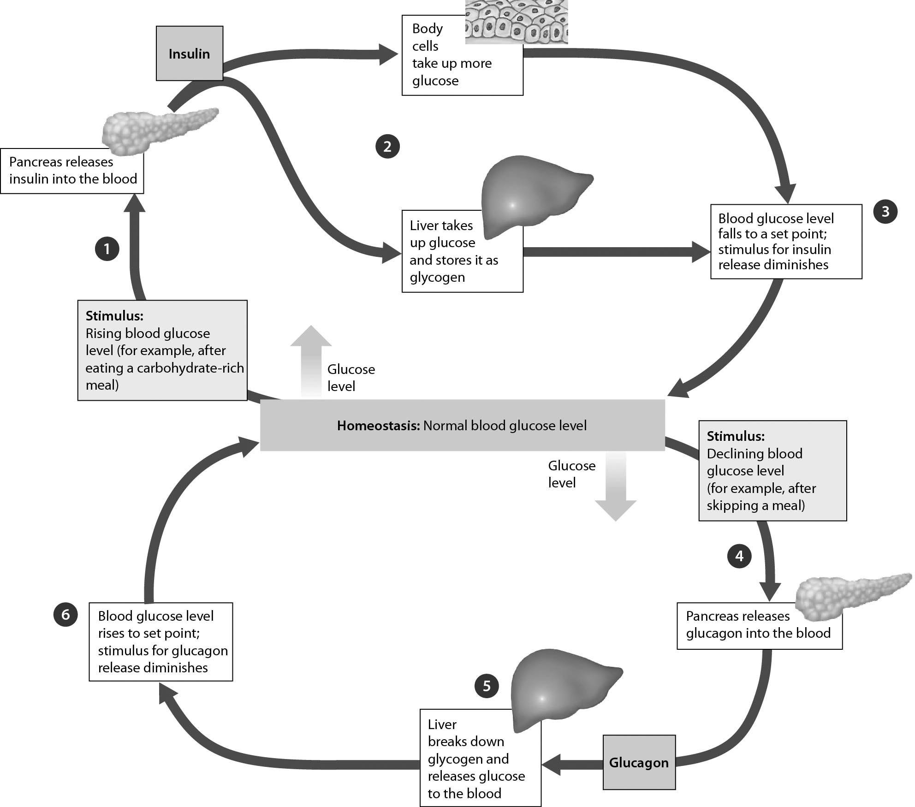

A) the pancreas releases more glucagon, which causes glucose to be released into the blood
B) the pancreas releases more insulin, which causes glucose to be released into the blood
C) body cells take up more glucose
D) liver cells convert glucose to glycogen
Answer: A
Topic: 25.2 The Human Endocrine System
Skill: Application/Analysis
Learning Outcome: 25.6
Global LO: 2, 3
6) Examine the figure below. The behavior exhibited by these elephant seals is promoted by ________.
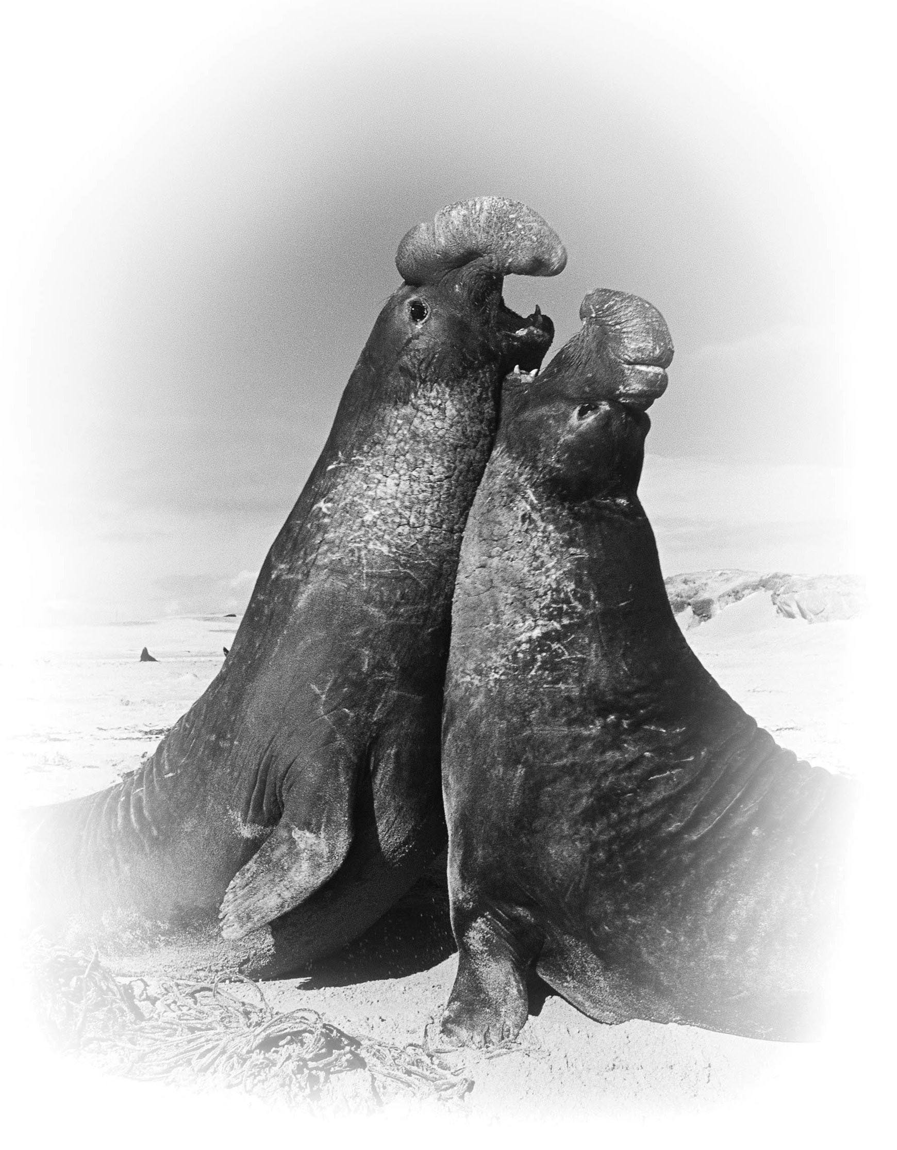
A) growth hormone, which has brought about full body size
B) testosterone, which has brought about sexual maturity
C) calcitonin, which has produced strong bones
D) antagonistic hormones, which cause aggression
Answer: B
Topic: 25.2 The Human Endocrine System
Skill: Knowledge/Comprehension
Learning Outcome: 25.3
25.3 Scenario Questions

Please read the following scenario to answer the following questions.

Osteoporosis is a disease characterized by loss of bone mass and an increased susceptibility to bone fractures. It threatens more than half of all Americans over the age of 50. Women are about four times more likely to suffer from the disease than men. Osteoporosis may progress undetected until bones become so weak that they break during common activities. Prevention of osteoporosis includes regular weight-bearing exercise, recommended intake of calcium and vitamin D, and avoidance of smoking and excessive alcohol.

1) Astronauts returning from long periods in space often have very fragile bones. This is likely related to ________.
A) overproduction of thyroid hormone
B) lack of gravity
C) diet lacking in calcium
D) excessive production of ADH
Answer: B
Topic: 25.2 The Human Endocrine System
Skill: Synthesis/Evaluation
Learning Outcome: 25.2
Global LO: 2, 5

2) Calcium levels are regulated by antagonistic hormones. This is likely because ________.
A) calcium has to be produced by the body and that production must be regulated
B) bone formation occurs only during puberty when many other hormones are present, thus careful regulation is necessary
C) both too much and too little calcium can have disastrous effects on the body, thus the levels need tight regulation
D) calcium is needed to repair bone fractures, so antagonistic hormones make sure it is available when needed
Answer: C
Topic: 25.2 The Human Endocrine System
Skill: Synthesis/Evaluation
Learning Outcome: 25.3
Global LO: 2, 5

