Campbell Essential Biology, 6e, Global Edition (Simon/Dickey/Hogan/Reece)

Chapter 27 Nervous, Sensory, and Locomotor Systems

Chapter 27 Learning Outcomes
27 Biology and Society: The Seismic Sense of Elephants
27 The Process of Science: How Do New Senses Arise?
27 Evolution Connection: Seeing UV
27.1. Describe adaptations for detecting sensory input in different animals and how those adaptations evolved.
27.1 An Overview of Animal Nervous Systems
27.2. Describe the structures and functions of neurons, nervous tissue, and organs, and how they are organized into and work together in the central and peripheral nervous systems and the different divisions of the peripheral nervous system.
27.3. Describe how electrical signals are sent through a neuron and into a receiving cell, including the cellular structures and chemicals needed, and how drugs can alter transmission of electrical signals.
27.2 The Human Nervous System: A Closer Look
27.4. Describe how neuroplasticity contributes to the normal functioning of the brain, and how alterations in neurological function are associated with diseases of the nervous system.
27.3 The Senses
27.5. List and describe the components of signal transduction, and explain how signal transduction is related to sensing and responding to external and internal conditions.
27.6. List and describe sensory systems that detect different environmental stimuli, including how sensory structures are related to their functions, and how alteration of structures leads to a loss of sensory function.
27.4 Locomotor Systems
27.7. Describe the structures, arrangement, and functions of the components of bones and joints, and how skeletal injury and disorders occur and are treated.
27.8. Describe the structures, arrangement, and functions of the components of a muscle.
27.9. Explain how a motor neuron signals a muscle fiber to contract, and describe an example of an animal using its sensory receptors, central nervous system, skeleton, and muscles to perform an activity.

Global learning outcomes
1. Demonstrate an understanding of the principles of scientific inquiry.
2. Demonstrate the ability to think critically and employ critical-thinking skills.
3. Read and interpret models, graphs, and data.
4. Demonstrate the quantitative skills needed to succeed in biology.
5. Demonstrate an understanding of the impact of science on society.
6. Evaluate the credibility of scientific information from various sources.
7. Demonstrate the ability to make connections between concepts across biology.
8. Communicate effectively in writing.
9. Apply the scientific method to interpret information and draw conclusions.

27.1 Multiple Choice Questions

1) What evolutionary adaptation allows elephants to migrate, meet, and mate over great distances?
A) echolocation
B) electroreception
C) magnetoreception
D) seismic detection
Answer: D
Topic: 27 Biology and Society
Skill: Knowledge/Comprehension
Learning Outcome: 27.1

2) The two major divisions of the nervous system are the ________.
A) sympathetic and parasympathetic
B) central nervous system (CNS) and peripheral nervous system (PNS)
C) sensory and motor
D) voluntary and involuntary
Answer: B
Topic: 27.1 An Overview of Animal Nervous Systems
Skill: Knowledge/Comprehension
Learning Outcome: 27.2

3) The cells that carry electric signals from one part of the body to another in the nervous system are ________.
A) dendrites
B) neurons
C) effectors
D) synapses
Answer: B
Topic: 27.1 An Overview of Animal Nervous Systems
Skill: Knowledge/Comprehension
Learning Outcome: 27.2

4) In the nervous system, integration ________.
A) occurs at the axon
B) inevitably results in the attainment of a threshold potential
C) is the analysis and interpretation of sensory signals and the formulation of appropriate responses
D) is the assimilation of memories
Answer: C
Topic: 27.1 An Overview of Animal Nervous Systems
Skill: Knowledge/Comprehension
Learning Outcome: 27.2

5) Which of the following neurons are part of the peripheral nervous system?
A) sensory neuron and motor neuron
B) interneuron neuron and motor neuron
C) interneuron neuron and sensory neuron
D) only motor neurons
Answer: A
Topic: 27.1 An Overview of Animal Nervous Systems
Skill: Knowledge/Comprehension
Learning Outcome: 27.2

6) Multiple sclerosis involves primarily ________.
A) destruction of the medulla oblongata
B) deterioration of the corpus callosum
C) destruction of the myelin sheath
D) deterioration of parts of the spinal cord
Answer: C
Topic: 27.1 An Overview of Animal Nervous Systems
Skill: Knowledge/Comprehension
Learning Outcome: 27.2, 27.4
Global LO: 5

7) Which of these carry incoming messages toward the cell body of a neuron?
A) axons
B) dendrites
C) actin filaments
D) supporting cells
Answer: B
Topic: 27.1 An Overview of Animal Nervous Systems
Skill: Knowledge/Comprehension
Learning Outcome: 27.2

8) Outnumbering neurons by up to 50 to 1, which cells protect, insulate, and reinforce neurons?
A) sensory cells
B) motor cells
C) satellite cells
D) supporting cells
Answer: D
Topic: 27.1 An Overview of Animal Nervous Systems
Skill: Knowledge/Comprehension
Learning Outcome: 27.2

9) The minimum change in a membrane's voltage that must occur to trigger an action potential is called the ________.
A) threshold
B) synaptic terminal
C) membrane potential
D) resting potential
Answer: A
Topic: 27.1 An Overview of Animal Nervous Systems
Skill: Knowledge/Comprehension
Learning Outcome: 27.3
10) What causes the inside of a membrane to become positively charged during an action potential?
A) Negatively charged ions rush out.
B) Positively charged ions rush in.
C) Positively charged ions rush out.
D) Negatively charged ions rush in.
Answer: B
Topic: 27.1 An Overview of Animal Nervous Systems
Skill: Knowledge/Comprehension
Learning Outcome: 27.3

11) The movement of an action potential along a neuron is most like ________.
A) the ripples created by dropping a pebble into a pond, gradually decreasing in size as the waves spread apart
B) a crowd at a sporting event doing the wave around a stadium
C) a radio tower emitting a signal that reaches only a small region
D) the sound of your voice spreading out as you yell loudly to your friend while at a park
Answer: B
Topic: 27.1 An Overview of Animal Nervous Systems
Skill: Application/Analysis
Learning Outcome: 27.3
Global LO: 2

12) A neuron can relay a more intense signal by ________.
A) sending a stronger action potential
B) sending more action potentials in a given amount of time
C) sending an action potential that travels more quickly
D) sending a longer action potential
Answer: B
Topic: 27.1 An Overview of Animal Nervous Systems
Skill: Knowledge/Comprehension
Learning Outcome: 27.3

13) In a chemical synapse, what is the name of the gap between the sending and receiving cells?
A) synaptic terminal
B) action potential
C) synaptic cleft
D) myelin sheath
Answer: C
Topic: 27.1 An Overview of Animal Nervous Systems
Skill: Knowledge/Comprehension
Learning Outcome: 27.3

14) Which of the following neurotransmitters is associated with sleep, mood, attention, and learning?
A) acetylcholine
B) epinephrine
C) serotonin
D) endorphins
Answer: C
Topic: 27.1 An Overview of Animal Nervous Systems
Skill: Knowledge/Comprehension
Learning Outcome: 27.3
15) Which of the following statements is TRUE?
A) Heroin binds to endorphin receptors.
B) Caffeine increases the effects of neurotransmitters that normally suppress nerve signals.
C) Alcohol is a stimulant.
D) Nicotine is a depressant.
Answer: A
Topic: 27.1 An Overview of Animal Nervous Systems
Skill: Knowledge/Comprehension
Learning Outcome: 27.3

16) Where would we expect to find electrical synapses?
A) within the brain
B) within the heart
C) within the spinal cord
D) between interneurons and motor neurons
Answer: B
Topic: 27.1 An Overview of Animal Nervous Systems
Skill: Application/Analysis
Learning Outcome: 27.3
Global LO: 2

17) Which of the following is(are) part of the central nervous system?
A) motor system
B) brain and spinal cord
C) brain only
D) spinal cord only
Answer: B
Topic: 27.2 The Human Nervous System: A Closer Look
Skill: Knowledge/Comprehension
Learning Outcome: 27.2

18) What part of the nervous system cushions the CNS and helps supply it with nutrients and hormones, and carries away wastes?
A) cerebrospinal fluid
B) spinal cord
C) interneurons
D) the bones of the skull
Answer: A
Topic: 27.2 The Human Nervous System: A Closer Look
Skill: Knowledge/Comprehension
Learning Outcome: 27.2

19) Which of the following effects could result from activation of the sympathetic nervous system?
A) decreased heart rate
B) stimulated digestive organs
C) secretion of epinephrine
D) narrowing of the bronchi
Answer: C
Topic: 27.2 The Human Nervous System: A Closer Look
Skill: Knowledge/Comprehension
Learning Outcome: 27.2
20) Realizing that you did not study as much as you needed to for this exam, you start to take the test. However, it is difficult to concentrate because your heart is racing, your stomach seems tied in a knot, you are breathing too quickly, and your mouth is dry. Most likely, you are experiencing the effects of the ________.
A) motor nervous system
B) sympathetic division
C) parasympathetic division
D) central nervous system
Answer: B
Topic: 27.2 The Human Nervous System: A Closer Look
Skill: Application/Analysis
Learning Outcome: 27.2
Global LO: 2

21) You start to trip, but you keep your balance and don't fall. Which of the following brain regions is responsible for the rapid coordination of muscle activity that kept you from falling?
A) cerebral cortex
B) thalamus
C) cerebellum
D) cerebrum
Answer: C
Topic: 27.2 The Human Nervous System: A Closer Look
Skill: Application/Analysis
Learning Outcome: 27.2
Global LO: 2

22) Which, if any, of the following types of personal characteristics are based in the cerebral cortex?
A) reasoning abilities only
B) artistic talents only
C) personality traits only
D) reasoning abilities, artistic talents, and personality traits
Answer: D
Topic: 27.2 The Human Nervous System: A Closer Look
Skill: Knowledge/Comprehension
Learning Outcome: 27.2

23) Which one of the following correctly pairs the structure with its major function(s)?
A) hypothalamus–regulates body temperature, blood pressure, and hunger
B) cerebellum–regulates memory, learning, and speech
C) brainstem–is the input center for sensory data going to the cerebrum
D) thalamus–coordinates balance
Answer: A
Topic: 27.2 The Human Nervous System: A Closer Look
Skill: Knowledge/Comprehension
Learning Outcome: 27.2
24) The cerebral cortex is highly folded. Why might this be an advantage for the functions of the cerebrum?
A) The increased surface area increases the area for higher-level thinking.
B) The increased surface area permits greater contact between the cerebrum and the cerebellum.
C) The folds form grooves that let the bones of the skull reach deeply down between brain regions.
D) The folds increase the areas where sensory receptors can reach the brain's surface.
Answer: A
Topic: 27.2 The Human Nervous System: A Closer Look
Skill: Synthesis/Evaluation
Learning Outcome: 27.2
Global LO: 2

25) Which of the following was supported by the terrible accident that happened to Phineas Gage?
A) The cerebrum plays a major role in the sense of balance.
B) You cannot live without your hypothalamus.
C) The frontal lobes are associated with personality.
D) The pons plays a crucial role in hearing.
Answer: C
Topic: 27.2 The Human Nervous System: A Closer Look
Skill: Application/Analysis
Learning Outcome: 27.4
Global LO: 2

26) Alzheimer's disease is characterized by ________.
A) mental deterioration, memory loss, and personality changes
B) extreme mood swings
C) loss of energy and suicidal thoughts
D) increased energy and extreme talkativeness
Answer: A
Topic: 27.2 The Human Nervous System: A Closer Look
Skill: Knowledge/Comprehension
Learning Outcome: 27.4
Global LO: 5

27) The receptor potential is the ________.
A) membrane potential produced when a neurotransmitter molecule binds to its receptor
B) membrane potential produced in the receptor cell by sensory transduction
C) membrane potential produced as an all-or-none phenomenon
D) membrane potential produced at a muscle cell
Answer: B
Topic: 27.3 The Senses
Skill: Knowledge/Comprehension
Learning Outcome: 27.5
28) Which of the following is an example of sensory adaptation of receptors?
A) going into deep sleep
B) distinguishing between different colors
C) ignoring the shoes on your feet
D) detecting sound and light simultaneously
Answer: C
Topic: 27.3 The Senses
Skill: Application/Analysis
Learning Outcome: 27.5
Global LO: 2

29) In contrast to action potentials, receptor potentials ________.
A) are all-or-none phenomena
B) vary in intensity
C) do not require a stimulus
D) do not rely on changes in the membrane potential
Answer: B
Topic: 27.3 The Senses
Skill: Knowledge/Comprehension
Learning Outcome: 27.5

30) In all types of chemoreceptors, receptor cells develop receptor potentials in response to ________.
A) changes in the movement of the surrounding molecules
B) the electrical properties of the surrounding cells
C) chemicals dissolved in a fluid such as blood or saliva
D) the addition of positively charged proteins
Answer: C
Topic: 27.3 The Senses
Skill: Knowledge/Comprehension
Learning Outcome: 27.6

31) Standing out in center field, the baseball player watches the hitter's bat strike the ball and then, slightly later, hears the sound of the impact. What types of sensory receptors did the player just use?
A) thermoreceptors and chemoreceptors
B) photoreceptors and mechanoreceptors
C) chemoreceptors and pain receptors
D) pain receptors and thermoreceptors
Answer: B
Topic: 27.3 The Senses
Skill: Application/Analysis
Learning Outcome: 27.6
Global LO: 2
32) Thermoreceptors detect ________.
A) motion
B) sound
C) pressure
D) temperature
Answer: D
Topic: 27.3 The Senses
Skill: Knowledge/Comprehension
Learning Outcome: 27.6

33) Which one of the following statements is TRUE?
A) Cones are more sensitive to light than rods.
B) Rods can distinguish color.
C) There are three different types of cones in the human eye.
D) The human retina is completely covered with photoreceptors.
Answer: C
Topic: 27.3 The Senses
Skill: Knowledge/Comprehension
Learning Outcome: 27.6

34) A person who cannot focus well on distant objects has ________.
A) farsightedness
B) nearsightedness
C) astigmatism
D) cataracts
Answer: B
Topic: 27.3 The Senses
Skill: Knowledge/Comprehension
Learning Outcome: 27.6
Global LO: 5

35) A person who has blurred vision caused by a misshapen lens or cornea has ________.
A) farsightedness
B) nearsightedness
C) astigmatism
D) cataracts
Answer: C
Topic: 27.3 The Senses
Skill: Knowledge/Comprehension
Learning Outcome: 27.6
Global LO: 5

36) A person whose eyeball is shorter than normal suffers from ________.
A) farsightedness
B) nearsightedness
C) astigmatism
D) cataracts
Answer: A
Topic: 27.3 The Senses
Skill: Knowledge/Comprehension
Learning Outcome: 27.6
Global LO: 5
37) The organ of Corti is in the ________.
A) outer ear
B) inner ear
C) middle ear
D) eardrum
Answer: B
Topic: 27.3 The Senses
Skill: Knowledge/Comprehension
Learning Outcome: 27.6

38) When you hear, the ________ vibrates.
I) eardrum
II) hammer
III) stirrup
A) I
B) II
C) III
D) I, II, and III
Answer: D
Topic: 27.3 The Senses
Skill: Knowledge/Comprehension
Learning Outcome: 27.6

39) Some adults with attention deficit hyperactivity disorder (ADHD) have abnormally low activity of the neurotransmitter involved in pleasure, attention, memory, sleep, movement, and learning, which increases their risk of drug abuse. Which drug are they most likely to abuse?
A) cocaine
B) morphine
C) codeine
D) alcohol
Answer: A
Topic: 27.1 An Overview of Animal Nervous Systems, 27.2 The Human Nervous System: A Closer Look
Skill: Synthesis/Evaluation
Learning Outcome: 27.3, 27.4
Global LO: 2, 5

40) If you lay your forearm along the table, you can rotate it so that your hand changes from a palm-down to a palm-up position. This is possible because your radius and ulna join at a ________ joint.
A) ball-and-socket
B) hinge
C) pivot
D) twist
Answer: C
Topic: 27.4 Locomotor Systems
Skill: Application/Analysis
Learning Outcome: 27.7
Global LO: 2
41) Which one of the following is used to combat osteoporosis?
A) calcium and vitamin therapy
B) anti-inflammatory medicines
C) opiates
D) splints or casts
Answer: A
Topic: 27.4 Locomotor Systems
Skill: Knowledge/Comprehension
Learning Outcome: 27.7
Global LO: 5

42) What best helps a broken bone heal?
A) grafting new bone to the region
B) exercising the area with the broken bone
C) taking calcium supplements
D) returning the broken bone parts back to their natural shape and then immobilizing the bone
Answer: D
Topic: 27.4 Locomotor Systems
Skill: Knowledge/Comprehension
Learning Outcome: 27.7
Global LO: 5

43) Arthritis is a common result of aging, affecting persons' ability to ________.
A) catch their breath after exercise
B) move their joints
C) heal broken bones
D) produce red blood cells
Answer: B
Topic: 27.4 Locomotor Systems
Skill: Application/Analysis
Learning Outcome: 27.7
Global LO: 2, 5

44) Muscles are connected to bones by ________.
A) thick filaments
B) ligaments
C) tendons
D) myofibrils
Answer: C
Topic: 27.4 Locomotor Systems
Skill: Knowledge/Comprehension
Learning Outcome: 27.8

45) Functionally, what is the muscle fiber's fundamental unit of contraction?
A) thick filament
B) thin filament
C) myofibril
D) sarcomere
Answer: D
Topic: 27.4 Locomotor Systems
Skill: Knowledge/Comprehension
Learning Outcome: 27.8
46) A thick filament is made up of ________.
A) actin
B) myosin
C) sarcomere
D) actin and myosin
Answer: B
Topic: 27.4 Locomotor Systems
Skill: Knowledge/Comprehension
Learning Outcome: 27.8

47) According to the sliding-filament model of muscle contraction, a sarcomere contracts when its ________.
A) thick filaments slide across the ends of the sarcomere
B) thin filaments slide across the ends of the sarcomere
C) thin and thick filaments slide further away from each other
D) thin and thick filaments slide past each other to get closer together
Answer: D
Topic: 27.4 Locomotor Systems
Skill: Knowledge/Comprehension
Learning Outcome: 27.8

48) Would you expect motor units to vary in size? If so, which of these structures would probably have the largest ones?
A) No; all motor units are the same size.
B) Yes; a motor unit in the thigh to control leg movements would be the largest one.
C) Yes; a motor unit that controls eye movements would be the largest one.
D) Yes; a motor unit that controls hand movements would be the largest one.
Answer: B
Topic: 27.4 Locomotor Systems
Skill: Application/Analysis
Learning Outcome: 27.8
Global LO: 2

49) A baseball player leaping for a baseball and a cricket jumping away from a frog are both using ________.
I) sensory receptors
II) the central nervous system
III) a muscle system
A) I only
B) II only
C) III only
D) I, II, and III
Answer: D
Topic: 27.4 Locomotor Systems
Skill: Application/Analysis
Learning Outcome: 27.9
Global LO: 2
50) In a species, what is required for a new sensory adaptation to evolve by natural selection?
A) Individuals that needed this trait mutated a sensory receptor to create the new adaptation.
B) Individuals that possessed this trait produced more offspring than those that did not possess the trait.
C) Individuals that possessed this trait survived by chance, and passed on the trait to their offspring.
D) Individuals immigrated to a new area, and brought the trait with them.
Answer: B
Topic: 27 The Process of Science, 27 Evolution connection
Skill: Application/Analysis
Learning Outcome: 27.1
Global LO: 2, 7
27.2 Art Questions

1) Examine the figure below. Once an action potential is triggered, ________.

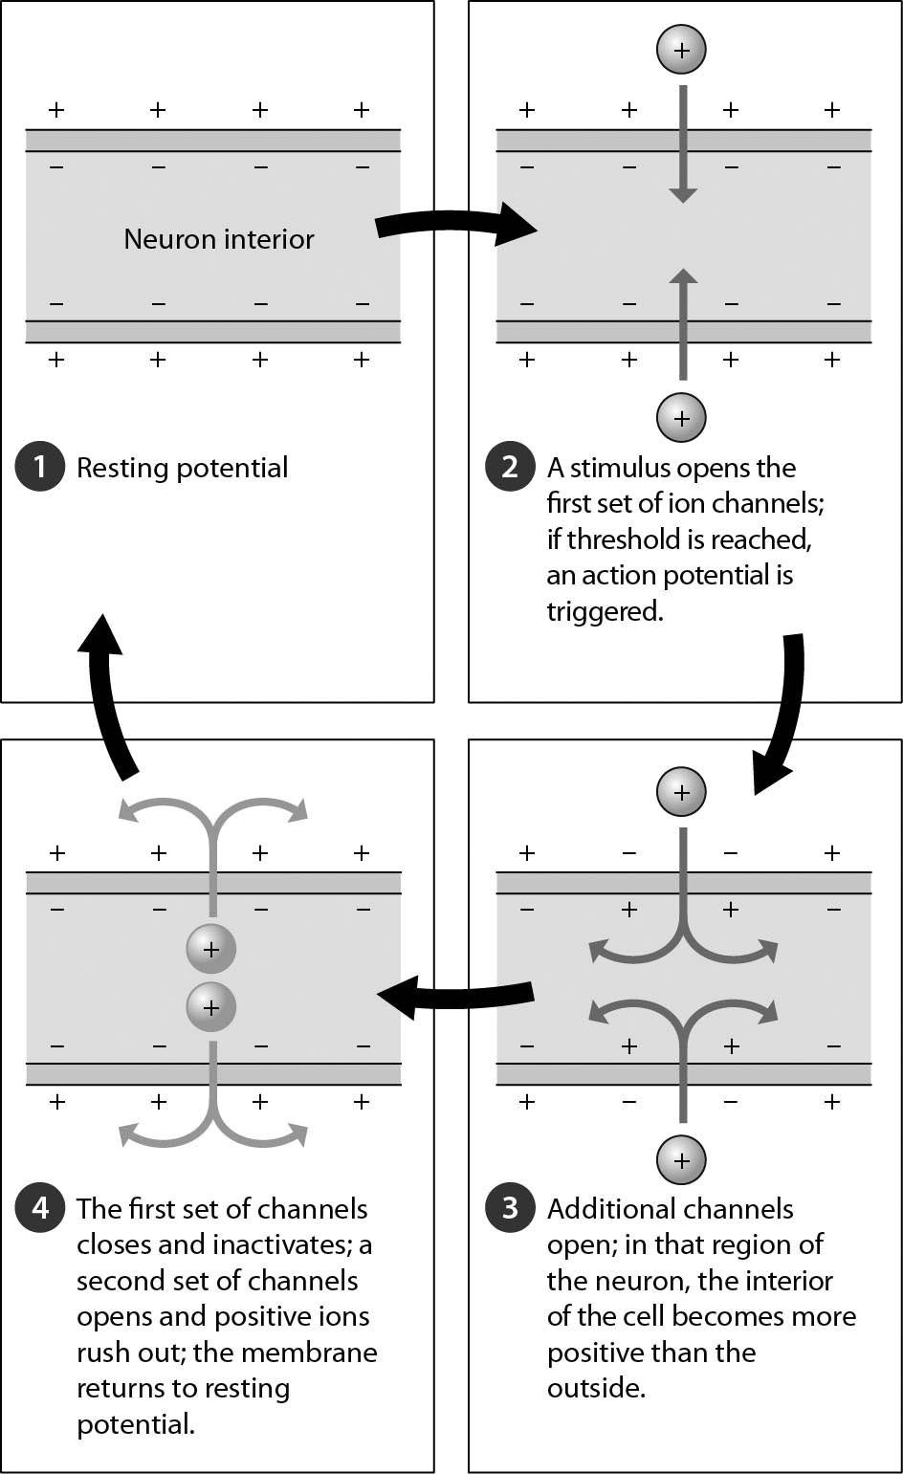

A) the interior of the cell becomes positively charged relative to the outside
B) the interior of the cell becomes negatively charged relative to the outside
C) all ion channels close
D) the cell soon reaches threshold
Answer: A
Topic: 27.1 An Overview of Animal Nervous Systems
Skill: Application/Analysis
Learning Outcome: 27.3
Global LO: 2, 3
2) Examine the neurotransmitters in the synapse in the accompanying figure. What might happen to these neurotransmitters after step 4 is complete? The neurotransmitters ________.

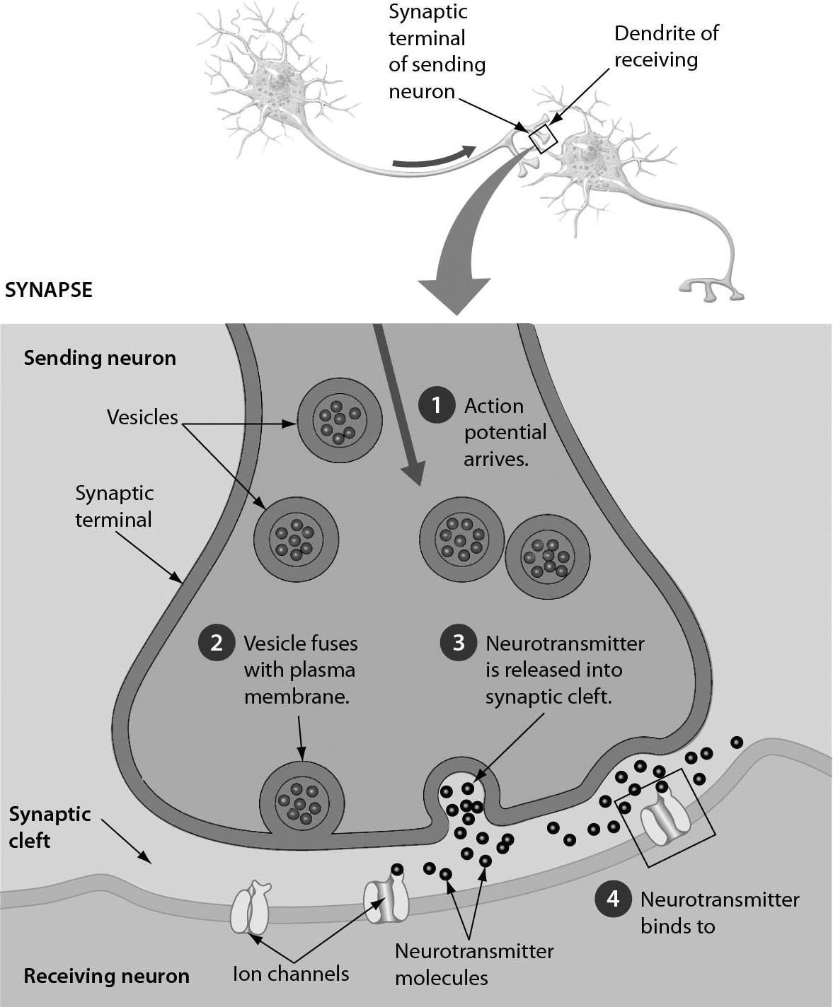

A) are transported back to the sending neuron
B) are transported into the receiving neuron
C) remain in the synaptic cleft
D) trigger an action potential in the sending neuron
Answer: A
Topic: 27.1 An Overview of Animal Nervous Systems
Skill: Application/Analysis
Learning Outcome: 27.3
Global LO: 2, 3
3) The figure shows the human eye. Which part of the eye gives the eye its color?

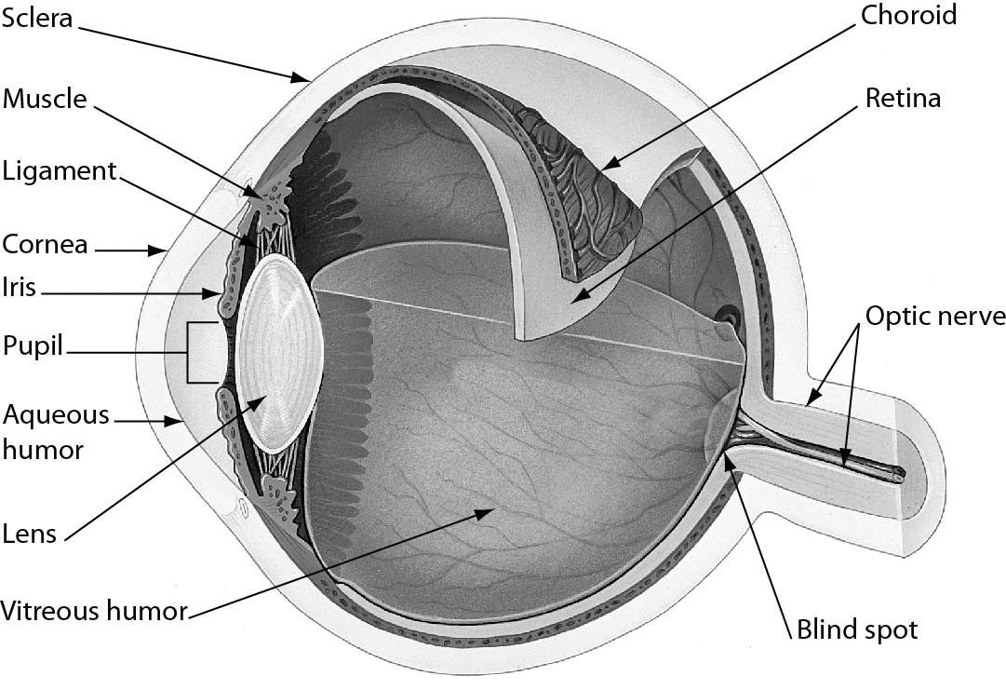
A) sclera
B) iris
C) pupil
D) retina
Answer: B
Topic: 27.3 The Senses
Skill: Application/Analysis
Learning Outcome: 27.6
Global LO: 2, 3
4) The figure below shows the structure of an arm bone. Which part of a bone contains stored fat?

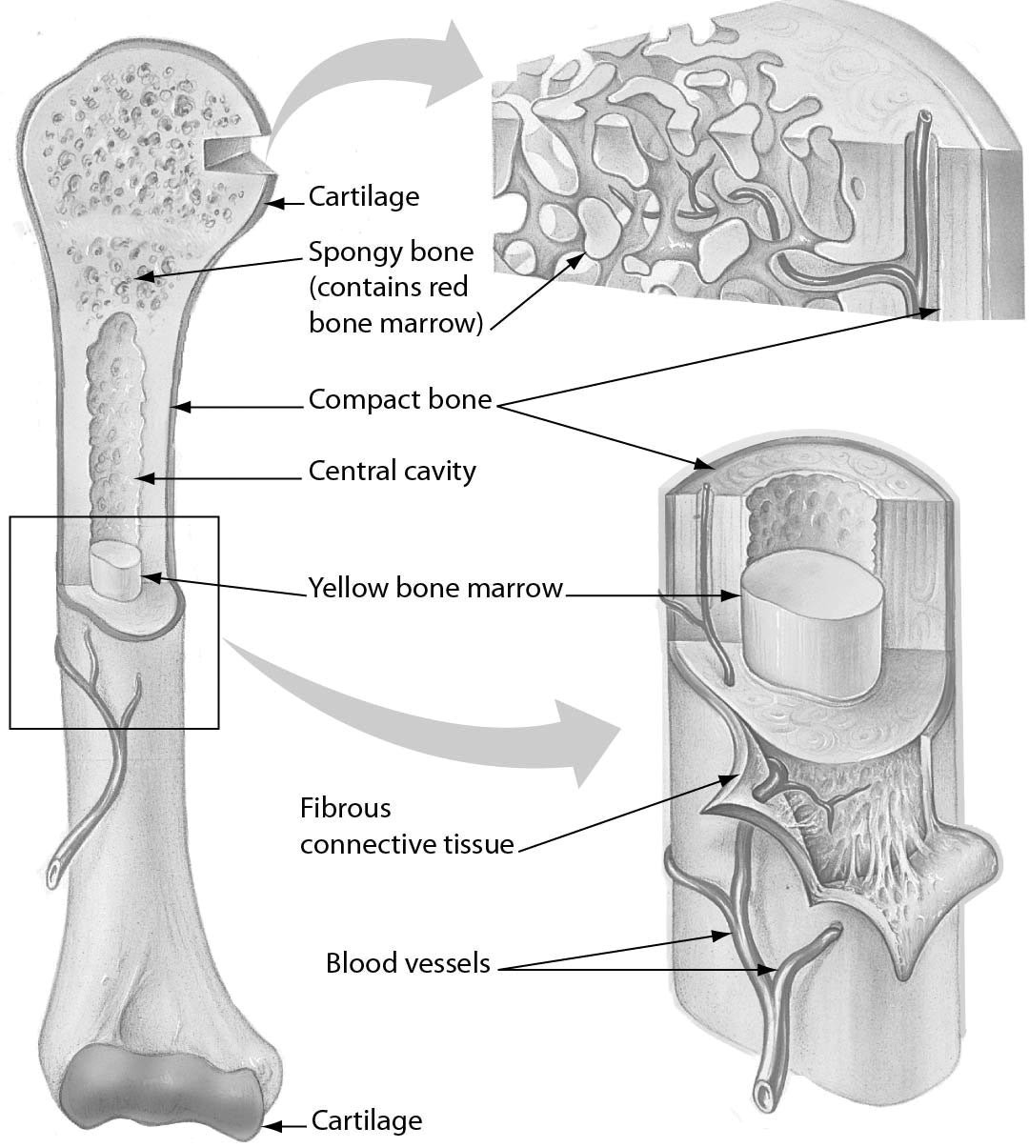

A) red bone marrow
B) cartilage
C) the ends
D) yellow bone marrow
Answer: D
Topic: 27.4 Locomotor Systems
Skill: Application/Analysis
Learning Outcome: 27.7
Global LO: 2, 3
5) Examine the structure of a muscle cell in the accompanying figure. Which one of the following statements about muscle structure is TRUE?

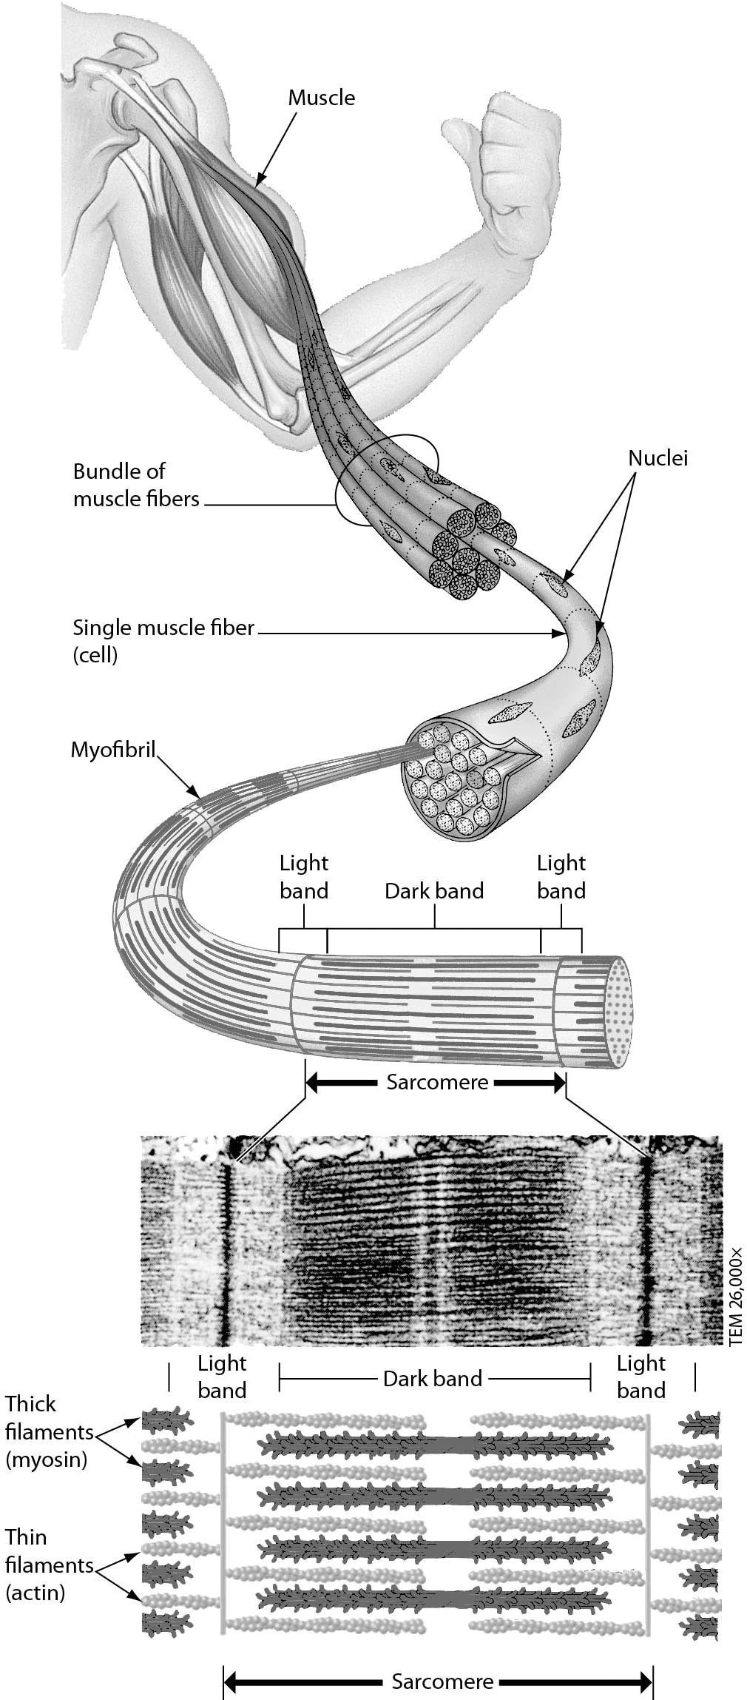

A) Each muscle cell has one nucleus.
B) Each myofibril consists of many muscle cells.
C) Each muscle cell has one sarcomere.
D) A sarcomere contains thick and thin filaments.
Answer: D
Topic: 27.4 Locomotor Systems
Skill: Application/Analysis
Learning Outcome: 27.8
Global LO: 2, 3

27.3 Scenario Questions

Please read the following paragraph and then answer the following questions.

The human eye is an incredible organ, capable of gathering light to focus on images near and far, in bright light or dim, and with quick adjustments between these extremes. However, eyes can develop problems, such as floaters, which are small particles that interfere with the transmission of light between the lens and the retina, and bloodshot eyes, which occur when irritants such as dust or smoke get in the eye.

1) Eyes can become bloodshot when irritants in the eye trigger an increased blood flow to the connective tissue covering the eye. These swollen blood vessels are located on the ________.
A) cornea
B) sclera
C) iris
D) lens
Answer: B
Topic: 27.3 The Senses
Skill: Application/Analysis
Learning Outcome: 27.6
Global LO: 2

2) If floaters are small particles that interfere with the transmission of light between the lens and the retina, they must be located in the ________.
A) pupil
B) cornea
C) jellylike fluid of the eye
D) blind spot
Answer: C
Topic: 27.3 The Senses
Skill: Application/Analysis
Learning Outcome: 27.6
Global LO: 2

3) When light levels suddenly increase, our eyes adjust quickly by reducing the size of the ________.
A) pupil
B) retina
C) iris
D) cornea
Answer: A
Topic: 27.3 The Senses
Skill: Application/Analysis
Learning Outcome: 27.6
Global LO: 2
Please read the following paragraph and then answer the following questions.

Huntington's disease is a genetic disorder in which a mutation causes the production of a protein, which damages cells in the brain. Symptoms typically begin with changes in personality, attention, and reasoning. Uncoordinated and uncontrolled movements develop, such that physical abilities become limited. Cognitive problems worsen into dementia. There is currently no cure for Huntington's disease.

4) Given the symptoms of Huntington's disease, which structure in the brain is being damaged by the abnormal protein?
A) cerebellum
B) cerebrum
C) hypothalamus
D) brainstem
Answer: B
Topic: 27.2 The Human Nervous System: A Closer Look
Skill: Synthesis/Evaluation
Learning Outcome: 27.4
Global LO: 2, 5, 7

5) Scientists hypothesize that the abnormal protein stops vesicles from moving through the cytoskeleton. Predict the effect of this protein on the nervous system.
A) Neurotransmitters cannot be released.
B) Receptor potentials cannot occur.
C) Cerebrospinal fluid leaks out of the brain.
D) Action potentials become smaller.
Answer: A
Topic: 27.2 The Human Nervous System: A Closer Look
Skill: Synthesis/Evaluation
Learning Outcome: 27.4
Global LO: 2, 5, 7

Please read the following paragraph and then answer the following questions.

Amyotrophic lateral sclerosis (ALS), or Lou Gehrig's disease, is a fatal disorder characterized by muscle weakness. Stumbling when walking or difficulty with using a hand is a typical early symptom. Individuals with ALS lose the ability to consciously control movement, though cognitive and sensory functions generally remain unimpaired. There is currently no cure for ALS.

6) Given the symptoms of ALS, what part of the nervous system is functioning abnormally?
A) autonomic nervous system
B) central nervous system
C) motor system
D) sympathetic division
Answer: C
Topic: 27.2 The Human Nervous System: A Closer Look
Skill: Synthesis/Evaluation
Learning Outcome: 27.4
Global LO: 2, 5
7) In ALS, sensory input and integration are unaffected, and muscle cells still respond to neurotransmitters when they are present. Which structure would you recommend scientists to study to find a cure for ALS?
A) sensory neurons
B) interneurons
C) motor neurons
D) mechanoreceptors
Answer: C
Topic: 27.2 The Human Nervous System: A Closer Look
Skill: Synthesis/Evaluation
Learning Outcome: 27.4
Global LO: 2, 5

