Campbell Essential Biology, 6e, Global Edition (Simon/Dickey/Hogan/Reece)

Chapter 28 The Life of a Flowering Plant

Chapter 28 Chapter Outcomes
28 Biology and Society: The Buzz on Coffee Plants
28.1. Describe the history of cultivation and consumption of plants such as coffee, and explain why the production of chemicals, such as caffeine by coffee plants, is adaptive.
28.1 The Structure and Function of a Flowering Plant
28.2. Compare the structures of monocots and eudicots.
28.3. Describe and compare the structures, functions, and development of root and shoot systems.
28.4. Describe and compare the structure, function, and arrangements of plant cells and tissues.
28.2 Plant Growth
28.5. Distinguish between annuals, biennials, and perennials.
28.6. Distinguish between primary and secondary growth.
28.3 The Life Cycle of a Flowering Plant
28.7. Describe the structures, functions, and formation of reproductive structures for a flowering plant during its life cycle.
28 Evolution Connection: The Problem of the Disappearing Bees
28.8. Explain how flowering plants and land animals each gain from their mutually beneficial relationship, and describe the latest threat to bees.

Global Learning Outcomes
1. Demonstrate an understanding of the principles of scientific inquiry.
2. Demonstrate the ability to think critically and employ critical-thinking skills.
3. Read and interpret models, graphs, and data.
4. Demonstrate the quantitative skills needed to succeed in biology.
5. Demonstrate an understanding of the impact of science on society.
6. Evaluate the credibility of scientific information from various sources.
7. Demonstrate the ability to make connections between concepts across biology.
8. Communicate effectively in writing.
9. Apply the scientific method to interpret information and draw conclusions.

28.1 Multiple Choice Questions

1) Which of the following products used by humans sometimes comes from plants?
A) fuel, only
B) clothing, only
C) food, only
D) fuel, clothing, and food
Answer: D
Topic: 28.1 The Structure and Function of a Flowering Plant, 28 Biology and Society
Skill: Knowledge/Comprehension
Learning Outcome: 28.1
Global LO: 5

2) Most domesticated food crops come from which of the following plant groups?
A) mosses
B) gymnosperms
C) ferns
D) angiosperms
Answer: D
Topic: 28 Biology and Society
Skill: Knowledge/Comprehension
Learning Outcome: 28.1
Global LO: 5

3) Which of the following best characterizes the monocots?
A) embryo with one seed leaf, leaves with parallel veins, stems with vascular bundles scattered, and flower parts in threes
B) embryo with one seed leaf, leaves with parallel veins, stems with a ring of vascular tissue, and flower parts in fives
C) embryo with two seed leaves, leaf veins not parallel, stems with ring of vascular tissue, and flower parts in fives
D) embryo with two seed leaves, leaf veins not parallel, stems with vascular bundles scattered, and flower parts in threes
Answer: A
Topic: 28.1 The Structure and Function of a Flowering Plant
Skill: Knowledge/Comprehension
Learning Outcome: 28.2

4) Which of the following best characterizes the eudicots?
A) flower parts in threes
B) leaves with parallel veins
C) an embryo with two seed leaves
D) stems with scattered vascular bundles
Answer: C
Topic: 28.1 The Structure and Function of a Flowering Plant
Skill: Knowledge/Comprehension
Learning Outcome: 28.2
5) Which of the following is a function of roots?
A) absorbs water only
B) absorbs nutrients from the soil only
C) stores food only
D) stores food and absorbs water and nutrients from the soil
Answer: D
Topic: 28.1 The Structure and Function of a Flowering Plant
Skill: Knowledge/Comprehension
Learning Outcome: 28.3

6) Which of the following are the tiny projections found on roots that increase the surface area?
A) root hairs
B) cotyledons
C) nodes
D) mesophyll
Answer: A
Topic: 28.1 The Structure and Function of a Flowering Plant
Skill: Knowledge/Comprehension
Learning Outcome: 28.3

7) Which of the following constitute the shoot system of a plant?
I) leaves
II) stems
III) roots
A) I only
B) I and II
C) II and III
D) I, II, and III
Answer: B
Topic: 28.1 The Structure and Function of a Flowering Plant
Skill: Knowledge/Comprehension
Learning Outcome: 28.3

8) Which of the following describes the sites of leaf attachment in a stem?
A) joints
B) nodes
C) internodes
D) cotyledons
Answer: B
Topic: 28.1 The Structure and Function of a Flowering Plant
Skill: Knowledge/Comprehension
Learning Outcome: 28.3

9) Which of the following is a stem modification for storage?
A) tuber
B) petiole
C) internode
D) runner
Answer: A
Topic: 28.1 The Structure and Function of a Flowering Plant
Skill: Knowledge/Comprehension
Learning Outcome: 28.3
10) Which of the following best describes the primary function of typical leaves?
A) anchoring
B) photosynthesis
C) shade
D) storage of the sugars produced
Answer: B
Topic: 28.1 The Structure and Function of a Flowering Plant
Skill: Knowledge/Comprehension
Learning Outcome: 28.3

11) Which of the following best describes the condition in which the terminal bud of many plants produces hormones that inhibit growth of axillary buds?
A) biennial
B) secondary growth
C) apical dominance
D) germination
Answer: C
Topic: 28.1 The Structure and Function of a Flowering Plant
Skill: Knowledge/Comprehension
Learning Outcome: 28.3

12) You trim two different houseplants. The first houseplant becomes bushier, but the pruning does not affect the growth of the second plant. A possible explanation is ________.
A) you removed the axillary bud on the first plant but not the second
B) the second plant forms tubers, but the first plant does not
C) the first plant has compound leaves and the second plant has simple leaves
D) you removed the terminal bud on the first plant but not the second
Answer: D
Topic: 28.1 The Structure and Function of a Flowering Plant
Skill: Application/Analysis
Learning Outcome: 28.3
Global LO: 2, 5

13) Which of the following describes the single layer of tightly packed cells that cover the entire root?
A) xylem
B) root hairs
C) epidermis
D) endodermis
Answer: C
Topic: 28.1 The Structure and Function of a Flowering Plant
Skill: Knowledge/Comprehension
Learning Outcome: 28.4
14) Which of the following describes the vascular system of a typical plant?
I) It is made up of xylem and phloem.
II) It provides support.
III) It transports nutrients throughout the plant.
A) I
B) I and II
C) I and III
D) I, II, and III
Answer: D
Topic: 28.1 The Structure and Function of a Flowering Plant
Skill: Knowledge/Comprehension
Learning Outcome: 28.4

15) Which of the following is the waxy coating secreted on leaves and most stems?
A) cuticle
B) lignin
C) endodermis
D) epidermis
Answer: A
Topic: 28.1 The Structure and Function of a Flowering Plant
Skill: Knowledge/Comprehension
Learning Outcome: 28.4

16) The ________ is the selective barrier of a root that determines which substances pass between the cortex and vascular tissue.
A) epidermis
B) endodermis
C) cuticle
D) xylem
Answer: B
Topic: 28.1 The Structure and Function of a Flowering Plant
Skill: Knowledge/Comprehension
Learning Outcome: 28.4

17) Which of the following do guard cells act to regulate?
A) stomata
B) cuticle
C) epidermis
D) root hairs
Answer: A
Topic: 28.1 The Structure and Function of a Flowering Plant
Skill: Knowledge/Comprehension
Learning Outcome: 28.4

18) Which of the following is the main site of photosynthesis in a typical leaf?
A) epidermis
B) endodermis
C) mesophyll
D) xylem
Answer: C
Topic: 28.1 The Structure and Function of a Flowering Plant
Skill: Knowledge/Comprehension
Learning Outcome: 28.4
19) Which of the following is the major component of most plant cell walls?
A) chloroplasts
B) lignin
C) starch
D) cellulose
Answer: D
Topic: 28.1 The Structure and Function of a Flowering Plant
Skill: Knowledge/Comprehension
Learning Outcome: 28.4

20) Which of the following cell types provide support in growing parts of a plant?
A) parenchyma cells
B) collenchyma cells
C) sclerenchyma cells
D) water-conducting cells
Answer: B
Topic: 28.1 The Structure and Function of a Flowering Plant
Skill: Knowledge/Comprehension
Learning Outcome: 28.4

21) Which of the following have thick secondary cell walls strengthened with lignin, and support plants like steel beams in a building?
A) parenchyma cells
B) collenchyma cells
C) sclerenchyma cells
D) water-conducting cells
Answer: C
Topic: 28.1 The Structure and Function of a Flowering Plant
Skill: Knowledge/Comprehension
Learning Outcome: 28.4

22) Which of the following are the most abundant cell type found in most plants?
A) parenchyma cells
B) collenchyma cells
C) sclerenchyma cells
D) food-conducting cells
Answer: A
Topic: 28.1 The Structure and Function of a Flowering Plant
Skill: Knowledge/Comprehension
Learning Outcome: 28.4

23) Which of the following form chains with overlapping ends to form a system of water-carrying tubes, and are dead when mature?
A) collenchyma cells
B) sclerenchyma cells
C) water-conducting cells
D) food-conducting cells
Answer: C
Topic: 28.1 The Structure and Function of a Flowering Plant
Skill: Knowledge/Comprehension
Learning Outcome: 28.4
24) Which of the following form tubes and are alive when mature?
A) parenchyma cells
B) collenchyma cells
C) water-conducting cells
D) food-conducting cells
Answer: D
Topic: 28.1 The Structure and Function of a Flowering Plant
Skill: Knowledge/Comprehension
Learning Outcome: 28.4

25) Which of the following is a function of parenchyma cells?
I) food storage
II) photosynthesis
III) divide and develop to become other types of cells
A) I
B) II
C) III
D) I, II, and III
Answer: A
Topic: 28.1 The Structure and Function of a Flowering Plant
Skill: Knowledge/Comprehension
Learning Outcome: 28.4

26) A tree grows wider each year because of ________.
I) apical meristem
II) vascular cambium
III) cork cambium
A) I only
B) II only
C) II and III
D) I, II, and III
Answer: C
Topic: 28.1 The Structure and Function of a Flowering Plant
Skill: Application/Analysis
Learning Outcome: 28.3, 28.4
Global LO: 2

27) A plant grows taller through ________, which involves cell division in the ________.
A) primary growth... vascular cambium
B) secondary growth... vascular cambium
C) primary growth... apical meristem
D) secondary growth... cork cambium
Answer: C
Topic: 28.2 Plant Growth
Skill: Knowledge/Comprehension
Learning Outcome: 28.6
28) Which of the following is responsible for the increase in girth (width) of trees?
A) primary growth
B) secondary growth
C) growth in apical meristems
D) an increase in the width of vessel elements
Answer: B
Topic: 28.2 Plant Growth
Skill: Knowledge/Comprehension
Learning Outcome: 28.6

29) Which of the following plant types complete their life cycle in 2 years?
A) annuals only
B) annuals and perennials
C) biennials only
D) perennials only
Answer: C
Topic: 28.2 Plant Growth
Skill: Knowledge/Comprehension
Learning Outcome: 28.5

30) A homeowner uses a nail to hang a "Home Sweet Home" sign on the trunk of an oak tree. The sign is 2 meters above the ground. The tree grows in height at a rate of 10 cm per year. How high above the ground will the sign be in 15 years?
A) 1.5 meters
B) 2 meters
C) 3.5 meters
D) 152 meters
Answer: B
Topic: 28.2 Plant Growth
Skill: Application/Analysis
Learning Outcome: 28.6
Global LO: 2, 4

31) Flowering plants reproduce through ________.
A) asexual reproduction only
B) sexual reproduction only
C) asexual reproduction and sexual reproduction
D) budding
Answer: C
Topic: 28.3 The Life Cycle of a Flowering Plant
Skill: Knowledge/Comprehension
Learning Outcome: 28.7

32) Which of the following is the part of a flower that contains the female reproductive structures?
A) carpel
B) stamen
C) sepal
D) petal
Answer: A
Topic: 28.3 The Life Cycle of a Flowering Plant
Skill: Knowledge/Comprehension
Learning Outcome: 28.7
33) In which structure do pollen grains develop?
A) stamen
B) sepal
C) filament
D) anther
Answer: D
Topic: 28.3 The Life Cycle of a Flowering Plant
Skill: Knowledge/Comprehension
Learning Outcome: 28.7

34) The ________ enclose and protect the flower bud, while the ________ advertise the flower to insects and other pollinators.
A) anthers... petals
B) carpels... stigmata
C) sepals... stamens
D) sepals... petals
Answer: D
Topic: 28.3 The Life Cycle of a Flowering Plant
Skill: Knowledge/Comprehension
Learning Outcome: 28.7

35) The main parts of a flower are modified versions of which of the following?
A) stems
B) rhizomes
C) internodes
D) leaves
Answer: D
Topic: 28.3 The Life Cycle of a Flowering Plant
Skill: Knowledge/Comprehension
Learning Outcome: 28.7

36) Which of the following contains the developing egg and cells that support it?
A) endosperm
B) ovule
C) anther
D) stigma
Answer: B
Topic: 28.3 The Life Cycle of a Flowering Plant
Skill: Knowledge/Comprehension
Learning Outcome: 28.7

37) A plant's diploid form is called the ________; the haploid form is called the ________.
A) sporophyte... pollen
B) sporophyte... gametophyte
C) gametophyte... sporophyte
D) gametophyte... fruit
Answer: B
Topic: 28.3 The Life Cycle of a Flowering Plant
Skill: Knowledge/Comprehension
Learning Outcome: 28.7
38) Which of the following describes the delivery of pollen to the stigma?
A) fertilization
B) double fertilization
C) germination
D) pollination
Answer: D
Topic: 28.3 The Life Cycle of a Flowering Plant
Skill: Knowledge/Comprehension
Learning Outcome: 28.7

39) The formation of a zygote and a cell with a triploid nucleus is unique to flowering plants. What is this process called?
A) fertilization
B) double fertilization
C) germination
D) pollination
Answer: B
Topic: 28.3 The Life Cycle of a Flowering Plant
Skill: Knowledge/Comprehension
Learning Outcome: 28.7

40) Which of the following is a multicellular mass that nourishes the embryo until it becomes a self-supporting seedling?
A) the endosperm
B) a seed coat
C) a fruit
D) a cotyledon
Answer: A
Topic: 28.3 The Life Cycle of a Flowering Plant
Skill: Knowledge/Comprehension
Learning Outcome: 28.7

41) What typically has to happen before a fruit develops?
I) flowering
II) pollination
III) double fertilization
A) I only
B) I and II
C) II and III
D) I, II, and III
Answer: D
Topic: 28.3 The Life Cycle of a Flowering Plant
Skill: Knowledge/Comprehension
Learning Outcome: 28.7
42) While on a hike, you notice that several burrs have become attached to your socks. You quickly pull them off. Inside the burr are several seeds. Burrs are produced by certain plants and frequently catch on animal fur (or people's clothing). After thinking about it, you decide that the burr is a type of ________ that is an adaptation for ________.
A) leaf...protecting plants from herbivores
B) fruit...seed dispersal
C) cambium...seed protection
D) pollen grain...successful pollination
Answer: B
Topic: 28.3 The Life Cycle of a Flowering Plant
Skill: Application/Analysis
Learning Outcome: 28.7, 28.8
Global LO: 2

43) Which of the following is the usual trigger for seed germination?
A) water
B) warm temperatures
C) oxygen
D) sunlight
Answer: A
Topic: 28.3 The Life Cycle of a Flowering Plant
Skill: Knowledge/Comprehension
Learning Outcome: 28.7

44) The diploid number for the tomato, a eudicot, is 24. One of its pollen grains has ________ chromosomes, and the nutritive tissue of the seed has ________ chromosomes.
A) 12… 12
B) 12… 24
C) 24… 24
D) 24… 36
Answer: D
Topic: 28.3 The Life Cycle of a Flowering Plant
Skill: Application/Analysis
Learning Outcome: 28.7
Global LO: 2, 4, 5, 7

45) Unlike angiosperms, gymnosperms like pines have single instead of double fertilization, but otherwise have an identical life cycle. What structure should have the greatest difference between angiosperms and gymnosperms?
A) egg cell
B) seedling
C) seed
D) leaf cell
Answer: C
Topic: 28.3 The Life Cycle of a Flowering Plant
Skill: Synthesis/Evaluation
Learning Outcome: 28.7
Global LO: 2
46) Which of the following is an example of flowering plant/animal interdependence?
I) Most angiosperms depend on insects, birds, or mammals for pollination.
II) Most angiosperms depend on insects, birds, or mammals for seed dispersal.
III) Most land animals depend on angiosperms for food.
A) I only
B) I and II
C) III only
D) I, II, and III
Answer: D
Topic: 28 Evolution Connection
Skill: Knowledge/Comprehension
Learning Outcome: 28.8

47) Bermudagrass is a plant that is commonly used on golf courses. It has a fibrous root system, and its leaf veins are parallel. Because it is mowed on a regular basis in golf courses, it spreads via horizontal stems that root at the nodes, rather than by seed. It can live for many years. What is the best classification for bermudagrass on a golf course?
A) It is a perennial monocot that reproduces asexually.
B) It is an annual eudicot that reproduces asexually.
C) It is a perennial eudicot that reproduces sexually.
D) It is an annual monocot that reproduces sexually.
Answer: A
Topic: 28.1 The Structure and Function of a Flowering Plant; 28.2 Plant Growth 28.3 The Life Cycle of a Flowering Plant
Skill: Application/Analysis
Learning Outcome: 28.2, 28.5, 28.7
Global LO: 2, 5

48) Humans domesticated the rose from a wild ancestor with large, scented flowers. Why might fragrant chemicals in flowers be adaptive for wild roses?
A) They attract herbivores.
B) They repel seed dispersal agents.
C) They attract pollinators.
D) They prevent seed germination.
Answer: C
Topic: 28 Biology and Society, 28 Evolution Connection
Skill: Application/Analysis
Learning Outcome: 28.1, 28.8
Global LO: 2, 5

49) In a sporophyte of an angiosperm, growth occurs at ________ via ________.
A) meristems… mitosis
B) meristems… meiosis
C) flowers… fertilization
D) seeds… dispersal
Answer: A
Topic: 28.2 Plant Growth, 28.3 The Life Cycle of a Flowering Plant
Skill: Synthesis/Evaluation
Learning Outcome: 28.6, 28.7
Global LO: 2, 7
28.2 Art Questions

1) What is the likely effect of pruning a plant at the dotted line?

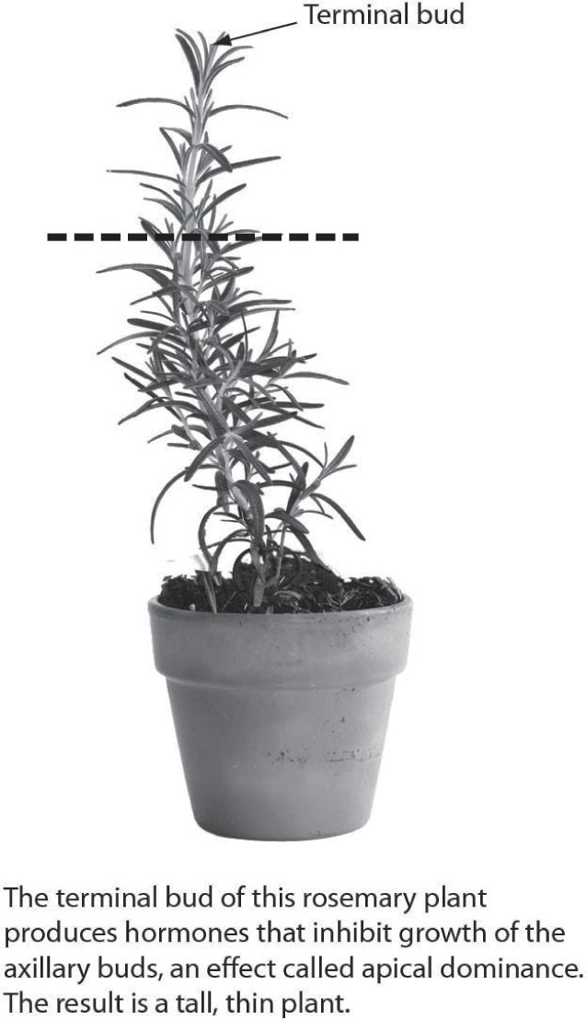

A) The plant will grow taller.
B) The plant will grow bushier.
C) The plant will produce flowers.
D) The plant will grow more roots.
Answer: B
Topic: 28.1 The Structure and Function of a Flowering Plant
Skill: Application/Analysis
Learning Outcome: 28.3
Global LO: 2, 3
2) The arrows in the figure below illustrate ________.

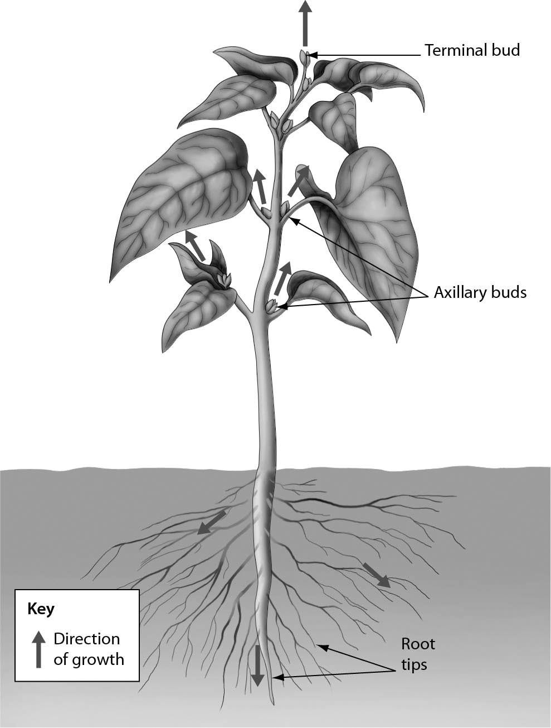

A) germination
B) secondary growth
C) meiosis
D) primary growth
Answer: D
Topic: 28.2 Plant Growth
Skill: Knowledge/Comprehension
Learning Outcome: 28.6
3) Examine the figure below. Secondary growth involves cell division in the ________.

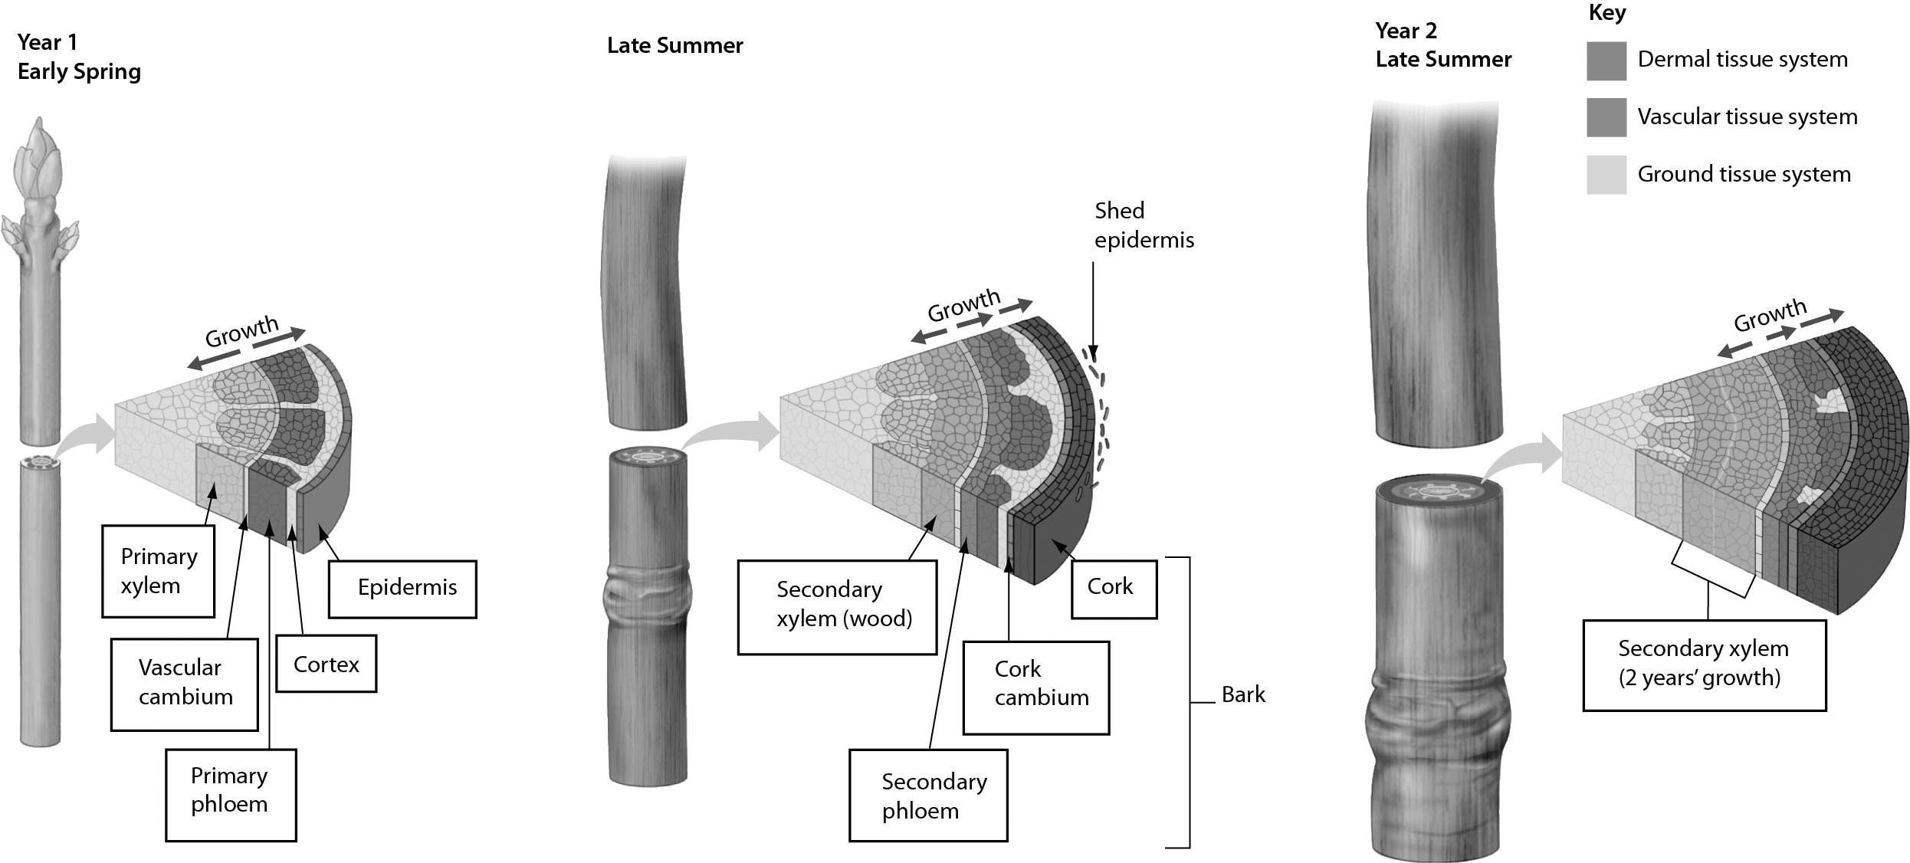

A) cork cambium and apical meristem
B) vascular cambium and apical meristem
C) vascular cambium and cork cambium
D) secondary xylem and secondary phloem
Answer: C
Topic: 28.2 Plant Growth
Skill: Application/Analysis
Learning Outcome: 28.6
Global LO: 2, 3
4) Examine the figure below. What process has to occur to produce a haploid embryo sac?

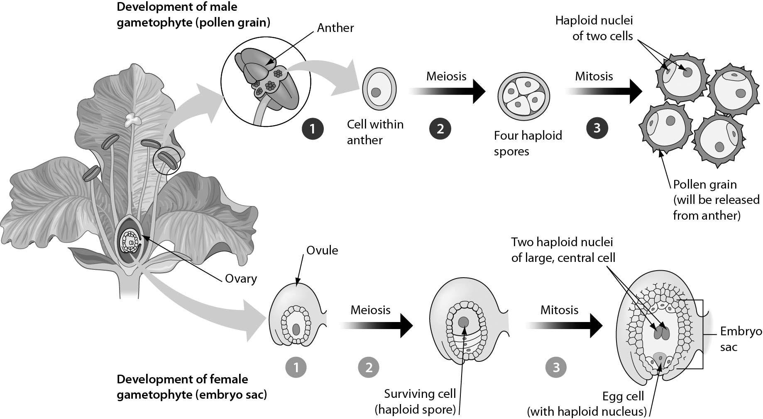
A) meiosis
B) meiosis followed by mitosis
C) mitosis followed by meiosis
D) mitosis
Answer: B
Topic: 28.3 The Life Cycle of a Flowering Plant
Skill: Application/Analysis
Learning Outcome: 28.7
Global LO: 2, 3
Please refer to the following art of the cross-sections of two trees to answer the following questions.

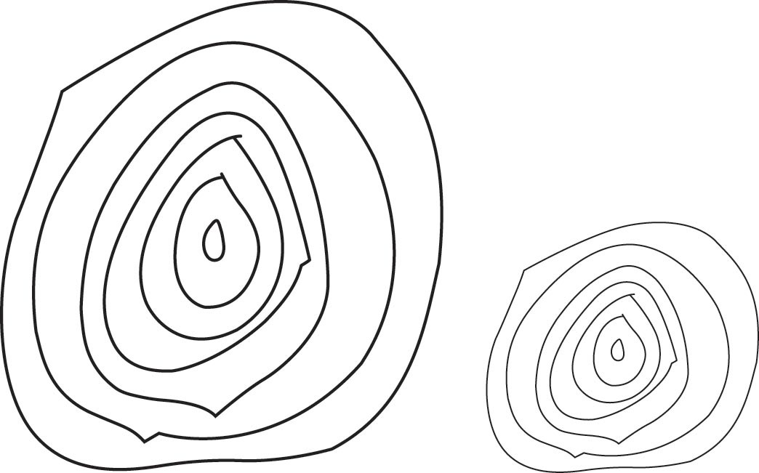

5) How old are these trees?
A) 3.5 years old
B) 7 years old
C) 14 years old
D) 28 years old
Answer: B
Topic: 28.2 Plant Growth
Skill: Application/Analysis
Learning Outcome: 28.6
Global LO: 2, 3

6) When were the cross-sections of these trees made?
A) before completion of the first year of growth
B) in the spring
C) later in the summer
D) in the winter
Answer: B
Topic: 28.2 Plant Growth, 28 The Process of Science
Skill: Application/Analysis
Learning Outcome: 28.6
Global LO: 2, 3

7) These trees most likely grew in an environment with ________.
A) constant cold temperatures
B) constant warm temperatures
C) alternating warm and cold seasons
D) It is not possible to predict the temperatures of the trees' environment.
Answer: C
Topic: 28.2 Plant Growth, 28 The Process of Science
Skill: Application/Analysis
Learning Outcome: 28.6
Global LO: 2, 3, 7
8) Which statement CORRECTLY compares the growth of these two trees?
A) The two trees grew at the same rate.
B) The tree on the left grew at a slower rate than the tree on the right.
C) The tree on the left grew at a faster rate than the tree on the right.
D) The growth of the two trees cannot be compared with the images shown.
Answer: C
Topic: 28.2 Plant Growth, 28 The Process of Science
Skill: Synthesis/Evaluation
Learning Outcome: 28.6
Global LO: 2, 3, 4

28.3 Scenario Questions

Read the following scenario to answer the following questions.

In late 2006, bee workers in the United States started to notice a disturbing phenomenon: the sudden disappearance of honeybees from commercial hives. This mysterious condition was called "colony collapse disorder," and it has caused a drastic reduction in commercial honeybee populations all over the country. It is estimated that one-third of our food supply relies on bees and is in danger. Crops that rely most heavily on honeybees include apples, almonds, blueberries, and pumpkins. If colony collapse disorder cannot be cured or treated effectively, farmers may have to turn to other insects, perhaps other bee species or even moths.

1) Without honeybees, which process in the life cycle of plants such as apples, almonds, blueberries, and pumpkins is most affected?
A) seed dispersal
B) secondary growth
C) pollination
D) seed germination
Answer: C
Topic: 28.3 The Life Cycle of a Flowering Plant, 28 Evolution Connection
Skill: Knowledge/Comprehension
Learning Outcome: 28.7, 28.8
Global LO: 5

2) Which plant structure is adapted for attracting beneficial insects such as honeybees?
A) axillary bud
B) terminal bud
C) flower
D) petiole
Answer: C
Topic: 28.3 The Life Cycle of a Flowering Plant, 28 Evolution Connection
Skill: Knowledge/Comprehension
Learning Outcome: 28.8
Read the following scenario to answer the following questions.

The North American beaver is a large rodent that builds dams to convert freshwater streams into ponds. Beavers build their dams out of trees, which they cut down using their front teeth. Beavers also eat the leaves and bark of trees, as well as the starchy roots of water lilies.

3) As a beaver chews from the outside to the inside of a tree, in what order does it encounter plant tissues?
A) secondary xylem ⇒ secondary phloem ⇒ cork ⇒ cork cambium ⇒ vascular cambium
B) cork cambium ⇒ cork ⇒ secondary xylem ⇒ vascular cambium ⇒ secondary phloem
C) cork ⇒ cork cambium ⇒ vascular cambium ⇒ secondary xylem ⇒ secondary phloem
D) cork ⇒ cork cambium ⇒ secondary phloem ⇒ vascular cambium ⇒ secondary xylem
Answer: D
Topic: 28.1 The Structure and Function of a Flowering Plant
Skill: Application/Analysis
Learning Outcome: 28.4
Global LO: 2

4) When a beaver is eating bark, what plant structures is it ingesting?
A) secondary phloem, cork cambium, and cork
B) secondary xylem, secondary phloem, and cork cambium
C) primary phloem, cortex, and endodermis
D) primary xylem, vascular cambium, and primary phloem
Answer: A
Topic: 28.1 The Structure and Function of a Flowering Plant
Skill: Application/Analysis
Learning Outcome: 28.4, 28.6
Global LO: 2

5) When a beaver is eating leaves, what plant structure(s) is it ingesting?
I) mesophyll
II) parenchyma
III) cork
A) I
B) II
C) III
D) I and II
Answer: D
Topic: 28.1 The Structure and Function of a Flowering Plant
Skill: Application/Analysis
Learning Outcome: 28.4
Global LO: 2
6) Water lilies store carbohydrates in their roots, which is why beavers like to eat water lily roots. What type of plant cells store these carbohydrates?
A) guard cells
B) sclerenchyma cells
C) parenchyma cells
D) collenchyma cells
Answer: C
Topic: 28.1 The Structure and Function of a Flowering Plant
Skill: Application/Analysis
Learning Outcome: 28.4
Global LO: 2

7) Beavers dams are sturdy, because the part of a tree that provides structural support when the tree is alive lends its strength to the dam, even after the tree is dead. What part of a tree provides this structural support?
A) heartwood
B) bark
C) collenchyma
D) parenchyma
Answer: A
Topic: 28.2 Plant Growth
Skill: Application/Analysis
Learning Outcome: 28.6
Global LO: 2

8) Water lily shoots and roots have very little structural support because this support is not needed in aquatic habitats. What structures would you be LEAST likely to see in a water lily stem?
A) epidermis
B) parenchyma
C) sclerenchyma
D) tracheids
Answer: C
Topic: 28.1 The Structure and Function of a Flowering Plant
Skill: Synthesis/Evaluation
Learning Outcome: 28.4
Global LO: 2
Read the following scenario to answer the following questions.

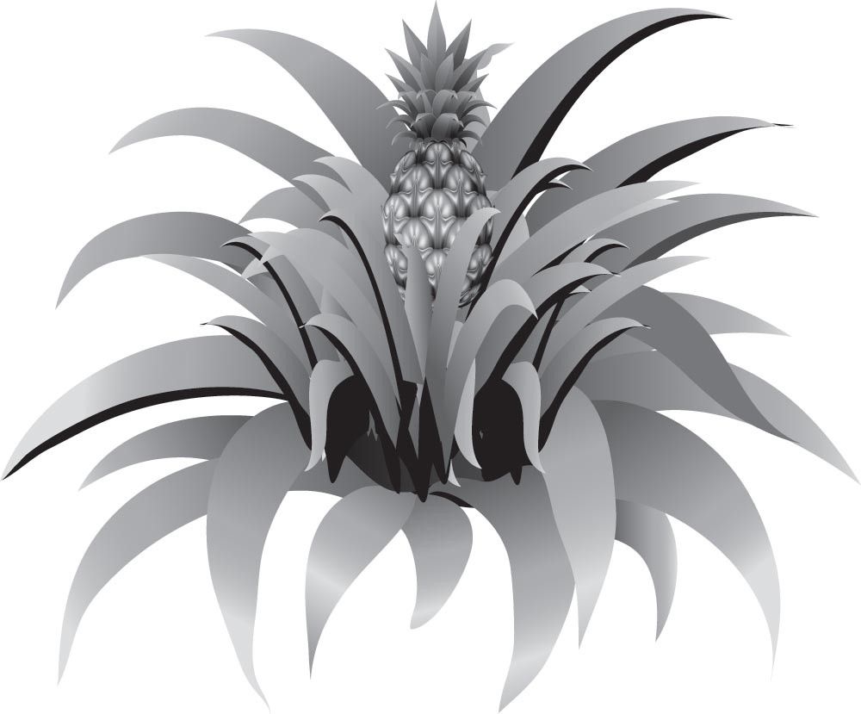

The pineapple, grown for its sweet fruit, is a tropical monocot with a diploid number of 50. It can live for many years. The plant starts as one short stem with tough leaves. The flowers of the pineapple are located as a cluster at the very top of the stem. After pollination, the single fruit forms from the fusion of the ovaries of the flowers in the cluster. The seeds are located just underneath the surface of the fruit. The pineapple fruit is harvested by cutting at the base of the fruit. After the first fruit is produced, side shoots grow from the main stem, which can go on to produce additional fruits.

9) The first pineapple on a plant develops from ________, whereas the pineapples from the second harvest of the same plant develop from ________.
A) the terminal bud… the axillary buds
B) the terminal bud… the root caps
C) the axillary bud… the terminal buds
D) primary growth… secondary growth
Answer: A
Topic: 28.1 The Structure and Function of a Flowering Plant, 28.2 Plant Growth
Skill: Application/Analysis
Learning Outcome: 28.3, 28.6
Global LO: 2

10) What evidence best supports the pineapple's classification as a monocot?
A) It does not produce woody tissue.
B) It produces a fruit.
C) Its flowers have three petals each.
D) It has double fertilization.
Answer: B
Topic: 28.1 The Structure and Function of a Flowering Plant
Skill: Application/Analysis
Learning Outcome: 28.2
Global LO: 2
11) Where would we expect to find cells with 25 unpaired chromosomes in a pineapple plant?
A) in the leaves
B) in the ovaries prior to pollination
C) in the fruit
D) in the fused ovaries
Answer: B
Topic: 28.3 The Life Cycle of a Flowering Plant
Skill: Synthesis/Evaluation
Learning Outcome: 28.7
Global LO: 2

