Campbell Essential Biology, 6e, Global Edition (Simon/Dickey/Hogan/Reece)

Chapter 29 The Working Plant

Chapter 29 Learning Outcomes
29 Biology and Society: Planting Hope in the Wake of Disaster
29.1. Explain how phytoremediation is helping to address the damage caused by the 2011 earthquake disaster that struck Japan.
29.1 How Plants Acquire and Transport Nutrients
29.2. Describe where and how a plant obtains all the materials necessary to construct all the organic materials it needs, including the adaptations used to obtain them.
29.3. Distinguish between micronutrients and macronutrients, noting examples of each.
29.4. Describe what constitutes organic farming, and list advantages of this type of farming.
29.5. Explain the cohesion-tension hypothesis responsible for the ascent of sap in xylem, and the plant structures involved.
29.6. Explain how, when, and where phloem conducts sap.
29.2 Plant Hormones
29.7. Describe the general roles and properties of plant hormones, the specific roles of the five major types, and how they are studied and used by humans to manipulate plants.
29.3 Response to Stimuli
29.8. Define phototropism, gravitropism, and thigmotropism and explain their significance in plants.
29.9. Distinguish between short-night plants and long-night plants.
29 Evolution Connection: Plants, Bugs, and People
29.10. Explain how interacting organisms affect each other’s fitness.
Global Learning Outcomes
1. Demonstrate an understanding of the principles of scientific inquiry.
2. Demonstrate the ability to think critically and employ critical-thinking skills.
3. Read and interpret models, graphs, and data.
4. Demonstrate the quantitative skills needed to succeed in biology.
5. Demonstrate an understanding of the impact of science on society.
6. Evaluate the credibility of scientific information from various sources.
7. Demonstrate the ability to make connections between concepts across biology.
8. Communicate effectively in writing.
9. Apply the scientific method to interpret information and draw conclusions.

29.1 Multiple Choice Questions

1) In phytoremediation, plants are used to remove ________ and ________ from the soil.
A) carbon… heavy metals
B) radioactive isotopes… heavy metals
C) nitrogen… phosphorus
D) water… sulfur
Answer: B
Topic: 29 Biology and Society
Skill: Knowledge/Comprehension
Learning Outcome: 29.1
Global LO: 5

2) Which of the following BEST describes the essential difference between plant and animal nutrition?
A) Plants use inorganic substances and energy from the sun to produce their own food.
B) Plants use organic substances to produce their own food.
C) Plants absorb food through their roots.
D) Plant and animal nutrition are essentially the same.
Answer: A
Topic: 29.1 How Plants Acquire and Transport Nutrients
Skill: Knowledge/Comprehension
Learning Outcome: 29.2
Global LO: 7

3) For a plant, carbon and nitrogen are ________.
A) macronutrients
B) micronutrients
C) minerals
D) compost
Answer: A
Topic: 29.1 How Plants Acquire and Transport Nutrients
Skill: Knowledge/Comprehension
Learning Outcome: 29.3

4) Which of the following describes a chemical element that a plant must obtain from its environment in order to complete its life cycle?
A) macronutrient
B) micronutrient
C) essential element
D) mineral
Answer: C
Topic: 29.1 How Plants Acquire and Transport Nutrients
Skill: Knowledge/Comprehension
Learning Outcome: 29.2
5) Which one of the following is a plant micronutrient?
A) iron
B) oxygen
C) sulfur
D) phosphorus
Answer: A
Topic: 29.1 How Plants Acquire and Transport Nutrients
Skill: Knowledge/Comprehension
Learning Outcome: 29.3

6) The three most important nutrients contained in fertilizers are ________.
A) nitrogen, iron, and phosphorus
B) zinc, sulfur, and phosphorus
C) nitrogen, phosphorus, and potassium
D) zinc, iron, and potassium
Answer: C
Topic: 29.1 How Plants Acquire and Transport Nutrients
Skill: Knowledge/Comprehension
Learning Outcome: 29.3
Global LO: 5

7) Which of the following best describes substances that enter a plant through the root system?
A) They are dissolved in water.
B) They are obtained from the air.
C) They are organic molecules.
D) They are brought in through stomata.
Answer: A
Topic: 29.1 How Plants Acquire and Transport Nutrients
Skill: Knowledge/Comprehension
Learning Outcome: 29.2

8) Which of the following supplies water and minerals to a typical plant?
A) the air
B) bacteria
C) sunlight
D) the soil
Answer: D
Topic: 29.1 How Plants Acquire and Transport Nutrients
Skill: Knowledge/Comprehension
Learning Outcome: 29.2

9) For plants, mycorrhizae are______.
A) parasitic
B) mutualistic
C) an adaptation for photosynthesis
D) agricultural pests
Answer: B
Topic: 29.1 How Plants Acquire and Transport Nutrients
Skill: Knowledge/Comprehension
Learning Outcome: 29.2
10) What does a plant gain from a mycorrhizal relationship?
A) It allows roots to absorb water and solutes more rapidly.
B) It increases the surface area for photosynthesis.
C) It helps to break down complex molecules in the soil to release micronutrients.
D) It helps to break down decaying organic matter into essential plant nutrients.
Answer: A
Topic: 29.1 How Plants Acquire and Transport Nutrients
Skill: Knowledge/Comprehension
Learning Outcome: 29.2

11) Which of the following convert atmospheric nitrogen to ammonium?
A) nitrifying bacteria
B) nitrogen-fixing bacteria
C) mycorrhizae
D) ammonifying bacteria
Answer: B
Topic: 29.1 How Plants Acquire and Transport Nutrients
Skill: Knowledge/Comprehension
Learning Outcome: 29.2

12) Which of the following convert soil ammonium to nitrate?
A) nitrifying bacteria
B) ammonifying bacteria
C) mycorrhizae
D) nitrogen-fixing bacteria
Answer: A
Topic: 29.1 How Plants Acquire and Transport Nutrients
Skill: Knowledge/Comprehension
Learning Outcome: 29.2

13) Which of the following best describes the role of plant root nodules in plants such as peas and beans?
A) They house nitrogen-fixing bacteria.
B) They help absorb nutrients from the soil.
C) They house mycorrhizae.
D) They store nutrients.
Answer: A
Topic: 29.1 How Plants Acquire and Transport Nutrients
Skill: Knowledge/Comprehension
Learning Outcome: 29.2

14) Most plants rely on bacteria to supply them with a usable form of which of the following substances?
A) nitrogen
B) carbon dioxide
C) water
D) amino acids
Answer: A
Topic: 29.1 How Plants Acquire and Transport Nutrients
Skill: Knowledge/Comprehension
Learning Outcome: 29.2
15) Which of the following best describes the conversion that occurs during nitrogen fixation?
A) ammonium to nitrate
B) nitrate to ammonium
C) nitrogen to ammonium
D) nitrogen to ammonium or nitrate
Answer: C
Topic: 29.1 How Plants Acquire and Transport Nutrients
Skill: Knowledge/Comprehension
Learning Outcome: 29.2

16) Which of the following best describes transpiration?
A) the loss of oxygen from a plant
B) evaporation from a plant's roots
C) the bulk flow movement of water in a plant
D) the loss of water from plant leaves through evaporation
Answer: D
Topic: 29.1 How Plants Acquire and Transport Nutrients
Skill: Knowledge/Comprehension
Learning Outcome: 29.5

17) Which of the following mechanisms best explains how xylem sap moves up against the downward pull of gravity?
A) cohesion-tension hypothesis
B) gravitropism
C) phototropism
D) expenditure of ATP
Answer: A
Topic: 29.1 How Plants Acquire and Transport Nutrients
Skill: Knowledge/Comprehension
Learning Outcome: 29.5

18) Which of the following weather conditions would cause transpiration to be most rapid?
A) hot, humid weather
B) cold, humid weather
C) hot, dry weather
D) windy, wet weather
Answer: C
Topic: 29.1 How Plants Acquire and Transport Nutrients
Skill: Knowledge/Comprehension
Learning Outcome: 29.5

19) Which of the following best describes the opening and closing of the stomata in most plants?
A) They are open during the day and closed at night.
B) They are open at night and closed during the day.
C) They are open almost all of the time.
D) They are closed except for brief periods of time during the day.
Answer: A
Topic: 29.1 How Plants Acquire and Transport Nutrients
Skill: Knowledge/Comprehension
Learning Outcome: 29.5
20) Which of the following best describes the mechanism that causes stomata to open?
A) Water accumulates below the opening and eventually causes the stoma to open.
B) A large bubble of oxygen accumulates below the stoma and eventually causes it to open.
C) Two guard cells flanking each stoma control its opening by changing shape.
D) The internal pressure of xylem sap expands the leaf, stretching the stoma open.
Answer: C
Topic: 29.1 How Plants Acquire and Transport Nutrients
Skill: Knowledge/Comprehension
Learning Outcome: 29.5

21) Transpiration pulls water up a plant because of two mechanisms: ________ describes water molecules sticking together and ________ describes water molecules sticking to the walls of the xylem.
A) cohesion... adhesion
B) adhesion... cohesion
C) adhesion... gravity
D) gravity... cohesion
Answer: A
Topic: 29.1 How Plants Acquire and Transport Nutrients
Skill: Knowledge/Comprehension
Learning Outcome: 29.5

22) Which of the following explains how phloem sap moves within a plant?
A) cohesion-tension mechanism
B) gravity pulls the phloem sap down
C) pressure-flow mechanism
D) transpiration
Answer: C
Topic: 29.1 How Plants Acquire and Transport Nutrients
Skill: Knowledge/Comprehension
Learning Outcome: 29.6

23) A location in a plant where sugar is being received for storage or consumption is ________.
A) a sugar sink
B) a sugar source
C) phloem sap
D) phloem tube
Answer: A
Topic: 29.1 How Plants Acquire and Transport Nutrients
Skill: Knowledge/Comprehension
Learning Outcome: 29.6
24) A farmer decides she wants to grow certified organic corn and sets out to meet all USDA standards to do so. Her crop grows well for the first 3 years; however, she notices during the 4th and 5th years that plants are getting smaller and producing much less corn. She has not altered farming practices and begins to wonder what is happening. She remembers someone mentioning planting peanuts every 3rd year in place of a corn crop, which leads to much healthier corn. Why would a farmer want to change to a different crop, especially something like peanuts?
A) Planting a legume like peanuts increases water retention in the soil, allowing the following year's corn crop to thrive.
B) Crop rotation with a legume like peanuts will increase nitrogen in the soil, reducing the need for chemical fertilizer.
C) Planting a legume like peanuts increases the available carbon in the soil.
D) Changing from corn to peanuts, a legume, allows the soil to "rest" for a year.
Answer: B
Topic: 29.1 How Plants Acquire and Transport Nutrients
Skill: Application/Analysis
Learning Outcome: 29.2, 29.4
Global LO: 2, 5

25) In a strawberry plant in the summer, the leaves are ________ and the strawberry fruits are ________.
A) sugar sources… sugar sources
B) sugar sources… sugar sinks
C) sugar sinks… sugar sources
D) sugar sinks… sugar sinks
Answer: B
Topic: 29.1 How Plants Acquire and Transport Nutrients
Skill: Application/Analysis
Learning Outcome: 29.6
Global LO: 2

26) Early in the spring, cherry trees produce flowers, even before their leaves develop, by using sugars that were stored in their roots the previous year. While cherry flowers are developing, we would expect the phloem pressure near flowers to be ________, and ________ near root storage cells.
A) high… high
B) high… low
C) low… low
D) low… high
Answer: D
Topic: 29.1 How Plants Acquire and Transport Nutrients
Skill: Application/Analysis
Learning Outcome: 29.6
Global LO: 2
27) Trace the flow of a water molecule that is used during photosynthesis.
A) stoma → xylem → root hair → mycorrhiza
B) soil → root hair → xylem → stoma → atmosphere
C) soil → root hair → xylem → leaf cell
D) soil → xylem → leaf cell → atmosphere
Answer: C
Topic: 29.1 How Plants Acquire and Transport Nutrients
Skill: Application/Analysis
Learning Outcome: 29.5
Global LO: 2, 7

28) Which of the following statements is TRUE?
A) A given hormone has the same effect on all parts of a plant.
B) A single hormone may have different effects depending on concentration and presence of other hormones.
C) Plants and animals use hormones in very different ways.
D) Large amounts of hormones are required to affect plant growth and development.
Answer: B
Topic: 29.2 Plant Hormones
Skill: Knowledge/Comprehension
Learning Outcome: 29.7

29) Which of the following plant hormones affect(s) development in the plant body?
I) auxin
II) cytokinin
III) gibberellin
A) I
B) I and II
C) III
D) I, II, and III
Answer: D
Topic: 29.2 Plant Hormones
Skill: Knowledge/Comprehension
Learning Outcome: 29.7

30) Which of the following hormones promotes cell elongation in stems?
A) auxin
B) cytokinin
C) ethylene
D) gibberellin
Answer: A
Topic: 29.2 Plant Hormones
Skill: Knowledge/Comprehension
Learning Outcome: 29.7
31) Which of the following best describes the condition of a twig if the auxin produced by its apical meristem is conveyed equally down all sides?
A) It will elongate.
B) It will branch near its tip.
C) It will produce a flower.
D) It will bend to one side.
Answer: A
Topic: 29.2 Plant Hormones
Skill: Knowledge/Comprehension
Learning Outcome: 29.7

32) Which of the following hormones promotes fruit ripening and dropping of leaves?
A) auxin
B) ethylene
C) gibberellin
D) abscisic acid
Answer: B
Topic: 29.2 Plant Hormones
Skill: Knowledge/Comprehension
Learning Outcome: 29.7

33) Which of the following hormones promotes cell division?
A) auxin
B) cytokinin
C) gibberellin
D) abscisic acid
Answer: B
Topic: 29.2 Plant Hormones
Skill: Knowledge/Comprehension
Learning Outcome: 29.7

34) Which of the following hormones promotes seed germination?
A) auxin
B) ethylene
C) gibberellin
D) abscisic acid
Answer: C
Topic: 29.2 Plant Hormones
Skill: Knowledge/Comprehension
Learning Outcome: 29.7

35) Which of the following hormones promotes seed dormancy?
A) cytokinin
B) ethylene
C) gibberellin
D) abscisic acid
Answer: D
Topic: 29.2 Plant Hormones
Skill: Knowledge/Comprehension
Learning Outcome: 29.7
36) Which of the following is exemplified by a pea tendril contacting a string or wire and coiling around it for support?
A) gravitropism
B) photoperiod
C) thigmotropism
D) phototropism
Answer: C
Topic: 29.3 Response to Stimuli
Skill: Knowledge/Comprehension
Learning Outcome: 29.8

37) Experimental plants that were sent up in space shuttle missions did not exhibit all of their normal tropisms. Which of the following responses would you most expect to be lacking from these plants?
A) gravitropism
B) photoperiod
C) thigmotropism
D) phototropism
Answer: A
Topic: 29.3 Response to Stimuli
Skill: Application/Analysis
Learning Outcome: 29.8
Global LO: 2

38) Which of the following best describes night-neutral plants?
A) The plants flower at night.
B) Plants tend to flower when nights become longer.
C) Plants tend to flower when nights become shorter.
D) The flowering in these plants is not affected by photoperiod.
Answer: D
Topic: 29.3 Response to Stimuli
Skill: Knowledge/Comprehension
Learning Outcome: 29.9

39) Which of the following triggers flowering for plants sensitive to photoperiod?
A) temperature
B) night length
C) day length
D) intensity of sunlight
Answer: B
Topic: 29.3 Response to Stimuli
Skill: Knowledge/Comprehension
Learning Outcome: 29.9
40) Which of the following best describe(s) the dependencies of most flowering plants?
I) Many depend on insects or other animals for pollination.
II) Many depend on insects or other animals for seed dispersal.
III) Many depend on fungi to help them acquire nutrients.
A) I
B) II
C) I and III
D) I, II, and III
Answer: D
Topic: 29 Evolution Connection
Skill: Knowledge/Comprehension
Learning Outcome: 29.10

41) Across the globe, billions of people eat rice. In order to make rice grains (the seed), a rice plant must flower and be pollinated. Rice plants flower only after days become shorter (i.e., summer to autumn). What is the best classification for rice?
A) long night
B) short night
C) night neutral
D) long day
Answer: A
Topic: 29.3 Response to Stimuli
Skill: Application/Analysis
Learning Outcome: 29.9
Global LO: 2, 5

42) Oats are eaten by humans as oatmeal or rolled oats, and as feed for livestock such as cattle. In order for an oat plant to make the part we eat (the seed), it must flower and be pollinated. Typically, oat plants flower when days are lengthening (i.e., late spring to early summer). What is the best classification for oat plants?
A) long night
B) short night
C) night neutral
D) short day
Answer: B
Topic: 29.3 Response to Stimuli
Skill: Application/Analysis
Learning Outcome: 29.9
Global LO: 2, 5
43) Three very popular strawberry cultivars grown by farmers in the United States are Earliglow, Ozark Beauty, and Tristar. Earliglow produces all of its fruit in the early summer (June-bearing). Ozark Beauty produces fruit from mid to late summer (everbearing). Tristar produces fruit all summer long, starting when conditions become favorable for flowering and fruit production. What is the best classification for these three strawberry cultivars?
A) Earliglow: long night; Ozark Beauty: short night; Tristar: night neutral
B) Earliglow: short night; Ozark Beauty: short night; Tristar: night neutral
C) Earliglow: night neutral; Ozark Beauty: short night; Tristar: long night
D) Earliglow: short night; Ozark Beauty: long night; Tristar: long neutral
Answer: A
Topic: 29.3 Response to Stimuli
Skill: Synthesis/Evaluation
Learning Outcome: 29.9
Global LO: 2, 5

29.2 Art Questions

1) Examine the figure below. Which of the following is the site of carbon dioxide uptake by a plant?

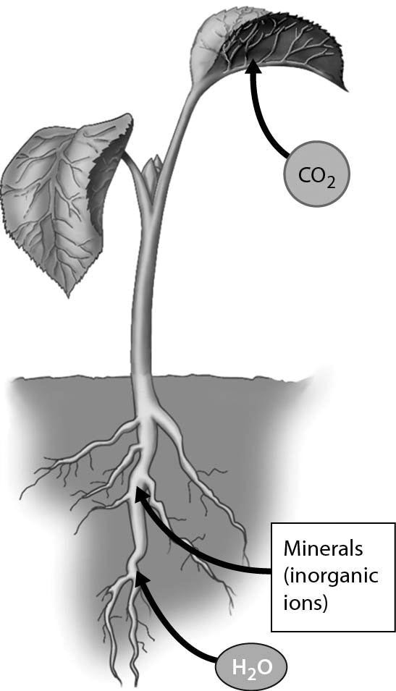

A) root hairs
B) stomata
C) rhizomes
D) internodes
Answer: B
Topic: 29.1 How Plants Acquire and Transport Nutrients
Skill: Application/Analysis
Learning Outcome: 29.2
Global LO: 2, 3
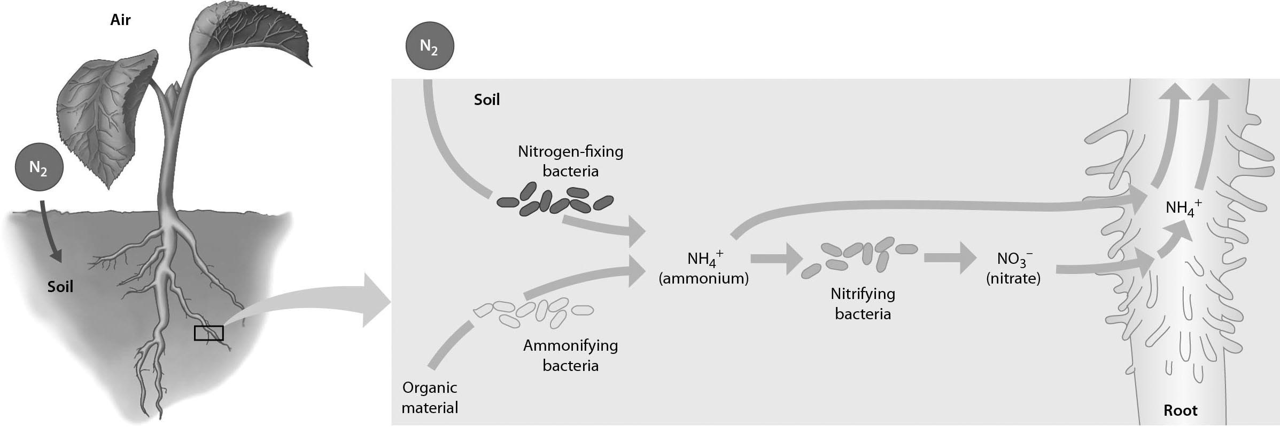

2) Examine the figure above. Which of the following add ammonium to the soil by decomposing organic matter?
A) nitrifying bacteria only
B) ammonifying bacteria only
C) nitrogen-fixing bacteria only
D) nitrifying bacteria and nitrogen fixing bacteria
Answer: B
Topic: 29.1 How Plants Acquire and Transport Nutrients
Skill: Application/Analysis
Learning Outcome: 29.2
Global LO: 2, 3

3) In the figure above, which of the following produce nitrogen in a form that can be used directly by the plant, without need for conversion?
A) nitrifying bacteria only
B) ammonifying bacteria only
C) nitrogen-fixing bacteria only
D) ammonifying bacteria and nitrogen fixing bacteria
Answer: D
Topic: 29.1 How Plants Acquire and Transport Nutrients
Skill: Application/Analysis
Learning Outcome: 29.2
Global LO: 2, 3
4) Examine the figure below. When considering the shaded side of a grass shoot, which of the following best describes why it bends toward the light?

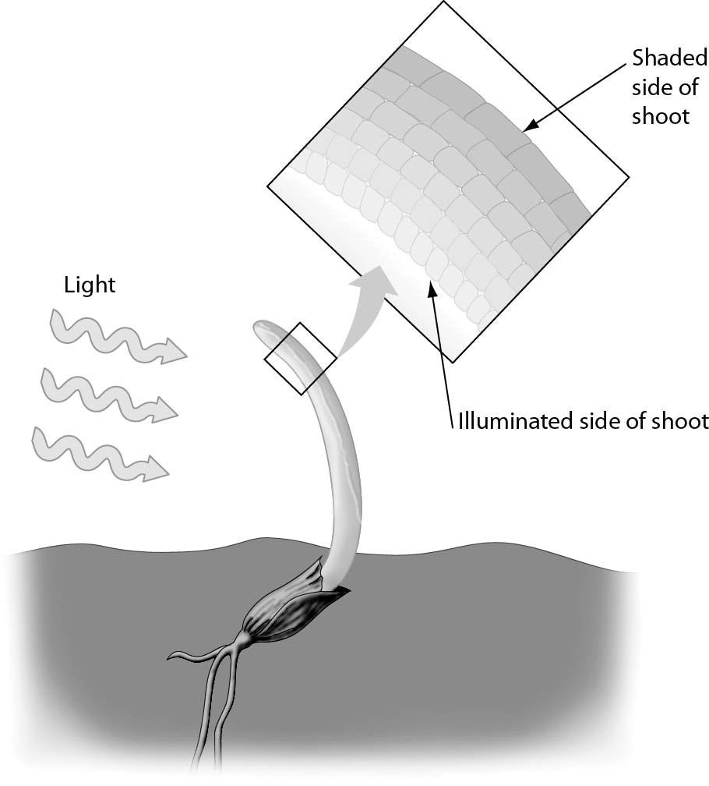

A) Reduction in auxin levels allows gibberellins to promote cell elongation.
B) Reduction in gibberellin levels allows auxin to promote cell elongation.
C) Increase in auxin levels promotes cell elongation.
D) Increase in auxin levels promotes cell proliferation.
Answer: C
Topic: 29.2 Plant Hormones
Skill: Application/Analysis
Learning Outcome: 29.7
Global LO: 2, 3
5) The figure below shows plants grown in the dark, and illustrates ________ in plants.

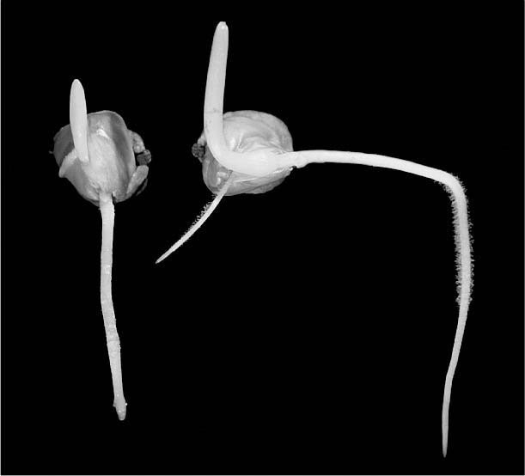

A) photoperiod
B) gravitropism
C) thigmotropism
D) phototropism
Answer: B
Topic: 29.3 Response to Stimuli
Skill: Application/Analysis
Learning Outcome: 29.9
Global LO: 2, 3

6) The figure below shows plants originally grown in the dark, and then a light is added on one side only (arrow). Predict the response of the plants to the addition of the light source.

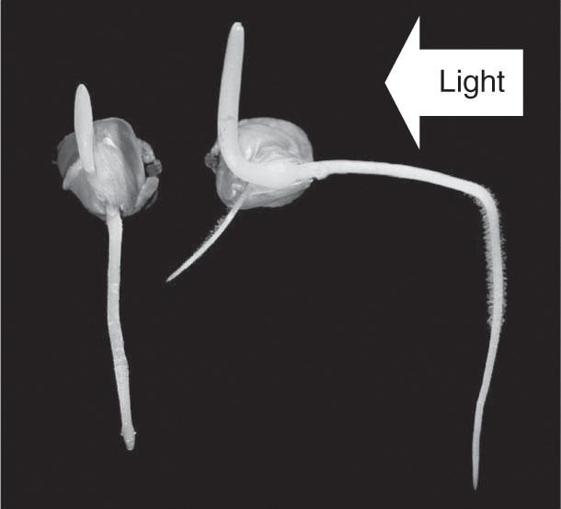

A) Auxin becomes concentrated on the lighted side of the plants, and the plants begin to grow toward the light.
B) Auxin becomes concentrated on the darker side of the plants, and the plants begin to grow toward the light.
C) Auxin becomes concentrated on the lighted side of the plants, and the plants begin to grow away from the light.
D) Auxin becomes concentrated on the darker side of the plants, and the plants begin to grow away from the light.
Answer: B
Topic: 29.3 Response to Stimuli
Skill: Application/Analysis
Learning Outcome: 29.9
Global LO: 2, 3
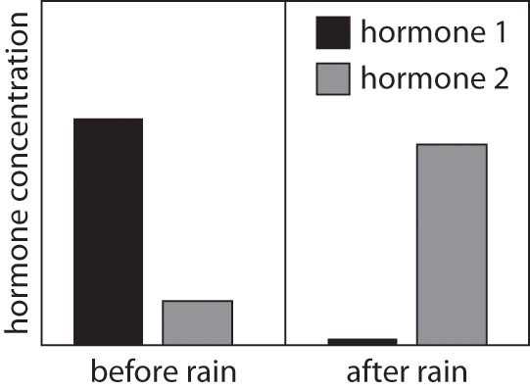

7) A scientist finds seeds of an unknown plant on top of the soil in a desert. She measures the concentration of two hormones in these seeds. After it rains, she collects more of these seeds, and finds that the concentration of the two hormones has changed. A graph of her results is shown above. Identify the most likely hormones measured by the scientist.
A) hormone 1: gibberellin; hormone 2: cytokinin
B) hormone 1: auxin; hormone 2: ethylene
C) hormone 1: abscisic acid; hormone 2: gibberellin
D) hormone 1: ethylene; hormone 2: auxin
Answer: C
Topic: 29.2 Plant Hormones
Skill: Synthesis/Evaluation
Learning Outcome: 29.7
Global LO: 2, 3

8) A scientist finds seeds of an unknown plant on top of the soil in a desert. She measures the concentration of two hormones in these seeds. After it rains, she collects more of these seeds, and finds that the concentration of the two hormones has changed. A graph of her results is shown above. If the scientist returns to the desert to collect more seeds, a few days later, what should she observe?
A) The seeds that are still in the desert will be dormant.
B) The seeds that are still in the desert will be germinating.
C) The seeds that are still in the desert will be dead.
D) The seeds that are still in the desert will have increased levels of hormones 1 and 2.
Answer: B
Topic: 29.2 Plant Hormones
Skill: Synthesis/Evaluation
Learning Outcome: 29.7
Global LO: 2, 3
29.3 Scenario Questions

Read the following scenario to answer the following questions.

Nitrogen shortage is a common nutritional problem for plants. In crops, a nitrogen deficiency can result in stunted growth as well as lower nutritional content. Farmers sometimes apply fertilizers containing nitrogen as well as other essential nutrients, such as phosphorus and potassium. Compost can also be used to fertilize soils. Compost consists of vegetable matter that adds nutrients to soil as it is decomposed by microorganisms, fungi, and animals. Certain plants, including legumes such as peas and beans, house nitrogen-fixing bacteria in swellings called "root nodules." The bacteria have enzymes that help convert atmospheric N2 to ammonium ions that can be readily used by the plants. The plant, in turn, provides the bacteria with other nutrients. When conditions are favorable, root nodule bacteria fix so much nitrogen that the nodules secrete excess ammonia.

1) Some farmers practice crop rotation, alternating between planting nonlegumes such as corn or wheat one year and legumes the next year. What is the advantage of crop rotation?
A) The legumes in the rotation will transfer nitrogen, phosphorus, and potassium to the other crop plants.
B) Planting legumes enriches the soil for the next year when root nodule bacteria fix so much nitrogen that excess ammonia is secreted into the soil.
C) The nitrogen-fixing bacteria in legumes can migrate to nonlegume crop plants and provide them with nitrogen.
D) Any nitrogen fertilizer that is applied to the soil will be converted into ammonium ions by the nitrogen-fixing bacteria.
Answer: B
Topic: 29.1 How Plants Acquire and Transport Nutrients
Skill: Knowledge/Comprehension
Learning Outcome: 29.2
Global LO: 5

2) Which approach could an organic farmer use to deal with nitrogen deficiency?
A) plant legumes in alternate years and fertilize the soil with compost
B) apply synthetic fertilizers that provide nitrogen
C) plant legumes in alternate years and use synthetic fertilizers
D) use genetically modified plants that require less nitrogen
Answer: A
Topic: 29.1 How Plants Acquire and Transport Nutrients
Skill: Application/Analysis
Learning Outcome: 29.4
Global LO: 2, 5
Read the following scenario to answer the following questions.

In the late 1800s, Charles Darwin and his son Francis conducted the first experiments on phototropism. Several years later, their work was furthered by Peter Boysen-Jensen, Arpad Paal, and Frits Went. Peter Boysen-Jensen separated the tip of grass shoots from the rest of the plant using either tiny blocks of agar (a gelatin) or a mica wafer (an impervious rock). Like the Darwins, Boysen-Jensen noticed that the grass did not grow toward a light without its tips. However, when he separated the tip from the rest of the plant using agar, the grass would grow toward a light. The grass would not grow toward a light if the tip of the shoot was separated using a mica wafer. Arpad Paal cut off the tips of grass shoots that were growing in the dark. He placed these cut tips back on the shoots, but with only part of the tip covering the cut surface, and found that the plants grew, in the dark, in the opposite direction from the side with the tip covering it. Lastly, Frits Went removed the tips of many grass shoots and placed them on a large block of agar for a few hours. Then, he cut up the agar block, and was able to make grass shoots without any tips at all grow toward a light by putting these agar blocks on the cut surfaces of the shoots (i.e., no tips were placed back on the shoots, only the agar).

3) Boysen-Jensen also used the mica to separate a tip of a grass shoot only partially, by cutting the tip halfway and inserting a wafer of mica into the cut. If this experiment supported the Darwins' hypothesis, what would Boysen-Jensen have observed?
A) The grass shoot would not grow toward a light.
B) The grass shoot would grow toward a light when the mica wafer was on the side of the grass that was facing the light.
C) The grass shoot would grow toward a light when the mica wafer was on the side of the grass that was shaded from the light.
D) The grass shoot would grow toward a light no matter which direction the light was coming from.
Answer: B
Topic: 29.2 Plant Hormones, 29.3 Response to Stimuli
Skill: Synthesis/Evaluation
Learning Outcome: 29.8, 29.9
Global LO: 1, 2, 9

4) If Paal grew his plants using a light source that was directly overhead, what should he have observed?
A) The grass shoot would not grow.
B) The grass shoot would grow upward and straight.
C) The grass shoot would grow in the opposite direction from the side with the tip covering the cut surface.
D) The grass shoot would grow in the same direction as the side with the tip covering the cut surface.
Answer: C
Topic: 29.2 Plant Hormones, 29.3 Response to Stimuli
Skill: Synthesis/Evaluation
Learning Outcome: 29.8, 29.9
Global LO: 1, 2, 9
5) If Wents placed his agar blocks only halfway on the cut surfaces of grass shoots with their tips removed, what should he have observed?
A) The grass shoot would not grow toward a light.
B) The grass shoot would grow toward a light when the agar block was on the side of the grass that was facing the light.
C) The grass shoot would grow toward a light when the agar block was on the side of the grass that was shaded from the light.
D) The grass shoot would grow toward a light no matter which direction the light was coming from.
Answer: C
Topic: 29.2 Plant Hormones, 29.3 Response to Stimuli
Skill: Synthesis/Evaluation
Learning Outcome: 29.8, 29.9
Global LO: 1, 2, 9

6) Considering the experiments of the Darwins, Boysen-Jensen, Paal, and Went, what do you conclude about phototropism?
A) We still do not know the mechanism for phototropism.
B) The substance that regulates phototropism is produced in the tips of plants, and causes the same response even when it comes from an external source (not from the same individual).
C) For a plant to bend toward a light source, the substance that regulates phototropism must be able to move into cells on the same side as the light source.
D) The substance that regulates phototropism is distributed throughout a plant equally, but cells on the side away from the light source are the only ones that respond to the substance.
Answer: B
Topic: 29.2 Plant Hormones, 29.3 Response to Stimuli
Skill: Synthesis/Evaluation
Learning Outcome: 29.8, 29.9
Global LO: 1, 2, 9

