Campbell Essential Biology, 6e, Global Edition (Simon/Dickey/Hogan/Reece)

Chapter 6 Cellular Respiration: Obtaining Energy from Food

Chapter 6 Learning Outcomes

6 Biology and Society: Getting the Most Out of Your Muscles
6.1. Define the aerobic capacity of an athlete and explain what happens when the intake of oxygen is no longer sufficient.
6.1 Energy Flow and Chemical Cycling in the Biosphere
6.2. Explain why photosynthesis is important to most ecosystems.
6.3. Define and compare autotrophs and heterotrophs, producers and consumers.
6.4. Explain how the processes of photosynthesis and cellular respiration are complementary to each other.
6.2 Cellular Respiration: Aerobic Harvest of Food Energy
6.5. Write and explain the overall equation for cellular respiration.
6.6. Explain how electrons are transferred from glucose to NADH to an electron transport chain to oxygen.
6.7. Compare the reactants, products, location in the cell, and energy yield of the three stages of cellular respiration (glycolysis, citric acid cycle, and electron transport chain).
6.3. Fermentation: Anaerobic Harvest of Food Energy AND
the Process of Science: Exercise Science
6.8. Compare the reactants, products, and energy yield of aerobic metabolism versus fermentation in human cells including where each occurs in a cell and what the consequences are of lactic acid buildup.
6 Evolution Connection: The Importance of Oxygen
6.9. Describe the lines of evidence that suggest that glycolysis is a primitive form of metabolism.

Global Learning Outcomes

1. Demonstrate an understanding of the principles of scientific inquiry.
2. Demonstrate the ability to think critically and employ critical-thinking skills.
3. Read and interpret models, graphs, and data.
4. Demonstrate the quantitative skills needed to succeed in biology.
5. Demonstrate an understanding of the impact of science on society.
6. Evaluate the credibility of scientific information from various sources.
7. Demonstrate the ability to make connections between concepts across biology.
8. Communicate effectively in writing.
9. Apply the scientific method to interpret information and draw conclusions.

6.1 Multiple Choice Questions

1) Lactic acid build up in muscles is a sign that ________.
A) aerobic respiration capacity has not been reached
B) respiration is operating effectively
C) insufficient oxygen is reaching the muscles
D) the muscles will be able to operate continuously for a long time
Answer: C
Topic: 6 Biology and Society: Getting the Most Out of Your Muscles
Skill: Knowledge/Comprehension
Learning Outcome: 6.1
Global LO: 5

2) A process is referred to as aerobic if it requires ________.
A) oxygen
B) carbon dioxide
C) ATP
D) carbohydrates
Answer: A
Topic: 6 Biology and Society: Getting the Most Out of Your Muscles
Skill: Knowledge/Comprehension
Learning Outcome: 6.1

3) Humans are both ________.
A) heterotrophs and consumers
B) heterotrophs and producers
C) producers and decomposers
D) autotrophs and producers
Answer: A
Topic: 6.1 Energy Flow and Chemical Cycling in the Biosphere
Skill: Application/Analysis
Learning Outcome: 6.3
Global LO: 2

4) Photosynthetic organisms are ________.
A) producers that make all of their organic matter from organic molecules that they take in
B) consumers that obtain organic molecules from other living organisms
C) producers that make all their own organic matter from inorganic molecules
D) decomposers that obtain nutrients from the soil
Answer: C
Topic: 6.1 Energy Flow and Chemical Cycling in the Biosphere
Skill: Knowledge/Comprehension
Learning Outcome: 6.3
5) Photosynthetic organisms like grass are able to ________.
A) make all of their organic matter from organic molecules in the soil.
B) use water they take in through their leaves as a final electron acceptor.
C) change the light energy from sunlight into sugars
D) use substances in the air as a major source of carbon.
Answer: D
Topic: 6.1 Energy Flow and Chemical Cycling in the Biosphere
Skill: Application/Analysis
Learning Outcome: 6.3
Global LO: 2

6) A horse eating some hay is an example of ________.
A) an autotroph eating a producer
B) an autotroph eating a consumer
C) a consumer eating a producer
D) a consumer eating a heterotroph
Answer: C
Topic: 6.1 Energy Flow and Chemical Cycling in the Biosphere
Skill: Application/Analysis
Learning Outcome: 6.3
Global LO: 2

7) Plants use photosynthesis to
A) store chemical energy, and they use cellular respiration to harvest energy.
B) change light energy into chemical energy as well as to harvest chemical energy.
C) harvest energy, and they use cellular respiration to store chemical energy.
D) change light energy into sugars.
Answer: A
Topic: 6.1 Energy Flow and Chemical Cycling in the Biosphere
Skill: Knowledge/Comprehension
Learning Outcome: 6.2

*8) The waste products of cellular respiration include ________.
A) water only
B) carbon dioxide only
C) water and carbon dioxide
D) water and glucose
Answer: C
Topic: 6.1 Energy Flow and Chemical Cycling in the Biosphere
Skill: Knowledge/Comprehension
Learning Outcome: 6.4

9) Plant cells ________.
A) do not need chloroplasts because their mitochondria meet their energy needs
B) have chloroplasts and mitochondria
C) use carbon dioxide but do not use oxygen
D) do not need mitochondria because their chloroplasts meet their energy needs
Answer: B
Topic: 6.1 Energy Flow and Chemical Cycling in the Biosphere
Skill: Knowledge/Comprehension
Learning Outcome: 6.4
10) The ultimate source of the energy in food is ________.
A) the sun
B) producers
C) ATP
D) consumers
Answer: A
Topic: 6.1 Energy Flow and Chemical Cycling in the Biosphere
Skill: Knowledge/Comprehension
Learning Outcome: 6.2

11) What compound directly provides energy for cellular work?
A) C6H12O6
B) glucose
C) ATP
D) fat
Answer: C
Topic: 6.1 Energy Flow and Chemical Cycling in the Biosphere
Skill: Knowledge/Comprehension
Learning Outcome: 6.4

12) Respiration describes the exchange of gases between your blood and the air. Cellular respiration ________.
A) produces ATP
B) produces oxygen
C) produces glucose
D) uses carbon dioxide
Answer: A
Topic: 6.2 Cellular Respiration: Aerobic Harvest of Food Energy
Skill: Knowledge/Comprehension
Learning Outcome: 6.7

13) Which of these equations describes aerobic cellular respiration?
A) glucose → lactic acid + energy
B) energy + carbon dioxide + water → glucose + oxygen + water
C) glucose + oxygen → carbon dioxide + water + energy
D) none of the above
Answer: C
Topic: 6.2 Cellular Respiration: Aerobic Harvest of Food Energy
Skill: Knowledge/Comprehension
Learning Outcome: 6.7

14) Which of the following are produced as a result of cellular respiration?
A) ATP and water
B) carbon dioxide and ATP
C) carbon dioxide, water, and ATP
D) oxygen and glucose
Answer: C
Topic: 6.2 Cellular Respiration: Aerobic Harvest of Food Energy
Skill: Knowledge/Comprehension
Learning Outcome: 6.7
15) During cellular respiration, electrons move through a series of electron acceptor molecules. Which of the following is a TRUE statement about this process?
A) The electrons gain energy as they move from one electron acceptor to another.
B) Oxygen is eventually reduced by the electrons to form water.
C) The electrons release large amounts of energy each time they are transferred from one electron acceptor to another.
D) Glucose is eventually reduced by the electrons to form water.
Answer: B
Topic: 6.2 Cellular Respiration: Aerobic Harvest of Food Energy
Skill: Knowledge/Comprehension
Learning Outcome: 6.6

16) Which of the following statements is TRUE?
A) Oxygen is a product of cellular respiration; carbon dioxide is a product of photosynthesis.
B) Lactic acid is a product of aerobic respiration; ethyl alcohol is a product of fermentation.
C) Oxidation is the loss of electrons; reduction is the gain of electrons.
D) Glucose is a product of aerobic respiration; lactic acid is a product of anaerobic respiration.
Answer: C
Topic: 6.2 Cellular Respiration: Aerobic Harvest of Food Energy
Skill: Knowledge/Comprehension
Learning Outcome: 6.4

*17) The first electron acceptor of cellular respiration is ________.
A) CO2
B) O2
C) NAD+
D) H2O
Answer: C
Topic: 6.2 Cellular Respiration: Aerobic Harvest of Food Energy
Skill: Knowledge/Comprehension
Learning Outcome: 6.6

*18) The final electron acceptor of aerobic respiration is ________.
A) ATP
B) oxygen
C) lactic acid
D) NAD+
Answer: B
Topic: 6.2 Cellular Respiration: Aerobic Harvest of Food Energy
Skill: Knowledge/Comprehension
Learning Outcome: 6.6

*19) Where in the cell does glycolysis occur?
A) cytoplasm
B) endoplasmic reticulum (ER)
C) within the fluid just inside the inner mitochondrial membrane
D) between the inner and outer mitochondrial membrane
Answer: A
Topic: 6.2 Cellular Respiration: Aerobic Harvest of Food Energy
Skill: Knowledge/Comprehension
Learning Outcome: 6.7
*20) Which of the following is the CORRECT sequence of stages in cellular respiration?
A) glycolysis, citric acid cycle, electron transport
B) citric acid cycle, glycolysis, electron transport
C) citric acid cycle, electron transport, glycolysis
D) electron transport, glycolysis, citric acid cycle
Answer: A
Topic: 6.2 Cellular Respiration: Aerobic Harvest of Food Energy
Skill: Knowledge/Comprehension
Learning Outcome: 6.7

*21) A product of glycolysis is ________.
A) lactic acid
B) ethyl alcohol
C) O2
D) pyruvic acid
Answer: D
Topic: 6.2 Cellular Respiration: Aerobic Harvest of Food Energy
Skill: Knowledge/Comprehension
Learning Outcome: 6.7

22) Which of the following is a result of glycolysis?
A) production of CO2
B) conversion of glucose to pyruvic acid
C) a net loss of two ATPs per glucose molecule
D) conversion of NADH to NAD+
Answer: B
Topic: 6.2 Cellular Respiration: Aerobic Harvest of Food Energy
Skill: Knowledge/Comprehension
Learning Outcome: 6.7

23) The second stage of aerobic respiration is ________.
A) ATP production
B) the citric acid cycle
C) lactic acid fermentation
D) glycolysis
Answer: B
Topic: 6.2 Cellular Respiration: Aerobic Harvest of Food Energy
Skill: Knowledge/Comprehension
Learning Outcome: 6.7

*24) What must pyruvic acid be converted to before it can enter the citric acid cycle?
A) acetyl CoA
B) lactic acid
C) ethyl alcohol
D) citric acid
Answer: A
Topic: 6.2 Cellular Respiration: Aerobic Harvest of Food Energy
Skill: Knowledge/Comprehension
Learning Outcome: 6.7
*25) In aerobic respiration, how many molecules of acetic acid are produced from six molecules of glucose?
A) 1
B) 38
C) 6
D) 12
Answer: D
Topic: 6.2 Cellular Respiration: Aerobic Harvest of Food Energy
Skill: Application/Analysis
Learning Outcome: 6.8
Global LO: 2, 4

*26) Which part of cellular respiration produces the most NADH?
A) electron transport chain
B) citric acid cycle
C) glycolysis
D) fermentation
Answer: B
Topic: 6.2 Cellular Respiration: Aerobic Harvest of Food Energy
Skill: Knowledge/Comprehension
Learning Outcome: 6.7

27) Electron transport takes place in the ________.
A) mitochondria
B) chloroplasts
C) cytoplasm
D) ribosomes
Answer: A
Topic: 6.2 Cellular Respiration: Aerobic Harvest of Food Energy
Skill: Knowledge/Comprehension
Learning Outcome: 6.6

*28) ATP synthase plays a role in ________.
A) pulling electrons down the electron transport chain
B) glycolysis
C) pumping hydrogen ions across the inner mitochondrial membrane
D) generating ATP
Answer: D
Topic: 6.2 Cellular Respiration: Aerobic Harvest of Food Energy
Skill: Knowledge/Comprehension
Learning Outcome: 6.7

29) Aerobic cellular respiration generates about ________ ATP from one glucose.
A) 2
B) 6
C) 32
D) The number generated depends on whether the end product of aerobic respiration is lactic acid or ethyl alcohol.
Answer: C
Topic: 6.2 Cellular Respiration: Aerobic Harvest of Food Energy
Skill: Knowledge/Comprehension
Learning Outcome: 6.7
30) In cellular respiration, most ATP is produced DIRECTLY as a result of ________.
A) the movement of hydrogen ions across the inner mitochondrial membrane
B) the citric acid cycle
C) fermentation
D) the electron transport chain
Answer: A
Topic: 6.2 Cellular Respiration: Aerobic Harvest of Food Energy
Skill: Knowledge/Comprehension
Learning Outcome: 6.7

31) Human muscle cells use lactic acid fermentation to ________.
A) produce more ATP than is possible through complete aerobic respiration
B) produce ATP using the electron transport chain
C) regenerate NADH
D) produce ATP without O2
Answer: D
Topic: 6.3 Fermentation: Anaerobic Harvest of Food Energy
Skill: Knowledge/Comprehension
Learning Outcome: 6.8

32) Anaerobic respiration produces a maximum of ________ ATP per glucose.
A) 0
B) 2
C) 10
D) 38
Answer: B
Topic: 6.3 Fermentation: Anaerobic Harvest of Food Energy
Skill: Knowledge/Comprehension
Learning Outcome: 6.8

33) Which of the following metabolic pathways is common to both aerobic and anaerobic processes of sugar breakdown?
A) the citric acid cycle
B) the electron transport chain
C) conversion of pyruvic acid to lactic acid
D) glycolysis
Answer: D
Topic: 6.3 Fermentation: Anaerobic Harvest of Food Energy
Skill: Knowledge/Comprehension
Learning Outcome: 6.9
34) A child is born with a rare disease in which mitochondria are missing from certain skeletal muscle cells. Physicians find that the muscle cells function. Not surprisingly, they also find that ________.
A) the muscles contain large amounts of lactic acid following even mild physical exercise
B) the muscles contain large amounts of carbon dioxide following even mild physical exercise
C) the muscles require extremely high levels of oxygen to function
D) the muscle cells cannot split glucose to pyruvic acid
Answer: A
Topic: 6.3 Fermentation: Anaerobic Harvest of Food Energy
Skill: Application/Analysis
Learning Outcome: 6.7
Global LO: 2, 5

35) Some friends are trying to make wine in their basement. They've added yeast to a sweet grape juice mixture and have allowed the yeast to grow. After several days, they find that sugar levels in the grape juice have dropped, but there's no alcohol in the mixture. The most likely explanation is that ________.
A) the mixture needs more sugar; yeast need a lot of energy before they can begin to produce alcohol
B) the mixture needs less oxygen; yeast only produce alcohol in the absence of oxygen
C) the mixture needs more oxygen; yeast need oxygen to break down sugar to produce alcohol
D) the mixture needs less sugar; high sugar concentrations stimulate cellular respiration, and alcohol is not a by-product of cellular respiration
Answer: B
Topic: 6.3 Fermentation: Anaerobic Harvest of Food Energy
Skill: Application/Analysis
Learning Outcome: 6.8
Global LO: 2, 5

36) What waste product do yeast produce under anaerobic conditions?
A) ethyl alcohol
B) pyruvic acid
C) lactic acid
D) creatine
Answer: A
Topic: 6.3 Fermentation: Anaerobic Harvest of Food Energy
Skill: Knowledge/Comprehension
Learning Outcome: 6.8
Global LO: 5

37) Large amounts of oxygen gas first appeared in Earth's atmosphere about ________ years ago.
A) 500,000
B) 10 million
C) 2.7 billion
D) 3.5 billion
Answer: C
Topic: 6 Evolution Connection: The Importance of Oxygen
Skill: Knowledge/Comprehension
Learning Outcome: 6.9
38) Which of these stages of cell respiration can occur without the others?
A) the electron transport chain
B) the citric acid cycle
C) lactic acid fermentation
D) glycolysis
Answer: D
Topic: 6.3 Fermentation: Anaerobic Harvest of Food Energy
Skill: Synthesis/Evaluation
Learning Outcome: 6.9
Global LO: 2

39) In Texas, a man showed up at a medical facility claiming that he felt drunk when he had not ingested any alcohol. Indeed his blood alcohol measured 0.37, many times the legal limit. Although he was a home brewer, he claimed that this intoxication had been happening often without his drinking any alcohol. Which of these hypotheses and actions might be most useful in diagnosing this problem?
A) His home brew concoctions have created a type of alcohol that lasts a long time. Have him refrain from home brewing for a week and recheck his blood alcohol.
B) He might have recently had a round of antibiotics that killed the bacteria that usually live in his gut and allowed a yeast species to overgrow. Put him on probiotics and a low carb diet for a week and recheck his blood alcohol.
C) The fumes from the alcohol that he is using as a cleaning solution might be getting into his bloodstream. Ask him if he is using alcohol externally.
D) Maybe he feels drunk because he has been eating mushrooms that have sprouted during this very wet weather. Check him for fungal toxins.
Answer: B
Topic: 6.3 Fermentation: Anaerobic Harvest of Food Energy
Skill: Synthesis/Evaluation
Learning Outcome: 6.8
Global LO: 2, 5, 7

40) Several students were talking about which came first in the history of the Earth. Which student has the best understanding of what happened?
A) Photosynthetic producers must have come first to provide food for other organisms.
B) Anaerobic bacteria must have come first because there was no carbon dioxide in the atmosphere.
C) Photosynthetic producers must have come first to provide oxygen for other organisms.
D) Anaerobic organisms must have come first because there was no oxygen in the atmosphere.
Answer: D
Topic: 6 Evolution Connection: The Importance of Oxygen
Skill: Knowledge/Comprehension
Learning Outcome: 6.9
Global LO: 7
6.2 Art Questions

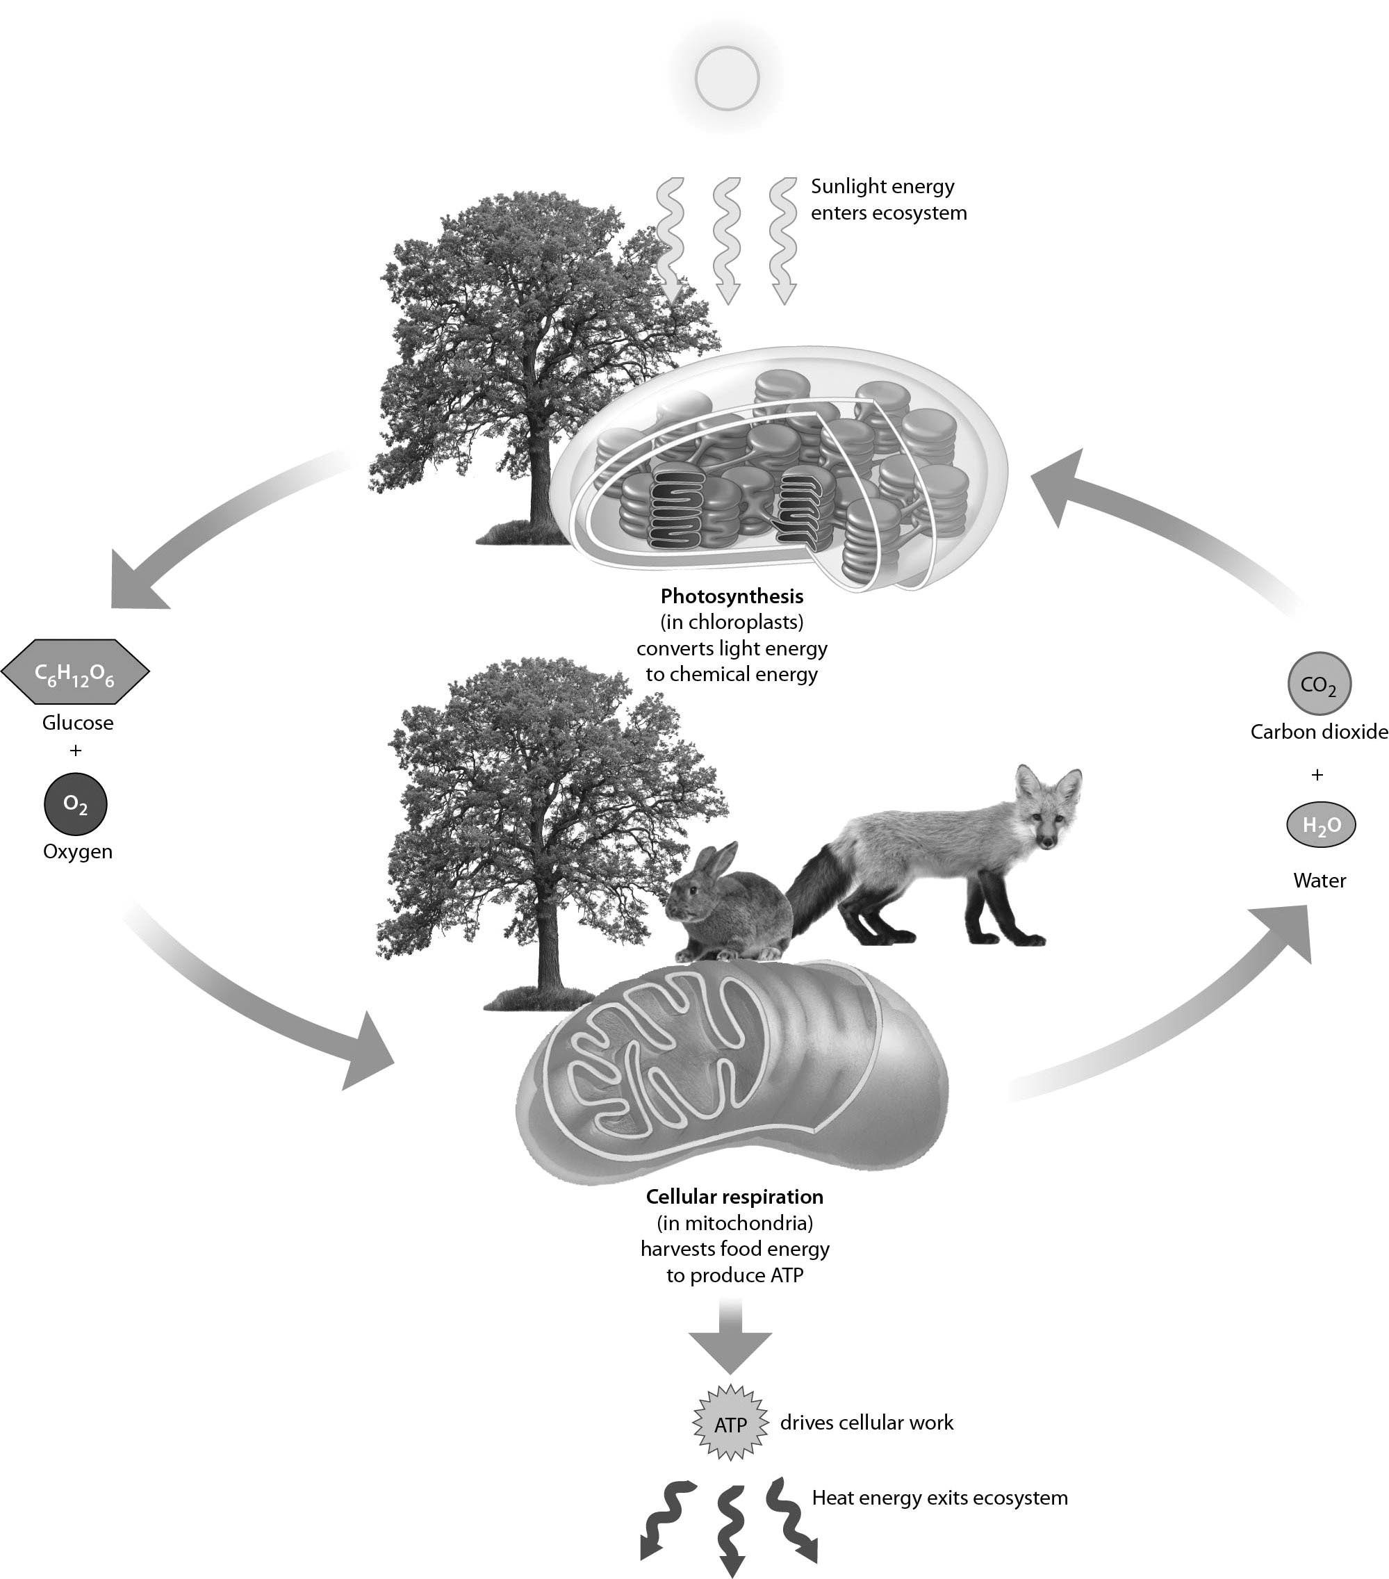

1) Examine the figure above. Which of the following reactant(s) primarily come(s) from the air?
A) water
B) glucose
C) carbon dioxide
D) oxygen and carbon dioxide
Answer: D
Topic: 6.1 Energy Flow and Chemical Cycling in the Biosphere
Skill: Application/Analysis
Learning Outcome: 6.4
Global LO: 2, 3
2) Examine the figure above. Most of the mass of the tree shown in the figure comes from ________.
A) water
B) glucose
C) the air
D) the soil
Answer: C
Topic: 6.1 Energy Flow and Chemical Cycling in the Biosphere
Skill: Application/Analysis
Learning Outcome: 6.4
Global LO: 2

3) Examine the following figure. Which of these stages occur(s) in the cytoplasm?

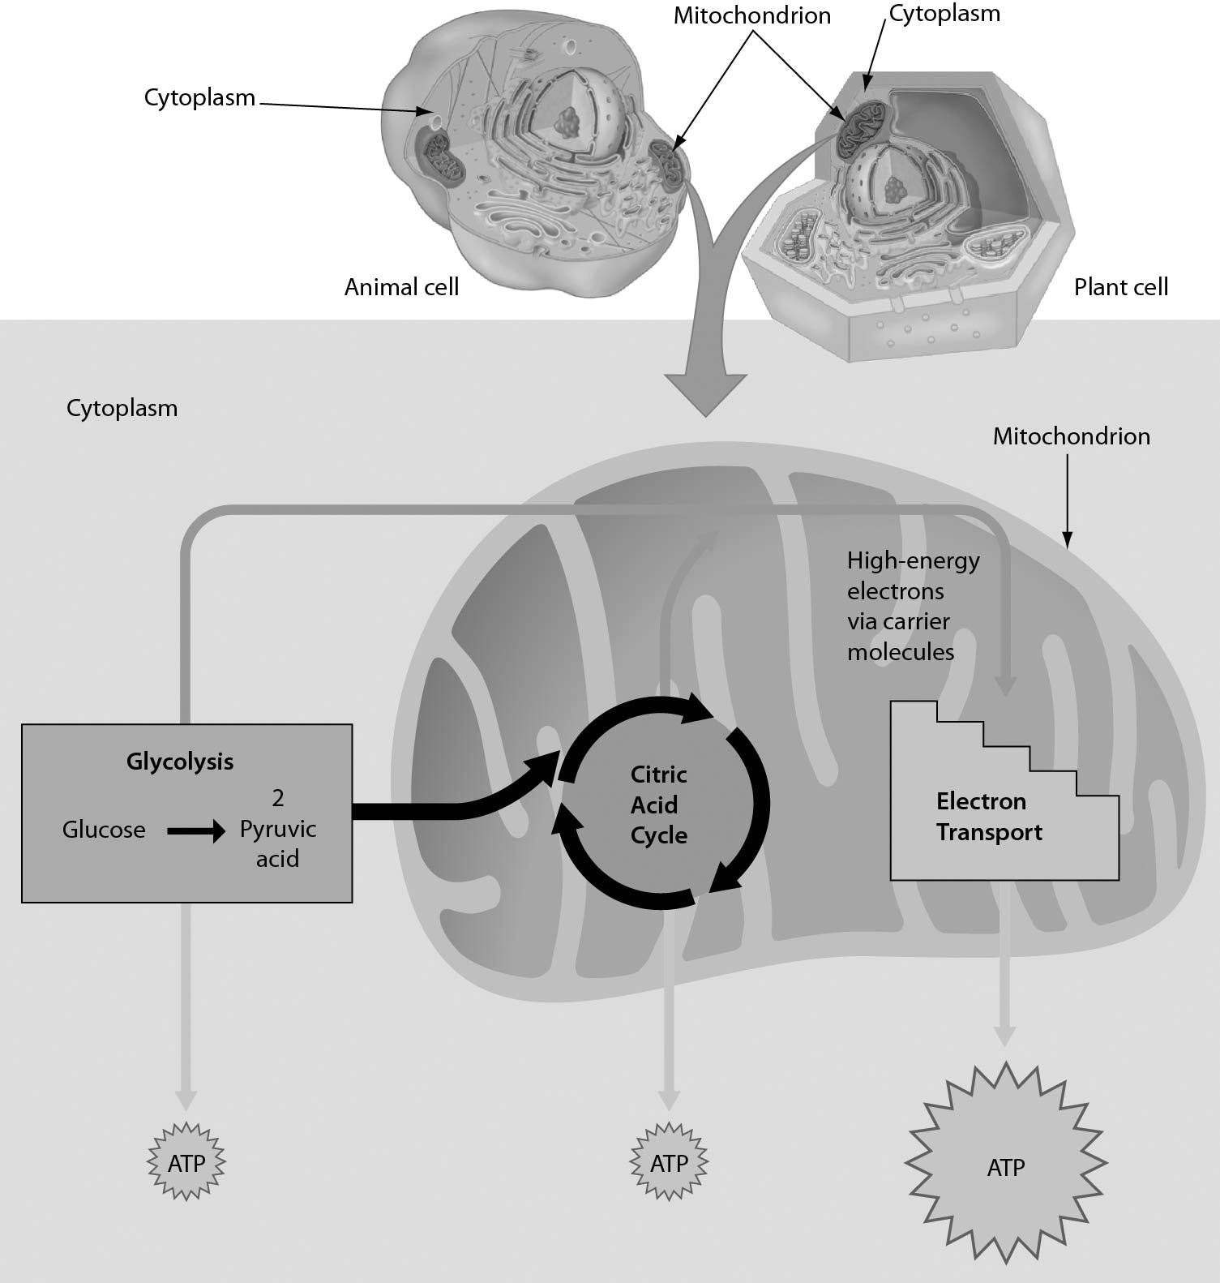

A) glycolysis
B) citric acid cycle
C) glycolysis and citric acid cycle
D) citric acid cycle and electron transport
Answer: A
Topic: 6.2 Cellular Respiration: Aerobic Harvest of Food Energy
Skill: Application/Analysis
Learning Outcome: 6.7
Global LO: 2, 3

4) What does the figure below show?

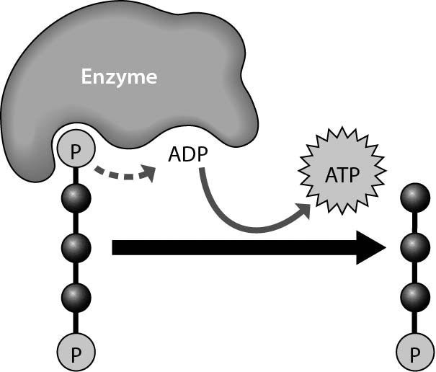

A) the synthesis of ADP
B) the breakdown of ATP to perform cellular work
C) the removal of a phosphate group from ADP
D) the synthesis of ATP through the addition of a phosphate group
Answer: D
Topic: 6.2 Cellular Respiration: Aerobic Harvest of Food Energy
Skill: Knowledge/Comprehension
Learning Outcome: 6.7
Global LO: 3
5) The figure below shows that ________.

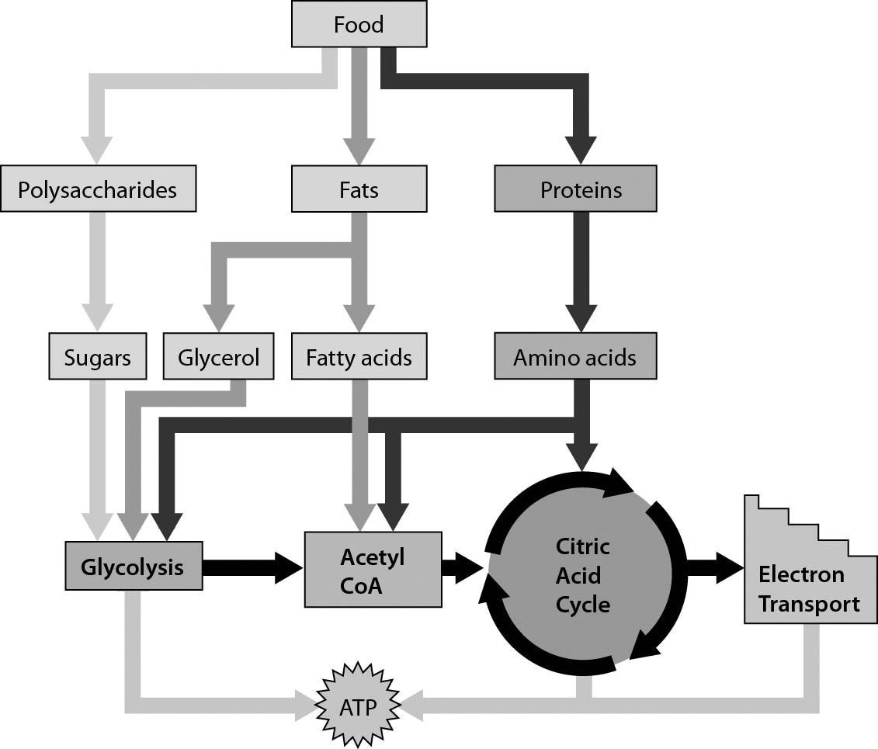

A) amino acids can move directly into the electron transport chain
B) our cells can use sugars, fatty acids, and amino acids to produce ATP
C) our cells can produce ATP only from glucose
D) our cells can produce ATP from sugars and glycerol, but not fatty acids
Answer: B
Topic: 6.2 Cellular Respiration: Aerobic Harvest of Food Energy
Skill: Synthesis/Evaluation
Learning Outcome: 6.7
Global LO: 2, 3, 7
6) Which of these shown in the figure below does NOT begin cellular respiration in the cytoplasm?

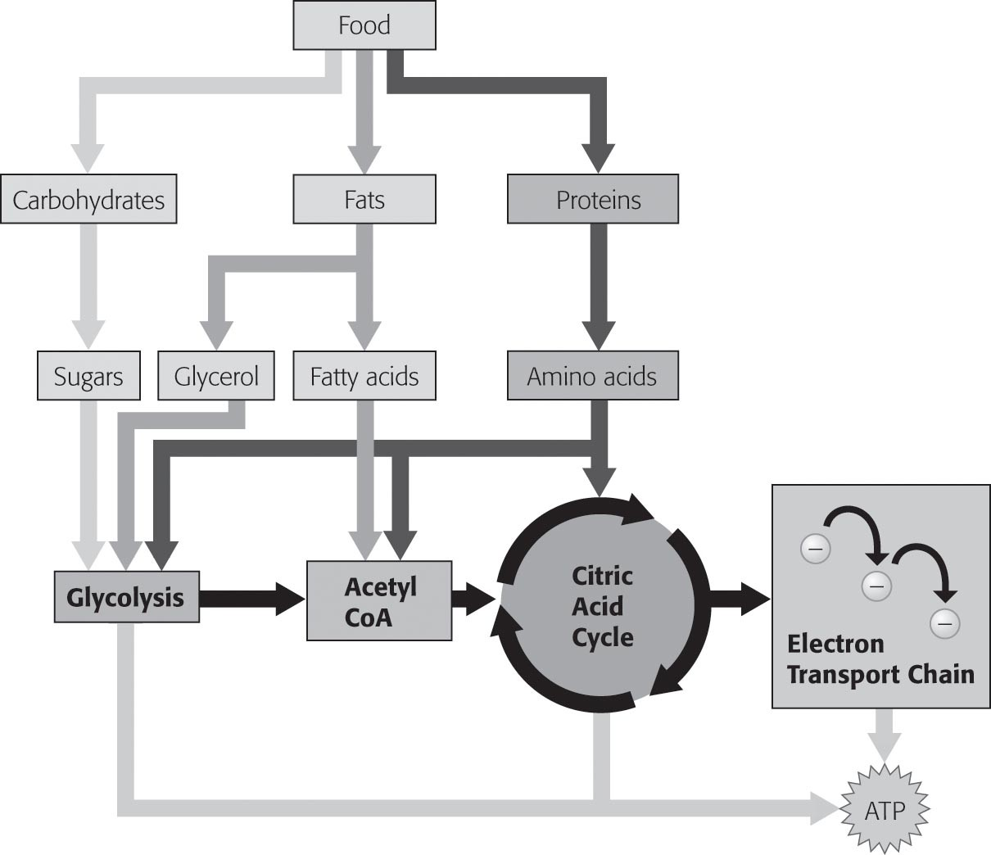
A) amino acids
B) fatty acids
C) glucose
D) glycerol
Answer: B
Topic: 6.2 Cellular Respiration: Aerobic Harvest of Food Energy
Skill: Synthesis/Evaluation
Learning Outcome: 6.7
Global LO: 2, 3

6.3 Scenario Questions

Read the following scenario to answer the following questions.

An abundant and continual supply of ATP is necessary for all living cells. Active muscle cells require an extraordinary amount of ATP to permit strenuous exercise for prolonged periods. Toxins, reduced blood flow, and a compromised respiratory system can interfere with the transport of oxygen to active cells. A runner in a marathon faces multiple obstacles to continue to produce sufficient ATP to remain competitive.

1) Breathing faster when we exercise is necessary to expel ________.
A) carbon dioxide and bring in more oxygen to support aerobic metabolism
B) oxygen and bring in more carbon dioxide to support aerobic metabolism
C) carbon dioxide and bring in more oxygen to support anaerobic metabolism
D) oxygen and bring in more carbon dioxide to support anaerobic metabolism
Answer: A
Topic: 6.2 Cellular Respiration: Aerobic Harvest of Food Energy
Skill: Knowledge/Comprehension
Learning Outcome: 6.4
2) When oxygen delivery becomes insufficient to support a runner's aerobic metabolism, cells switch to an emergency mode in which ________.
A) ATP is generated less efficiently by harvesting the heat energy in a cell
B) ATP is inefficiently produced and lactic acid is generated as a by-product
C) lactic acid is broken down to produce smaller amounts of ATP
D) carbon dioxide is joined with water to generate much smaller amounts of ATP
Answer: B
Topic: 6.3 Fermentation: Anaerobic Harvest of Food Energy
Skill: Knowledge/Comprehension
Learning Outcome: 6.8

The table below shows experimental data from poultry scientists. Examine the table to answer the following questions.

Oviposition time, egg weight, chicken hatch weight and hatch weight/egg weight from young and mid-age broiler breeder flocks.

Flock  age | Oviposition  time (h) | n | Egg  weight (g) | Chicken hatch  weight (g) | Chicken hatch weight/  egg weight (%)
Young | Early | 168 | 59.3±0.2a | 38.8±0.2a | 65.4
 | Middle | 168 | 58.2±0.3b | 37.8±0.3b | 65.0
 | Late | 168 | 58.7±0.1b | 38.1±0.2b | 64.9
 | Total | 504 | 58.9±0.1 | 38.3±0.1 | 65.0

Mid | Early | 252 | 66.8±0.2a | 45.8±0.2a | 68.6
 | Middle | 252 | 65.5±0.2b | 44.0±0.3b | 67.2
 | Late | 252 | 66.0±0.2b | 43.2±0.2c | 65.5
 | Total | 756 | 66.1±0.1 | 44.1±0.1 | 66.7

3) Which hypothesis were the poultry scientists likely testing?
A) The time of egg laying (oviposition) has an impact on egg weight.
B) Bigger eggs result in larger mature chickens.
C) Young hens have a harder time laying eggs than do older hens.
D) Egg weight is related to the weight of the hatchling (newly hatched chick).
Answer: A
Topic: 6.2 Cellular Respiration: Aerobic Harvest of Food Energy
Skill: Synthesis/Evaluation
Learning Outcome: 6.5
Global LO: 1, 2, 3, 4, 6, 7
4) What are (is) the main factor(s) causing differences between the chick hatch weight and the weight of the egg when it is laid?
A) The only factor that causes the chick to weigh less than the egg when it is laid is the removal of the shell.
B) Not only does the hatchling have no shell, but it has lost some of its mass (weight) to the air during development.
C) During development, the chick gains new parts so the weight increases.
D) Egg weight at oviposition includes a lot of water that evaporates during development.
Answer: B
Topic: 6.2 Cellular Respiration: Aerobic Harvest of Food Energy
Skill: Synthesis/Evaluation
Learning Outcome: 6.5
Global LO: 1, 2, 3, 4, 7

5) If the egg was weighed halfway between being laid and hatching, how would you expect that weight to compare to the weight of the newly hatched chick?
A) The egg would weigh more at this midpoint than when newly hatched because, during development, the chick gains new parts.
B) The egg would weigh more at this midpoint than when newly hatched because it is taking in oxygen.
C) The egg would weigh less at this midpoint than when newly hatched because the shell wears away over time.
D) The egg would weigh less at this midpoint than when newly hatched because some of the mass of the egg would be released through cell respiration.
Answer: D
Topic: 6.2 Cellular Respiration: Aerobic Harvest of Food Energy
Skill: Synthesis/Evaluation
Learning Outcome: 6.5
Global LO: 2, 4, 7

