# Answer sheet Processing lab 1

Instructions: Fill out your answers below. Make a PDF of the complete file, and upload that **PDF** on Blackboard.

Student 1 (Full name & student number): Sterre van Strien (6138942)

Student 2 (Full name & student number): Vito Vekic (1091719)

## **Blackboard question 1**

***1A: For example 3: what is the predicted task time for the model that does all steps as fastman in milliseconds?***

The predicted task time for the model which does all steps as fastman is 180 ms. This is calculated by adding the time for the perceptual step twice (each being 50 ms, so together they’re 100 ms), the time for the cognitive step is added twice (which are 25 ms respectively, resulting in a total time of 150 ms together with the perceptual step) and the motor step is added once (which is 30 ms), resulting in a total of 180 ms.

***1B: For example 3: What is the predicted task time for a model that has the fastest perception, takes average time for cognitive steps, but is the slowest in motor execution?***

The predicted task time for the model which does the steps as described above is 340 ms. In this case, the time for the fast perceptual step is 50 ms, the average cognitive step is 70 ms and the slow motor step is 100. We know that the total time is twice the perceptual time (so 2x 50 ms equals 100 ms) plus twice the cognitive step (so 2x 70 ms, which is 140, resulting in a total of 240 ms) and once the motor step (which is 100 ms), resulting in a total predicted task time of 340 ms.

***1C: For example 4: What is the predicted slowest time that we might observe in this experiment?***

The predicted slowest time we might observe is 1040 ms. The predicted slowest time is the case in which all steps are the slowest, so the perceptual step takes 200 ms, the cognitive step takes 170 ms and the motor step takes 100 ms. We then calculate the total predicted slowest time by adding the slowest timing for the stimulus, 240 ms, to twice the perceptual step (240 + 400 = 600 ms), twice the cognitive step (600 + 340 = 940 ms) and once the motor step (940 + 100 = 1040 ms). So the total is 1040 ms.

***1D (paste a picture or screenshot below): For example 5: add a picture or screenshot of the scatterplot (as an image), Make sure to clearly label the x- and y-axis (give name and measurement unit, e.g. “time (ms)”) and to use an appropriate range of values on each axis.***

[Insert answer + picture]

## **Blackboard question 2:**

***2A (Copy screenshots or pictures of 10 different plots below): Create 10 plots and paste a picture or screenshot of them in the answer sheet. Each of plot should be a different outcome of running the “runTrial” function with parameters nrWordsPerSentence=17, nrSentences = 10, nrSteeringMovementsWhenSteering = 4, and interleaving=”word”. Please mind the criteria that were mentioned at the end of the engineering assignment for that model.***

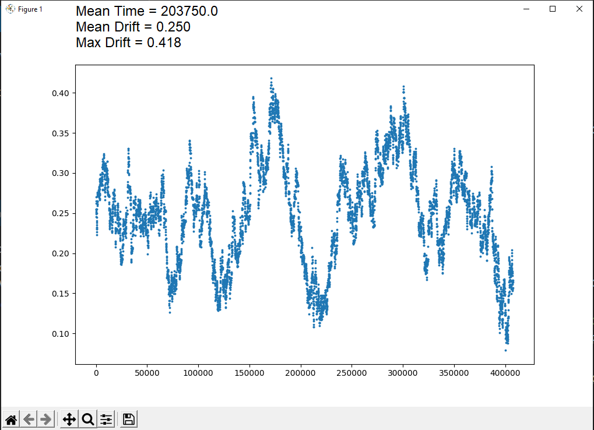

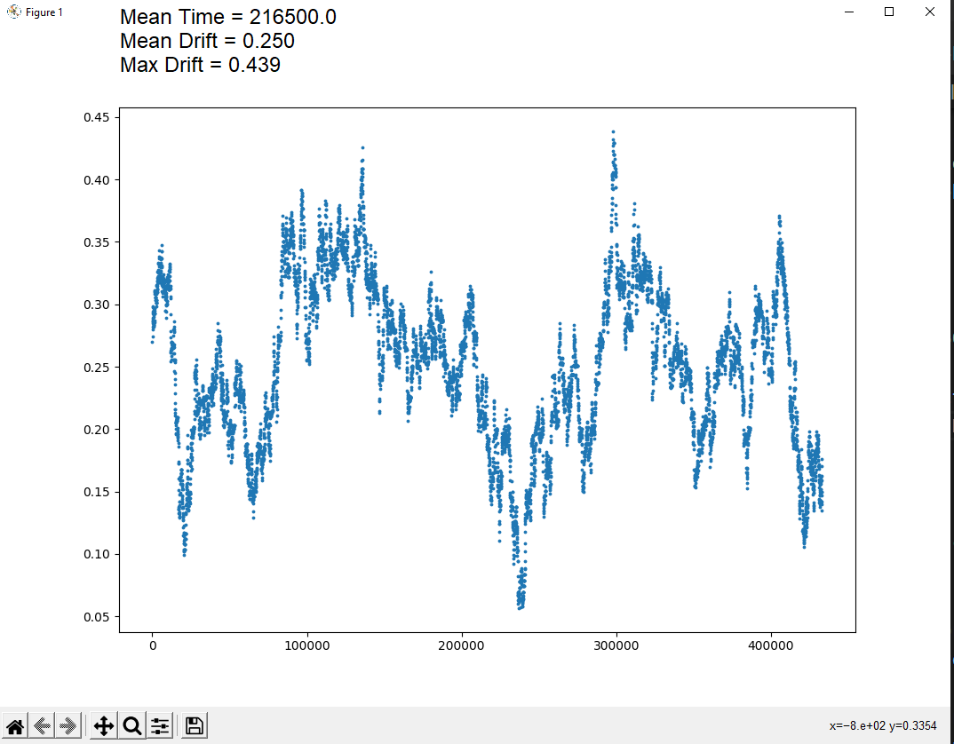

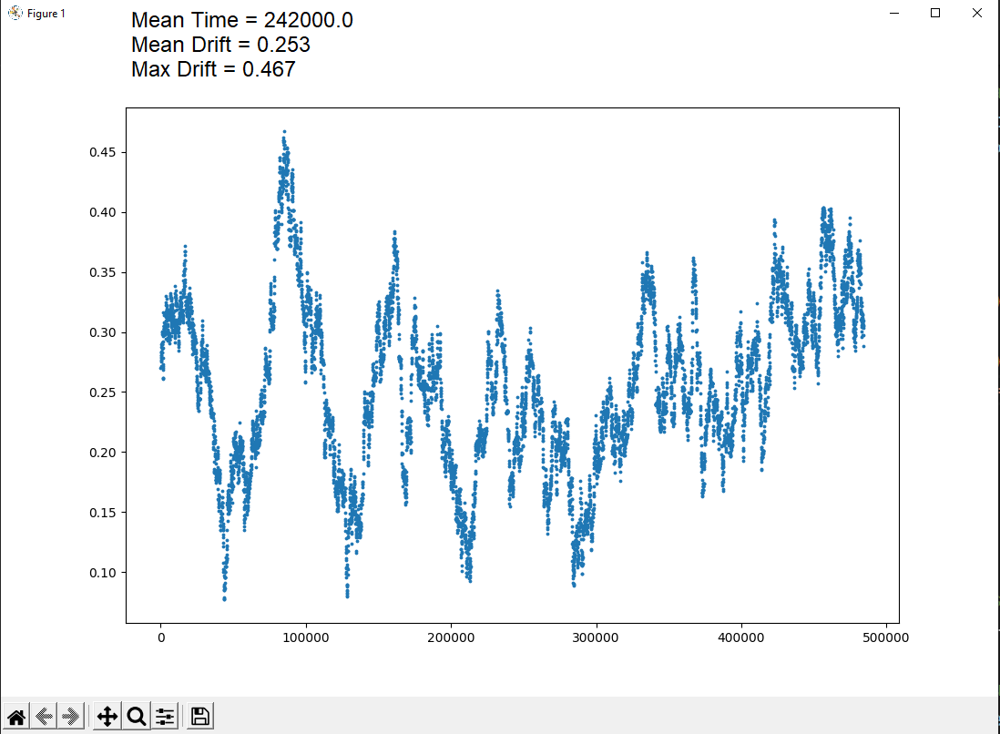

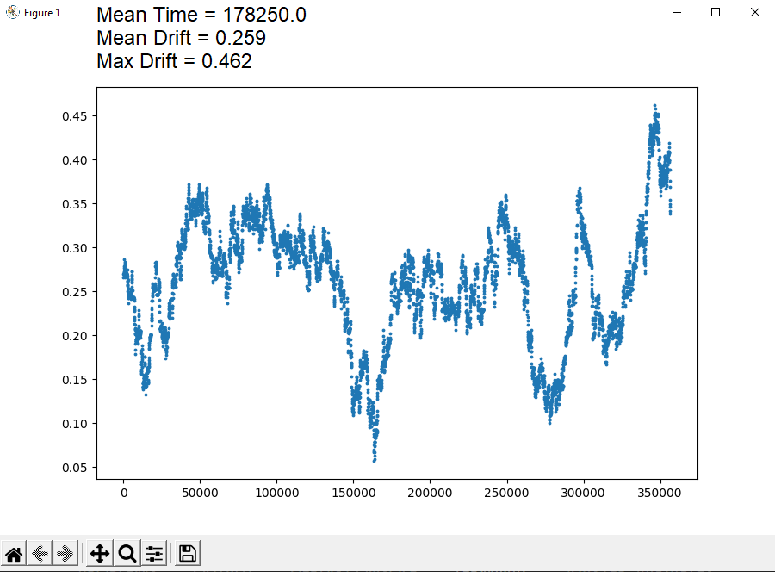

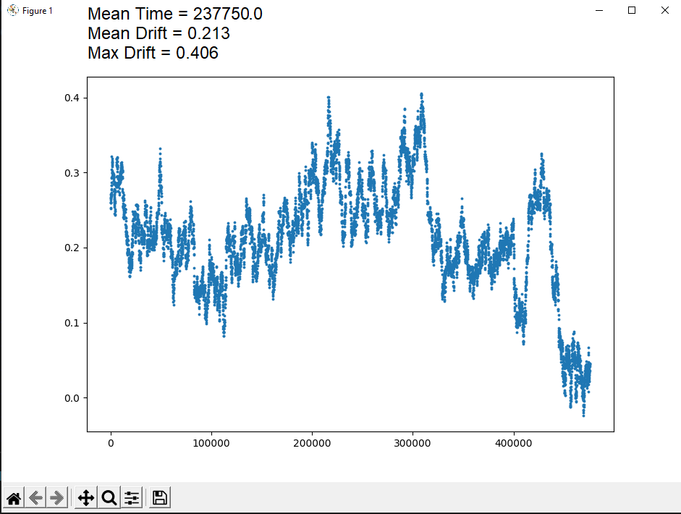

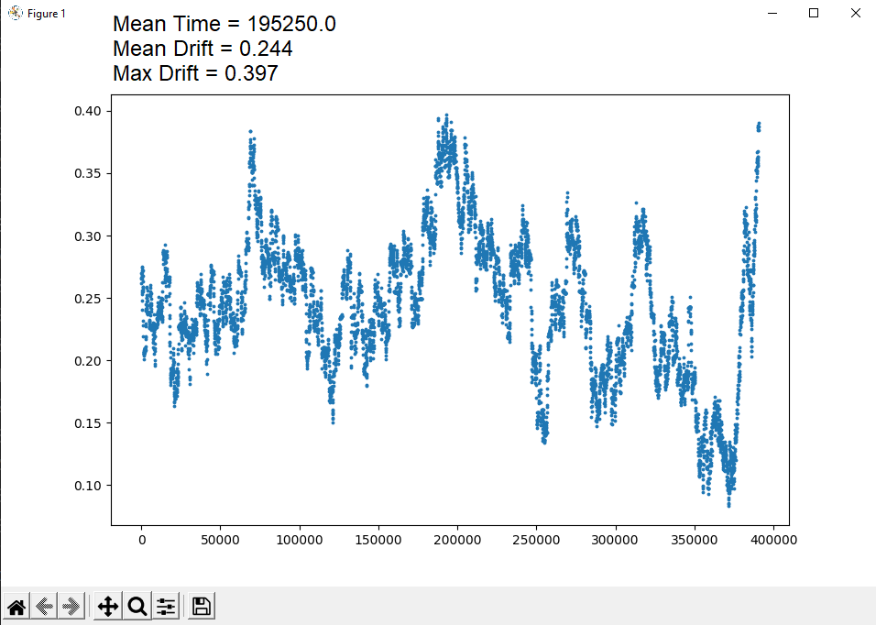

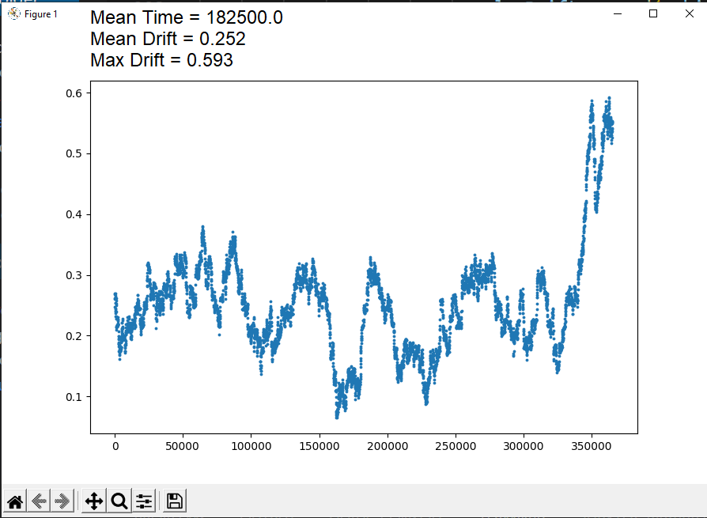

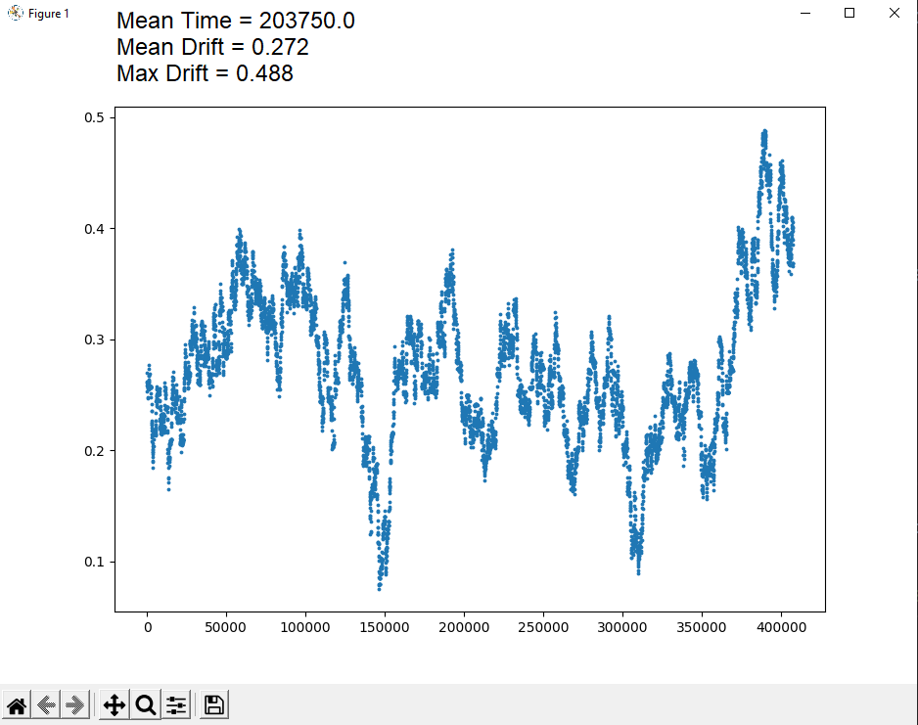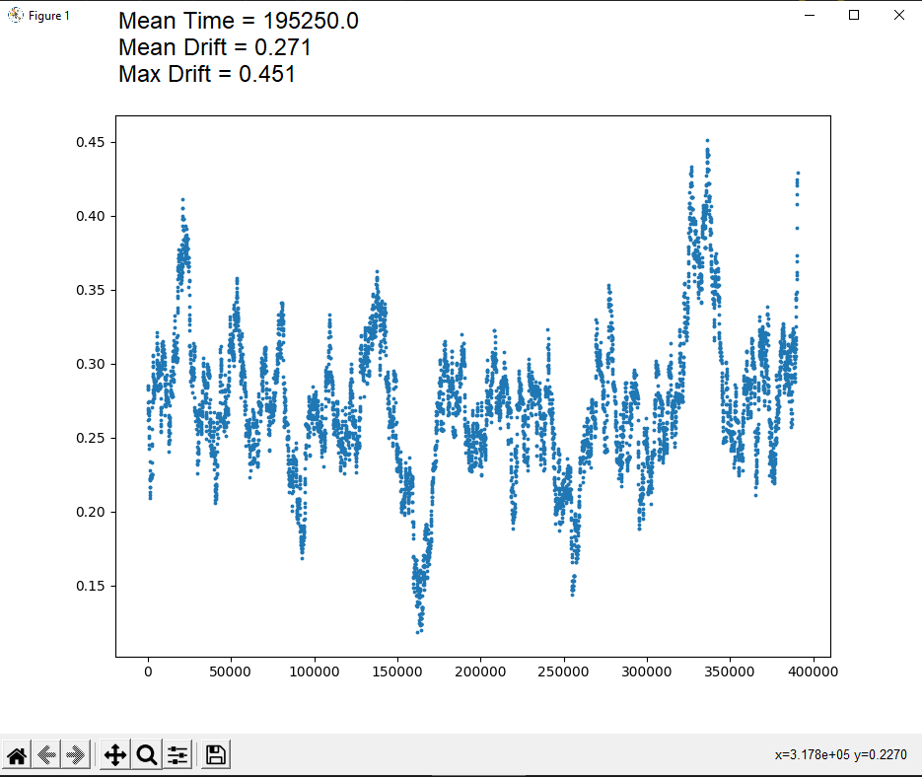

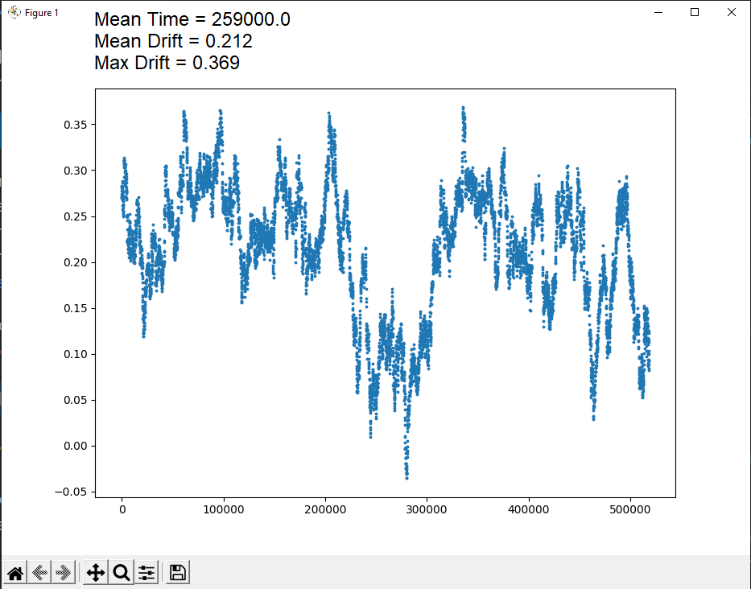

***2B (Copy screenshots or pictures of 10 different plots below): Create another 10 plots and paste a picture or screenshot of them in the answer sheet. These plots should be 10 different outcomes of running the “runTrial” function with the same parameter settings as for question 2A, except that the interleaving strategy should be “sentence”.***

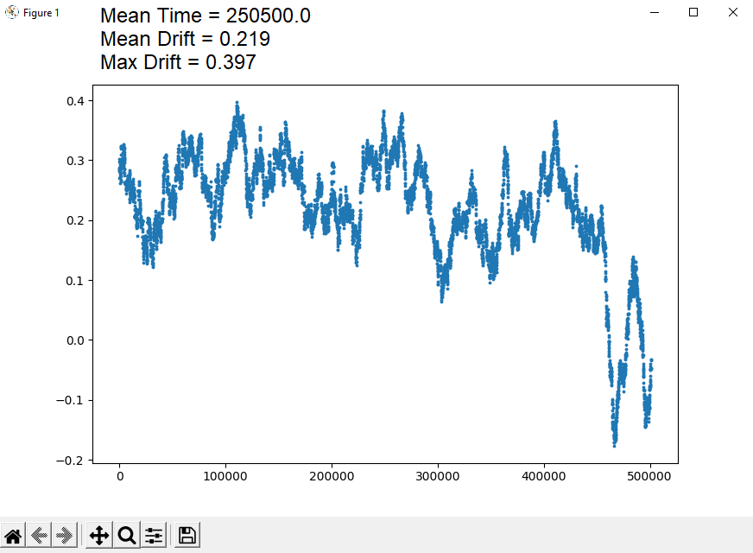

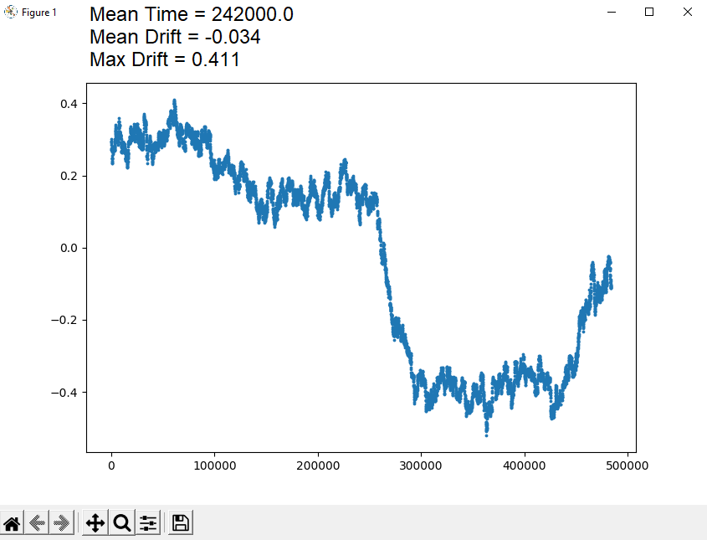

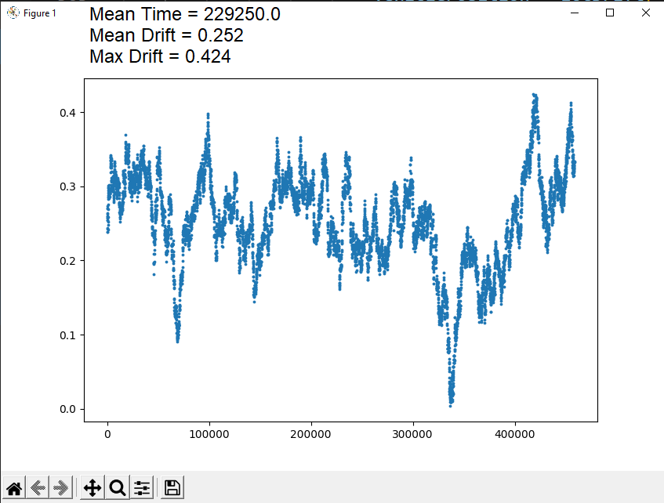

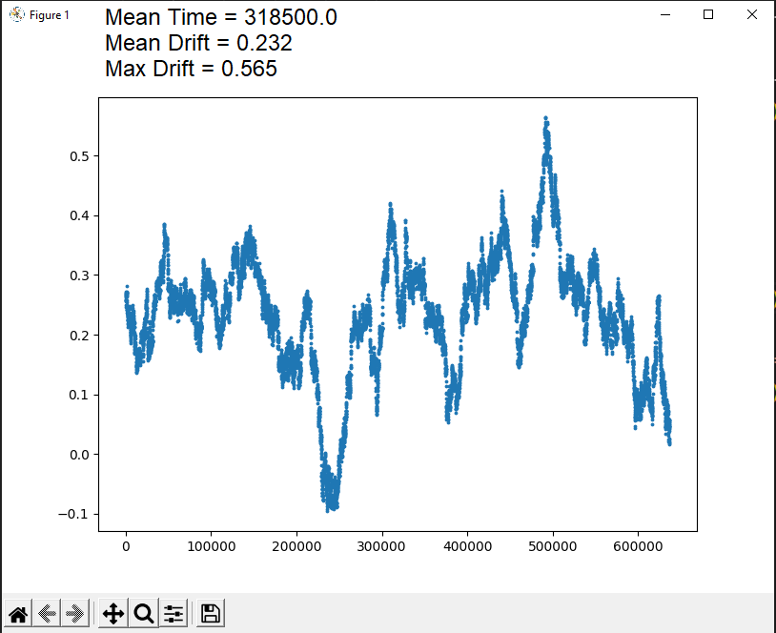

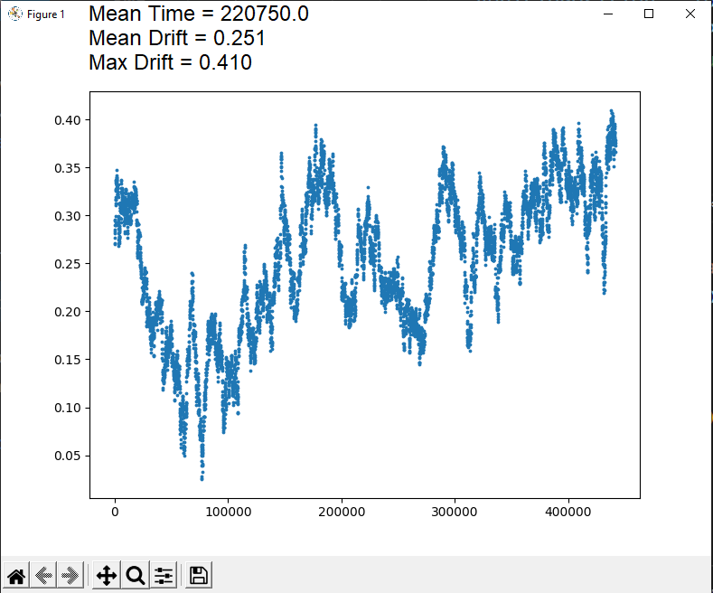

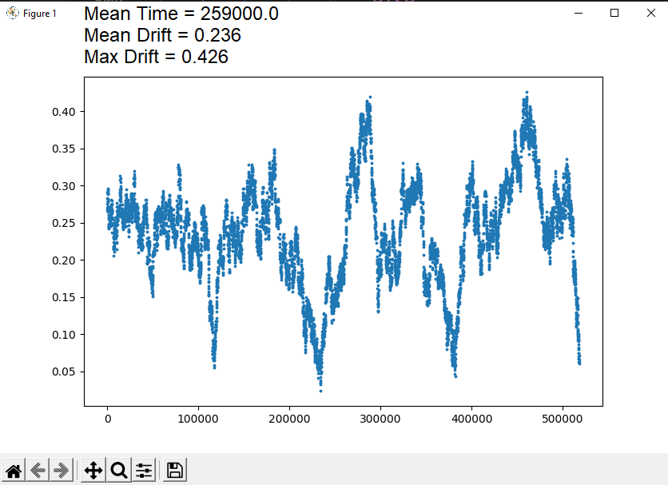

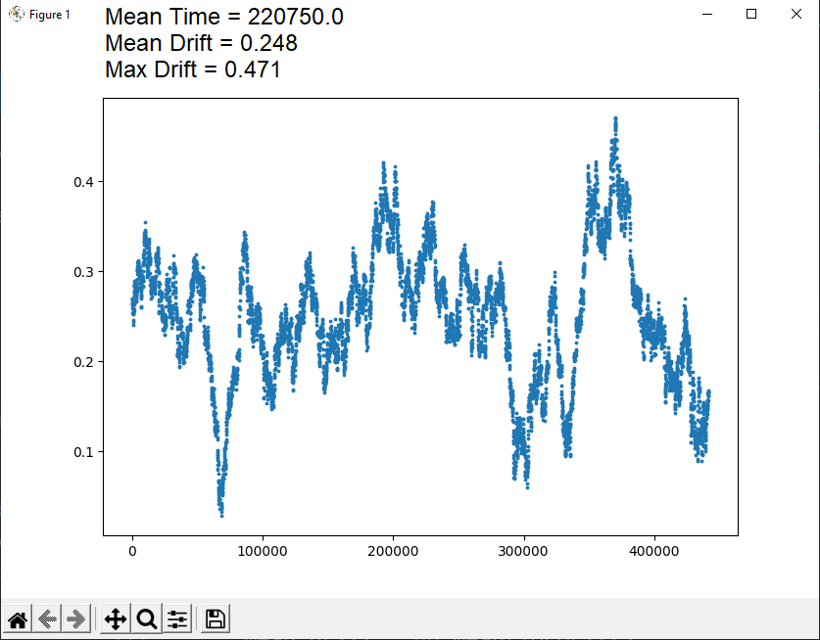

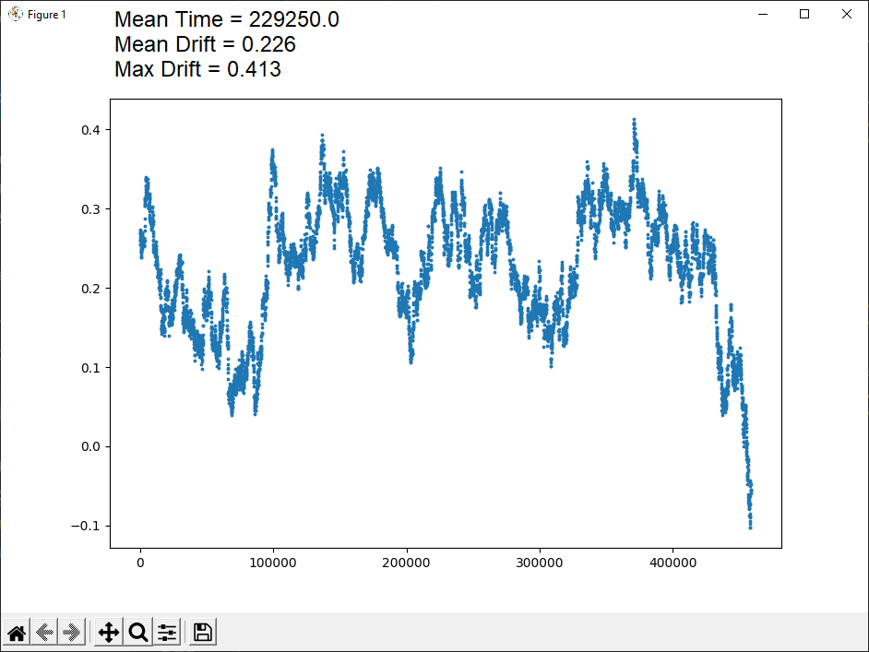

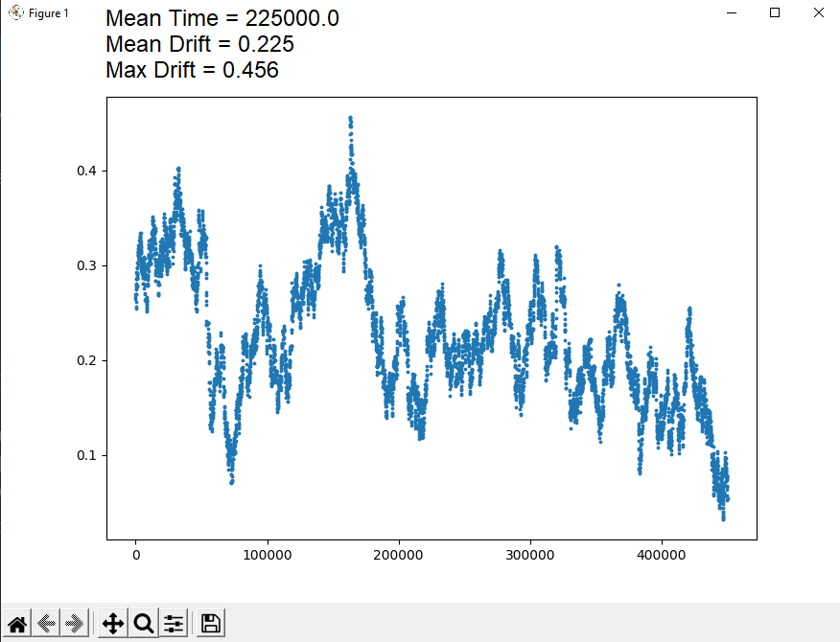

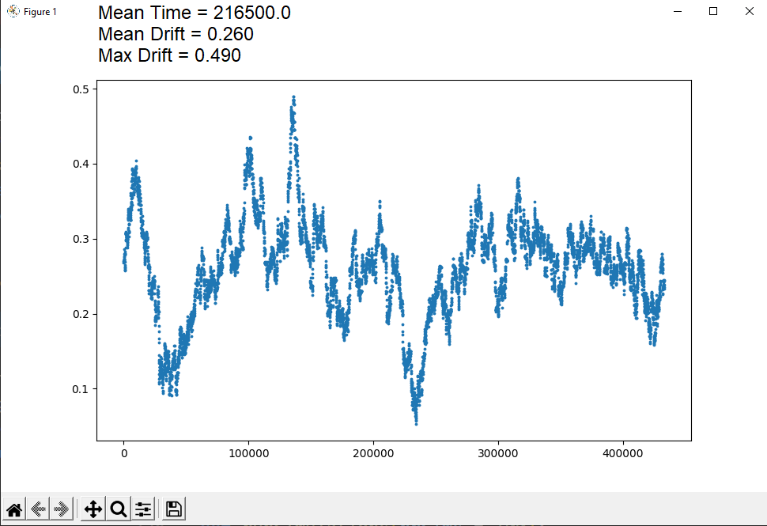

***2C: Explain what you see in the Figures. Specifically: i. How does the pattern of the different strategy show itself in the Figures? (e.g., how does this differ between the file you submitted for A and the file you submitted for B) ii. Within one type of strategy: what causes that each individual plot is different from the others? What causes these differences?***

In the sections where the trial is set to “word” we can see that the deviations are closer together and more sporadic. In the sections where the user is correcting after each sentence the time before each steering update is larger. This is caused by the amount of time needed to finish a sentence than it is to finish a word and then steer.

## **Blackboard question 3:**

***3A (Copy screenshot or picture of your plot below): Submit a picture or screenshot of the plot that you generated (in the function “runSimulations”) which shows the predictions of individual trials (horizontal axis: total trial time, vertical axis: max lateral deviation) and their mean performance + standard deviation (see above engineering question). This should be a plot for 100 simulations per condition (so 400 simulations total). If there are grounds why your computer could not do this, submit a plot based on fewer trials (e.g., 50 trials).***

***3B: Explain using your plot from question A whether you would recommend drivers to interleave after every word or after every sentence. In your explanation make sure to refer to patterns that can be seen in the Figure, such as average performance in a condition, variability within that condition, and how the strategies impact both time for writing an e-mail and maximum deviation of the car.***

***3C: The model could be expanded in many ways. One aspect to consider is that people do not always have their phones in their hands, but sometimes further away, such as on their lap or in a cradle. They would then have to reach for the phone before typing, and reach back to the steering wheel afterwards. Explain if and how such reaching behavior (a motor “switch cost”) impacts each of the four strategies that you simulated (none, drivingOnly, word, sentence). You do not need to implement this model, but rather explain what pattern you would expect and why***

### Bonus question:

If you complete a bonus question (optional), please answer the questions of the assignment below.

***1.What scenario did you model (interleaving after X words, or error making)***

Interleaving after X words. We implemented it where it will interleave after a random amount of words, where this random number is at least 1 and at most equal to the maximum amount of words in this sentence. We chose to implement it where it interleaves after a random amount of words because this would be most realistic (and thus would create a better model of reality). A person might return to steering after every word or every sentence as these are logical cutoffs, but a certain number of words would not be a logical cutoff. A person would be more likely to suddenly remember they were driving or return to driving due to outside influences (a car horn or people yelling), which would be after a random amount of words. We chose to make it scale from 1 to the total number of words, so they'd always still check at least once every sentence. We started at 1 instead of 0, because else the person could switch before having typed a single word (since either the beginning or last check).

***2.Submit a screenshot or PDF of the critical part of your code***

***3.Submit a plot of what performance now looks like. The plot should be in the style of Blackboard question 3, but adjusted to the scenario at hand.***

***4.Explain how and why performance of the model has (not) changed compared to the strategies that you modelled before.***