DOCUMENTATION WEB SITE PROJECT’S
I created my portfolio through a static website made of an html page, css and a script in javascript. To realize it I used also Bootstrap an open source toolkit for devepoling html, css and javascript.

The project is divided :
- an html file.
- a style sheet.
- a javascript script.
- images folder.
- library folder.

Many components of bootstrap require various plugins for :
- jquery
- popper.min.js
- bootstrap.min.js
- bootstrap.min.css

I imported a typed animation library called typed.min.js.

In the style.css file I imported from the fonts.googleapis.com some fonts like: staattliches, oswald and rambla.

HTML FILE’S

In the body I have inserted various sections to better divide the page :
- Header area
- Site banner area
- about me aerea
- ability
- services
- work
- contacts

In the header section I created a navigation menu with a bootstrap navbar “navbar-expand-md”, with average width and modified in the css file.
In order to have a navigation menu adaptable to mobile devices, I created a toogle that will move the menu on the left of the window.
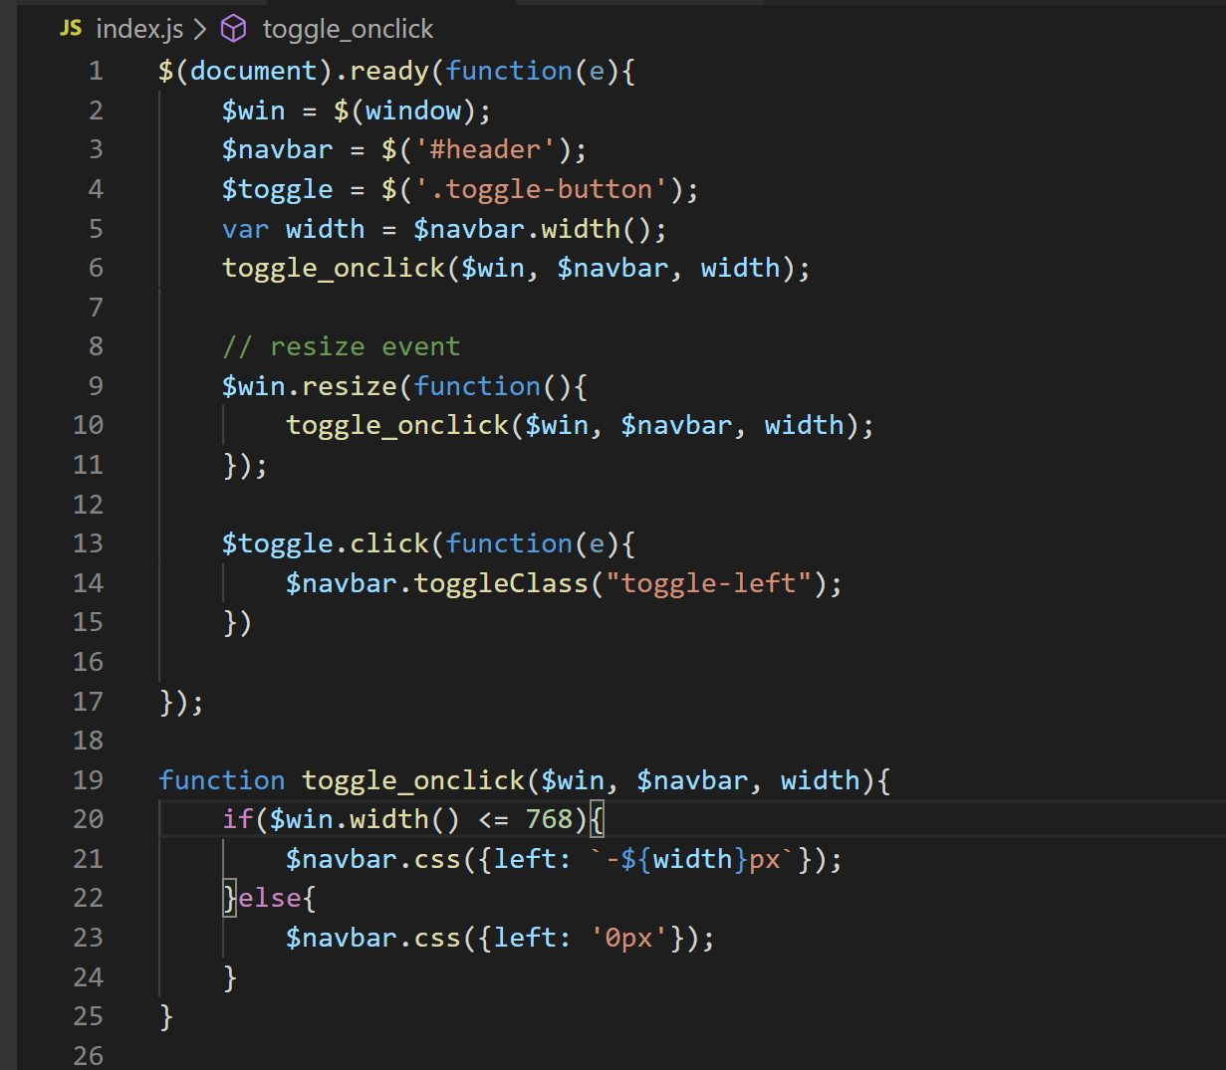

I created a toogle that moves the window, the toongle_onclick function allows you to adapt the menu according to your needs.
The ready method makes the functions must be executed after loading the page.

In the Site banner area section I used typed.min.js to make the writing scroll. I just set the strings, speeds and loop.
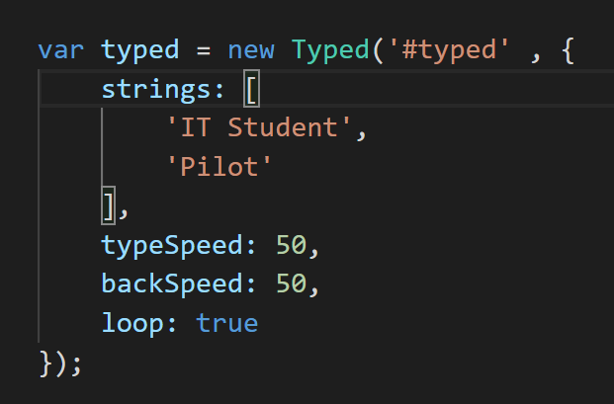

To make the profile image a circle I set the border radius to 50%.

In the section about me area I simply put some information about myself and added once button to download the cv. I used again the script typed.min.js to make the writing scroll.

In the Ability section in the second column I added three bars indicating the percentage of my skills. I used a bootstrap sliders
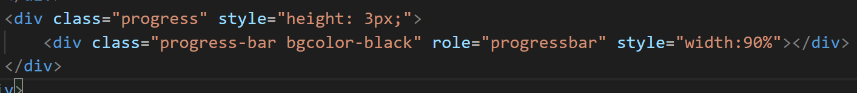

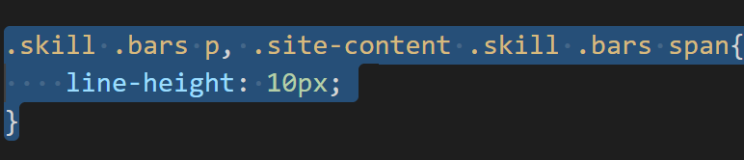

In the services section I used a grid to insert icons, I inserted six panels with borders and a padding = 4.

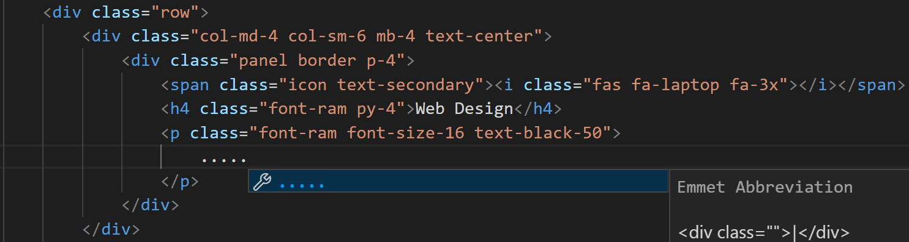

In the Work section I created a row by inserting six between images and gifs.

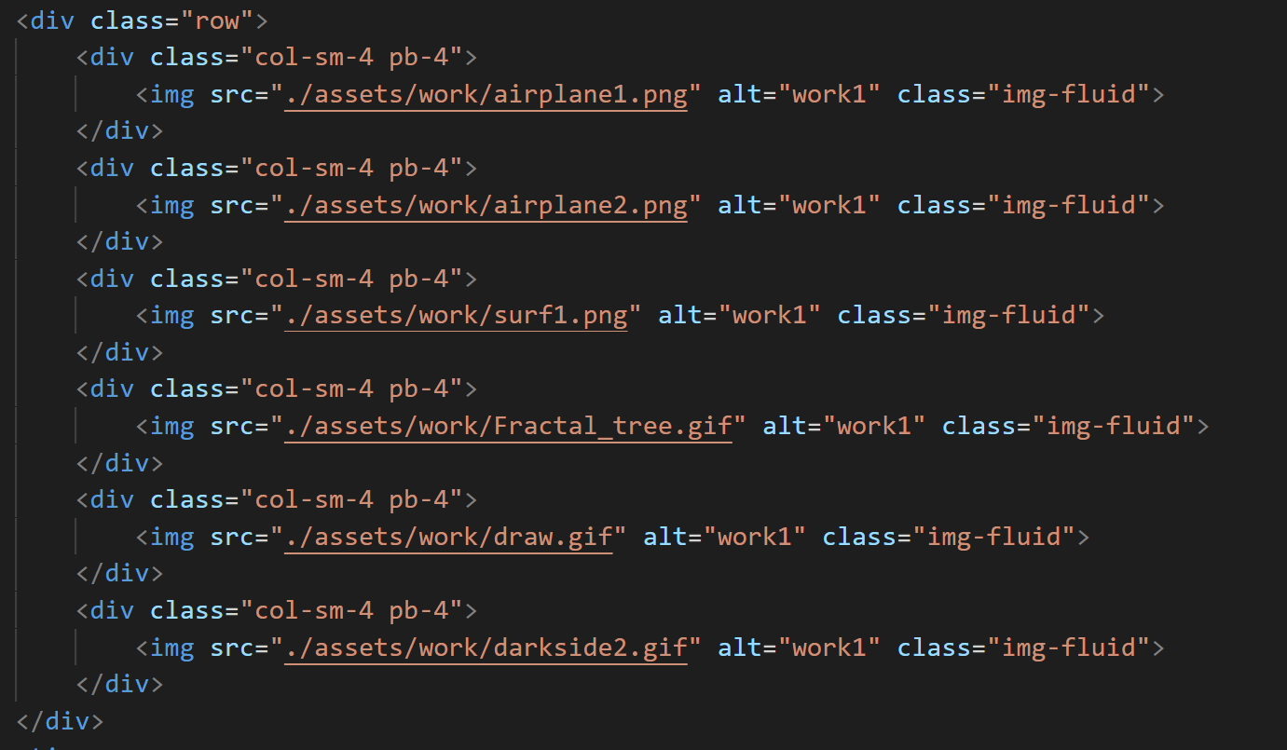

In the contacts section I created a footer where in the first column I inserted contact information and in the second column I inserted a mailbox.

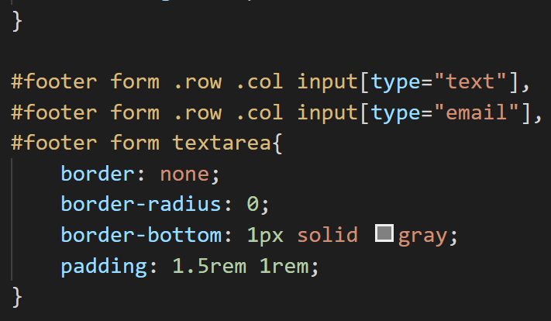

The footer is the bottom of a web page layout. Inside the footer I have inserted some typical information such as privacy policy and social logos

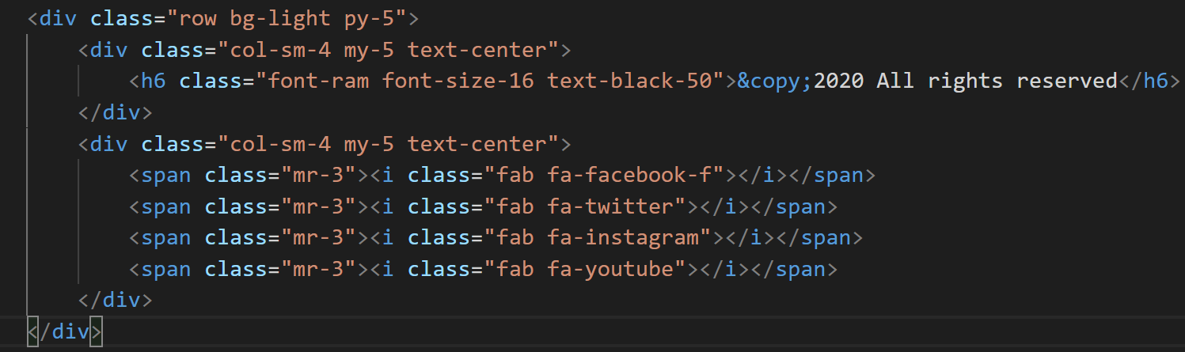

This is the code with which I wanted to make an example of mailbox, the site not being online obviously does not really send email.
The various sections email name and message are linkable and insert the various information.
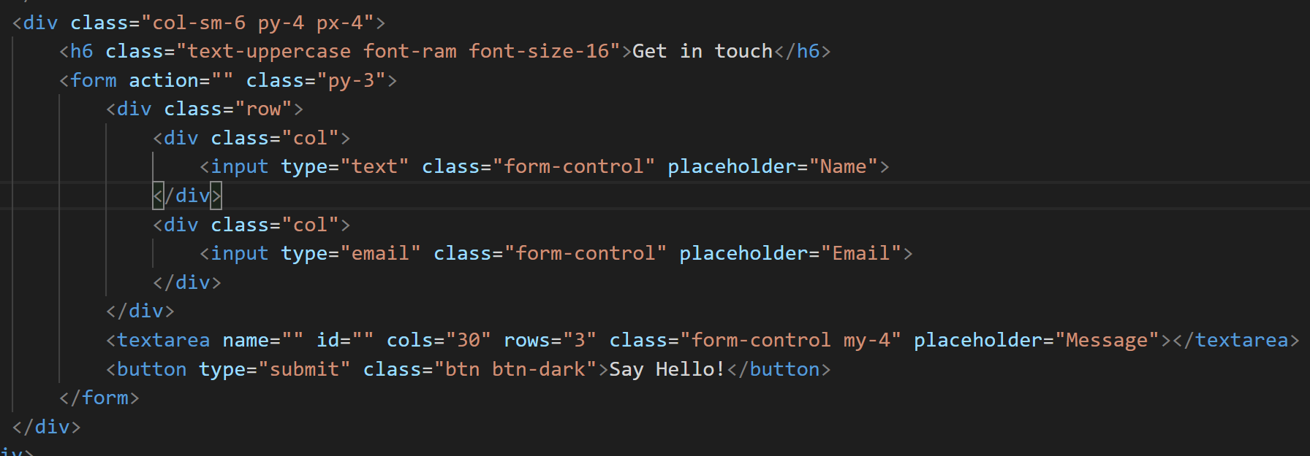

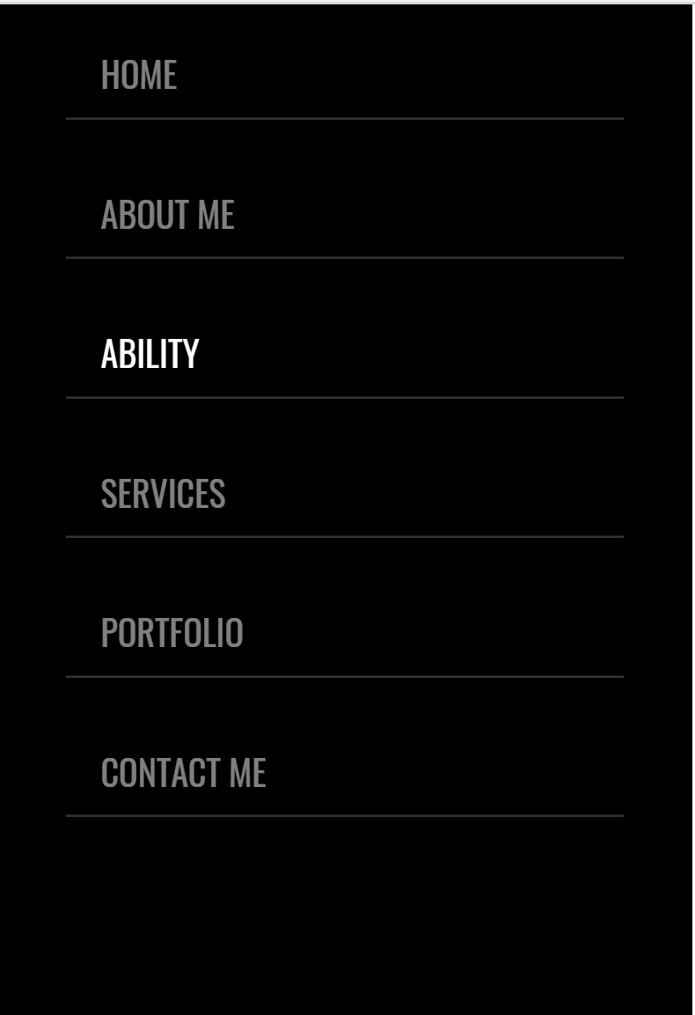

In order to make the text boxes linkable in all platforms I have implemented

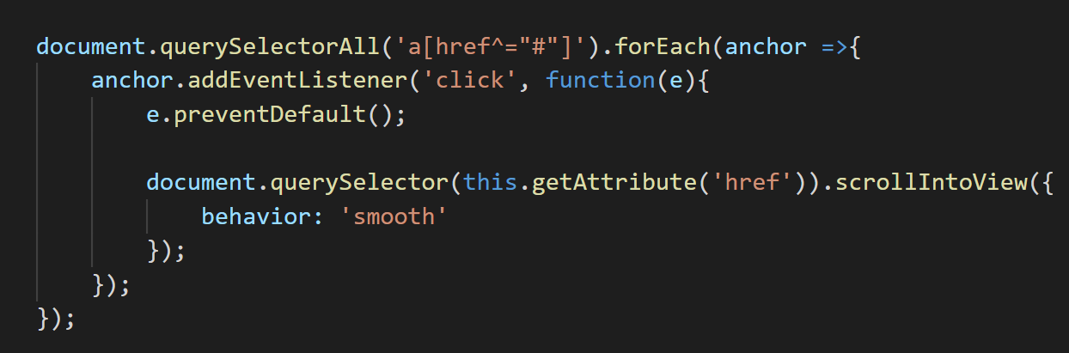

The Document querySelector() method returns the first Element within the document that corresponds to the specified selector or group of selectors.

To make the text boxes of the mail box linkable I had to make a media query and change the higher value to the z-index property of the header
