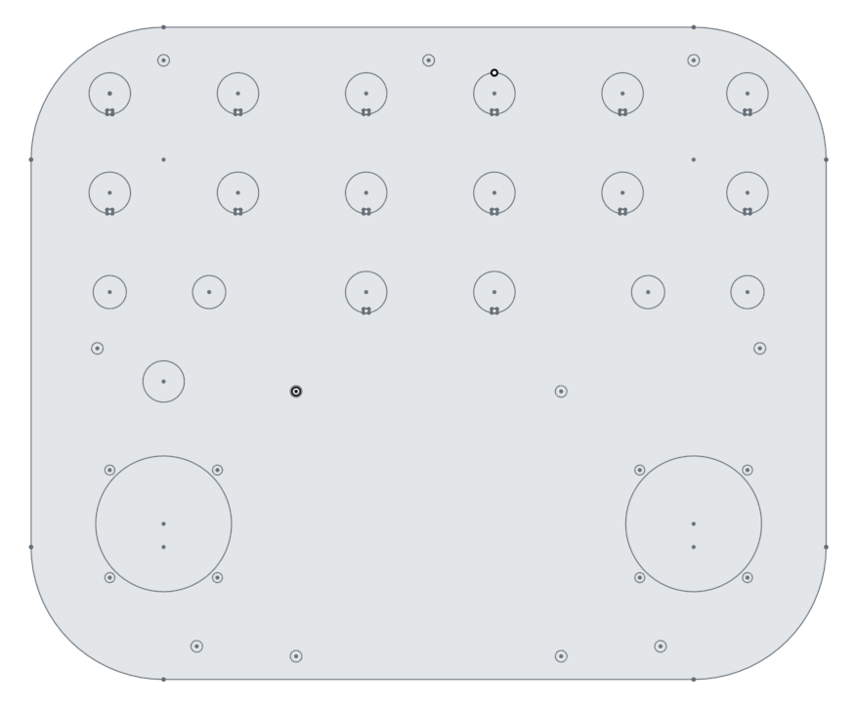

Channel 1

Channel 2

Channel 4

Channel 3

5

6

7

8

15

16

11

12

22

21

20

17

18

19

9

10

13

14

