

assessment 2

Project Management



VITOR vOLPINI ID:70406

Wells International College

|  |  |  |  |
| --- | --- | --- | --- |
| Name of Student | VITOR MATHEUS VOLPINI | ID | 70406 |

1. A diagram of a company

   Description automatically generatedWhat advice do we give about factoring in the commitments of project stakeholders when making your own plans?
   1. Consult student timetables to see when they might be free to attend data collection sessions.
   2. Ask external organizations what the most convenient times would be for you to visit.
   3. Neither of these

d) Both A and B

Comment: It suggests that there is some advice or guidance being sought regarding how to incorporate the interests, responsibilities, and constraints of key stakeholders when developing one's own project plans.

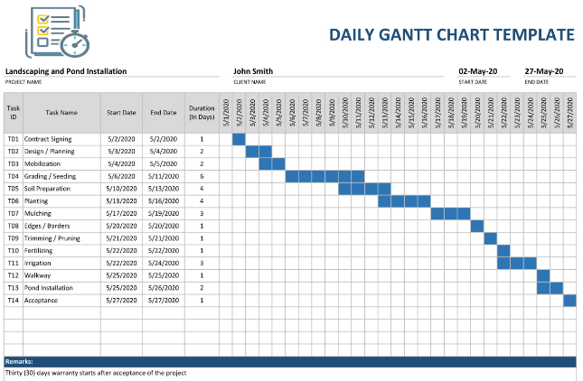

1. Which of the following are essential components of a GANTT chart used to plan your project?
   1. Your home telephone number
   2. Your supervisor’s home telephone number
   3. The email address for the chair of the ethics committee
   4. None of the above

Comment: A Gantt chart is a visual representation of a project's schedule, showing tasks, their start and end dates, dependencies, and the overall project timeline, it focuses on project-related information to track and manage the project's progress.

1. 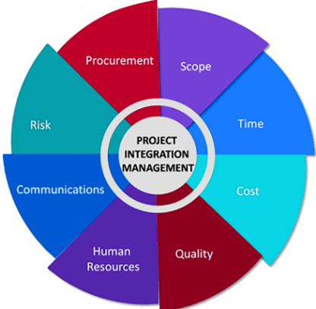The intended outcome of strategy/projects integration is.
   1. Clear organization focus
   2. Best use of scarce organization resources
   3. Improved communication across projects and departments
   4. Both A and C are correct
   5. A, B, and C are all correct

Comment: Integrating strategy and projects aims to achieve a clear organizational focus (A), make the best use of scarce organizational resources (B), and improve communication across projects and departments (C). This alignment ensures that projects contribute effectively to the overall strategic goals of the organization while optimizing resource allocation and enhancing collaboration and coordination.

1. 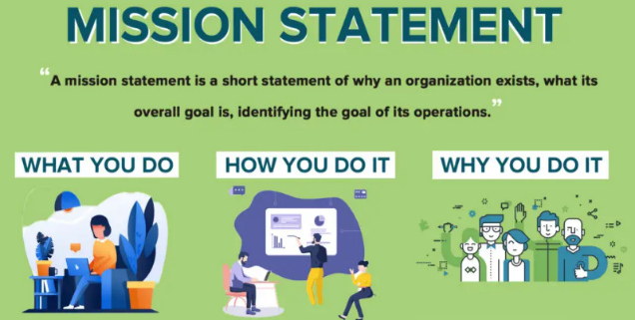Which of the following questions does the organization's mission statement answer?
   1. What are our long-term strategies?
   2. What are our long-term goals and objectives?
   3. How do we operate in the existing environment?
   4. What do we want to become?
   5. All of these are answered by the mission statement.

Comment: While the other options (a, b, and c) are important and may be addressed in various documents or statements, the mission statement primarily articulates the fundamental purpose and long-term aspirations of the organization, answering the question of what the organization aims to become or achieve in the future.

1. 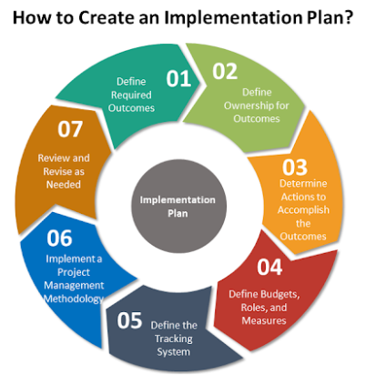Which of the following is not one of the requirements for successful implementation of strategies through projects?
   1. Allocation of resources
   2. Prioritizing of projects
   3. Motivation of project contributors
   4. Adequate planning and control systems
   5. All of these are requirements

Comment: All the options listed (a, b, c, and d) are essential requirements for the successful implementation of strategies through projects. Allocating resources, prioritizing projects, motivating project contributors, and having adequate planning and control systems in place are critical elements to ensure that strategies are effectively executed through projects.

1. A diagram of a project manager

   Description automatically generatedWhich of the following is the reason(s) why project managers need to understand their organization's mission and strategy?
   1. To make appropriate decisions and adjustments
   2. To be effective project advocates
   3. To be able to get their job done.
   4. Both A and B are correct
   5. A, B, and C are all correct

Comment: Understanding the organization's mission and strategy allows project managers to make appropriate decisions and adjustments (A) and to be effective project advocates (B). It helps them align their projects with the broader goals of the organization and ensure that their project management decisions are in line with the strategic objectives.

1. 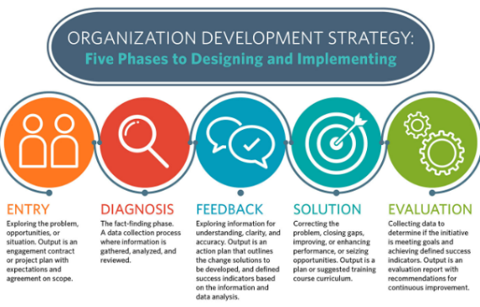 Which of these is the highest priority and first strategy required for any organizational change?

a) Communication

* 1. Stress management
  2. Negotiation
  3. Learning
  4. Employee involvement

Comment: Effective communication is essential in any organizational change initiative. It helps convey the reasons for the change, the vision for the future, and the expectations from employees. Clear, open, and transparent communication is crucial to gain buy-in, reduce resistance, and guide the organization through the change process.

1. 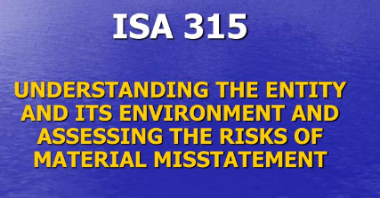Which of the following is not a procedure to obtain an understanding risk in the planning stage (described in ISA 315):
   1. Inquiries of management
   2. Analytical procedures
   3. Observation and inspection
   4. Procedures for sampling audit tests

Comment: In ISA 315, procedures such as inquiries of management, analytical procedures, and observation and inspection are typically used to gain an understanding of the entity and its environment, including internal control. Sampling audit tests are more commonly associated with substantive audit procedures performed during the execution phase rather than the initial understanding of risk during the planning stage.

1. A diagram of a risk assessment process

   Description automatically generatedAssessment of control risk includes three steps. Which of the following is not one of these steps?
   1. Obtaining an understanding of internal controls and documentation of the controls
   2. Evaluate sufficiency and appropriateness of audit evidence
   3. An initial assessment and response to assessed risk based on the design of internal controls resulting in an audit planning memorandum and audit plan.
   4. A final assessment based upon test of controls of operating effectiveness.

Comment: The evaluation of the sufficiency and appropriateness of audit evidence is a broader auditing process that occurs during the substantive testing phase and is not specific to the assessment of control risk.

1. 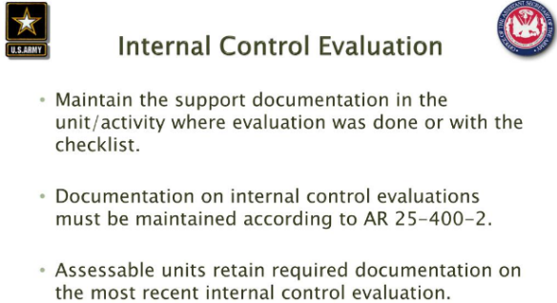Which of the following are not common internal control documentation techniques used by auditors?

a) Questionnaires

* 1. Company internal control manuals
  2. Narrative descriptions
  3. Check lists

Comment: These methods are employed to document, evaluate, and assess an organization's internal controls as part of the auditing process.

1. 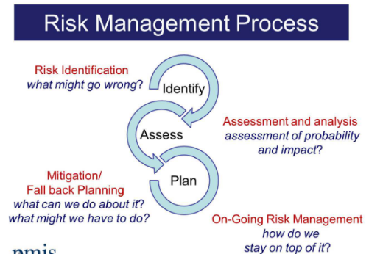Overall response to assessed risk may include:
   1. Identify the absence of key controls (where controls are lacking)
   2. Identify existing controls
   3. Incorporating additional elements of unpredictability in the selection of further audit procedures to be performed
   4. Determine potential material misstatements that could result.

Comment: This practice involves introducing an element of surprise or randomness into the audit process to enhance its effectiveness. This approach adds a layer of robustness to the audit process and increases the chances of identifying and addressing critical issues.

1. 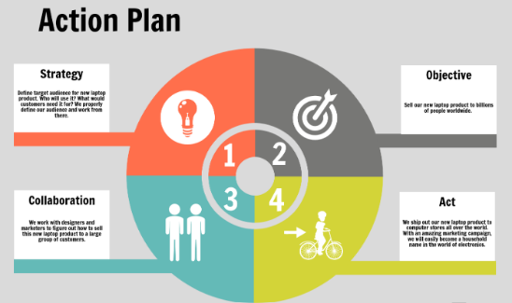Action plan Should be:
   1. Specific
   2. Countable
   3. Realistic
   4. Achievable

Comment: A countable action plan outlines clear, detailed, and well-defined steps and objectives. This specificity helps in avoiding ambiguity and provides a precise roadmap for what needs to be done.

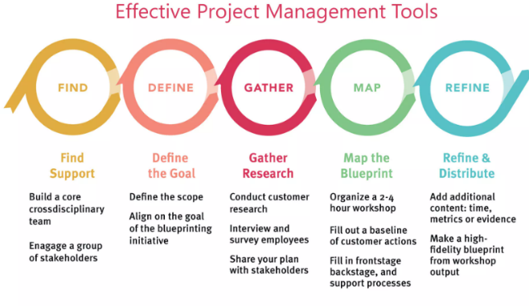13) Which of the following is not a function of Project Management Tool?

* 1. Plan a project
  2. Manage Tasks
  3. Manage Issues
  4. Time Tracking
  5. Non of above

Comment: Project management tools play a crucial role in efficiently overseeing and controlling projects. They typically encompass a range of functions, including planning projects, managing tasks, handling issues, and tracking time.

14) John, the project manager for the ERP Project, is about to complete the project phase review. The completion of a project phase is also known as which of the following?

a) A lesson learned

* 1. A kill point
  2. Earned value management
  3. Conditional advancement

Comment: "A kill point" in project management signifies the completion of a project phase and is often a critical juncture in evaluating progress and deciding whether to continue or terminate the project. It's a term commonly used to assess the feasibility and success of a project phase.

15) Which of the following is not a key stakeholder in a project that creates a service internal to an organization?

* 1. The project manager
  2. External customers
  3. Project vendors
  4. Project team members

Comment: In a project focused on creating a service internal to an organization, external customers are not typically considered key stakeholders.

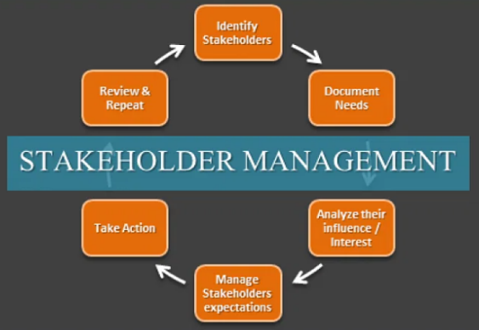17) Managing a project is best described as which one of the following?

a) Establishing direction

b) Functional controls over the project team and stakeholders

c)Consistently producing key results expected by stakeholders

d)Motivating and inspiring the project team to produce results that are expected by project stakeholders.

Comment: Project management involves orchestrating various aspects, but at its core, it's about consistently delivering the key results that stakeholders expect. This entails planning, organizing, and overseeing the project to ensure that it stays on track, meets its objectives, and satisfies stakeholder requirements.

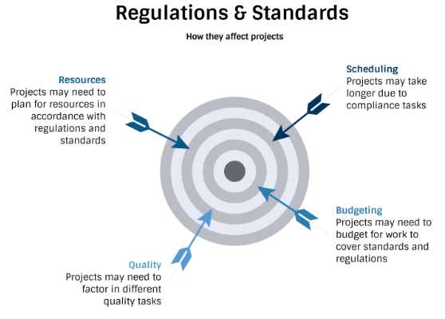18)What is the difference between a standard and a regulation?

1. Standards are mandatory; regulations are not.
2. Standards are optional; regulations are not.
3. Regulations and standards are essentially the same.
4. Regulations are usually mandatory; standards may be seen as guidelines.

Comment: Regulations are typically legally binding and enforceable, meaning they must be followed, and compliance is mandatory. Standards, on the other hand, are often considered as guidelines or best practices but are not necessarily mandatory.

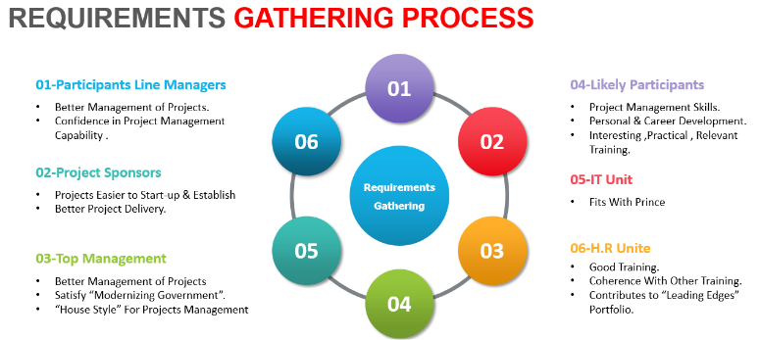19)Which of the following is an example of a deliverable at the end of the requirements-gathering phase in a software design project?

1. Responsibility matrix creation
2. Detail design document
3. Business needs
4. Project team assembled

Comment: In the context of a software design project, the requirements-gathering phase typically culminates in identifying and documenting the business needs, which serve as a critical input for the subsequent stages of the project.

1. 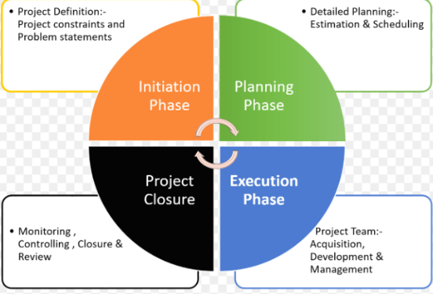At what point in a project would a kill point be acceptable?
2. When a project team member is not performing as planned
3. When a project reaches the end of a project phase
4. When a project reaches the end of its budget
5. When a project manager determines the project team cannot continue

Comment: In project management, a kill point is typically established at the end of a project phase to assess progress, evaluate the project's feasibility, and make decisions about whether to continue, modify, or terminate the project.

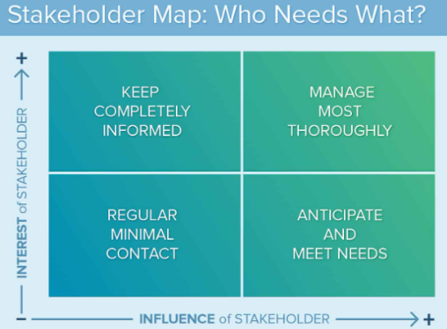21) Of the following, which is not an exit criterion?

1. Customer sign-offs
2. Quality metrics
3. Stakeholder analysis
4. Regulatory inspections

Comment: Stakeholder analysis is an essential process in project management but is not typically considered an exit criterion on its own. It helps in understanding and managing the interests and expectations of various project stakeholders but does not directly signify project completion or readiness for the next phase.

1. A diagram of a project life cycle

   Description automatically generatedAt which point is the risk of failure the least but the consequence of failure the highest?

a) During the early stages

* 1. During the middle stages
  2. During the final stages
  3. Risk of failure is even across all project phases.

Comment: During the final stages of a project, many risks have already been addressed and mitigated, reducing the overall risk of failure. However, the consequences of failure at this point can be the highest because resources, time, and effort have been invested, and any failure or issues that arise late in the project.

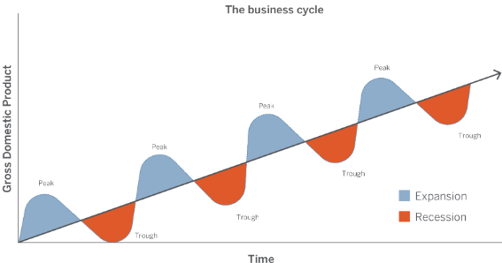23)In project estimation, project manager has to provide an expert judgement, which are considered of the following EXCEPT:

* 1. Impact of inflation over the project lifecycle
  2. Required labour and labour rates
  3. Material costs and assumptions
  4. Costs of quality
  5. All of above
  6. None of above

Comment: Expert judgment involves taking into account factors such as the impact of inflation over the project lifecycle, required labour and labour rates, material costs and assumptions, and costs of quality when estimating the overall project costs. Therefore,

"None of above" is the correct choice as all these factors are relevant in the estimation process.

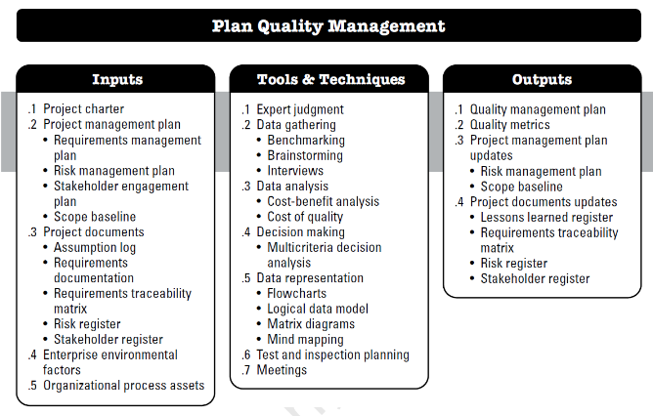24)Which component is/are included in Quality Management Plan

* 1. Quality objectives
  2. Key project deliverables
  3. Quality standards
  4. Quality control and assurance activities
  5. All of above

Comment: The Quality Management Plan is a comprehensive document in project management that outlines how quality will be managed throughout a project. It includes quality objectives, key project deliverables, quality standards, and quality control and assurance activities.

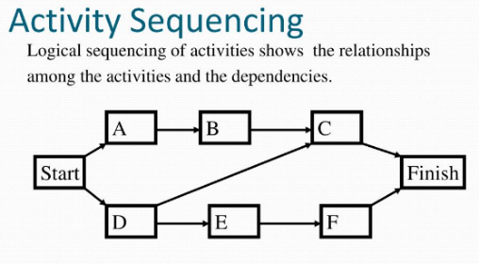25)What's an activity sequencing:

* 1. The process for identifying and documenting dependencies among schedule activities
  2. The process for identifying critical activities.
  3. The process for identifying ordering and schedule activities.
  4. The process for planning the project.

Comment: This process helps create a logical sequence for project tasks, determining which activities must be performed before or after others. It is essential for creating an effective project schedule and ensuring that activities are carried out in the right order to meet project objectives.