IT5012

Data Handling & Web Concepts

Project 2

Client-side Web Project

New Zealand Pics

Name: Vitor Antunes Cazella

Student ID: 91050051

Date: 26/11/2019

# New Zealand Pics

For this project I choose to create a photo sharing website, inspired by famous sites such as Instagram and Facebook. The idea for the site is to share photos of New Zealand showing some landscapes and great views of the country, also to give information about photography to people interested in the subject.

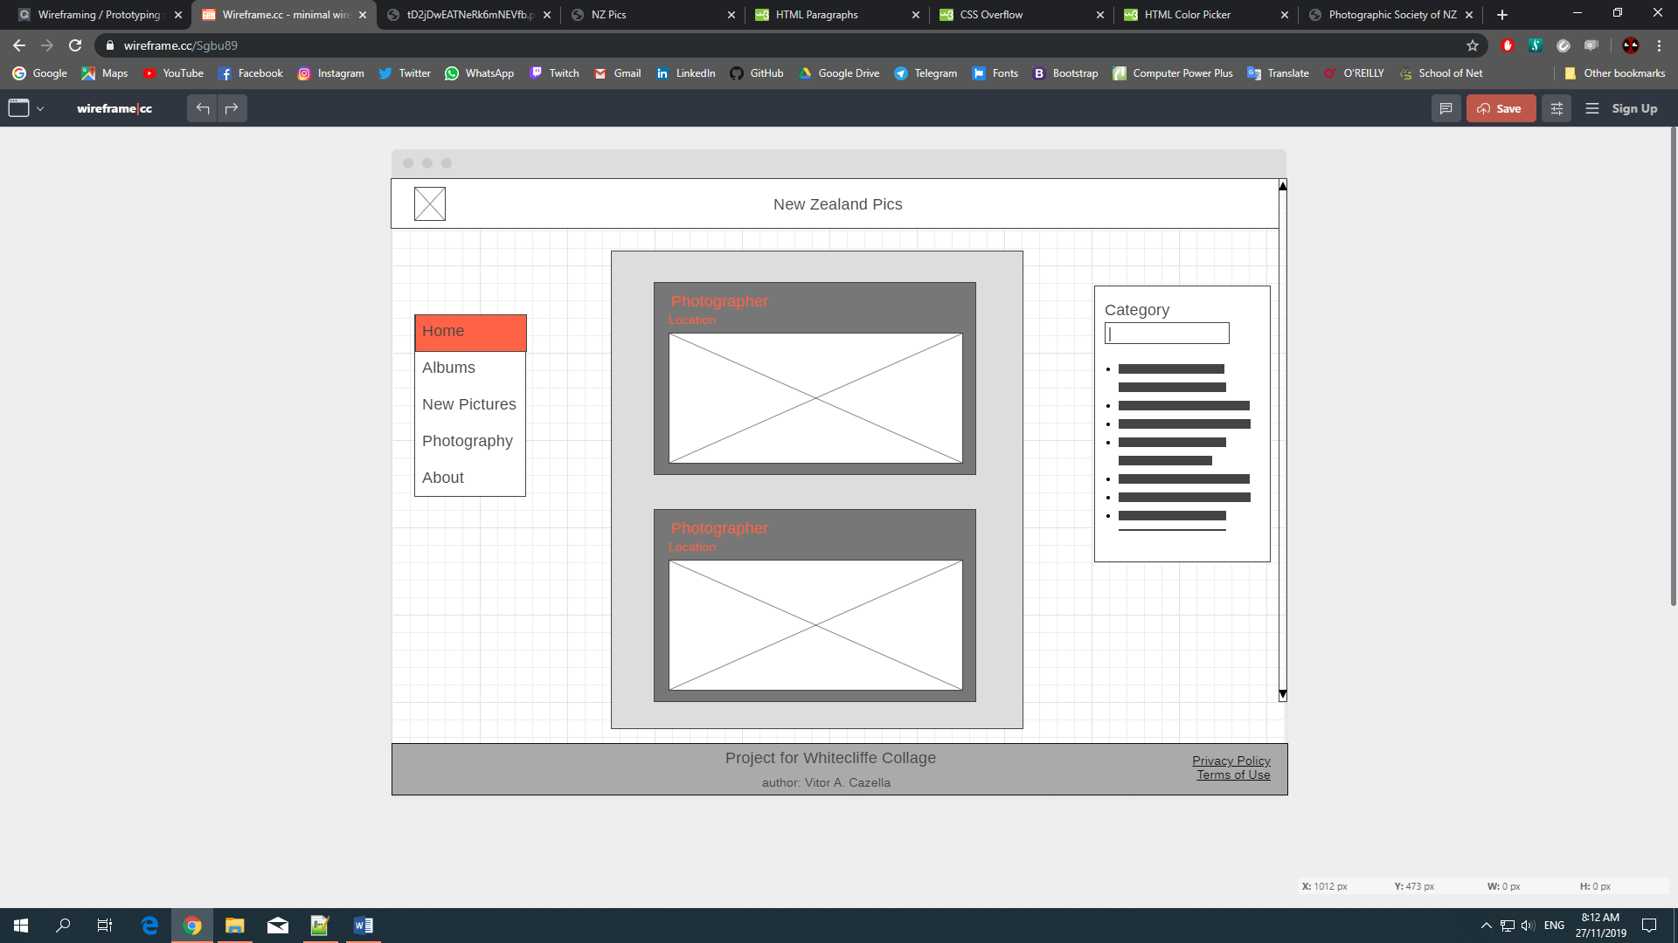

Home page

## Schedule

The creation of the website was planned for 4 days work.

1st day – Research and creating ideas

2nd day – modelling

3rd and 4th days – coding the HTML and CSS files

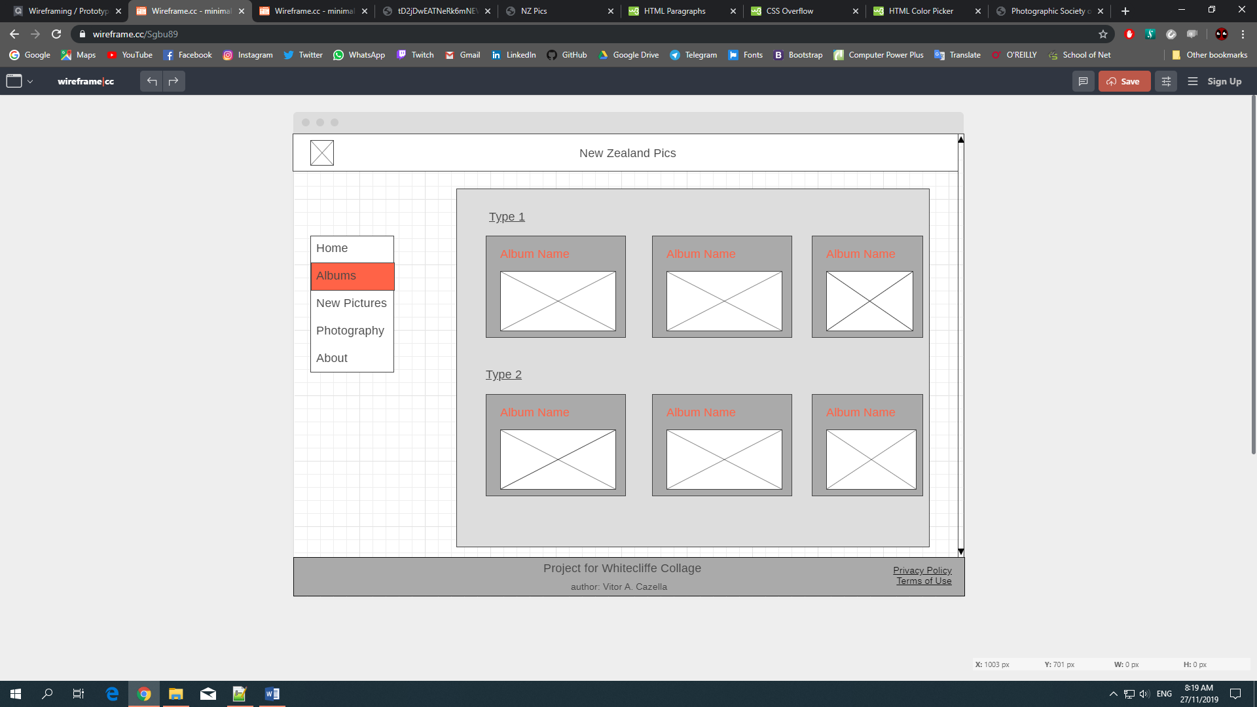

Albums Page

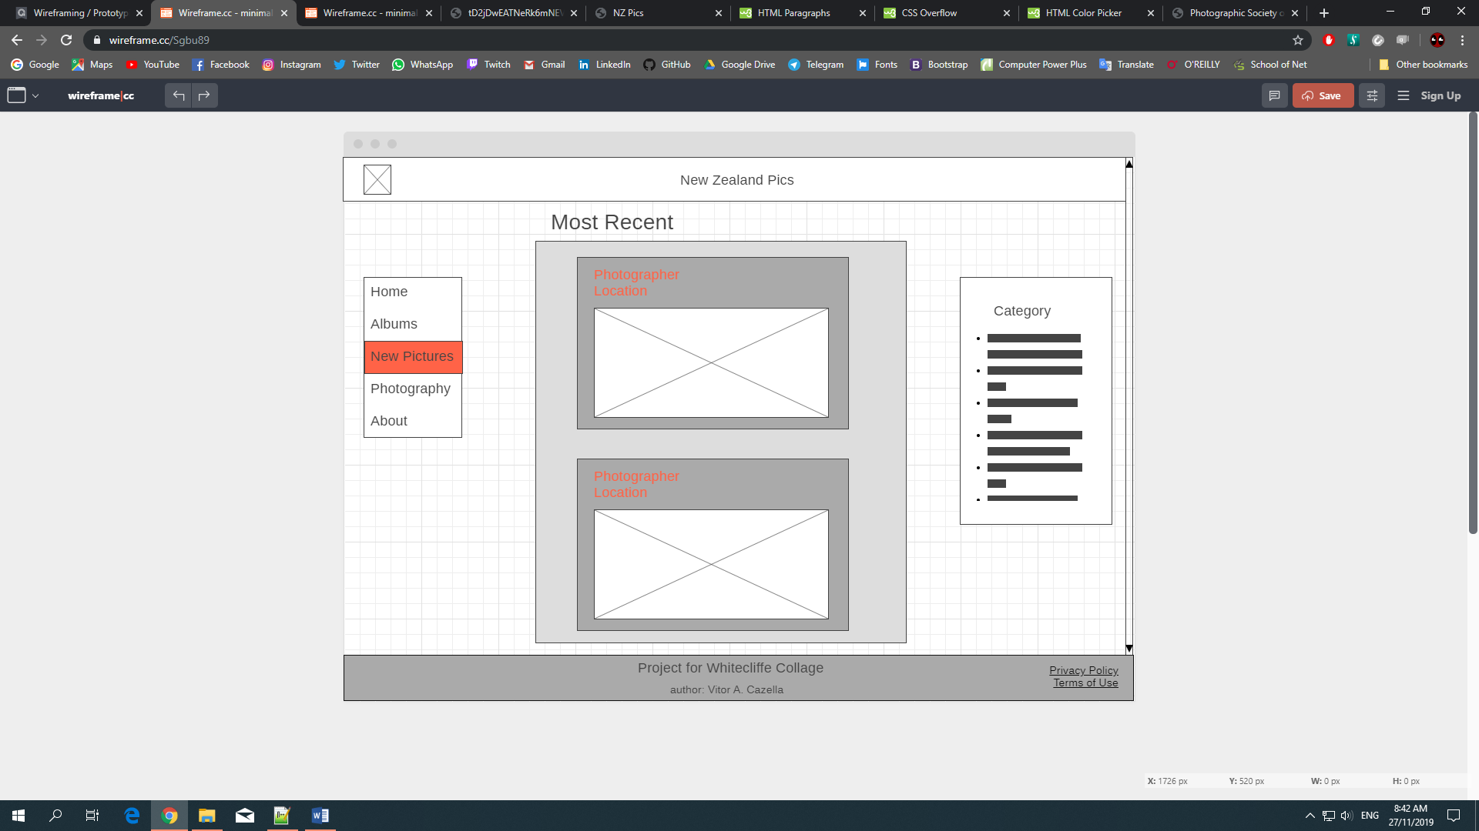

New Pictures Page

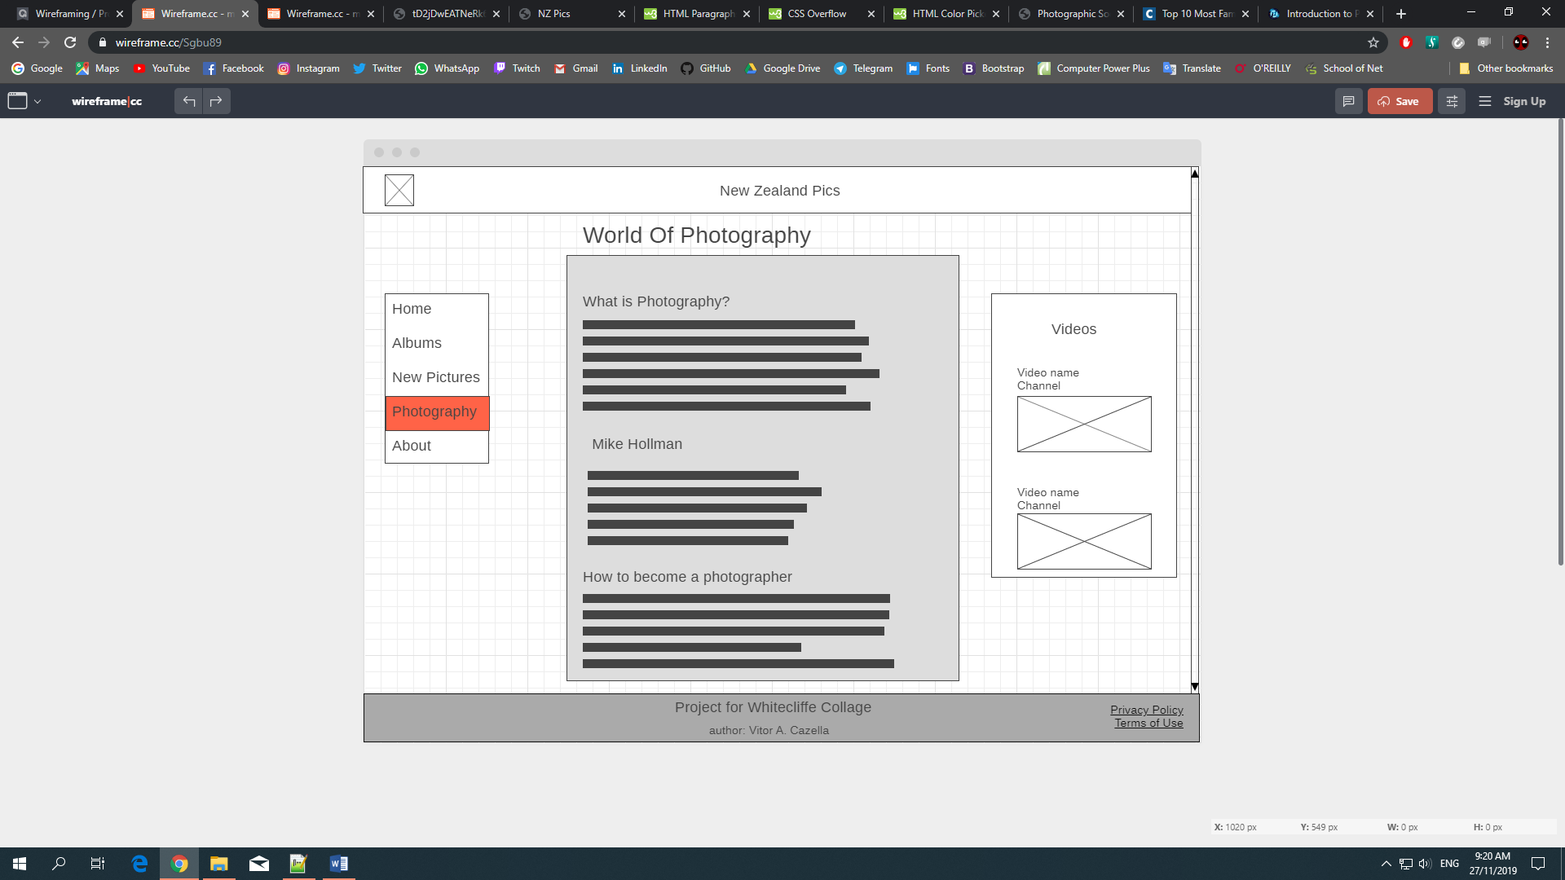

Photography Page



About Page

## Reference

**HTML and CSS references:**

iQualify material

w3Schools

<https://www.w3schools.com/>

**Research about photography:**

Photography life:

<https://photographylife.com/what-is-photography>

Photographic Society of New Zealand INC:

<https://photography.org.nz/>