IT5039

Client-Side Development

Project:

New Zealand Pics

Name: Vitor Antunes Cazella

Student ID: 91050051

Date: 01/07/2020

# Planning

I started thinking on what would be a good website idea to present the skills required for the project, and then I ended up deciding on continue and improve an idea from one of my first courses here on Whitecliffe, IT5012 Data Handling & Web Concepts, the NZ Pics website.

That idea was developed during that course while learning basic Web Concepts, using HTML5 and CSS only, therefore came the idea of updating the website to be responsive and more interactive, using the newly acquired skills on JavaScript and its React library.

# Wireframes

Since this a continuation from the Web Concepts project, I will keeping the original website idea with a few tweaks.

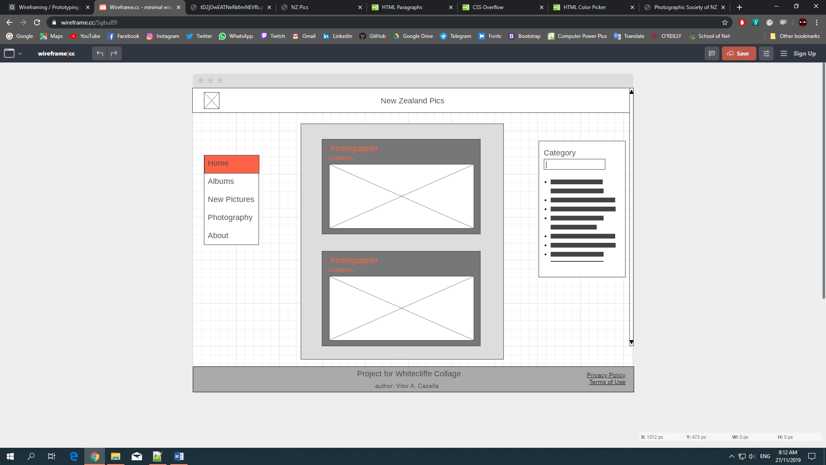

Home Page

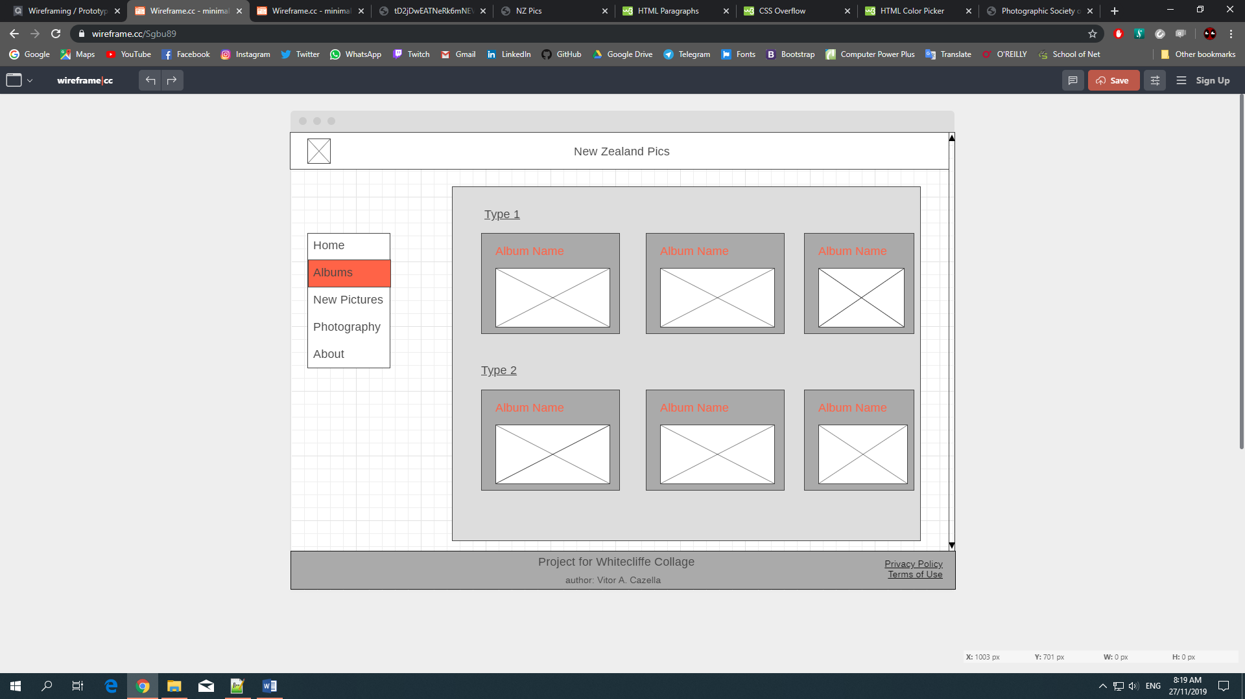Albums Page

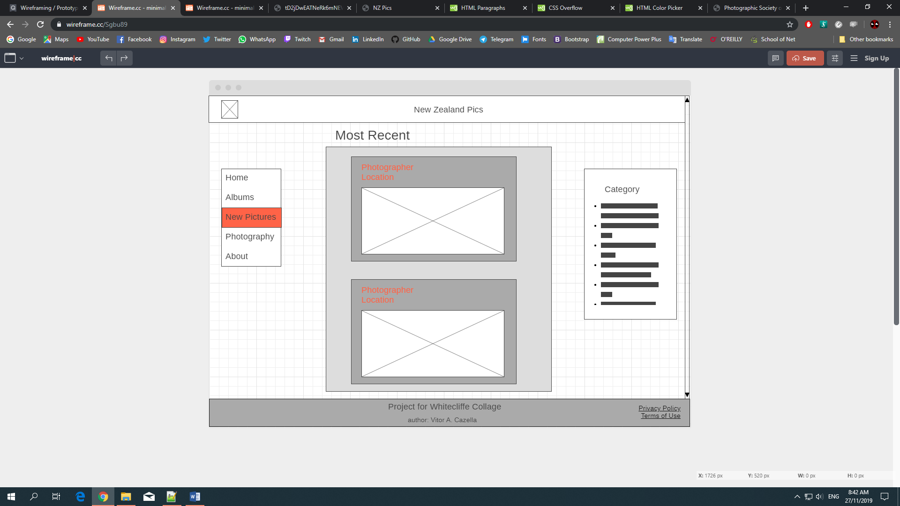New Pictures Page

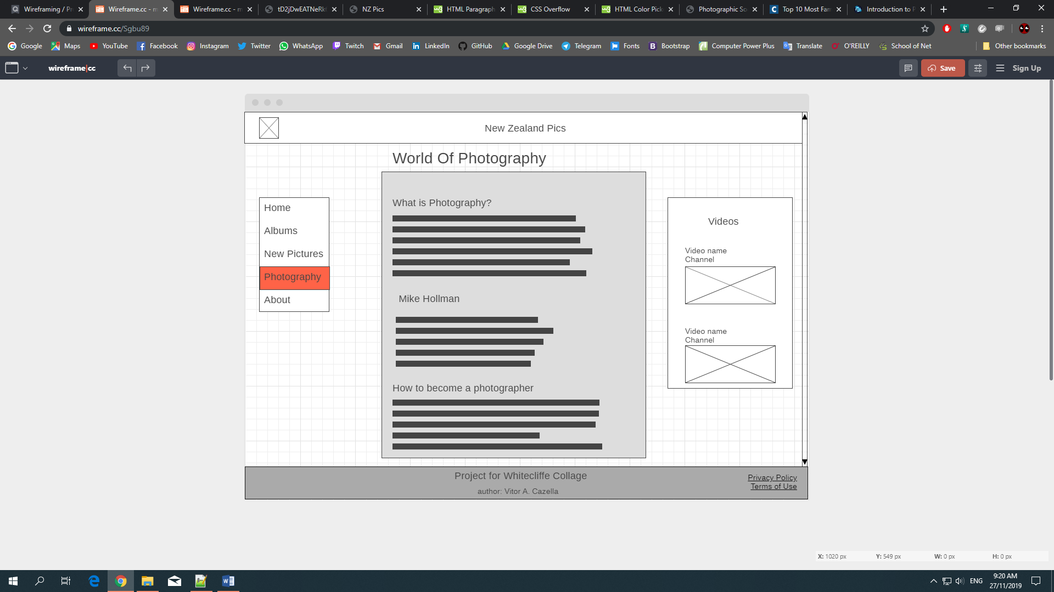

Photography Page

**HTML and CSS references:**

iQualify material

w3Schools

<https://www.w3schools.com/>

**Research about photography:**

Photography life:

<https://photographylife.com/what-is-photography>

Photographic Society of New Zealand INC:

<https://photography.org.nz/>