Game Test and Analysis

IT6034 Practical Task 2 Game Optimisation

Name: Vitor Antunes Cazella

Student ID: 91050051

The project that is given us meet requirements for visual usability, however it had performance issues since the game wasn’t optimized. First test the game hits a maximum of 30 fps and the longer it runs the fps also starts dropping, which happens due to the raindrop nodes being spawned infinitely and then requires more processing to do.

With this in mind, some changes were proposed, and the first one that would definitely make a difference in performance was to delete the nodes that get out the screen, so after the change we hit the mark of 60 fps that didn’t drop while executing which was already a great improvement from the last test.

The second change was caching the raindrop node in a variable so it would have to be loaded every time we need to use the node, this is also a great technique to improve the game’s performance which made it run better.

Other proposed changes that I choose to implemented:

* RigidBody2D Mode to “Character”
* CollisionShape2D turn Disabled on
* Put five sprites in the rain drop scene instead of one

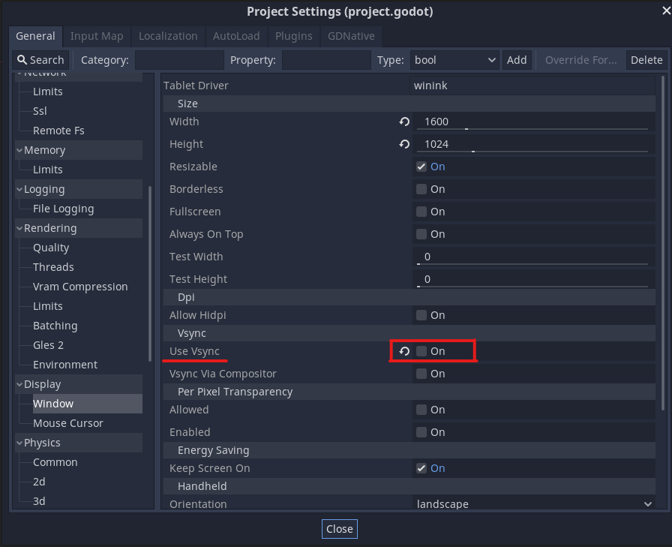However after the program hit 60 fps even with every change made we couldn’t see a difference in performance, then we found out about the fps limitation being on in the configurations of the project, an option called VSync, that locks the fps according to the monitor’s framerate. And then after disable the setting the program started hitting above 150 fps without any framedrops.