

Mobile Development

IT6035

Group Workshop Guidelines

Developing Mobile App

Name: Vitor Antunes Cazella

Student ID: 91050051

# Refining the idea

**Requirements**

**Client Mobile App Ideas**

1. **Hotel’s automated service.** Features:

* Guests can order a room service meal.
* Guests can ask to make up their room.
* Guest can set up an electronic “Do not disturb” sign visible to the hotel staff through the app.
* Guests can book a spa treatment.
* Guests can order a wakeup call.

2. **Restaurant’s automated service.** Features:

* Guests can order a meal from various menu categories.
* Guests can order a drink from the drinks menu.
* Guests can take a photo of their meal through the app that will automatically frame it with the restaurant name.
* Guests can rate their food through the app.
* Guests can share the photos of their food and their restaurant experience to Instagram.

## **Research Log**

**Choosing the idea**

Looking at the two ideas for the App I decided to go with the Hotel’s automated service called my attention the most since in a hotel there are so many areas to explore and since hotels usually, not only have several activities to entertain the guests, and also hotels tend to have a restaurant which doesn’t exclude the idea of a restaurant automated service on the App.

**User Groups**

Before going further with the project I had to determine the group of user that the app would be targeting, which are the hotel guests. The app could also support the hotel staff to orientate on the guest’s needs. Also the app won’t be able to be used outside the booking dates for guests, then these user would fall in the non-supported area.

# Sketching and Wireframing

### App Sketch

Made while trying to visualize the app and be able to explain better the idea.

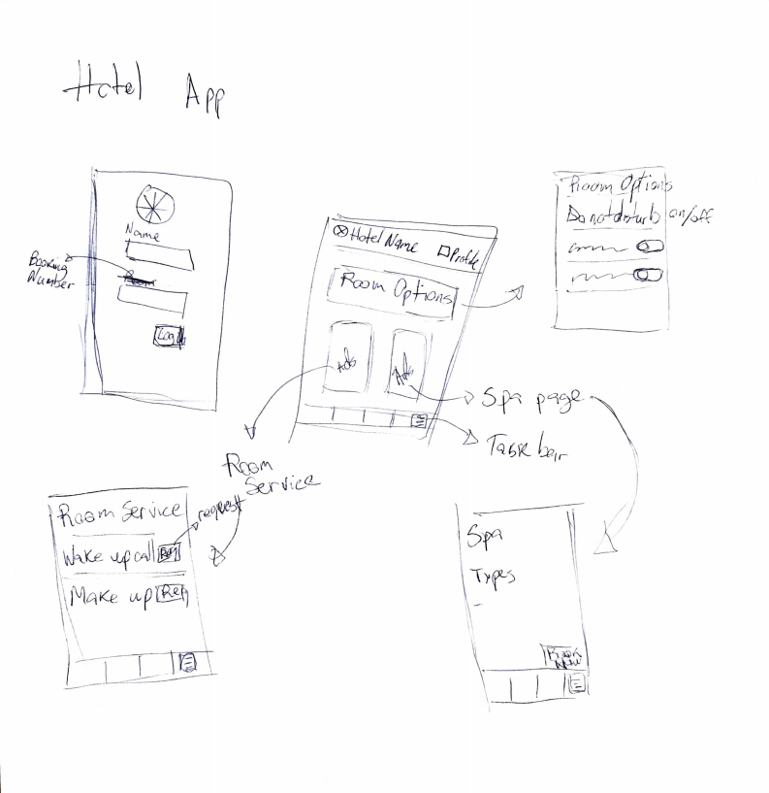

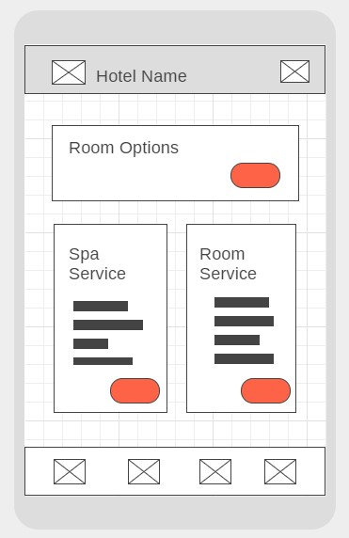

### Wireframes

These wireframe models were designed after the sketches seen above, it was thought to be simple to be used as a fast resource by the hotel guests.

The wireframes were made on the website <https://wireframe.cc/>

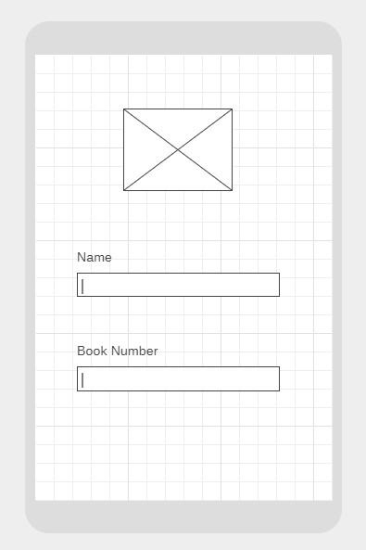

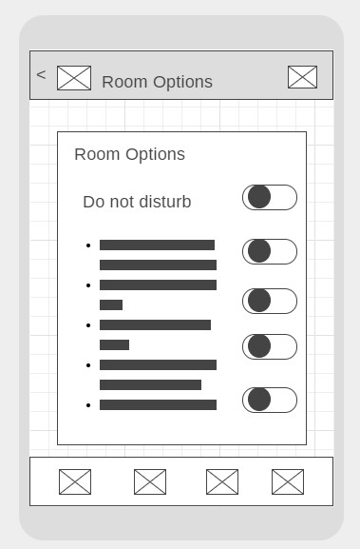

# UX Accessibility in Mobile Apps

During the research and drawing development parts of the app, therefore only had a couple tweaks to make on the design to make sure that people with disabilities could also enjoy the application without frustration, one example of change made for the wireframe was the back button on “Room Options” page, made so it would be easier for the user to navigate through different pages dynamically.