Mobile Development

Project IT6035

Name: Vitor Antunes Cazella

ID Student: 91050051

# Requirements Analysis and Design

**Client Information and Mobile App Overview**

**Client’s background.**

The company provides merchandising services to various retail shops. The company works with multiple clients and has a fleet of merchandisers who, on an agreed day, will come to the agreed space and set up a goods display in the way specified by the client.

The company would like to create a mobile app that both individual merchandisers and supervisors can use.

**Mobile app users:**

Two groups of users will use the mobile app: merchandisers and their supervisors.

* **Merchandisers** are responsible for setting up product displays in such a way that stimulates interest and entices customers to make a purchase. Each day merchandisers have a list of displays to set up (referred to as tickets in the mobile app). Normally merchandisers will have several tickets a day to action.

Merchandisers are paid on an hourly basis, so they need to record the time each display took to set up (using a timer in the mobile app) and provide it to their supervisor.

* **Supervisors** are merchandisers’ managers; they are responsible for monitoring the merchandisers, making sure the appropriate tickets are actioned and the displays are set up to a high standard. Supervisors also liaise with retail shops regarding their setups.

**Mobile App Access**

In this instance, the app access for different types of users should be set up through navigation.

In the future, the client would set up proper authentication and authorisation, but it falls beyond the scope of this first iteration of mobile app development that you were asked to undertake.

**Functionality Overview**

For the supervisors, the app should show a list of merchandisers they are monitoring. And include individual merchandiser profiles that contain their names and contact details. They should also be able to see a list of retail shop clients, and be allowed to add a new client or update the existing client’s details.

For the *merchandiser*, the app should display the list of tickets and highlight today’s tickets. It also has to have the functionality to select the current ticket, record the time taken for the current ticket and then mark the ticket as complete. Moreover, the merchandiser should also be able to add comments to the ticket.

**User Stories**

The user stories are provided with this document. Some of the user stories may be incomplete.

Feel free to contact your client (tutor) to find out more information.

# System Design

**Sketches**

Going through design requirements from the client was decided to implement a project visualisation technique that allowed a better understanding of the app. On a white board I drawed a first design idea.

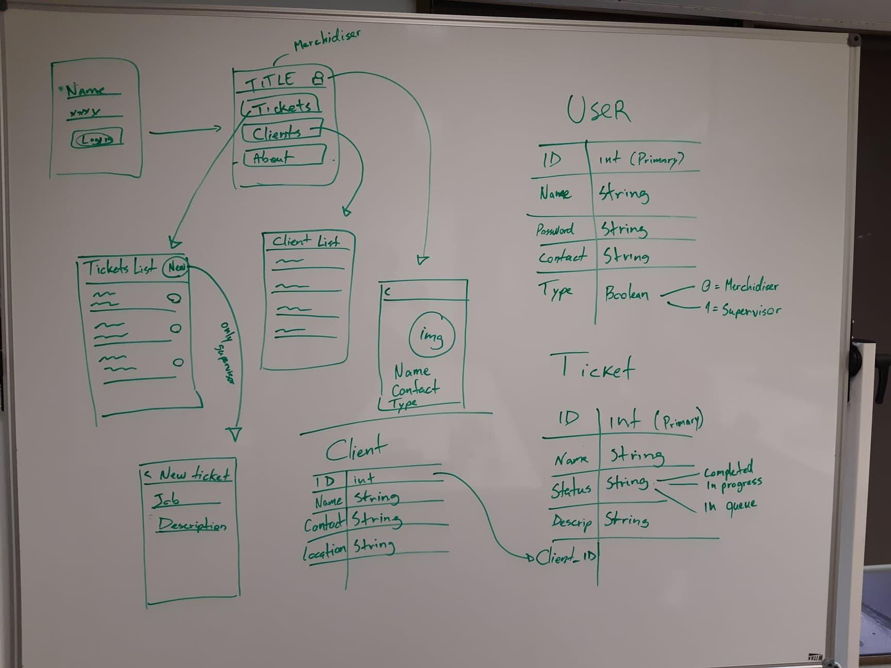

**Mockup**

The mockups were done with a tool proper for application projects called JustInMind.