Consider a game in which there is a bag with an equal number of blue and red balls, and there is a two-pan balance. Randomly drawing one ball at a time from the bag, you must place the ball on the left pan if it is blue or on the right pan if it is red. If, at any moment, there are more than 3 balls of one color than the other, the balance becomes unbalanced, and all the balls fall to the ground, resulting in the loss of the game. The game ends successfully when the bag is empty, provided the balance does not become unbalanced until the last ball is placed.

1. Considering the sequence of drawn balls, construct a regular expression (RE) to check whether the player won the game or not.

Answer:

**Regular Expression: ^(**B**\*(**R**{0,3}**B**){0,3}**R**{0,3})*$**

**Explanation:**

* $ and ^ stand for the sequence's start and finish, respectively.
* B* corresponds with at least one blue ball.
* (R{0,3}B){0,3} permits a maximum of three red balls to follow by a blue ball, and this group can be repeated three times in total.
* Up to three consecutive red balls are permitted with R{0,3}.
* The pattern can be repeated zero or more times by using the outermost *.

The key to winning the game is to make sure that the difference between the number of blue and red balls at any one time stays within the given bound using this regular expression.

1. Using the Thompson construction, transform the RE from the previous point into a minimal deterministic finite automaton (min-DFA).

Answer:

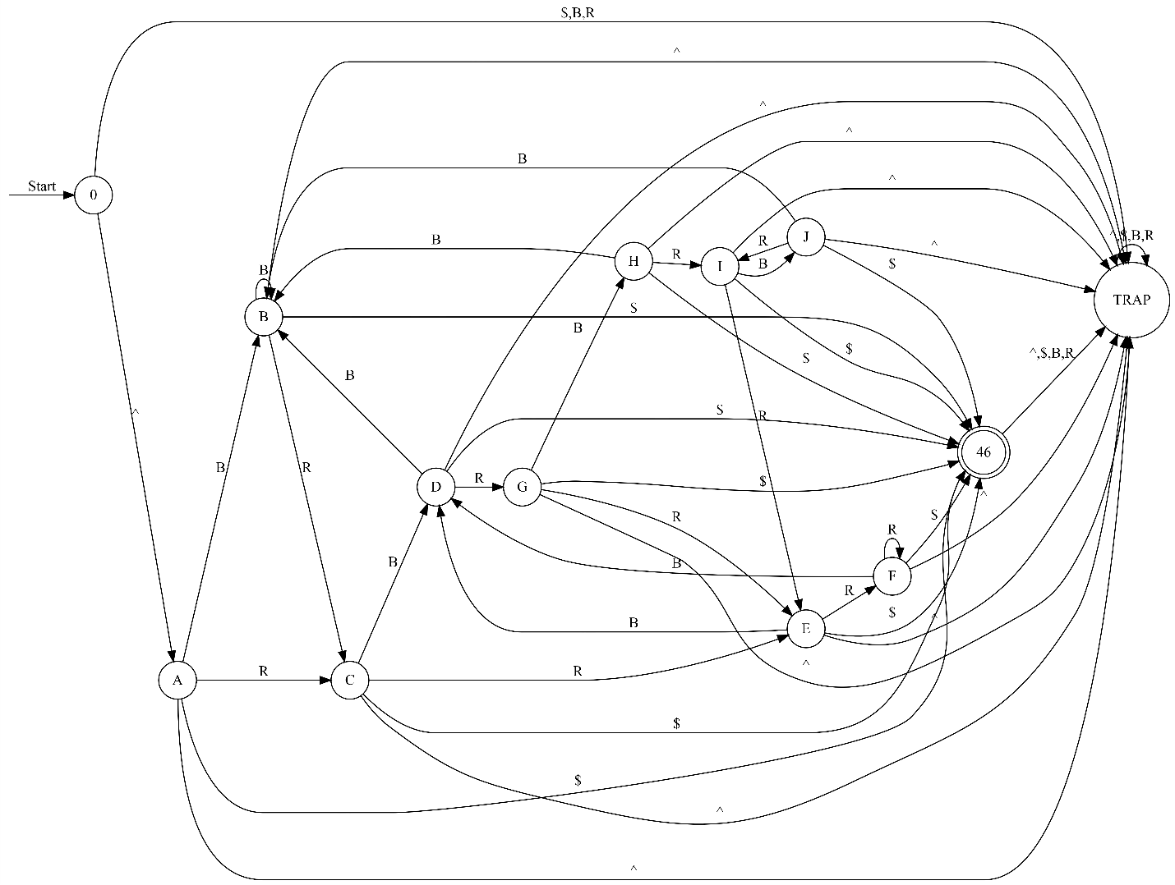

Min-DFA

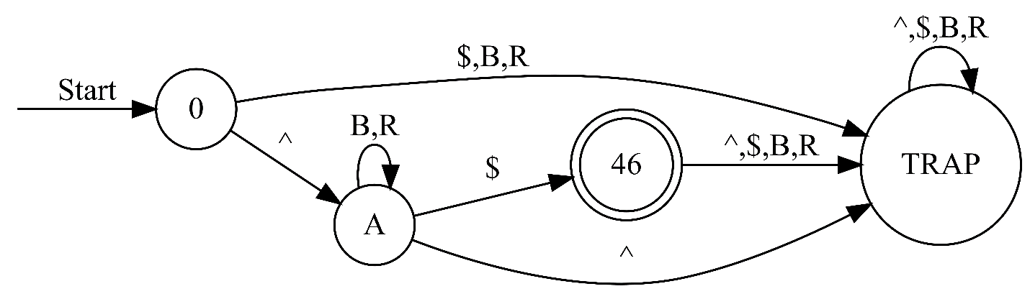

1. Build an RE, considering that the number of balls of each color inside the bag may be different.

Answer:

RE: ^(B*|R*)$

Explanation:

If there is room for variation in the number of balls of each color inside the bag, we may create a more broad regular expression that does not place restrictions on the range of counts that can differ. This phrase accepts any combination of red and blue balls.

1. Construct a minimal DFA that recognizes the same sequences as the RE

Answer:

