Consider a game in which there is a bag with an equal number of blue and red balls, and there is a two-pan balance. Randomly drawing one ball at a time from the bag, you must place the ball on the left pan if it is blue or on the right pan if it is red. If, at any moment, there are more than 3 balls of one color than the other, the balance becomes unbalanced, and all the balls fall to the ground, resulting in the loss of the game. The game ends successfully when the bag is empty, provided the balance does not become unbalanced until the last ball is placed.

1. Considering the sequence of drawn balls, construct a regular expression (RE) to check whether the player won the game or not.

Answer:

**Regular Expression: ^((BR){0,3}|(RB){0,3})*(BR){0,3}(RB){0,3}*((BR){0,3}|(RB){0,3})*$**

**Explanation:**

* $ and ^ denote the beginning and end of the series, respectively.
* At least one blue ball and B* match.
* A maximum of three red balls may be followed by a blue ball in (R{0,3}B){0,3}, and this group can be repeated thrice overall.
* With R{0,3}, up to three consecutive red balls are allowed.
* The outermost * can be used to repeat the pattern zero or more times.

1. Using the Thompson construction, transform the RE from the previous point into a minimal deterministic finite automaton (min-DFA).

Answer:

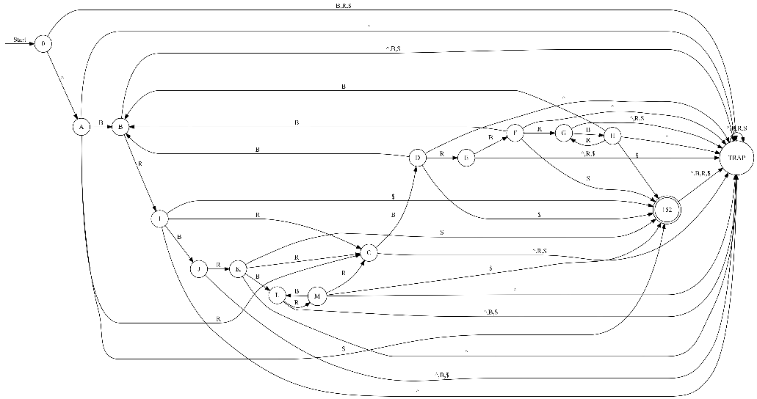

Min-DFA

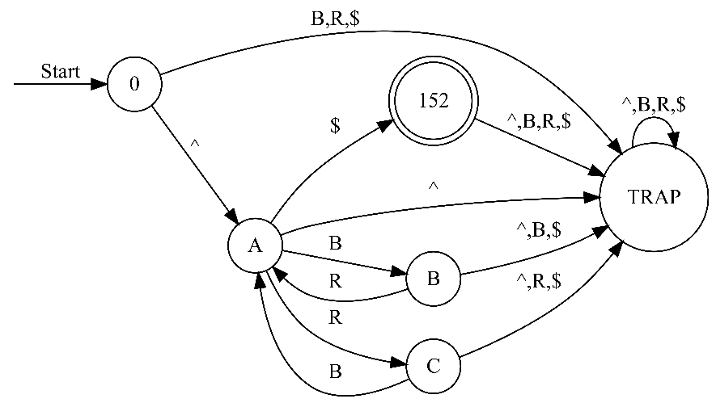

1. Build an RE, considering that the number of balls of each color inside the bag may be different.

Answer:

RE: ^((BR|RB){0,3})*(BR|RB){0,3}((BR|RB){0,3})*$

Explanation:

* The expression is anchored at the start of the string with this symbol.
* ((BR|RB){0,3})*: Permits 0–3 instances of the 'BR' or 'RB' sequence.
* (BR|RB){0,3}: Permits one instance of either 'BR' or 'RB' to occur up to three times.
* ((BR|RB){0,3})*: Permits any number of iterations (zero or more) of the previous patterns.
* $: Sets the expression's anchor to the string's end.

This regular expression guarantees that any number of balanced pairs may occur between any optional combination of 'BR' or 'RB' pairs at the beginning and conclusion of the sequence. The quantifier {0,3} indicates that the pattern can appear anywhere from 0 to 3 times.

1. Construct a minimal DFA that recognizes the same sequences as the RE

Answer:

