Орищенко Виталий

@Vitosh992

Группа 1

**Архитектор ИИ**

**Задание 9**

a.

**select** **name**, telegram_contact

**from** student s

**where** city = 'Москва' **or** city = 'Казань'

**order** **by** **name** **DESC**

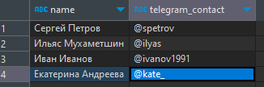

b.

**select** ('Университет: ' || **name** || '; ' || ' количество студентов: ' || **size**) **as** "Полная информация"

**from** college c

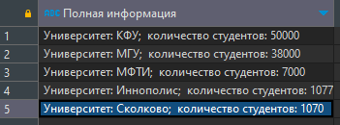

c.

**select** **name**, **size** **from** college c

**where** id **in** (10, 30, 50)

**order** **by** **size**, **name**

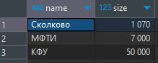

d.

**select** **name**, **size** **from** college c

**where** id **not** **in** (10, 30, 50)

**order** **by** **size**, **name**

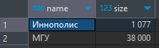

e.

**select** **name**, amount_of_students

**from** course c

**where** amount_of_students **between** 27 **and** 310

**order** **by** **name**, amount_of_students **desc**

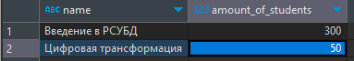

f.

**select** * **from** ((**select** c.**name**

**from** course c

**join** college c2

**on** c.college_id = c2.id)

**union**

(**select** s.**name** **from** student s

**join** student_on_course soc

**on** s.id = soc.student_id)) **as** name2

**order** **by** name2 **desc**

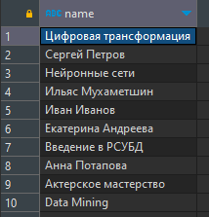

g.

**select** * **from** ((**select** c.**name**, 'курс' **as** "object_type" **from** course c)

**union**

(**select** c2.**name**, 'университет' **from** college c2)) **as** **result**

**order** **by** object_type **desc**, **name**

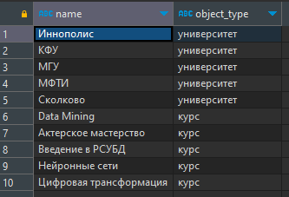

h.

**select** c.**name**, c.amount_of_students **from** course c

**order** **by** **case**

**when** c.amount_of_students = 300 **then** 1

**end**

**limit** 3

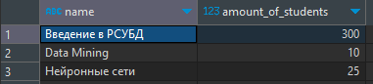

i.

**insert** **into** course (id, **name**, is_online, amount_of_students, college_id)

**values** (60, 'Machine Learning', **false**, 17,

(**select** c2.id

**from** course c

**join** college c2 **ON** c.college_id = c2.id

**where** c.**name** = 'Data Mining'));

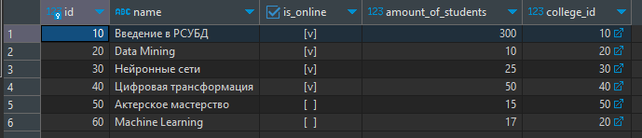

j.

**select** id **from** ((**select** c.id **from** course c

**left** **join** student_on_course soc

**on** c.id = soc.id

**where** soc.id **is** **null**)

**Union**

(**select** soc.id **from** course c

**right** **join** student_on_course soc

**on** c.id = soc.id

**where** c.id **is** **null**)) **as** t2

**order** **by** t2.id



k.

**select** s.**name** **as** student_name, c.**name** **as** course_name, c.**name** **as** student_college, soc.student_rating **from** student s

**join** college c **on** c.id = s.college_id

**join** student_on_course soc **ON** soc.student_id = s.id

**where** soc.student_rating > 50 **and** c.**size** > 5000

**order** **by** student_name, course_name

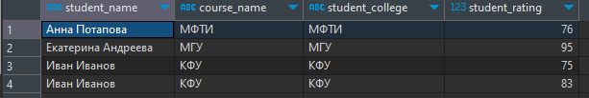

l.

**select** s.**name** **as** student_1, s22.**name** **as** student_2, s.city **from** student s

**join**

(**select** * **from** student s2) **as** s22

**on** s.city = s22.city

**where** s.**name** <> s22.**name**

**order** **by** s.**name**

**limit** 2

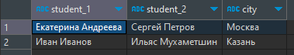

m.

**select**

**case**

**when** student_rating < 30 **then** 'неудовлетворительно'

**when** student_rating >= 30 **and** student_rating < 60 **then** 'удовлетворительно'

**when** student_rating >= 60 **and** student_rating < 85 **then** 'хорошо'

**else** 'отлично'

**end** **as** оценка,

**count**(student_id) **AS** "количество студентов"

**from**

student_on_course

**group** **by**

оценка

**order** **by**

оценка;

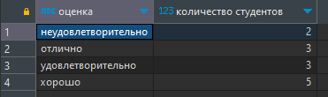

n.

**select**

c.**name** **AS** курс,

**case**

**when** soc.student_rating < 30 **then** 'неудовлетворительно'

**when** soc.student_rating >= 30 **and** soc.student_rating < 60 **then** 'удовлетворительно'

**when** soc.student_rating >= 60 **and** soc.student_rating < 85 **then** 'хорошо'

**else** 'отлично'

**end** **as** оценка,

**count**(soc.student_id) **as** "количество студентов"

**from**

student_on_course soc

**join**

course c **ON** soc.course_id = c.id

**group** **by**

c.**name**, оценка

**order** **by**

c.**name**, оценка;

