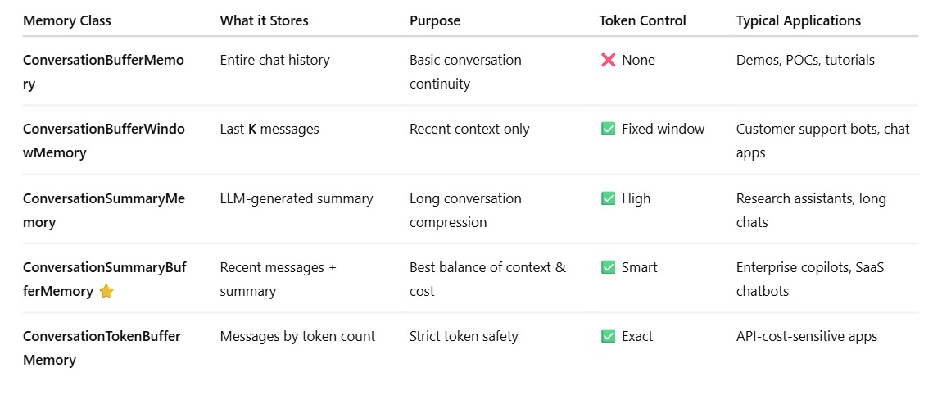
ConversationSummaryBufferMemory is used .
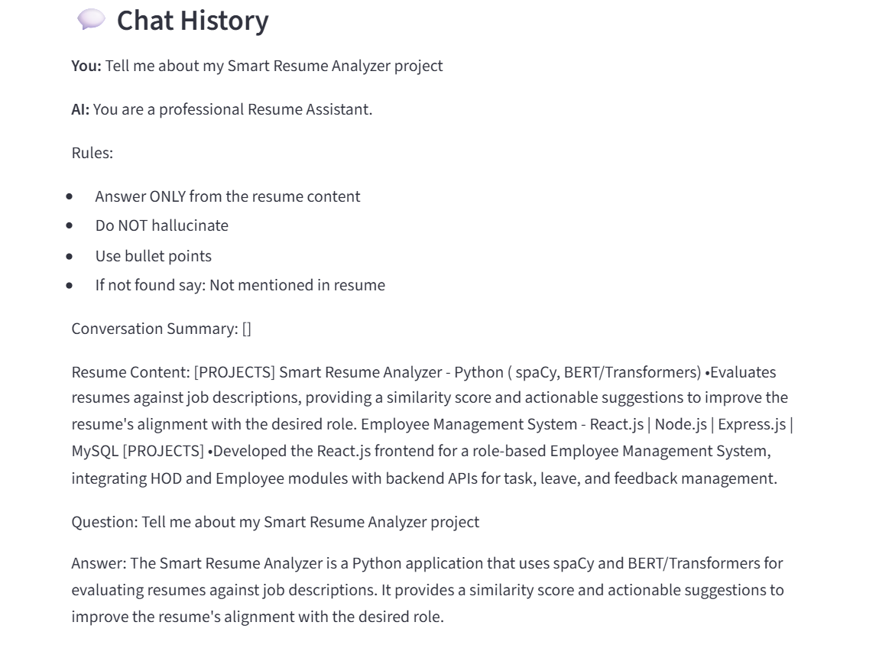

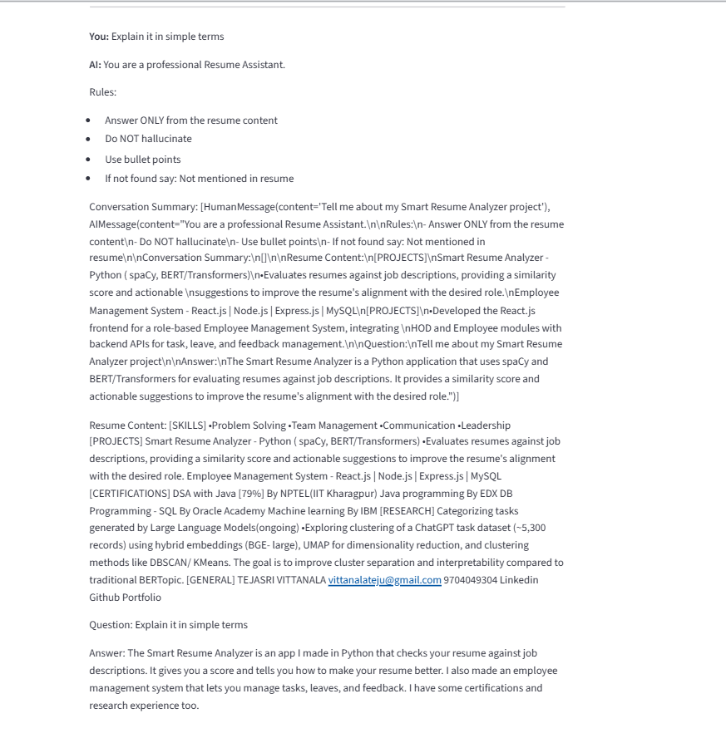

Question: What did I study in it
Answer: Computer Science fundamentals

You: what is the degree i did in above study
AI: You are a professional Resume Assistant.
Rules:
- Answer ONLY from the resume content
- Do NOT hallucinate
- Use bullet points
- If not found say: Not mentioned in resume
Conversation Summary: [HumanMessage(content='What did I study in it'), AIMessage(content="You are a professional Resume Assistant.\n\nRules:\n- Answer ONLY from the resume content\n- Do NOT hallucinate\n- Use bullet points\n- If not found say: Not mentioned in resume\n\nConversation Summary:\n[]\n\nResume Content:\n[CERTIFICATIONS]\nDSA with Java [79%]\nBy NPTEL(IIT Kharagpur)\nJava programming\nBy EDX\nDB Programming - SQL\nBy Oracle Academy\nMachine learning\nBy IBM\n[SKILLS]\n•Programming : Java, Python, DSA.\n•Web Development : HTML5, CSS3, JavaScript.\n•Tools : GitHub, Tableau.\n•Databases: MySQL, MongoDB.\n•CS fundamentals : OOPS, DBMS, OS.\n[SKILLS]\n•Problem Solving\n•Team Management\n•Communication\n•Leadership\n[PROJECTS]\nSmart Resume Analyzer - Python ( spaCy, BERT/Transformers)\n•Evaluates resumes against job descriptions, providing a similarity score and actionable \nsuggestions to improve the resume's alignment with the desired role.\nEmployee Management System - React.js | Node.js | Express.js | MySQL\n[ACHIEVEMENTS]\nAdobe Career Academy\n•Selected as 1 of 200 mentees across India for mentorship focusing on Data Structures and \nAlgorithms, Computer Science fundamentals, and interview preparation.\nSmart coder (Mentorship)\n•Smart Interviews Certified Smart Coder with expertise in DSA and mentorship experience.\n\nQuestion:\nWhat did I study in it\n\nAnswer:\nComputer Science fundamentals")]
Resume Content: [CERTIFICATIONS] DSA with Java [79%] By NPTEL(IIT Kharagpur) Java programming By EDX DB Programming - SQL By Oracle Academy Machine learning By IBM [EDUCATION] 2022 – 2026 Bhimavaram BTech - CSE , Shri Vishnu Engineering College for women •CGPA - 9.5 •Honors in Artificial Intelligence CGPA - 9.3 2020 – 2022 Amalapuram Intermediate - MPC , Sri Chaitanya Junior college Percentage - 98% [ACHIEVEMENTS] Adobe Career Academy •Selected as 1 of 200 mentees across India for mentorship focusing on Data Structures and Algorithms, Computer Science fundamentals, and interview preparation. Smart coder (Mentorship) •Smart Interviews Certified Smart Coder with expertise in DSA and mentorship experience. [SKILLS] •Problem Solving •Team Management •Communication •Leadership [SKILLS] •Programming : Java, Python, DSA. •Web Development : HTML5, CSS3, JavaScript. •Tools : GitHub, Tableau. •Databases: MySQL, MongoDB. •CS fundamentals : OOPS, DBMS, OS.
Question: what is the degree i did in above study
Answer: BTech - CSE, Shri Vishnu Engineering College for women

