

**COMPUTER SCIENCE PROJECT**

**2022-23**



**Name– Vitthal Choudhary**

**Class- XII MPC CS**

**Roll Number-**



**Dedicated at his lotus feet**

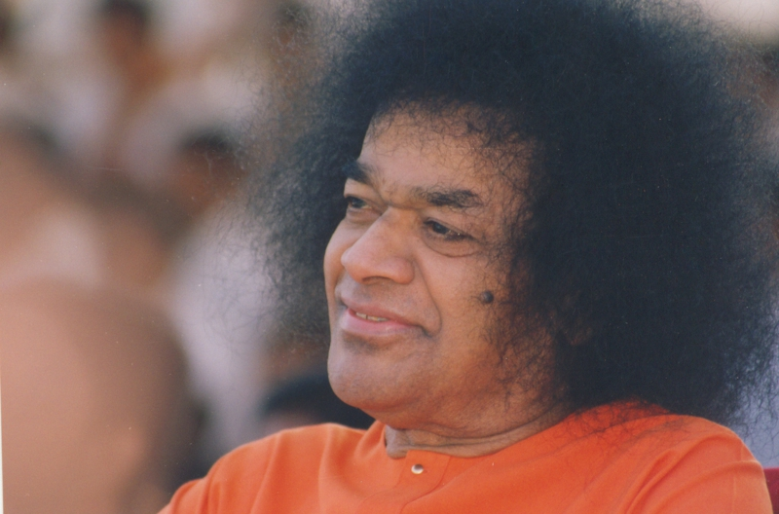

**ACKNOWLEDGEMENT**

I would like to express my gratitude and thankfulness to swami, for giving me this opportunity.

I would like to thank our dear Venkateswar Prusty Sir for teaching me this subject, guiding and correcting me on every step with so much love and patience.

I would also thank our principal sir for showing constant support towards our project.

I would like to thank Surbhi Taneja, Rohan Saha and my other dear friends for constant support to me.

I would like to thank my parents who encouraged and motivated me while making the project.

**TABLE OF CONTENTS**

1. Aim 1
2. Introduction 2
3. Theory 3
4. Implementation 4-14
5. Program code 15-43
6. Output 44-51
7. Future enhancements 52
8. Bibliography 53
9. Thank you 54

**AIM**

To make a food delivery app “Vivs” with user friendly interface using python’s module Tkinter.

**INTRODUCTION**

The concept of online food delivery from people’s favourite restaurants is fairly new to our world, yet apps like Zomato, Swiggy, Food Panda have taken over the world by a storm.

I got inspired from all of these apps and tried to create an application with user friendly interface which can help people ordering food online easily at same cost with minimal delivery charges.

**THEORY**

“Vivs” is an online food delivery app with user friendly interface. One can order food using this app easily with just few clicks. The best part about our app is you get the ordered items at same price as that in the restaurant with a very minimal delivery charge of Rs.50.

The app consists of 4 different restaurants: Madras Café, Amrik Sukhdev, Dominoes and Barista.

The aim of our app is to deliver fresh food to customers in least possible time at minimal cost.

**IMPLEMENTATION**

**Modules used:**

1. Tkinter
   1. ttk
   2. messagebox
2. PIL
   1. Image
   2. ImageTk
3. Os
4. random

**Screens:**

More and more screens make the interface of app classic. The screens are created using

main_screen = Tk() and main_screen.mainloop()

the screens are configured using functions like –

1. .iconbitmap() # for putting icon
2. .title() # for putting logo
3. .geometry() # for setting geometry of screen
4. .config() # for putting background color.

**Opening images:**

Images are opened using the PIL module’s libraries ImageTk, Image as:-

dominos = ImageTk.PhotoImage

(Image.open("dominos.jpg"))

**Label:**

Labels are used on the screens to display text and images. The labels are placed on the screen at specific coordinates as:

Label_on_main = Label(main_screen, text = Welcome to Vivs’, bg = ‘black’, fg = ‘cyan’,

font = (“Algerian”,50))

Label_on_main.place(x=170, y=50)

# for images : ---->

logo_img = ImageTk.PhotoImage

(Image.open("logo.png"))

logo_on_screen = Label

(main_screen,image=logo_img)

logo_on_screen.place(x=250,y=180)

**Entry Box:**

Entry box are used in app for asking user for his details like Name, phone number, address for delivering.

The values entered by user are stored in memory using **.get()** function as:

# entry boxes

NAME_value = StringVar()

ADDRESS_value = StringVar()

PHONE_NO_value = StringVar()

ent1 = Entry(main_screen,

textvariable=NAME_value, font="arial 20 bold", bd=4)

ent1.place(x=400, y=200)

ent2 = Entry(main_screen,

textvariable=ADDRESS_value, font="arial 20 bold", bd=4)

ent2.place(x=400, y=280)

ent3 = Entry(main_screen,

textvariable=PHONE_NO_value, font="arial 20 bold", bd=4)

ent3.place(x=400, y=360)

def print_():

if NAME_value.get() == "" or ADDRESS_value.get() == "" or PHONE_NO_value.get() == "":

messagebox.showerror("Vivs", "Enter details correctly")

else:

fil = open('Bill.txt', 'a+')

fil.write('\nOrder To be delivered at\n')

fil.writelines(["NAME :", NAME_value.get(),

'\n', "ADDRESS :",

ADDRESS_value.get(), '\n', "PHONE NUMBER :", PHONE_NO_value.get(), '\n'])

fil.write('********************************

***************\n')

fil.close()

btn3['state'] = 'disable'

os.system(r'D:\Vitthal_12_MPC_CS\PycharmProj

ects\Vivs\code\receipt.py python')

# buttons

btn3 = Button(main_screen, text="CONTINUE TO ORDER", font=("georgia", 20), bd=4, command=print_)

btn3.place(x=280, y=500)**Buttons:**

Buttons are the main part of the app as it helps the users to navigate through the app

as desired by them. The buttons are created using tkinter’s class Buttons as:

button1 = Button(main_screen,text="start ordering",bg='black',fg='cyan',

font=("georgia",40)

,command=press_button)

button1.place(x=270,y=480)

**Use of Functions:**

Functions are used to assign tasks to be undertaken by a button. Functions are created and buttons are assigned the command as:

def third_screen(value):

if value==1:

os.system(r'D:\Vitthal_12_MPC_CS\PycharmProjects\Vivs\code\madras.py python')

madras_button = Button(main_screen,

image=madras_cafe,

command=lambda:third_screen(1))

madras_button.place(x=20, y=20)

**Use of Class to Create Spinbox:**

Spinboxes are used in the app to record the number of items the customer would like to order through app. They are created as:

class spinboxes_on_screen:

def __init__(self,a,b,c):

global box

box = Spinbox(main_screen,

textvariable=c,from_=0,to=50,

width=10,font="calibri")

box.place(x=a,y=b)

a = IntVar()

box1 = spinboxes_on_screen(680,180,a)

**Use of Treeview widget to display menu:**

treeview_for_menu=ttk.Treeview(

main_screen,columns=(

"c1","c2","c3"),

show='headings',

height=10)

treeview_for_menu.column(

"# 1",

anchor=CENTER,

width=200)

treeview_for_menu.heading(

"# 1",

text="Serial Number")

treeview_for_menu.insert('', 'end', text="1",

values=('1', 'Masala Dosa', '70'))

style = ttk.Style().configure("Treeview",

rowheight=40)

treeview_for_menu.place(x=40, y=150)

**Use of file handling for generating receipt:**

generate_bill = open("Bill.txt", "w")

generate_bill.write("You have ordered: \n")

def place_order():

global a,b,c,d,e,f,g,h,i,j

a = a.get()

b = b.get()

c = c.get()

d = d.get()

e = e.get()

f = f.get()

g = g.get()

h = h.get()

i = i.get()

j = j.get()

list = [a,b,c,d,e,f,g,h,i,j]

bill = 0

for i in range(len(list)):

if i == 0:

item = "Margherita Pizza"

price = 109

elif i == 1:

item = "Farmhouse"

price = 269

elif i == 2:

item = "Peppy Paneer"

price = 269

elif i == 3:

item = "Garlic Bread sticks"

price = 109

elif i == 4:

item = "Taco Mexican Veg"

price = 79

elif i == 5:

item = "Moroccan Spice Pasta Pizza"

price = 189

elif i == 6:

item = "Party Combo"

price = 2588

elif i == 7:

item = "Choco Lava Cake"

price= 109

elif i == 8:

item = "Butterscotch Mousse Cake"

price = 103

elif i == 9:

item = "Brownie Fantasy"

price = 79

if list[i] > 0:

bill = bill+ price*list[i]

r = str(list[i]) + " " + item + " "

generate_bill.write(r)

generate_bill.write("\n")

generate_bill.write(("Amount to pay "

+ str(bill)))

**Use of random module to assign a driver:**

riders_details=[

("Nishant","+91 8420157520"), ("Raghav","+91 9452136050"),

("Mohan","+91 9925600350"), ("Sohan", "+91 7015240650"), ("Ravi","+91 8024510630"), ("Arpit","+91 7201546020")]

x = random.randrange(0, len(riders_details))

detail = (riders_details[x][0],

riders_details[x][1])

**Displaying the receipt:**

with open('Bill.txt', 'r') as fil:

rcpt = fil.read()

rcpt_label=Label(

reciept_window,text=rcpt, bg="white", fg="red", font=("Comic Sans MS", 30))

rcpt_label.place(x=180,y=300)

**PROGRAM CODE**

**Main.py**

from tkinter import *  
from PIL import Image, ImageTk  
import os  
main_screen = Tk()  
main_screen.iconbitmap("logo.ico")  
main_screen.title("Vivs")  
main_screen.geometry("900x700")  
main_screen.config(bg="black")  
label_on_main = Label(main_screen, text='Welcome to Vivs', bg="black", fg="cyan", font=("ALGERIAN", 50))  
label_on_main.place(x=170, y=50)  
logo_img = ImageTk.PhotoImage(Image.open("logo.png"))  
logo_on_screen = Label(main_screen, image=logo_img)  
logo_on_screen.place(x=250, y=180)  
# photos for restaurant screen buttons  
madras_cafe = ImageTk.PhotoImage(Image.open("MADRAS cafe.jpg"))  
dominos = ImageTk.PhotoImage(Image.open("dominos.jpg"))  
sukhdev = ImageTk.PhotoImage(Image.open("AS.jpg"))  
barista = ImageTk.PhotoImage(Image.open("barista.jpg"))  
def press_button():  
 global main_screen  
 global madras_cafe, dominos, sukhdev, barista  
 for widget in main_screen.winfo_children():  
 widget.destroy()  
 main_screen.title("Vivs")  
 main_screen.geometry("900x700")  
 main_screen.config(bg="black")  
 def third_screen(value):  
 if value == 1: os.system(r'D:\Vitthal_12_MPC_CS\PycharmProjects\Vivs\code\madras.py python')  
 if value == 2: os.system(r"D:\Vitthal_12_MPC_CS\PycharmProjects\Vivs\code\dominos.py python")  
 if value == 3: os.system(r"D:\Vitthal_12_MPC_CS\PycharmProjects\Vivs\code\sukhdev.py python")  
 if value == 4: os.system(r"D:\Vitthal_12_MPC_CS\PycharmProjects\Vivs\code\barista.py python")  
 madras_button = Button(main_screen, image=madras_cafe, command=lambda: third_screen(1))  
 madras_button.place(x=20, y=20)  
 domino_button = Button(main_screen, image=dominos, command=lambda: third_screen(2))  
 domino_button.place(x=20, y=370)  
 sukhdev_button = Button(main_screen, image=sukhdev, command=lambda: third_screen(3))  
 sukhdev_button.place(x=570, y=20)  
 barista_button = Button(main_screen, image=barista, command=lambda: third_screen(4))  
 barista_button.place(x=570, y=370)  
button1 = Button(main_screen, text="start ordering", bg='black', fg='cyan', font=("georgia", 40), command=press_button)  
button1.place(x=270, y=480)

main_screen.mainloop()

**Madras.py**

from tkinter import *  
from tkinter import ttk  
import os  
main_screen = Tk()  
main_screen.iconbitmap("logo.ico")  
main_screen.title("Vivs")  
main_screen.geometry("900x700")  
main_screen.config(bg="black")  
Label = Label(main_screen, text="Madras Cafe", bg="yellow", fg="black", font=("Comic Sans MS", 50))  
Label.pack()  
class spinboxes_on_screen:  
 def __init__(self, a, b, c):  
 global box  
 box = Spinbox(main_screen, textvariable=c, from_=0, to=50, width=10, font="calibri")  
 box.place(x=a, y=b)  
a = IntVar()  
b = IntVar()  
c = IntVar()  
d = IntVar()  
e = IntVar()  
f = IntVar()  
g = IntVar()  
h = IntVar()  
i = IntVar()  
j = IntVar()  
# spinbox for number of item customer wants to order.  
box1 = spinboxes_on_screen(680, 180, a)  
box2 = spinboxes_on_screen(680, 220, b)  
box3 = spinboxes_on_screen(680, 260, c)  
box4 = spinboxes_on_screen(680, 300, d)  
box5 = spinboxes_on_screen(680, 340, e)  
box6 = spinboxes_on_screen(680, 380, f)  
box7 = spinboxes_on_screen(680, 420, g)  
box8 = spinboxes_on_screen(680, 460, h)  
box9 = spinboxes_on_screen(680, 500, i)  
box10 = spinboxes_on_screen(680, 540, j)  
treeview_for_menu = ttk.Treeview(main_screen, columns=("c1", "c2", "c3"), show='headings', height=10)  
treeview_for_menu.column("# 1", anchor=CENTER, width=200)  
treeview_for_menu.heading("# 1", text="Serial Number")  
treeview_for_menu.column("# 2", anchor=CENTER, width=200)  
treeview_for_menu.heading("# 2", text="Items")  
treeview_for_menu.column("# 3", anchor=CENTER, width=200)  
treeview_for_menu.heading("# 3", text="Price")  
treeview_for_menu.insert('', 'end', text="1", values=('1', 'Masala Dosa', '70'))  
treeview_for_menu.insert('', 'end', text="2", values=('2', 'Cheese Dosa', '100'))  
treeview_for_menu.insert('', 'end', text="3", values=('3', 'Onion Dosa', '120'))  
treeview_for_menu.insert('', 'end', text="4", values=('4', 'Rava Dosa', '150'))  
treeview_for_menu.insert('', 'end', text="5", values=('5', 'Mix Veg Uttpam', '130'))  
treeview_for_menu.insert('', 'end', text="6", values=('6', 'Idli Samber ', '60'))  
treeview_for_menu.insert('', 'end', text="7", values=('7', 'Samber Vada', '60'))  
treeview_for_menu.insert('', 'end', text="8", values=('8', 'Fried Idli', '90'))  
treeview_for_menu.insert('', 'end', text="9", values=('9', 'Upma Sambar', '150'))  
treeview_for_menu.insert('', 'end', text="10", values=('10', 'Imli Rice', '120'))  
style = ttk.Style().configure("Treeview", rowheight=40)  
treeview_for_menu.place(x=40, y=150)  
generate_bill = open("Bill.txt", "w+")  
generate_bill.write("You have ordered: \n")  
def place_order():  
 global a, b, c, d, e, f, g, h, i, j  
 a = a.get()  
 b = b.get()  
 c = c.get()  
 d = d.get()  
 e = e.get()  
 f = f.get()  
 g = g.get()  
 h = h.get()  
 i = i.get()  
 j = j.get()  
 list = [a, b, c, d, e, f, g, h, i, j]  
 bill = 0  
 for i in range(len(list)):  
 if i == 0:  
 item = "Masala Dosa"  
 price = 70  
 elif i == 1:  
 item = "Cheese Dosa"  
 price = 100  
 elif i == 2:  
 item = "Onion Dosa"  
 price = 120  
 elif i == 3:  
 item = "Rava Dosa"  
 price = 150  
 elif i == 4:  
 item = "Mixed Veg Uttpam"  
 price = 130  
 elif i == 5:  
 item = "Idli Samber"  
 price = 60  
 elif i == 6:  
 item = "Sambar Vada"  
 price = 60  
 elif i == 7:  
 item = "fried Idli"  
 price = 90  
 elif i == 8:  
 item = "Upma Samber"  
 price = 150  
 elif i == 9:  
 item = "Imli Rice"  
 price = 120  
 if list[i] > 0:  
 bill = bill + price * list[i]  
 r = str(list[i]) + " " + item + " "  
 generate_bill.write(r)  
 generate_bill.write("\n")  
 generate_bill.write(("Amount to pay " + str(bill)) + '\n')  
 generate_bill.close() os.system(r'D:\Vitthal_12_MPC_CS\PycharmProjects\Vivs\code\address.py python')  
proceed = Button(main_screen, text="Proceed", font=("georgia", 20), command=place_order)  
proceed.place(x=670, y=600)  
main_screen.mainloop()

**Dominoes.py**

from tkinter import *  
from tkinter import ttk  
import os  
main_screen = Tk()  
main_screen.iconbitmap("logo.ico")  
main_screen.title("Vivs")  
main_screen.geometry("900x700")  
main_screen.config(bg="black")  
Label = Label(main_screen, text="Dominoes", bg="Blue", fg="white", font=("Comic Sans MS", 50))  
Label.pack()  
class spinboxes_on_screen:  
 def __init__(self, a, b, c):  
 box = Spinbox(main_screen, textvariable=c, from_=0, to=50, width=10, font="calibri")  
 box.place(x=a, y=b)  
a = IntVar()  
b = IntVar()  
c = IntVar()  
d = IntVar()  
e = IntVar()  
f = IntVar()  
g = IntVar()  
h = IntVar()  
i = IntVar()  
j = IntVar()  
# spinboxes for number of item customer wants to order.  
box1 = spinboxes_on_screen(680, 180, a)  
box2 = spinboxes_on_screen(680, 220, b)  
box3 = spinboxes_on_screen(680, 260, c)  
box4 = spinboxes_on_screen(680, 300, d)  
box5 = spinboxes_on_screen(680, 340, e)  
box6 = spinboxes_on_screen(680, 380, f)  
box7 = spinboxes_on_screen(680, 420, g)  
box8 = spinboxes_on_screen(680, 460, h)  
box9 = spinboxes_on_screen(680, 500, i)  
box10 = spinboxes_on_screen(680, 540, j)  
treeview_for_menu = ttk.Treeview(main_screen, columns=("c1", "c2", "c3"), show='headings', height=10)  
treeview_for_menu.column("# 1", anchor=CENTER, width=200)  
treeview_for_menu.heading("# 1", text="Serial Number")  
treeview_for_menu.column("# 2", anchor=CENTER, width=200)  
treeview_for_menu.heading("# 2", text="Items")  
treeview_for_menu.column("# 3", anchor=CENTER, width=200)  
treeview_for_menu.heading("# 3", text="Price")  
treeview_for_menu.insert('', 'end', text="1", values=('1', 'Margherita Pizza', '109'))  
treeview_for_menu.insert('', 'end', text="2", values=('2', 'Farmhouse', '269'))  
treeview_for_menu.insert('', 'end', text="3", values=('3', 'Peppy Paneer', '269'))  
treeview_for_menu.insert('', 'end', text="4", values=('4', 'Garlic Bread Sticks', '109'))  
treeview_for_menu.insert('', 'end', text="5", values=('5', 'Taco Mexican Veg', '79'))  
treeview_for_menu.insert('', 'end', text="6", values=('6', 'Moroccan Spice Pasta Pizza', '189'))  
treeview_for_menu.insert('', 'end', text="7", values=('7', 'Party Combo', '2558'))  
treeview_for_menu.insert('', 'end', text="8", values=('8', 'Choco Lava Cake', '109'))  
treeview_for_menu.insert('', 'end', text="9", values=('9', 'Butterscotch Mousse Cake', '103'))  
treeview_for_menu.insert('', 'end', text="10", values=('10', 'Brownie Fantasy', '79'))  
style = ttk.Style().configure("Treeview", rowheight=40)  
treeview_for_menu.place(x=40, y=150)  
generate_bill = open("Bill.txt", "w+")  
generate_bill.write("You have ordered: \n")  
def place_order():  
 global a, b, c, d, e, f, g, h, i, j  
 a = a.get()  
 b = b.get()  
 c = c.get()  
 d = d.get()  
 e = e.get()  
 f = f.get()  
 g = g.get()  
 h = h.get()  
 i = i.get()  
 j = j.get()  
 list = [a, b, c, d, e, f, g, h, i, j]  
 bill = 0  
 for i in range(len(list)):  
 if i == 0:  
 item = "Margherita Pizza"  
 price = 109  
 elif i == 1:  
 item = "Farmhouse"  
 price = 269  
 elif i == 2:  
 item = "Peppy Paneer"  
 price = 269  
 elif i == 3:  
 item = "Garlic Bread sticks"  
 price = 109  
 elif i == 4:  
 item = "Taco Mexican Veg"  
 price = 79  
 elif i == 5:  
 item = "Moroccan Spice Pasta Pizza"  
 price = 189  
 elif i == 6:  
 item = "Party Combo"  
 price = 2588  
 elif i == 7:  
 item = "Choco Lava Cake"  
 price = 109  
 elif i == 8:  
 item = "Butterscotch Mousse Cake"  
 price = 103  
 elif i == 9:  
 item = "Brownie Fantasy"  
 price = 79  
 if list[i] > 0:  
 bill = bill + price * list[i]  
 r = str(list[i]) + " " + item + " "  
 generate_bill.write(r)  
 generate_bill.write("\n")  
 generate_bill.write(("Amount to pay " + str(bill)) + '\n')  
 generate_bill.close()  
 os.system(r'D:\Vitthal_12_MPC_CS\PycharmProjects\Vivs\code\address.py python')  
proceed = Button(main_screen, text="Proceed", font=("georgia", 20), command=place_order)  
proceed.place(x=670, y=600)  
main_screen.mainloop()

**Barista.py**

from tkinter import *  
from tkinter import ttk  
import os  
main_screen = Tk()  
main_screen.iconbitmap("logo.ico")  
main_screen.title("Vivs")  
main_screen.geometry("900x700")  
main_screen.config(bg="black")  
Label = Label(main_screen, text="Barista", bg="#B87333", fg="white", font=("Comic Sans MS", 50))  
Label.pack()  
class spinboxes_on_screen:  
 def __init__(self, a, b, c):  
 global box  
 box = Spinbox(main_screen, textvariable=c, from_=0, to=50, width=10, font="calibri")  
 box.place(x=a, y=b)  
a = IntVar()  
b = IntVar()  
c = IntVar()  
d = IntVar()  
e = IntVar()  
f = IntVar()  
g = IntVar()  
h = IntVar()  
i = IntVar()  
j = IntVar()  
# spinboxes for number of item customer wants to order.  
box1 = spinboxes_on_screen(680, 180, a)  
box2 = spinboxes_on_screen(680, 220, b)  
box3 = spinboxes_on_screen(680, 260, c)  
box4 = spinboxes_on_screen(680, 300, d)  
box5 = spinboxes_on_screen(680, 340, e)  
box6 = spinboxes_on_screen(680, 380, f)  
box7 = spinboxes_on_screen(680, 420, g)  
box8 = spinboxes_on_screen(680, 460, h)  
box9 = spinboxes_on_screen(680, 500, i)  
box10 = spinboxes_on_screen(680, 540, j)  
treeview_for_menu = ttk.Treeview(main_screen, columns=("c1", "c2", "c3"), show='headings', height=10)  
treeview_for_menu.column("# 1", anchor=CENTER, width=200)  
treeview_for_menu.heading("# 1", text="Serial Number")  
treeview_for_menu.column("# 2", anchor=CENTER, width=200)  
treeview_for_menu.heading("# 2", text="Items")  
treeview_for_menu.column("# 3", anchor=CENTER, width=200)  
treeview_for_menu.heading("# 3", text="Price")  
treeview_for_menu.insert('', 'end', text="1", values=('1', 'cold coffee', '215'))  
treeview_for_menu.insert('', 'end', text="2", values=('2', 'Coffee Cappuccino', '205'))  
treeview_for_menu.insert('', 'end', text="3", values=('3', 'Ice Cafe Mocha', '270'))  
treeview_for_menu.insert('', 'end', text="4", values=('4', 'Iced Americano', '185'))  
treeview_for_menu.insert('', 'end', text="5", values=('5', 'Green Apple Lemonade', '255'))  
treeview_for_menu.insert('', 'end', text="6", values=('6', 'Brownie fondente', '190'))  
treeview_for_menu.insert('', 'end', text="7", values=('7', 'Blueberry Muffin', '175'))  
treeview_for_menu.insert('', 'end', text="8", values=('8', 'Cold Coffee Brownie Frappe', '385'))  
treeview_for_menu.insert('', 'end', text="9", values=('9', 'Sulaimani tea', '209'))  
treeview_for_menu.insert('', 'end', text="10", values=('10', 'Holiday Spice', '265'))  
style = ttk.Style().configure("Treeview", rowheight=40)  
treeview_for_menu.place(x=40, y=150)  
generate_bill = open("Bill.txt", "w+")  
generate_bill.write("You have ordered: \n")  
def place_order():  
 global a, b, c, d, e, f, g, h, i, j, menu  
 a = a.get()  
 b = b.get()  
 c = c.get()  
 d = d.get()  
 e = e.get()  
 f = f.get()  
 g = g.get()  
 h = h.get()  
 i = i.get()  
 j = j.get()  
 list = [a, b, c, d, e, f, g, h, i, j]  
 bill = 0  
 for i in range(len(list)):  
 if i == 0:  
 item = "Cold Coffee"  
 price = 215  
 elif i == 1:  
 item = "Coffee Cappuccino"  
 price = 205  
 elif i == 2:  
 item = "Ice cafe mocha"  
 price = 270  
 elif i == 3:  
 item = "Iced Americano"  
 price = 185  
 elif i == 4:  
 item = "Green Apple Lemonade"  
 price = 255  
 elif i == 5:  
 item = "Brownie Fondente"  
 price = 190  
 elif i == 6:  
 item = "Blueberry muffin"  
 price = 175  
 elif i == 7:  
 item = "Cold Coffee Brownie Frappe"  
 price = 385  
 elif i == 8:  
 item = "Sulaimani tea"  
 price = 209  
 elif i == 9:  
 item = "Holiday spice"  
 price = 265  
 if list[i] > 0:  
 bill = bill + price * list[i]  
 r = str(list[i]) + " " + item + " "  
 generate_bill.write(r)  
 generate_bill.write("\n")  
 generate_bill.write(("Amount to pay " + str(bill)) + '\n')  
 generate_bill.close() os.system(r'D:\Vitthal_12_MPC_CS\PycharmProjects\Vivs\code\address.py python')  
proceed = Button(main_screen, text="Proceed", font=("georgia", 20), command=place_order)  
proceed.place(x=670, y=600)  
main_screen.mainloop()

**Sukhdev.py**

from tkinter import *  
from tkinter import ttk  
import os  
main_screen = Tk()  
main_screen.iconbitmap("logo.ico")  
main_screen.title("Vivs")  
main_screen.geometry("900x700")  
main_screen.config(bg="black")  
Label = Label(main_screen, text="Sukhdev", bg="yellow", fg="red", font=("Comic Sans MS", 50))  
Label.pack()  
class spinboxes_on_screen:  
 def __init__(self, a, b, c):  
 box = Spinbox(main_screen, textvariable=c, from_=0, to=50, width=10, font="calibri")  
 box.place(x=a, y=b)  
a = IntVar()  
b = IntVar()  
c = IntVar()  
d = IntVar()  
e = IntVar()  
f = IntVar()  
g = IntVar()  
h = IntVar()  
i = IntVar()  
j = IntVar()  
# spinboxes for number of item customer wants to order.  
box1 = spinboxes_on_screen(680, 180, a)  
box2 = spinboxes_on_screen(680, 220, b)  
box3 = spinboxes_on_screen(680, 260, c)  
box4 = spinboxes_on_screen(680, 300, d)  
box5 = spinboxes_on_screen(680, 340, e)  
box6 = spinboxes_on_screen(680, 380, f)  
box7 = spinboxes_on_screen(680, 420, g)  
box8 = spinboxes_on_screen(680, 460, h)  
box9 = spinboxes_on_screen(680, 500, i)  
box10 = spinboxes_on_screen(680, 540, j)  
treeview_for_menu = ttk.Treeview(main_screen, columns=("c1", "c2", "c3"), show='headings', height=10)  
treeview_for_menu.column("# 1", anchor=CENTER, width=200)  
treeview_for_menu.heading("# 1", text="Serial Number")  
treeview_for_menu.column("# 2", anchor=CENTER, width=200)  
treeview_for_menu.heading("# 2", text="Items")  
treeview_for_menu.column("# 3", anchor=CENTER, width=200)  
treeview_for_menu.heading("# 3", text="Price")  
  
treeview_for_menu.insert('', 'end', text="1", values=('1', 'Aalo Parantha', '100'))  
treeview_for_menu.insert('', 'end', text="2", values=('2', 'Paneer Parantha', '120'))  
treeview_for_menu.insert('', 'end', text="3", values=('3', 'Roti', '30'))  
treeview_for_menu.insert('', 'end', text="4", values=('4', 'Stuffed Naan', '60'))  
treeview_for_menu.insert('', 'end', text="5", values=('5', 'Paneer-do-pyaaza', '260'))  
treeview_for_menu.insert('', 'end', text="6", values=('6', 'Daal Balti', '240'))  
treeview_for_menu.insert('', 'end', text="7", values=('7', 'Kadhai Paneer', '250'))  
treeview_for_menu.insert('', 'end', text="8", values=('8', 'Malai Chaap', '260'))  
treeview_for_menu.insert('', 'end', text="9", values=('9', 'Tandoori Chaap', '240'))  
treeview_for_menu.insert('', 'end', text="10", values=('10', 'Deluxe Thaali', '400'))  
style = ttk.Style().configure("Treeview", rowheight=40)  
treeview_for_menu.place(x=40, y=150)  
generate_bill = open("Bill.txt", "w+")  
generate_bill.write("You have ordered: \n")  
def place_order():  
 global a, b, c, d, e, f, g, h, i, j  
 a = a.get()  
 b = b.get()  
 c = c.get()  
 d = d.get()  
 e = e.get()  
 f = f.get()  
 g = g.get()  
 h = h.get()  
 i = i.get()  
 j = j.get()  
 list = [a, b, c, d, e, f, g, h, i, j]  
 bill = 0  
 for i in range(len(list)):  
 if i == 0:  
 item = "Aloo parantha"  
 price = 100  
 elif i == 1:  
 item = "Paneer parantha"  
 price = 120  
 elif i == 2:  
 item = "Roti"  
 price = 30  
 elif i == 3:  
 item = "Stuffed Naan"  
 price = 60  
 elif i == 4:  
 item = "Paneer-do-pyaaza"  
 price = 260  
 elif i == 5:  
 item = "Daal Balti"  
 price = 240  
 elif i == 6:  
 item = "Kadhai Paneer"  
 price = 250  
 elif i == 7:  
 item = "Malai Chaap"  
 price = 250  
 elif i == 8:  
 item = "Tandoori Chaap"  
 price = 240  
 elif i == 9:  
 item = "Deluxe Thaali"  
 price = 400  
 if list[i] > 0:  
 bill = bill + price * list[i]  
 r = str(list[i]) + " " + item + " "  
 generate_bill.write(r)  
 generate_bill.write("\n")  
 generate_bill.write(("Amount to pay " + str(bill)) + '\n')  
 generate_bill.close()  
 os.system(r'D:\Vitthal_12_MPC_CS\PycharmProjects\Vivs\code\address.py python')  
proceed = Button(main_screen, text="Proceed", font=("georgia", 20), command=place_order)  
proceed.place(x=670, y=600)  
main_screen.mainloop()

**Address.py**

from tkinter import *  
from tkinter import messagebox  
import os

main_screen = Tk()  
main_screen.iconbitmap("logo.ico")  
main_screen.title("Vivs")  
main_screen.geometry("900x700")  
main_screen.config(bg="black")

Label(main_screen, text="Vivs", font="arial 60 bold", bg="cyan", fg="black").pack(fill='both')

Label(main_screen, text="NAME", font="arial 20 bold", fg="blue", bd=8).place(x=150, y=200) # LABEL 1

Label(main_screen, text="ADDRESS", font="arial 20 bold", fg="blue", bd=8).place(x=150, y=280) # LABEL 2

Label(main_screen, text="PHONE NO", font="arial 20 bold", fg="blue", bd=8).place(x=150, y=360) # LABEL 3  
# entry boxes  
NAME_value = StringVar()  
ADDRESS_value = StringVar()  
PHONE_NO_value = StringVar()  
ent1 = Entry(main_screen, textvariable=NAME_value, font="arial 20 bold", bd=4)  
ent1.place(x=400, y=200)

ent2 = Entry(main_screen, textvariable=ADDRESS_value, font="arial 20 bold", bd=4)

ent2.place(x=400, y=280)

ent3 = Entry(main_screen, textvariable=PHONE_NO_value, font="arial 20 bold", bd=4)  
ent3.place(x=400, y=360)

def print_():  
 if NAME_value.get() == "" or ADDRESS_value.get() == "" or PHONE_NO_value.get() == "":  
 messagebox.showerror("Vivs", "Enter details correctly")  
 else:  
 fil = open('Bill.txt', 'a+')  
 fil.write('\nOrder To be delivered at\n')  
 fil.writelines(["NAME :", NAME_value.get(), '\n', "ADDRESS :", ADDRESS_value.get(), '\n', "PHONE NUMBER :",  
 PHONE_NO_value.get(), '\n'])  
 fil.write('************************************************\n')  
 fil.close()  
 btn3['state'] = 'disable' os.system(r'D:\Vitthal_12_MPC_CS\PycharmProjects\Vivs\code\receipt.py python')  
# buttons

btn3 = Button(main_screen, text="CONTINUE TO ORDER", font=("georgia", 20), bd=4, command=print_)

btn3.place(x=280, y=500)

main_screen.mainloop()

**Reciept.py**

from tkinter import *  
import random

receipt_window = Tk()  
receipt_window.iconbitmap("logo.ico")  
receipt_window.title("Vivs")  
receipt_window.geometry("900x700")  
receipt_window.config(bg="black")

riders_details = [("Nishant", "+91 8420157520"), ("Raghav", "+91 9452136050"),  
 ("Mohan", "+91 9925600350"), ("Sohan", "+91 7015240650"),  
 ("Ravi", "+91 8024510630"), ("Arpit", "+91 7201546020")]

x = random.randrange(0, len(riders_details))

detail = (riders_details[x][0], riders_details[x][1])

receipt = Label(receipt_window, text="Thanks for using Vivs \n Your order will be delivered by :-", bg="white", fg="red", font=("Comic Sans MS", 30))

receipt.place(x=140, y=50)

rider = Label(receipt_window, text=detail, bg="white", fg="red", font=("Comic Sans MS", 30))

rider.place(x=220, y=200)

with open('Bill.txt', 'r') as fil:  
 rcpt = fil.read()  
 rcpt_label = Label(receipt_window, text=rcpt, bg="white", fg="red", font=('cosmic sans', 15))

rcpt_label.place(x=260, y=300)

receipt_window.mainloop()

**Snaps of Project**

**1st Screen :-**

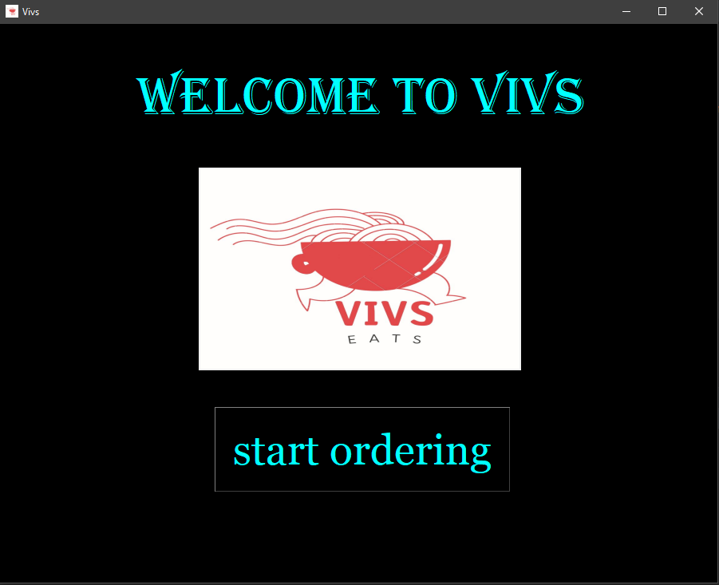

**2nd Screen:-**

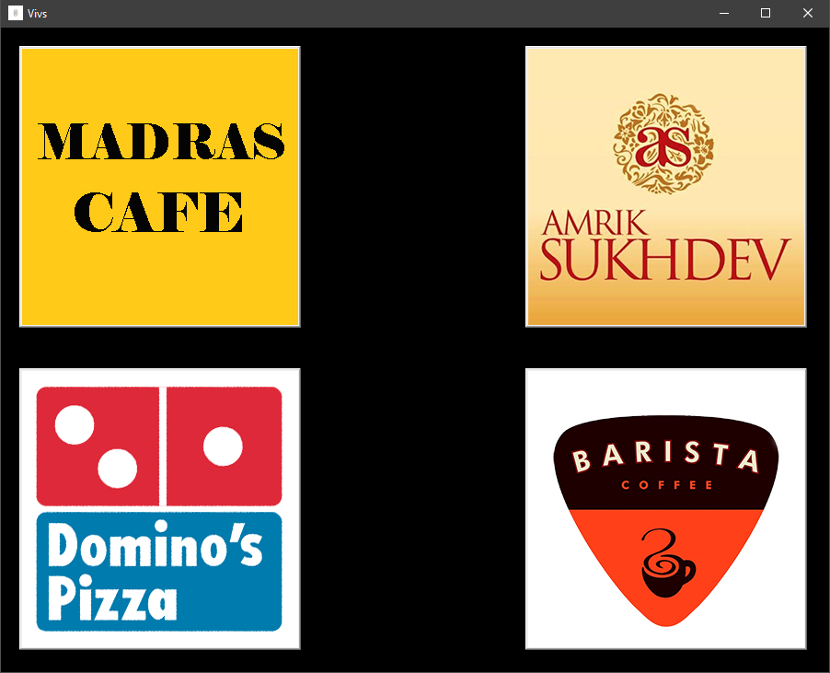

**3rd Screen:-** Madras Cafe

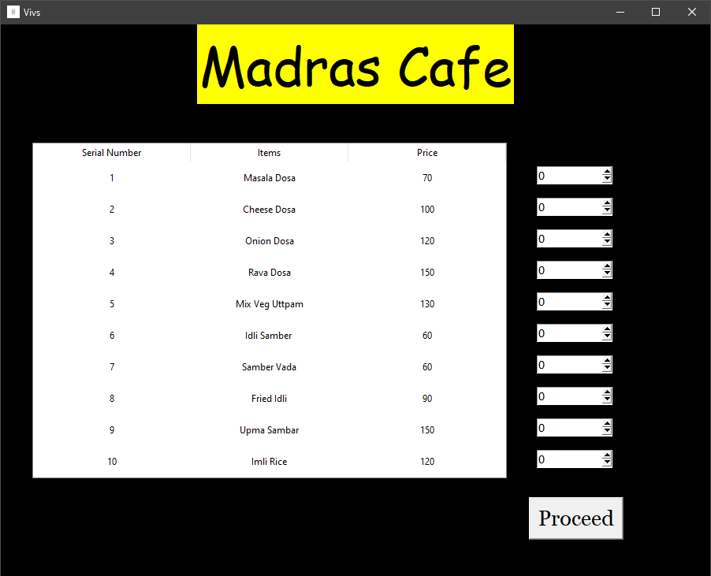

**4th Screen:-** Amrik Sukhdev

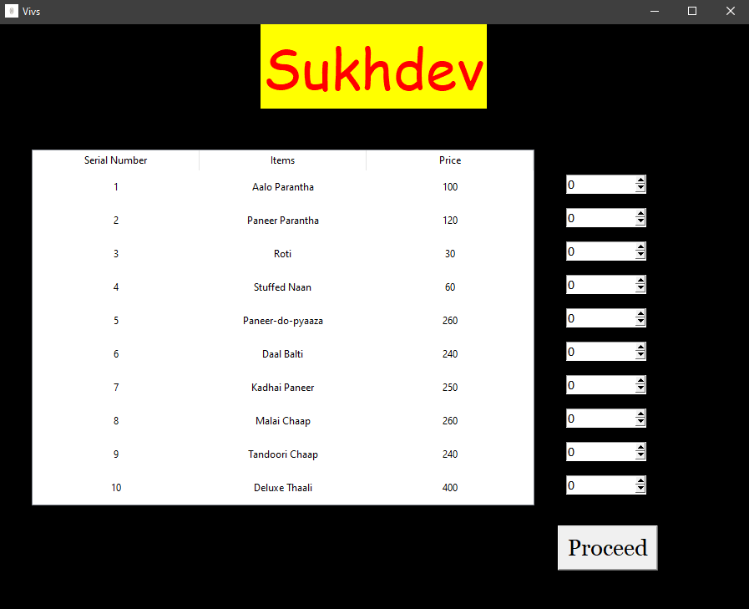

**5th Screen:-** Dominoes

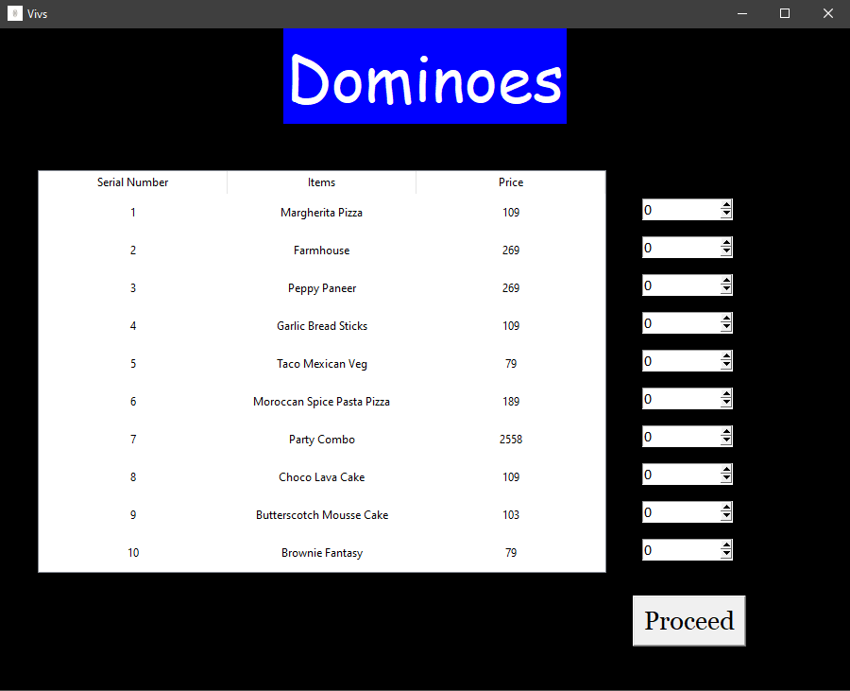

**6th Screen:-** Barista

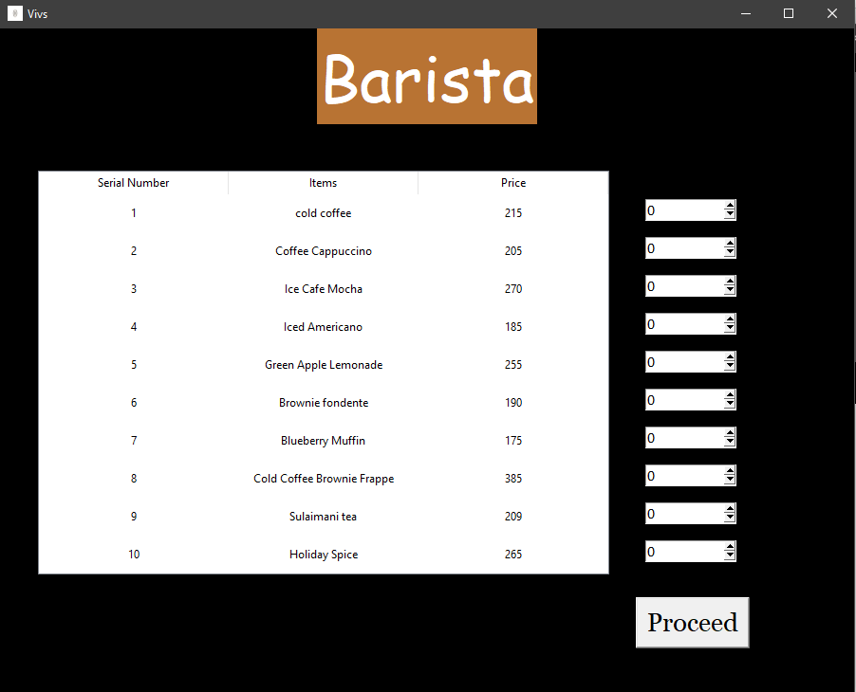

**7th Screen:-** Address

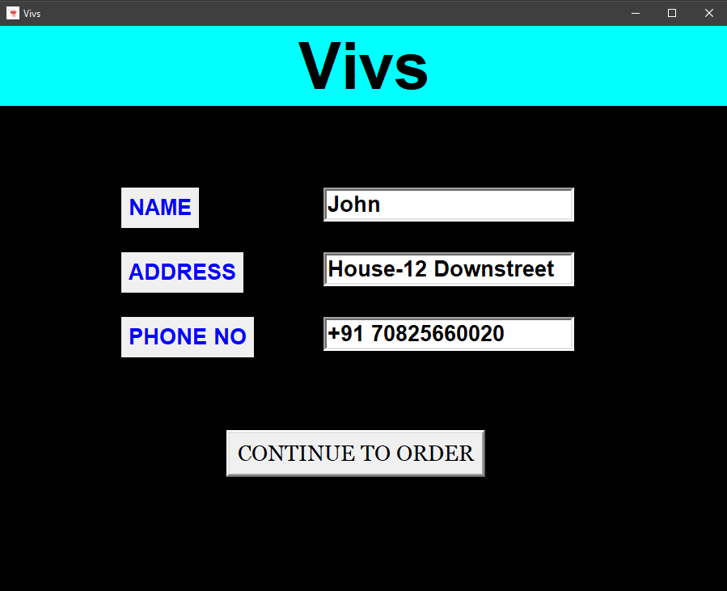

**8th Screen:-** Receipt

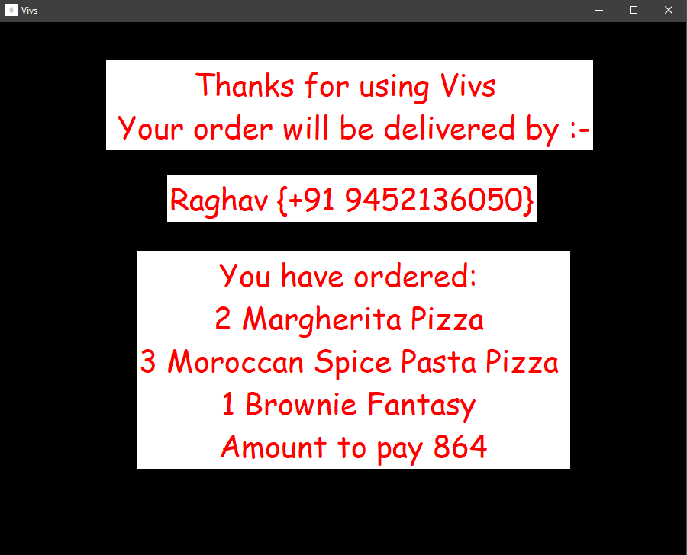

**Bill:-** Stored text file

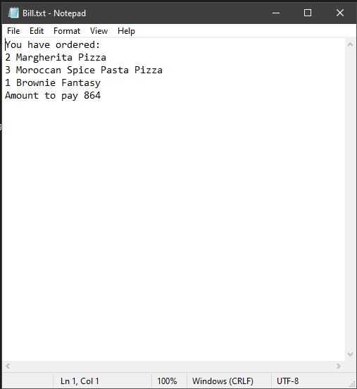

**FUTURE ENHANCEMENTS**

* Adding more and more restaurants
* A login page for customers security
* Connecting a database and keeping record of all the orders.
* Food order tracking using live location of the rider.

**Bibliography**

1. Class XII CS by Sumita Arora.
2. <https://www.dominos.co.in/>
3. <https://barista.co.in/>
4. <https://www.amriksukhdev.com/>
5. Madras café’s menu

