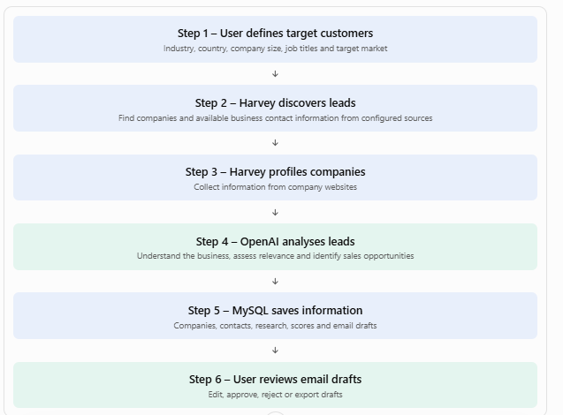

There are two types of requirements:
- Software and technical requirements.
- Paid services and monthly operating costs.
1. Software requirements
Software / component | Purpose | Cost
Windows 10/11 | Local development computer | Existing
Python 3.11+ | Run Harvey and FastAPI | Free
Git | Download and manage Harvey source code | Free
Harvey | Lead discovery and company profiling | Free (MIT licence)
FastAPI | Browser application backend | Free
Jinja2 | Dashboard interface | Free
OpenAI API | AI company analysis and email drafts | Usage-based
SQLite | Harvey's local application data | Free
MySQL | Optional storage for your custom application | Free software
VS Code | Development and editing | Free
Google Chrome | Access the local dashboard | Free
Important: Harvey's current dashboard is already running on your computer at 127.0.0.1:5555. FastAPI would be an additional application, normally on port 8000.
2. Accounts and API requirements
For your custom OpenAI workflow:
Account / service | Required? | Purpose
OpenAI Platform | Required | Generate company analysis and email drafts
Claude Pro | No | Not needed for our custom OpenAI integration
Gmail / Outlook | No | Not needed for manual draft generation
Email verification service | Optional | Verify prospect email addresses
Google Workspace | No | Only needed if you later send emails through Gmail
Paid lead database | No | Start with Harvey's free discovery source
Important distinction: Harvey's original agent uses Claude or Codex subscription access, not a native OpenAI API key. Our OpenAI integration is a custom Python service alongside Harvey.
GitHub+1
3. Hardware requirements
For local Windows development, I recommend:
Component | Minimum | Recommended
RAM | 8 GB | 16 GB
Processor | Intel i3 / Ryzen 3 | Intel i5 / Ryzen 5
Storage | 5 GB free | 10–20 GB free
OS | Windows 10 | Windows 11
Internet | Required | Stable broadband
Browser | Chrome / Edge | Latest Chrome
You do not need a GPU because OpenAI processes the AI requests in the cloud.
4. Monthly cost estimate
Low-cost testing setup
Item | Testing cost per month
Harvey software | ₹0
Python, FastAPI, Jinja2 | ₹0
Git and VS Code | ₹0
Free lead discovery source | ₹0
Website profiling | ₹0
OpenAI API | Usage-based
Email service | ₹0
Hosting | ₹0 – running locally
Total fixed cost | ₹0
For initial OpenAI API testing, I suggest setting a spending budget of approximately ₹500–₹1,000 per month. This is a suggested budget cap, not a guaranteed usage price. Actual charges depend on the model, prompt size and number of companies processed.
OpenAI pricing: Official API pricing.
5. Costs if you later enable automated emails
These are additional services, not required for your current project.
Additional requirement | Cost
Dedicated sending domain | Depends on registrar
Google Workspace mailbox | Paid monthly plan
Email warm-up | Depends on provider
Email verification | Free quotas or paid usage
Paid lead discovery signals | Depends on selected provider
Harvey recommends a dedicated sending domain and 2–4 weeks of mailbox warm-up before cold email campaigns.
GitHub+2
6. Requirements for your implementation
Here is the exact scope I recommend building first:
Phase 1 – Local development
- Harvey installation and dashboard
- Free business discovery
- Company website profiling
- FastAPI + Jinja2 dashboard
- OpenAI API integration
- Personalized email draft generation
- CSV / Excel export
Phase 2 – Future enhancements
- MySQL database integration
- User login and access control
- Advanced lead scoring
- Email verification
- Email sending and reply tracking
- Automated follow-ups
7. Official project resources
- Harvey GitHub repository
- OpenAI API platform
- FastAPI documentation
- Jinja2 documentation
My recommendation: Start with the local setup and keep the initial monthly budget around ₹500–₹1,000 for OpenAI usage. No Claude Pro, email subscription, dedicated server or paid lead database is necessary for your first version.

Workflow

1. Today (2)
- Use: your home page. At the top it lists what needs a decision from you; the number is how many. Below that is the pipeline: companies → contacts → emails → replies → meetings.
- How: open it first every day and deal with each item at the top. When it's empty, you're done.
2. Outbox (13)
- Use: every email Harvey wants to send waits here for your approval. This is the only place where approving leads to a real send (once sending is resumed).
- How: open each email and read it, then Approve, Edit or Reject.
- Right now: reject all 13. They were written while Harvey was trained on Apollo.io, so they present you as Apollo.
3. Conversations
- Use: every reply from a prospect, what Harvey thinks the person wants (interested, not interested, unsubscribe, question…), and the answer it suggests.
- How: read new replies here. Harvey's answers also go through the Outbox for approval.
- Right now: empty. Harvey can't read your inbox yet, because the Gmail connection fails on your M365 mailbox.
PIPELINE: building your leads
4. Lead flow (appears after the restart)
- Use: the six-step page we built: target customers → discover → profile → OpenAI analysis → MySQL → review drafts.
- How: click Run all steps, then review the drafts in Step 6. Nothing on it sends email.
5. Signals
- Use: the facts Harvey can collect about a company: its tech stack, whether it's hiring, its Google ranking, whether it runs ads, its funding, and so on. Harvey collects nothing until you confirm a signal.
- How: click Confirm on each signal you care about. Each row shows what it costs; most are free.
  - At the bottom, the cohort builder turns confirmed signals into a target list, for example "is hiring sales roles, uses HubSpot, not using Salesforce". It counts the matches as you build it.
6. Discover
- Use: find new companies that match your target, or import your own CSV list.
- How:
  - To search: pick an industry and a source, click Estimate to see the cost, then Run. OpenStreetMap is free.
  - To import: under Import a company list, choose a CSV (name, website, status) and click Import. Harvey reads each site, finds people and saves to MySQL.
7. Companies
- Use: every company Harvey knows about, best fit first, with its website, industry, fit score and what Harvey learned from its site.
- How: click a company to see its contacts and details. Find people for one company from here. Export downloads the full list.
8. Contacts
- Use: every person Harvey found, with their title, email and email status:
  - verified: safe to send.
  - risky: probably fine (the company's mail server accepts any address).
  - guess: never sent to.
  - invalid: the email bounced.
- How: filter and search. Export gives a CSV of usable emails you can use in your own email tool.
9. Campaigns
- Use: the 3-email sequences Claude wrote (first email, follow-up, last email) for a group of contacts, and how far each one has got.
- How: open a campaign to read its emails. If the style is wrong, tell me and I'll change Harvey's writing rules.
SYSTEM: running and controlling Harvey
10. Activity
- Use: a log of everything Harvey did, with a time on each: searched, wrote, read a reply, skipped something and why.
- How: when you wonder "what did Harvey do?" or "why didn't it email X?", look here.
11. Usage
- Use: how much of your Claude Max quota Harvey has used today, broken down by agent (writer, scout, handler…). Harvey keeps its use under 80% so you still have Claude for your own work.
- How: check it if Claude feels slow, or if Harvey says it's pausing for budget.
12. Controls
- Use: start and stop Harvey's automatic loop (it wakes every 15 minutes), and see what it's doing right now. This does the same as harvey run in a terminal.
- How: Start or Stop. Stopping Harvey doesn't delete anything.
- Note: sending is paused separately, so even when Harvey is running, nothing is sent until you resume sending.
13. Settings
- Use: your keys and connections (Hunter, Reoon, SMTP and so on), the email provider, and the sending mode:
  - Approval: every email waits in the Outbox. This is the current setting.
  - Autopilot: Harvey sends on its own. Turning it on requires typing autopilot.
- How: add keys here instead of editing .env by hand, and test each connection with its button.
- For your mailbox: the email provider can be gmail, microsoft, smtp or instantly. Since your mailbox is on M365, choose microsoft or smtp instead of gmail; that fixes the error you saw in harvey run.

Service | Free per month | Notes
Reoon | 600 | Best free tier
Hunter | 50 | You already have this key

