Assessment

Q1: Many to Many - > Student

Models:

Student:

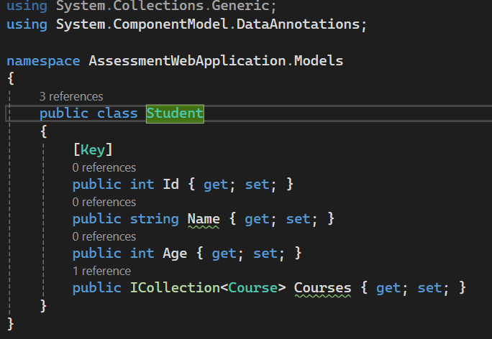

Course:

Connection String in appsettings.json:



Build Succeed:

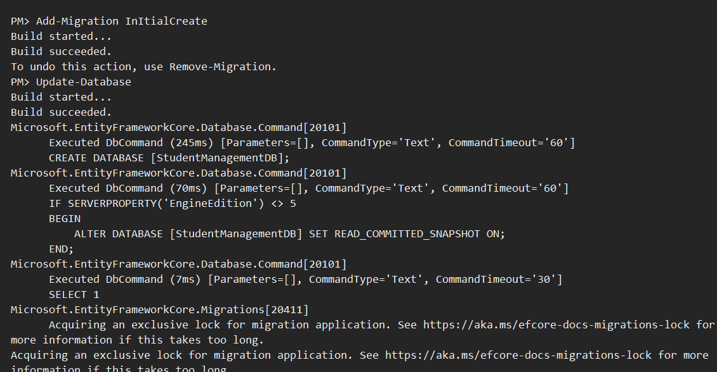

Final Database Creation:

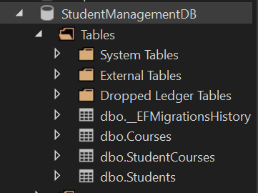

Q2: Employee -> Stored Procedure

Employee Model:

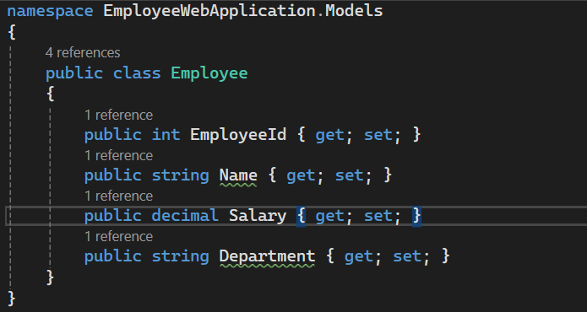

Employee Controller:

Index View:

Stored Procedure:

Final Output:

