**Assignment 5**

**Name:Manisha Bhalla**

**Roll No: G24AI1073**

**Github**: <https://github.com/Manisshabhlla/Redis_bigdata_Assignment5>

**Setup**:

sudo apt update

sudo apt install python3-pip

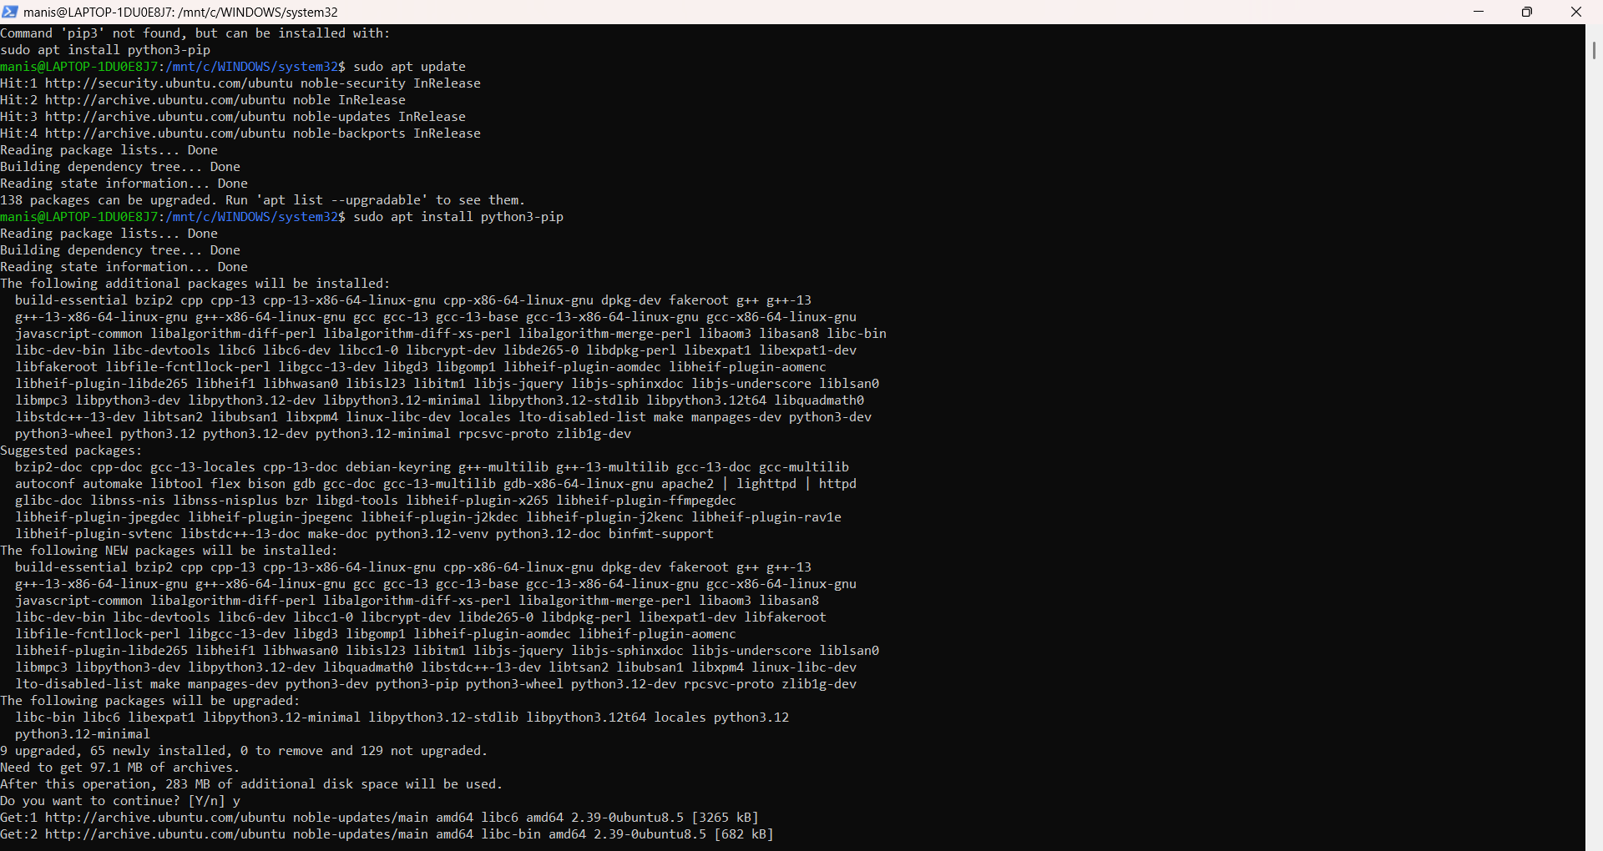

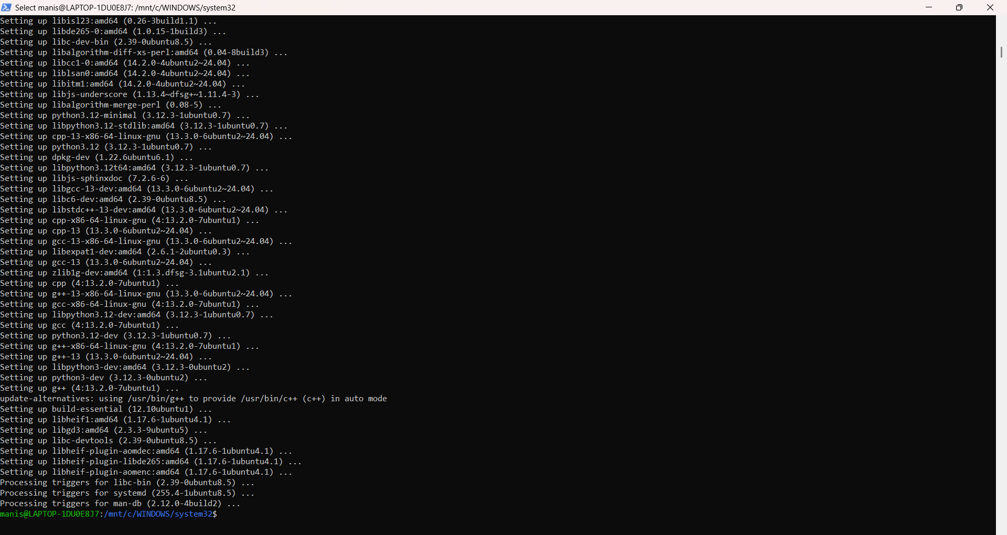

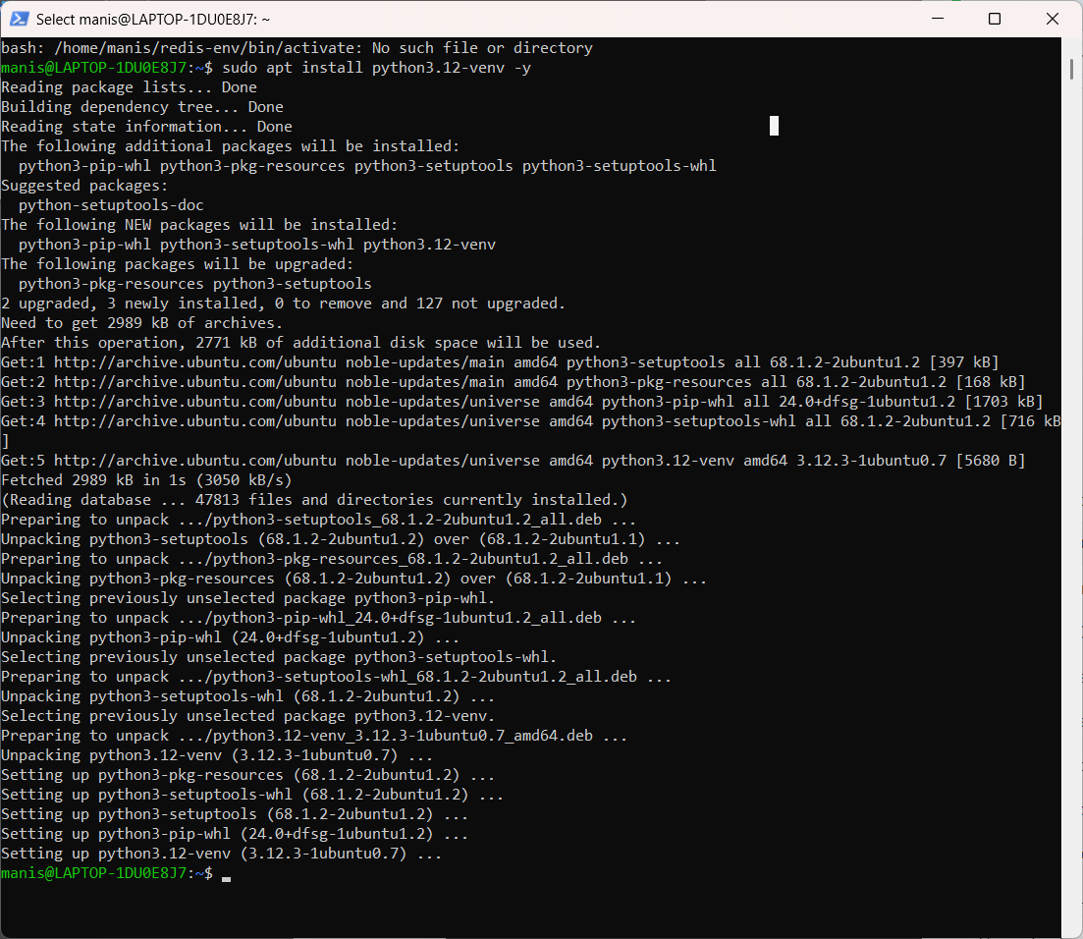

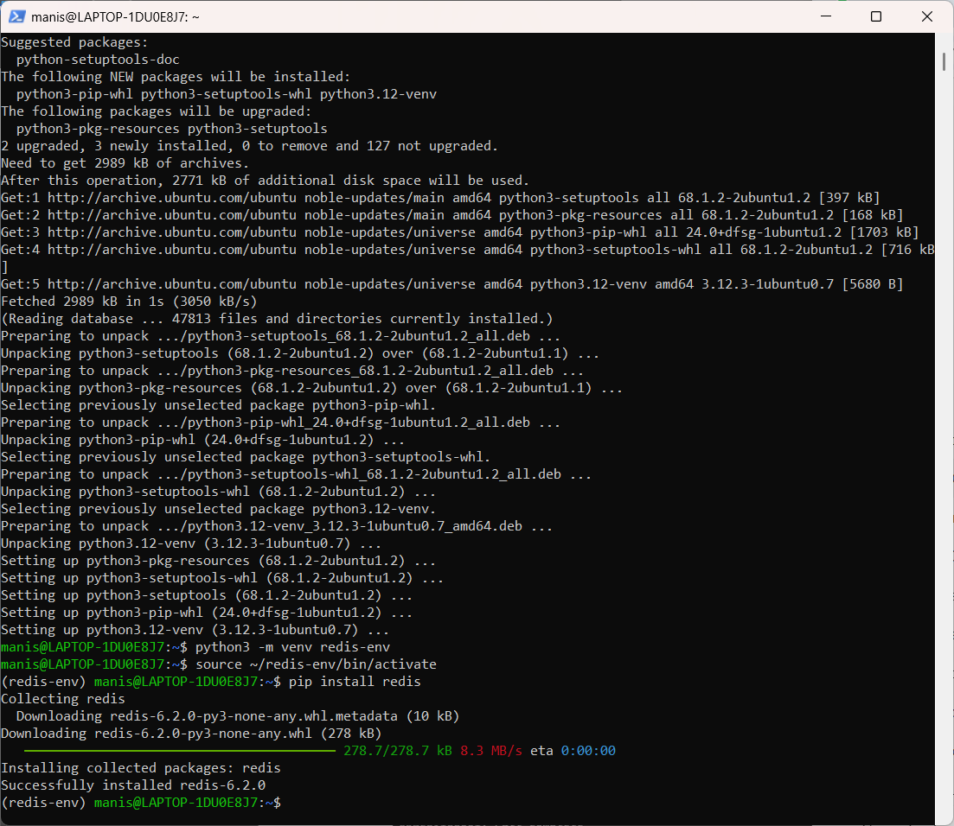

pip install redis

pip install pandas

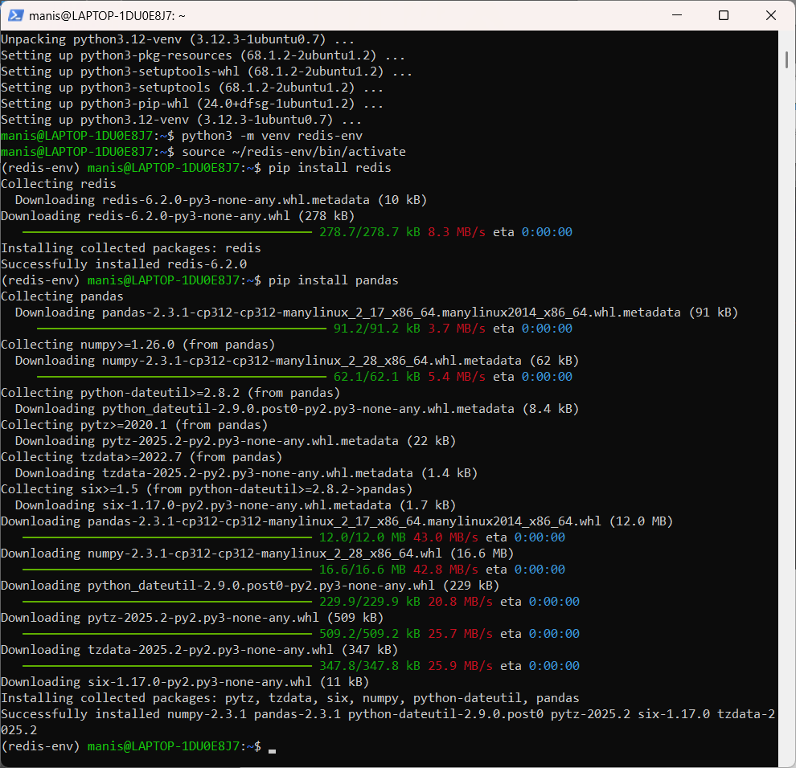

docker run -d --name redis-stack -p 6379:6379 -p 8001:8001 redis/redis-stack:latest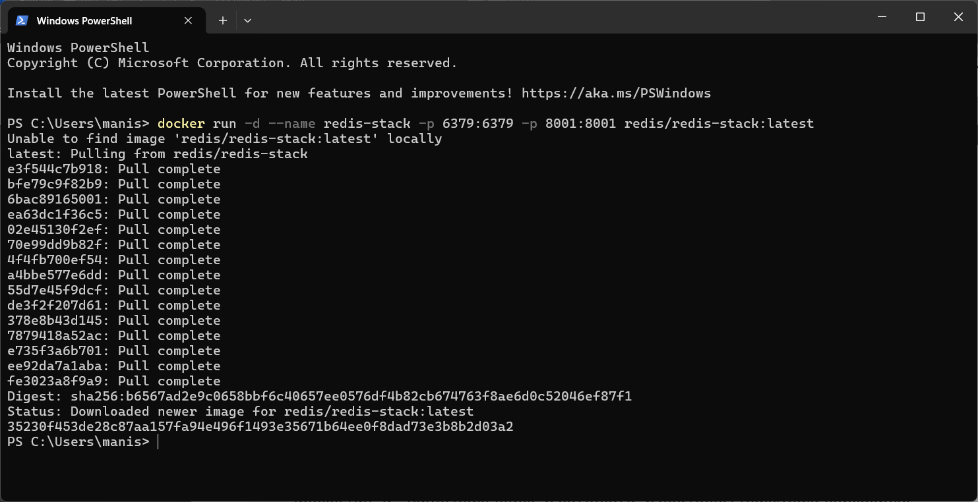

**Ques 1 Write the method connect() to create a connection to Redis. [5]**

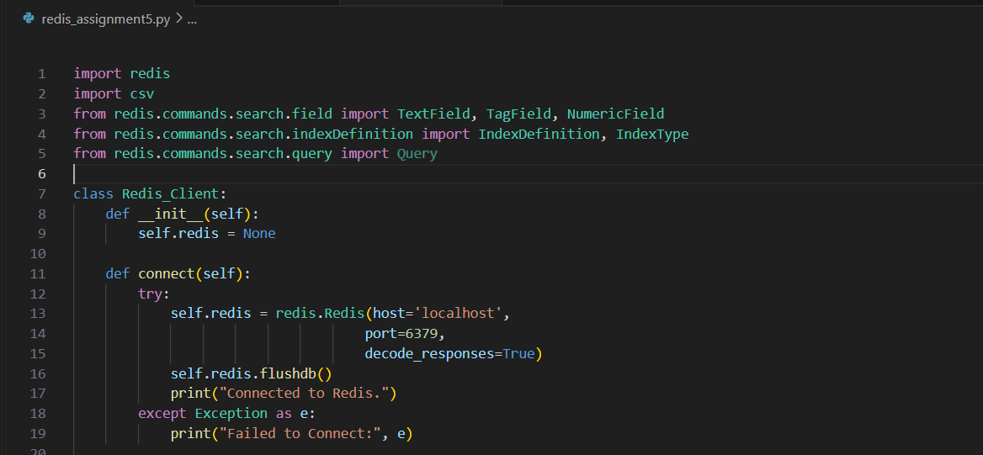



**Ques 2 Write the methods load_users() and load_scores() to load the data into the redis db. Use appropriate data structures. Provide details of the Redis data structures that you are using. [5]**

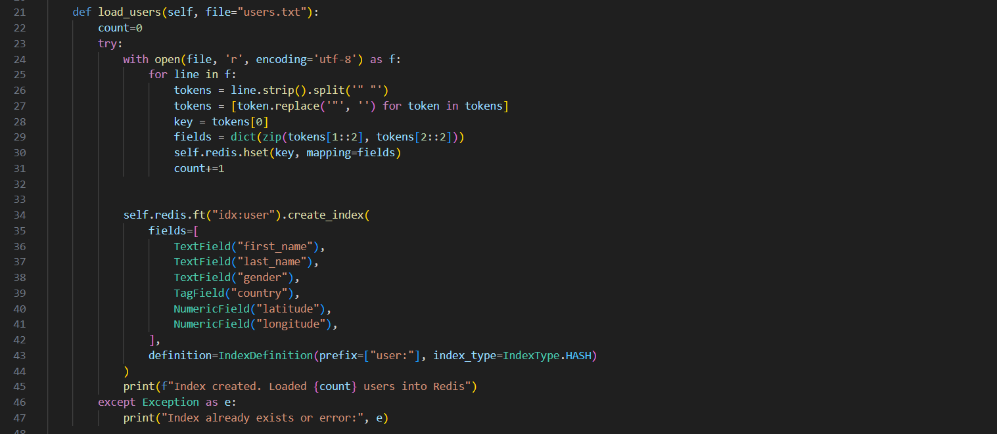

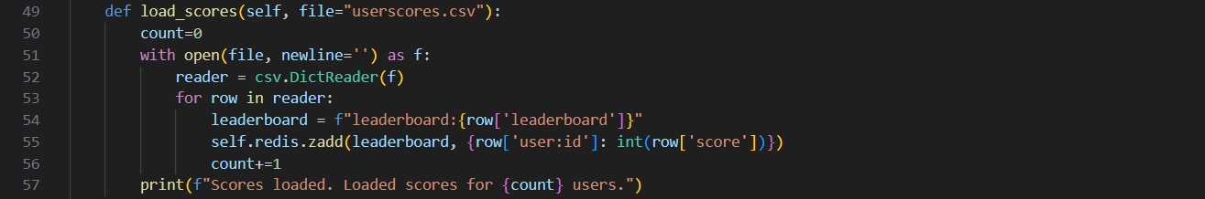



**Ques 3 Write the method query1() that returns all the attributes of the user by usr. [5]**

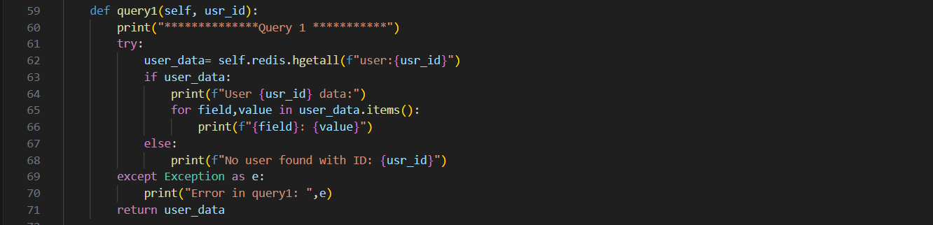

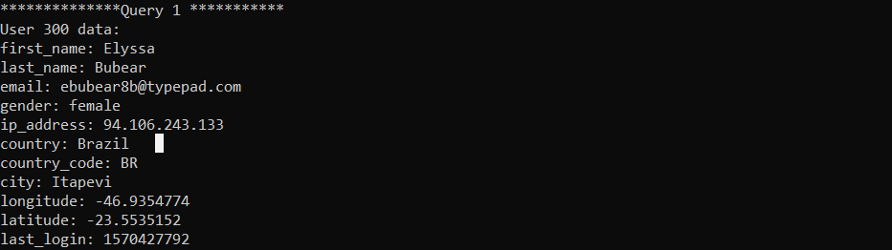

**Ques 4 Write the method query2() that the coordinate (longitude and latitude) of the user by the usr. [5]**

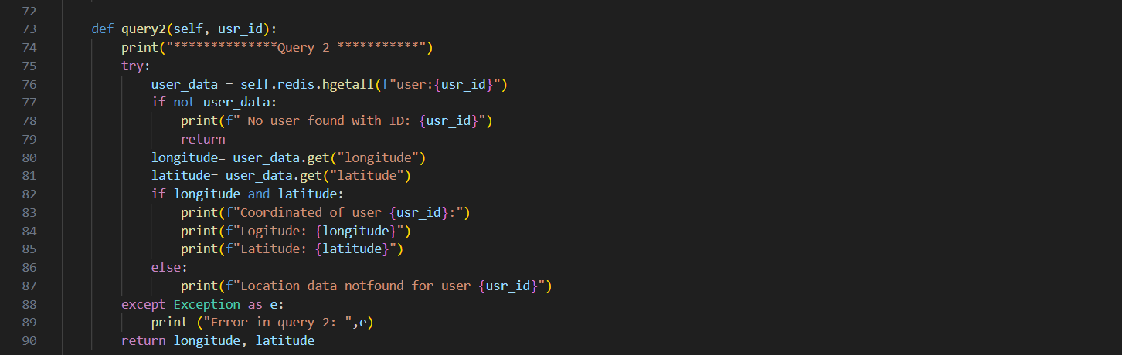

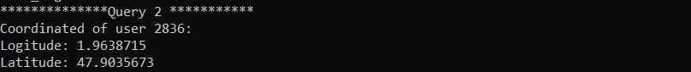

**Ques 5 Write the method query3() that get the keys and last names of the users whose ids do not start with an odd number. [5]**

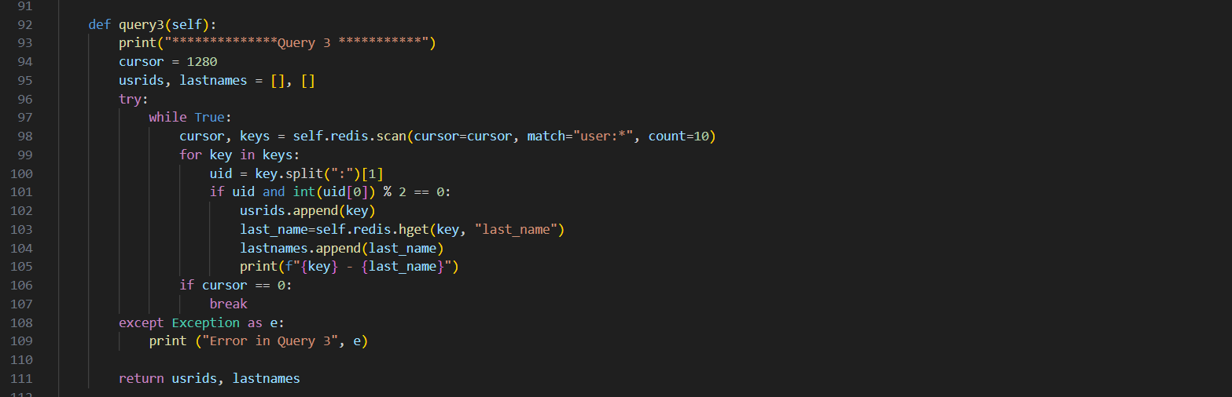

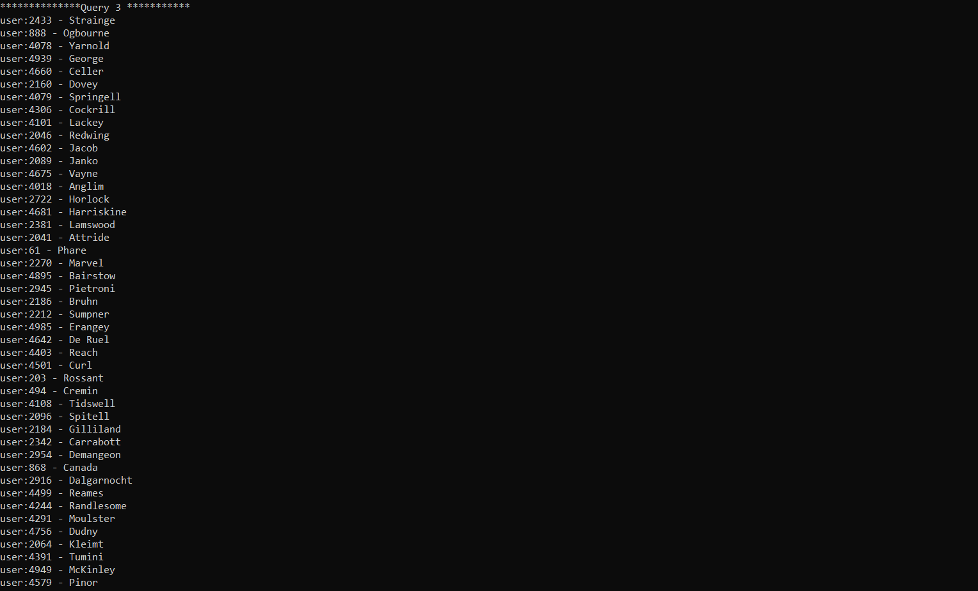

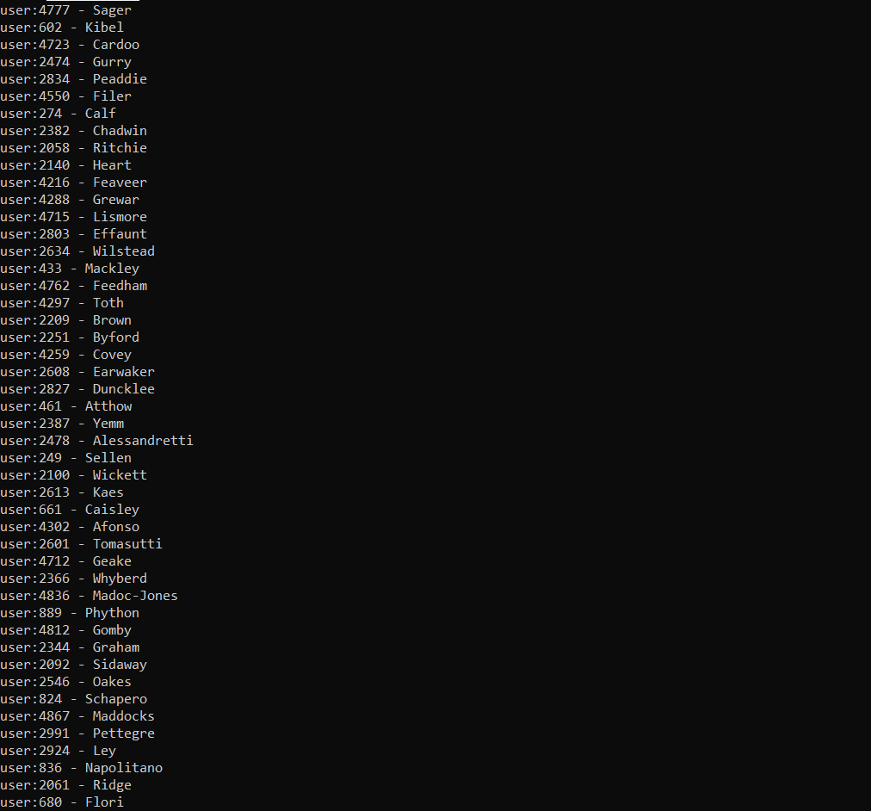

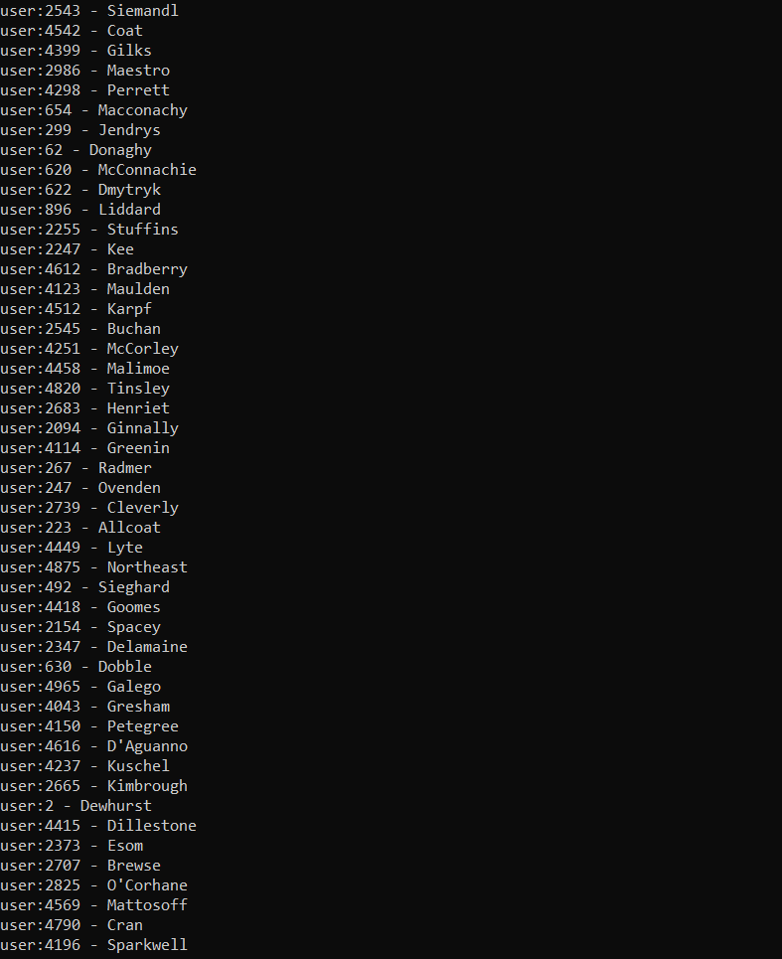

**Ques 6 Write the method query4() that returns the female in China or Russia with a latitude between 40 and 46. [5]**

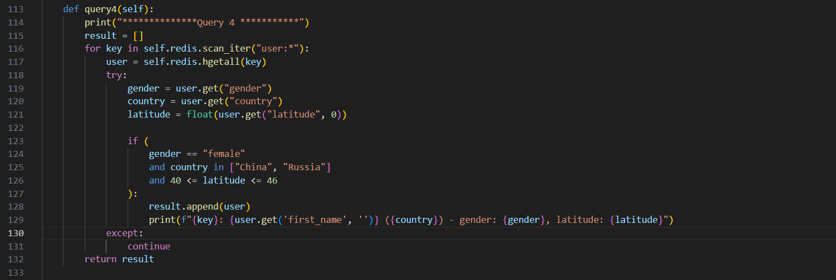

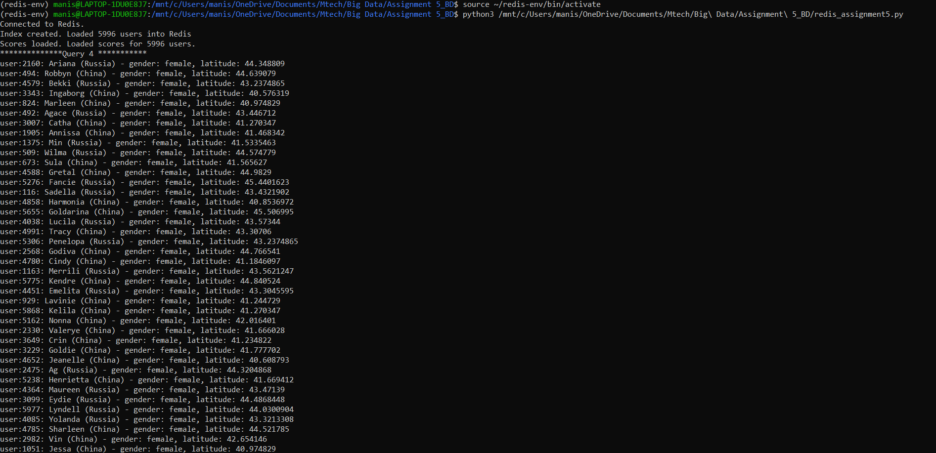

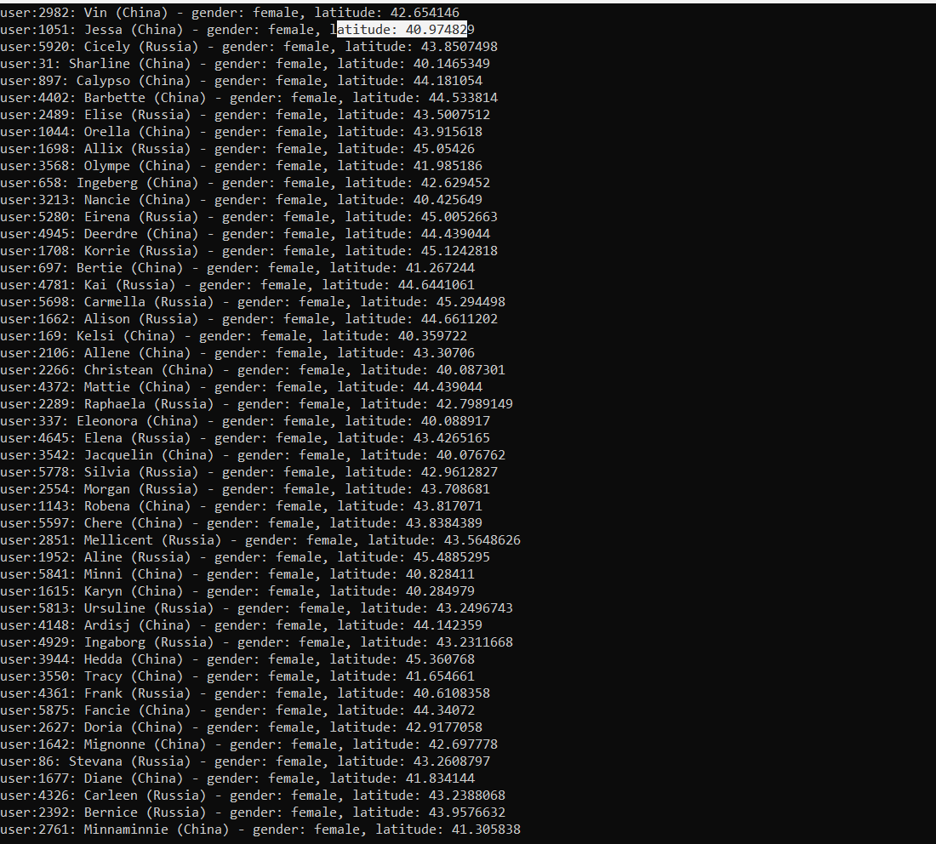

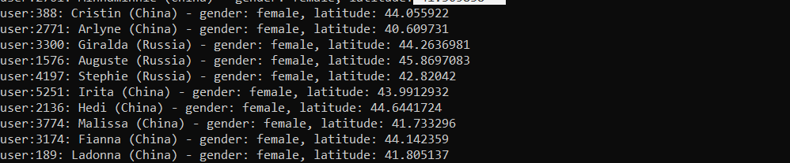

**Ques 7 Write the method query5() that gets the email ids of the top 10 players(in terms of score) in leaderboard:2. [5]**

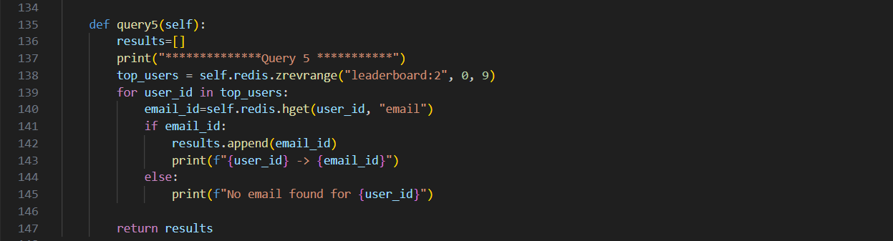

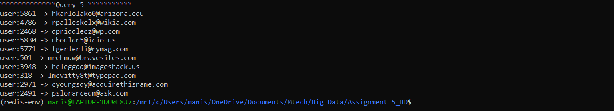

**Main function:**

