Heuristic Evaluation – Arngren Website (Based on Screenshots)

Screenshot 1 – Top & Middle Section of Homepage
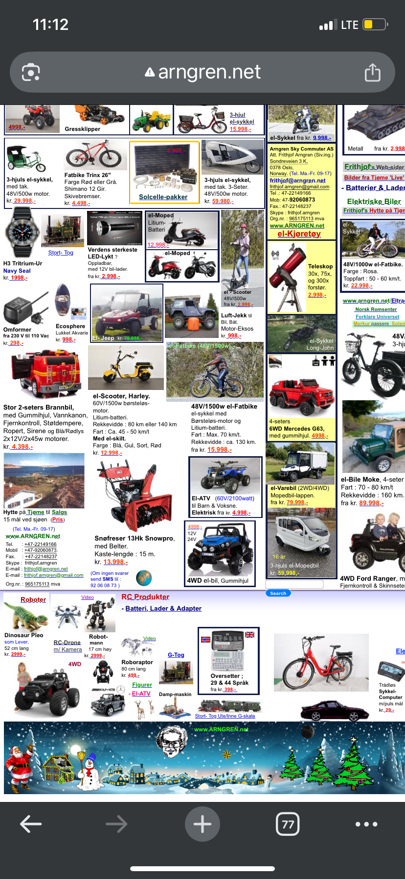
Description:
This screenshot shows the top and middle sections of the Arngren website. The interface displays dozens of products randomly placed without any clear layout or alignment. There is no navigation structure, no whitespace, and no visual hierarchy. Products appear mixed together regardless of category, with inconsistent text sizes, colors, and formatting.
Usability Problems Identified:
- Extremely cluttered layout with no spacing.
- No visible navigation bar or menu structure.
- Fonts, colors, and text sizes are inconsistent.
- Overlapping images and text blocks.
- Irregular and misaligned product images.
- No hierarchy—titles, prices, and product names blend together.

Screenshot 2 – Product Cluster Area
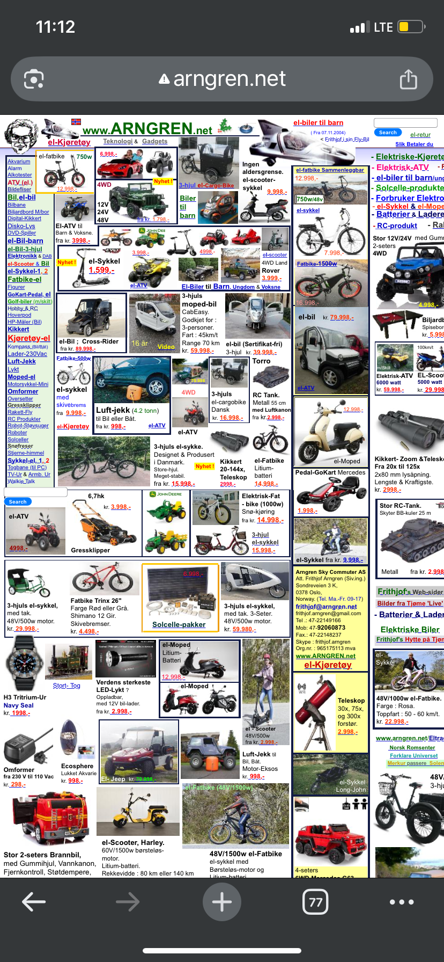
Description:
This screenshot shows the product clusters in the main content area. Products from unrelated categories (bikes, ATVs, telescopes, toys) are mixed together without grouping. There is no search function, no categories, and no filters to help users browse. Visual overload makes it extremely difficult for users to scan or locate specific items.
Usability Problems Identified:
- Products are not grouped into categories.
- No search or filtering options available.
- Tiny, hard-to-read text on mobile view.
- Misaligned and differently sized product images.
- Heavy visual overload from excessive content.
- Prices and product descriptions formatted inconsistently.

