Звіт
Лабораторна робота №4
Студента ПМІ-44
Стегнея Віктора
Варіант 15
Задана вибірка №3: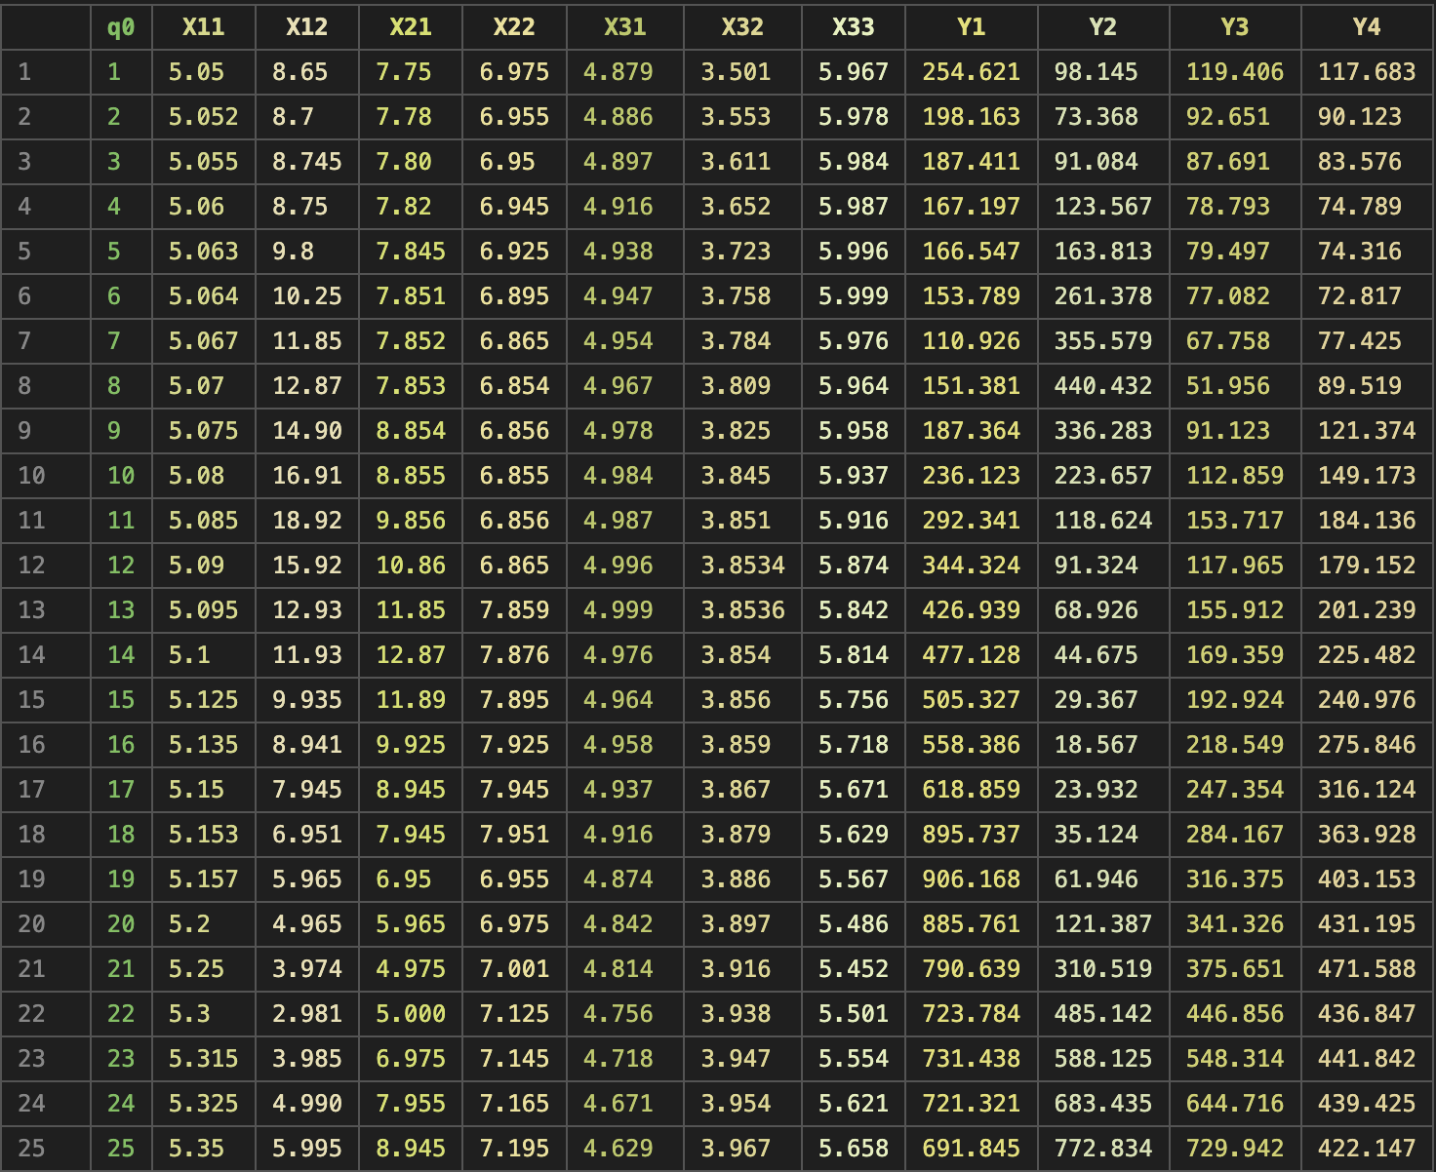
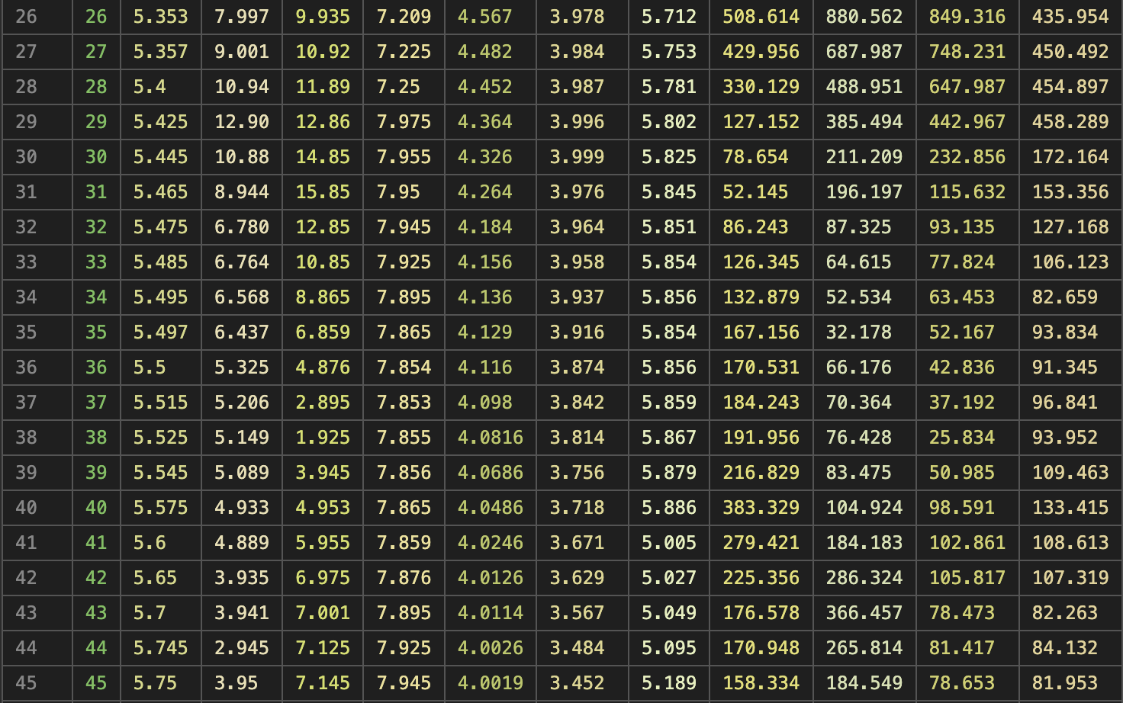
Модель: мультиплікативна, реалізована через log1p / expm1
Задання вхідних даних
Вибірка задана csv файлом, вказаним вище, інші параметри прикріпляю:
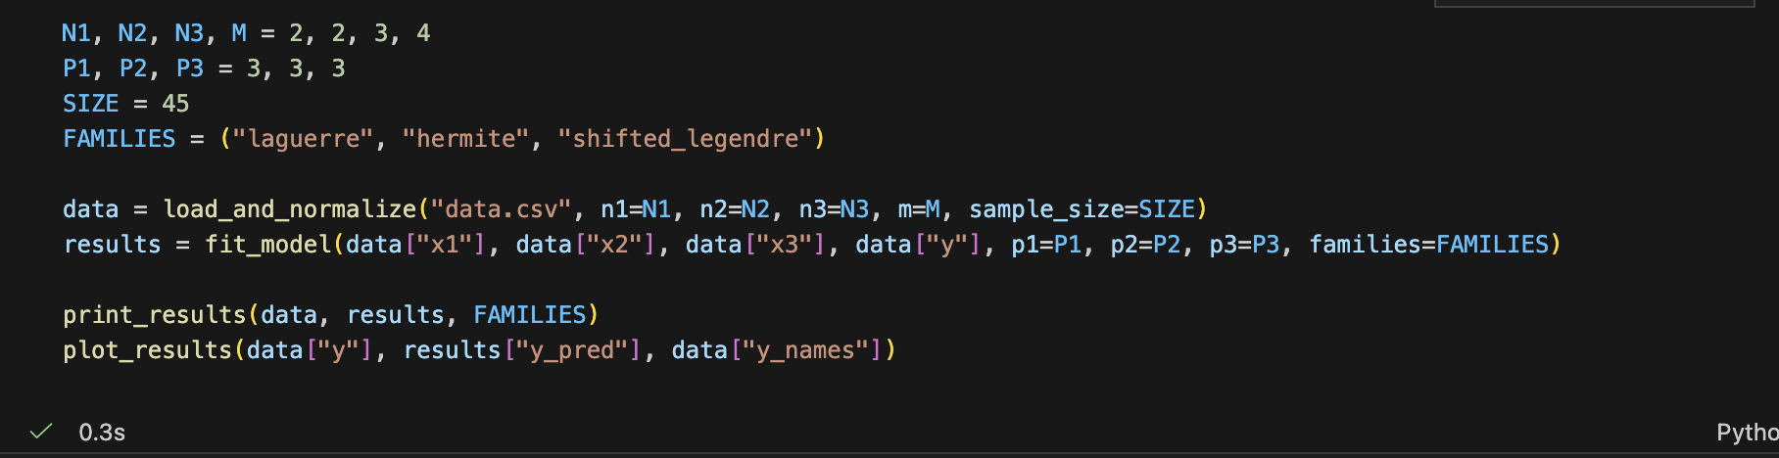
Результати
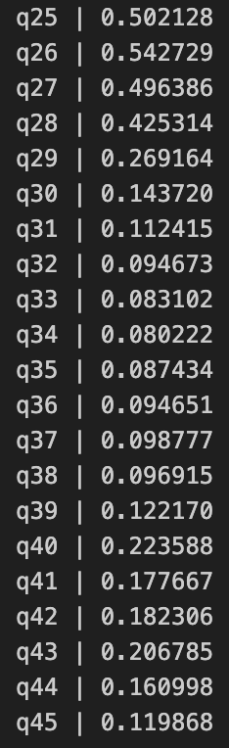
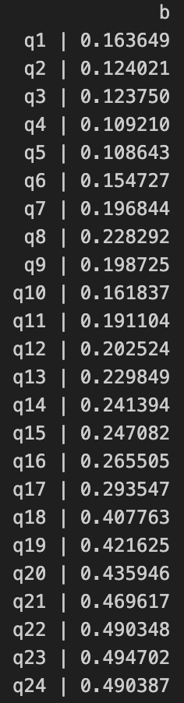
- Вектор b у log-п росторі
- Lambda для X1: 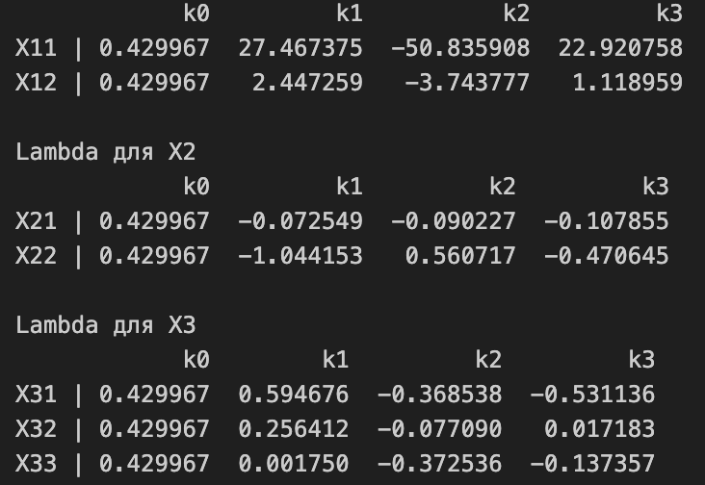
- Матриця A1:
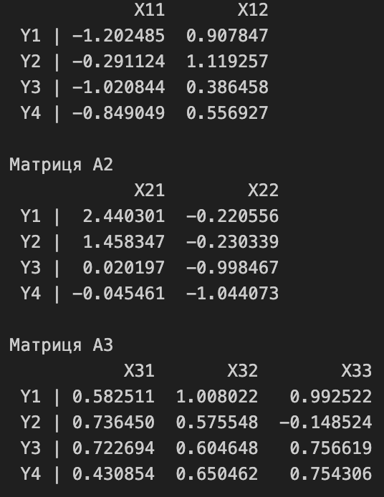
- Частинні функції у логарифмічному просторі:
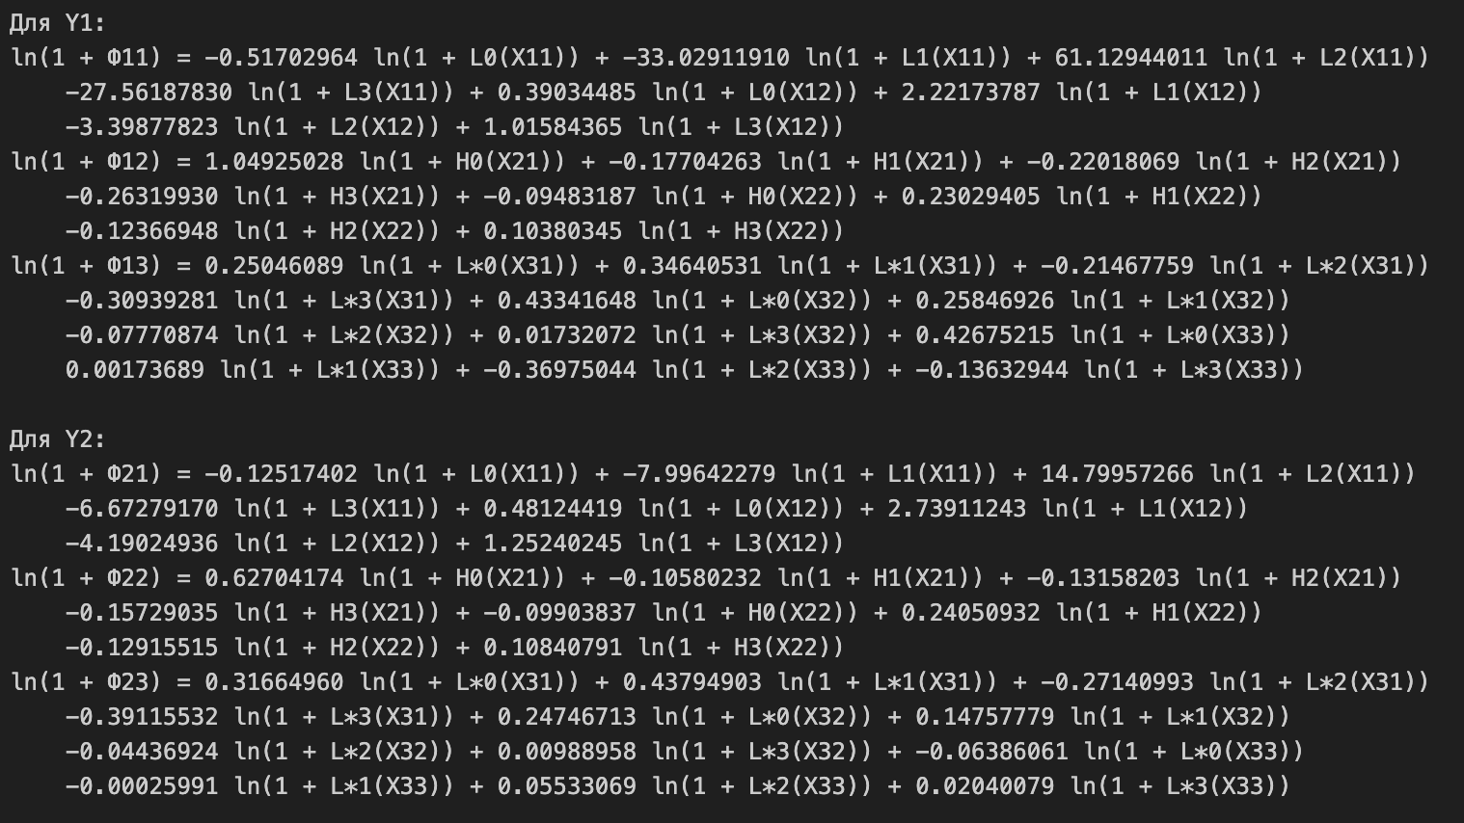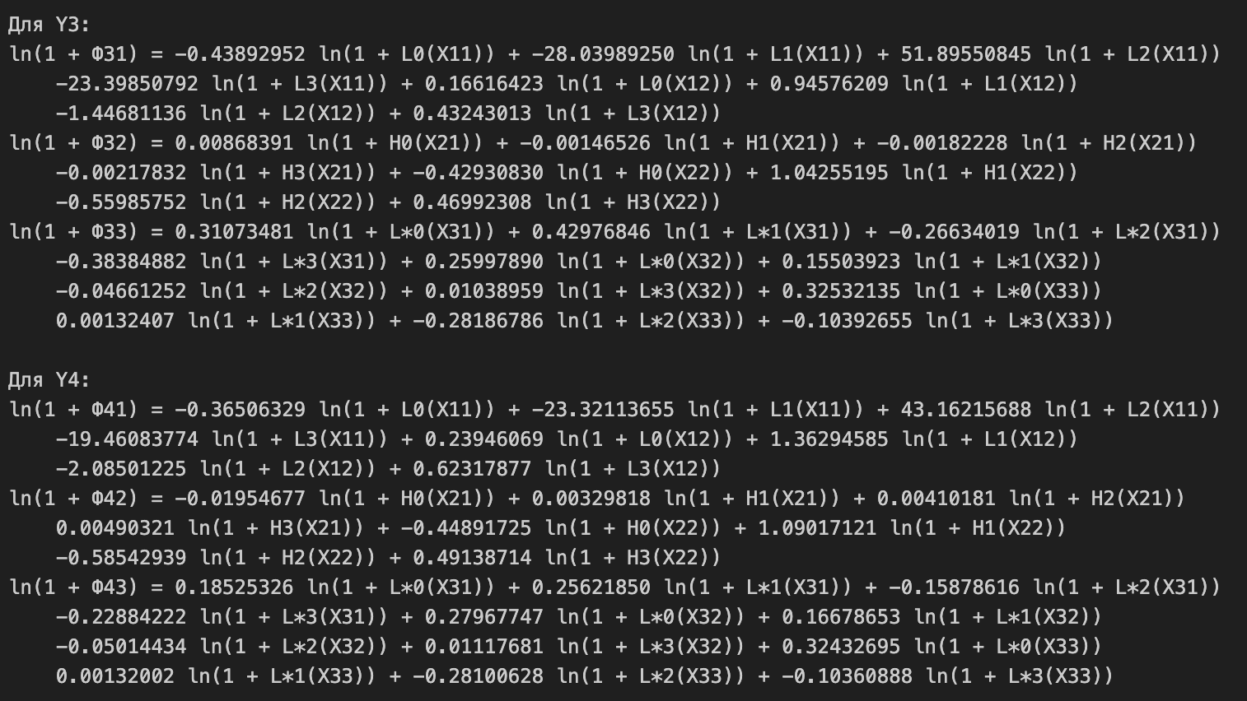
- Підсумкові функції:
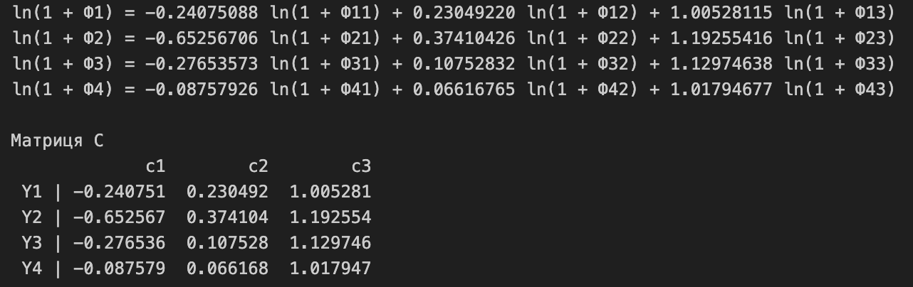
- Порівняння реальних і відновлених значень Y:
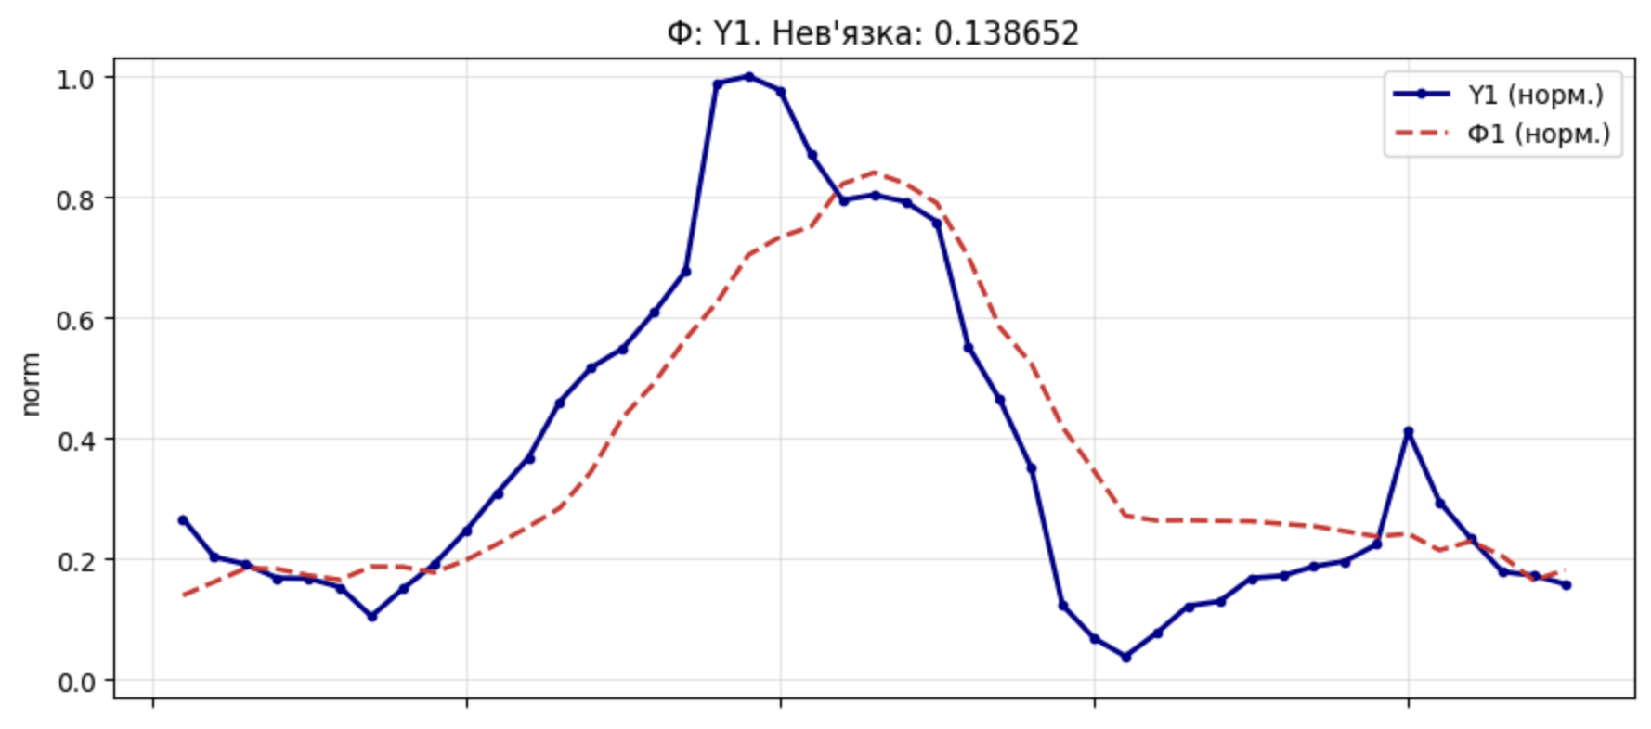
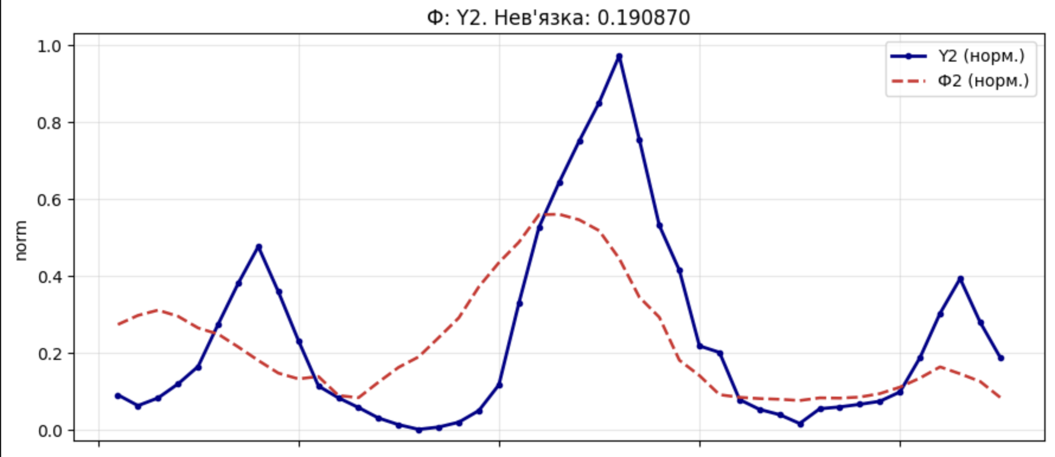
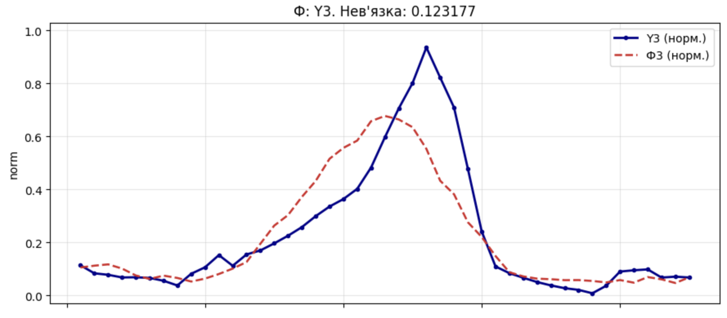
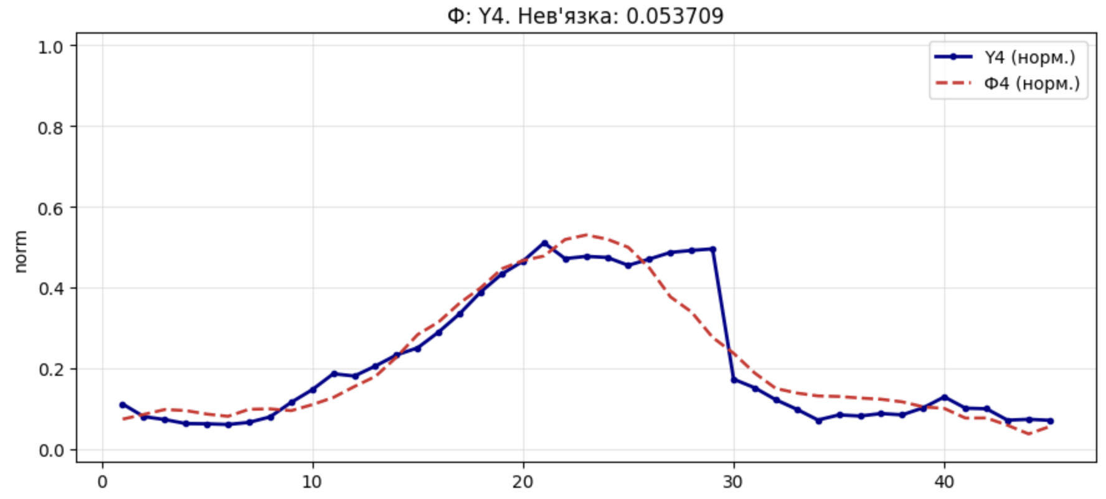
Код реалізації
def laguerre(x, degree):
if degree == 0:
return np.ones_like(x)
if degree == 1:
return 1.0 - x

l_prev2 = np.ones_like(x)
l_prev1 = 1.0 - x
for n in range(2, degree + 1):
current = ((2 * n - 1 - x) * l_prev1 - (n - 1) * l_prev2) / n
l_prev2, l_prev1 = l_prev1, current
return l_prev1

def hermite(x, degree):
if degree == 0:
return np.ones_like(x)
if degree == 1:
return 2.0 * x

h_prev2 = np.ones_like(x)
h_prev1 = 2.0 * x
for n in range(2, degree + 1):
current = 2.0 * x * h_prev1 - 2.0 * (n - 1) * h_prev2
h_prev2, h_prev1 = h_prev1, current
return h_prev1

def shifted_legendre(x, degree):
z = 2.0 * x - 1.0
if degree == 0:
return np.ones_like(z)
if degree == 1:
return z

p_prev2 = np.ones_like(z)
p_prev1 = z
for n in range(2, degree + 1):
current = ((2 * n - 1) * z * p_prev1 - (n - 1) * p_prev2) / n
p_prev2, p_prev1 = p_prev1, current
return p_prev1

def basis_value(x, degree, family):
if degree == 0:
return np.full_like(x, 0.5, dtype=float)

if family == "laguerre":
raw = laguerre(x, degree)
elif family == "hermite":
raw = hermite(x, degree)
elif family == "shifted_legendre":
raw = shifted_legendre(x, degree)
else:
raise ValueError(f"Невідомий базис: {family}")

min_value = float(raw.min())
max_value = float(raw.max())
diff = max_value - min_value
if diff == 0:
return np.full_like(x, 0.5, dtype=float)
return (raw - min_value) / diff

def basis_symbol(family):
return {
"laguerre": "L",
"hermite": "H",
"shifted_legendre": "L*",
}[family]

def safe_log1p(values):
clipped = np.maximum(values, -0.999999999)
return np.log1p(clipped)

def solve_lstsq(a, b):
return np.linalg.lstsq(a, b, rcond=None)[0]

def calc_b_values(y):
average_level = (y.max(axis=1) + y.min(axis=1)) / 2.0
return safe_log1p(average_level).reshape(-1, 1)

def build_log_design_matrix(x_groups, degrees, families):
columns = []
for x_matrix, degree, family in zip(x_groups, degrees, families):
for j in range(x_matrix.shape[1]):
for k in range(degree + 1):
columns.append(safe_log1p(basis_value(x_matrix[:, j], k, family)))
return np.column_stack(columns)

def split_lambda_coefficients(lambdas, dims, degrees):
matrices = []
start = 0
for dim, degree in zip(dims, degrees):
width = dim * (degree + 1)
matrices.append(lambdas[start:start + width].reshape(dim, degree + 1))
start += width
return matrices

def calculate_log_psi(lambda_matrix, x, degree, family):
log_psi = np.zeros((x.shape[0], x.shape[1]))
for j in range(x.shape[1]):
for k in range(degree + 1):
log_psi[:, j] += lambda_matrix[j, k] * safe_log1p(basis_value(x[:, j], k, family))
return log_psi

def incoherence(y_pred, y_true):
return np.sqrt(np.mean((y_pred - y_true) ** 2, axis=0))

def denormalize(matrix, y_min, y_max):
return matrix * (y_max - y_min) + y_min

def build_comparison_table(y_names, y_real, y_pred):
header = ["q"]
for name in y_names:
header.extend([f"{name}_real", f"{name}_pred"])

rows = []
for idx in range(y_real.shape[0]):
row = [str(idx + 1)]
for column in range(y_real.shape[1]):
row.extend([
f"{y_real[idx, column]:.6f}",
f"{y_pred[idx, column]:.6f}",
])
rows.append(row)
return header, rows

def fit_model(x1, x2, x3, y, p1, p2, p3, families):
tz_matrix = build_log_design_matrix((x1, x2, x3), (p1, p2, p3), families)
b_vector = calc_b_values(y)
lambda_all = solve_lstsq(tz_matrix, b_vector)
lambda_x1, lambda_x2, lambda_x3 = split_lambda_coefficients(
lambda_all,
(x1.shape[1], x2.shape[1], x3.shape[1]),
(p1, p2, p3),
)

psi_1_log = calculate_log_psi(lambda_x1, x1, p1, families[0])
psi_2_log = calculate_log_psi(lambda_x2, x2, p2, families[1])
psi_3_log = calculate_log_psi(lambda_x3, x3, p3, families[2])

psi_1 = np.expm1(psi_1_log)
psi_2 = np.expm1(psi_2_log)
psi_3 = np.expm1(psi_3_log)

z_y = safe_log1p(y)
a1 = solve_lstsq(safe_log1p(psi_1), z_y)
a2 = solve_lstsq(safe_log1p(psi_2), z_y)
a3 = solve_lstsq(safe_log1p(psi_3), z_y)

phi_1_log = safe_log1p(psi_1) @ a1
phi_2_log = safe_log1p(psi_2) @ a2
phi_3_log = safe_log1p(psi_3) @ a3

phi_1 = np.expm1(phi_1_log)
phi_2 = np.expm1(phi_2_log)
phi_3 = np.expm1(phi_3_log)

c_matrix = np.zeros((3, y.shape[1]))
z_pred = np.zeros_like(y)
y_pred = np.zeros_like(y)
for idx in range(y.shape[1]):
current = np.column_stack((phi_1_log[:, idx], phi_2_log[:, idx], phi_3_log[:, idx]))
c_matrix[:, idx] = solve_lstsq(current, z_y[:, idx]).ravel()
z_pred[:, idx] = current @ c_matrix[:, idx]
y_pred[:, idx] = np.expm1(z_pred[:, idx])

return {
"tz_matrix": tz_matrix,
"b_vector": b_vector,
"lambda_x1": lambda_x1,
"lambda_x2": lambda_x2,
"lambda_x3": lambda_x3,
"psi_1": psi_1,
"psi_2": psi_2,
"psi_3": psi_3,
"a1": a1,
"a2": a2,
"a3": a3,
"phi_1": phi_1,
"phi_2": phi_2,
"phi_3": phi_3,
"phi_1_log": phi_1_log,
"phi_2_log": phi_2_log,
"phi_3_log": phi_3_log,
"c_matrix": c_matrix,
"z_pred": z_pred,
"y_pred": y_pred,
"rmse": incoherence(y_pred, y),
}

