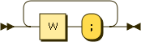
S:

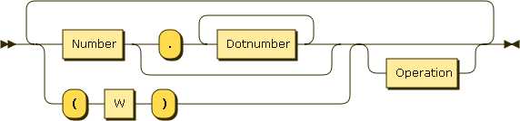
W:

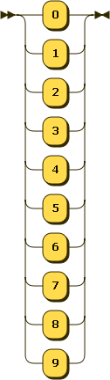

Number: Dotnumber:

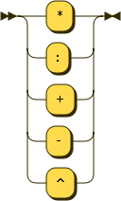
Operation:

