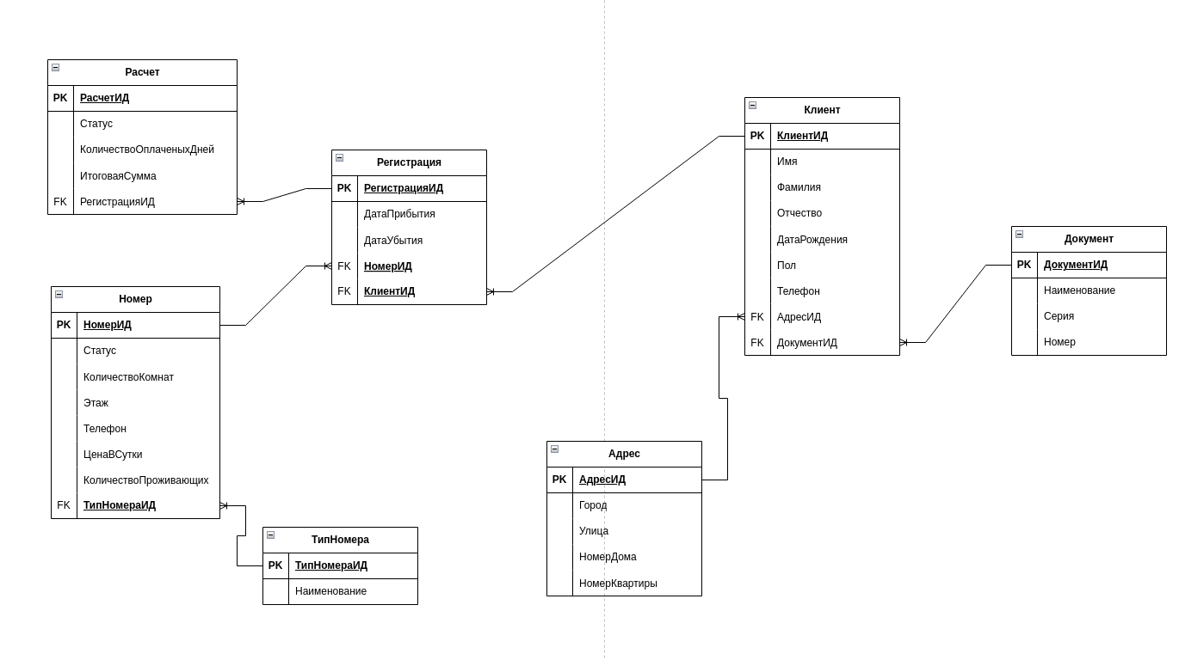

CREATE TABLE Client (
ClientID SERIAL PRIMARY KEY,
FirstName VARCHAR(50) NOT NULL,
LastName VARCHAR(50) NOT NULL,
MiddleName VARCHAR(50) ,
DateOfBirth DATE not null,
Floor VARCHAR(1) not null,
Phone VARCHAR(12) not null,
AdressID INT not null,
DocumentID INT not null,
FOREIGN KEY (DocumentID) REFERENCES Document(DocumentID),
FOREIGN KEY (AdressID) REFERENCES Adress(AdressID)
);

CREATE TABLE Adress (
AdressID SERIAL PRIMARY KEY,
City VARCHAR(100) NOT NULL,
Street VARCHAR(100) NOT NULL,
HouseNumber VARCHAR(10) not null ,
ApartmentNumber VARCHAR(10) not null
);

CREATE TABLE Document (
DocumentID SERIAL PRIMARY KEY,
Name VARCHAR(100) not null,
Series int not null,
Number int not null
);

CREATE TABLE Number (
NumberID SERIAL PRIMARY KEY,
Status VARCHAR(50) NOT NULL,
NumberOfRooms VARCHAR(4) NOT NULL,
Floor VARCHAR(10) ,
Phone VARCHAR(12) not null,
PricePerDay int not null,
NumberOfResidents int ,
TypeNumberID INT not null,
FOREIGN KEY (TypeNumberID) REFERENCES TypeNumber(TypeNumberID)

);

CREATE TABLE TypeNumber (
TypeNumberID SERIAL PRIMARY KEY,
Name VARCHAR(50) NOT NULL

);

CREATE TABLE Registration (
RegistrationID SERIAL PRIMARY KEY,
ArrivalDate timestamp NOT null,
DepartureDate Timestamp ,
NumberID int not null,
ClientID int not null,
FOREIGN KEY (NumberID) REFERENCES Number(NumberID),
FOREIGN KEY (ClientID) REFERENCES Client(ClientID)

);

CREATE TABLE Сalculation (
СalculationID SERIAL PRIMARY KEY,
Paid BOOLEAN DEFAULT FALSE,
NumberOfDays int not null,
TotalAmount int not null,
RegistrationID int not null,
FOREIGN KEY (RegistrationID) REFERENCES Registration(RegistrationID)
);

INSERT INTO Adress (City, Street, HouseNumber, ApartmentNumber) VALUES
('Москва', 'Тверская', '12', '45'),
('Санкт-Петербург', 'Невский проспект', '25', '10'),
('Казань', 'Баумана', '5', '3'),
('Екатеринбург', 'Ленина', '100', '20'),
('Новосибирск', 'Красный проспект', '50', '7');

INSERT INTO Document (Name, Series, Number) VALUES
('Паспорт', 4501, 123456),
('Паспорт', 4602, 654321),
('Загранпаспорт', 7703, 987654),
('Паспорт', 5504, 112233),
('Паспорт', 6605, 445566);

INSERT INTO Client (FirstName, LastName, MiddleName, DateOfBirth, Floor, Phone, AdressID, DocumentID) VALUES
('Иван', 'Иванов', 'Иванович', '1985-05-15', 'M', '79991234567', 1, 1),
('Петр', 'Петров', 'Петрович', '1990-07-20', 'M', '79997654321', 2, 2),
('Анна', 'Сидорова', 'Васильевна', '1995-03-10', 'F', '79993456789', 3, 3),
('Мария', 'Козлова', 'Андреевна', '1988-12-05', 'F', '79994561234', 4, 4),
('Алексей', 'Смирнов', 'Олегович', '2000-01-25', 'M', '79995678901', 5, 5);

INSERT INTO TypeNumber (Name) VALUES
('Люкс'),
('Полулюкс'),
('Одноместный'),
('Двухместный'),
('Многоместный');

INSERT INTO Number (Status, NumberOfRooms, Floor, Phone, PricePerDay, NumberOfResidents, TypeNumberID) VALUES
('Свободен', '3', '5', '84951234567', 5000, 2, 1),
('Занят', '2', '3', '84952345678', 3000, 1, 2),
('Свободен', '1', '2', '84953456789', 2000, 1, 3),
('Свободен', '1', '1', '84954567890', 2500, 2, 4),
('Занят', '4', '6', '84955678901', 8000, 4, 5);

INSERT INTO Registration (ArrivalDate, DepartureDate, NumberID, ClientID) VALUES
('2025-03-01 14:00:00', '2025-03-05 12:00:00', 1, 1),
('2025-03-02 16:00:00', '2025-03-06 12:00:00', 2, 2),
('2025-03-03 15:00:00', '2025-03-07 11:00:00', 3, 3),
('2025-03-04 12:00:00', '2025-03-08 10:00:00', 4, 4),
('2025-03-05 18:00:00', '2025-03-09 11:00:00', 5, 5);

INSERT INTO Сalculation (Paid, NumberOfDays, TotalAmount, RegistrationID) VALUES
(TRUE, 4, 20000, 1),
(FALSE, 4, 12000, 2),
(TRUE, 4, 8000, 3),
(TRUE, 4, 10000, 4),
(FALSE, 4, 32000, 5);

SELECT COUNT(*) AS КоличествоПроживающих
FROM Registration
WHERE DepartureDate > NOW();

SELECT SUM(TotalAmount) AS Выручка
FROM Сalculation
JOIN Registration ON Сalculation.RegistrationID = Registration.RegistrationID
WHERE ArrivalDate BETWEEN '2025-03-01' AND '2025-03-10'
AND Paid = TRUE;

- Напишите запрос для подсчета количества проживающих в гостинице

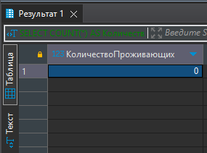

Напишите запрос для подсчета выручки гостиницы за определенный период

