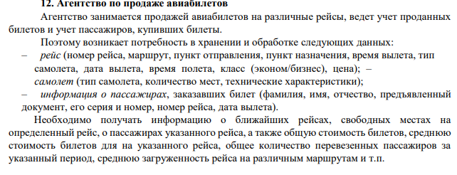

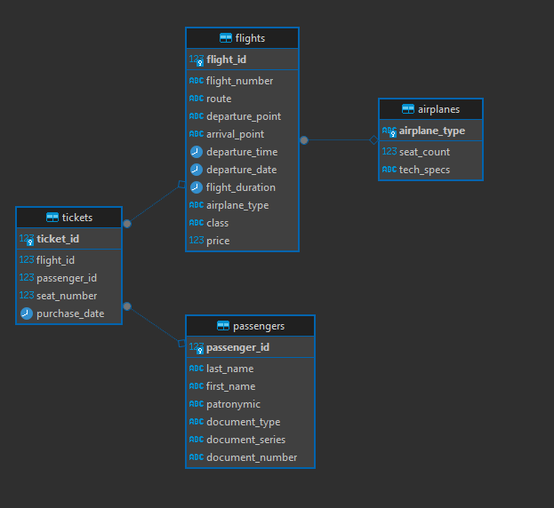

Скрипт

|  |
| --- |
| -- Таблица самолётов  **CREATE** **TABLE** airplanes (  airplane_type **VARCHAR**(50) **PRIMARY** **KEY**,  seat_count **INTEGER** **NOT** **NULL**,  tech_specs **TEXT**  );  -- Таблица рейсов  **CREATE** **TABLE** flights (  flight_id SERIAL **PRIMARY** **KEY**,  flight_number **VARCHAR**(20) **NOT** **NULL**,  route **TEXT** **NOT** **NULL**,  departure_point **VARCHAR**(100),  arrival_point **VARCHAR**(100),  departure_time **TIME**,  departure_date **DATE**,  flight_duration **INTERVAL**,  airplane_type **VARCHAR**(50) **REFERENCES** airplanes(airplane_type) **ON** **DELETE** **SET** **NULL**,  **class** **VARCHAR**(20) **CHECK** (**class** **IN** (**'эконом'**, **'бизнес'**)),  price **NUMERIC**(10,2)  );  -- Таблица пассажиров  **CREATE** **TABLE** passengers (  passenger_id SERIAL **PRIMARY** **KEY**,  last_name **VARCHAR**(100),  first_name **VARCHAR**(100),  patronymic **VARCHAR**(100),  document_type **VARCHAR**(50),  document_series **VARCHAR**(20),  document_number **VARCHAR**(20)  );  -- Таблица билетов  **CREATE** **TABLE** tickets (  ticket_id SERIAL **PRIMARY** **KEY**,  flight_id **INTEGER** **REFERENCES** flights(flight_id) **ON** **DELETE** **CASCADE**,  passenger_id **INTEGER** **REFERENCES** passengers(passenger_id) **ON** **DELETE** **CASCADE**,  seat_number **INTEGER**,  purchase_date **DATE** **DEFAULT** **CURRENT_DATE**,  **UNIQUE**(flight_id, seat_number) -- уникальность места на рейс  ); |