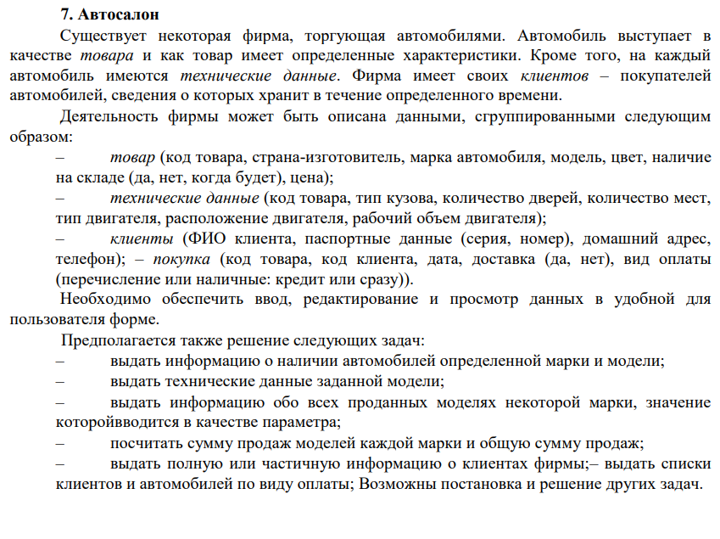

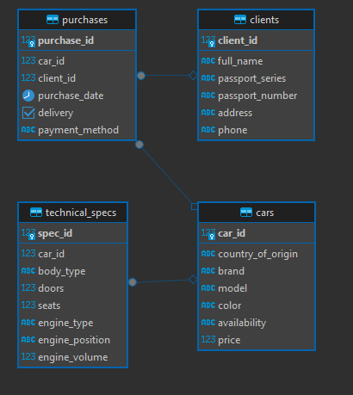

Скрипт

|  |
| --- |
| **CREATE** **TABLE** cars (  car_id SERIAL **PRIMARY** **KEY**,  country_of_origin **VARCHAR**(100),  brand **VARCHAR**(100),  model **VARCHAR**(100),  color **VARCHAR**(50),  availability **VARCHAR**(100),  price **NUMERIC**(12,2)  );  **CREATE** **TABLE** technical_specs (  spec_id SERIAL **PRIMARY** **KEY**,  car_id **INTEGER** **REFERENCES** cars(car_id) **ON** **DELETE** **CASCADE**,  body_type **VARCHAR**(100),  doors **INTEGER**,  seats **INTEGER**,  engine_type **VARCHAR**(100),  engine_position **VARCHAR**(100),  engine_volume **NUMERIC**(6,2)  );  **CREATE** **TABLE** clients (  client_id SERIAL **PRIMARY** **KEY**,  full_name **VARCHAR**(255),  passport_series **VARCHAR**(20),  passport_number **VARCHAR**(20),  address **TEXT**,  phone **VARCHAR**(50)  );  **CREATE** **TABLE** purchases (  purchase_id SERIAL **PRIMARY** **KEY**,  car_id **INTEGER** **REFERENCES** cars(car_id) **ON** **DELETE** **SET** **NULL**,  client_id **INTEGER** **REFERENCES** clients(client_id) **ON** **DELETE** **SET** **NULL**,  purchase_date **DATE**,  delivery **BOOLEAN**,  payment_method **VARCHAR**(50)  ); |