

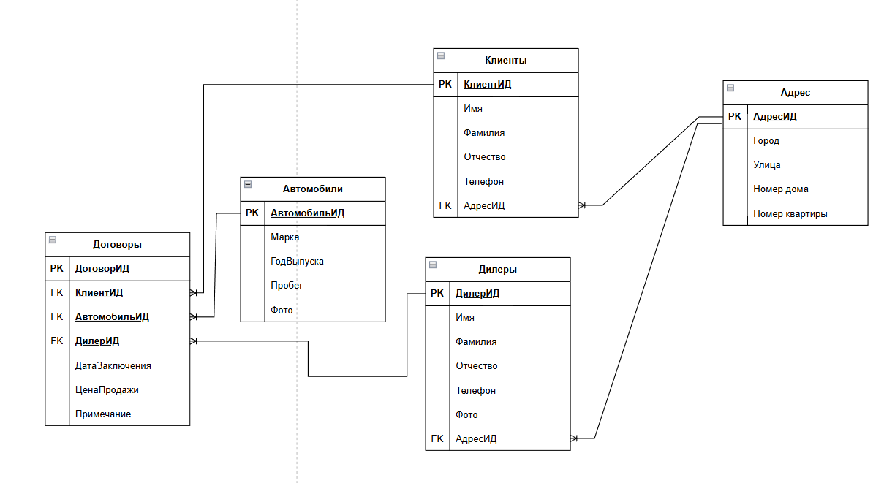

Скрипт

|  |
| --- |
| **CREATE** **TABLE** Client (  ClientID SERIAL **PRIMARY** **KEY**,  FirstName **VARCHAR**(50) **NOT** **NULL**,  LastName **VARCHAR**(50) **NOT** **NULL**,  MiddleName **VARCHAR**(50)  );  **CREATE** **TABLE** Tailor (  TailorID SERIAL **PRIMARY** **KEY**,  FirstName **VARCHAR**(50) **NOT** **NULL**,  LastName **VARCHAR**(50) **NOT** **NULL**,  MiddleName **VARCHAR**(50)  );  **CREATE** **TABLE** **Order** (  OrderID SERIAL **PRIMARY** **KEY**,  IsCompleted **BOOLEAN** **DEFAULT** **FALSE**,  ReceptionDate **DATE** **NOT** **NULL**,  CompletionDate **DATE**,  ClientID **INT** **NOT** **NULL**,  TailorID **INT** **NOT** **NULL**,  **FOREIGN** **KEY** (ClientID) **REFERENCES** Client(ClientID),  **FOREIGN** **KEY** (TailorID) **REFERENCES** Tailor(TailorID)  );  **CREATE** **TABLE** Model (  ModelID SERIAL **PRIMARY** **KEY**,  FabricConsumption **DECIMAL**(10,2) **NOT** **NULL**,  FinalPrice **DECIMAL**(10,2) **NOT** **NULL**,  SewingCost **DECIMAL**(10,2) **NOT** **NULL**  );  **CREATE** **TABLE** Fabric (  FabricID SERIAL **PRIMARY** **KEY**,  **Name** **VARCHAR**(100) **NOT** **NULL**,  Manufacturer **VARCHAR**(100),  **Width** **DECIMAL**(10,2) **NOT** **NULL**,  PricePerMeter **DECIMAL**(10,2) **NOT** **NULL**  );  **CREATE** **TABLE** OrderModel (  OrderModelID SERIAL **PRIMARY** **KEY**,  OrderID **INT** **NOT** **NULL**,  ModelID **INT** **NOT** **NULL**,  **FOREIGN** **KEY** (OrderID) **REFERENCES** **"Order"**(OrderID),  **FOREIGN** **KEY** (ModelID) **REFERENCES** Model(ModelID)  );  **CREATE** **TABLE** ModelFabric (  ModelFabricID SERIAL **PRIMARY** **KEY**,  ModelID **INT** **NOT** **NULL**,  FabricID **INT** **NOT** **NULL**,  **FOREIGN** **KEY** (ModelID) **REFERENCES** Model(ModelID),  **FOREIGN** **KEY** (FabricID) **REFERENCES** Fabric(FabricID) |