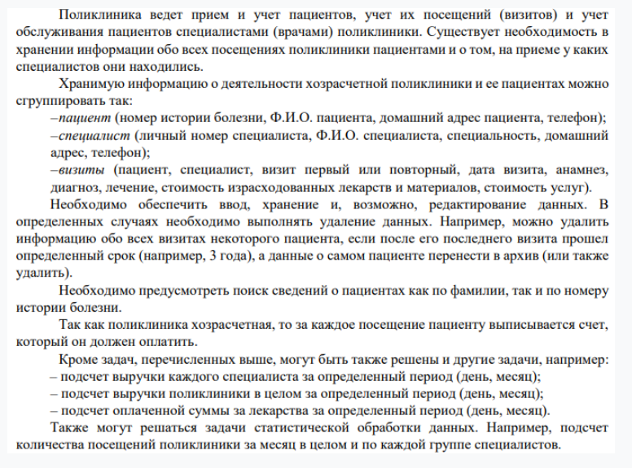

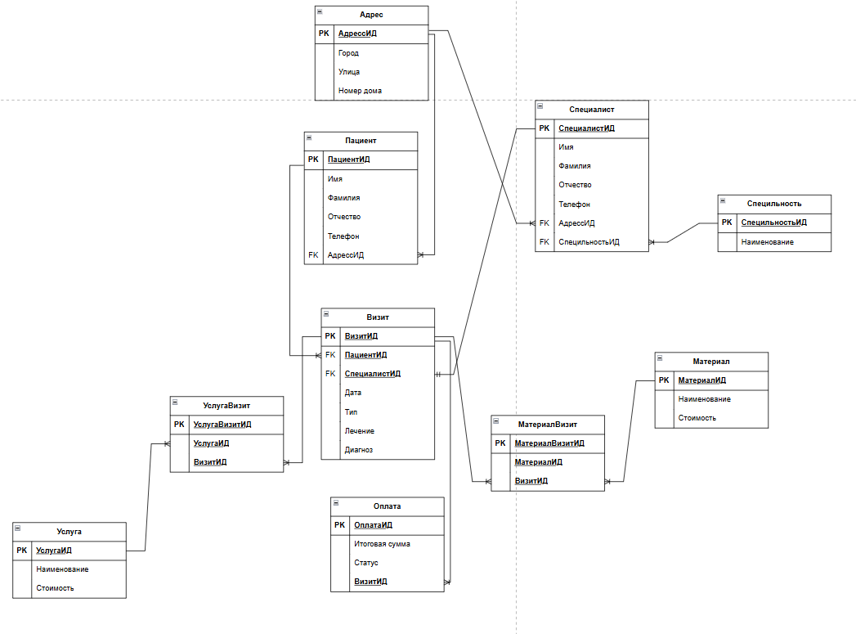

Скрипт

|  |
| --- |
| **CREATE** **TABLE** Specialty (  SpecialtyID SERIAL **PRIMARY** **KEY**,  **Name** **VARCHAR**(100) **UNIQUE**  );  **CREATE** **TABLE** Specialist (  SpecialistID SERIAL **PRIMARY** **KEY**,  FirstName **VARCHAR**(50),  LastName **VARCHAR**(50),  MiddleName **VARCHAR**(50),  Phone **VARCHAR**(20),  AddressID **INT** **REFERENCES** Address(AddressID),  SpecialtyID **INT** **REFERENCES** Specialty(SpecialtyID)  );  **CREATE** **TABLE** Patient (  PatientID SERIAL **PRIMARY** **KEY**,  FirstName **VARCHAR**(50),  LastName **VARCHAR**(50),  MiddleName **VARCHAR**(50),  Phone **VARCHAR**(20),  AddressID **INT** **REFERENCES** Address(AddressID)  );  **CREATE** **TABLE** Visit (  VisitID SERIAL **PRIMARY** **KEY**,  PatientID **INT** **REFERENCES** Patient(PatientID),  SpecialistID **INT** **REFERENCES** Specialist(SpecialistID),  VisitDate **DATE** **NOT** **NULL**,  VisitType **VARCHAR**(50),  Treatment **TEXT**,  Diagnosis **TEXT**  );  **CREATE** **TABLE** Payment (  PaymentID SERIAL **PRIMARY** **KEY**,  TotalAmount **DECIMAL**(10,2),  Status **VARCHAR**(50),  VisitID **INT** **REFERENCES** Visit(VisitID)  );  **CREATE** **TABLE** Service (  ServiceID SERIAL **PRIMARY** **KEY**,  **Name** **VARCHAR**(100) **UNIQUE**,  **Cost** **DECIMAL**(10,2)  );  **CREATE** **TABLE** VisitService (  VisitServiceID SERIAL **PRIMARY** **KEY**,  ServiceID **INT** **REFERENCES** Service(ServiceID),  VisitID **INT** **REFERENCES** Visit(VisitID)  );  **CREATE** **TABLE** Material (  MaterialID SERIAL **PRIMARY** **KEY**,  **Name** **VARCHAR**(100) **UNIQUE**,  **Cost** **DECIMAL**(10,2)  );  **CREATE** **TABLE** VisitMaterial (  VisitMaterialID SERIAL **PRIMARY** **KEY**,  MaterialID **INT** **REFERENCES** Material(MaterialID),  VisitID **INT** **REFERENCES** Visit(VisitID)  ); |