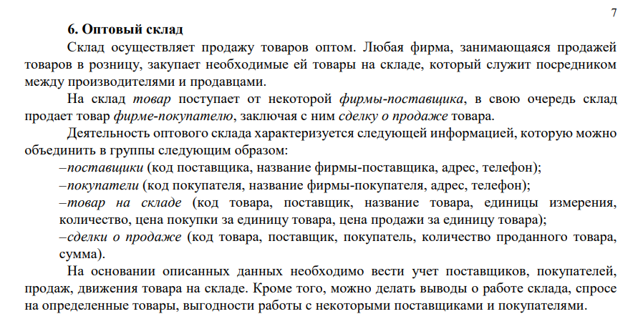

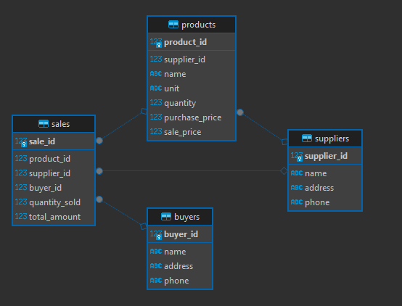

Скрипт

|  |
| --- |
| **CREATE** **TABLE** suppliers (  supplier_id SERIAL **PRIMARY** **KEY**,  **name** **VARCHAR**(255) **NOT** **NULL**,  address **TEXT**,  phone **VARCHAR**(50)  );  **CREATE** **TABLE** buyers (  buyer_id SERIAL **PRIMARY** **KEY**,  **name** **VARCHAR**(255) **NOT** **NULL**,  address **TEXT**,  phone **VARCHAR**(50)  );  **CREATE** **TABLE** products (  product_id SERIAL **PRIMARY** **KEY**,  supplier_id **INTEGER** **REFERENCES** suppliers(supplier_id) **ON** **DELETE** **SET** **NULL**,  **name** **VARCHAR**(255) **NOT** **NULL**,  unit **VARCHAR**(50),  quantity **INTEGER** **NOT** **NULL** **DEFAULT** 0,  purchase_price **NUMERIC**(12,2),  sale_price **NUMERIC**(12,2)  );  **CREATE** **TABLE** sales (  sale_id SERIAL **PRIMARY** **KEY**,  product_id **INTEGER** **REFERENCES** products(product_id) **ON** **DELETE** **CASCADE**,  supplier_id **INTEGER** **REFERENCES** suppliers(supplier_id) **ON** **DELETE** **SET** **NULL**,  buyer_id **INTEGER** **REFERENCES** buyers(buyer_id) **ON** **DELETE** **CASCADE**,  quantity_sold **INTEGER** **NOT** **NULL**,  total_amount **NUMERIC**(14,2)  ); |