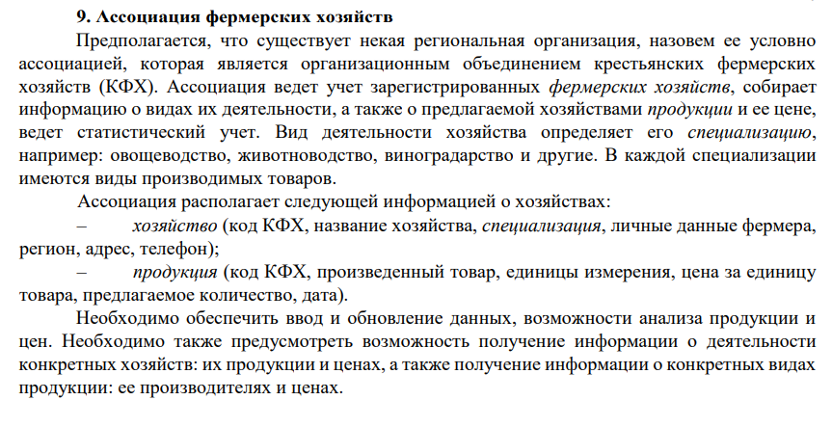

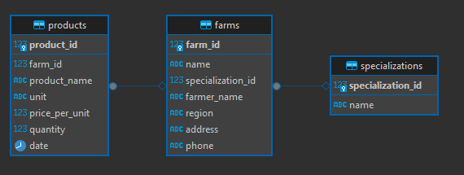

Скрипт

|  |
| --- |
| **CREATE** **TABLE** specializations (  specialization_id SERIAL **PRIMARY** **KEY**,  **name** **VARCHAR**(100) **NOT** **NULL**  );  **CREATE** **TABLE** farms (  farm_id SERIAL **PRIMARY** **KEY**,  **name** **VARCHAR**(255) **NOT** **NULL**,  specialization_id **INTEGER** **REFERENCES** specializations(specialization_id) **ON** **DELETE** **SET** **NULL**,  farmer_name **VARCHAR**(255),  region **VARCHAR**(100),  address **TEXT**,  phone **VARCHAR**(50)  );  **CREATE** **TABLE** products (  product_id SERIAL **PRIMARY** **KEY**,  farm_id **INTEGER** **REFERENCES** farms(farm_id) **ON** **DELETE** **CASCADE**,  product_name **VARCHAR**(255),  unit **VARCHAR**(50),  price_per_unit **NUMERIC**(10,2),  quantity **NUMERIC**(10,2),  **date** **DATE**  ); |