Supplementary Data
Notes/Reasoning for Analysis
Cluster Level Family Wise Error & Analysis Parameters/Output
- Why did I use Cluster Level FWE?
  - Less stringent than voxel-level FWE, allowing for detection of weaker but spatially coherent effects.
  - Better suited for meta-analysis because cluster correction prioritizes statistically significant, spatially contiguous regions.
  - When you expect distributed activation rather than focal points.
  - If voxel-level correction is too conservative and no clusters survive.
  - If you want results that align better with network-level interpretations of brain function.
- GingerALE Single Dataset Parameters:
  - CLFWE = .05, 1000 threshold permutations, p-value = .05
  - 29 MDD Foci
    - ALE Range = 0 – 0.013
    - Sagittal => left hemisphere crosshair
    - Axial => right hemisphere crosshair
    - Coronal => right hemisphere crosshair
  - 101 Healthy Foci
    - ALE Range = 0 – 0.01
    - All pictures are of the right hemisphere (crosshair)
  - Pooled Analysis => 130 Foci
- GingerALE Contrast Parameters:
  - p = .05, 10,000 threshold permutations, min volume = 200 mm³
  - Median Full Width at Half Maximum Value = 9.282869490900032
  - Cluster Contrast Analysis did not yield any significant ALE results => This is my reasoning for not including the contrast analysis heatmaps/tables, include this reasoning at the end of the second section (single dataset analysis, HC)

FWHM Value | Interpretation
4 -6 mm | Low smoothing, good for detecting fine-scale activation but more sensitive to noise.
7 – 10 mm | Moderate smoothing, balances noise reduction and spatial precision.
>10 mm | High smoothing, good for detecting large activation patterns but may blur distinct regions.

- Overlays/ Formatting Used in MANGO:
  - Template: Colin27_T1_seg_MNI.nii
  - Overlay: Threshold ALE Maps from single dataset analysis
    - Files updated to image range => adjusts images to fit data
- Interpreting ALE Scores:
  - < 0.001 Low activation likelihood (likely noise)
  - 0.001 – 0.01 Weak
  - 0.01 – 0.02 Moderate
  - > 0.02 Strong activation likelihood
  - > 0.05 High activation likelihood, robust effect
- Tables with cluster information
  - Cluster number, Peak cluster coordinate, anatomical location, peak cluster ALE score, anatomical composition of cluster, z-score, and p-value
  - All numbers rounded to five significant figures
ADDITIONAL FILES:

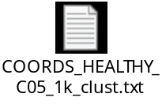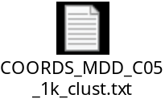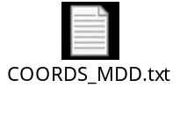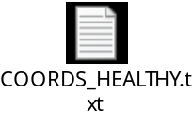
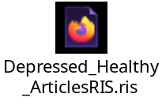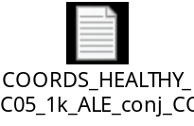

MNI Template: https://nist.mni.mcgill.ca/colin-27-average-brain/
Cluster Number | Cluster Volume (mm³) | Peak MNI Coordinate | Anatomical Location of Peak Coordinate | Peak ALE Value
1 | 8248 | (55.7, -30, 24.9) | Right Inferior Parietal Lobe | 0
Anatomical Composition of Cluster (% out of 100%)
1 | 58.2% Parietal Lobe, 25.6% Sub-lobar, 16.2% Temporal Lobe
Supplementary Table 1 Activation clusters from cluster-level FWE contrast ALE analysis.
No significant (threshold permutations = 10000, p < .05), FWE-corrected, activation clusters were found following GingerALE (CITE) contrast analysis. Peak MNI coordinates (x, y, z) indicate the voxel with the highest activation likelihood within the cluster. The anatomical location corresponds to the peak coordinate based on the MNI atlas. The ALE score represents activation convergence across studies, with higher values indicating greater consistency. The anatomical composition of the cluster is expressed as a percentage of the total cluster volume, with only regions contributing ≥1% reported.

