Hallo-Man

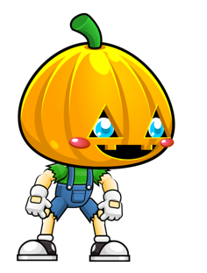

Table of Contents

2. Game Overview 1

Genre 1

Targeted Audience: 1

Game Flow 1

Look and feel 2

3. Game play & Mechanics 2

Mission: 2

Objectives 2

Mechanics: 2

Objects 2

4.Story Setting and Character 2

Story Narrative 2

# 2. Game Overview

Hallo-Man is a single player 2D action game with polished pixel graphics. The game is about collecting the candies and progressing to next level. Each level has different creeps, obstacles, and main enemies. The difficulty will be increasing on each level, and the player will get an opportunity to purchase weapons, other stuffs.

Genre: Action & Thriller

Targeted Audience: We are targeting kids from age 8 – 15, as the game is about the Halloween the kids will be more inclined and interested to try the game

Game Flow: The player controller has 4 functionalities, to move right, left, jump, and attack. There will be will different traps set up through out the level, with the help of the functionalities the player should tackle and pass each levels.

Look and feel : The game is built with the 2d graphics and animation that will allow the users to feel the game.

# 3. Game play & Mechanics

The game has only few controls which is not complicated to play. Each sprite is added to a layer component with different animation triggers when it satisfies the loop.

Mission: Kill the enemies and progress to next level.

Objectives: To collect the candies to increase the score and buy the items for future levels.

## Mechanics:

Physics: we added colliders to track the object, we also use transform location to locate the player axis.

Objects: We use colliders like On Collision method to collect the collectables

# 4.Story Setting and Character

Story Narrative – Hallo man moves through the world of Halloween, collecting candies, destroying raining skulls, avoiding spikes and traps. On dying he can respawn at units away from death. The end Skull Boss – Skeletorr gets killed after getting attacked by the bullet blue pumpkins.

4.2 Game World

4.2.1 Halloween themed Game World with scary spiders, pumpkins etc

4.2.2 Areas – There are clouds that are buoyant, background with parallax effect, crates that can be used to jump on and off.

4.3 Characters

Hallo-man – It is the main character and he travels through the world collecting coins and destroying the evil skulls ,avoiding spikes and traps and in the end kills the Boss -Skeletorr by shooting him with 5 or more pumpkin bullets.

Screenshot