DJSCE Institutional Brain — IPD Report (final draft)
Structure follows the department’s IPD report format (../references/senior_samples/AgriScan_IPD3_Report_Sem5.pdf). Only ⟨…⟩ placeholders remain: team, guide, course and signature details, which the team must fill. Every number in this report comes from the evaluation run recorded in results/RESULTS.md (19 Oct 2026, 14:55 UTC, model openai/gpt-oss-120b) or from the repository at commit time; nothing is estimated. Data disclaimer (repeat in the printed report): committee meetings, people, commitments and internal procedures are synthetic and are not official DJSCE records or policy. Public knowledge is authentic information published on https://www.djsce.ac.in, cited per file by URL and retrieval date (13 Oct 2026).

Front matter
- Title page. DJSCE Institutional Brain: An Evidence-Grounded, Access-Aware Knowledge and Help-Desk Platform for Colleges. “Submitted in partial fulfilment of the requirements of the course Innovative Product Development-⟨N⟩, Year ⟨Y⟩, Sem ⟨S⟩, Computer Engineering.” Team names and SAP IDs ⟨…⟩; guide ⟨name, designation⟩; Dwarkadas J. Sanghvi College of Engineering, University of Mumbai, ⟨academic year⟩.
- Certificate signed by the internal guide, Head of Department and Principal.
- Project report approval with two examiner lines, date and place.
- Declaration of academic integrity, signed by each member.
- Acknowledgement of the guide, the department, and the use of public content from djsce.ac.in.
- Abstract, Contents, List of Figures, List of Tables, List of Abbreviations (below).

Abstract
Colleges take most operational decisions in committee meetings and keep their procedures in scattered circulars. Action items go untracked, procedures are re-learned every cycle, and students depend on office visits for routine information. General-purpose chatbots are a poor fit: they cannot cite institutional sources, may invent policy, and ignore who is allowed to see what. This report presents DJSCE Institutional Brain, a web platform that ingests meeting transcripts and documents, uses a large language model (LLM) to extract decisions, owner-assigned commitments and step-by-step procedures, and routes every AI output through human review. All knowledge is stored as citable evidence fragments labelled internal or public and tagged with a department; student retrieval is restricted to public evidence inside the vector query and re-checked afterwards. Students use a Help Desk that answers from public information and escalates unresolved questions as tickets, which an LLM classifier triages (with a deterministic keyword fallback) and faculty answer from an AI-drafted, cited reply. The system is built with FastAPI, Next.js, PostgreSQL, ChromaDB, Neo4j and Celery, deployed with Docker Compose, and covered by 235 automated backend tests. On synthetic committee records combined with authentic public website content, the LLM triage reached 90.6 % accuracy against 57.3 % for the keyword baseline; the assistant retrieved a correct source in the top five for 100 % of 33 questions and answered 91 % correctly; commitment extraction scored precision 1.00 and recall 1.00; and adversarial tests found 0 visibility leaks in 20 student queries and 0 department leaks in 10.
Keywords: retrieval-augmented generation, access control, meeting action items, help desk, human-in-the-loop.

List of abbreviations
Abbr. | Expansion
AI | Artificial Intelligence
API | Application Programming Interface
CE / IT | Computer Engineering / Information Technology (departments)
IQAC | Internal Quality Assurance Cell
JWT | JSON Web Token
KB | Knowledge Base
LLM | Large Language Model
NBA / NAAC | National Board of Accreditation / National Assessment and Accreditation Council
NER | Named-Entity Recognition
RAG | Retrieval-Augmented Generation
RBAC | Role-Based Access Control
SOP | Standard Operating Procedure

List of figures
No. | Title | File (figures/)
5.1 | Layered system architecture | fig5_1_architecture.png
5.2 | Evidence pipeline and access-aware retrieval | fig5_2_evidence_pipeline.png
5.3 | Help-desk sequence (student → triage → faculty reply) | fig5_3_helpdesk_sequence.png
5.4 | Procedure (skill) lifecycle | fig5_4_skill_lifecycle.png
6.1 | Sign-in page with demo-prototype notice | fig6_01_login.png
6.2 | Student Help Desk | fig6_02_student_helpdesk.png
6.3 | Student answer from public information, with sources | fig6_03_student_answer.png
6.4 | Staff overview: insights and upcoming commitments | fig6_04_overview.png
6.5 | My Work: commitment with progress and due date | fig6_05_my_work.png
6.6 | Ticket review: AI triage and unsent AI draft | fig6_06_ticket_review.png
6.7 | Procedure with owner, review date and steps | fig6_07_procedure_evidence.png
6.8 | Meetings list | fig6_08_meetings.png
6.9 | Knowledge graph | fig6_09_knowledge_graph.png
6.10 | Analytics | fig6_10_analytics.png
6.11 | Staff assistant answer with citations | fig6_11_assistant_cited.png
7.1 | Triage accuracy by engine | fig7_1_triage.png

1. Introduction
Indian engineering colleges are run through committees: the Academic Council, Boards of Studies, the IQAC, the Examination Cell, the Training and Placement Cell and department committees. Each meeting produces decisions (“the elective is approved for 60 students”) and commitments (“Prof. X will circulate the rubric by Friday”). These are written as free-text minutes, stored as files and rarely tracked. Procedures such as revaluation or equipment-breakage recovery live in circulars and in the memory of a few staff members, so they are re-learned every academic cycle. Students, meanwhile, ask the same routine questions at office counters, and their queries leave no record.
Large language models can now read transcripts and documents and answer questions about them. An institution, however, cannot simply put a chatbot in front of its records. Answers must be traceable to a source, AI output that becomes policy must be reviewed by a person, and a student must never see internal discussion. This project builds a platform around those three requirements: evidence first, a human in the loop, and access control enforced inside retrieval.
DJSCE Institutional Brain turns meetings and documents into structured, cited knowledge (decisions, accountable commitments, reviewed procedures), serves it to staff through an assistant and dashboards, and serves students through a Help Desk that answers only from public information and escalates the rest to faculty as tracked tickets.
The report is organised as follows. Chapter 2 explains the need and compares existing systems. Chapter 3 surveys the literature. Chapter 4 formulates the problem and objectives. Chapter 5 describes the design, Chapter 6 the implementation, and Chapter 7 the evaluation. Chapter 8 concludes.

2. Need of the Product

2.1 Introduction and need
Stakeholder | Current pain | What the product gives them
Committee coordinators | Action items from meetings are forgotten; follow-up is manual | Commitments extracted with owner and due date; overdue alerts; confirm or send back completed work
Faculty | Re-learn procedures; repeat answers to students | Cited procedures; AI-drafted ticket replies they edit and send; end-of-day check-in updates tasks
Students | Office visits for routine questions; no record of queries | Instant answers from public department information; tickets routed to the right office
IQAC / accreditation | Evidence for decisions scattered across files | Every decision and procedure linked to its source excerpt; audit log; minutes export

2.2 Analysis of existing systems
Criterion | College ERP / LMS | Generic chatbot | Enterprise search / RAG demo | Institutional Brain
Captures meeting decisions and commitments | ✗ | ✗ | ✗ | ✓ owners and due dates
Answers cite institutional sources | ✗ | ✗ | partial | ✓ every answer
Human review before AI output is published | n/a | ✗ | ✗ | ✓ procedures, ticket replies
Role-aware retrieval (students vs staff) | role-based pages | ✗ | rarely | ✓ inside the vector query
Student query tracking | partial | ✗ | ✗ | ✓ tickets with routing
Detects outdated procedures | ✗ | ✗ | ✗ | ✓ contradiction → stale
⟨Team: name two or three real products per column with a source each, for example the college’s ERP/LMS, a general chatbot, and a commercial enterprise-search product.⟩
Generic chatbots answer fluently but without institutional grounding, and they hallucinate [8], [9]. RAG systems ground answers in retrieved text [1], [2], but typical deployments retrieve from a single shared index and so do not distinguish what a student may see from what staff may see; recent work shows that RAG can leak the private documents it retrieves from [12]. ERPs record transactions, not the reasoning and commitments made in meetings.

2.3 Applications
Committee secretariats (minutes → tracked commitments), department offices and the Examination Cell (procedures and student queries), IQAC and accreditation preparation (decision evidence with sources), and a student help desk. The system is configured per institution through one file (institution.yaml: branding, departments, help-desk categories and offices, members, academic calendar), so it can be adopted by another college without code changes.

3. Survey

3.1 Literature survey
Retrieval-augmented generation and grounding. Lewis et al. [1] introduced RAG, combining a pre-trained generator with a dense index retrieved at inference time, and showed more specific and factual output than a parametric-only model. Gao et al. [2] survey the design space (naive, advanced and modular RAG) and identify retrieval quality and evaluation as open problems. Dense passage retrieval [3] and sentence embeddings [4] made semantic retrieval practical; our system uses the BGE family of embedding models [5].
Citations and evaluation. Gao, Yen, Yu and Chen [6] built ALCE, a benchmark for answers with citations, and found that even strong models lacked full citation support about half the time on ELI5. RAGAs [7] separates retrieval quality, faithfulness and answer relevance. We adopt the same separation: we measure whether the right source was retrieved separately from whether the answer is correct.
Hallucination. Ji et al. [8] and Huang et al. [9] survey hallucination in generation and in LLMs; both list retrieval grounding and human verification among the main mitigations. This motivates our rule that no AI output becomes a procedure or reaches a student without a person approving it.
Meeting information extraction. Purver et al. [10] detect action items in multi-party meetings by modelling the dialogue structure in which tasks are proposed and agreed, then summarise each task. QMSum [11] frames meeting understanding as query-focused summarisation. We use an LLM with a constrained JSON schema to extract decisions and commitments (owner, task, due date) from speaker-attributed transcripts.
Access control and RAG security. Role-based access control [14] assigns permissions to roles rather than individuals; we use four ranked roles. Zeng et al. [12] show empirically that RAG systems can leak their retrieval database, and Greshake et al. [13] show that retrieved content can carry indirect prompt injection. We therefore filter by visibility and department inside the vector query, re-check every hit, and keep AI drafts and triage fields away from students.
Ticket triage. Revina et al. [15] find that well-chosen simple features can match complex models for IT ticket classification, and Zangari et al. [16] survey ticket automation and multi-level classification. We compare an LLM classifier with a keyword baseline and a small non-generative classifier (laya), and use the keyword classifier as a deterministic fallback.
Knowledge graphs. Hogan et al. [17] survey graph data models and knowledge extraction; GraphRAG [18] builds an entity graph to answer corpus-wide questions. We use a lighter graph (people, committees, meetings, documents) for navigation rather than for answer generation.
Chatbots in education. Systematic reviews by Okonkwo and Ade-Ibijola [19] and Wollny et al. [20] find chatbots useful for routine student support, but point to weak evaluation and limited integration with institutional processes. Our Help Desk is evaluated on a labelled set and is tied to staff workflows.

3.2 Outcome of the survey
What works: RAG with explicit citations, structured extraction from dialogue, and simple, robust classifiers. What is missing in existing tools for colleges: (1) access-aware retrieval where students and staff search different evidence, (2) accountability for commitments made in meetings, and (3) human review built into the workflow. These three gaps define our design (Chapter 4.3).

4. Problem Formulation

4.1 Problem statement
To design and implement a platform that converts a college’s meeting transcripts and documents into structured, citable institutional knowledge (decisions, accountable commitments and reviewed procedures) and serves it to staff and students through grounded, role-restricted AI assistance with human oversight.

4.2 Product objectives
Targets below were set by the team from the baseline run (run 1, 13 Oct 2026); ⟨confirm with guide⟩.
# | Objective | Target | Result (19 Oct 2026, 14:55 UTC)
1 | Extract commitments from transcripts | precision ≥ 0.80, recall ≥ 0.80 | P 1.00, R 1.00
2 | Retrieve a correct source for questions | hit@5 ≥ 90 % | 100 %
3 | Answer questions correctly from sources | ≥ 80 % | 91 %
4 | No internal evidence reaches students | 0 leaks on adversarial set | 0 / 20
5 | No cross-department leaks for students | 0 leaks | 0 / 10
6 | Route tickets correctly | LLM accuracy ≥ 85 %, above keyword baseline | 90.6 % vs 57.3 %
7 | Responsive answers | p95 answer latency ≤ 10 s | 10.0 s

4.3 Novelty
- Evidence first. Every answer, procedure and ticket draft carries the excerpts it came from.
- Human in the loop by design. Procedures start as drafts that a coordinator approves; ticket replies are written by faculty from an AI draft that the student never sees.
- Access-aware retrieval. Visibility and department are stored on each fragment, filtered in the vector query, and re-checked on every hit.
- Meetings → accountability. Commitments get owners, due dates, progress, blockers and a coordinator confirmation step; a conversational check-in updates them.
- Constrained triage with a deterministic fallback. The LLM may only choose configured categories; otherwise the keyword classifier decides.
- Freshness. New evidence that contradicts an approved procedure marks it stale for re-review.

4.4 Scope
In scope: transcript and document ingestion (.txt, .pdf, .docx), decision and commitment extraction, procedures with versions and review dates, cited Q&A, student Help Desk with tickets, notices filtered by department, year, semester and division, academic calendar, knowledge graph, analytics, audit log, minutes export (DOCX/PDF), four roles and per-department scope. Out of scope: live meeting recording, ERP integration, and real internal records or personal data. Public knowledge is a snapshot of public pages of https://www.djsce.ac.in retrieved on 13 Oct 2026, without personal contact data.

5. Proposed Design

5.1 Approach selection
Need | Choice | Alternatives considered and why not
Language understanding and generation | Hosted LLM (openai/gpt-oss-120b via Groq), JSON-constrained prompts | Fine-tuning needs labelled institutional data we do not have; a local LLM needs a GPU the demo machine lacks
Retrieval | Dense embeddings BAAI/bge-large-en-v1.5 [5] in ChromaDB, cosine similarity | BM25 misses paraphrases (“re-checking” vs “revaluation”); a hosted vector DB adds cost and moves data off-site
Metadata and workflow | PostgreSQL with Alembic migrations | Document stores make relational workflows (owners, versions, tickets) harder
Entity relations | spaCy NER → Neo4j | Building the graph with an LLM costs more tokens with no gain for navigation
Triage | LLM restricted to configured categories → keyword fallback; laya compared | LLM alone fails when the API is unavailable; keyword alone is inaccurate (Table 7.3)
Background work | Celery + Redis (ingestion, scans, reminders) | Doing ingestion inside the request blocks the UI for tens of seconds

5.2 System architecture
Figure 5.1 shows five layers: sources, processing services, the evidence layer, access-aware retrieval, and the web application with human review. Figure 5.2 details the evidence pipeline: every transcript turn or document chunk becomes a Fragment with visibility (internal/public) and department, stored in PostgreSQL and mirrored with the same metadata in ChromaDB, with entities sent to Neo4j. Figure 5.3 shows the help-desk sequence, and Figure 5.4 the procedure lifecycle.
Table 5.1 Roles and permissions (enforced in the API; the UI only hides what the API already refuses)
Capability | Student | Faculty | Committee Coordinator | System Administrator
Help Desk answers (public knowledge only) | ✓ | ✓ | ✓ | ✓
Raise tickets, see own tickets | ✓ | ✓ | ✓ | ✓
Read notices addressed to them | ✓ | ✓ | ✓ | ✓
Staff assistant over internal evidence | ✗ | own dept + institution-wide | all | all
Ticket queue, AI draft, reply | ✗ | ✓ | ✓ | ✓
My Work, Faculty Desk check-in | ✗ | ✓ | ✓ | ✓
Approve/reject/retire procedures, extract | ✗ | ✗ | ✓ | ✓
Analytics, assign tasks, confirm completion | ✗ | ✗ | ✓ | ✓
Manage users and roles | ✗ | ✗ | ✗ | ✓

5.3 Data model
Table 5.2 Main tables (backend/app/models/structured.py; 17 tables, lists stored as JSON strings)
Table | Purpose
User | Login, role, department, year/semester/division for students
Employee | Staff directory (seeded from institution.yaml)
Meeting | Title, date, summary, decisions, participants, raw transcript, department
Fragment | One citable excerpt: text, source, speaker, visibility, department (mirrored in ChromaDB)
Commitment, CommitmentUpdate | Task, owner, due date, status, progress, blocker; history of updates
CheckIn | Faculty end-of-day conversation and the task updates it produced
Skill, SkillVersion, SkillCitation | Procedure (steps, rules, owner office, review date, status), its versions, and cited fragments
Ticket | Student query, triage (category, priority, office, engine), AI draft and sources, human reply
Notice, NoticeRecipient | Notices with audience filters and read receipts
ActiveInsight | Deadline, risk and bottleneck alerts on the overview
QueryLog | Questions asked (for analytics and knowledge gaps)
AuditLog | Who did what and when
Document, ProgressReport | Uploaded document records; generated progress reports

6. Implementation

6.1 Backend services
The backend is FastAPI (backend/app). Routers in api/v1/ (17 routers) stay thin; logic lives in module-level services in services/ (24 modules). The main services:
- transcript_service / extraction_service parse speaker turns, create fragments, and call the LLM with a JSON schema for summary, decisions and commitments; owners are matched to staff.
- fragment_service is the only writer to the evidence store: a PostgreSQL row plus a ChromaDB vector with the same visibility and department.
- parser splits documents into chunks of up to 800 characters with 150-character overlap, keeping question–answer pairs together.
- skill_service / procedure_service synthesise procedures from internal fragments, keep versions, owner office and review dates, write student summaries, and export DOCX/PDF and a handbook.
- freshness_service scans new evidence for contradictions with approved procedures and marks them stale with the reason and evidence.
- rag_service retrieves the top 5 fragments plus up to 2 approved procedures, filtered by role and department, and asks the LLM (temperature 0.2) for an answer with numbered citations.
- ticket_service triages tickets (LLM → keyword), routes them to the configured office, and drafts a cited reply for staff.
- commitment_service / pa_service handle progress, blockers, confirmation, follow-up messages and the end-of-day check-in that turns plain-language updates into task changes.
- graph_service / ner_service build Employee, Project, Document and Meeting nodes with MENTIONS and ATTENDED edges; people are added only with supporting evidence.
- notice_service, calendar_service, analytics_service, audit_service, user_service provide notices, reminders, dashboards, the audit trail and user administration.
Background jobs (Celery beat, core/celery.py): the daily 08:00 insight sweep, the faculty check-in at a configured hour, an hourly follow-up scan for stale or overdue commitments, procedure extraction at 03:00, the freshness scan at 04:00, and reminders for academic dates and commitments due within three days. Ingestion endpoints return 202 and enqueue work.

6.2 Access control
Users have one of four ranked roles (student < employee < manager < admin). Internal routes depend on require_staff; elevated actions on require_role("manager"). Self-registration creates students only. Retrieval applies the policy twice:
ALGORITHM AnswerQuestion(question, user)
public_only ← (user.role = student)
depts ← {user.department, "all"} unless user.role ≥ manager
filter ← {visibility = public if public_only} ∧ {department ∈ depts if depts}
hits ← VectorSearch(embed(question), k = 5, where = filter)
∪ VectorSearch(procedures, k = 2, where = filter)
hits ← [h ∈ hits | (¬public_only ∨ h.visibility = public) ∧ (no depts ∨ h.department ∈ depts)]
answer ← LLM(rules + numbered hits, question)
RETURN answer, hits # sources always returned with the answer
ALGORITHM TriageTicket(subject, description)
r ← LLMClassify(text, allowed = categories from institution.yaml)
IF r invalid OR r.category ∉ allowed: r ← KeywordClassify(text)
ticket.routed_to ← office(r.category); ticket.priority ← r.priority
ticket.ai_draft, ticket.ai_sources ← AnswerQuestion(text, staff) # never returned to students
Students receive 404 for other people’s tickets and never receive ai_* fields.

6.3 Frontend
Next.js 16 / React 19 with Tailwind CSS (frontend/src). Students see the Help Desk, Assistant, Notices and Calendar; staff additionally see Overview, My Work, Faculty Desk, Ticket Queue, Meetings, Procedures, Documents and Knowledge Graph; coordinators see Analytics; administrators see Users. All API calls go through one helper, and /api/* is proxied to the backend. Figures 6.1–6.11 show the main screens. A persistent banner states that the system is a demonstration prototype.

6.4 Deployment
Docker Compose runs eight services: PostgreSQL, ChromaDB, Redis, the backend, a Celery worker, Celery beat, the frontend, and an on-demand evaluator. Startup runs alembic upgrade head, so data survives rebuilds. Health checks gate start order. A tunnelling script exposes the demo for remote review.

6.5 Testing
235 backend tests in 26 test modules run with SQLite and mocked LLM, ChromaDB and Neo4j. They cover authentication and roles, student access (every internal route refuses students), department scope, transcripts and extraction, commitments and My Work, the Faculty Desk, procedures (versions, approval, rejection, retirement, export), freshness, help desk, notices, calendar, analytics, admin users, graph, audit, insights, parsing and date parsing, and a test that fails if models and migrations drift. The frontend is checked by ESLint and the TypeScript compiler in CI.

7. Experimentation and Results

7.1 Datasets
Table 7.1 Datasets (all labels written by the team; evaluation/data/)
Set | Contents | Size
Committee transcripts | synthetic: Academic Council, IQAC, departmental lab readiness, placement planning (+1 demo minutes file for the live upload) | 4 (+1)
Internal documents | synthetic proposals, guidelines and SOPs | 3 documents + 3 SOPs
Public knowledge (mini-project) | CE department FAQs, IT department overview | 2 documents
Public website knowledge base | authentic content from https://www.djsce.ac.in, each file cited by URL, retrieved 13 Oct 2026 | 26 files
Triage set | labelled student queries, 6 categories, urgency labels | 96
Q&A set | questions with gold sources and answer keywords | 33
Visibility set | adversarial student questions about internal content | 20
Department set | CE/IT students asking about the other department | 10
Commitments gold set | hand-labelled commitments in the transcripts | 9

7.2 Test cases
Table 7.2 Functional test cases (each automated in backend/tests/, all passing)
ID | Feature | Case | Expected | Result
T1 | Access | Student calls any internal route | 403 | Pass
T2 | Access | Student opens another student’s ticket | 404, no ai_* fields | Pass
T3 | Visibility | Student question whose best match is internal | only public sources returned | Pass
T4 | Department | CE faculty retrieves IT-only fragment | not returned | Pass
T5 | Transcripts | Submit an empty transcript | 400, nothing queued | Pass
T6 | Extraction | Transcript with “I will … by Friday” | commitment with owner and due date | Pass
T7 | My Work | Owner marks task done | status review, coordinator confirms or sends back | Pass
T8 | Procedures | Approve, edit, reject with reason, retire | versions kept, reason stored | Pass
T9 | Freshness | New fragment contradicts approved procedure | procedure marked stale with evidence | Pass
T10 | Help desk | LLM unavailable | keyword triage used, ticket still routed | Pass
T11 | Notices | Notice to TE CE division A | only matching students receive it | Pass
T12 | Admin | Non-admin opens user management; deactivated user logs in | refused; login and old token rejected | Pass
T13 | Migrations | Models changed without migration | test fails | Pass
The role-access matrix in Table 5.1 is covered by test_student_access.py, test_departments.py and test_admin_users.py.

7.3 Parameter choices
No large parameter sweep was run (the LLM API has a daily token quota). Parameters were chosen once and changed only when the baseline run (run 1) exposed a specific failure:
Parameter | Value | Reason
Chunk size / overlap | 800 / 150 characters, paragraph-aware | Run 1 split FAQ answers from their questions; chunks now keep Q–A pairs together
Retrieval depth | top 5 fragments + up to 2 approved procedures | Approved procedures should outrank meeting discussion when equally relevant
Answer temperature | 0.2 | Factual answers; 0.6 only for the conversational check-in
Classification temperature | 0.1, JSON output | Stable labels
Speaker names in fragments | included | Run 1 missed “who decided” questions without them
LLM | openai/gpt-oss-120b (Groq) | Large open-weight model with JSON output, available on Groq’s free tier

7.4 Results
All results are from results/RESULTS.md (19 Oct 2026, 14:55 UTC). Run 1 (13 Oct 2026, results/RESULTS_run1_baseline.md) is shown for comparison.
Table 7.3 Help-desk triage (96 queries, 6 categories)
Engine | Coverage | Accuracy | Macro-F1 | Urgency F1 | p50 latency (s) | p95 latency (s)
keyword | 100% | 57.3% | 0.586 | 0.533 | 0.0 | 0.0
llm | 100% | 90.6% | 0.907 | 1.000 | 2.489 | 4.53
laya | 67% | 51.0% | 0.563 | 0.533 | 1.387 | 1.923
llm→keyword | 100% | 90.6% | 0.907 | 1.000 | 2.489 | 4.53
laya→keyword | 100% | 68.8% | 0.684 | 0.533 | 1.387 | 1.923
laya→llm→keyword | 100% | 80.2% | 0.794 | 0.625 | 1.537 | 4.466
Engines alone count an abstention as wrong; chains fall back to the keyword classifier. Figure 7.1 plots accuracy per engine.
Table 7.4 Question answering
Asked as | n | Retrieval hit@5 | Answer correct | Cited | Abstained | p50 (s) | p95 (s)
student | 21 | 100% | 90% | 100% | 0% | 3.249 | 7.84
staff | 12 | 100% | 92% | 92% | 0% | 8.8 | 10.111
overall | 33 | 100% | 91% | 97% | 0% | 6.725 | 10.031
Table 7.5 Visibility and department isolation
Test | Queries | Leaks | Definition of a leak
Visibility (adversarial) | 20 | 0 | an internal source returned, or an internal-only fact stated
Department isolation | 10 | 0 | a source from a department outside the student’s own plus institution-wide
Table 7.6 Commitment extraction
Gold | Extracted | Matched | Precision | Recall | F1
9 | 9 | 9 | 1.00 | 1.00 | 1.00
Table 7.7 Baseline (run 1) vs final run
Measure | Run 1 (13 Oct) | Final (19 Oct)
Triage accuracy, LLM / keyword / laya | 90.6 % / 57.3 % / 51.0 % | 90.6 % / 57.3 % / 51.0 %
Q&A questions | 24 | 33 (adds 8 public-website and IT-department questions)
Retrieval hit@5 | 100 % | 100 %
Answer correct (overall) | 71 % | 91 %
Answer correct (student) | 75 % | 90 %
Cited | 88 % | 97 %
Abstained | 8 % | 0 %
p95 answer latency | 8.2 s | 10.0 s
Visibility leaks | 0 / 20 | 0 / 20
Department leaks | not measured | 0 / 10
Commitments P / R | 1.00 / 1.00 | 1.00 / 1.00

7.5 Discussion
Triage. The LLM classifier is clearly best (90.6 % accuracy, macro-F1 0.907, urgency F1 1.00), 33 points above the keyword baseline. laya abstained on a third of the queries (coverage 67 %) and was less accurate even with a keyword fallback (68.8 %); placing it before the LLM lowered accuracy to 80.2 %. The default chain therefore stays LLM → keyword, which keeps 90.6 % while the keyword fallback guarantees a category when the LLM is unavailable. The keyword classifier answers in under a millisecond; the LLM’s p95 is 4.5 s, acceptable for a ticket that a person answers later.
Question answering. Retrieval found a correct source in the top five for every question in both runs, so the remaining errors are in answer generation. Answer correctness rose from 71 % to 91 % after two changes motivated by run 1: paragraph-aware chunking that keeps FAQ questions with their answers, and speaker names in transcript fragments. Abstentions fell from 8 % to 0 %. Latency rose: overall p95 went from 8.2 s to 10.0 s (staff questions 10.1 s), just above the 10 s target, so Objective 7 is narrowly missed. Likely causes are the extra procedure retrieval and longer chunks in the prompt, and the hosted API’s own variance; we did not isolate them. Note also that the final Q&A set is larger (33 vs 24 questions), so the two runs are not strictly like-for-like. Student answers, which search only public knowledge, have a p95 of 7.8 s.
Isolation. No internal source and no internal-only fact reached a student in 20 adversarial queries, and no out-of-department source reached a student in 10 cross-department queries. Because the filter is applied in the vector query and checked again on every hit, a single bug in either layer would not be enough to leak.
Extraction. All 9 hand-labelled commitments in the 4 transcripts were extracted with the correct owner, and nothing extra was extracted. The set is small, so this shows that the pipeline works on clearly phrased commitments; ambiguous or implied commitments are future work.
Threats to validity. All committee data and every gold label were written by the team, so the results show that the system works as designed on realistic data; they are not a field study with real users. “Answer correct” is a keyword check against gold facts and does not judge fluency. LLM outputs vary between runs. The public knowledge base is a snapshot and may drift from the live website.

8. Conclusion
This project built and evaluated a platform that turns a college’s meetings and documents into cited, reviewed and access-controlled knowledge. Its contribution is the combination: evidence-first answers, human review built into procedures and ticket replies, and visibility and department filters enforced inside retrieval. On the evaluation sets, the LLM triage routed 90.6 % of tickets correctly (keyword baseline 57.3 %), a correct source was retrieved for every question and 91 % of answers were correct, all 9 labelled commitments were extracted, and no internal or out-of-department evidence reached a student. Six of the seven objectives were met; p95 answer latency (10.0 s) narrowly missed its 10 s target.
Limitations. Synthetic committee data and team-written labels; dependence on a hosted LLM and its quota; two visibility levels (internal/public) plus department, but no per-committee confidentiality; English only.
Future scope. Per-committee confidentiality; notice attachments and e-mail delivery; feedback on answers to improve retrieval; an NBA/NAAC evidence tracker linking decisions and documents to criteria; integration with the college ERP and timetable; a pilot with one department and real (consented) records; a locally hosted LLM to remove the external dependency.

9. References

Appendix: Figures
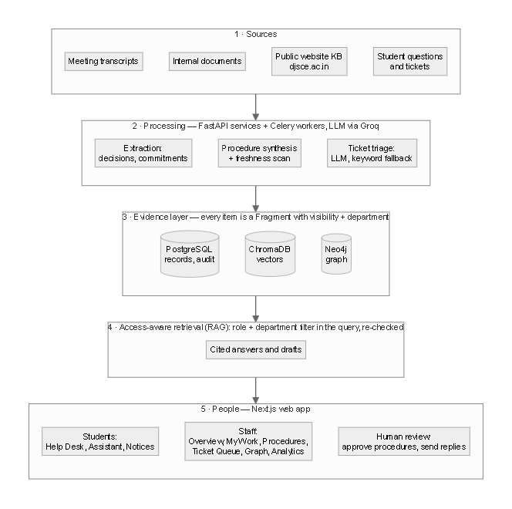
Figure 5.1: Layered system architecture
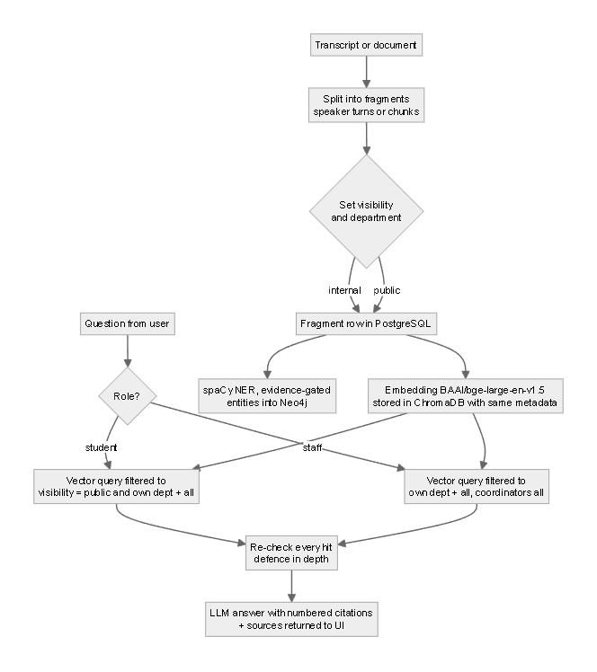
Figure 5.2: Evidence pipeline and access-aware retrieval
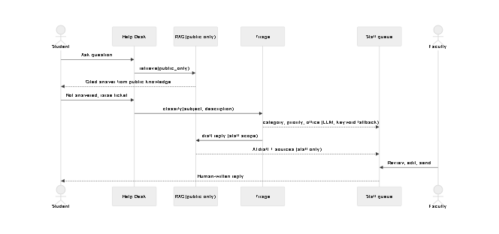
Figure 5.3: Help-desk sequence (student → triage → faculty reply)
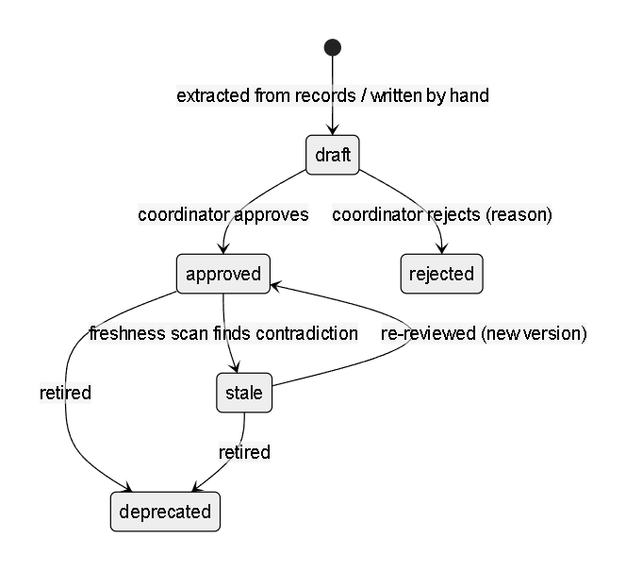
Figure 5.4: Procedure (skill) lifecycle
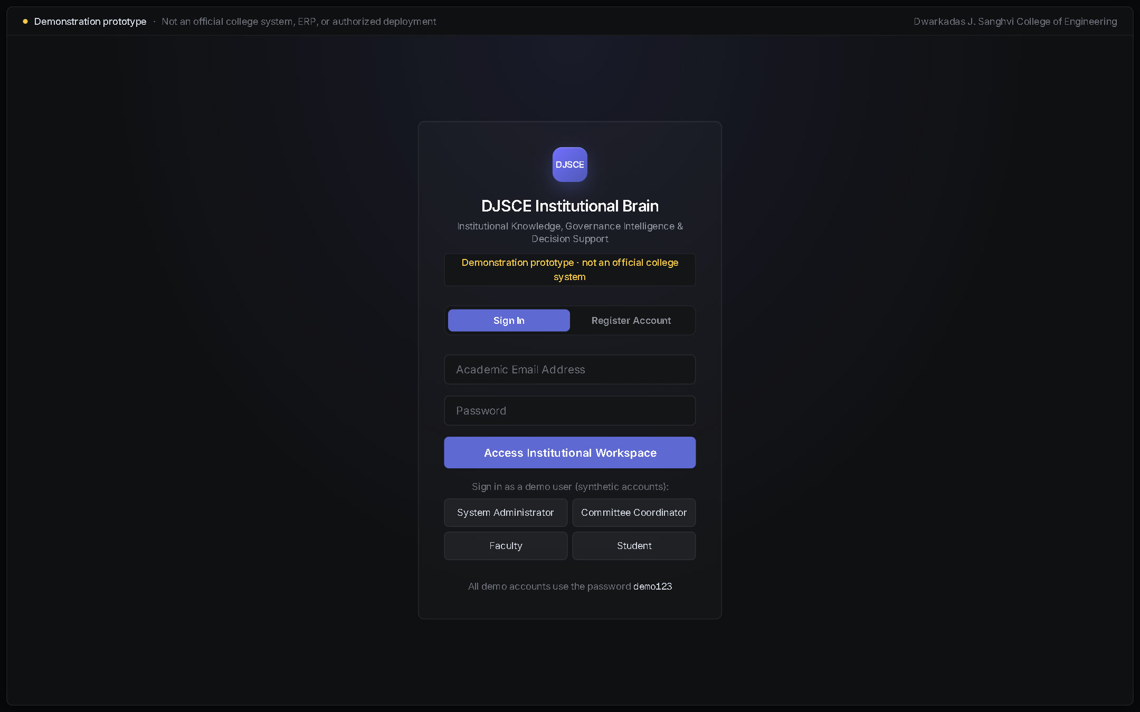
Figure 6.1: Sign-in page with demo-prototype notice
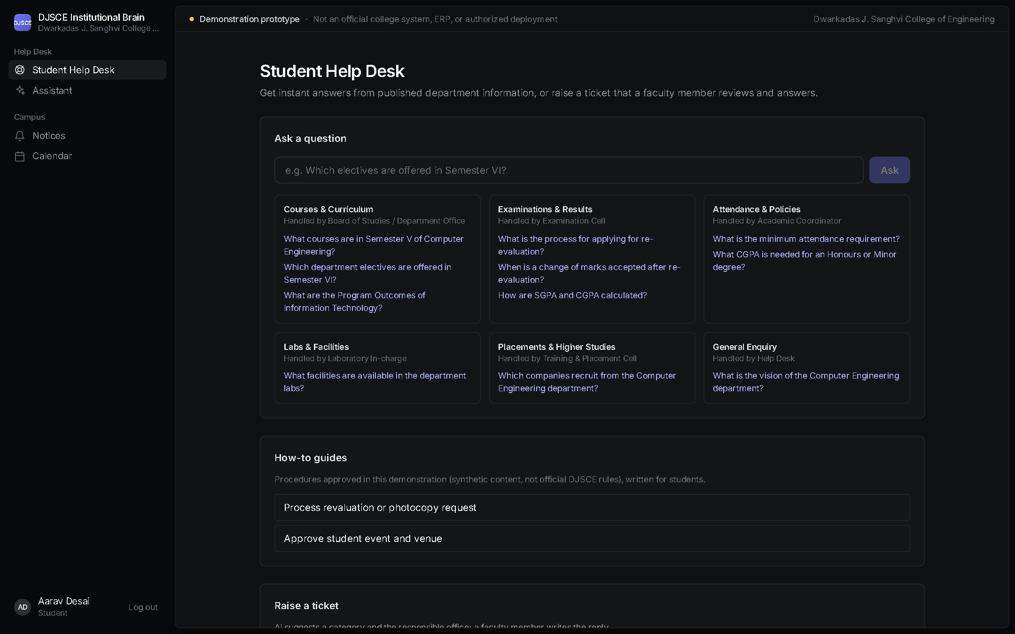
Figure 6.2: Student Help Desk
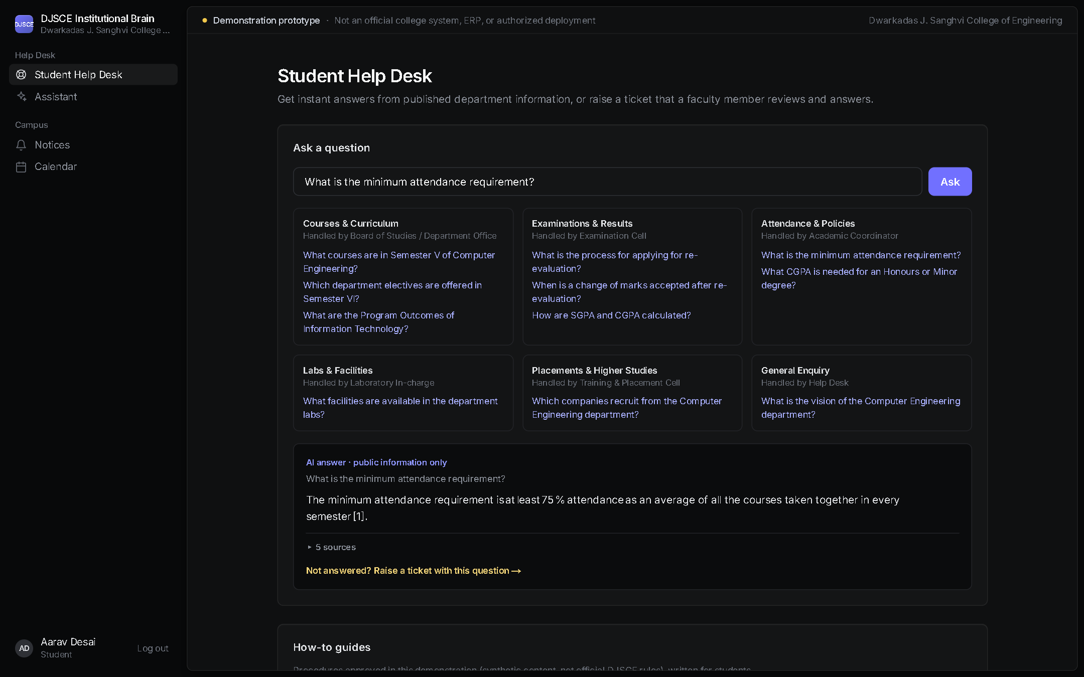
Figure 6.3: Student answer from public information, with sources
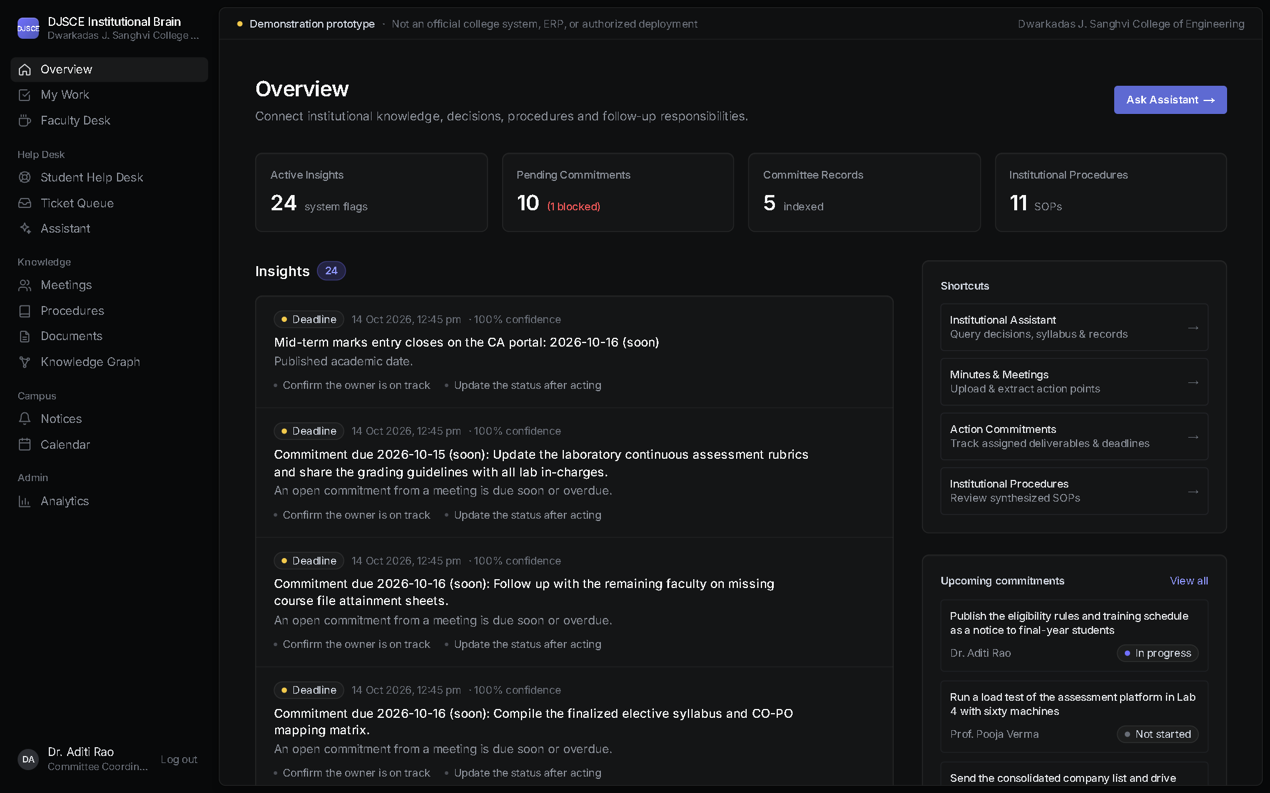
Figure 6.4: Staff overview: insights and upcoming commitments
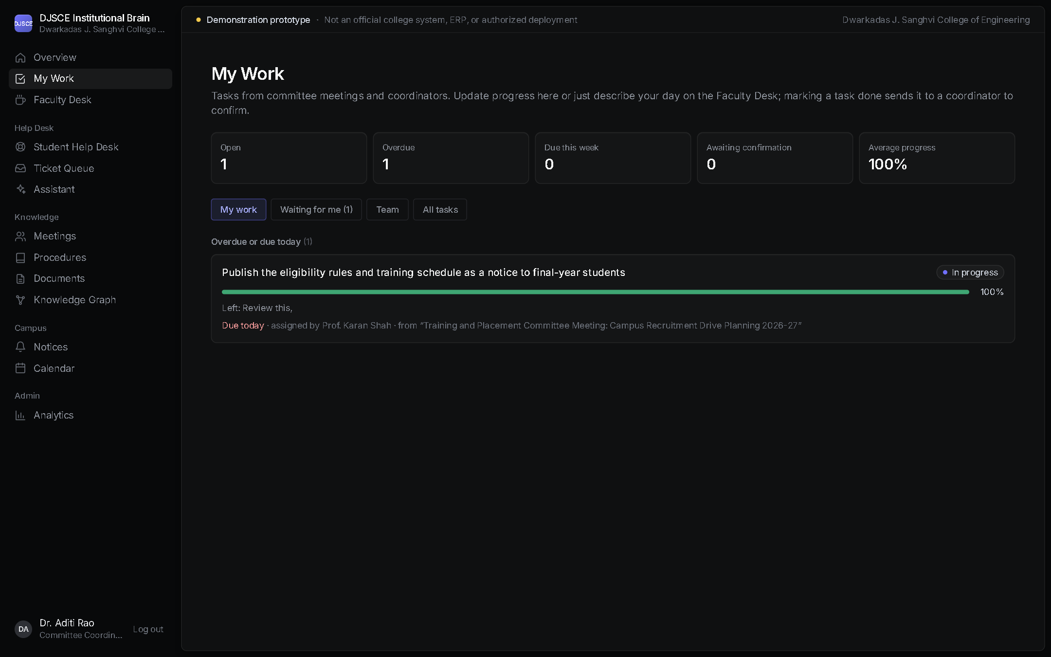
Figure 6.5: My Work: commitment with progress and due date
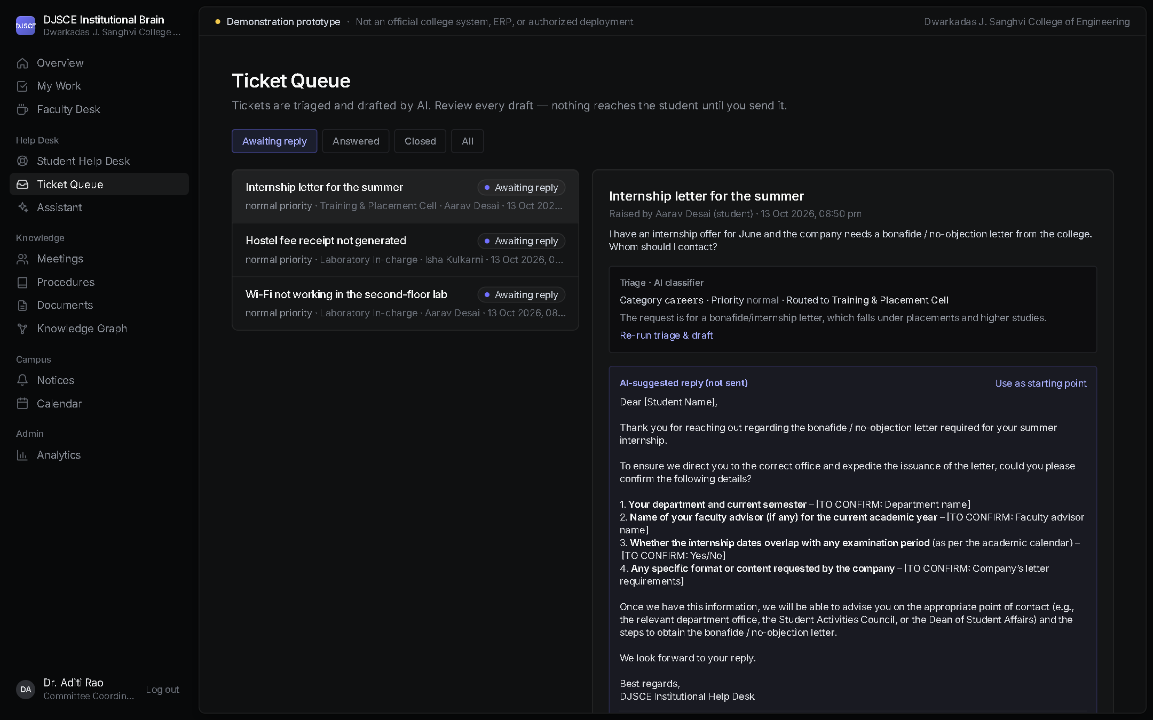
Figure 6.6: Ticket review: AI triage and unsent AI draft
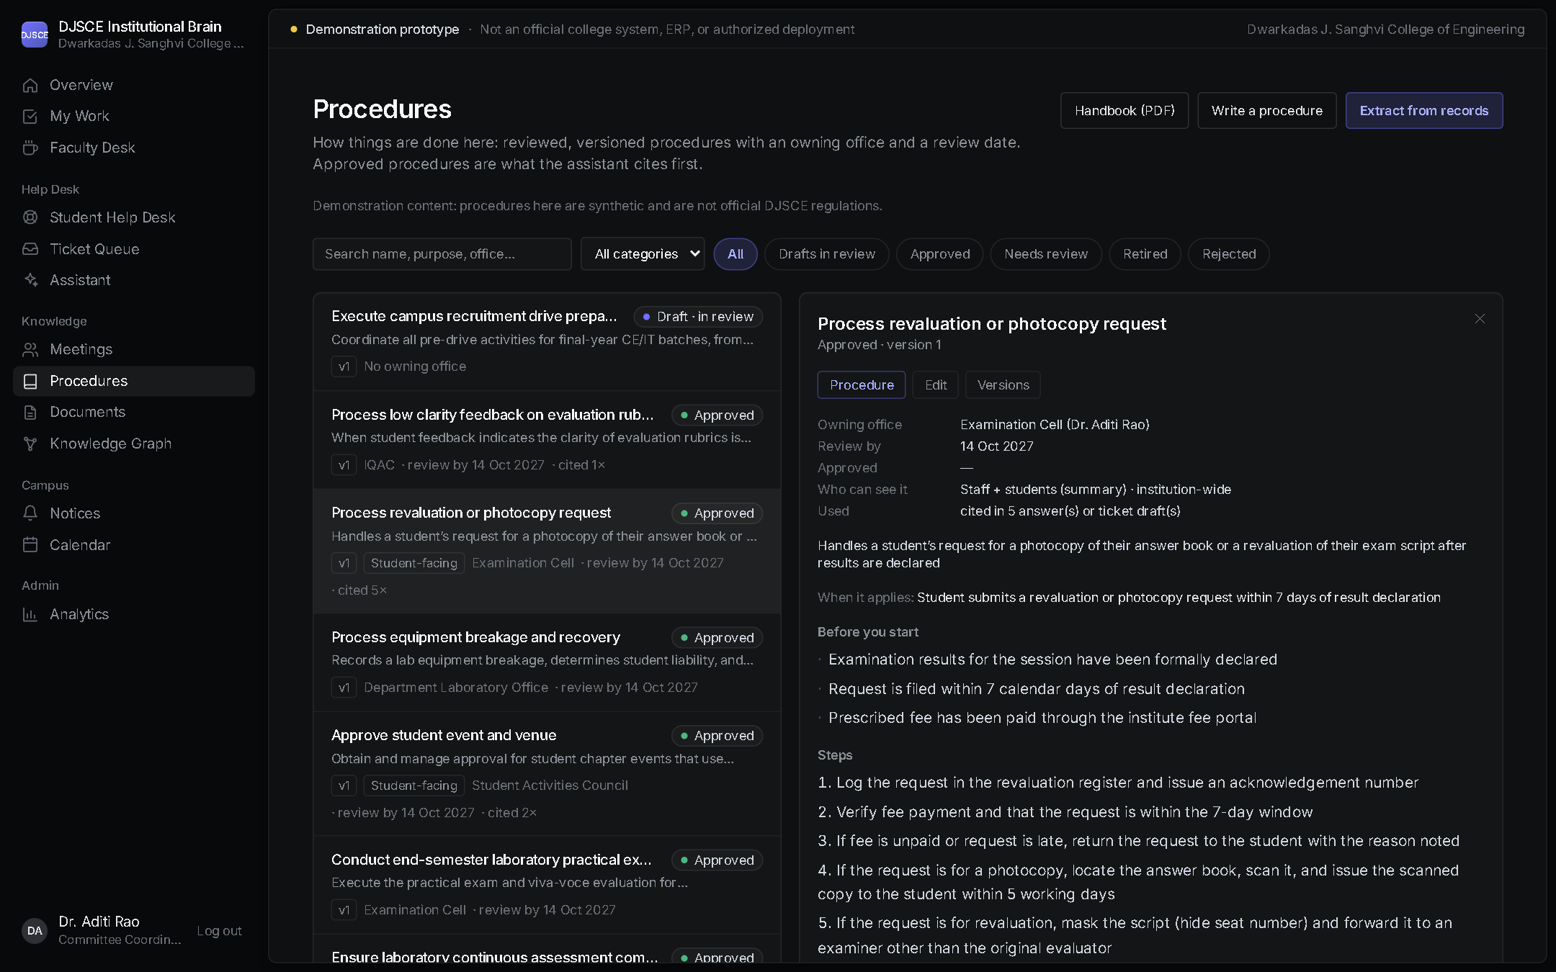
Figure 6.7: Procedure with owner, review date and steps
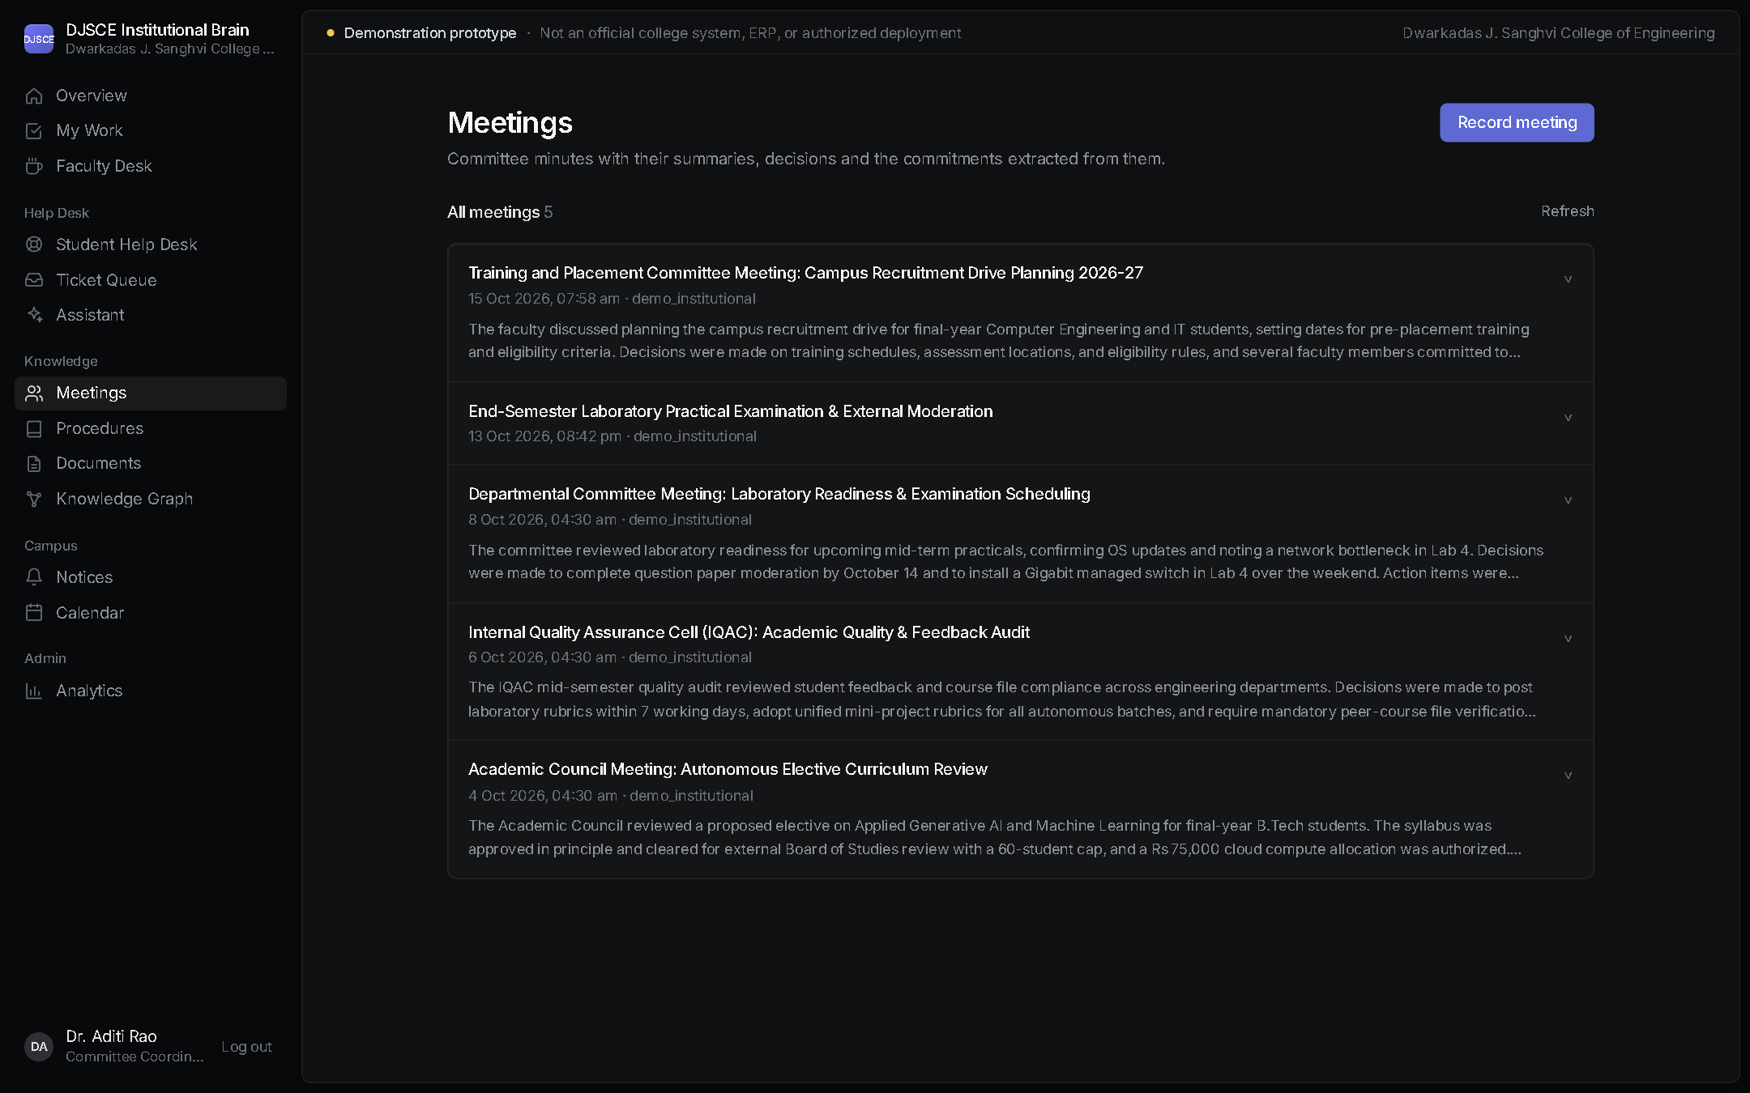
Figure 6.8: Meetings list
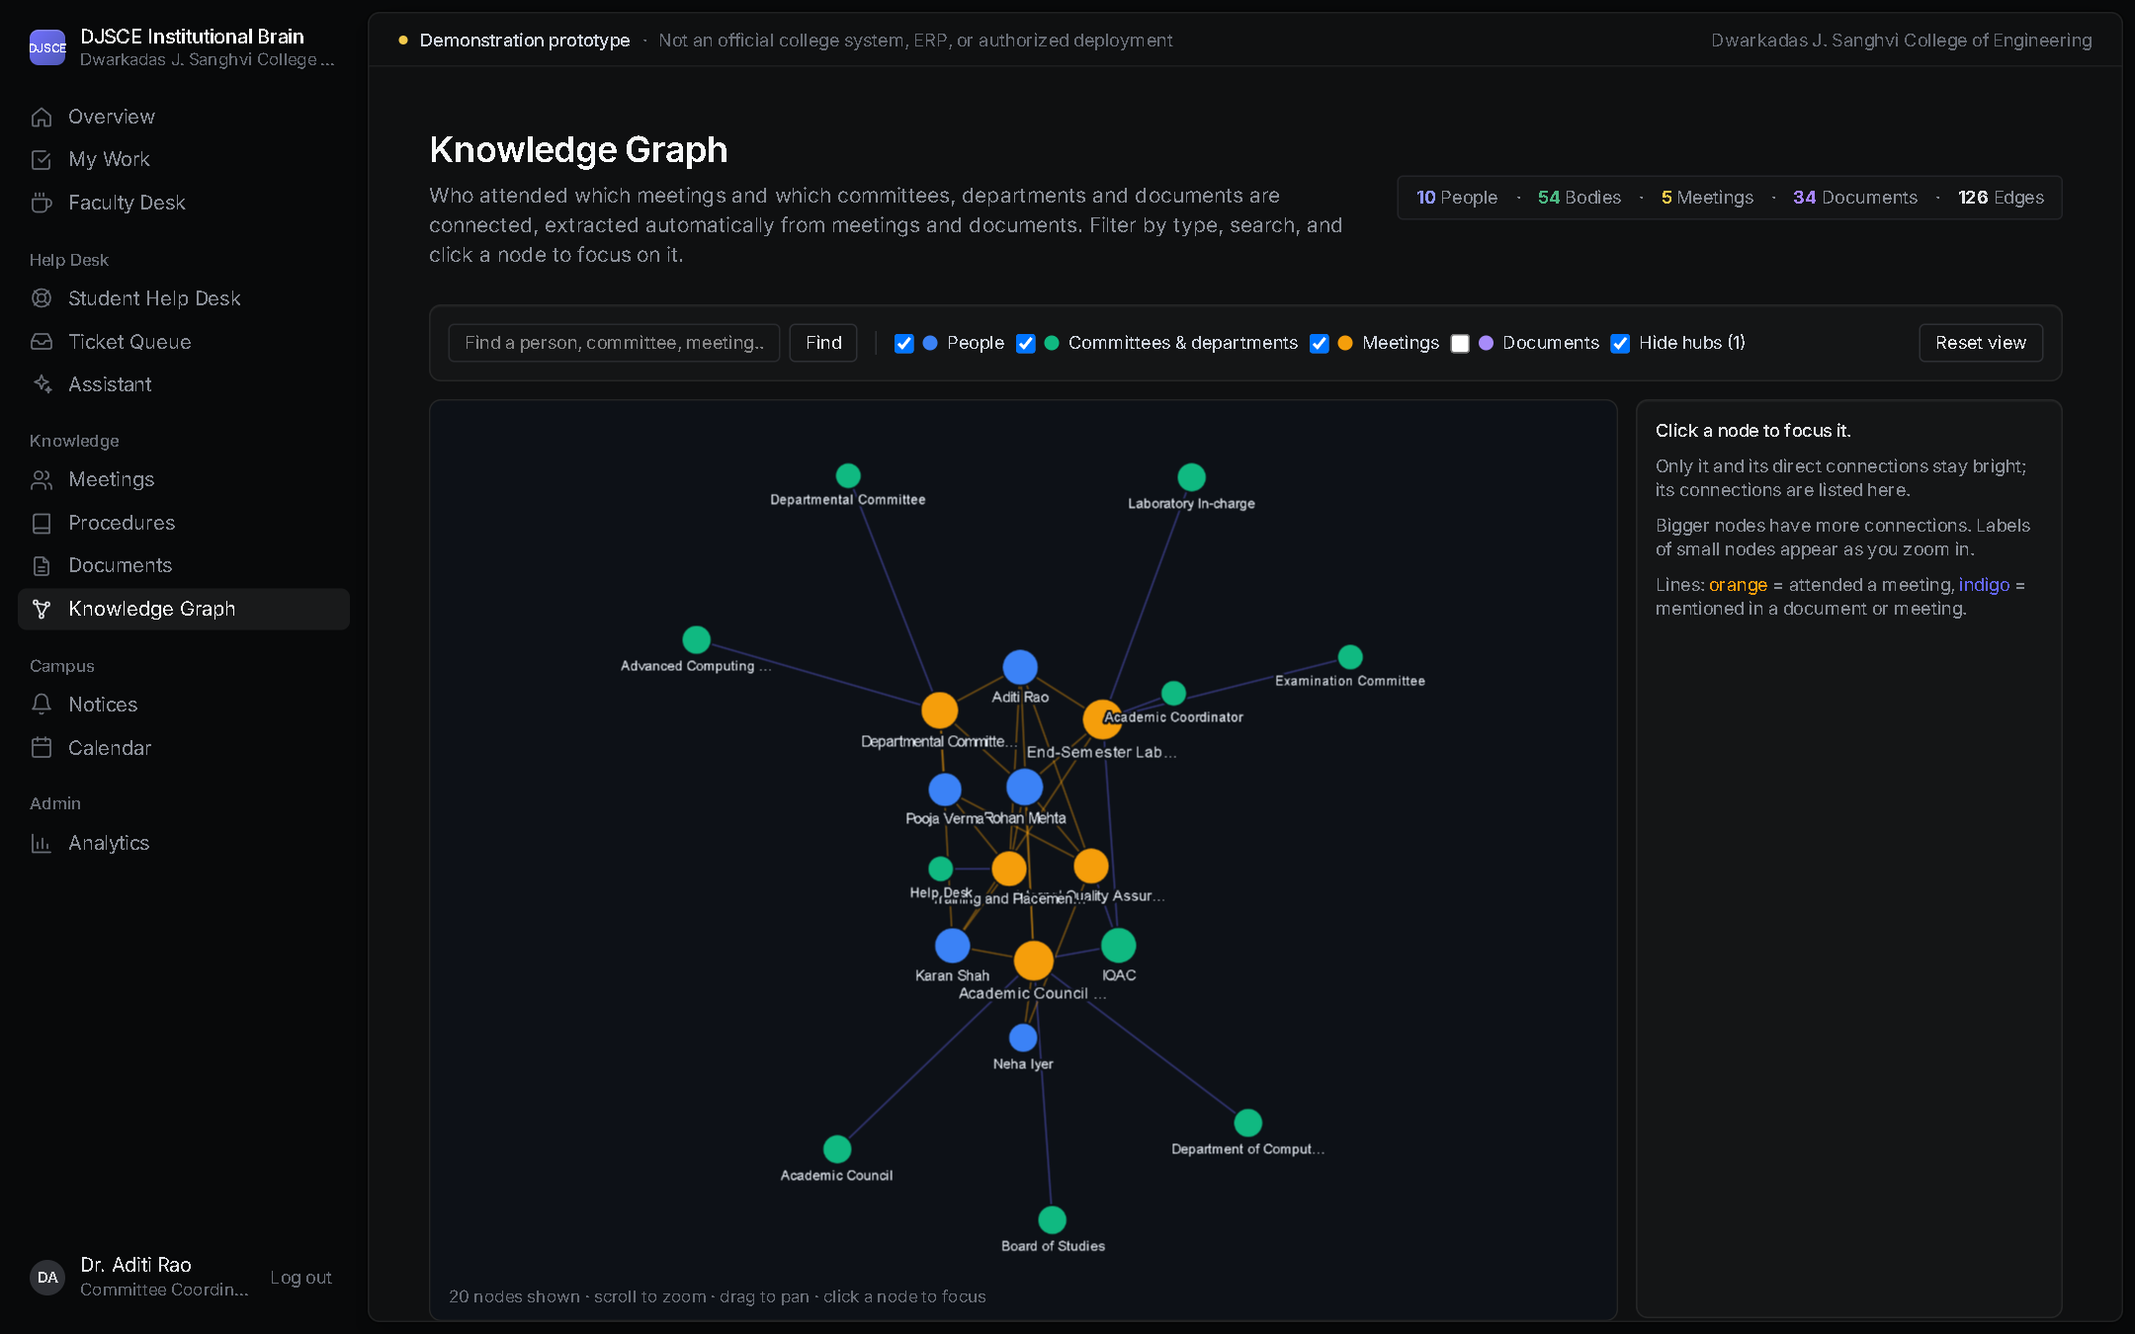
Figure 6.9: Knowledge graph
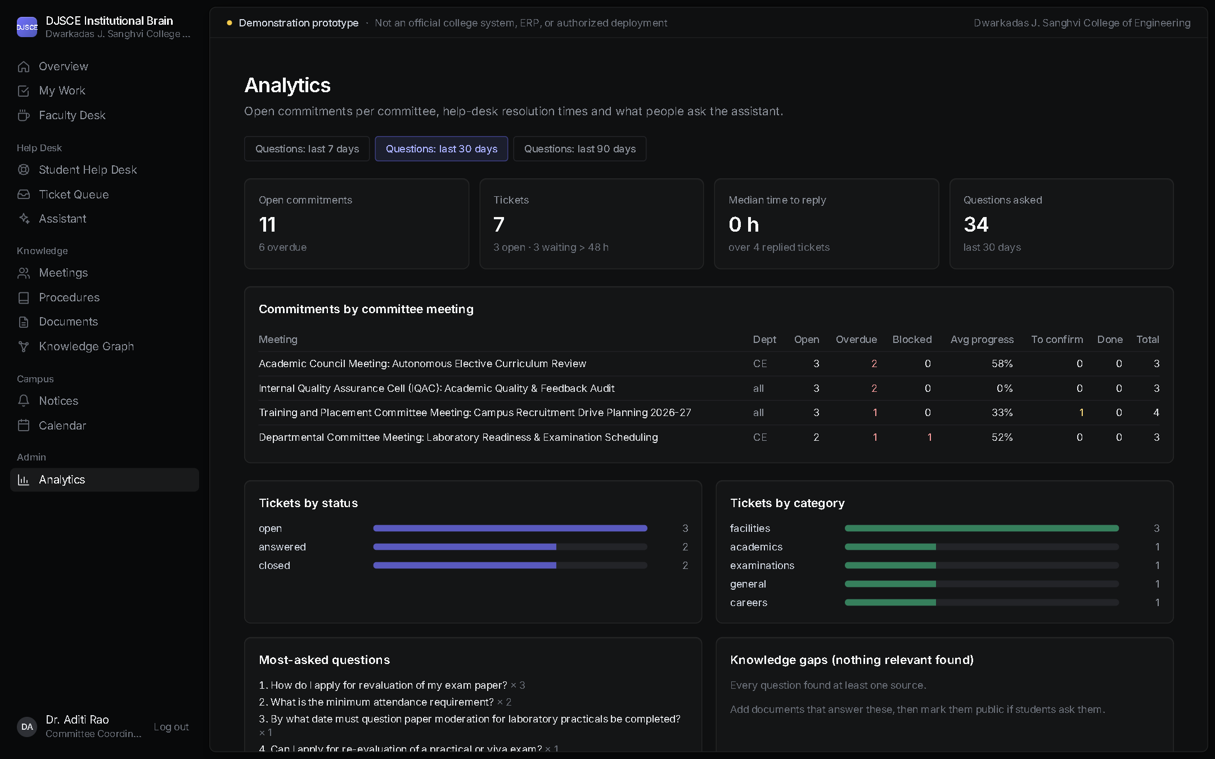
Figure 6.10: Analytics
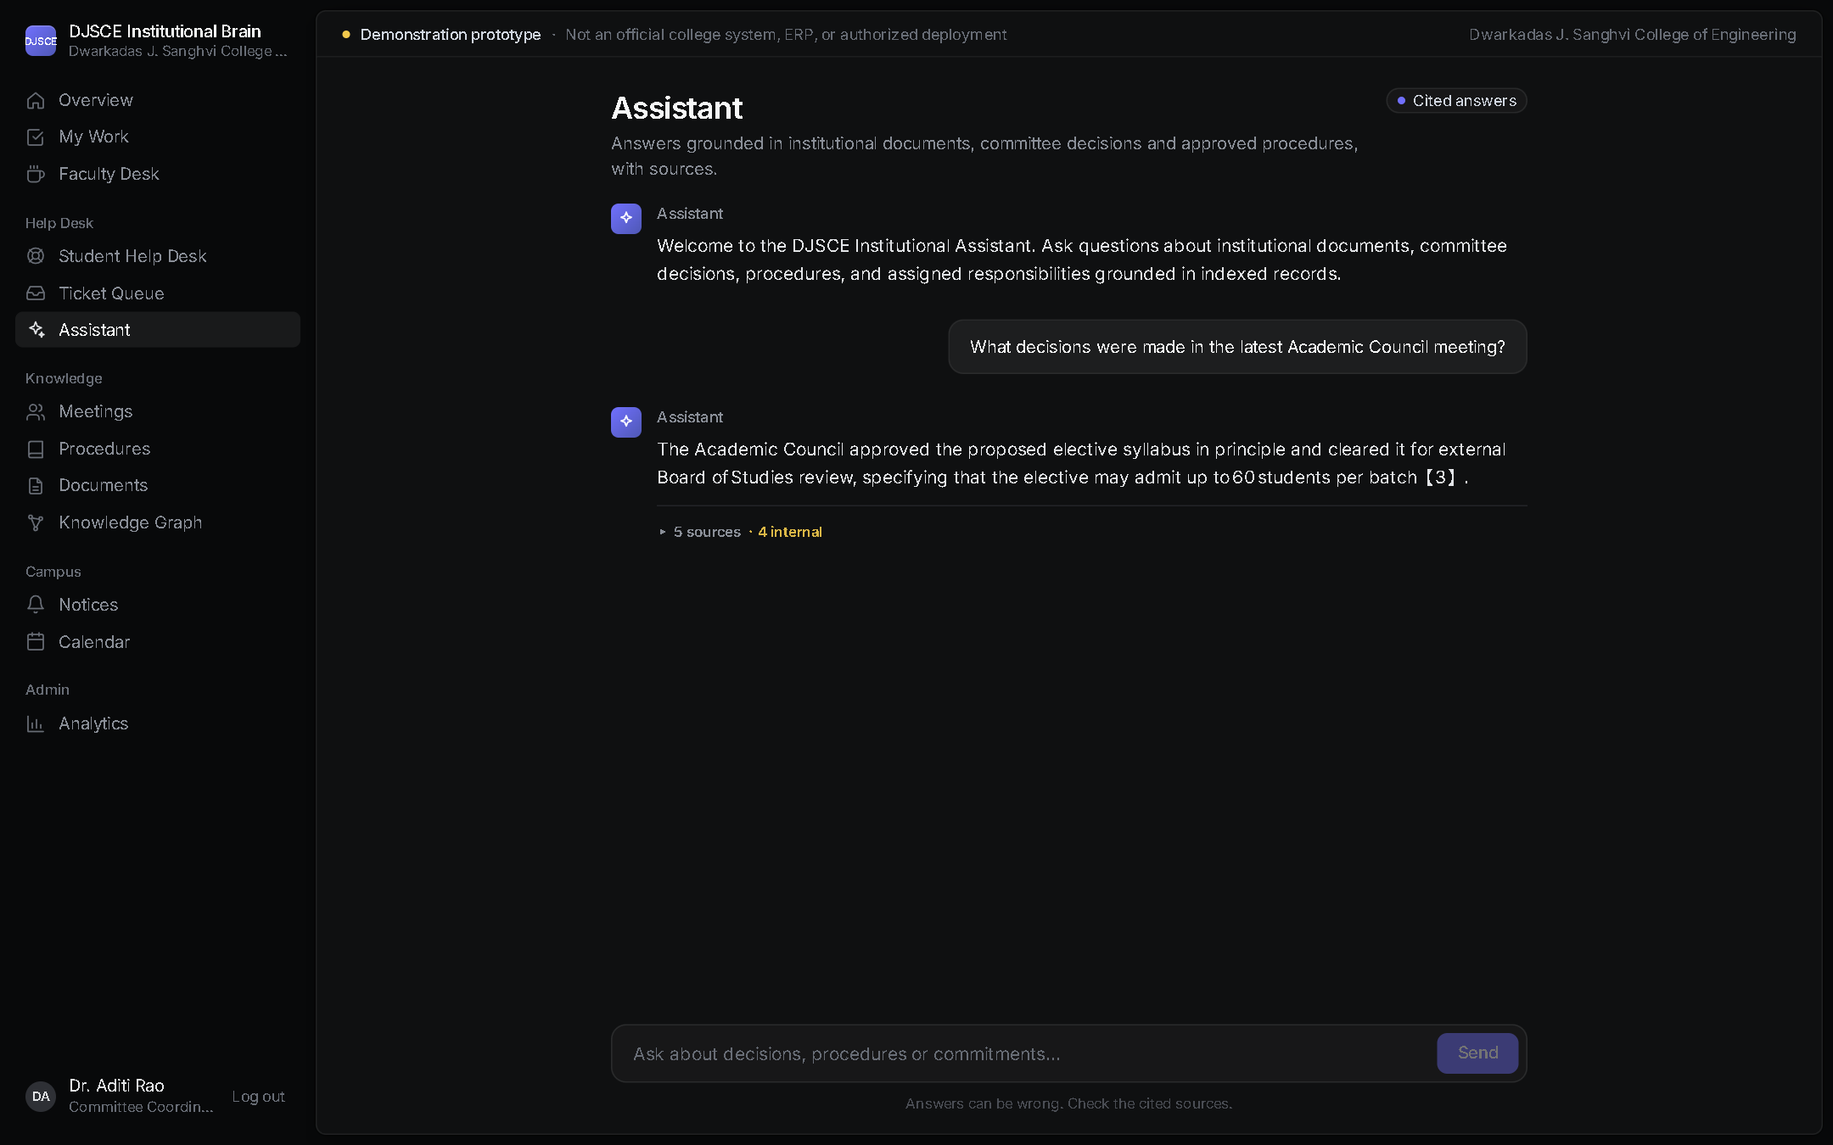
Figure 6.11: Staff assistant answer with citations
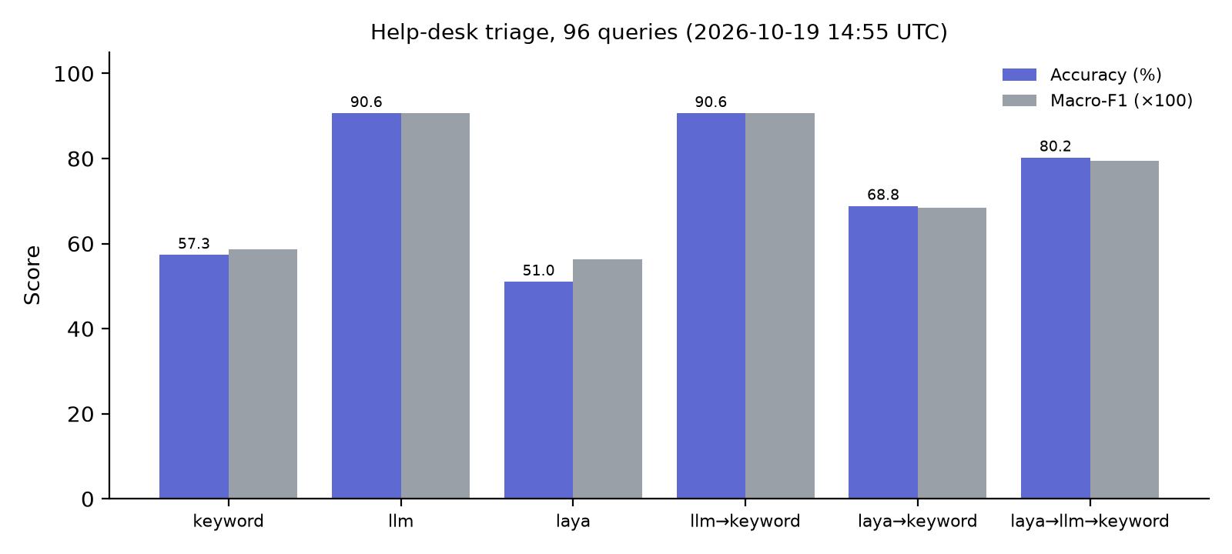
Figure 7.1: Triage accuracy by engine

Appendix: References
Every entry below was checked against the publisher, ACL Anthology, arXiv or an institutional repository on 19 Oct 2026. Numbers follow order of first citation in REPORT_DRAFT.md. Where a field could not be confirmed (page range, final issue), it is left out rather than guessed.
[1] P. Lewis, E. Perez, A. Piktus, F. Petroni, V. Karpukhin, N. Goyal, H. Küttler, M. Lewis, W. Yih, T. Rocktäschel, S. Riedel, and D. Kiela, “Retrieval-augmented generation for knowledge-intensive NLP tasks,” in Advances in Neural Information Processing Systems 33 (NeurIPS), 2020. arXiv:2005.11401.
[2] Y. Gao et al., “Retrieval-augmented generation for large language models: A survey,” arXiv:2312.10997, 2023 (v5, Mar. 2024).
[3] V. Karpukhin, B. Oğuz, S. Min, P. Lewis, L. Wu, S. Edunov, D. Chen, and W. Yih, “Dense passage retrieval for open-domain question answering,” in Proc. EMNLP, 2020, pp. 6769–6781.
[4] N. Reimers and I. Gurevych, “Sentence-BERT: Sentence embeddings using Siamese BERT-networks,” in Proc. EMNLP-IJCNLP, Hong Kong, 2019, pp. 3982–3992, doi: 10.18653/v1/D19-1410.
[5] S. Xiao, Z. Liu, P. Zhang, N. Muennighoff, D. Lian, and J.-Y. Nie, “C-Pack: Packed resources for general Chinese embeddings,” in Proc. 47th Int. ACM SIGIR Conf., 2024. arXiv:2309.07597. (Source of the BGE embedding models used here.)
[6] T. Gao, H. Yen, J. Yu, and D. Chen, “Enabling large language models to generate text with citations,” in Proc. EMNLP, 2023, pp. 6465–6488.
[7] S. Es, J. James, L. Espinosa-Anke, and S. Schockaert, “RAGAs: Automated evaluation of retrieval augmented generation,” in Proc. 18th Conf. EACL: System Demonstrations, St. Julian’s, Malta, 2024, pp. 150–158.
[8] Z. Ji, N. Lee, R. Frieske, T. Yu, D. Su, Y. Xu, E. Ishii, Y. Bang, A. Madotto, and P. Fung, “Survey of hallucination in natural language generation,” ACM Computing Surveys, vol. 55, no. 12, Art. 248, pp. 1–38, 2023.
[9] L. Huang et al., “A survey on hallucination in large language models: Principles, taxonomy, challenges, and open questions,” ACM Transactions on Information Systems, doi: 10.1145/3703155. arXiv:2311.05232.
[10] M. Purver, J. Dowding, J. Niekrasz, P. Ehlen, S. Noorbaloochi, and S. Peters, “Detecting and summarizing action items in multi-party dialogue,” in Proc. 8th SIGdial Workshop on Discourse and Dialogue, Antwerp, Belgium, 2007, pp. 18–25.
[11] M. Zhong et al., “QMSum: A new benchmark for query-based multi-domain meeting summarization,” in Proc. NAACL-HLT, 2021, pp. 5905–5921, doi: 10.18653/v1/2021.naacl-main.472.
[12] S. Zeng, J. Zhang et al., “The good and the bad: Exploring privacy issues in retrieval-augmented generation (RAG),” in Findings of ACL 2024, Bangkok, 2024, pp. 4505–4524, doi: 10.18653/v1/2024.findings-acl.267.
[13] K. Greshake, S. Abdelnabi, S. Mishra, C. Endres, T. Holz, and M. Fritz, “Not what you’ve signed up for: Compromising real-world LLM-integrated applications with indirect prompt injection,” in Proc. 16th ACM Workshop on Artificial Intelligence and Security (AISec ’23), 2023. arXiv:2302.12173.
[14] R. S. Sandhu, E. J. Coyne, H. L. Feinstein, and C. E. Youman, “Role-based access control models,” IEEE Computer, vol. 29, no. 2, pp. 38–47, Feb. 1996.
[15] A. Revina, K. Buza, and V. G. Meister, “IT ticket classification: The simpler, the better,” IEEE Access, 2020. Available: TU Berlin DepositOnce repository.
[16] F. Zangari, M. Marcuzzo, M. Schiavinato, A. Gasparetto, and A. Albarelli, “Ticket automation: An insight into current research with applications to multi-level classification scenarios,” Expert Systems with Applications, vol. 225, Art. 119984, 2023, doi: 10.1016/j.eswa.2023.119984.
[17] A. Hogan et al., “Knowledge graphs,” ACM Computing Surveys, vol. 54, no. 4, Art. 71, pp. 1–37, 2021, doi: 10.1145/3447772.
[18] D. Edge et al., “From local to global: A graph RAG approach to query-focused summarization,” arXiv:2404.16130, 2024.
[19] C. W. Okonkwo and A. Ade-Ibijola, “Chatbots applications in education: A systematic review,” Computers and Education: Artificial Intelligence, vol. 2, Art. 100033, 2021, doi: 10.1016/j.caeai.2021.100033.
[20] S. Wollny, J. Schneider, D. Di Mitri, J. Weidlich, M. Rittberger, and H. Drachsler, “Are we there yet? — A systematic literature review on chatbots in education,” Frontiers in Artificial Intelligence, vol. 4, Art. 654924, 2021, doi: 10.3389/frai.2021.654924.

Data and software sources
[21] Dwarkadas J. Sanghvi College of Engineering, public website, https://www.djsce.ac.in (pages listed per file in djsce_public_data/kb/), retrieved 13 Oct 2026.

