AI-Enhanced User Security for Application
Access using Zscaler Private Access (ZPA)

S.no | Name | College | Contact Details
1 | Vive Divina J | Sri Krishna Adithya College of Arts & Science | 23bscs164vivedivinaj@skacas.ac.in
2 | Shreeja G | Sri Krishna Adithya College of Arts & Science | 23bscs152shreejag@skacas.ac.in
3 | Vijay G | Sri Krishna Adithya College of Arts & Science | 23bscs160vijayg@skacas.ac.in
4 | Vasumathi P | Sri Krishna Adithya College of Arts & Science | 23bscs159vasumathip@skacas.ac.in
List Of Members:

Project Title

Title: AI Enhanced User Security For Application Access Using Zscaler Private Access (ZPA)

In today’s rapidly evolving digital environment, organizations are increasingly dependent on cloud applications and remote access technologies to support their workforce. However, this growing digital transformation has also increased the risk of cyber threats, unauthorized access, and data breaches. Ensuring secure access to enterprise applications while maintaining user productivity has therefore become a critical challenge. To address these concerns, this project proposes an AI-Enhanced User Security framework for application access using Zscaler Private Access (ZPA), which combines artificial intelligence with Zero Trust security principles to strengthen modern access control mechanisms.
Traditional remote access solutions such as Virtual Private Networks (VPNs) often provide broad network-level access once a user is authenticated. This approach creates security vulnerabilities, allowing attackers to potentially move laterally within the network if credentials are compromised. To overcome these limitations, this project adopts a Zero Trust security architecture, which operates on the principle of “never trust, always verify.” Instead of granting full network access, the system verifies user identity, device status, and contextual factors before allowing access to specific applications.
The core component of this system is Zscaler Private Access (ZPA), a cloud-based Zero Trust access platform that enables secure, application-level connectivity between users and enterprise applications. Unlike traditional VPN models, ZPA creates direct and secure connections between authenticated users and the applications they are authorized to use, without exposing the internal network to the internet. This approach significantly reduces the attack surface and protects applications from threats such as unauthorized scanning, lateral movement, and distributed denial-of-service (DDoS) attacks.
To further enhance security, the proposed system integrates Artificial Intelligence (AI) to analyze user behavior, login patterns, device information, and access context. The AI component can detect unusual or suspicious activities, such as abnormal login locations, unexpected access times, or unusual application usage patterns. When such anomalies are detected, the system can trigger additional verification steps or restrict access, thereby preventing potential security breaches.
Ultimately, this project aims to implement a least-privilege access model, where users are granted only the minimum level of access required to perform their tasks. By combining AI-driven user behavior analysis with ZPA’s secure application access framework, the system strengthens enterprise security, improves threat detection, and simplifies remote access management. This approach not only enhances protection for critical applications and sensitive data but also ensures a seamless and secure user experience in modern enterprise environments.

ABSTRACT:

The rapid adoption of hybrid work environments and cloud-based enterprise applications has exposed the limitations of traditional perimeter-based security solutions such as Virtual Private Networks (VPNs). These legacy models often grant excessive network-level access once a user is authenticated, increasing the risk of unauthorized access, credential misuse, and lateral movement within the network. This project addresses these security challenges by implementing an AI-Enhanced User Security framework for application access using Zscaler Private Access (ZPA). The primary objective is to strengthen access control by combining Zero Trust Architecture (ZTA) with Artificial Intelligence–based user behavior analysis, thereby enforcing secure and context-aware access to enterprise applications.
The methodology focuses on deploying Zscaler Private Access (ZPA) as a cloud-based Zero Trust solution that enables secure, identity-aware connections between users and specific applications. Instead of placing users directly on the internal corporate network, ZPA establishes application-specific, encrypted micro-tunnels that connect authenticated users only to the applications they are authorized to access. To further enhance security, an AI-driven analysis layer monitors user behavior, login patterns, device posture, and contextual attributes such as location and access time. By continuously analyzing these parameters, the AI component can identify anomalies or suspicious activities and trigger additional verification or access restrictions when necessary.
Through this approach, application access becomes identity-centric and context-aware, ensuring that users receive only the minimum level of access required to perform their tasks. Unauthorized users cannot discover or interact with internal applications because the network infrastructure and services remain invisible to them. This effectively reduces the potential attack surface and prevents common threats such as unauthorized access attempts, reconnaissance activities, and lateral movement within the network.
The implementation of this AI-enhanced ZPA framework successfully strengthens organizational security while maintaining seamless user access to required applications. By integrating intelligent monitoring with Zero Trust principles, the system provides a scalable, efficient, and secure application access model for modern enterprises. Ultimately, this project demonstrates how combining AI-driven security analysis with Zero Trust access technologies can significantly improve threat detection, enforce least-privilege access, and enhance the overall cybersecurity posture of organizations operating in a dynamic digital environment.

Use Case Scenarios

Scenario 1: Finance Department Access to ERP System
A finance department employee needs to access the company's ERP system to manage payroll and financial records. The employee logs in using the ZPA Client Connector from a company-managed laptop. After authentication through the identity provider with multi-factor authentication (MFA), the AI security module analyzes the user’s behavior patterns such as login time, device fingerprint, and access history.
Since the user’s behavior matches normal patterns and the device meets security compliance requirements (updated OS, active antivirus), ZPA establishes a secure application-specific micro-tunnel between the user and the ERP system. The user is able to access the ERP application securely without gaining visibility into other internal applications or network resources.
Output:
- AI verifies normal user behavior and device compliance
- Secure micro-tunnel established to ERP application only
- Other internal systems remain hidden and inaccessible

Scenario 2: Suspicious Login Detection by AI
A user attempts to access a corporate document management system from an unfamiliar location and device. The AI module detects that the login location, device ID, and access time differ significantly from the user's usual patterns.
Based on the anomaly detection, the system triggers additional authentication requirements such as biometric verification or one-time password validation. If the verification fails or suspicious activity continues, ZPA blocks the access request and logs the incident for security monitoring.
Output:
- AI detects abnormal login behavior
- Additional verification triggered automatically
- Unauthorized access attempt blocked and logged

Scenario 3: Contractor Access to Development Repository
An external contractor requires temporary access to a development repository for a specific project. The contractor is assigned to a restricted access group within the organization’s identity management system.
When the contractor logs in using the ZPA client, AI analyzes login behavior and device posture while ZPA verifies user identity and role. The system allows access only to the designated repository application during approved working hours.
Output:
- AI monitors contractor activity patterns
- Access restricted to a single project repository
- Network-level visibility completely blocked

Scenario 4: Executive Access to Confidential Reports
A company executive needs to access confidential financial reports stored on an internal server while traveling. The executive connects using a tablet device. The AI module verifies user behavior patterns and confirms that the access request matches the executive's historical activity profile.
ZPA checks the device posture through mobile device management (MDM) compliance and ensures encryption and passcode protection are enabled. After validation, a secure connection is established to the specific application hosting the reports.
Output:
- AI verifies trusted user behavior
- Secure encrypted connection to confidential documents
- Access limited only to authorized data resources

Scenario 5: AI-Based Insider Threat Detection
An employee suddenly attempts to access multiple sensitive applications that are not part of their normal job role. The AI monitoring system detects abnormal application access patterns and flags the behavior as suspicious.
ZPA immediately enforces strict policy controls, restricting further access attempts and alerting the security team for investigation.
Output:
- AI identifies unusual access behavior
- Suspicious activity automatically restricted
- Security team notified for incident response

Stage – 1

Title:
AI-Enhanced User Security for Application Access using Zscaler Private Access (ZPA)
Overview:
With the rapid growth of cloud computing, remote work, and digital transformation, organizations face increasing cybersecurity threats and unauthorized access risks. Traditional security solutions such as VPN-based remote access often provide broad network-level access once a user is authenticated, which can expose internal systems to attacks and enable lateral movement within the network. To overcome these limitations, this project proposes AI-Enhanced User Security for Application Access using Zscaler Private Access (ZPA). The solution follows the Zero Trust Architecture (ZTA) principle of “never trust, always verify,” where access decisions are based on continuous verification of user identity, device security posture, and contextual factors rather than network location alone.
The system leverages Zscaler Private Access (ZPA) to establish secure, application-specific connections between users and authorized enterprise applications without exposing the internal network. Additionally, an AI-based monitoring mechanism analyzes user behavior, login patterns, and device information to detect anomalies and potential security threats. By combining AI-driven analysis with Zero Trust access control, the project enforces a least-privilege access model, ensuring users can only access the applications necessary for their roles. This approach significantly reduces the attack surface, prevents unauthorized access and lateral movement, and provides a secure, scalable, and efficient framework for modern enterprise application access.

List of Vulnerability:

S. No. | Vulnerability Name | CWE No.
1. | Improper Access Control | 284
2. | Insecure Temporary File | 377
3. | Cleartext Storage of Sensitive Information in a Cookie | 315
4. | Active Debug Code | 489
5. | Unimplemented or Unsupported Feature in UI | 447
6. | Reusing a Nonce, Key Pair in Encryption | 323
7. | Improper Neutralization of Special Elements used in an OS Command (‘OS Command injection’) | 78
8. | Cleartext Storage in a File or on Disk | 313
9. | Improper Certificate Validation | 295
10. | Deserialization of Untrusted Data | 502
11. | Information Loss or Omission | 221
12. | Improper Handling of Insufficient Privileges | 274

Report:
- Vulnerability name: Improper Access Control
CWE: 284
OWASP category: A01:2025 Broken Access Control

Description:
It occurs when a system fails to properly restrict access to resources from unauthorized users. Improper access control allows users to perform actions or access data beyond their intended permissions. This vulnerability happens when authentication or authorization mechanisms are not correctly implemented, allowing attackers to bypass security restrictions and gain unauthorized access to sensitive systems or information.
Business Impact:
Improper access control can allow attackers to access confidential data, modify system settings, or perform actions with higher privileges than intended. From an attacker's perspective, this vulnerability can be exploited to bypass security checks and gain unauthorized access to critical resources. If a privileged user account is compromised, the attacker may perform administrative operations, steal sensitive information, or disrupt system functionality, which can lead to data breaches, financial loss, and damage to the organization's reputation.
- Access the URL
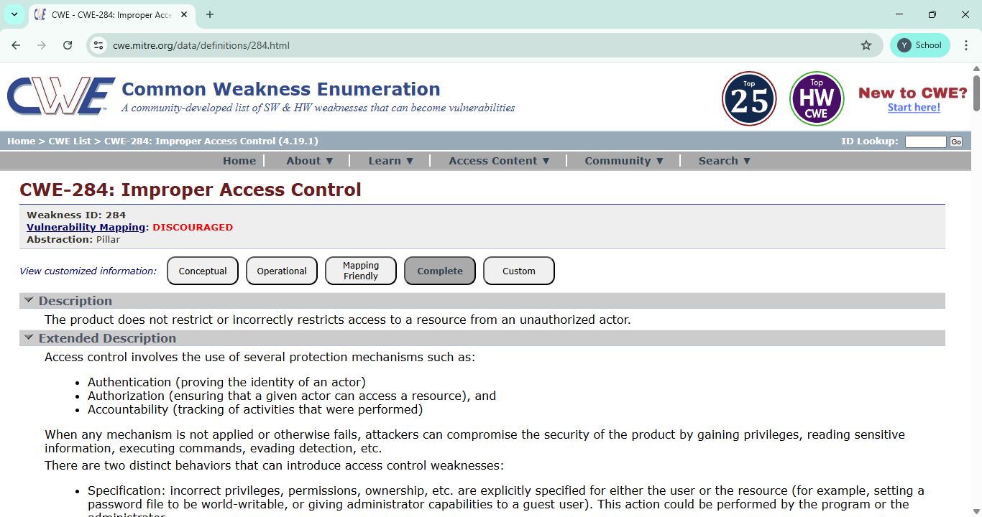
- In the search box we will input some code to perform the vulnerability.

- Vulnerability name: Insecure Temporary File
CWE: 377
OWASP category: A01:2025 Broken Access Control
Description:
This vulnerability occurs when an application creates temporary files in an insecure location or without proper permissions. As a result, unauthorized users may access, modify, or delete these files, which can expose sensitive information or affect system functionality.
Business Impact:
This vulnerability can lead to data exposure, system manipulation, financial loss, and damage to the organization's reputation. It may also cause operational disruption and loss of customer trust.

  - Access the URL

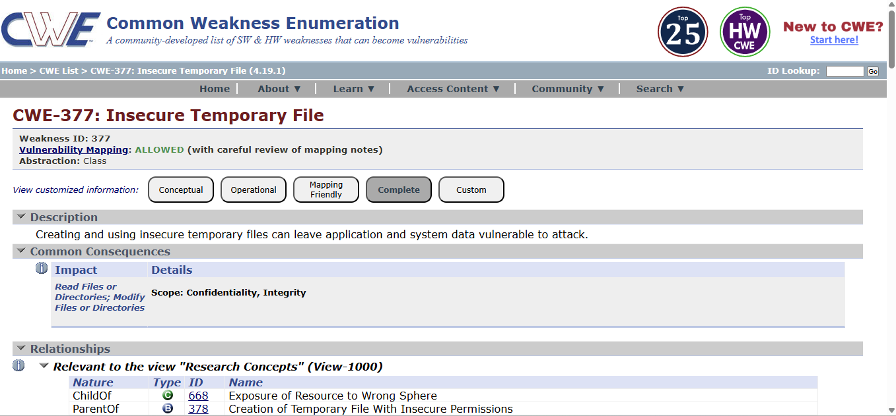
  - Now the home page will be displayed.
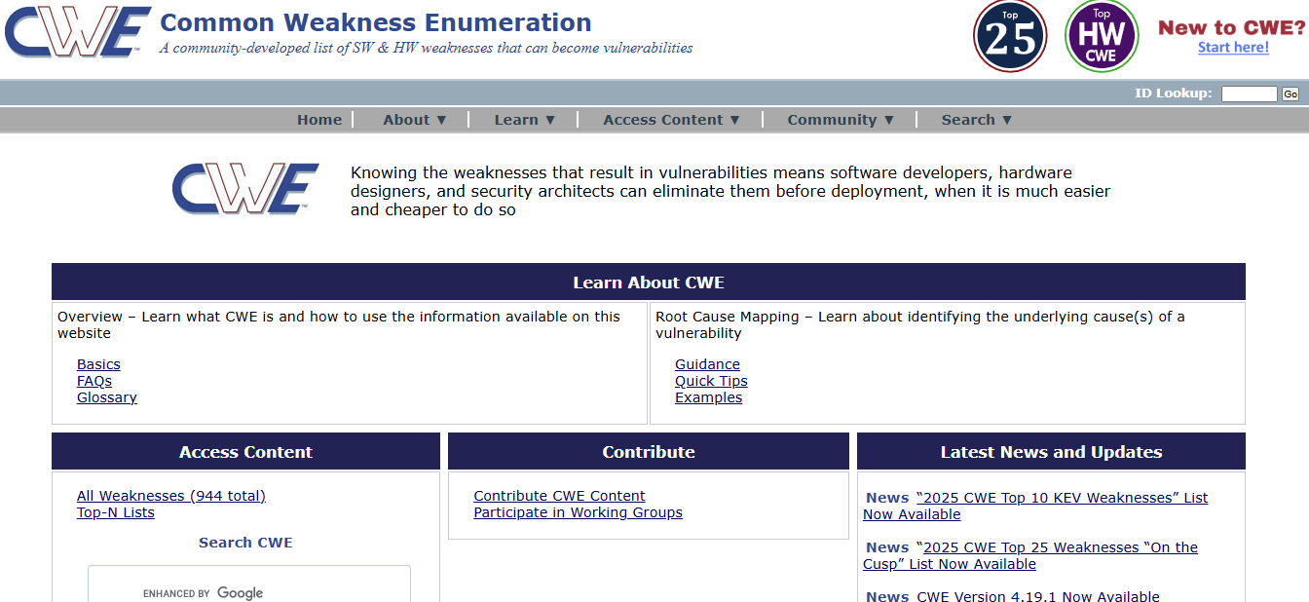
  - Also, the course content is available to access it.
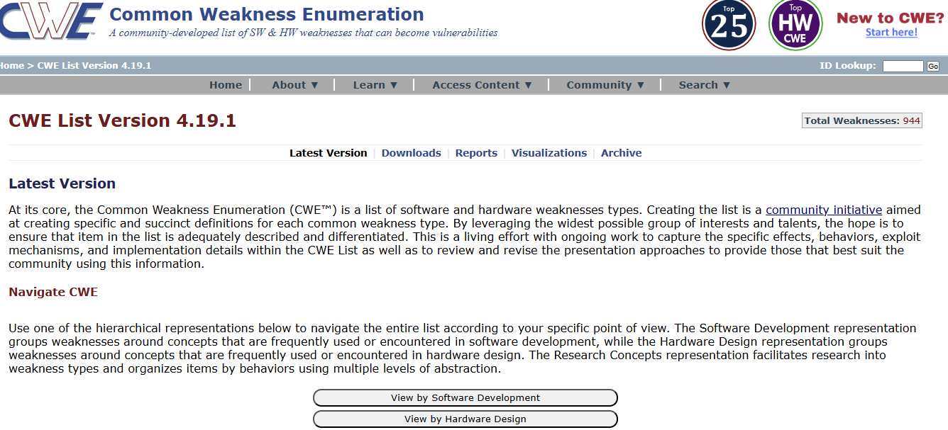

  - The latest news content will be displayed in screen to make it use and also the report will be provided according to it.

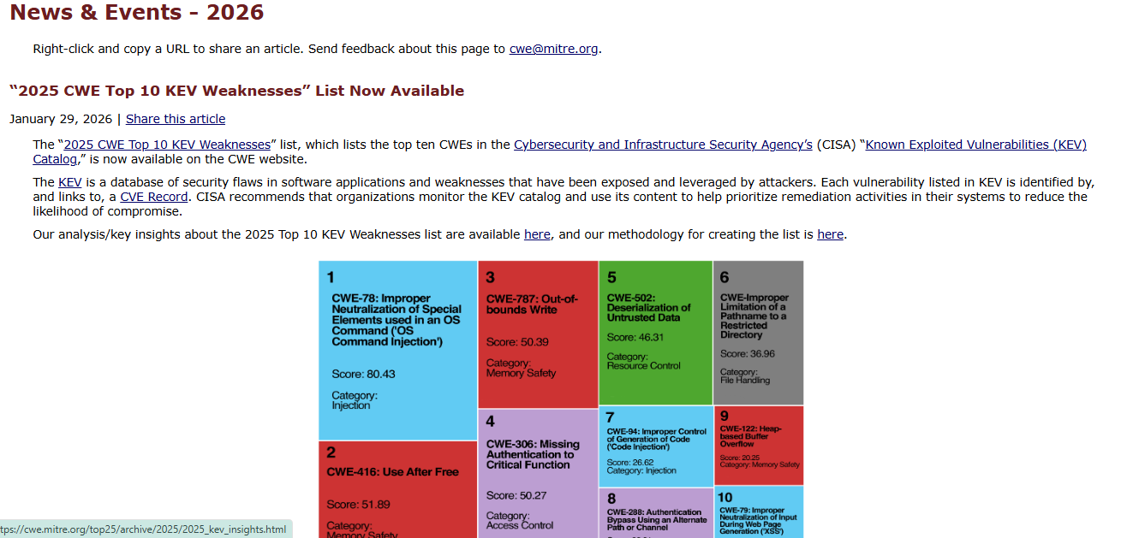

- Vulnerability name: Cleartext Storage of Sensitive Information in a Cookie
CWE: 315
OWASP category: A02:2025 Security Misconfiguration
Description:
This vulnerability occurs when sensitive information such as user credentials, session IDs, or personal data is stored in cookies without proper encryption. Because cookies are stored on the user's browser, attackers may access or intercept this information if it is stored in cleartext.
Business Impact:
This vulnerability can lead to unauthorized access to user accounts, data leakage, and session hijacking. It may result in financial loss, privacy violations, and damage to the organization's reputation.

  - Access the URL
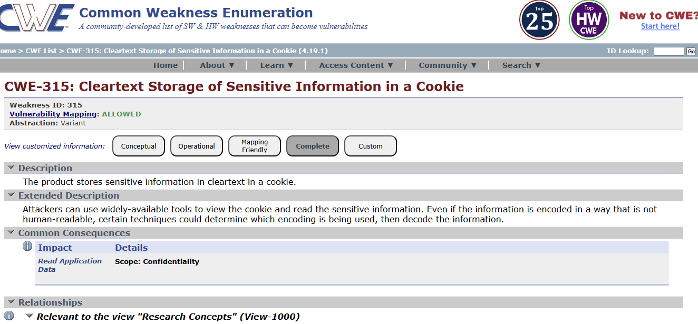
  - Now we will see the software weakness which is used to see the software components.
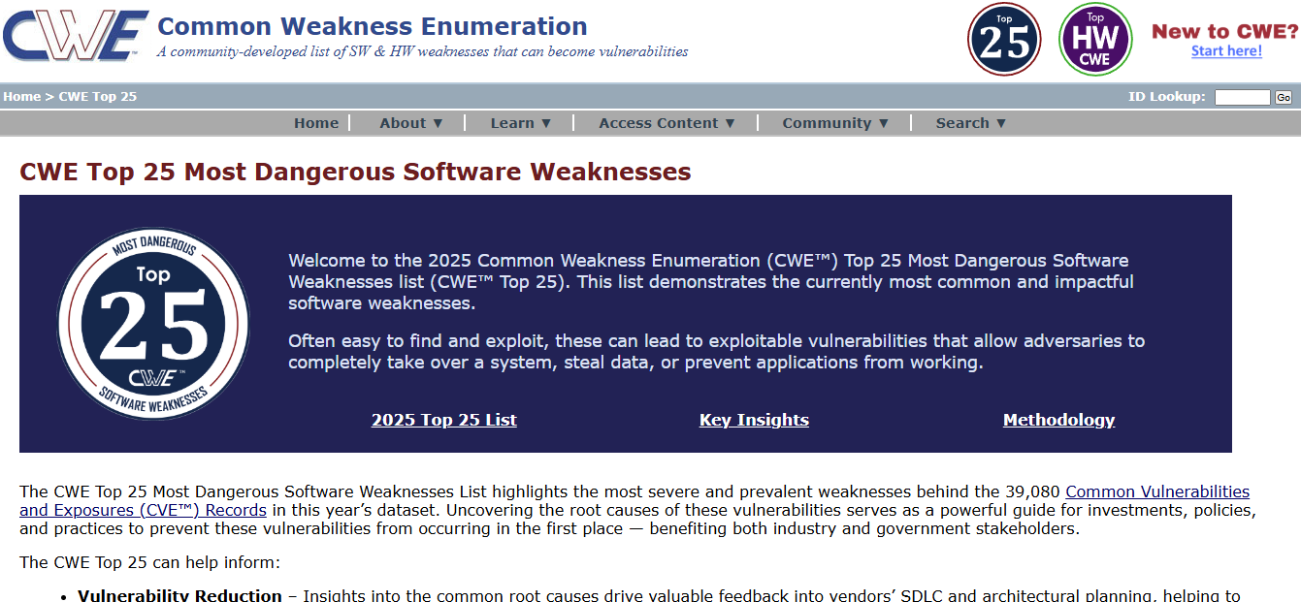

  - Also, here the software components will be open so that we can me the access to it.
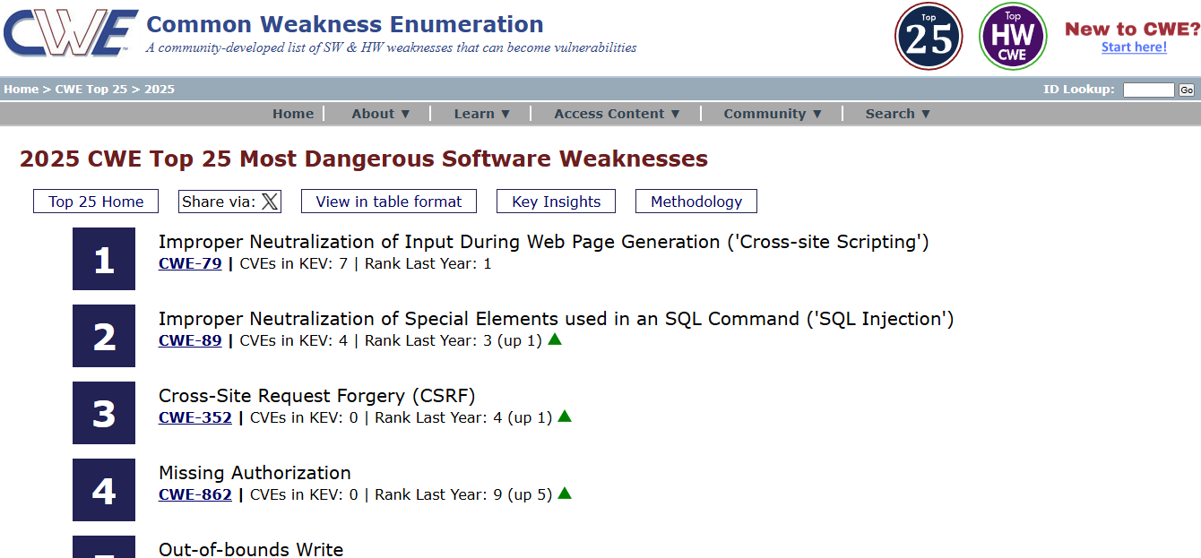

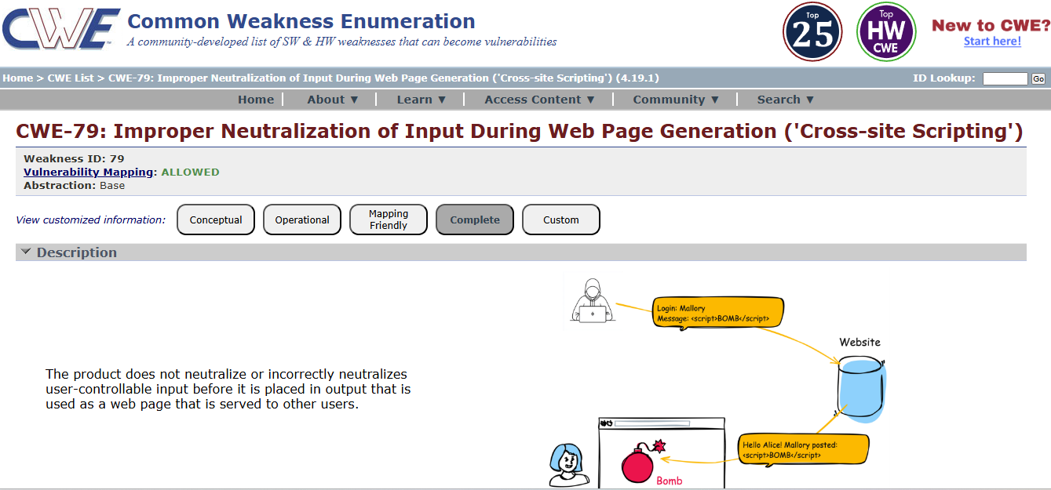

- Vulnerability name: Active Debug Code
CWE: 489
OWASP category: A02:2025 Security Misconfiguration
Description:
This vulnerability occurs when debug or testing code is left active in the application after development. Debug code may expose internal system information, error messages, or hidden functionalities that attackers can use to understand the system and exploit vulnerabilities.
Business Impact:
Active debug code can expose sensitive system details and make it easier for attackers to identify security weaknesses. This may lead to unauthorized access, system manipulation, data breaches, and damage to the organization's reputation.
  - Access the URL

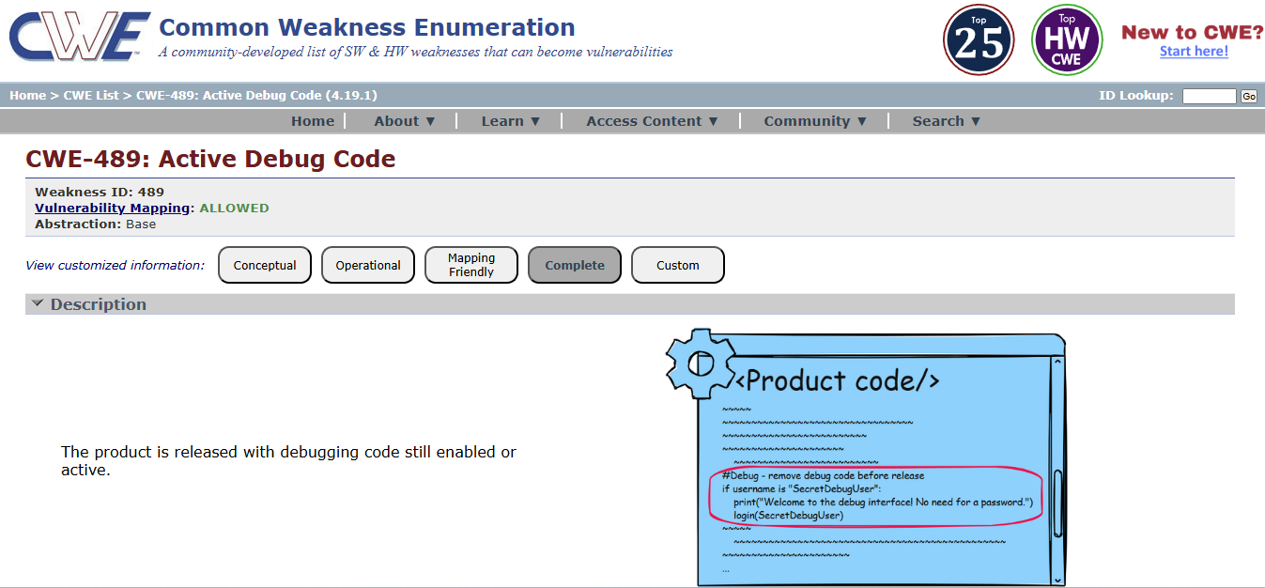
  - This the custom page where we can edit the page any time.
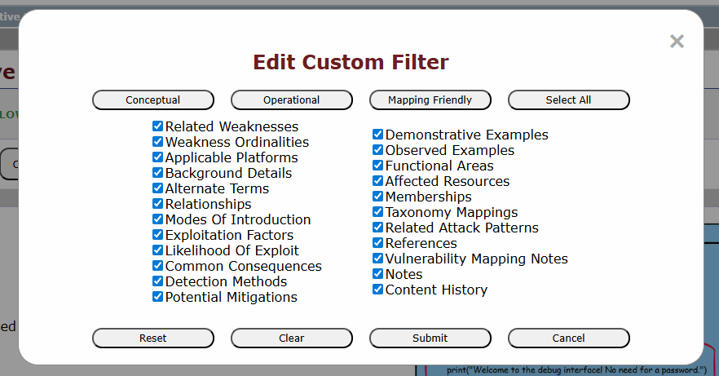
  - As we know which there is a page to learn the basics of product which is Root Cause Mapping.
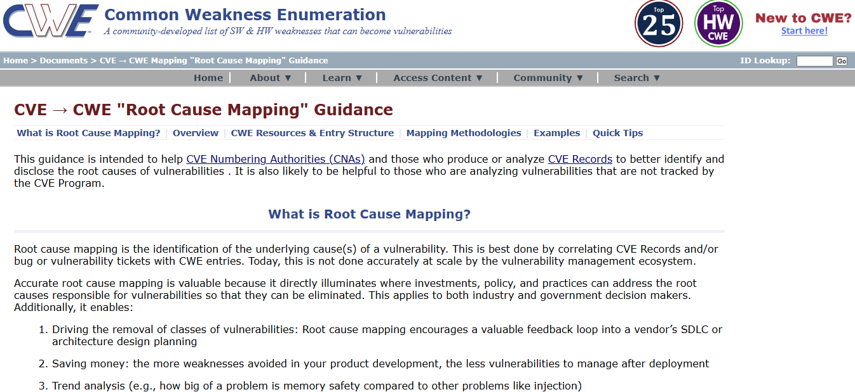

- Vulnerability Name: Unimplemented or Unsupported Feature in UI
CWE: 447
OWASP Category: A03:2025 Software Supply Chain Failures
Description:
This vulnerability occurs when a user interface displays features or options that are not fully implemented or supported by the system. Such features may confuse users or create security risks if they trigger unexpected system behaviour or expose incomplete functionality.

Business Impact:
Unimplemented or unsupported features can lead to user confusion, system errors, and potential security risks. Attackers may attempt to exploit these incomplete features to gain unauthorized access or disrupt system operations, which can affect the reliability and reputation of the organization.
- Go to the domain.
- Sign into the site.

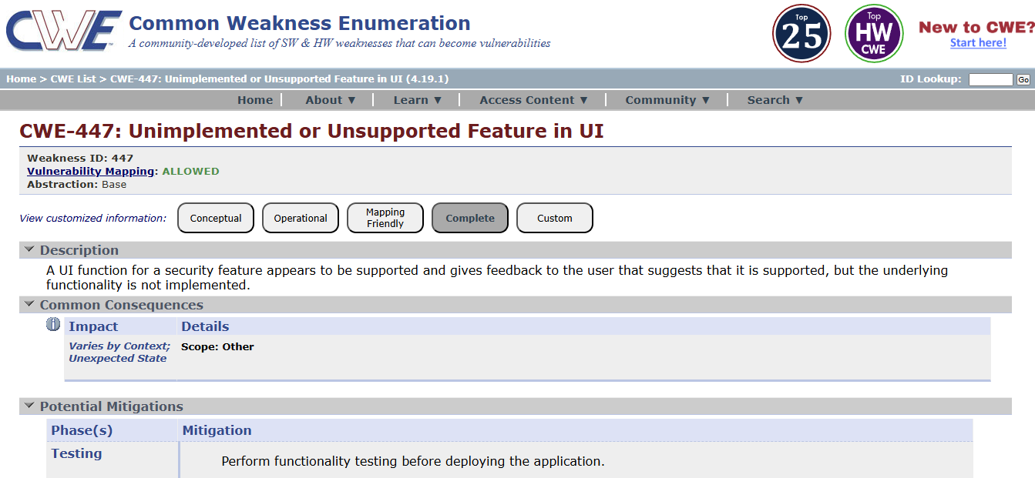

- Vulnerability name: Reusing a Nonce, Key Pair in Encryption
CWE:323
OWASP Category: A04:2025 Cryptographic Failures
Description:
This vulnerability occurs when the same nonce (number used once) or cryptographic key pair is reused during encryption processes. Nonces and key pairs are meant to be unique for each encryption operation. Reusing them can weaken the security of the encryption algorithm and may allow attackers to analyze patterns and potentially recover sensitive data.
Business Impact:
Reusing nonces or key pairs can compromise the confidentiality of encrypted data. Attackers may decrypt sensitive information, leading to data breaches, financial loss, and damage to the organization's reputation.

  - Access the URL
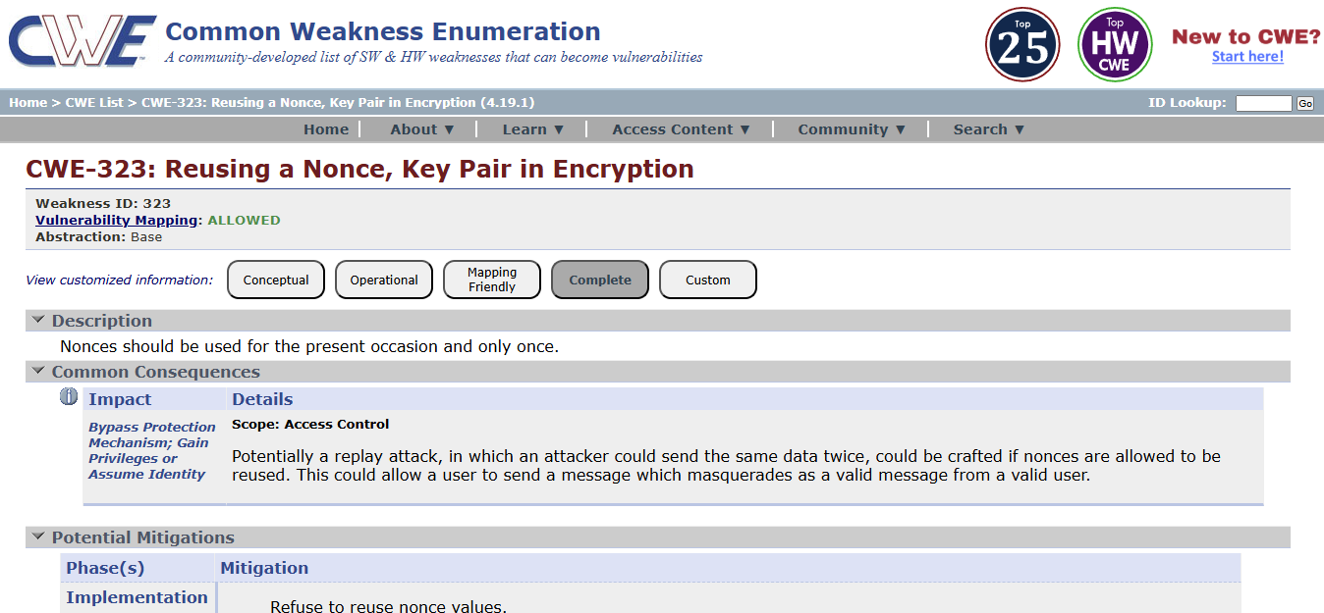

- Vulnerability Name: Improper Neutralization of Special Elements used in an OS Command ('OS Command Injection')
CWS: 78
OWASP Category: A05:2025 Injection
Description:
This vulnerability occurs when an application executes operating system commands using user input without properly validating or sanitizing that input. Attackers can insert malicious commands into the input fields, which the system may execute on the server. This can allow attackers to run unauthorized system commands and gain control over the affected system.

Business Impact:
OS Command Injection can allow attackers to execute arbitrary commands on the server, leading to unauthorized access, data theft, or system compromise. This may cause operational disruption, financial loss, and damage to the organization's reputation.
  - Open
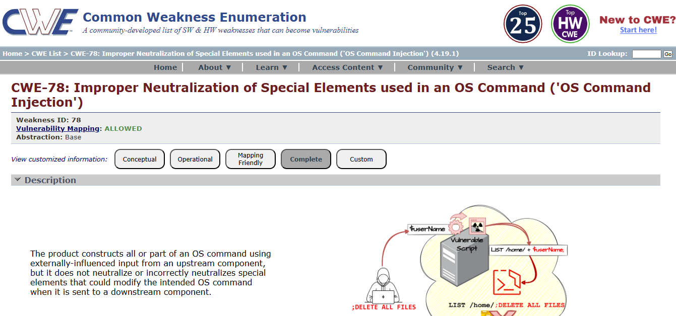
- Vulnerability name: Cleartext Storage in a File or on Disk
CWE: 313
OWASP Category: A06:2025 Insecure Design
Description:
This vulnerability occurs when sensitive information such as passwords, personal data, or confidential system information is stored in files or on disk without encryption. If an attacker gains access to the system or storage location, they may easily read and misuse the stored data.
Business Impact:
Cleartext storage of sensitive data can lead to data breaches, unauthorized access, and exposure of confidential information. This may result in financial loss, legal issues, and damage to the organization’s reputation.
  - Access the URL
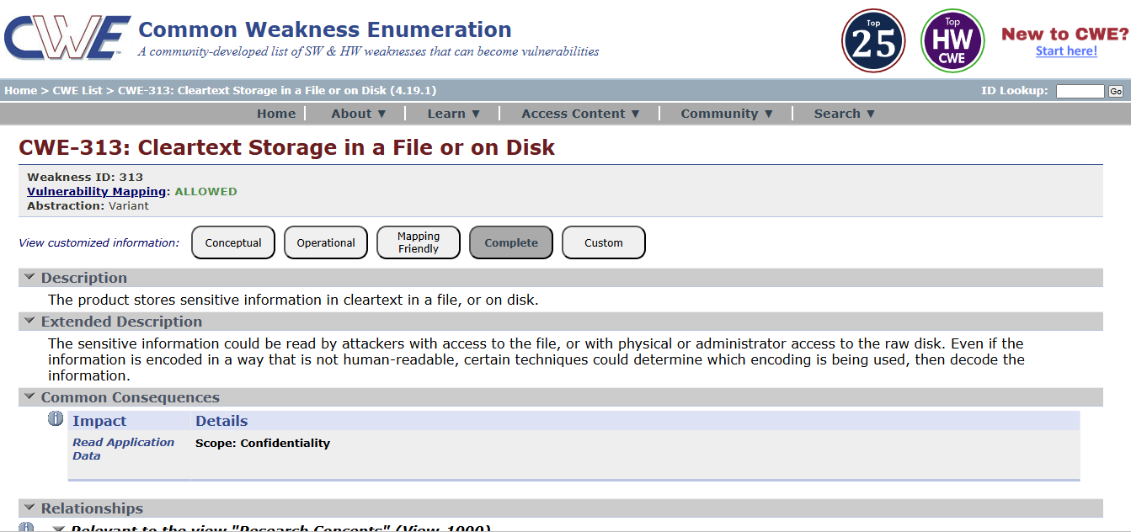

- Vulnerability name: Improper Certificate Validation
CWE: 295
OWASP Category: A07:2025 Authentication Failures
Description:
This vulnerability occurs when an application fails to properly verify the validity of SSL/TLS certificates during secure communication. If certificate validation is not performed correctly, attackers may use fake or malicious certificates to intercept communication between the user and the server.

Business Impact:
Improper certificate validation can allow attackers to perform man-in-the-middle (MITM) attacks, leading to data interception, unauthorized access, and exposure of sensitive information. This can result in financial loss, security breaches, and damage to the organization’s reputation.

  - Access the URL
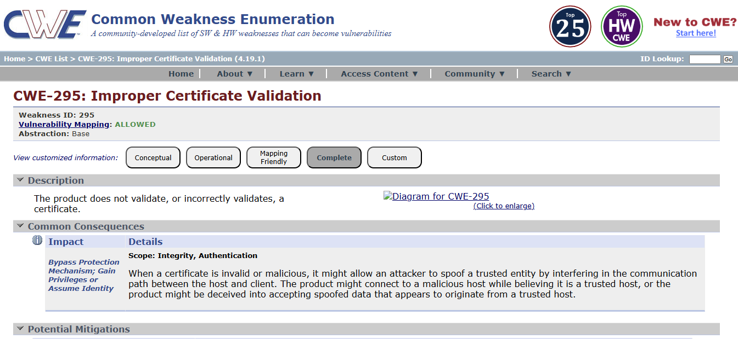

- Vulnerability name: Deserialization of Untrusted Data
CWE: 502
OWASP Category: A08:2025 Software or Data Integrity Failures
Description:
This vulnerability occurs when an application deserializes data from untrusted or unknown sources without proper validation. Attackers may modify serialized data and send malicious input to the application. When the application processes this data, it may execute harmful code or perform unintended actions.

Business Impact:
Deserialization of untrusted data can allow attackers to execute arbitrary code, access sensitive information, or compromise the entire system. This can lead to data breaches, financial loss, and damage to the organization's reputation.

  - Access the URL
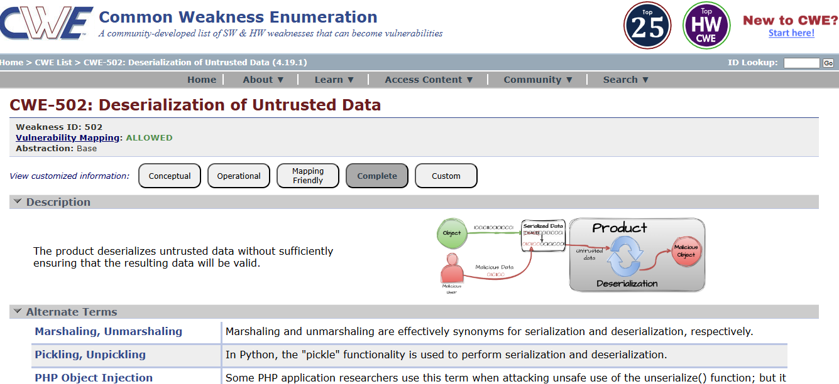

- Vulnerability name: Information Loss or Omission
CWE: 221
OWASP category: A09:2025 Security Logging & Alerting Failures
Description:
This vulnerability occurs when important information is lost, omitted, or not properly recorded during data processing, communication, or system operations. Missing or incomplete information may lead to incorrect system behaviour, misunderstanding of data, or failure to properly track user actions and system events.
Business Impact:
Information loss or omission can cause inaccurate decision-making, operational errors, and difficulty in auditing system activities. It may also lead to compliance issues, reduced data reliability, and potential security risks for the organization.

- Access the URL

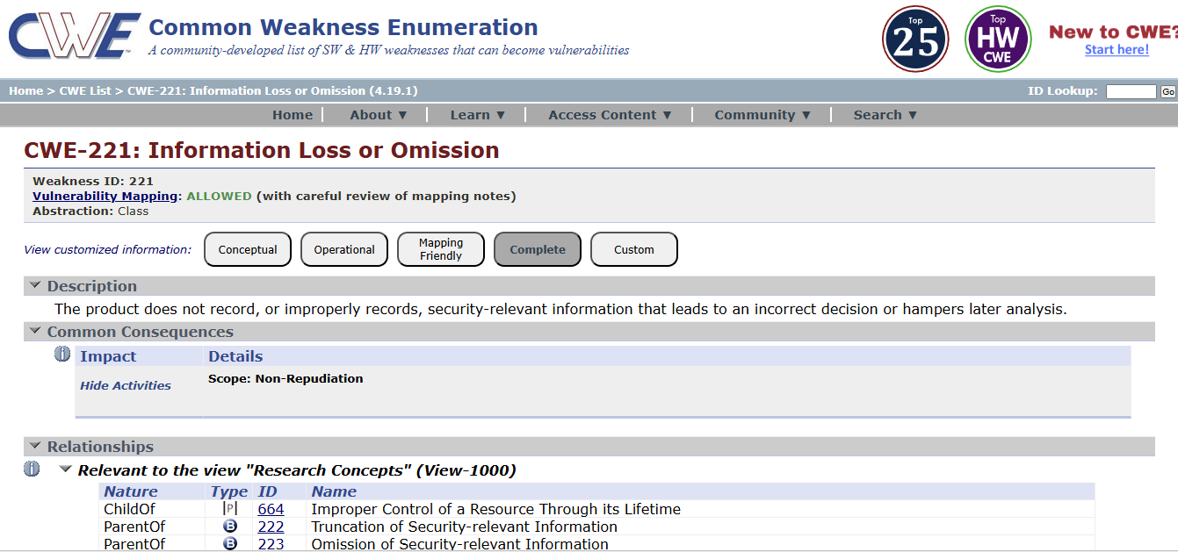

- Vulnerability name: Improper Handling of Insufficient Privileges
CWE: 274
OWASP category: A10:2025 Mishandling of Exceptional Conditions

Description:
This vulnerability occurs when an application does not properly handle situations where a user has insufficient privileges to perform an action. Instead of denying access, the system may allow the operation to proceed or may not correctly enforce permission checks. This can enable unauthorized users to access restricted resources or perform actions beyond their assigned permissions.
Business Impact:
Improper handling of insufficient privileges can lead to unauthorized access to sensitive data or system functions. Attackers may exploit this weakness bypassing security restrictions, which can result in data breaches, system misuse, and damage to the organization's reputation.

- Access the URL

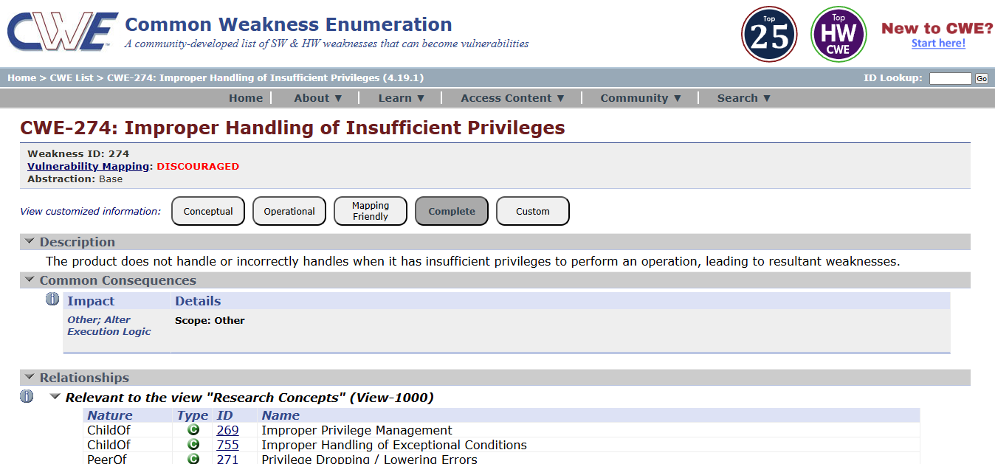

NESSUS SCAN REPORT: ginandjuice.shop
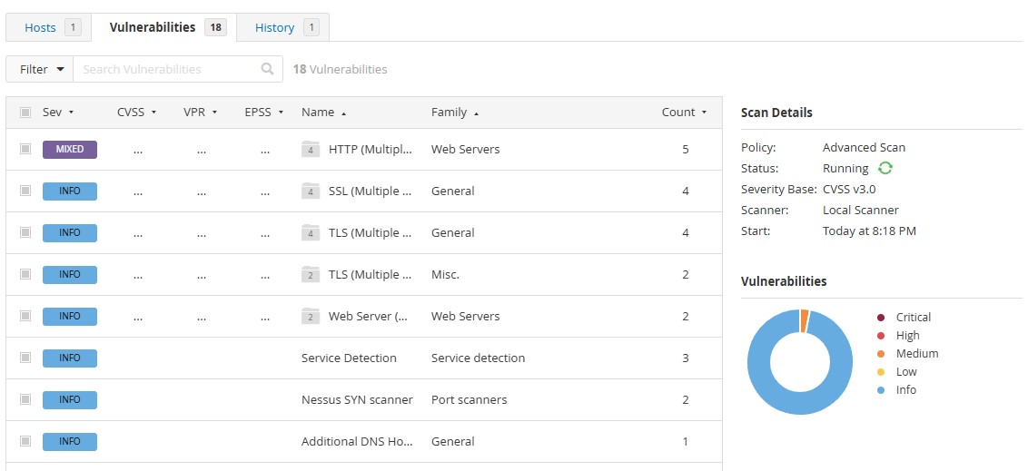

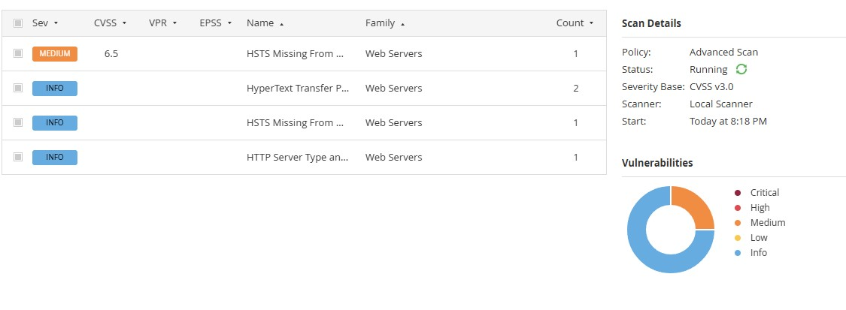

"With the Nessus scan report now at our disposal, we're equipped with critical data on the existing vulnerabilities and potential threats. This invaluable information will serve as a foundation for our project planning phase, as we chart the course to develop our AI-driven incident response platform with a well- informed strategy and timeline."

Stage – 2

Overview: -
An overview of AI-Enhanced Secure Application Access Management using Zscaler Private Access (ZPA) typically involves the following key steps and aspects:

1. Preparation:
Define Objectives:
Determine the scope and objectives of the secure access management system. Identify which applications, users, and network resources need secure access and what level of protection is required.
System Access:
Ensure that administrators have the necessary permissions and configurations to deploy ZPA and integrate AI-based security monitoring mechanisms.

2. Configuration
SetUpAccessPolicies:
Create security and access policies using ZPA to control how users connect to internal applications. AI models can assist in identifying unusual access patterns and enforcing adaptive security policies.
DefineProtectedApplications:
Specify the internal applications, servers, and services that need to be protected and accessed securely through the ZPA platform.

3. Secure Access Implementation
DeployZPAConnectors:
Install ZPA connectors within the internal network environment to establish a secure connection between users and applications without exposing the internal network.
AI-BasedMonitoring:
AI technologies analyze user behavior and access patterns to detect anomalies and potential threats in real time.

4. Threat Detection and Access Control
The system continuously monitors user activities and application access requests. AI-based analytics help detect suspicious behavior, unauthorized access attempts, and abnormal traffic patterns. Based on severity and risk level, the system can automatically enforce stricter access controls or block malicious activity.

5. Reporting
The system generates detailed reports on user access activities, detected threats, and security events. These reports include severity levels, recommended mitigation strategies, and evidence of suspicious activity. Reports can be exported in formats such as PDF, CSV, or dashboards for security monitoring.

6. Remediation
ReviewSecurityFindings:
Security teams analyze alerts and reports generated by the AI monitoring system and ZPA platform.
CorrectiveActions:
Take appropriate actions such as modifying access policies, blocking malicious users, updating security configurations, or strengthening authentication mechanisms.

7. Follow-Up and Continuous Monitoring
ContinuousMonitoring:
Regular monitoring ensures that the system detects new threats and unauthorized access attempts.
Integration:
Integrate the system with other security tools such as SIEM platforms or identity management systems to enhance the overall security posture.

8. Compliance Management
If compliance requirements are applicable, review security policies and access logs to ensure adherence to regulatory standards and organizational security policies.

9. Documentation
Maintain detailed records of system configurations, access logs, detected threats, and remediation actions. Proper documentation helps in auditing, compliance verification, and improving the system.

10. User Awareness and Training
Ensure that IT administrators and users understand how the secure access system works, including authentication procedures and security best practices to prevent unauthorized access.

Understanding the System:
AI-Enhanced Secure Application Access Management using Zscaler Private Access is a modern security approach designed to protect internal applications and network resources. It follows the Zero Trust security model, where users are granted access only after verification of identity, device posture, and security policies.

Key Features:
- Secure Application Access:
Users can securely access internal applications without exposing the internal network to the internet.
- Zero Trust Architecture:
Access is granted based on identity verification and security policies rather than traditional network trust.
- AI-Based Threat Detection:
Artificial Intelligence helps analyze access patterns and identify suspicious activities.
- Application Segmentation:
Applications are segmented and protected individually, reducing the attack surface.
- Policy-Based Access Control:
Administrators can define granular access policies based on user roles, devices, and location.
- Detailed Reporting:
The system provides comprehensive logs and reports for monitoring access activities and security events.
- Continuous Monitoring:
AI continuously monitors system behavior to detect and prevent potential threats.
- Integration Capabilities:
The system can integrate with identity providers, security tools, and monitoring platforms.

- Scalability:
ZPA supports large-scale enterprise environments and cloud-based applications.
- User-Friendly Management Interface:
Administrators can easily manage policies, monitor activity, and generate reports through an intuitive interface.

It's important to note that Nessus is a valuable tool for identifying vulnerabilities, but it doesn't fix these vulnerabilities itself. It's up to the organization's IT and security teams to take the necessary steps to remediate the identified issues to enhance their security.

List of vulnerability:

S. No | Vulnerability Name | Severity | Plugins
1. | Service Detection | Info | 22964
2. | Nessus SYN scanner | Info | 11219
3. | Host Fully Qualified Domain Name (FQDN) Resolution | Info | 12053
4. | Additional DNS Hostnames | Info | 46180
5. | HSTS Missing From HTTPS Server (RFC 6797) | Medium | 142960
6. | Device Type | Info | 54615
7. | Host Fully Qualified Domain Name (FQDN) Resolution | Info | 12053
8. | OS Fingerprints Detected | Info | 209654
9. | OS Identification | Info | 11936
10. | Remote Services Not Using Post-Quantum Ciphers | Info | 277650
Target Website: ginandjuice.shop
Target IP Address: 34.246.169.176

Report:
- VULNERABILITY NAME: Service Detection SEVERITY: Info
PLUGIN: 22964
PORT: 80 / tcp / www

Description:
Nessus was able to identify the remote service running on the target system by analyzing the service banner or the response generated when an HTTP request was sent. This means the server is revealing information about the service or software running on the system.

Solution:
• Disable unnecessary services that are not required on the server.
• Configure the web server to hide or limit banner information that reveals server details.
• Use security configurations to prevent detailed error messages from being displayed.
• Regularly update and patch the web server software to reduce the risk of vulnerabilities.
• Implement firewall rules to restrict unauthorized access to open ports and services.

Business Impact:
If attackers are able to identify the Fully Qualified Domain Name of a system, it may reveal useful information about the organization’s network structure and domain environment. This information can assist attackers in mapping the network and identifying potential targets for further attacks.

- VULNERABILITY NAME: Nessus SYN scanner
SEVERITY: Info
PLUGIN: 11219
PORT: 80 / tcp / www

Description:
The Nessus SYN scanner is used to identify open TCP ports on the target system by sending SYN packets and analyzing the responses. This type of scan helps determine which services are running on the system and whether those services are accessible from the network.

Solution:
• Disable or close unnecessary ports and services that are not required for the system’s operation.
• Configure firewall rules to restrict access to critical services and limit connections from unauthorized sources.
• Use intrusion detection or intrusion prevention systems (IDS/IPS) to monitor suspicious scanning activities.
• Regularly review open ports and network services to ensure that only essential services are exposed.
• Implement network segmentation to reduce the exposure of internal systems.

Business Impact:
Open ports and exposed services may provide attackers with information about the system’s network structure and running services. This information can be used by attackers to identify potential vulnerabilities and plan further attacks. If sensitive services are exposed, it could lead to unauthorized access, exploitation of known vulnerabilities, and compromise of system security.

- VULNERABILITY NAME: Host Fully Qualified Domain Name (FQDN) Resolution
SEVERITY: Info
PLUGIN: 12053
PORT: port 80/443

Description:

Nessus was able to determine the Fully Qualified Domain Name (FQDN) of the target host. The FQDN is the complete domain name that uniquely identifies a host within the Domain Name System (DNS). This information can help identify the system’s role in the network and the domain it belongs to.

• Restrict unnecessary DNS information exposure to external users or networks.
• Configure DNS servers and network devices to limit domain name information disclosure.
• Implement firewall rules to control external access to internal network services.
• Ensure proper network segmentation to prevent attackers from gathering detailed system information.
• Regularly review system configurations to avoid revealing sensitive network details.

Business Impact:
If attackers are able to identify the Fully Qualified Domain Name of a system, it may reveal useful information about the organization’s network structure and domain environment. This information can assist attackers in mapping the network and identifying potential targets for further attacks. Although this issue is informational, it can still contribute to reconnaissance activities that may lead to more serious security threats.

- VULNERABILITY NAME:
Additional DNS Hostnames
SEVERITY: Info
PLUGIN: 46180
PORT: N/A

Description:
Nessus discovered additional DNS hostnames that resolve to the target system. These hostnames may represent alternative domain names or aliases associated with the same host. This information can reveal additional details about the network structure or services related to the target system.

Solution:
• Limit unnecessary DNS information exposure to external networks.
• Configure DNS servers to restrict public access to internal hostname records.
• Use firewall rules to control access to internal network services.
• Regularly review DNS configurations and remove unused or unnecessary hostnames.
• Implement network monitoring tools to detect suspicious DNS queries.

Business Impact:
If additional DNS hostnames are publicly accessible, attackers may gain insights into the organization’s network infrastructure and discover related systems or services. This information can assist attackers in reconnaissance activities, helping them identify potential targets for further attacks. Although this vulnerability is informational, it may increase the risk of targeted attacks if sensitive network details are exposed.

- VULNERABILITY NAME:
HSTS Missing From HTTPS Server (RFC 6797)
SEVERITY: Medium
PLUGIN: 142960
PORT: 443 / tcp / www

Description:
The remote HTTPS server does not send the HTTP Strict Transport Security (HSTS) header. HSTS is a security feature that forces browsers to communicate with the server only over secure HTTPS connections. Without HSTS, users may still connect to the website using insecure HTTP connections, which could expose them to man-in-the-middle attacks.

Solution:
• Configure the web server to enable the HTTP Strict Transport Security (HSTS) header.
• Ensure that all HTTP requests are automatically redirected to HTTPS.
• Use strong SSL/TLS configurations to secure communication between the client and the server.
• Regularly review web server security configurations to ensure secure transport protocols are enforced.
• Example header configuration:
Strict-Transport-Security: max-age=31536000; includeSubDomains

Business Impact:
If HSTS is not enabled, users may accidentally access the website over insecure HTTP connections. Attackers could intercept or manipulate the communication between the user and the server through man-in-the-middle attacks. This could lead to the exposure of sensitive information such as login credentials, personal data, or session cookies, potentially resulting in data breaches and
loss of user trust

- VULNERABILITY NAME: Device Type
SEVERITY: Info
PLUGIN: 54615
PORT: N/A

Description:
Nessus was able to determine the type of device running on the target system. The scanner identifies whether the host is a server, workstation, network device, printer, or another type of system based on its responses and detected services. This information helps in understanding the role of the system within the network.

Solution:
• Limit unnecessary information disclosure about system configuration and device details.
• Configure network security controls such as firewalls to restrict unauthorized scanning activities.
• Regularly review system and network configurations to ensure sensitive information is not publicly exposed.
• Implement network monitoring tools to detect suspicious reconnaissance or scanning attempts.

Business Impact:
If attackers can identify the type of device running on a system, it may help them understand the role of the system in the network and plan targeted attacks. For example, knowing that a system is a database server or network device may allow attackers to search for specific vulnerabilities related to that device. Although this issue is informational, it may assist attackers during the reconnaissance phase of an attack.

- VULNERABILITY NAME:
Host Fully Qualified Domain Name (FQDN) ResolutionForgery
SEVERITY: Info
PLUGIN: 12053
PORT: N/A

Description:
Nessus was able to determine the Fully Qualified Domain Name (FQDN) of the target host. The FQDN represents the complete domain name of a system in the Domain Name System (DNS), which uniquely identifies the host within a network. This information can reveal details about the system’s domain structure and its role within the organization’s network.

Solution:
• Restrict unnecessary exposure of DNS information to external networks.
• Configure DNS servers to limit access to internal domain information.
• Use firewall rules to control external access to internal systems and services.
• Regularly review DNS records and remove unused or unnecessary domain entries.
• Implement network monitoring tools to detect suspicious reconnaissance or scanning activities.

Business Impact:
If attackers are able to identify the Fully Qualified Domain Name of a system, it may provide useful information about the organization’s domain structure and network environment. This information can assist attackers during the reconnaissance phase of an attack, helping them map the network and identify potential targets. Although this vulnerability is informational, it may increase the risk of further attacks if sensitive network details are exposed.

- VULNERABILITY NAME: OS Fingerprints Detected
SEVERITY: Info
PLUGIN: 209654
PORT: N/A

Description:
Nessus detected operating system fingerprints on the target host. By analyzing network responses and system characteristics, the scanner was able to identify the probable operating system running on the device. This information may include details about the operating system type, version, or platform used by the host.

Solution:
• Limit unnecessary exposure of system information that may reveal operating system details.
• Configure firewalls and security devices to restrict unauthorized network scanning activities.
• Keep the operating system updated with the latest security patches and updates.
• Implement network monitoring tools to detect suspicious reconnaissance or fingerprinting attempts.
• Apply security hardening techniques to minimize system information disclosure.

Business Impact:
If attackers are able to identify the operating system running on a system, they may use this information to search for known vulnerabilities related to that specific OS version. This can help attackers plan targeted attacks against the system. Although this issue is informational, it may assist attackers during the reconnaissance phase and increase the likelihood of further exploitation attempts.

- VULNERABILITY NAME: OS Identification
SEVERITY: Info
PLUGIN: 11936
PORT: N/A

Description:

Nessus was able to identify the operating system running on the remote host. This is achieved by analyzing network responses, service banners, and system characteristics. The identified information may include the operating system type, platform, or version used by the target system.

Solution:

• Limit unnecessary disclosure of system and operating system information.
• Configure firewalls and network security devices to block unauthorized scanning attempts.
• Apply operating system security hardening techniques to reduce information exposure.
• Keep the operating system updated with the latest security patches and updates.
• Monitor network traffic to detect suspicious scanning or reconnaissance activities.

Business Impact:

If attackers can identify the operating system running on a system, they may use this information to search for known vulnerabilities associated with that OS version. This can help attackers plan targeted attacks or exploit specific weaknesses in the system. Although this vulnerability is informational, it may assist attackers in the reconnaissance phase of an attack.

- VULNERABILITY NAME:
Remote Services Not Using Post-Quantum Ciphers
SEVERITY: Info
PLUGIN: 277650
PORT: 443 / tcp / www

Description:
The remote service supports standard TLS encryption but does not use post-quantum cryptographic ciphers. Post-quantum cryptography refers to encryption algorithms designed to remain secure even against attacks from quantum computers. The absence of such ciphers does not currently pose an immediate risk, but it indicates that the system may not be prepared for future cryptographic threats.

Solution:
• Monitor developments in post-quantum cryptography standards and update cryptographic implementations when supported.
• Keep TLS configurations updated with modern and secure cipher suites.
• Regularly update server software and security libraries to support newer cryptographic algorithms.
• Follow security recommendations from standards organizations and vendors regarding quantum-resistant encryption.

Business Impact:
Currently, this issue has minimal immediate impact because most systems today still rely on traditional encryption algorithms. However, as quantum computing technology evolves, traditional cryptographic methods may become vulnerable to advanced attacks. Organizations that do not adopt future-ready encryption standards may face long-term risks related to data confidentiality and security.

Stage – 3

Title:
Enforce least-privilege access through identity-aware, application-specific access policies using Zscaler Private Access (ZPA).

Zero Trust Network Access (ZTNA) is a cybersecurity framework that shifts access control from a network-centric model to an identity-centric model. The foundational principle of ZTNA is "never trust, always verify," meaning that no user or device is trusted by default, regardless of whether they are connecting from inside or outside the corporate network. Unlike traditional remote access solutions that grant users broad access to the entire network, ZTNA creates a secure, application-specific tunnel between the user and the resources they are authorized to access. This ensures that the application remains invisible to unauthorized users and the broader internet, effectively shrinking the attack surface and eliminating the risk of lateral movement across the network.
Zscaler Private Access (ZPA)
Zscaler Private Access (ZPA) is a cloud-delivered ZTNA solution that provides identity- and contextbased access to private applications without granting network-level access. ZPA operates on a "serviceinitiated" model, where users connect to the Zscaler cloud, and the cloud brokers a secure connection to the specific application via ZPA App Connectors deployed in the data center or cloud environment. Because ZPA never places the user on the corporate network, internal IP addresses and network infrastructure are completely hidden. Access policies are dynamically enforced based on user identity, group membership, device posture, and location, ensuring that each user sees only the applications they are explicitly permitted to use. Principle of Least Privilege
The principle of least privilege (PoLP) is a security concept in which a user, device, or process is granted only the minimum levels of access—or permissions—necessary to perform its function. In the context of network security, this means moving away from "fat" network access (where authenticated users can reach large segments of the network) to "thin," application-specific access. By enforcing least privilege through ZPA, organizations ensure that even if a user's credentials are compromised, the attacker cannot pivot to other systems because the network itself is invisible and inaccessible. This principle is foundational to reducing insider threats and limiting blast radius during a security incident.
Identity-Aware Access
Identity-aware access is a security model that bases access decisions on who the user is, rather than where they are connecting from. ZPA integrates directly with existing identity providers (IdPs) such as Microsoft Active Directory, Azure AD, Okta, or Ping Identity. This integration allows security teams to leverage existing user attributes, group memberships, and roles to build granular access policies. For example, a policy can state that only members of the "Finance" group, using a company-managed device, can access the "SAP Finance" application during business hours. This ensures that access is tightly coupled with the user's identity and context, reducing reliance on static IP addresses or network segments.
Application-Specific Access Policies
Application-specific access policies are the core enforcement mechanism within ZPA. Instead of creating rules that allow traffic to entire subnets or IP ranges, administrators define policies that target individual applications or groups of applications. These policies are written in plain language logic and can incorporate multiple conditions, including user identity, device posture, location, and time of day. ZPA allows for the segmentation of internal applications—such as HR systems, internal wikis, development servers, and database interfaces—so that each application has its own unique access policy. This micro-segmentation ensures that a user authenticated for one application has no visibility or connectivity to any other application.
ZPA Architecture and Components
The ZPA architecture is composed of several key components that work together to provide secure, scalable access:

- Zscaler Cloud (Service Edge): A globally distributed cloud platform that acts as the broker between users and applications. It handles authentication, policy enforcement, and connection brokering without sitting in the data path.
- App Connectors: Lightweight software VMs or containers deployed within the private data center or cloud environments. These connectors initiate outbound connections to the Zscaler cloud, eliminating the need for inbound firewall rules. They establish secure tunnels to the ZPA edge and forward traffic to the internal applications.
- ZPA Client Connector: A software client installed on end-user devices (Windows, macOS, Linux, iOS, Android). It authenticates the user, checks device compliance, and establishes a micro-tunnel to the ZPA edge for application access.
- Application Segments: Logical groupings of applications defined within the ZPA admin console. These segments represent the private resources that users need to access.
Implementation Methodology
The deployment of ZPA follows a structured, phased approach to ensure minimal disruption and maximum security efficacy:
- Phase 1: Discovery and Inventory: Identify all internal applications currently in use. Categorize them by criticality, department, and user base. Tools like network scanners, configuration management databases (CMDB), and interviews with department heads are used to build a comprehensive application inventory.
- Phase 2: Connector Deployment: Deploy ZPA App Connectors in the data center or cloud environments where the applications reside. This involves provisioning virtual machines (using VMware, Hyper-V, or cloud-specific images) and configuring them to connect to the ZPA cloud.
- Phase 3: Application Onboarding: Define application segments within the ZPA console. This includes specifying the IP addresses and ports of the internal applications and associating them with the appropriate App Connector groups.
- Phase 4: Policy Creation: Integrate ZPA with the corporate identity provider (e.g., Azure AD). Create granular access policies based on user groups, device posture, and location. Policies are tested in a simulation mode before enforcement.
- Phase 5: Pilot and Rollout: Select a pilot group of users to test the new access method. Gather feedback, monitor performance, and refine policies. Gradually migrate user populations from legacy VPN access to ZPA.
- Phase 6: VPN Decommissioning: Once all users and applications are migrated, the legacy VPN infrastructure is decommissioned, eliminating a significant attack surface.
Tools and Technologies
- Primary Platform: Zscaler Private Access (ZPA) – The core Zero Trust access broker.
- Identity Provider (IdP): Microsoft Azure Active Directory (AD), Okta, or Ping Identity for user authentication and group synchronization.
- Endpoint Protection Platform (EPP): Integration with endpoint security tools (e.g., CrowdStrike, SentinelOne, Microsoft Defender for Endpoint) to assess device posture and hygiene before granting access.
- Security Information and Event Management (SIEM): Integration with SIEM platforms (e.g., IBM QRadar, Splunk, LogRhythm) for centralized logging and correlation of access events.
- Virtualization Platforms: VMware vSphere, Microsoft Hyper-V, or public cloud environments (AWS, Azure, GCP) for hosting ZPA App Connectors.
- Infrastructure as Code (IaC): Tools like Terraform or Ansible for automated deployment and configuration of App Connectors at scale.
- Digital Experience Monitoring (DEM): Tools to monitor end-user connection quality and application performance.
Integration with Identity Providers
Integrating ZPA with the organization's existing identity provider is a critical step in establishing identity-aware access. This integration is typically done via SAML (Security Assertion Markup Language) or LDAP (Lightweight Directory Access Protocol). Once integrated, ZPA synchronizes user attributes and group memberships, allowing policies to reference these groups directly. For example, when a user authenticates via the ZPA Client Connector, they are redirected to the corporate IdP for credentials and multi-factor authentication (MFA). Upon successful authentication, ZPA receives identity attributes that are then used to evaluate access policies and determine which applications the user is allowed to see and connect to. Device Posture Checking
Beyond user identity, ZPA can enforce policies based on the security posture of the connecting device. Through integration with endpoint detection and response (EDR) and mobile device management (MDM) solutions, ZPA can assess factors such as:
- Antivirus software status and definition updates
- Disk encryption status (e.g., BitLocker, FileVault)
- Operating system patch level
- Presence of jailbreak or root compromise on mobile devices
- Real-time risk score from the EDR tool
If a device fails to meet the defined posture requirements (e.g., antivirus is disabled), ZPA can block access, grant limited access, or trigger a remediation workflow.
Micro-tunneling and Application Visibility
ZPA establishes a secure TLS/DTLS tunnel between the ZPA Client Connector and the ZPA service edge, and another tunnel between the service edge and the App Connector. Crucially, this creates a direct "app-to-user" micro-tunnel. The user's device is never placed on the corporate network; instead, traffic is proxied at Layer 7 (application layer). From the user's perspective, they can only resolve and connect to the specific DNS names or IP addresses of the applications they are authorized to access. All other internal resources remain completely invisible, preventing port scanning, vulnerability reconnaissance, and lateral movement.
Threat Intelligence Integration
To enhance security monitoring, ZPA can be integrated with threat intelligence platforms. Logs generated by ZPA—including connection attempts, policy violations, and user activity—can be forwarded to a SIEM (Security Information and Event Management) system. Within the SIEM, these logs can be correlated with threat intelligence feeds (such as those from MISP) to identify suspicious behavior. For example, if a user's credentials are used to access an application from an IP address associated with known malicious activity, the SIEM can trigger an alert, and integration with ZPA can automatically revoke that user's session. Incident Response in a ZPA Environment
ZPA significantly streamlines the incident response process. When a potential threat is detected, security teams can leverage ZPA's capabilities to:
- Isolation: Immediately revoke access for a compromised user account or device through the ZPA console, cutting off their connectivity to all internal applications.
- Forensics: Access detailed logs within ZPA showing exactly which applications were accessed, by whom, from which location, and for how long.
- Containment: Because users have no network-level access, a compromised endpoint cannot be used to scan or attack other internal systems, containing the blast radius.
- Granular Blocking: Temporarily block access to specific high-risk applications while allowing access to others, ensuring business continuity during an investigation.
Understanding ZPA: Key Takeaways
Zscaler Private Access represents a fundamental shift in how remote access is architected and secured. Here are the key aspects to understand about the solution:
- It is cloud-native: ZPA is delivered entirely from the Zscaler cloud, eliminating the need for hardware appliances and complex VPN head-end management.
- It is identity-centric: Policies are built around users and groups, not IP addresses, making access control more intuitive and aligned with organizational structure.
- It ensures network invisibility: By never placing users on the network, ZPA renders internal infrastructure invisible to the internet, preventing reconnaissance and DDoS attacks.
- It is scalable: The cloud architecture allows ZPA to scale instantly to accommodate thousands of concurrent users without performance degradation.
- It supports hybrid environments: ZPA works seamlessly for applications hosted in on-premises data centers, private clouds, and public cloud environments.

- It improves user experience: Users get direct, optimized connections to applications without backhauling traffic through a centralized VPN concentrator, reducing latency.

Conclusion:

Stage 1: In conclusion, web application testing is a crucial process that ensures the security, functionality, and reliability of web-based software. It involves a comprehensive evaluation of various aspects, including user interface, functionality, performance, and security to identify and rectify issues before they impact end-users. This process not only enhances the quality of web applications but also bolsters their resilience against potential threats and vulnerabilities. In an age where online services and applications are integral to our daily lives, effective web application testing is essential to deliver a seamless and secure user experience.

Stage 2: The Nessus report for the specific website has highlighted key security insights. It identified vulnerabilities, categorized by severity, with a focus on critical and high-risk issues that need immediate attention. Recommendations for addressing these vulnerabilities include patching, reconfiguration, and other security measures, with a priority on actions that can have the most significant impact. Compliance with industry standards and best practices is considered, ensuring alignment with recognized security benchmarks like OWASP guidelines. The report underscores the need for continuous monitoring, regular updates, and ongoing security efforts to maintain a strong security posture. In summary, the Nessus report offers a clear view of the website's security state, provides guidance on mitigating vulnerabilities, and stresses the importance of sustained vigilance against evolving threats.

Stage 3:
The implementation of Zscaler Private Access marks a pivotal shift from a vulnerable, networkcentric security model to a resilient, identity-centric Zero Trust architecture. By enforcing leastprivilege access and rendering private applications invisible to the internet, this project effectively neutralizes the threats of lateral movement and network-based attacks. The solution not only fortifies the organization's security posture against modern cyber threats but also delivers a seamless and high-performance experience for a distributed workforce. Furthermore, the decoupling of access from the network simplifies IT operations, reduces dependency on legacy VPN infrastructure, and provides granular visibility into user-application interactions. Ultimately, this initiative establishes a future-ready foundation for secure digital transformation..

Future Scope:
Stage 1: future scope of web application testing
The future scope of web application testing is promising and evolving rapidly, driven by the continuous growth of the internet and web-based applications.

Here are some key aspects of its future scope:

- Increased Demand: As more businesses and services move online, the demand for web applications continues to grow. This, in turn, increases the demand for web application testing to ensure security, reliability, and functionality.
- Advanced Technologies: The complexity of web applications is rising with the integration of advanced technologies like AI, IoT, and blockchain. Testing these cutting-edge applications will require specialized skills and tools.
- Security Emphasis: With the growing number of cyber threats and data breaches, security testing for web applications will become even more critical. Testers will need to focus on vulnerabilities, data protection, and compliance with regulations like GDPR.
- Mobile and Cross-Browser Testing: Mobile usage is on the rise, and web applications must be responsive and functional on various devices and browsers. Testing for cross-compatibility will be essential.
- Performance Testing: As user expectations for speed and performance increase, load testing, stress testing, and other performance testing types will be crucial to ensure web applications can handle traffic spikes.

Stage 2: future scope of the testing process you understood.

The future scope of the web application testing process, particularly in terms of identifying vulnerabilities, is exceedingly promising due to the continuous growth of digital platforms, the escalating importance of cybersecurity, and the ever-evolving threat landscape. Here are some key aspects that highlight the prospective scope of web application testing for vulnerability discovery:

- AI-Driven Testing: The integration of artificial intelligence (AI) and machine learning (ML) into web application testing tools will revolutionize the way vulnerabilities are identified. AI algorithms can swiftly scan vast amounts of code and data to pinpoint vulnerabilities that might elude human testers.
- IoT and Mobile App Testing: With the proliferation of Internet of Things (IoT) devices and the increasing usage of mobile applications, the scope of web application testing will extend to encompass these areas. Ensuring the security of IoT devices and the interfaces they use will become critical.
- Blockchain and Cryptocurrency Security: As blockchain technology and cryptocurrencies continue to gain traction, security testing will be imperative to safeguard transactions and digital assets. Ensuring the robustness of blockchain-based applications will be a specialized niche in web application testing. Serverless Architectures: With the adoption of serverless computing, web application testing will need to adapt to assess the security of serverless functions and APIs. Ensuring that serverless components are free from vulnerabilities will be paramount.
- Container Security: As containerization technologies like Docker and Kubernetes become ubiquitous, web application testing will extend to cover container security. This includes ensuring that container images and orchestration configurations are free from vulnerabilities.

Stage 3: future scope of Zero Trust
The successful deployment of ZPA lays the groundwork for a broader, more integrated security ecosystem. Future enhancements can be explored to further mature the organization's security capabilities:
- Integration with Zscaler Internet Access (ZIA): Converging Private Access (ZPA) with Internet Access (ZIA) to create a unified Secure Access Service Edge (SASE) platform, managing all web and private traffic through a single policy framework.
- Advanced Device Posture Checking: Moving beyond basic compliance to incorporate real-time risk scores from EDR tools, blocking access if a device shows signs of active compromise.
- Privileged Remote Access: Extending ZPA to third-party vendors and contractors with time-bound, audited access to specific critical systems, replacing jump boxes and bastion hosts.
- IoT/OT Segmentation: Applying the same micro-tunneling principles to Internet of Things (IoT) and Operational Technology (OT) devices to ensure they can only communicate with specific management servers.
- AI-Driven Anomaly Detection: Leveraging machine learning on ZPA logs to detect behavioral anomalies, such as a user accessing an application at an unusual hour or from a strange location, triggering automated MFA challenges or access revocation.
- Cloud Workload Protection: Utilizing ZPA to secure connections between containers and microservices in multi-cloud environments (AWS, Azure, GCP), ensuring east-west traffic between workloads is encrypted and authenticated.
- Automated Provisioning/Deprovisioning: Enhancing the identity provider integration to automatically revoke application access the moment an employee is terminated or changes roles, ensuring near real-time access control.
- Digital Experience Monitoring (DEM): Implementing DEM tools to proactively monitor the enduser experience, identifying network latency or application performance issues before they impact productivity.

Topics Explored:
- Zscaler
- Zero trust
- ZPA
- VPN
- MISP
- College Network Information
- Deployment of SOC in the College
- Threat Intelligence
- Incident Response

Tools Explored:
▪ Nessus Scanner

