**Machine Learning Advanced Nanodegree**

**Capstone Proposal for Classifier for Kaggle’s Amazon from Space competition**

Vivek Pothina

December 21st, 2018

**Domain Background**

A few decades ago, Image Classification was a difficult task for computers, but now using Deep Learning we can empower satellites to label satellite images. Planet: Understanding Amazon from Space is competition in Kaggle. Planet, designer and builder of the world’s largest constellation of Earth-imaging satellites, collected images of 3-5-meter resolution around Amazon Rainforest. On Kaggle, the competition was a challenge to label satellite image chips with atmospheric conditions and various classes of land cover/land use. This is a multi-label classification problem too. Using a simple neural network to solve this problem would be slow and ineffective. CNN/Convnet has been used to use the spatial information to capture features of the satellite images such as cloudy or rain forest features.

*Reference: Ciresan, Dan C., et al. "Flexible, high performance convolutional neural networks for image classification." IJCAI Proceedings-International Joint Conference on Artificial Intelligence. Vol. 22. No. 1. 2011.*

*http://www.aaai.org/ocs/index.php/IJCAI/IJCAI11/paper/download/3098/3425*

In the above-mentioned paper, the author has used CNNs to perform image classification on MNIST, NORB and CIFAR-10 datasets.

**Problem Statement**

The input is a satellite image chip, we need to determine the classes under which the image has a high probability.

**Dataset and Inputs**

The data was obtained from Kaggle. The data consists of train-jpg.tar.7z and train.csv, the dataset consists of around 40479 images which belong one or more classes among 17 classes. The images are in jpg format, each of shape (256, 256, 4). The color space is RGB + near infrared band. Each image has a unique id and the labels are given in train.csv file. The validation set has been created with a split of 80% from training set.

Label: agriculture clear habitation primary road

Shape: (256, 256, 4)Max: 255, Min: 0

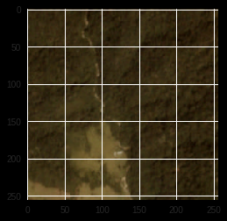

Distribution of target class

{'haze': 2696, 'primary': 37512, 'agriculture': 12314, 'clear': 28430, 'water': 7410, 'habitation': 3659, 'road': 8070, 'cultivation': 4546, 'slash_burn': 208, 'cloudy': 2088, 'partly_cloudy': 7260, 'conventional_mine': 99, 'bare_ground': 861, 'artisinal_mine': 338, 'blooming': 331, 'selective_logging': 339, 'blow_down': 100}

No. of Labels: 17

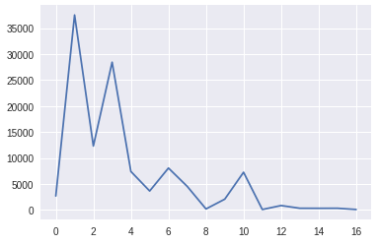

**Solution Statement**

As mentioned above, a CNN was used to solve the problem. The CNN will learn the important features and classify the image to one or more classes. The loss function used was the binary cross entropy function which is present in Keras.

$$-\frac{1}{N}\sum_{n=1}^{N}{[y_{n}\log{(\overbrace{y_{n}})}}+(1- y_{n})\log\left(1 - \overbrace{y_{n}}\right)]$$

Where N = 17 i.e. the number of classes/labels in the dataset, $y_{n}$ is the label vector and $\overbrace{y_{n}}$ is the prediction vector. Weights and biases are updated using the Adam optimizer using a learning rate of 0.001

**Benchmark Model**

One kaggler achieved accuracy of 93% on the validation set. <https://gist.github.com/EKami/33ec0172590ab9f2e3a6b757c9f9dcb4>

The model was run on 20 epochs and has tried learning rates = 0.01, 0.001.

**Evaluation Metrics**

As mentioned above, the evaluation metric would be a multi-label log loss function between the predicted probabilities and the actual value for the image.

**Project Design**

The steps taken to complete this project are:

1. Import the labels from the .csv file
2. Resize all the images to 128, 128. Color data of the images has been considered.
3. The CNN architecture used in the project is:
   * Conv 1: inputs = 32, kernel_size = (3,3)
   * Maxpool Layer
   * Conv 2: inputs = 64, kernel_size = (3,3)
   * Maxpool Layer
   * Conv 3: inputs = 128, kernel_size = (3,3)
   * Dropout: probability = 0.7
   * Flatten
   * Dense or fully connected layer: inputs = 512
   * Output layer with sigmoid activation function
4. For this project, Google Colab notebooks (https://colab.research.google.com) has been used to use a cloud GPU for better machine efficiency.
5. Test the network’s performance and tweak the performance.