Satya-Score: An AI Hallucination Detection & Scoring Framework
Vivek Yeshwantrao Borkar, Piyush Devidas Nande, Aasawari Sahebrao Jumade, Arunima Tridip Wankhade, R. R. Karwa
Dept. of Artificial Intelligence and Data Science, Prof. Ram Meghe Institute of Technology & Research, Badnera-Amravati, India
[e-mail addresses of the authors]

Abstract-Large language model (LLM) answers read well yet may contain falsehoods, and Hindi has little tooling to find them. This paper describes Satya-Score, a detector that judges English and Hindi text one claim at a time. A claim goes first to official statistics (World Bank, WHO) or the Wikidata knowledge graph when either can decide it, next to published fact-checks, and only then to Wikipedia passages assessed by a multilingual inference model with a deliberately cautious evidence rule. Each claim receives a verdict, a score and evidence, plus the true value when a structured source decides. Most changes to the design were judged against rules written down before the experiment. On real chatbot claims, true statements were seldom flagged (9 of 258 in training, 3 of 66 in testing), but text-based evidence exposed only 5 of 45 hallucinations. Structured sources proved dependable: altered country statistics were caught in all 137 cases with no true figure rejected, and a pre-registered ablation on 40 relational claims showed the knowledge graph lifting AUC from 0.704 to 0.784. On the public FEVER set, 71% of supported claims were verified, 11% raised false alarms, and 43% of refuted claims were caught. On Mu-SHROOM the system marked few spans, giving a span IoU well under a mark-all baseline (Hindi 0.011 vs. 0.271), yet 71% (Hindi) and 82% (English) of its flags fell on annotated errors. Discarded designs are also reported, including an LLM judge with almost four times the false-alarm rate.
Index Terms-LLM hallucination, claim verification, knowledge graphs, natural language inference, Hindi NLP, explainable fact-checking.
I. Introduction
Assistants such as those based on Llama [1] are now asked about medicine, government schemes and history. They compose the most probable continuation of a prompt instead of consulting a record of facts, and so they sometimes state invented or incorrect details with full confidence, the behaviour known as hallucination [2], [3]. The fault is usually confined to one statement inside an otherwise sound answer, which is why checking has to happen per claim and has to point to evidence [4]. Nearly all available checkers handle English, even though Hindi, with several hundred million speakers, turns up more and more often in chatbot replies.
We designed, built and tested Satya-Score, a claim-level checker for English and Hindi. The paper contributes:
- Source routing: each claim is answered by the most trustworthy source that covers it (statistics, knowledge graph, fact-check, encyclopaedic text), and the verdict names that source and, for structured sources, gives the correct value.
- Per-source safeguards: a namesake rule for Wikidata, two-agency agreement for statistics, entailment in the required direction for fact-checks, and an evidence rule under which only passages about the claim’s subject may refute it.
- An evaluation that fixed its decision rules in advance, covering a pre-registered knowledge-graph ablation, the public FEVER and Mu-SHROOM (Hindi, English) benchmarks, and the designs that did not work.
- Labelled data: 456 claims from chatbot answers in two languages and 40 relational claims from two other LLMs.
II. Related Work
The FEVER dataset [5] made verification of claims against Wikipedia a standard task. For model output, FActScore [4] breaks long answers into atomic facts and looks each up in Wikipedia, while SAFE [6] has an LLM agent search the web for every fact; both are English-only and lean on large models. SelfCheckGPT [7] compares several sampled answers, so an error the model makes consistently goes unnoticed. AlignScore [8] and MiniCheck [9] decide whether a supplied document backs a sentence, and inference models are known to mistake lexical overlap for support [10]. SemEval-2025 Mu-SHROOM [11] asked teams to mark hallucinated spans in 14 languages, Hindi included, and BHRAM-IL [12] quantifies LLM hallucination rates across Indian languages. Graph-based work includes FactKG [13], which reasons over graph paths, KGR [14], which repairs drafts using a graph, and MultiHal [15], a multilingual benchmark built on graph paths; reviews describe the value of graphs as promising yet not established [16], [17]. Retrieval-augmented generation [18] grounds text during writing, which does not help when auditing what an external chatbot has already said. We are not aware of a system that joins claim-level checking, official statistics, a knowledge graph and published fact-checks, supports Hindi and states the correct value.
III. System
A. Claim Extraction
For English we use the spaCy dependency parser [19]. Coordinated statements become separate claims, each list entry becomes a claim, and a pronoun is resolved to the topic of the passage instead of the closest name; in a pre-registered test on 400 held-out Wikipedia introductions this increased correct resolutions from 93 to 277. Hindi input is segmented into sentences by the Indic NLP Library [20]. Questions, greetings and advice are recognised and left unchecked.
B. Retrieval and Inference
An XLM-R multilingual sentence encoder [21], [22] maps claims and passages to vectors, and FAISS [23] searches an index of 102,069 Wikipedia passages (89,594 English, 12,475 Hindi) that grows when a relevant article is missing. Up to ten nearest passages whose cosine similarity reaches 0.3 go to an mDeBERTa-v3 classifier [24] trained on MultiNLI and XNLI [25], [26], which returns an entailment probability e(p) and a contradiction probability c(p) per passage. They are combined as
s = 0.5 + 0.5 max e(p), if max e(p) ≥ 0.5 (1)
s = 0.5 + 0.5 (max e(p) − max c(q)), q on-topic, otherwise (2)
where a passage counts as on-topic if the title of its article occurs in the claim. Support may therefore come from anywhere, but refutation only from text about the claim’s own subject.
C. Structured Sources
A claim on a country’s population, GDP, life expectancy, literacy or infant mortality is checked against World Bank figures [27] and, for the two health indicators, WHO figures [28]; the comparison respects the precision in which the claim is stated, and if both agencies hold a value their verdicts must coincide. Relations such as birth and death places and dates, founding dates, capitals, authorship, office-holders, quantities and currencies are looked up in Wikidata [29] through templates for both languages. When a name is shared by several entities, one match suffices for support, while refutation needs disagreement from all namesakes that have a value. Published fact-checks are retrieved with the Google Fact Check Tools API [30]; a “false” rating transfers to our claim only when the claim entails the checked statement, a “true” rating only when the reverse entailment holds, and no rating transfers if either direction is contradictory.
D. Scoring
The Composite Multilingual Hallucination Scoring Algorithm (CMHSA) has the form HalluScore = α·SemSim + β·NLI + γ·KG, with per-language softmax weights. Because similarity reflects topic and not truth, α is set to 0, and training gives β ≈ γ ≈ 0.5. In operation the first available source decides: a statistics or Wikidata answer yields 1.0 or 0.0, an applicable fact-check 0.05 or 0.95, and otherwise s is used; a claim without evidence gets 0.5. Scores under 0.35 mean Hallucinated, scores over 0.65 Verified, and the middle range Uncertain, and a whole text is labelled Hallucinated once a third or more of its claims are. Fig. 1 gives the architecture and Fig. 2 the decision order. The service runs on FastAPI with a React front end, and Table I shows outputs of the deployed system.
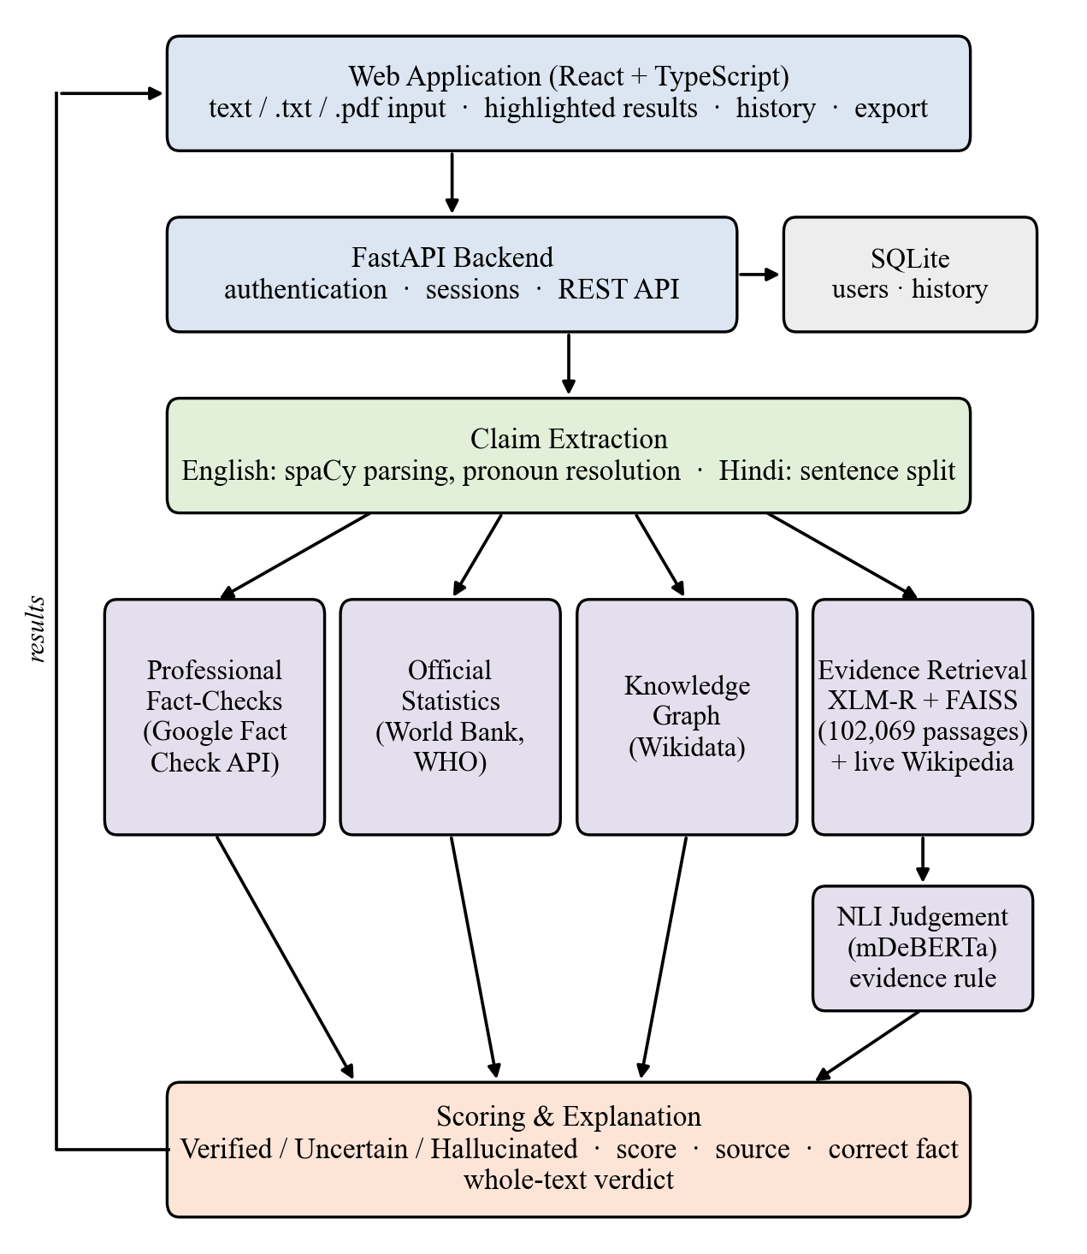
Fig. 1. Architecture of Satya-Score.
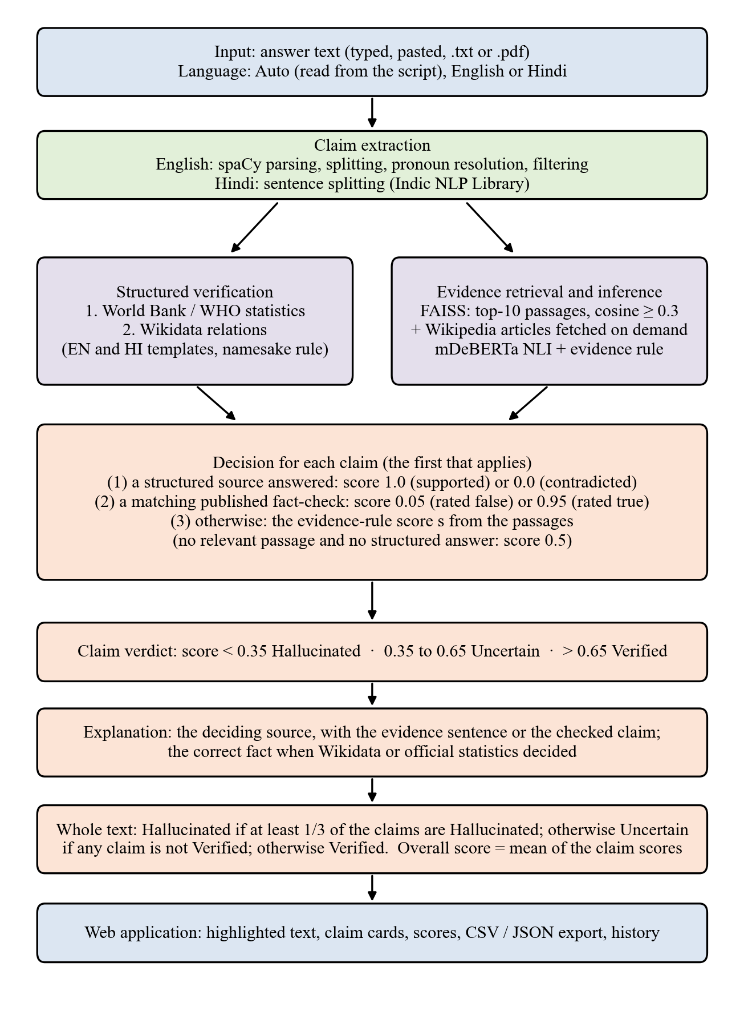
Fig. 2. Processing of one request: the first applicable source sets each claim’s score.
TABLE I
Examples from the running system
Claim | Verdict | Deciding evidence
The capital of Japan is Beijing. | Halluc. | Wikidata; correct: Tokyo
Mahatma Gandhi was born in Delhi. | Halluc. | Wikidata; correct: Porbandar
Cricket is a bat-and-ball sport played between two teams usually with 11 players per team. | Verified | Wikipedia passage (Cricket)
यूनेस्को ने नरेंद्र मोदी को दुनिया का सर्वश्रेष्ठ प्रधानमंत्री घोषित किया है। (UNESCO declared Modi the best PM) | Halluc. | Fact-check (Vishvas News): False
Drinking hot water does not kill the coronavirus. | Verified | Fact-check of the opposite claim not applied

IV. Experimental Setup
A. Data
Table II summarises the evaluation data. The core set consists of claims taken from answers of Llama 3.3 (70B) to questions in five domains, and all claims of one answer are kept in the same split. The relational set was drawn from answers of gpt-oss-120b and qwen3.8-27b.
TABLE II
Evaluation data
Set | Size | Labels
Chatbot claims (EN 266, HI 190) | 456 | Annotator
binary train / test | 303 / 76 | 258+45 / 66+10
Relational claims (EN) | 40 | 25 true, 15 false
Unseen true Wikipedia sentences | 128 | true
Statistics (40 countries) | 274 | 137 true, 137 altered
Fact-check set | 40 | 25 rumours, 15 true
FEVER paper_dev sample | 300 | 150 SUP., 150 REF.
Mu-SHROOM test HI / EN | 150 / 154 | char. spans

B. Annotation
The 456 core claims were labelled by a team of four annotators, the authors. An AI system first proposed a verdict for every claim; the annotators shared the claims among themselves and confirmed or overrode each proposal, and the merged file was not altered afterwards. 79% of the final labels coincide with the proposal. Two blind studies examined this procedure. In the first, two people labelled 56 claims independently and agreed with κ = 0.53 (88% raw) on hallucinated versus not; in the second, wherever both blind annotators agreed, the existing label matched in 45 of 46 claims. The relational claims carry labels from two annotators assisted by AI, and only the 40 on which they agreed are used.
C. Protocol and Measures
For most changes, the criterion for accepting them was written and committed before the experiment. The final decision departed from the criterion four times (Section V-D), and two analyses of the knowledge graph were exploratory. The benchmark protocol was likewise fixed in advance, and no setting was tuned on benchmark data. We count a false alarm when a true claim is labelled Hallucinated and a catch when a hallucinated claim is; an Uncertain verdict is never scored as correct. For Mu-SHROOM we apply the official measures, character-level IoU between predicted spans (claims labelled Hallucinated) and gold spans, and Spearman correlation with the soft labels.
V. Results
A. Public Benchmarks
FEVER results are in Table III. Of the supported claims, 71% were verified (95% CI 64–78%) and 17/150 drew false alarms; of the refuted claims, 43% were caught (35–51%). A definite verdict was given for 71% of the claims, and 81% of those verdicts were right. Using the inference signal alone yields practically the same figures, because statistics or Wikidata decided just 9 claims (7 correctly) and no fact-check applied: FEVER statements seldom fall into the relations our templates handle. The false-alarm rate is higher than on chatbot claims. Among the 17 false alarms are facts that held in 2017 but no longer do (“Marillyn Hewson is currently the President of Lockheed Martin”), vague statements (“Kesha has a full name”), real inference mistakes (“Tim McGraw acted in The Blind Side”) and one knowledge-graph mistake (“The Bee Gees wrote songs”).
TABLE III
FEVER sample (150 supported, 150 refuted)
 | Live | NLI only
Supported → Verified | 107/150 | 107/150
Supported → Halluc. (false alarm) | 17/150 | 17/150
Refuted → Halluc. (caught) | 64/150 | 64/150
Refuted → Verified (missed) | 24/150 | 23/150
Uncertain (all) | 88/300 | 89/300
Accuracy when decided | 81% | 81%

Table IV covers Mu-SHROOM. At least one claim was flagged in 7% of the Hindi and 30% of the English answers, and 71% (Hindi) and 82% (English) of the flagged claims intersect an annotated span. Since these answers are dense with hallucinated spans and few claims are flagged, IoU stays far below the mark-all baseline; no Hindi claim and only 3 English claims were settled by a structured source. Flags are mostly well placed, and scores correlate weakly but positively with the soft labels. The task report gives best IoU values of 0.74 for Hindi and 0.65 for English, with team averages of 0.50 and 0.40 [11], all far above our results. Span-level IoU rewards recall, which our cautious design gives up on purpose.
TABLE IV
Mu-SHROOM test sets (mean IoU / Spearman)
Method | Hindi (150) | English (154)
Satya-Score | 0.011 / 0.053 | 0.102 / 0.112
Mark-all baseline | 0.271 / 0.000 | 0.349 / 0.000
Mark-none baseline | 0.000 / 0.000 | 0.033 / 0.000
Best team (task report) | 0.74 / 0.78 | 0.65 / 0.62
Mean of teams (task report) | 0.50 / 0.52 | 0.40 / 0.37

B. Chatbot Claims and Unseen Text
On the labelled chatbot claims (Table V) false alarms are uncommon, 3.5% of true training claims and 4 of 128 unseen true sentences, yet most hallucinations slip through: 27 of the 45 in the training split were labelled Verified.
TABLE V
Live system on chatbot claims and unseen text
Set | Correct | False al. | Caught | Uncert.
Train (303) | 157 | 9/258 | 5/45 | 110
Test (76) | 38 | 3/66 | 0/10 | 27
Unseen true (128) | 113 | 4/128 | - | 11

C. Structured Sources
Results for the structured sources appear in Table VI. In the pre-registered ablation, combining the knowledge graph with the inference score improved AUC from 0.704 to 0.784 (difference +0.080, 95% CI +0.003 to +0.189) and Hallucinated-F1 from 0.512 to 0.615. Of 13 pre-registered graph decisions 11 were correct; the two errors arose from place names linked to the wrong items, and once the linking was repaired all 12 decisions were correct (exploratory). Giving the graph the final say whenever it answers was selected in an exploratory comparison (AUC 0.872 vs. 0.848 for the weighted sum; difference +0.024, 95% CI −0.000 to +0.083).
TABLE VI
Structured sources
Component (data) | Result
KG decisions, pre-registered (40) | 11/13 correct
KG decisions after fix (exploratory) | 12/12 correct
KG ablation, pre-registered: AUC | 0.704 → 0.784
Statistics (137 altered / 137 true) | 137 caught / 0 contradicted
Fact-checks (40): wrong decisions | 0; rumours caught 3 → 10

D. Rejected Designs
Table VII collects the changes and what was decided. Two changes were kept even though one of their checks failed. The evidence rule cut false alarms on 99 unseen true statements from 33 to 8 but reduced hallucinations caught in training from 11 to 3 of 45; reading ten passages instead of three raised correct training verdicts from 130 to 170 of 303 while false alarms went from 8 to 11 of 258. Two changes favoured by their rules were not kept. An LLM judge reached a training AUC of 0.717 against 0.552 and found 18 rather than 5 of 45 hallucinations, but its false alarms grew from 9 to 35 of 258; a larger inference model improved only within noise.
TABLE VII
Changes tested and decisions
Change | Outcome | Decision
Evidence rule | FA 33→8/99; caught 11→3/45 | adopted*
Top-10 passages | correct 130→170/303; FA 8→11/258 | adopted*
LLM judge | caught 5→18/45; FA 9→35/258 | kept off*
Larger NLI model | within noise | not adopted*
Number guard | verified 115→101 | rejected
MedlinePlus source | FA 9→11/258 | rejected
Strict support rule | verified 152→47 | rejected
MiniCheck (probe) | 7/9 false common-sense supported | not pursued

* Decision against the outcome of the pre-fixed rule. FA: false alarms.
E. Latency
Running look-ups concurrently, with a separate request pace for each web service, shortened the check of a six-claim English answer on an RTX 4050 laptop GPU from 27.7 s to 5.1 s the first time and from 10.1 s to 0.7 s when repeated, without any change in verdicts; on the CPU alone the corresponding times were 13.7 s and 0.7 s.
VI. Discussion and Limitations
Two situations emerge. When a structured source contains the fact, the verdict is dependable and the reader also learns the right value. When only encyclopaedic text is available, the inference model frequently accepts a passage that merely discusses the topic as support. About 31 of the 45 training hallucinations were artefacts of an older extraction step rather than chatbot errors, and most of the genuine ones are misconceptions that no structured source records. All 9 false statements among 15 common-sense probes were judged Verified (“Humans can breathe naturally underwater” was backed by a scuba-diving passage), and the MiniCheck grounding model still accepted 7 of the 9. Our cautious design gives up detections in exchange for few false alarms, a reasonable trade for an auditing tool but one that keeps recall low. The benchmarks show the same picture: flags are usually right but rare, and the structured sources behind the reliable verdicts apply to few FEVER or Mu-SHROOM claims.
The study has limits. The labelled sets are small, with only nine Hindi hallucinations; each core claim was labelled once, by one of the four annotators, with the AI suggestion visible; the knowledge-graph decision rule and linking repair were chosen on the same 40 claims used to assess them; FEVER labels reflect Wikipedia as of 2017; our claim-level spans are coarser than Mu-SHROOM’s token spans; live look-ups require internet access; and the WHO data licence permits non-commercial use only.
VII. Conclusion
Satya-Score examines English and Hindi answers claim by claim and supports every verdict with evidence that readers can inspect. Sending claims to official statistics, a knowledge graph and published fact-checks makes it accurate wherever those sources reach, and committing to acceptance criteria before experiments revealed which appealing ideas failed. Next steps are adding Marathi and building a larger Hindi test set labelled blind by two people. The code and the labelled data can be obtained from the authors.
Acknowledgment
We are grateful to the Department of Artificial Intelligence and Data Science, PRMIT&R, for its support. AI tools were used for code assistance, for drafting the text of this manuscript and for drawing Figs. 1 and 2; AI also proposed the initial verdicts that the authors reviewed (Section IV-B). All experiments, labels and reported figures were checked by the authors, who take full responsibility for the content.
References
[1] A. Grattafiori et al., “The Llama 3 herd of models,” arXiv:2407.21783, 2024, doi: 10.48550/arXiv.2407.21783.
[2] Z. Ji et al., “Survey of hallucination in natural language generation,” ACM Comput. Surv., vol. 55, no. 12, 2023.
[3] L. Huang et al., “A survey on hallucination in large language models: Principles, taxonomy, challenges, and open questions,” ACM Trans. Inf. Syst., vol. 43, no. 2, 2025, doi: 10.1145/3703155.
[4] S. Min et al., “FActScore: Fine-grained atomic evaluation of factual precision in long form text generation,” in Proc. EMNLP, 2023, doi: 10.48550/arXiv.2305.14251.
[5] J. Thorne, A. Vlachos, C. Christodoulopoulos, and A. Mittal, “FEVER: A large-scale dataset for fact extraction and VERification,” in Proc. NAACL-HLT, 2018, doi: 10.18653/v1/N18-1074.
[6] J. Wei et al., “Long-form factuality in large language models,” arXiv:2403.18802, 2024.
[7] P. Manakul, A. Liusie, and M. J. F. Gales, “SelfCheckGPT: Zero-resource black-box hallucination detection for generative large language models,” in Proc. EMNLP, 2023, doi: 10.48550/arXiv.2303.08896.
[8] Y. Zha, Y. Yang, R. Li, and Z. Hu, “AlignScore: Evaluating factual consistency with a unified alignment function,” in Proc. ACL, 2023, pp. 11328–11348.
[9] L. Tang, P. Laban, and G. Durrett, “MiniCheck: Efficient fact-checking of LLMs on grounding documents,” in Proc. EMNLP, 2024, doi: 10.48550/arXiv.2404.10774.
[10] R. T. McCoy, E. Pavlick, and T. Linzen, “Right for the wrong reasons: Diagnosing syntactic heuristics in natural language inference,” in Proc. ACL, 2019, doi: 10.18653/v1/P19-1334.
[11] R. Vázquez et al., “SemEval-2025 Task 3: Mu-SHROOM, the multilingual shared task on hallucinations and related observable overgeneration mistakes,” in Proc. SemEval, 2025, arXiv:2504.11975, doi: 10.48550/arXiv.2504.11975.
[12] H. Terdalkar, K. Bhojani, A. Dongare, and O. A. Behera, “BHRAM-IL: A benchmark for hallucination recognition and assessment in multiple Indian languages,” in Proc. BHASHA Workshop, 2025, doi: 10.18653/v1/2025.bhasha-1.9.
[13] J. Kim, S. Park, Y. Kwon, Y. Jo, J. Thorne, and E. Choi, “FactKG: Fact verification via reasoning on knowledge graphs,” in Proc. ACL, 2023, doi: 10.18653/v1/2023.acl-long.895.
[14] X. Guan et al., “Mitigating large language model hallucinations via autonomous knowledge graph-based retrofitting,” in Proc. AAAI, vol. 38, no. 16, pp. 18126–18134, 2024, doi: 10.1609/aaai.v38i16.29770.
[15] K. Lavrinovics, R. Biswas, K. Hose, and J. Bjerva, “MultiHal: Multilingual dataset for knowledge-graph grounded evaluation of LLM hallucinations,” arXiv:2505.14101, 2025, doi: 10.48550/arXiv.2505.14101.
[16] G. Agrawal, T. Kumarage, Z. Alghamdi, and H. Liu, “Can knowledge graphs reduce hallucinations in LLMs? A survey,” arXiv:2311.07914, 2023, doi: 10.48550/arXiv.2311.07914.
[17] K. Lavrinovics, R. Biswas, J. Bjerva, and K. Hose, “Knowledge graphs, large language models, and hallucinations: An NLP perspective,” J. Web Semantics, vol. 85, art. 100844, 2025, doi: 10.1016/j.websem.2024.100844.
[18] P. Lewis et al., “Retrieval-augmented generation for knowledge-intensive NLP tasks,” in Proc. NeurIPS, 2020, doi: 10.48550/arXiv.2005.11401.
[19] M. Honnibal, I. Montani, S. Van Landeghem, and A. Boyd, “spaCy: Industrial-strength natural language processing in Python,” Zenodo, 2020, doi: 10.5281/zenodo.1212303.
[20] A. Kunchukuttan, “The IndicNLP Library,” 2020. [Online]. Available: https://github.com/anoopkunchukuttan/indic_nlp_library
[21] N. Reimers and I. Gurevych, “Making monolingual sentence embeddings multilingual using knowledge distillation,” in Proc. EMNLP, 2020, doi: 10.48550/arXiv.2004.09813.
[22] A. Conneau et al., “Unsupervised cross-lingual representation learning at scale,” in Proc. ACL, 2020, doi: 10.18653/v1/2020.acl-main.747.
[23] J. Johnson, M. Douze, and H. Jégou, “Billion-scale similarity search with GPUs,” IEEE Trans. Big Data, vol. 7, no. 3, pp. 535–547, 2021, doi: 10.1109/TBDATA.2019.2921572.
[24] P. He, J. Gao, and W. Chen, “DeBERTaV3: Improving DeBERTa using ELECTRA-style pre-training with gradient-disentangled embedding sharing,” in Proc. ICLR, 2023, doi: 10.48550/arXiv.2111.09543.
[25] A. Williams, N. Nangia, and S. R. Bowman, “A broad-coverage challenge corpus for sentence understanding through inference,” in Proc. NAACL-HLT, 2018, doi: 10.18653/v1/N18-1101.
[26] A. Conneau et al., “XNLI: Evaluating cross-lingual sentence representations,” in Proc. EMNLP, 2018, doi: 10.18653/v1/D18-1269.
[27] The World Bank, “World Bank Open Data.” [Online]. Available: https://data.worldbank.org
[28] World Health Organization, “The Global Health Observatory.” [Online]. Available: https://www.who.int/data/gho
[29] D. Vrandečić and M. Krötzsch, “Wikidata: A free collaborative knowledgebase,” Commun. ACM, vol. 57, no. 10, pp. 78–85, 2014, doi: 10.1145/2629489.
[30] Google, “Fact Check Tools API.” [Online]. Available: https://developers.google.com/fact-check/tools/api

